Sample mix with F beads: Create back pressure by dispensing 5ul into each lane one lane at time twice. Aspirate then dispense 10ul on each lane (10ul in the first two cycles, 15ul next two cycles). Increase backpressure every cycle by dispensing 5ul onto each channel. Aspirate then dispense 15ul on each lane twice.

Purge lane 13 to waste III and wash image (lane 13 through imaging to waste II) at 15ul/sec

gmix: mix F elute with G beads. Equilibrate both sides of of v21 before opening. Dispense 5ul to each lane one at a time. Aspirate 4ul then dispense 5ul 3 times individually on each lane, run loop twice. Close transition valves 21 and 16 (F to G). Delay 90s.

Wash with reagent A, path X, lane 13 through imaging to waste II

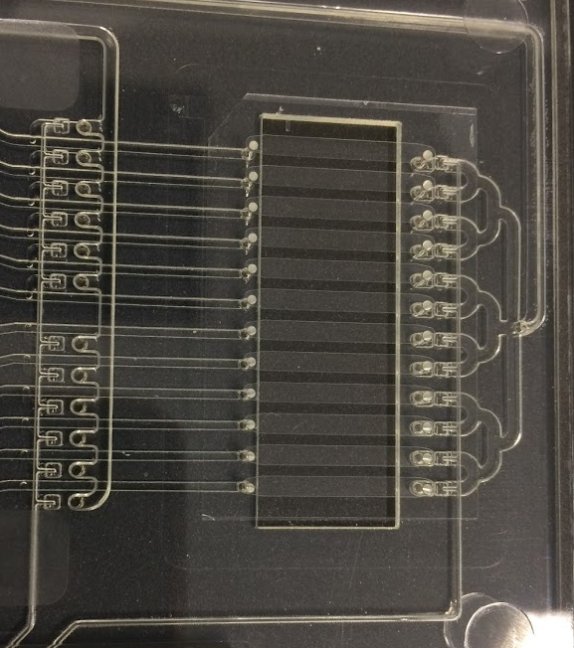

**X**

**waste**

Immobilize with reagent C, path X, waste III through imaging to waste II

Flushing immobilize line (off card), closed to imaging