Creating a New QGIS Template / Product

# Prerequisites

Every QGIS template has the following required associations:

1. A QGIS template (Data/templates/)
2. A layer stylesheet (Data/styles/raster/ or Data/styles/vector/)
3. A legend stylesheet (Data/styles/legend/EN and Data/styles/ legend/FR)

# 0. Creating the required files

For each new product, you will need to create new QGIS templates (1 per region), at least 1 layer stylesheet and 2 legend stylesheets (one for EN, one for FR)

The paths to their respective directories are outlined above.

# 1. Creating a Legend Stylesheet

1. Load the legend.tif (Data/legend.tif) onto QIGS.

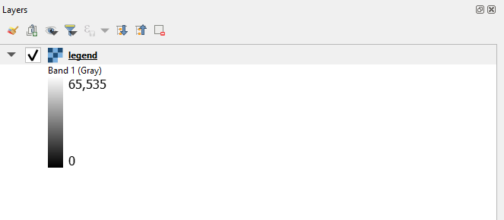

2. Right click the item 🡪 Properties 🡪 Symbology. Under Render type, change to Paletted/Unique values

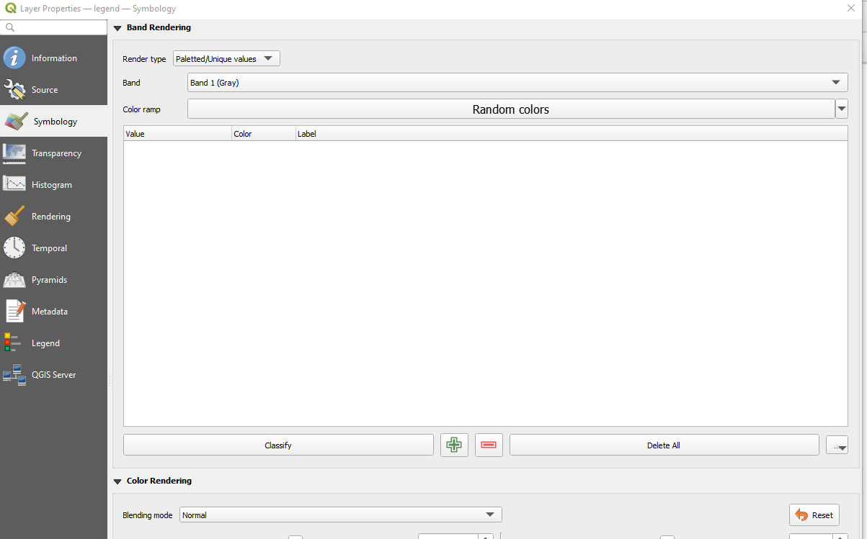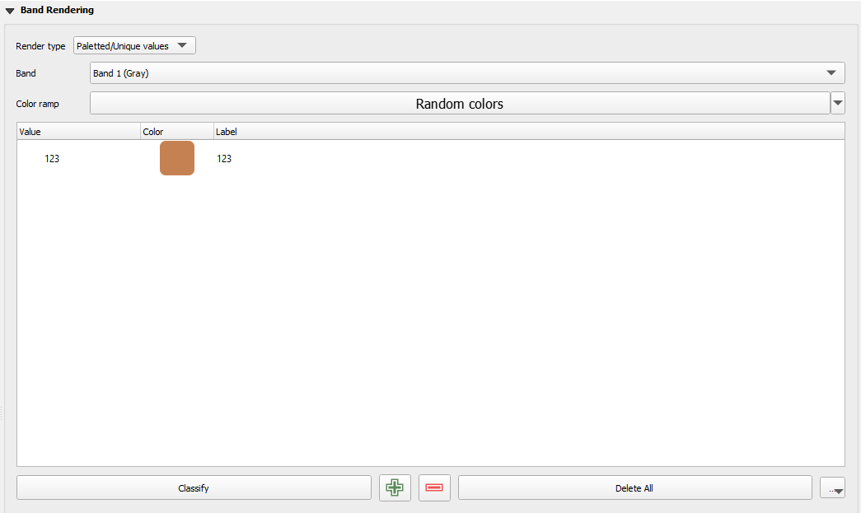

Here, you can add new symbology for the English (left) side of the legend.

3. Once completed, click on the bottom left Style button 🡪 Save Style 🡪 browse to Data/styles/legend/EN or

4. Repeat for French and store in Data/styles/ legend/FR.

# 2. Creating a Layer Stylesheet

The process is similar to creating a legend style sheet.

1. Load shapefile or raster onto QGIS.

2. Add new symbology manually or click on the Classify button. This will auto generate all unique values present in the given layer.

* *Note, if shapefile, you must select the proper column under the Value dropdown*

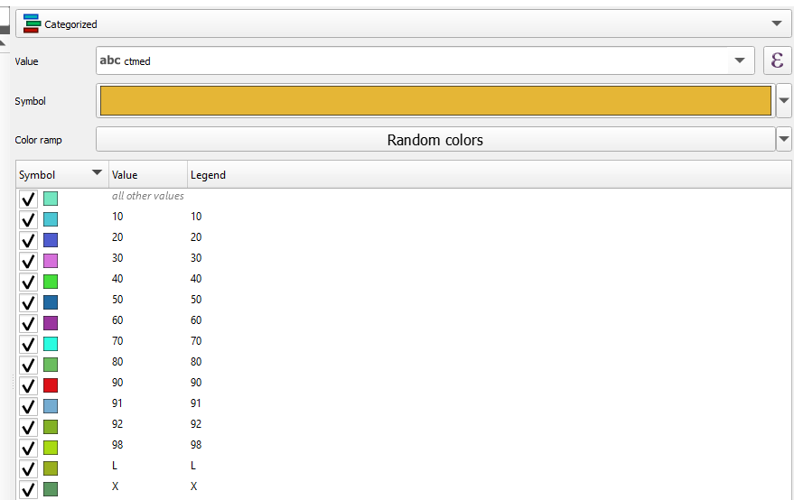

If the layer is a shapefile, you have several options to choose for symbology patterns (Categorized, Graduated, etc.). This choice is dependent on if the symbology is related to a range of values (i.e.: frequency), specific individual values (i.e.: ctmed), etc.

3. Export to (Data/styles/raster/ or Data/styles/vector/). Note that different products can use the same raster stylesheet. However, when dealing with shapefiles since you must select a Value you **must create one file per product**

# 3. Creating a new Template

When creating a new product, chances are it will be very similar to an existing template. If so, please read the file titled howto_modify_template.pdf

However, if creating from scratch

1. Please first follow Step #0 in the aforementioned document to get started.

2. Click on the New Print Layout button

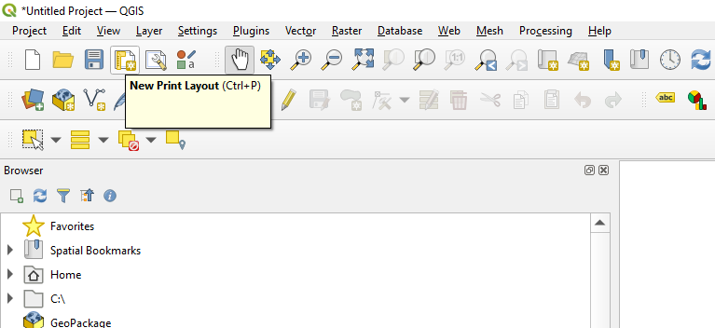

# 4. Adding the new product to the repository

1. Majority of the modifications are done in the configuration file: (Common/config.json)

The following keys within the file will require updating (please follow existing lines for a general idea):

1. filenames
2. templates
3. raster_style or vector_style
4. legend_style

2. If the logic is more complicated than pre-existing products, then the code within AtlasChart.py will require modification to accommodate for these new changes.