Modifying an Existing QGIS Template

# Prerequisites

Every QGIS template has the following required associations:

1. A QGIS template (Data/templates/)
2. A layer stylesheet (Data/styles/raster/ or Data/styles/vector/)
3. A legend stylesheet (Data/styles/legend/EN and Data/styles/ legend/FR)

Please read the file titled: Creating a new QGIS Templatefor more information

# 0. Load necessary layers into QGIS

This step is *optional*, only required if making modifications to the legend symbology. For example, added more symbols, need to resize surrounding text.

1. Load necessary layers onto QGIS. Add stylesheet (located above #2).

2. [Required] Load legend.tif (x2) (Data/legend.tif) onto QGIS. Add stylesheet (located above #3 one for EN, one for FR).

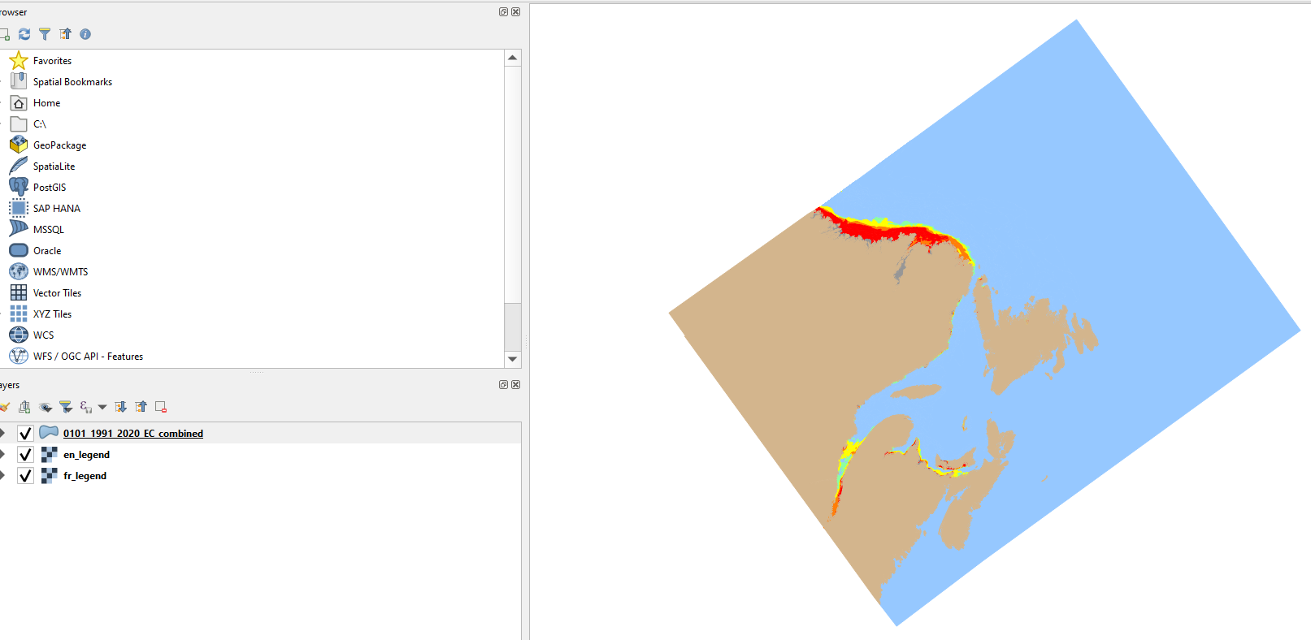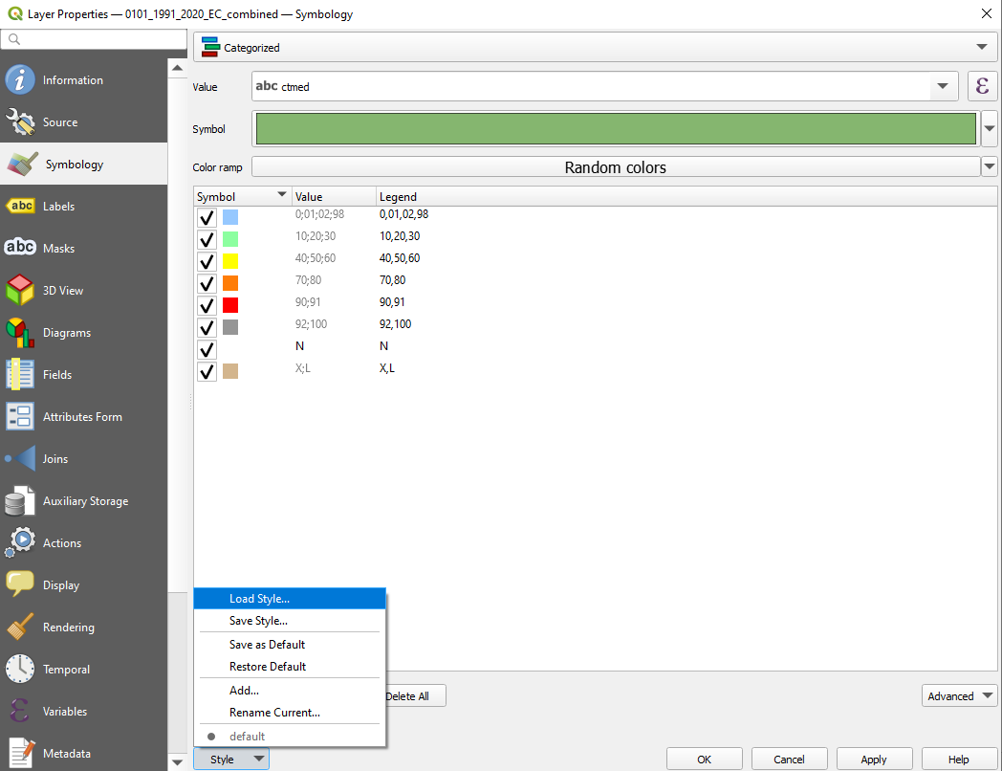

# 1. Load Template onto QGIS

Drag and Drop the template onto QGIS and load it

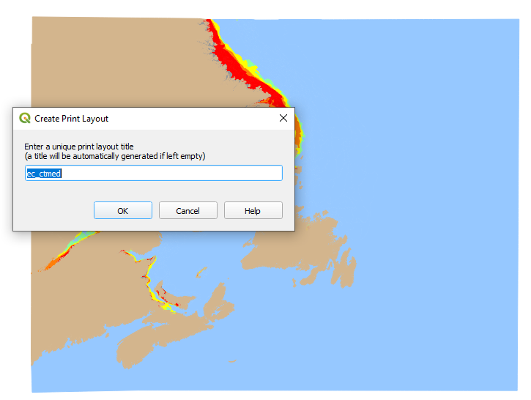

# 2A. Fix Wonky Legend (if Step 0 was performed)

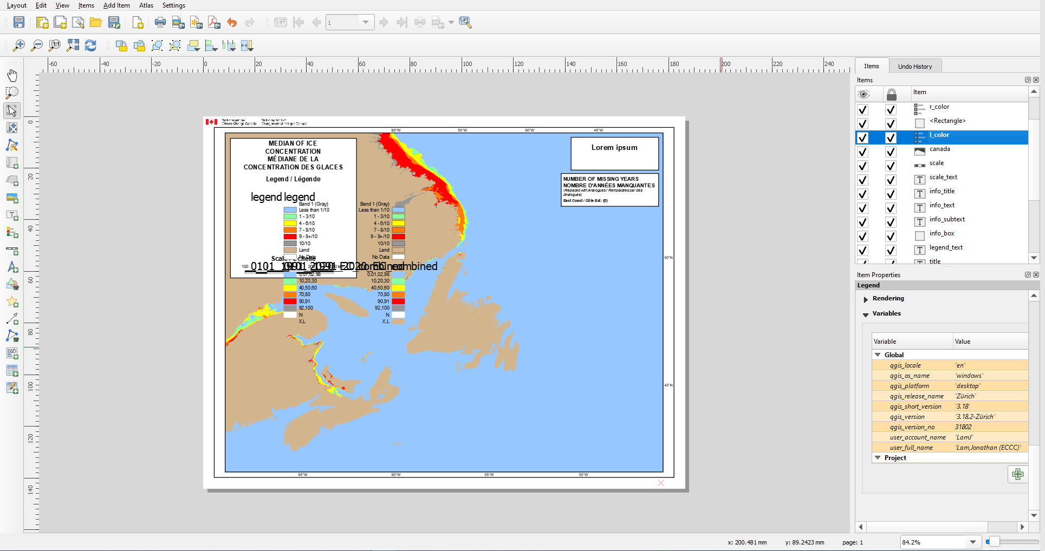

The legend auto populates with all symbologies from the loaded layers. To fix, follow below procedures for items titled: l_color and r_color:

1. Click on the item, under Legend Item, uncheck Auto update

2. Delete all layers but legend using the – (minus) sign

3. Remove unnecessary symbols

4. Right click legend and check the Hidden checkbox

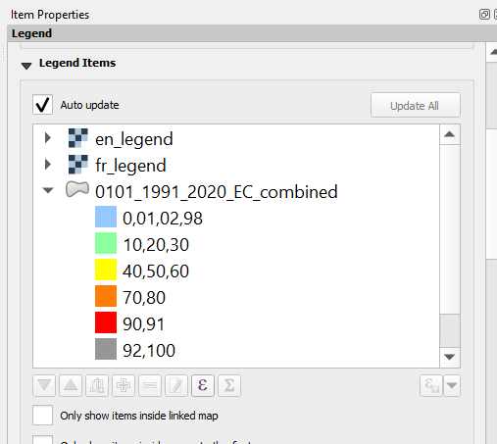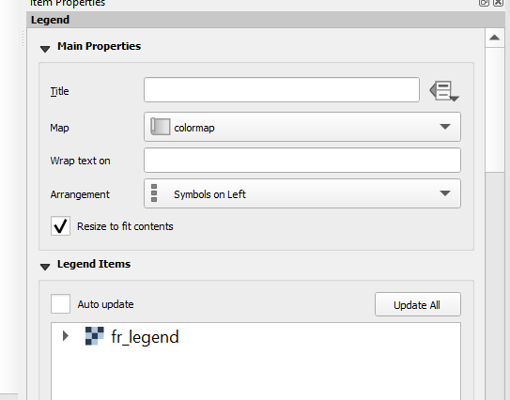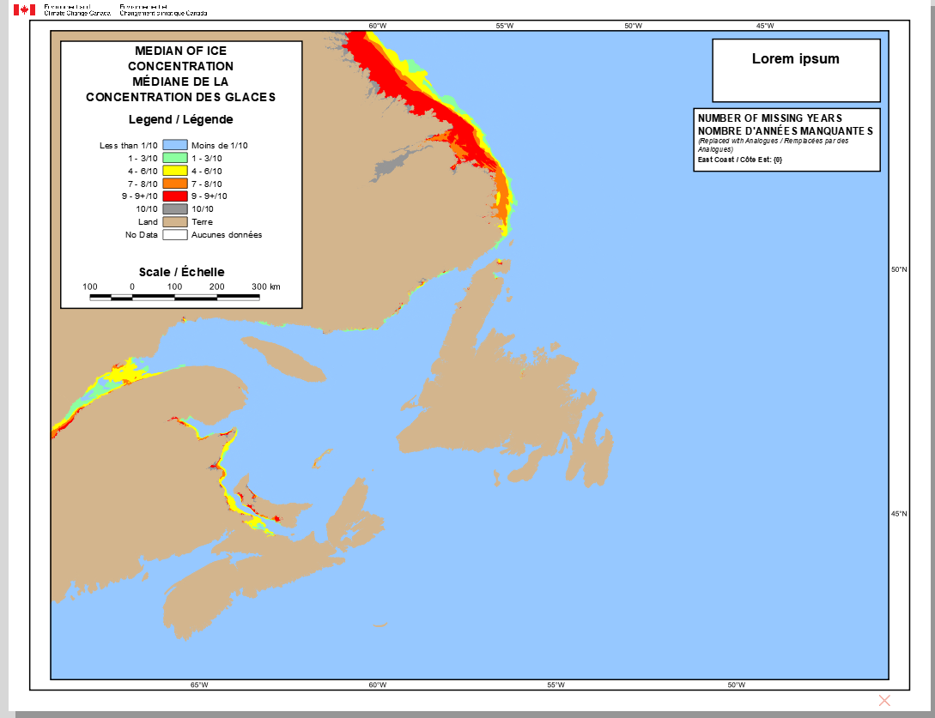

# 2B. Make needed changes

Now you can make the unnecessary changes. Note that by default the template items are mostly locked. You will need to unlock it to be able to move them around in the template

# 3. Export

To export the template (i.e.: to save changes), Click on Layout 🡪 Export to Template.

Important: before exporting to template, please remove all layers loaded into QGIS. Otherwise, the template will store layer-related information and in turn make the resulting template file very bulky.S