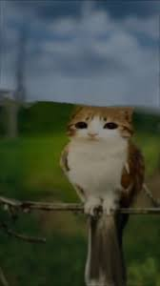

You sit there perched

With longing in your eyes

Your feathers in the wind

As you fantasize

Of a world of quiet

Where meowls roam

A place of solace

That you would call home

My fur keeps me warm

In the brisk autumn night

In the morn I awake

And off I take flight

My kittens have hatched

Within their homely nest

I will be a good mother

Who does her very best

The meowl lives humbly

As she yearns for more

For a happier home

For her chicks to adore

While she feeds her kin

One late October night

She realizes then

That she is enough.