**Index**

* Intro to the project
* Source Code
* Outputs
* Future Enhancements
* Conclusion

**INTRODUCTION**

The aim of the project is to ease out the process of creating a new account for a customer as well as to cater the needs of the old account holders with options like depositing amount into the account, withdrawing amount from the account and checking the account for balance. It also allows the bank personnel to view all account holders list, close an account and to modify the account according to customer’s requirement.

**OUTPUT**

*Login screen*

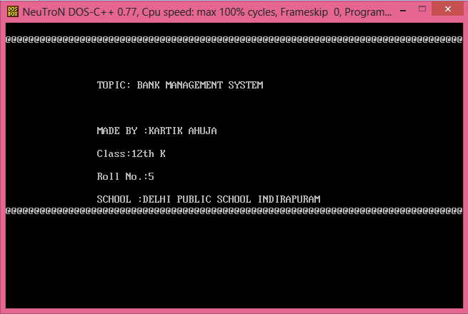

*Main menu*

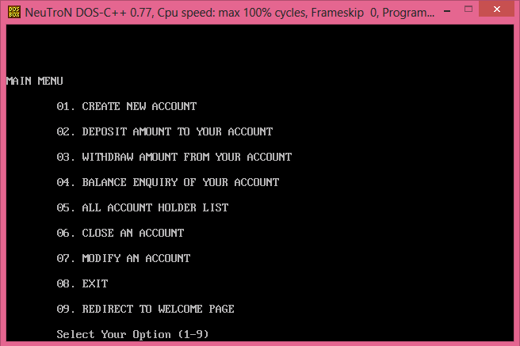

*Create a new account*

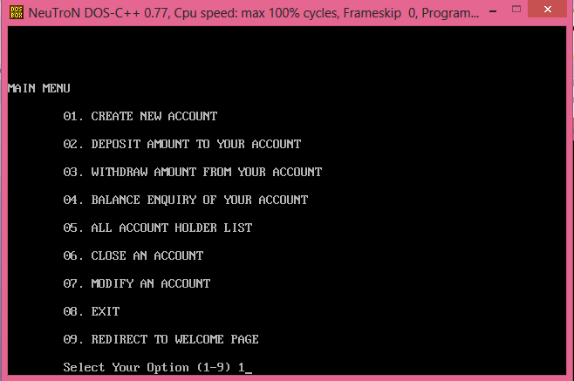

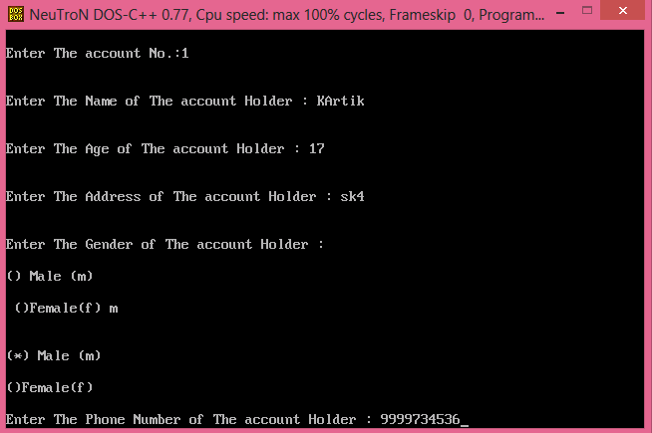

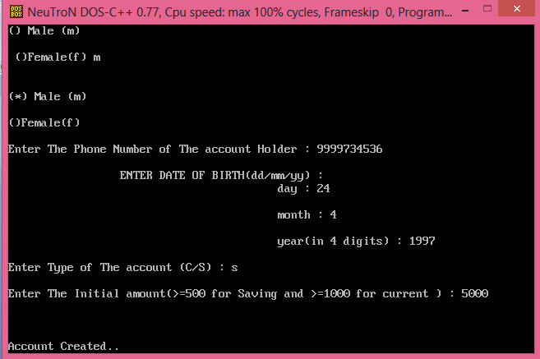

*Depositing amount*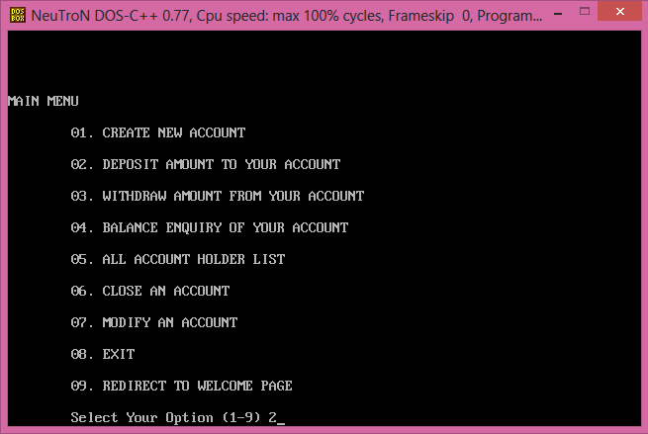

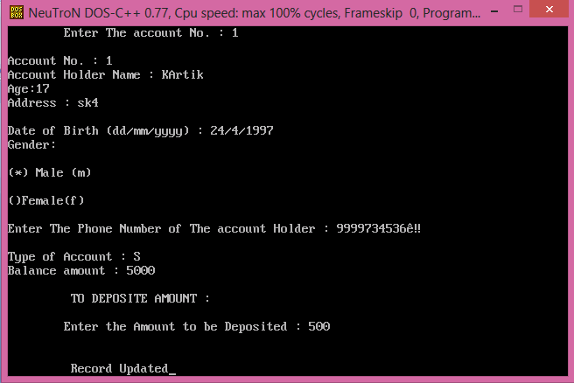

*Withdrawing amount*

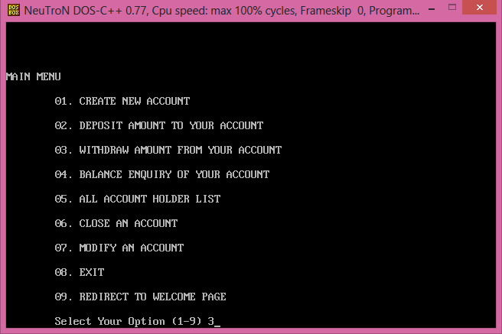

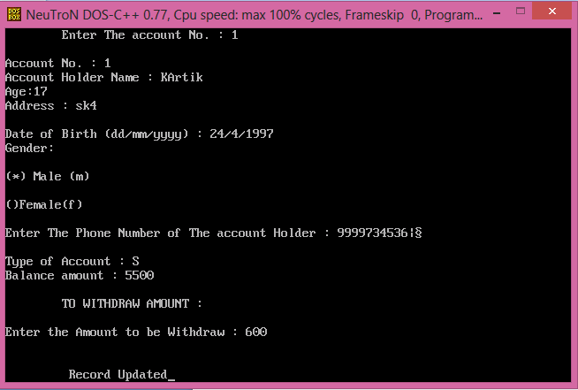

*Balance enquiry*

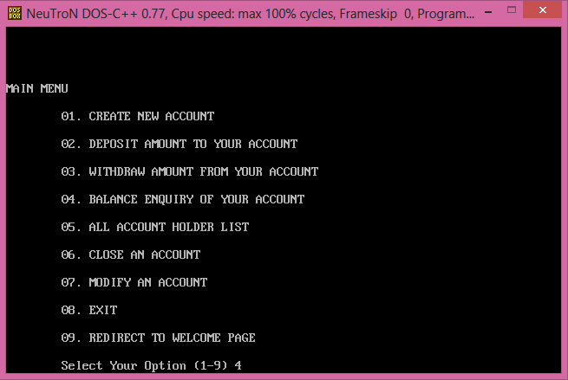

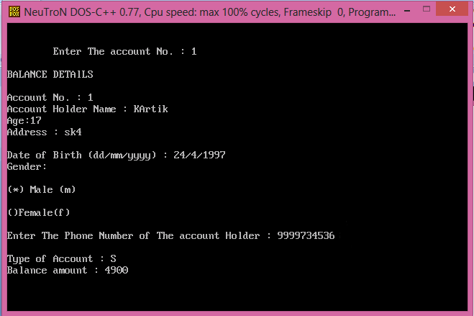

*All Account holder’s list*

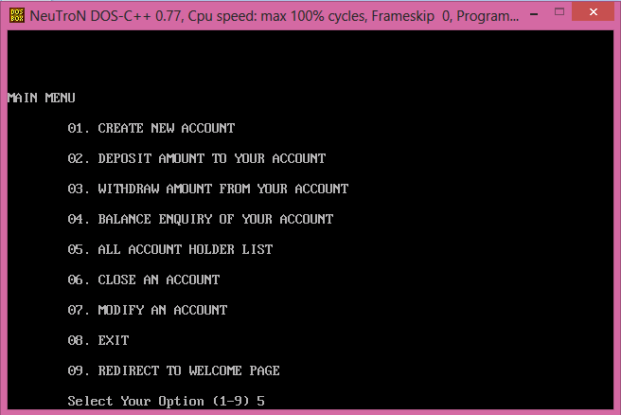

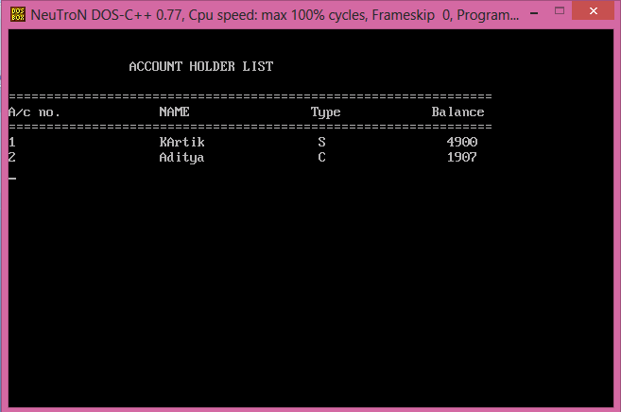

*Close Account*

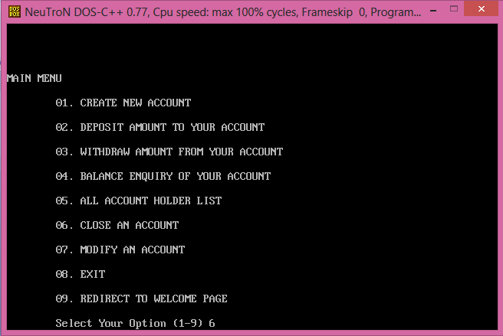

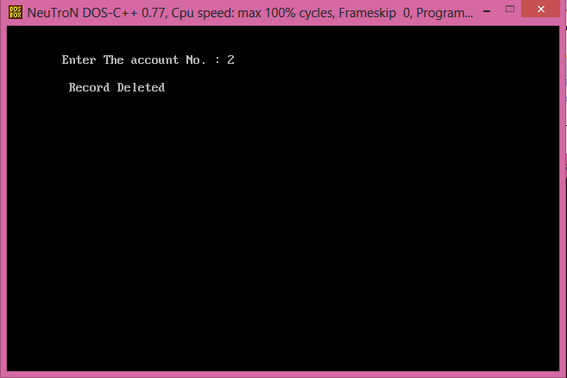

*Modifying an account*

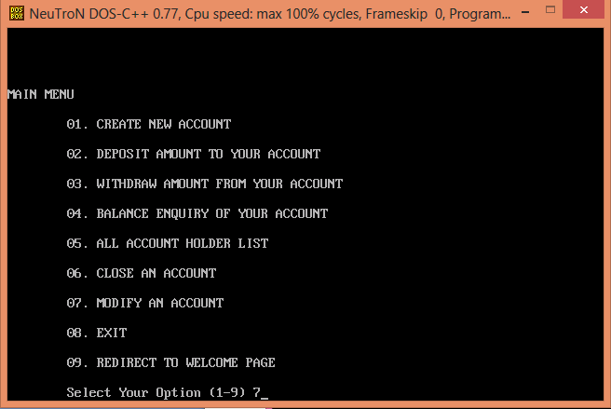

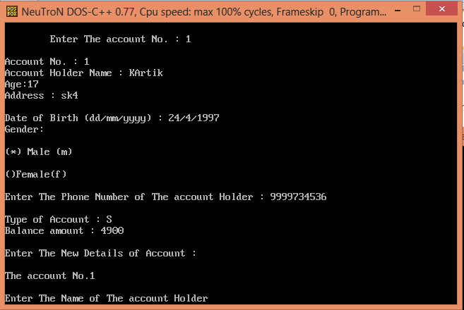

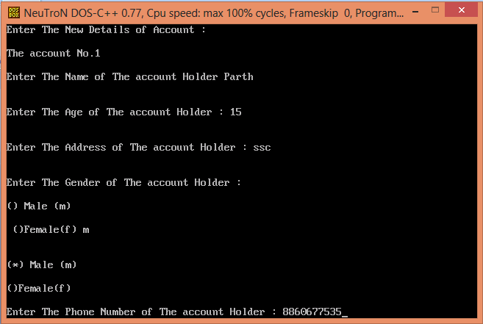

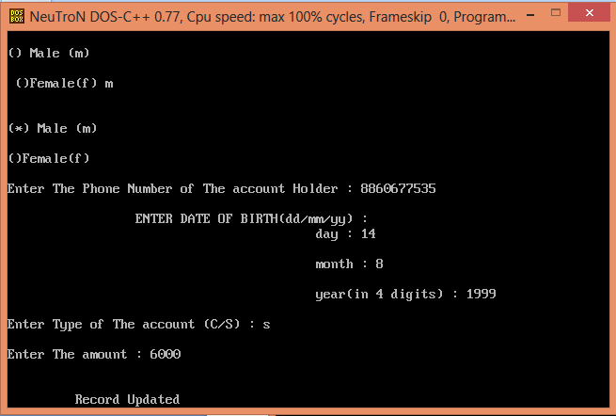

*EXIT*

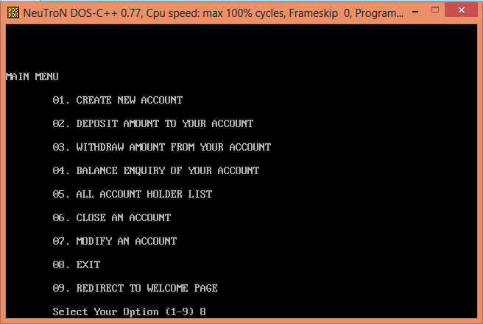

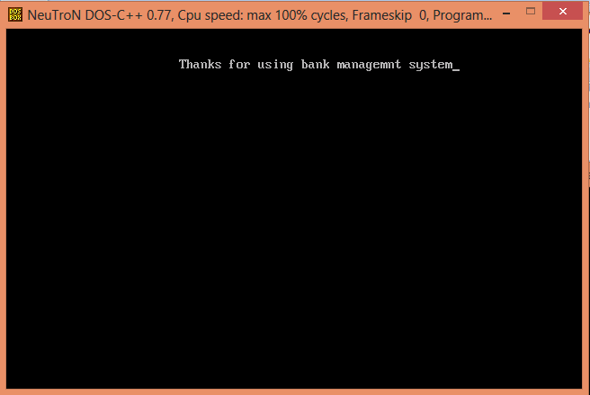

*Redirect to login page*

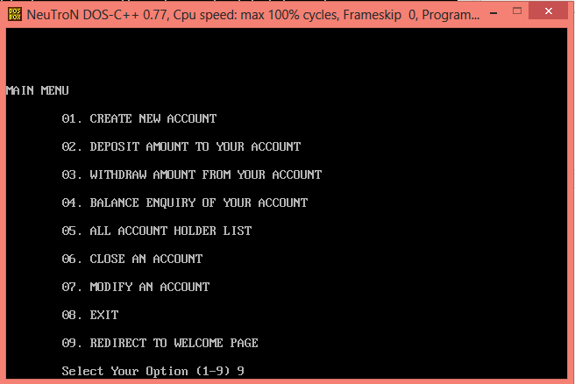

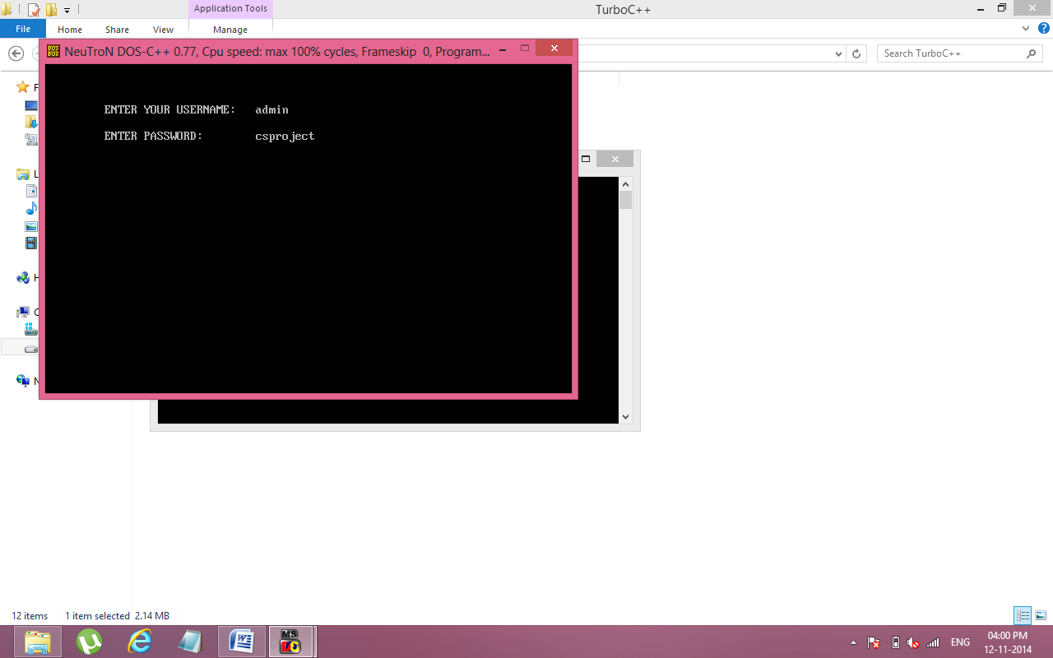

**Future enhancement**

The bank management system has been designed in such a way that more features could be added easily in near future without actually changing the basic functioning of the program. Each menu option has its own function which makes editing in the future much easier. Although according to the requirements displaying ‘mini statements’ and ‘all transactions’ of the account holder from the records could be added so as to make the system more informative.

**Conclusion**

The project not only helped me to enhance my C++ skills but also helped me to realise how the banking system works.

During the making of my project I also got the experience of organising, designing, creating and executing real life related projects.

The project also helped me in realising the importance of using functions, classes and structures in a program and the importance of dividing my program into modules for better understanding and editing of the code.