# Chapter - 3 Design

This is the phase where designing or modelling of the system is done as per the gathered requirements. It provides outline of what the system will do and how the processes are carried/performed. This is considered as an important phase during the software development. Structural, Behavioral, Database and UI modelling are various phases of designing.

## 3.1 Structural Modelling

Structural model displays the organization of a system in terms of the relationship between the components. It may be either static or dynamic.

### 3.1.1 Final Class Diagram

Class Diagram is a static structure that defines system by illustrating operations, attributes, objects, classes and their inter-relationship. It works on principles of object orientation and this orientation describes the interaction between objects.

**Justification of using Class diagram**

* The structure of this system i.e. Sports Event Management System can be illustrated by the Class diagram in a detail and appropriate way.
* This project is to be developed using OOP (object oriented programming) and class diagram also works on the principle of OO (Object Orientation).
* By the use of class diagram, relationship between different classes in this system can be easily signified.

**Notations Used**

|  |  |  |
| --- | --- | --- |
| **Name** | **Notations** | **Description** |
| **Public specifier** | + | It is used for those properties which are not to be restricted. |
| **Private specifier** | - | It is used to restrict the privilege of accessing properties between classes. |
| **Association** |  | It is used to represent a relationship between classes. |
| **Multiplicity** |  | It allows statements about the number of objects that are involved in association. |

## 3.2 Flowchart

A flowchart is a graphical representation of the workflow or process in the system .It is also a diagrammatic representation of the step by step task or algorithm. Various boxes or notations are used to describe the processes and are connected with each other to indicate the workflow.

**Justification**

* By the use of flowchart this system’s (i.e. Sport Event Management System) processes can be identified easily.
* Work flow in this system can also be illustrated in a systematic way.
* Multiple progresses and their sequence in this system can be clearly visualized.
* Only the necessary steps are listed in the flowchart which helps to remove unnecessary steps or errors. Simultaneously, it will help to increase the efficiency of the system.

**Notations Used**

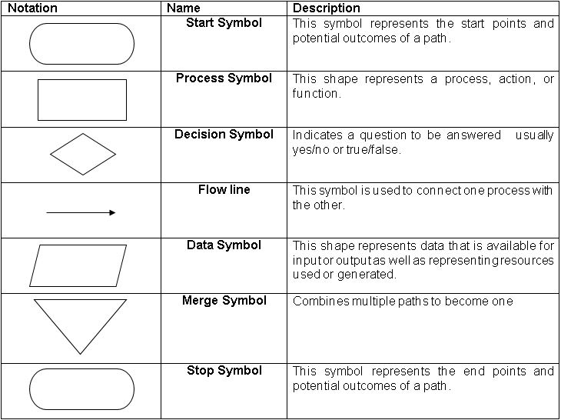

Figure 1: Notations used in flowchart

1. **Flowchart showing the workflow of admin in the system**

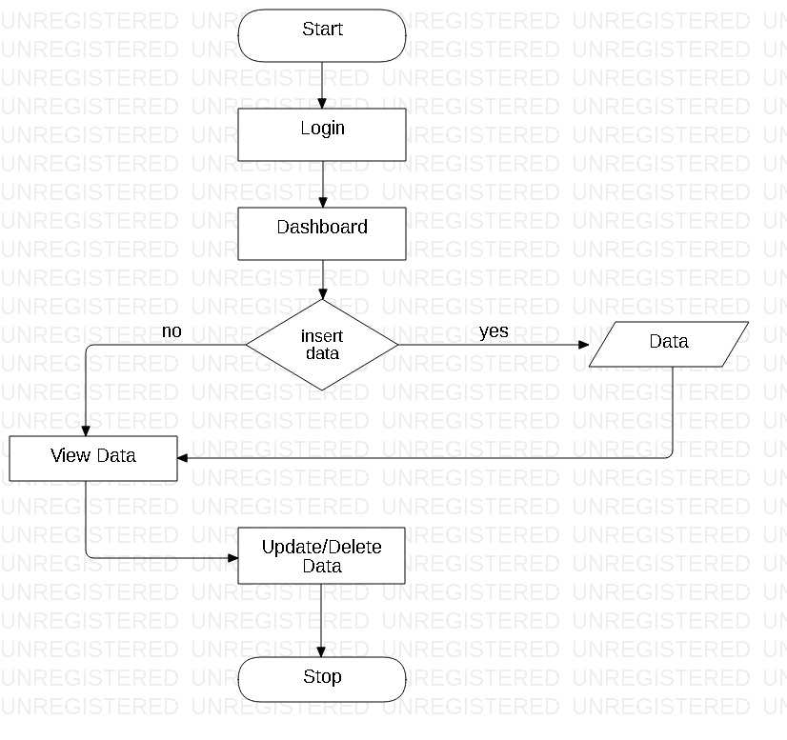

Figure 2: Admin’s work Flowchart

Above diagram shows the flow of the works that are performed by admin in the system. Firstly, admin logs into the system and is re-directed to the admin’s dashboard, where either he/she inserts, updates, or deletes data. If he/she choose to insert data then data is inserted and then it is viewed and if data is not to be inserted then it is viewed in order to update or delete already inserted data as needed.

1. **Flowchart showing the workflow of user in the system**

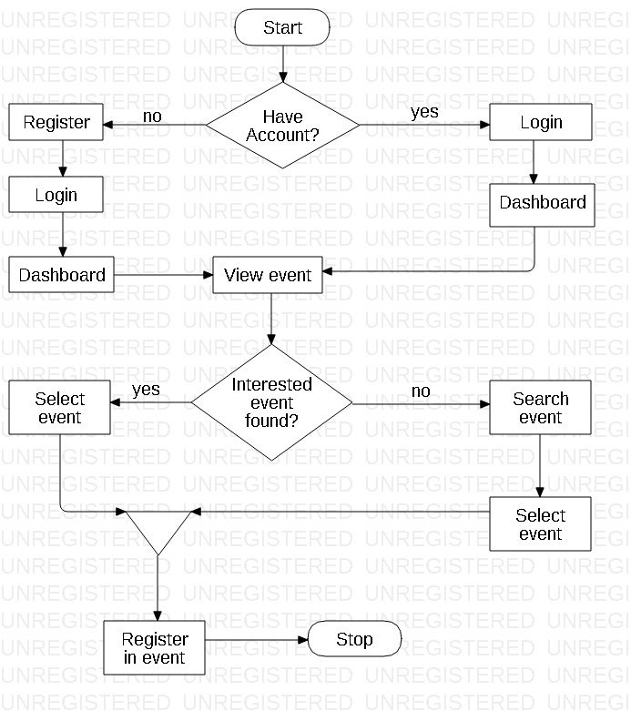

Figure 3: User's work flowchart

Above is the flowchart showing the work flow of the user’s work in the system. Registered users who already have account can login to the system and is redirected to the user’s dashboard and unregistered users should register themselves at first to login. After login they can view events, and can search the particular event they want if they are unable to find one. Then they select that event and register themselves in that particular event.

## 3.3 Behavioral Modelling

Behavioral modelling is a process of creating models that describes the dynamic behavior of the system during the execution phase.

### 3.3.1 Activity Diagram

Activity diagram is a UML behavior diagram that signifies the work flow of stepwise activities of the system. It is also a dynamic structure that represents a flow from one activity to another.

**Justification of using Activity Diagram**

* Activity diagram can be useful for understanding the work flow of this system (i.e. Sport Event Management System).
* Different complicated sequential algorithm in the system can also be described by the use of activity diagram.
* It can also help to analyze the use case of this system.
* Activity diagram can help to illustrate the different activities that is to be done by different actors and sequential flow of those activities in this system.

**Notations used**

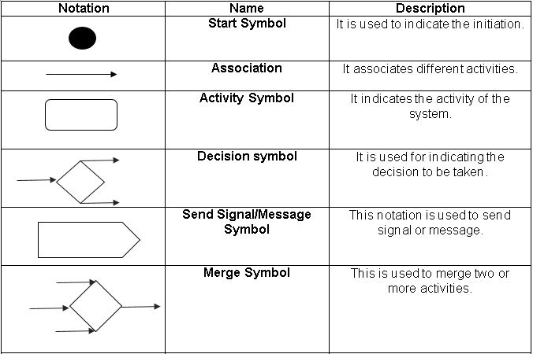

Figure 4: Table of Notations used in Activity Diagram

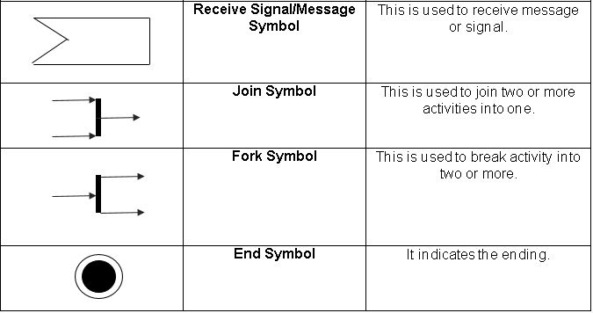

1. Activity diagram illustrating the data flow during the login process in the system.

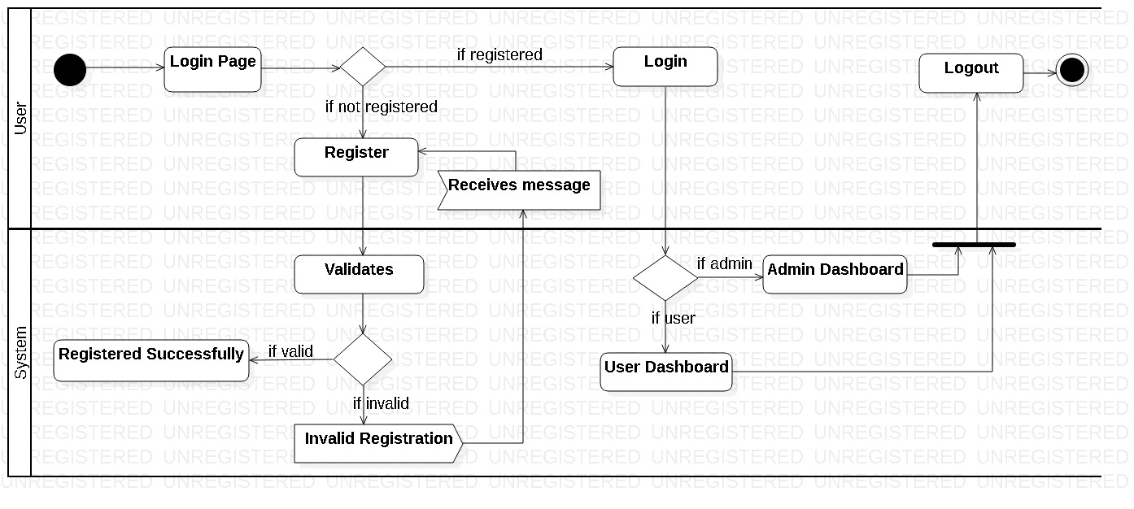

Figure 5: Login Activity diagram

Above diagram shows the activities that are done by the user while logging in to the system. User opens a login page first off all, and if the user is already registered then user directly logs in to the system otherwise user should create a new account or should register themselves. Only after successful registration users can login.

During registration if a user inputs invalid data then system generates error message and the system only generates successful message after the valid registration. Then after the successful registration user logins to the system. And according to the nature of the user (i.e. Admin or normal user) they are directed to the admin or user dashboard respectively where they can use different features of the system. And after the proper involvement with the features the users logs out of the system.

1. Activity diagram illustrating the activities done by the user and the data flow in the system

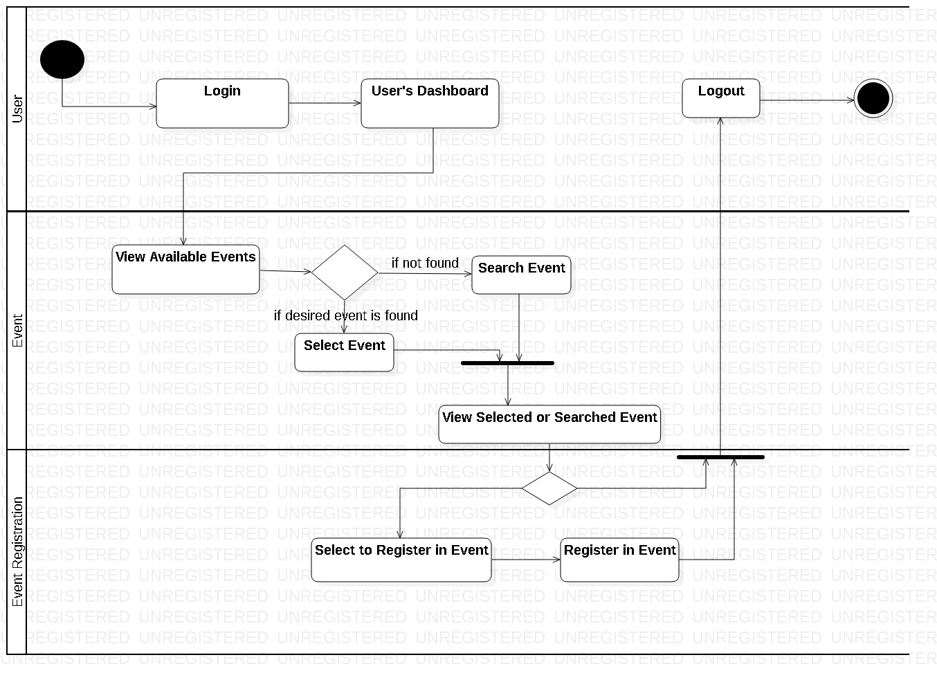

Figure 6: User Activity diagram

This diagram shows the activities done by the user in the system. Users login to the system and are directed towards the dashboard where they can perform various crud functions as well as they can search as they want. Firstly, user views the events that are added by the admin. If they found the event in which they are interested then they can view event details and if they are unable to find the interested event then they can search it.

After finding the interested one, they selects that particular event, views it and selects to registers themselves in that event. Finally, they register themselves in the particular event and logouts of the system.

1. Activity diagram illustrating the activities done by the admin and the data flow in the system

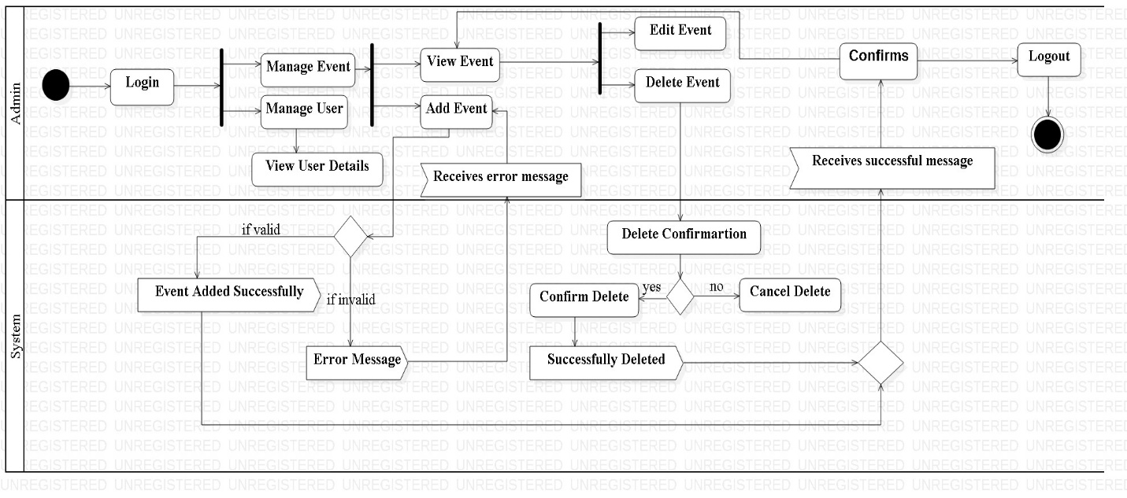

Figure 7: Admin Activity diagram

Above diagram shows the association between the activities done by the admin. Admin logins into the system and is directed to the admin’s dashboard where he/she can manage user s or events. Admin will either manage event first or user second and vice versa. If admin decides to manage users first then he/she views the user details and manage accordingly. And if admin choose to manage events first then he/she will add new events as required, views event that are already added and either deletes them if they are not available anymore or edits the events as needed.

Every time system generates the successful message for valid input and error message for invalid input given by the admin. Then finally after managing the users and the events successfully admin logs out of the system.

### 3.3.2 Sequence Diagram

Sequence diagram describes what in and how a group of objects work together. It is a type of an interaction diagram as it demonstrates the interaction between the objects.

**Justification of using Sequence Diagram**

* To represent the interaction between the objects in this system sequence diagram can be very helpful.
* This system’s requirement can be easily understand by the use of sequence diagram.
* Behavior of this system over a specific time can also be illustrated by the use of it.

**Notations Used**

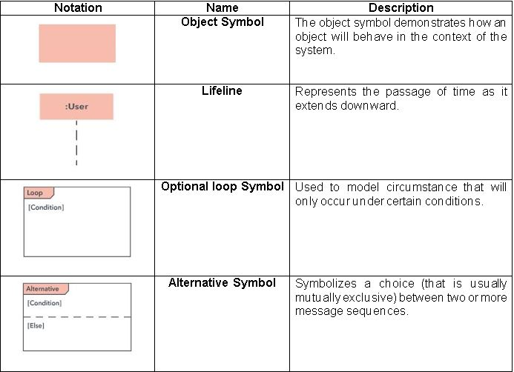

Figure 8: Notations used in sequence diagram

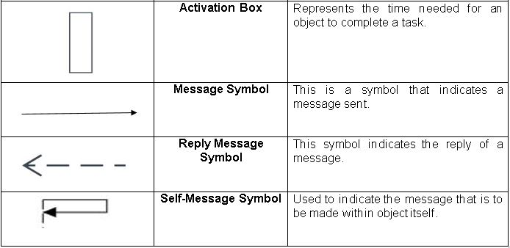

1. Login Sequence Diagram

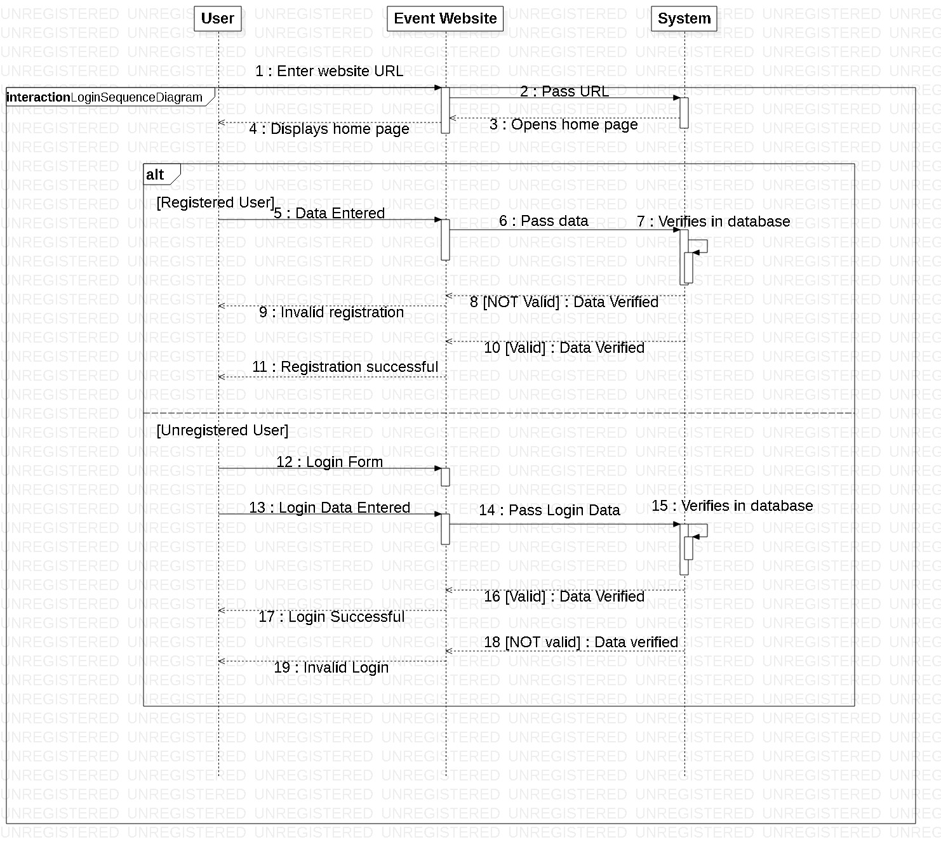

Figure 9: Login Sequence diagram

Above diagram shows the login and registration process done by the registered or unregistered users. Firstly, user enters the website url and gets into the event website and system opens the home page of the website and displays it to the users. Then unregistered user should register themselves to login into the system. Unregistered user enters data in the event website page and that data is passed to the system where it verifies that data and displays result for valid and invalid registration accordingly.

Likewise registered user can directly login in to the system without registration. Registered user opens the login form enters the login data and that data is passed to the system, which verifies them and displays the result as per the verification.

1. User Sequence Diagram

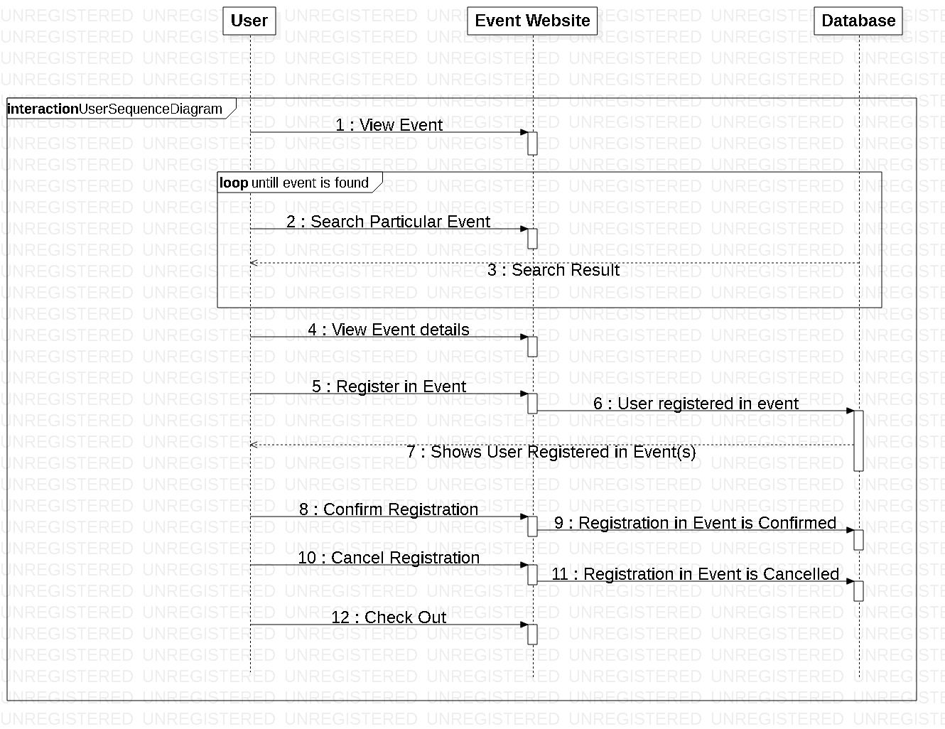

Figure 10: User Sequence diagram

This diagram shows the sequence of the work done by users. Users view the events that are added by the admin, search and views them and chooses whether to register in the event or not. If they choose to register in the particular interested event then they select that event and register themselves in that event. They can confirm their registration or can cancel their registration ass per their interest. And can visit the site for any other event information or exits from the site.

1. Admin Sequence Diagram

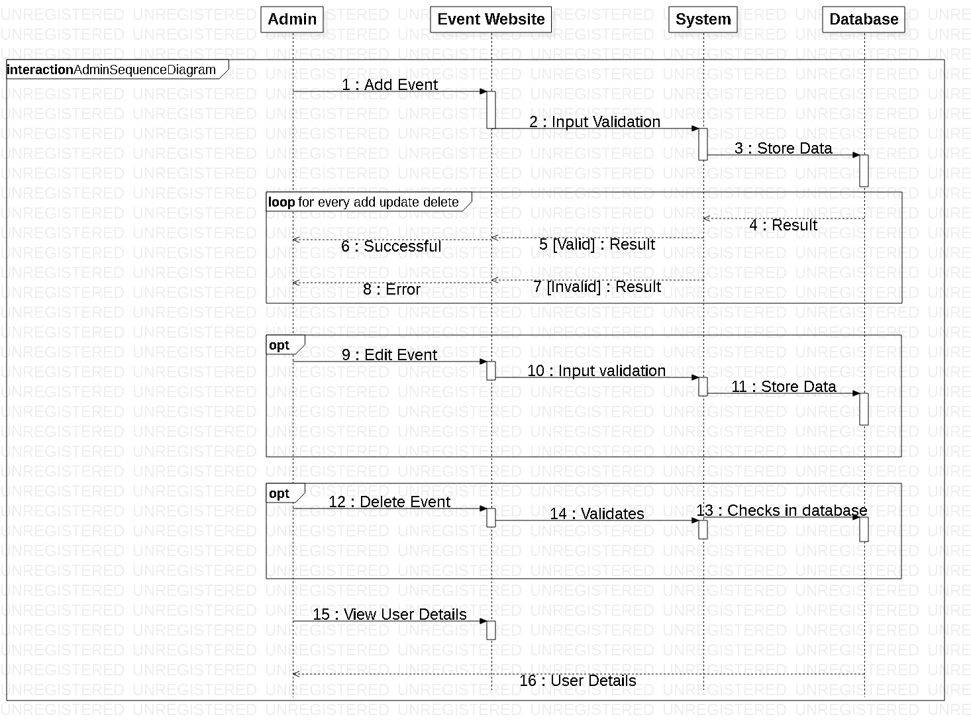

Figure 11: Admin Sequence diagram

Above diagram shows the sequence in which admin’s works are performed. Admin first off all adds event and other event associated details. And edits or deletes them as required. Every time when admin performs adding, deleting or editing functions then system generates error message for invalid input and successful message for valid input. Admin also views the user details in order to manage them.

## 3.4 Data Modelling

It is a process of creating data model for the data that is to be stored in the database. It is also known as the analysis of data objects and their relationship with other data objects.

### 3.4.1 Data dictionary

It is a metadata i.e. data of a data. It is a set of files that contain a database’s metadata. The data dictionary contains various records such as data relationship, data ownership, and other data.

**Justification**

* Data quality of this system (Sport Event Management System) can be improved.
* This system’s data can be analyzed easily.
* Data redundancy in this system can also be reduced.
* Data of this system can also be reused.

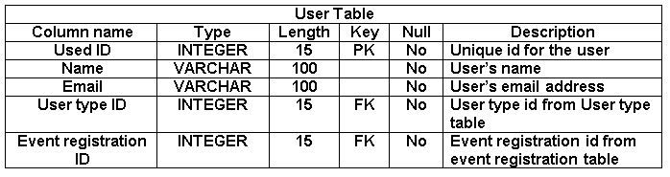

Figure 12: Data dictionary of User table

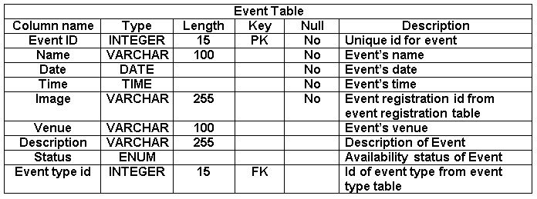

Figure 13: Data dictionary of Event table

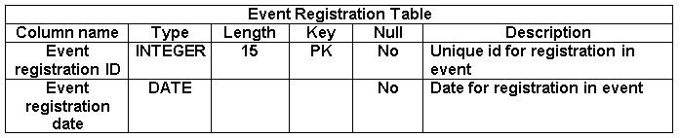

Figure 14: Data dictionary of Event Registration Table

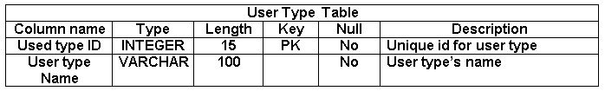

Figure 15: Data dictionary of User type table

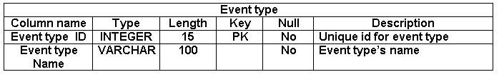

Figure 16: Data dictionary of Event type table

### 3.4.2 ER diagram

ER (Entity Relationship) diagram is a high level conceptual data model. It is a diagrammatic representation of different entities and their relationships.

**Justification**

* It enables better visual representation of this system (Sport Event Management System) i.e. relationship among entities and relationship can be easily understood by seeing ER diagram.
* It is highly flexible so that this systems data can be increased or decreased over a time.
* ER diagram will help to illustrates different entities of this system in a simple and easy way.

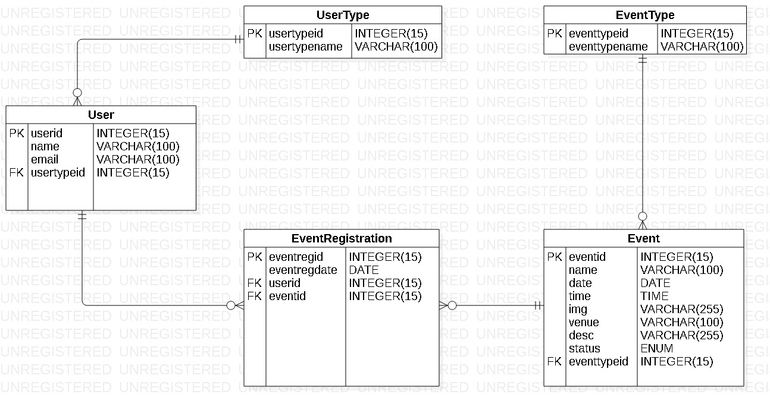

Figure 18: ER diagram

## 3.5 UI Modelling

User Interface modelling is a development technique used to design and develop the interface which will be presented to the users. It plays an important role in achieving better usability.

### 3.5.1 Prototyping

Prototype is a blueprint or sample of the system that is to be developed and released and the process is known as prototyping. Mainly there are two types of prototyping i.e. paper and digital prototyping.

**Justification**

* It can help to reduce the development time of this system i.e. (Sport Event Management System).
* It can act as a reference tool in the process of developing this system.
* In the process of interpreting this systems functionality and requirements, it can help to eliminate ambiguity and improve accuracy.
* It can also help to achieve better usability of this system/software.

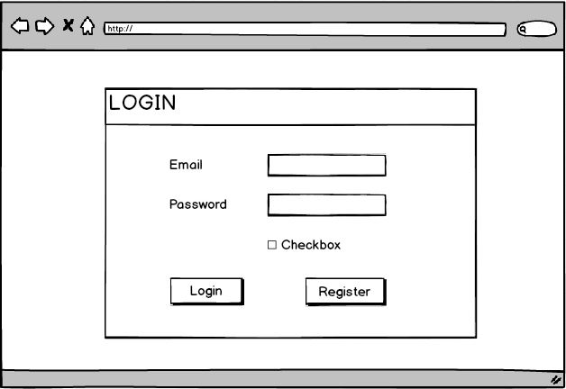

Figure 19: Login Page

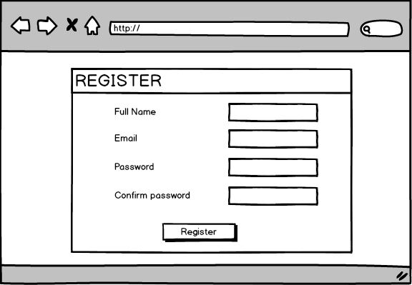

Figure 20: Registration Page

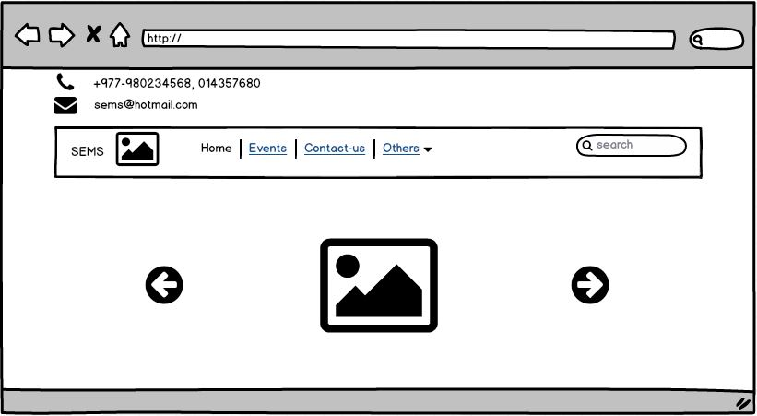

Figure 21: Home Page

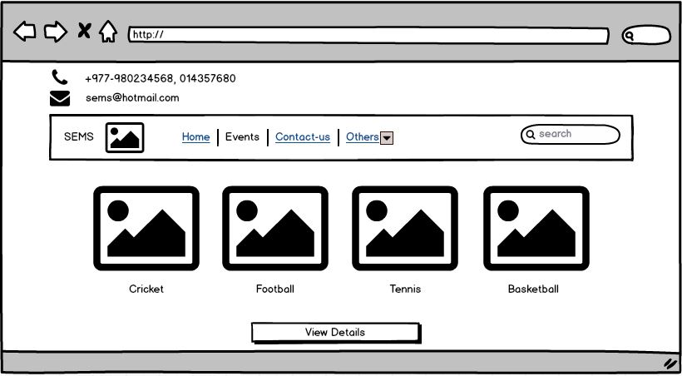

Figure 22: Prototype of Events Page

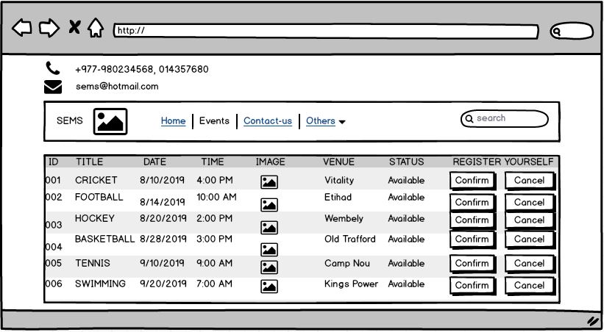

Figure 23: Prototype of Event Details

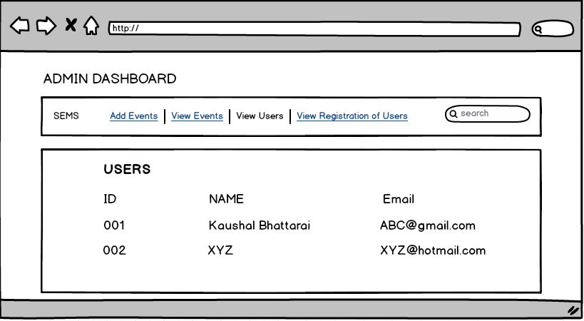

Figure 24: Admin Dashboard