# Chapter-1 Introduction

## 1.1 Introduction to the system

Sports Event Management System (SEMS) which provides different kinds of management solutions to individuals or group of people. In the current state, almost everybody gets involved directly or indirectly into the sports. So, this system will be able to manage all the sports event related activities as required. Activities such as selecting/approving the teams or players, viewing the reports, managing venues etc. can be performed efficiently. For the effective and durable management of sports event, this management system can be used.

## 1.2 Background of the system

A system is only considered to be an efficient and systematic if it bears all the essential functionalities i.e. availability, security, maintainability etc. So, it is only possible by the use of automated system. In the past, all the sports event were managed through the paperwork/manually that compromises the availability and security of the data. As well as more time was consumed while undertaking various processes.

Therefore, to overcome all the errors/weakness of the manual work, an automated sports event management system should be used which simultaneously will improve the overall functionality of the system.

### I Problem Statement

Different problems like problem of proper budget allocation, time management, proper allocation of resources and planning may arise during the development of the project. These problems directly or indirectly impacts the project so, the type of the problem should be identified and potential solution to that problem should be applied as quickly as possible.

## 1.3 Justification of the project/system

The Sports Event Management System (SEMS) objective is to process a system that manages the activity of many sports at a time. It will also manage the selection activity of individuals or group of people to college to state level. As it is automated, the users will consume less amount of time as compared to manual paperwork. Data storing is also easier and safe in comparison. It will also be able to check any report at any time. As well as it will make easier to perform all the activities in a quick manner.

## 1.4 Overview of the purposed system

Sports Event Management System will be incorporated with the various features to make it more efficient and easily accessible to the users. The system will allow admins to control or manage the users as well as all the activities such as editing events, viewing reports, creating events, managing users etc. Similarly, it will allow users to view all the available sports event and also allows to register themselves for the particular sport event. And admin’s approval will be required to confirm the registration of users.

# Chapter-2 Scope

## 2.1 Aims of the project

Main goals of this project are;

* To deal with the selection of individual or group of people regarding sport events.
* To perform required activities in an easy and quick manner with efficient interface.

## 2.2 Objectives of the project

To achieve the desired aim followings objectives are developed;

* To set up or process a well-managed and effective sport event management system.
* To provide a platform for managing all type of sport activities.
* To provide a platform for users to get information and to maintain their active participation on sport events.
* To keep the system secure and functional.

2.3 Features to be included

Some of the key features that are to be included are as follows;

* Admin login.
* Admin can create/delete/view events.
* Admin can manage users.
* User can view events.
* View game schedules.
* Send and receive game schedules notification.
* Maintain security and data integrity.

## 2.4 Overview of the scope

The main aim of the project is to manage and provide the details of the sport activities at a time. To achieve this aim certain objectives are to be developed and attained. For fulfilling the aims and objectives of the project proper implementation should be done. By the fulfillment of aims and objectives only, a scope of a project can be maximized. So, a project should be developed within the scope as well as without getting off-track.

# Chapter-3 Development Methodology

## 3.1 Methodology

Waterfall model has been applied for this project as it is suitable for small projects where the requirements are not altered frequently or where the requirements are predefined. It is a step by step methodology, under which second step is only started after the completion of first step. Each steps are inter-related with each other so, all the steps are essential. Steps performed while undertaking waterfall methodology are as follows;

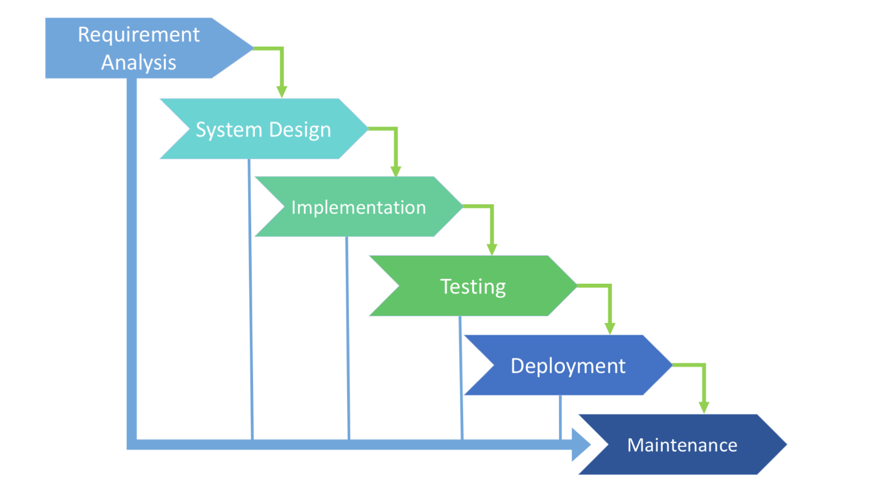

Figure 1: Waterfall model

These are the steps that are to be done while using water fall model. And these are the steps that are carried out to complete this project.

Some advantages of using Waterfall model over other techniques are as follows;

**Advantages**

* Suitable for small projects where the requirements are pre-defined.
* It is easy to manage and to understand as well.
* It focuses on clear structure or set of steps than any other techniques.
* Second step is not done until first step is not completed. So, it ensures the completion of every step.

However it has some disadvantages also;

**Disadvantages**

* It is irreversible process.
* Sometimes it may be time consuming.
* Not suitable for large projects.

## 3.2 Design Pattern

**Model-View-Controller (MVC)**

MVC design pattern has been applied for this project. It is an architectural pattern which separates application/system into three main components i.e. model, view and controller. For handling particular development aspect of an application, these components are built. As well as to produce extensible and scalable projects, MVC is considered as one of the most used in industry-standard web development framework.

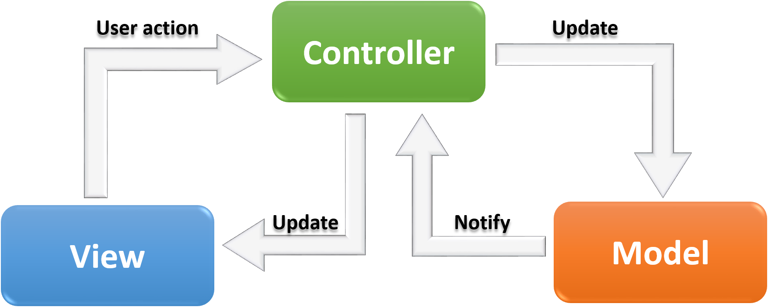

Figure 2: MVC

[MVC]

**Model:** All the logical data with which user work falls under the Model component. [BlogSpot]

**View:** All the UI (User Interface) logic of the application comes under this component.

**Controller:** Commonly known as an interface between Model and the View.

MVC design pattern has been used for this project because it has many benefits over other design patterns. Some of the advantages of using it are as follows;

**Advantages**

* Faster development process
* Entire part is not affected while modification
* Provides platform for SEO friendly development
* Data is returned without applying any formatting
* It has ability of providing multiple views

However it also has some limitations;

**Limitations**

* Complexity may increase
* In case of modern interface it may be difficult to use
* Proper knowledge about multiple technologies is required

## 3.3 System Architecture

A system architecture or systems architecture is the conceptual model that defines the structure, behavior, and more views of a system. A 3-tier system architecture has been used for this project because it facilitates the use of object oriented concepts and data security through application layer. [3-Tier]

A 3-tier is a type of system architecture which is composed of three “tiers” or “layers” of logical computing. They are often used as a specific client server-system in applications. The three tiers are as follows;

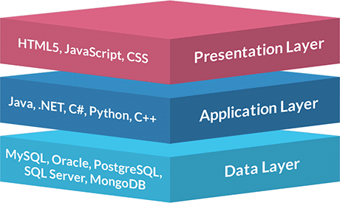

Figure 3: three layers function

**Presentation tier -** that sends content to browsers in the form of HTML/CSS/JS.

**Application tier -** that uses an application server and processes the business logic for the application.

**Data tier -** which is a database management system that provides access to application data.

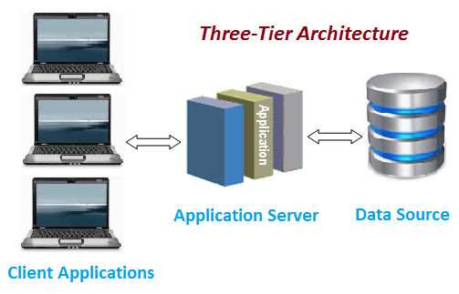

Figure 4: 3-tier Architecture

Advantages of using 3-tier System architecture are as follows;

**Advantages**

* Separation of business, presentation and data layers can be enabled by the use of this architecture.
* It enables the faster migration to new graphical environment.
* Application layer provides data security.
* Changes made to one layer will not affect the other layers.
* It also enables object-oriented concepts.

# Chapter-4 Scheduling

## 4.1 WBS (Work Breakdown System)

Work breakdown structure (WBS) is a hierarchical tree structure which outlies the project and breaks it down into smaller, more manageable portions.

Following is the work break down of Sports Event Management System (SEMS).

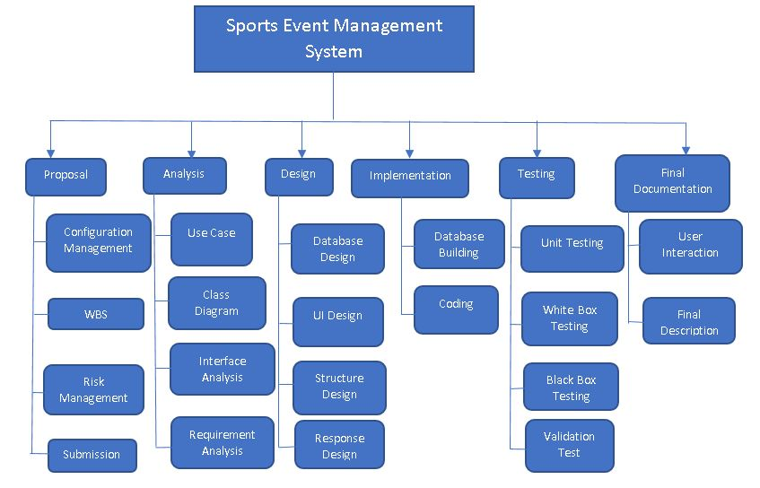

Figure 5: Work Breakdown Structure

In this way the main tasks such as Proposal, Analysis, Design, Implementation, Testing and Final Documentation are divided into sub tasks in order to ensure the completion of each task before the deadline or at a particular fixed time.

## 4.2 Milestone

Following is the table illustrating the milestones of particular tasks and sub tasks of my project.

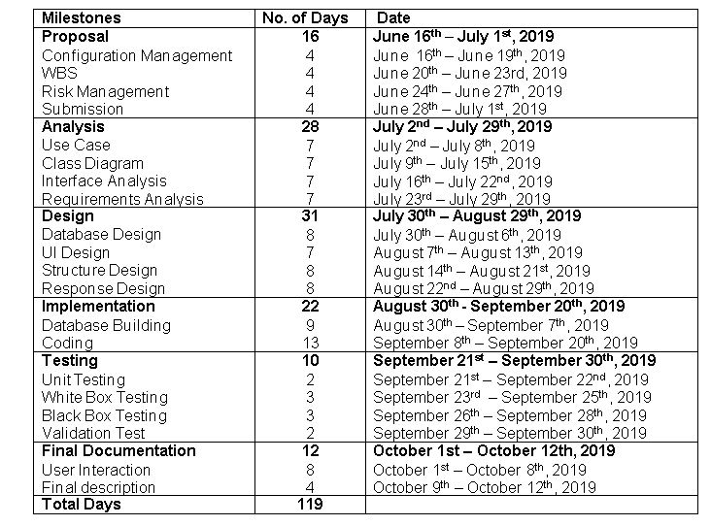

Figure 6: Table showing Milestones

**Description of Allocation**

**Proposal**

Total of 16 days has been allocated for the proposal which is further sub-divided. 4 days each for the tasks under proposal is then allotted. All of the tasks are equally important and none of these task requires more time than another. So, equal time has been allocated.

**Analysis**

Analysis is allocated with 28 days. Likewise, proposal it has also been divided into four sub tasks. And all the tasks are given equal days i.e. 7 days. All of them are equally important and time consuming so, equal number of time has been given to each task.

**Design**

For design a total of 31 days is allocated because it is one of the most important and time consuming task among all. Design is also further divided into four sub tasks. Each tasks is allotted with 7 days of time except user interface design because other task consumes more time.

**Implementation**

Implementation is given 22 days. Implementation is divided into two sub tasks i.e. Database building and coding. Both plays a crucial role but coding requires to be changed frequently and consumes more time so, 13 days is allocated for coding and 9 days is given to database building.

**Testing**

For testing 10 days has been allocated. Under which 2 days each is allotted to unit and validation testing and 3 days each to black box and white box testing respectively. Black box and white box testing requires more time than validation and unit testing so, they are given more priority with 3 days.

**Final Documentation**

It is given 12 days. Under final documentation 8 days is given for user interaction and 4 days is allocated for final description. Final description is done after interacting with the user. So, more time is allotted for user interaction.

## 4.3 Gantt Chart

Following is the Gantt chart illustrating Milestones.

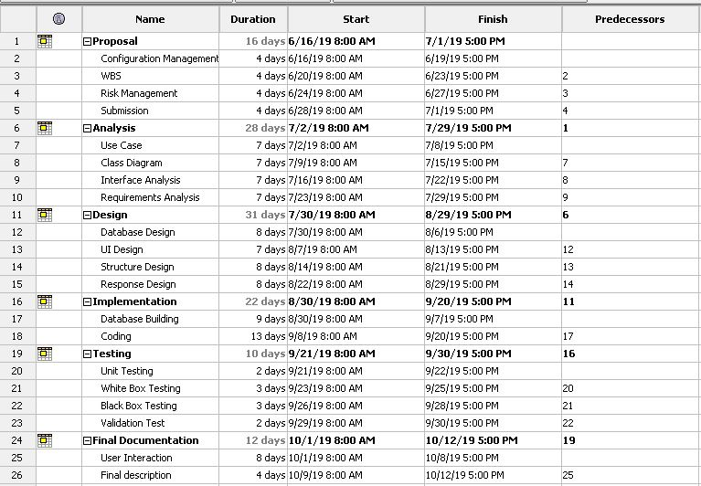

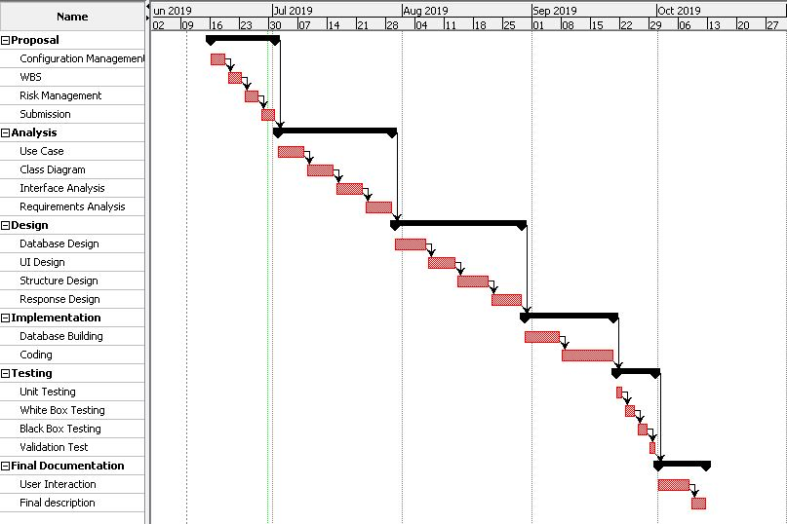

Figure 7: Gantt chart

# Chapter-5 Risk Management

It is the process of identifying, assessing and controlling threats. These threats or risks could stem from a wide variety of sources, including financial uncertainty, legal liabilities, strategic management errors, accidents and natural disasters. [Risk]

There are various ways or processes of Risk management. Some of them are Risk identification, Risk analysis, Risk evaluation, Risk mitigating and Risk monitoring.

Table for Risk’s likelihood

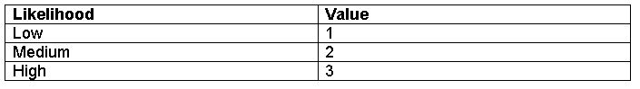  
Table for Risk’s Consequence

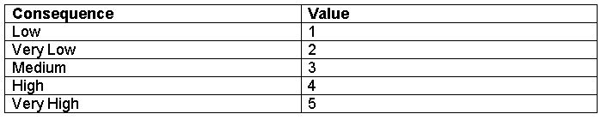

Impact is determined by;   
**Impact = Likelihood * Consequence**

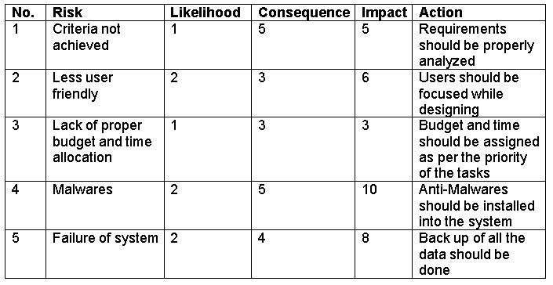

Figure 8: Impact of risk table

# Chapter-6 Configuration Management

A configuration is the set of functional and physical characteristics of a final deliverable defined in the specification and achieved in the execution of plans. Configuration management can be regarded as asset control and is essential whether or not multiple versions of a deliverable will be created. At its simplest, configuration management is version control. [APM]

GitHub is a web-based version control and collaboration platform for the software developers. So, GitHub with ID **imkaushal10** is used to store this project (i.e. Sports Event Management System) files. Some benefits of using GitHub are;

* It is version control system i.e. no manual backup is needed while switching to versions.
* It is secure storage.
* Configuration files can be shared fast and easily.

**GitHub Link:** <https://github.com/imkaushal10/CP>

There are three main activities done under configuration management i.e. Version control, Release Management and Change Management.

## 6.1 Version Control

Following is the file directory of my project published in GitHub.

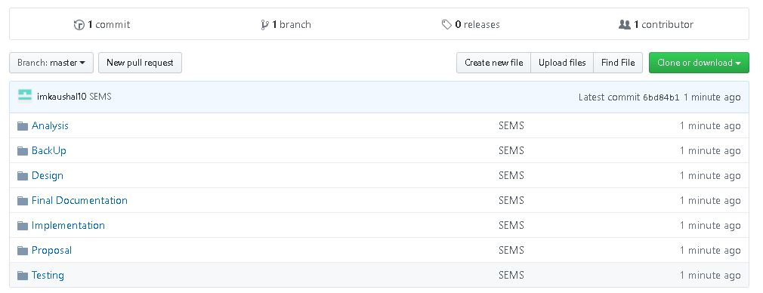

Figure 9: GitHub Directory

Following is the screenshot of tree directory of my project files on local computer.

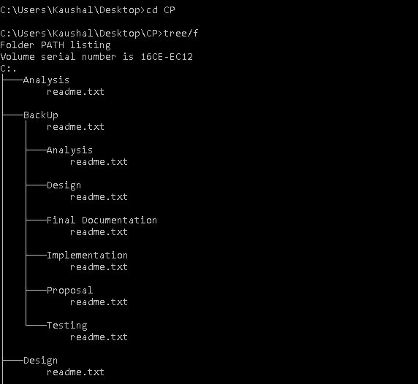

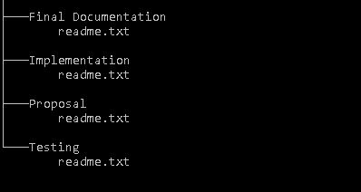

Figure 10: Local directory with backup

## 6.2 Release Management

It is the process for planning, scheduling, managing and controlling a software build through different environments and stages, in addition to testing and deploying software releases. Its primary goal is to ensure the integrity of the live environment is protected and the correct components are released.

## 6.3 Change Management

## Commonly, systematic approach of dealing with transformation and transition of project’s goal, processes or technologies is known as Change Management. Its main purpose is to implement strategies for effective change, controlling the change and helping to adapt the change.

# Chapter-6 Conclusion

The project (i.e. Sports Event Management System) will focus on managing all the sports related events/activities in a way that it will be easier for the user to interact with. It will allow users to view the events and also allows to register that particular sport event. But the user registration will only be accountable after the approval by the admin. Admin will have all the privileges to manage the user and events.

Therefore, with the incorporation of various features project should be developed in a systematic way.

# Chapter-7 References

* Blog spot [2019] **MVC framework - introduction** [online]Available at: <https://alpimrek.blogspot.com/2019/> **[Accessed on: 20th June 2019]**
* Medium [2017] **Testing Apple MVC** [online] Available at: <https://medium.com/mobile-quality/testing-apples-mvc-dab15830139a> [**Accessed on: 22nd June 2019**]
* R. Margaret[2019] **Risk Management** [online] Available at: <https://searchcompliance.techtarget.com/definition/risk-management> [**Accessed on: 24th June 2019**]
* APM [2019] **Configuration Management** [online] Available at: <https://www.apm.org.uk/body-of-knowledge/delivery/scope-management/configuration-management/> [**Accessed on: 26th June 2019**]
* Jinfonet [2019] **3-Tier Architecture: A Complete Overview** [online] Available at: <https://www.jinfonet.com/resources/bi-defined/3-tier-architecture-complete-overview/> [**Accessed on: 28th June 2019**]