https://forum.kodi.tv/showthread.php?tid=241600

Hi, I'm a long time user of XBMC and of PseudoTV Live. I'm creating this guide to try and help out others use this great addon for Kodi if this makes you think of the blind leading the blind, don't worry that's pretty much 100% accurate! I honestly don't know how everything works or what everything does, but that's okay because as a Dumbass I'm used to people telling me I'm wrong often and in detail! As soon as I make a mistake people will be climbing out of the walls to let me know just how badly I screwed it up! So don't feel you need to hold back, let me have it! Then I'll fix it!
The Dumbass Guide to PseudoTV Live! v.000001f
by: Mister Dumbass.
Part One: Get your sheet together.
Step One: Get Kodi
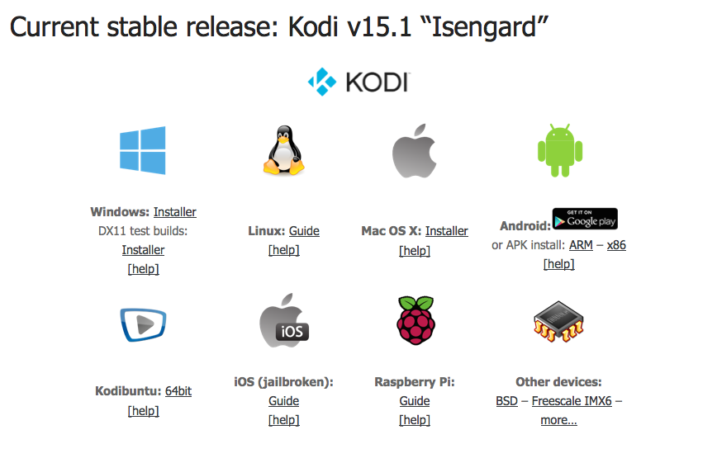
It doesn't matter which version you need, you need Kodi to use PseudoTVLive! (PTVL). If this has already blown your mind you're in the wrong place. I can't help you. This is kindergarten. You need to download Kodi and install it for your platform dawg!
Step Two: You're going to have to collect the Lunatixz repository for PseudoTV Live! and the required dependencies.
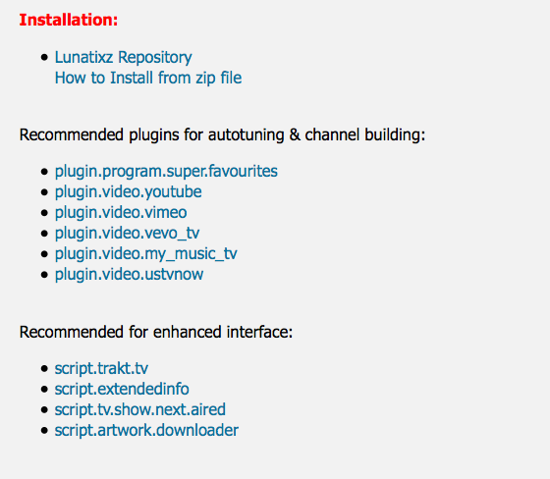
Go ahead and get the Lunatixz repository and save it to a safe location. Then get the rest of the linked files. These should all be zip files you can save in a directory on your disk. Make it easy to get to because you're going to want to be able to get in there over and over again. Sheet, look at all the linked files you need! At minimum seven files! You're going to want this accessible! Maybe save it at the root of your home folder or at the root of C:\ if you're one of those Windows fanbois. Make it easy on yourself!

You''re going to run into broken links eventually. Don't worry about it, listen to my dumbass explain to you how you can work around the situation! First off, don't panic! You have your towel right? Oh wait...wrong guide!
Aight, highlight that link:
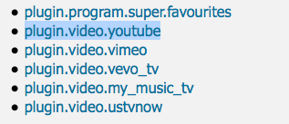
Yeah, you like that, don't you? Now right click the link you highlighted and google the name, like this:
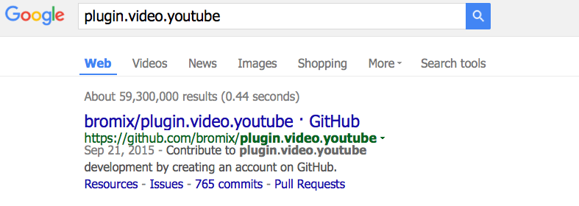
Whoa! first result is the bromix repo! Awesome prank, brah! Am I moving too fast for you? Here, try this. How's that? Don't ever say I never did nothing for you buddy!
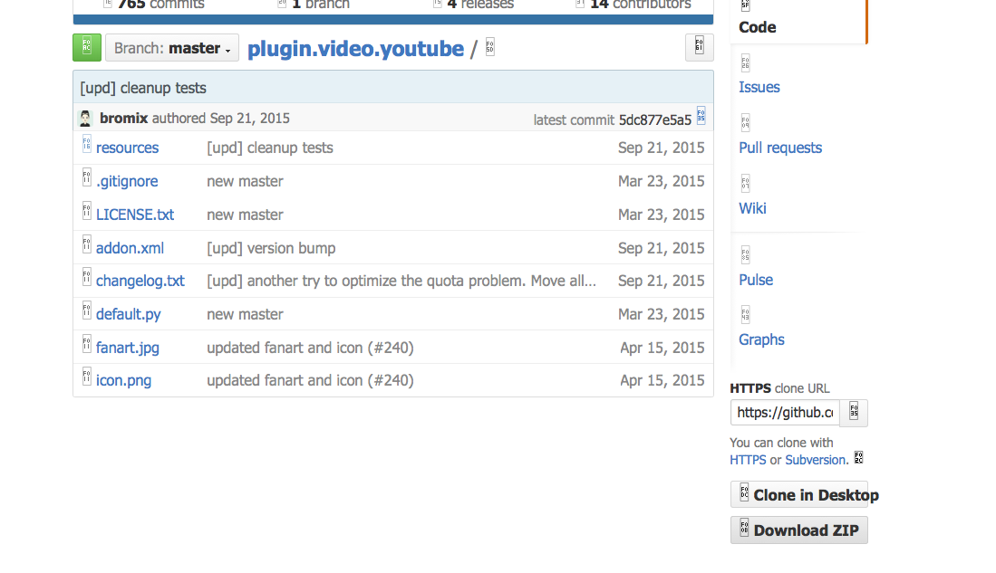
See where it says "Download ZIP" in the lower right corner? Guess what my dumbass wants you to do next? Can you feel the anticipation? Awwwww yessssshhhhh! Download that puppy!
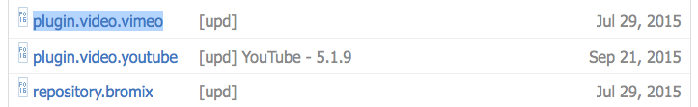
Oh and nicely enough, the bromix repo is a two for one shot, when we get to installing the video plugins later, you'll see that the bromix repo includes both the needed Youtube Plugin and the Vimeo plugin! Noice, huh?
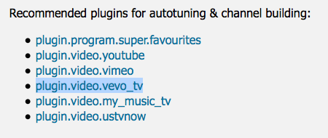
Now do it again, for every missing dependency that PseudoTV Live requires to function.
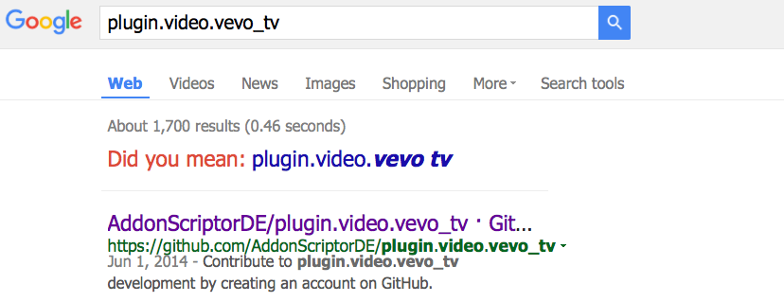
See, there's the other one. Hmmm... looks like another github link. What are you waiting for? Dooooo iiiiitttttt!
When you get all your stuff together in one folder it should probably look like this:
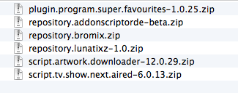
Congratulations! You got your sheet together! you put it in the backpack! You're ready for Part Two! See ya in the next post! I like exclamation marks! They make me feel pretty!

Find

Mr Dumbass
Junior Member
Posts: 20
Joined: Oct 2015
Reputation: 6
#2
2015-10-08, 05:27 (This post was last modified: 2015-10-08, 06:01 by Mr Dumbass.)
Part Two: Installing PseudoTV Live! and dependencies
You should go ahead and install Kodi on whatever you're planning to use it on. If you're using some sort of weird waffle iron to watch your movies you're probably going to have to get help installing it elsewhere. If you're planning to install it on a dead badger, my hat's off to you but I'd really love to know how you plan on viewing... ahem!
Go ahead and start your Kodi up. It should come up in the default Confluence skin unless you changed it already. You're going to head to the right, to the System button.
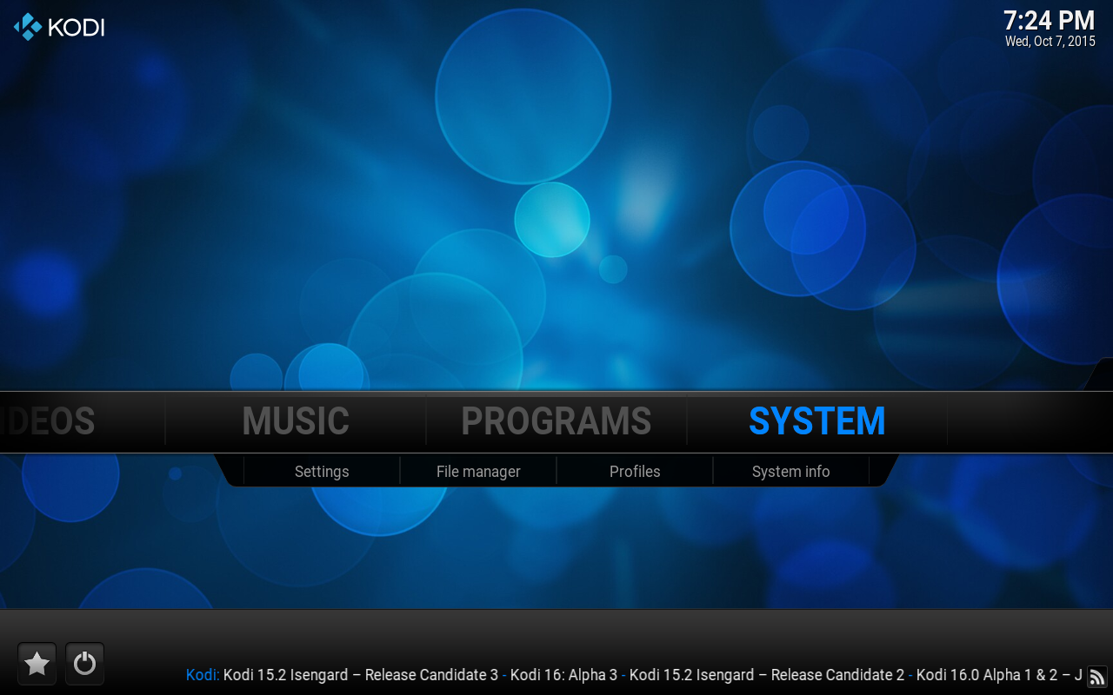
Go ahead and enter the System, which will take you the a list of items to configure. For now you just want to head to the Addons section.
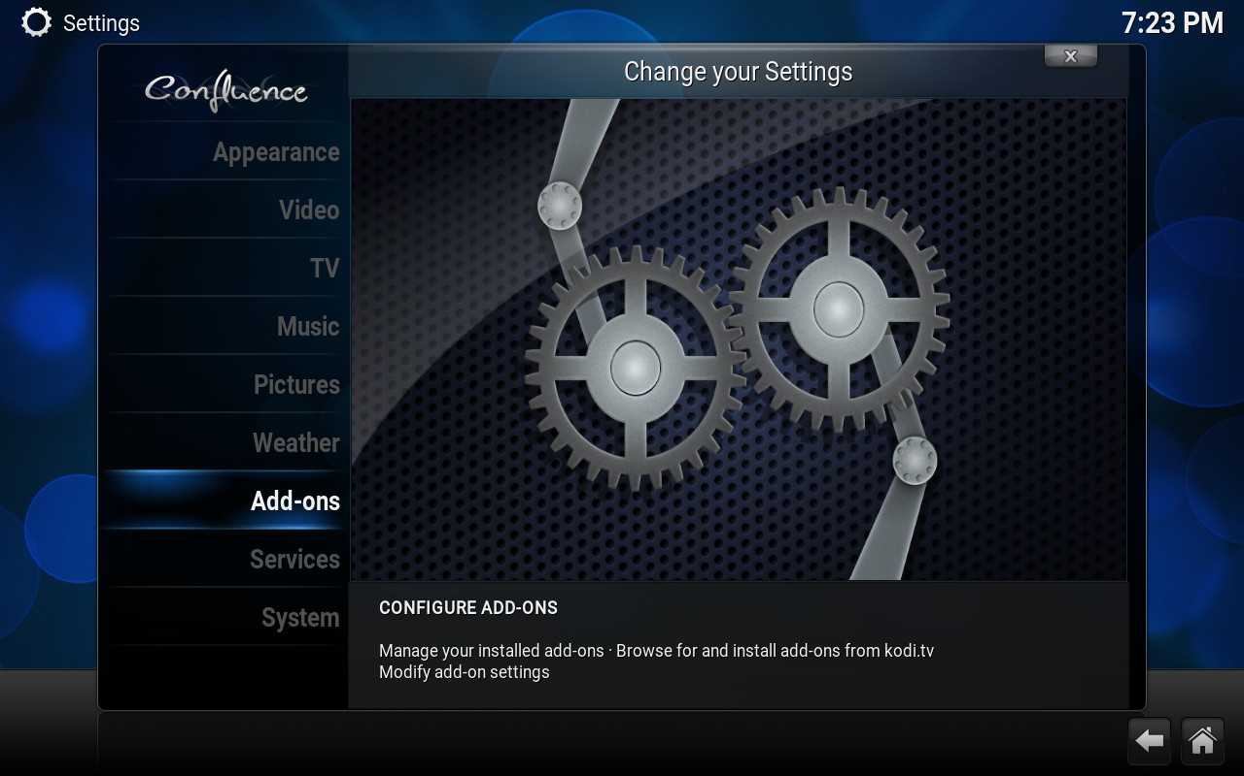
On the next screen you'll see a variety of ways you can get your addons installed. Most of the time you're just going to use the default Kodi repository, which is the safest and most secure method of obtaining plugins not known to infringe on copyright. This time though we need to add a few things.
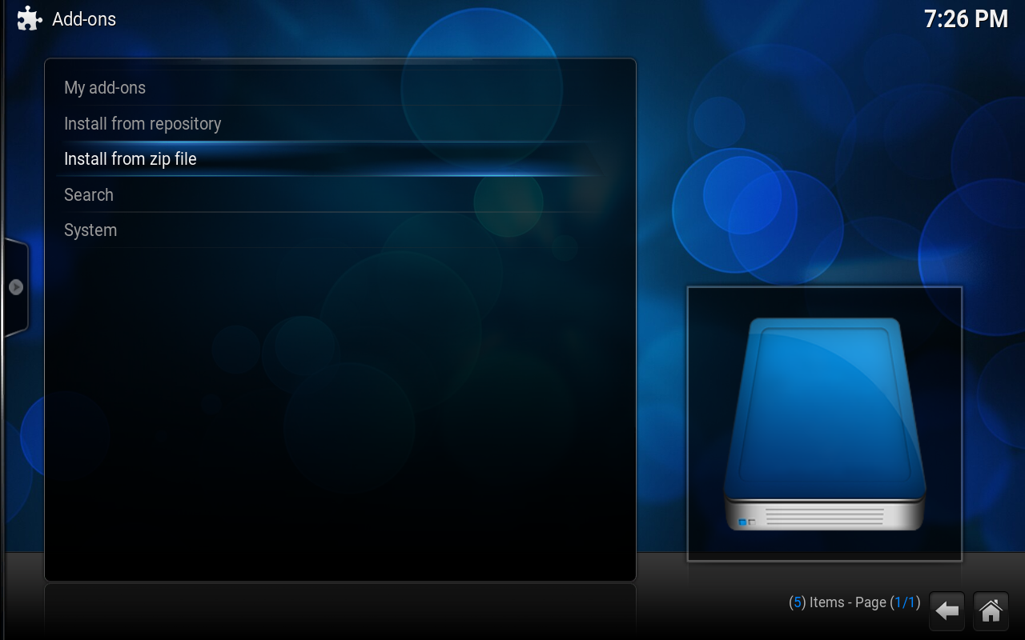
We want to install those zip files we got in part one. You remember the zip files we put together? All in one place? Hmmm...? You saved them somewhere easy to get to I hope, because we're going to be installing a lot of stuff!
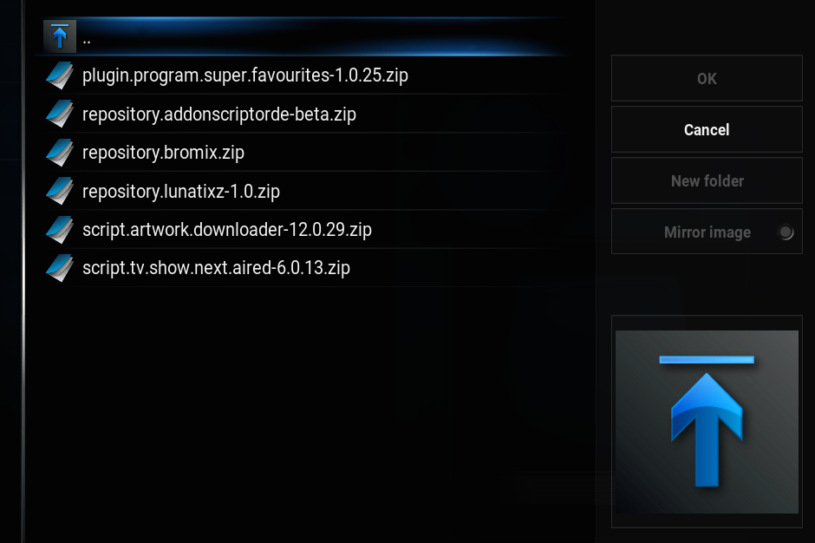
See these? Install those puppies! Oh and personally I always install the actual addons first and the repositories last with the Lunatixz repository being the last of those. You can do what you want, that's just how I roll dawg! Once you get done installing all the zip files, head over to the button that says Install from Repository.
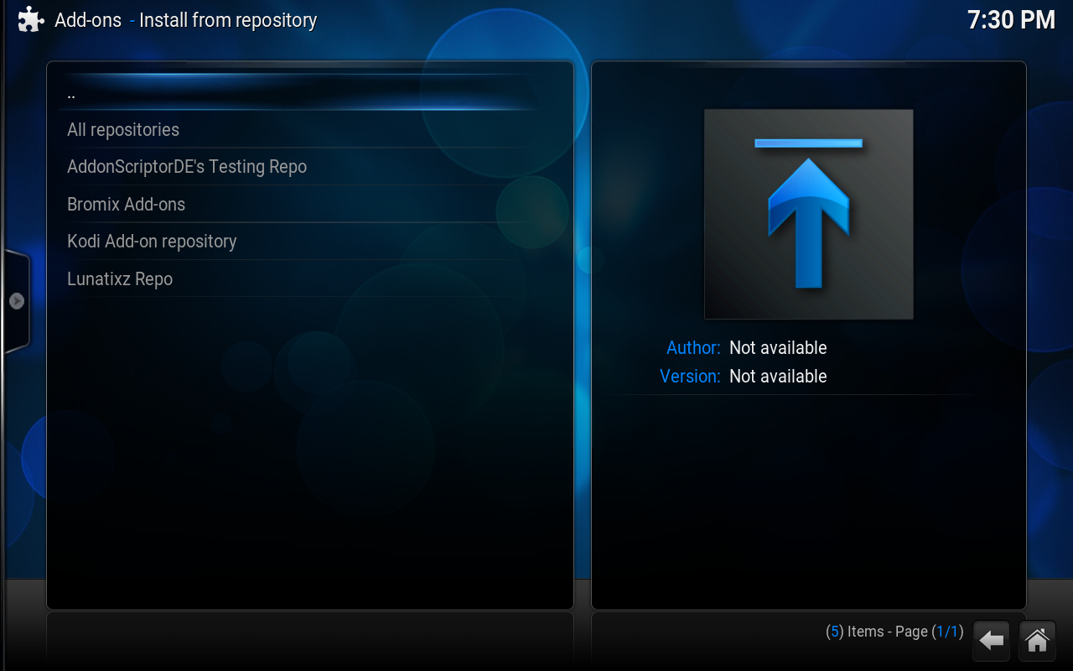
Awww yessssshhhhh! Look at that dawg! Look at those beautiful repositories installed!
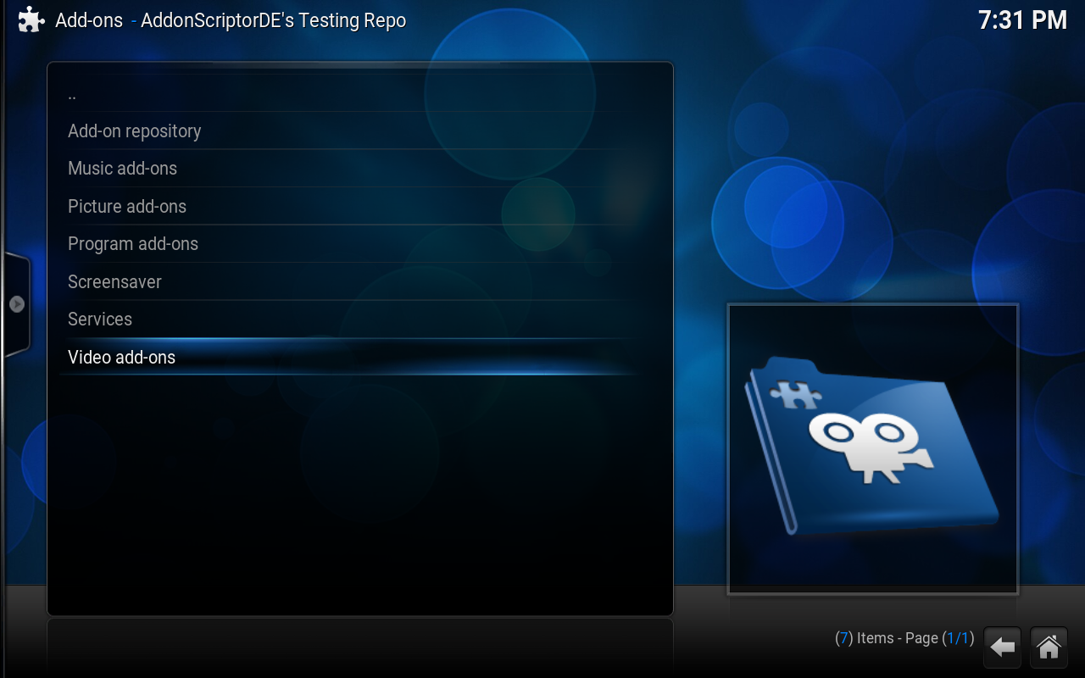
Now what we need to do is head into the link for AddonScriptorDE's repository first and make our way down to the videos section...
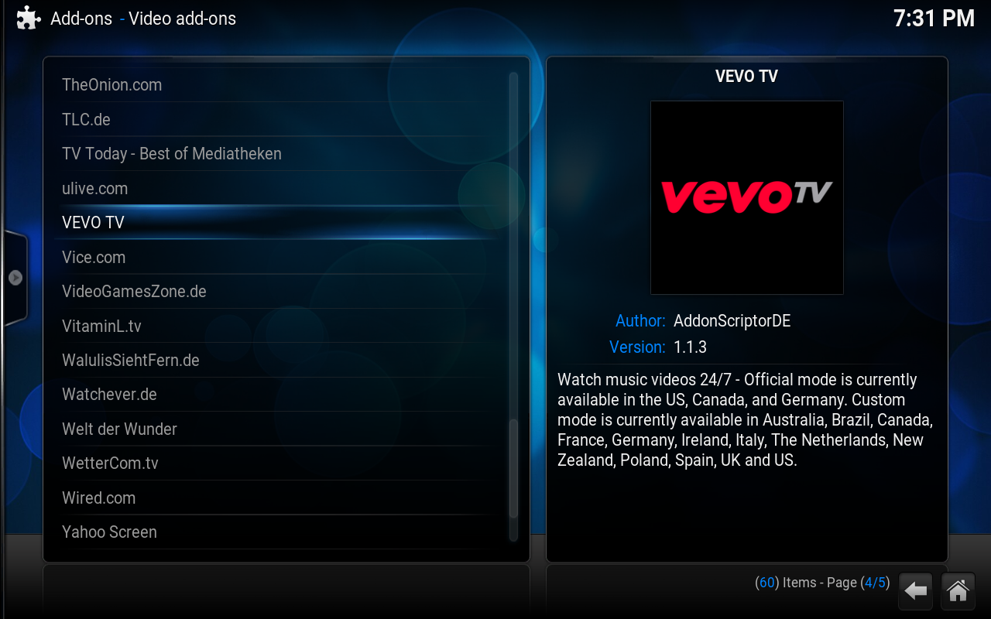
And make our way down to the Vevo TV video addon. Go ahead and install it. You can grab some of the other video addons that look good to you later, right now we're just focused on getting the basic PseudoTV Live! stuff up and working, okay? Gah! You would install the Onion, wouldn't you? Yeah, the nation's most accurate and useful news source I get it. I get it. But can we get on with it now?
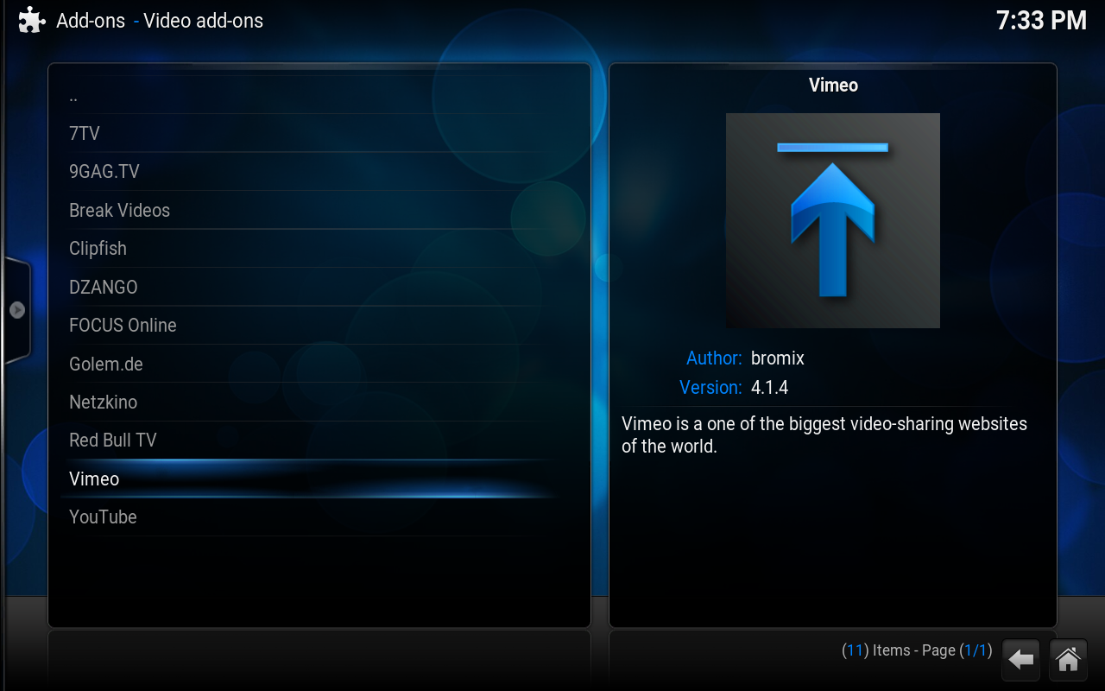
Now go to the bromix repository, head to the video addons and get your Vimeo and YouTube addons installed. Remember the two for one from part one? That's right we just went meta! It's how I roll dawg!
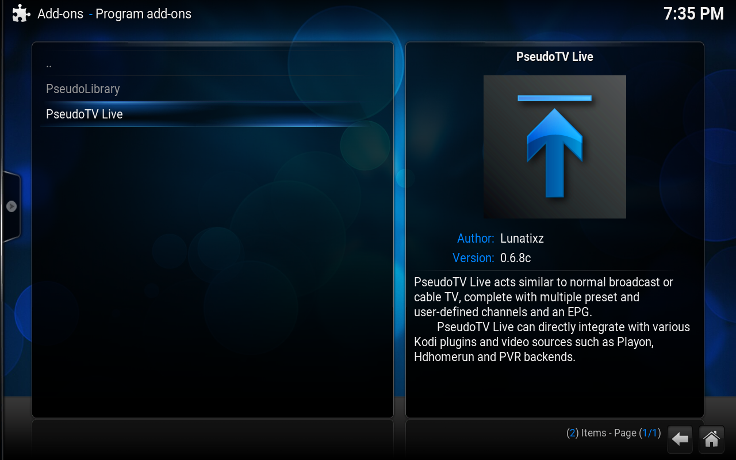
Oh yeah, don't forget to install PseudoTV Live itself, that was kind of the whole point after all... You will find that in the program addons section. Oh and have some patience while the PseudoTV Live install takes place. There were a bunch more dependencies needed for the program to work, thankfully though those can be installed automatically. Noice, huh?
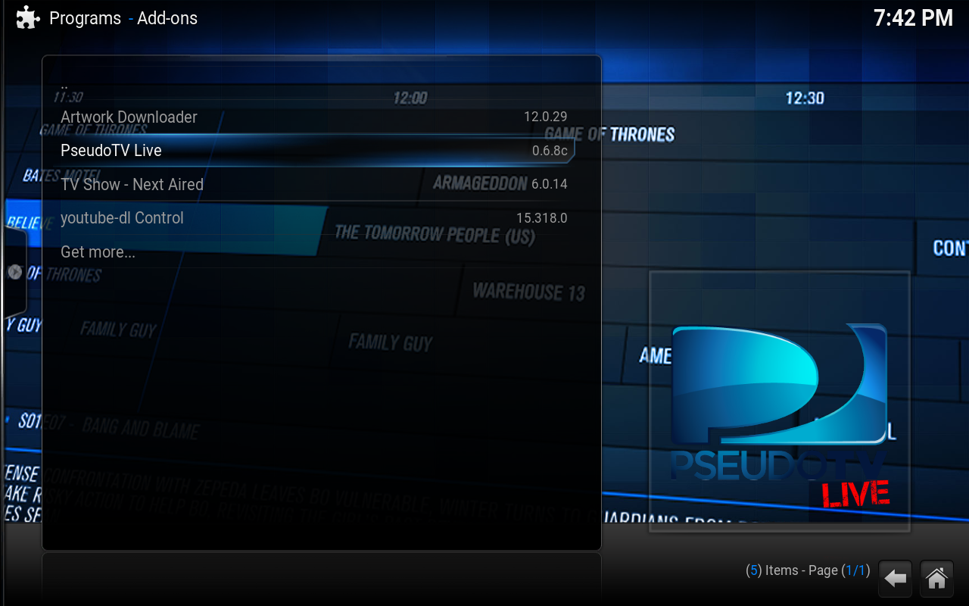
There! That's Part Two of this guide all wrapped up. Huh. Feels like I'm forgetting something somehow. Oh well, I'm sure it's not important or we'll see it in Part Three!

Find
Mr Dumbass
Junior Member
Posts: 20
Joined: Oct 2015
Reputation: 6
#3
2015-10-08, 05:27 (This post was last modified: 2015-10-08, 06:43 by Mr Dumbass.)
Part Three: The basic freebies
Okay, you did all that. Awesome! Now what we need to do is go ahead and try to open the program. The first time you hit the button, you'll get a change log. As you use the PTVL more and more you'll want to keep a close eye on the change log to see what's been changed. Yeah, I know. Who knew what that meant?
Go ahead and hit escape on the keyboard or the arrow button on your remote to get out of there. Now hit the program's button again. PseudoTV Live! will ask you if you want to autotune some channels. It should look like this:
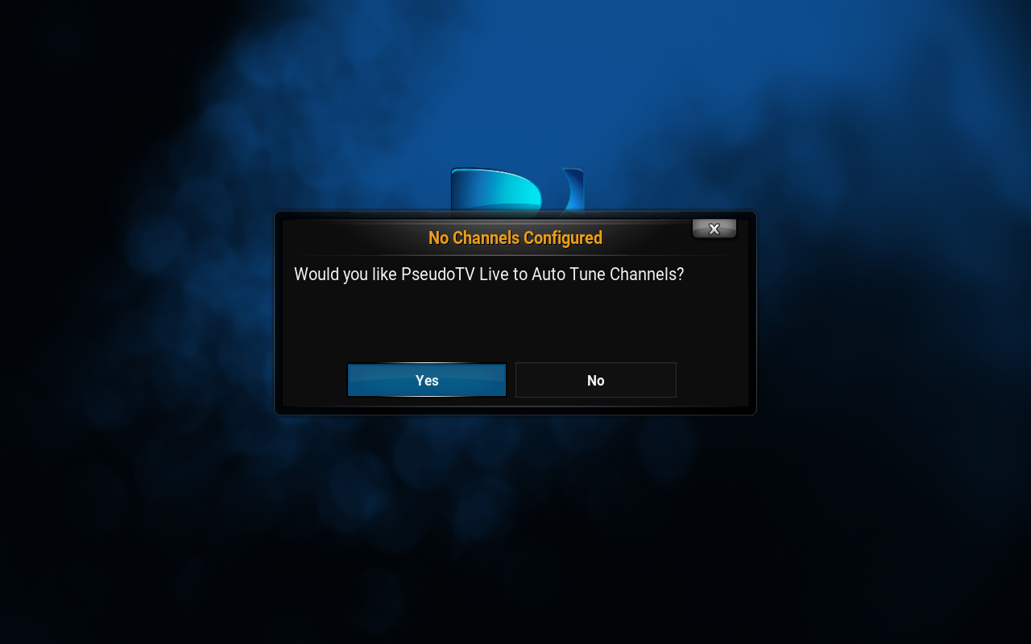
You''re going to want to hit the no button and close Kodi and reopen it. Trust me. No, seriously. Close that thing man! Then come right back and try opening the PTVL program again....
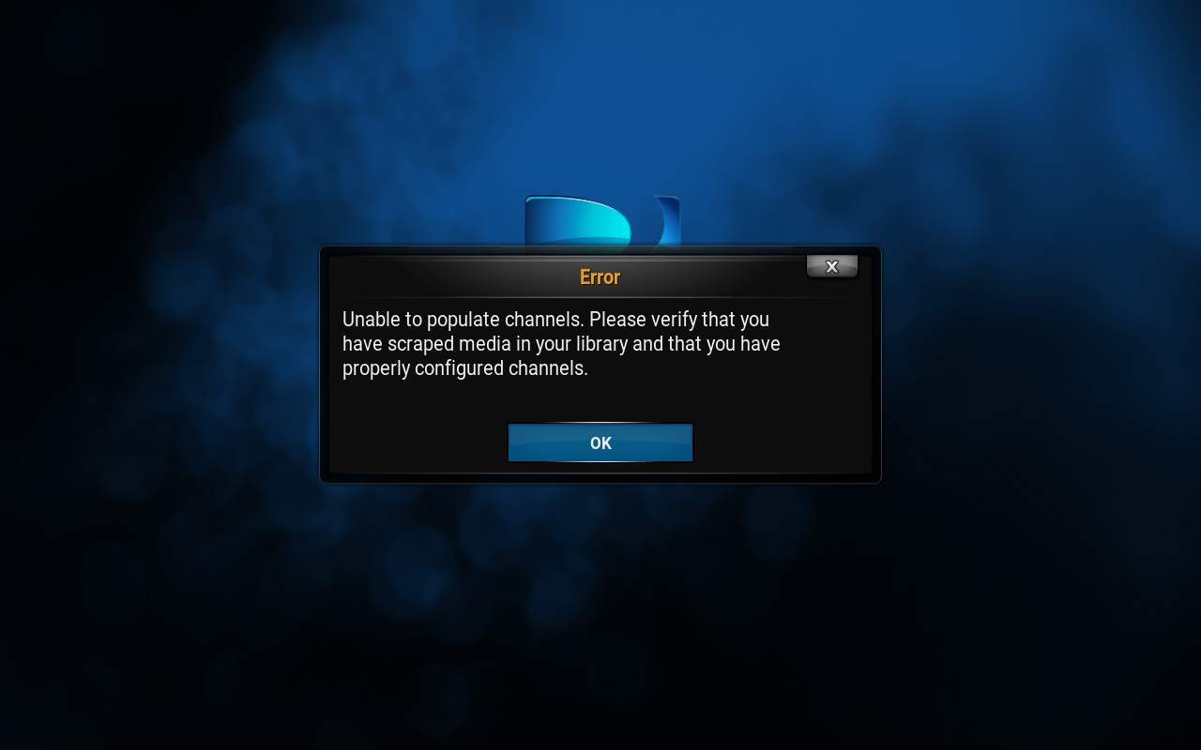
Whoa! Mega bummer dude. Maybe we should have copied some media into Kodi after all?
What's that? You in the back? Yeah, the guy with the asshat. No the other guy with an asshat--yes you! You say 'you don't care about copying your local media into Kodi you just want the free channels from the internet...'
Okay, but that's going to take some work. Are you ready for it?
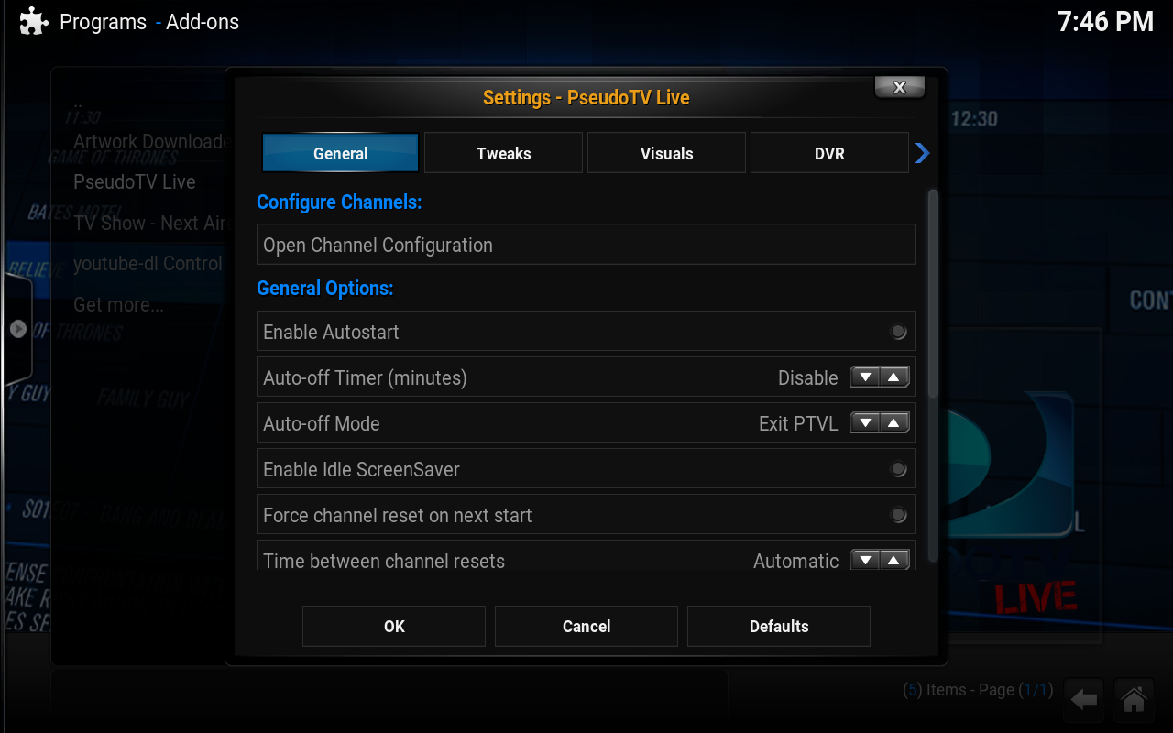
Hoary sheet! WTFBBQ! What are all these options! I'm not good computer, how did I get here? Has anyone really been far as decided to use even go want to do look more like? You've got to be kidding me. I've been further even more decided to use even go need to do look more as anyone can. Can you really be far even as decided half as much to use go wish for that?
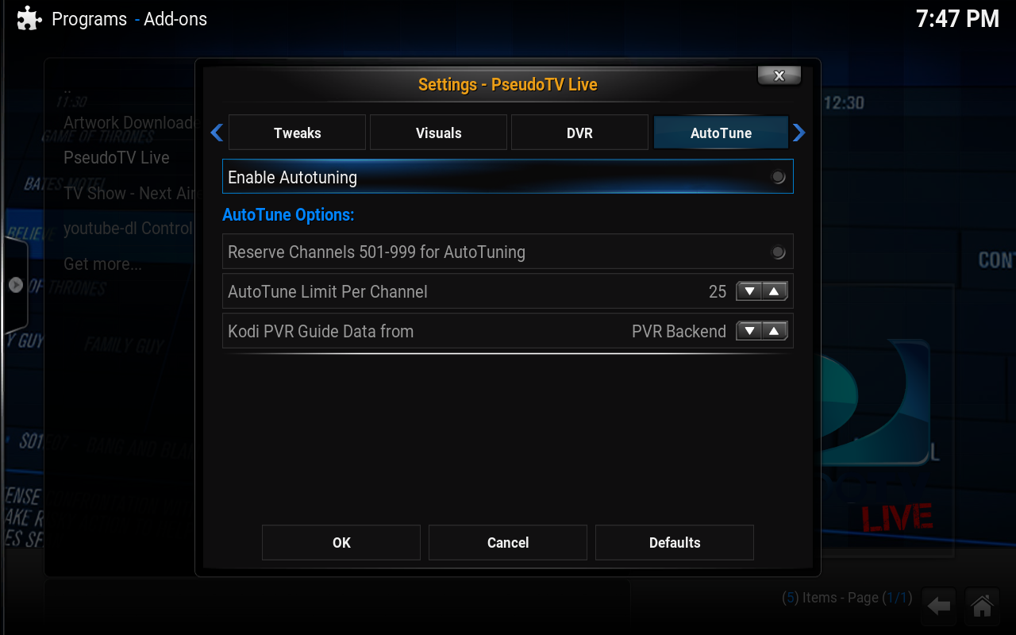
LOL, just kidding. Head to the right until you see the Autotune button on the top.
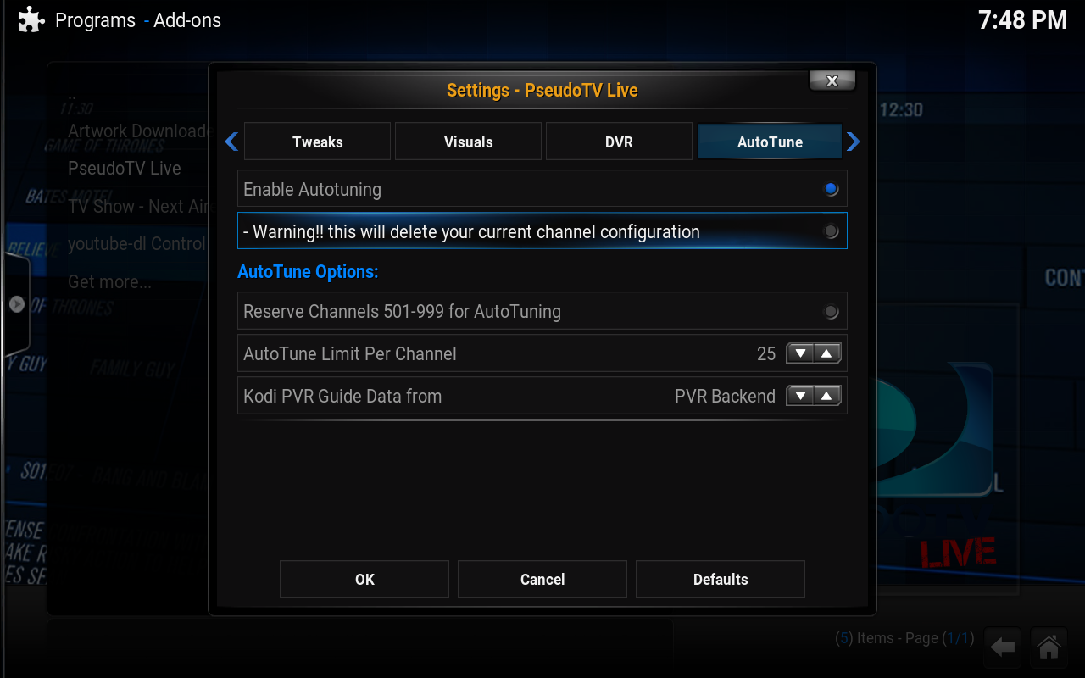
Once you've highlighted the Autotune header at the top, bring the arrow down to click the button underneath it, selecting Enable Autotuning and go ahead and delete the channel configuration you don't actually have at the moment. That will allow you to see what you can select for autotuning of live streams from the internet.
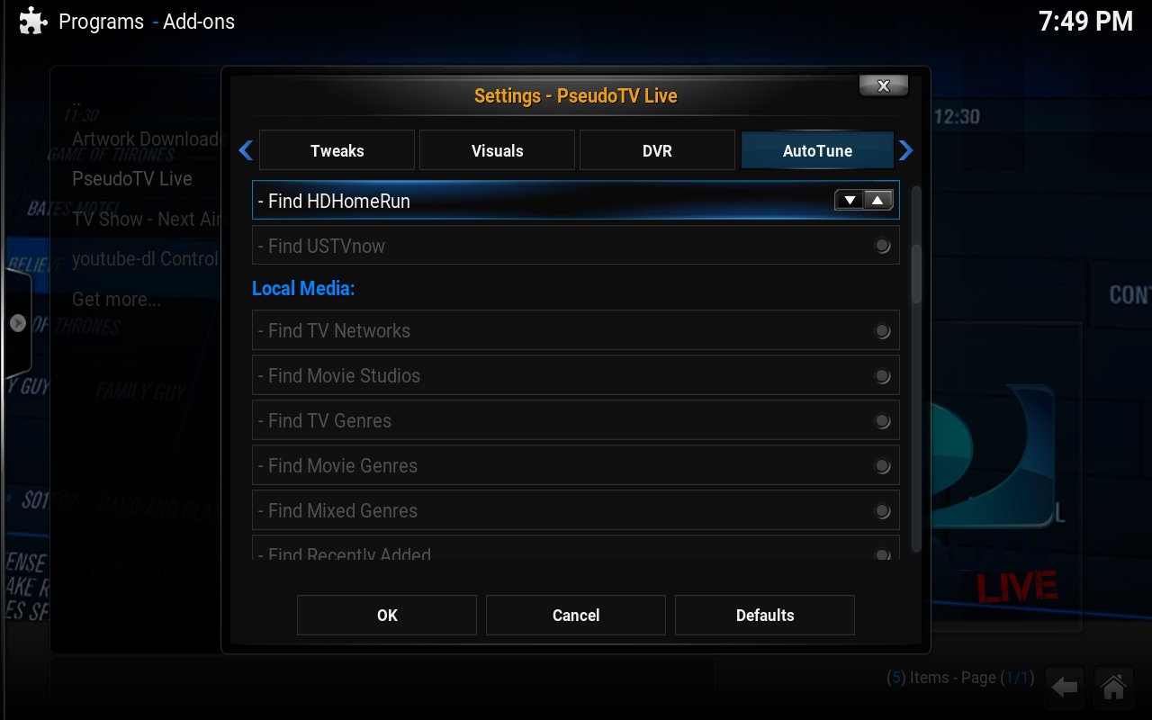
Oh dayummmm... My bad, my dumbass totally forgot that we didn't install the USTVNow video addon! That's what we forgot to do in part two!
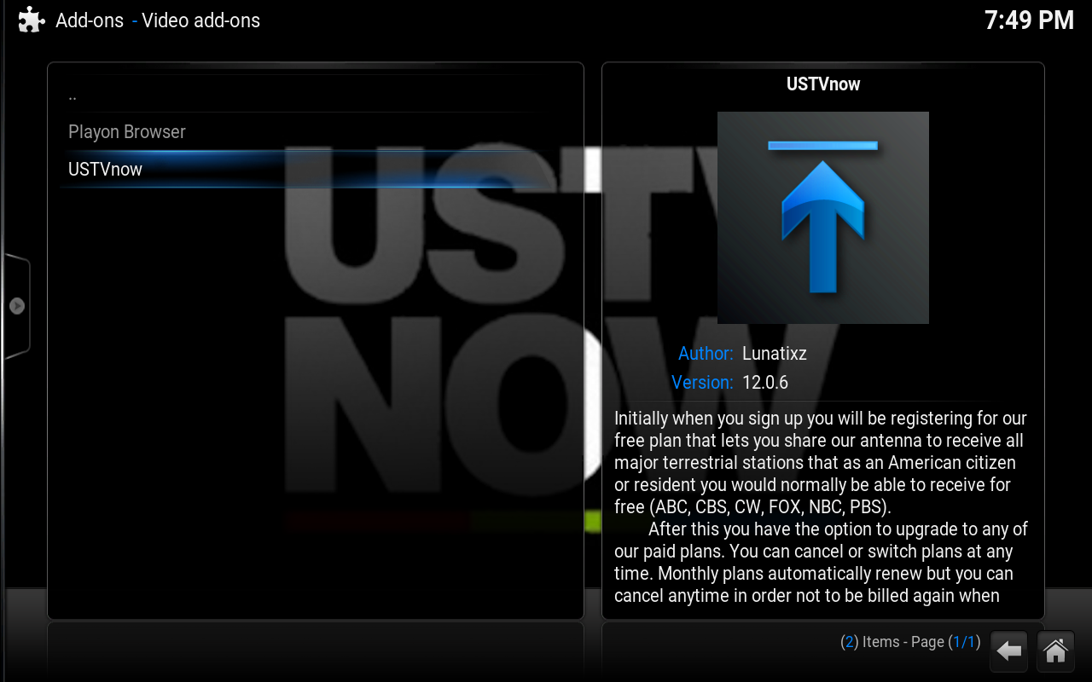
Okay, head back to Lunatixz's repository and install the video addon. That should make the option available to the configuration tool....
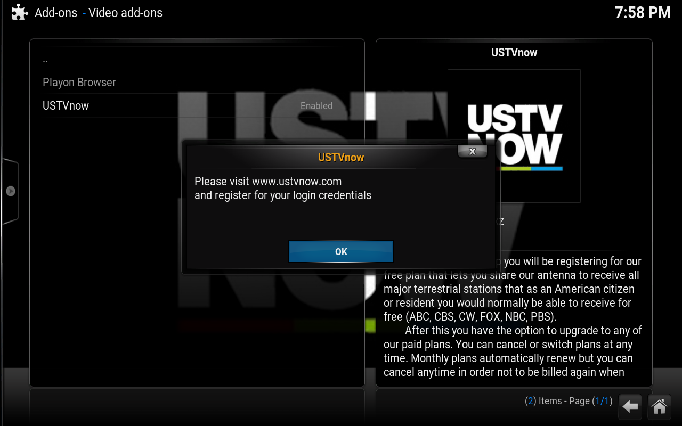
Bogus! Why can't this sheet be easy? I just want a cool program for totes no money man! Why do I have to do all this configuration bullcrap? :igh::
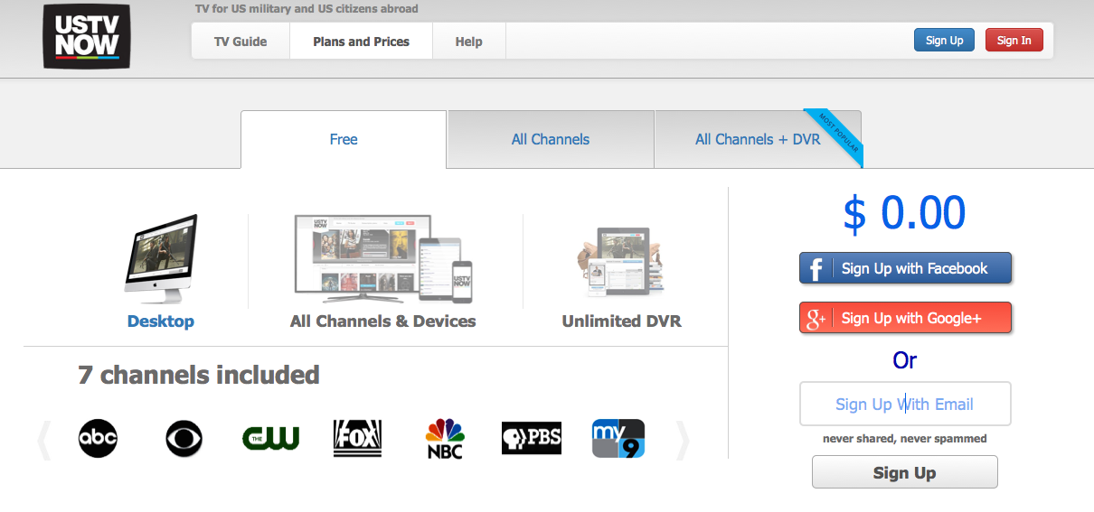
Okay, create an email address (because you're going to need it again, so don't forget it make something nice you can reuse) and head over to ustvnow.com, go to the sign up section and make sure you are on the free option. Fill out the form, use the email address you created and head to the inbox to authorize the free account.
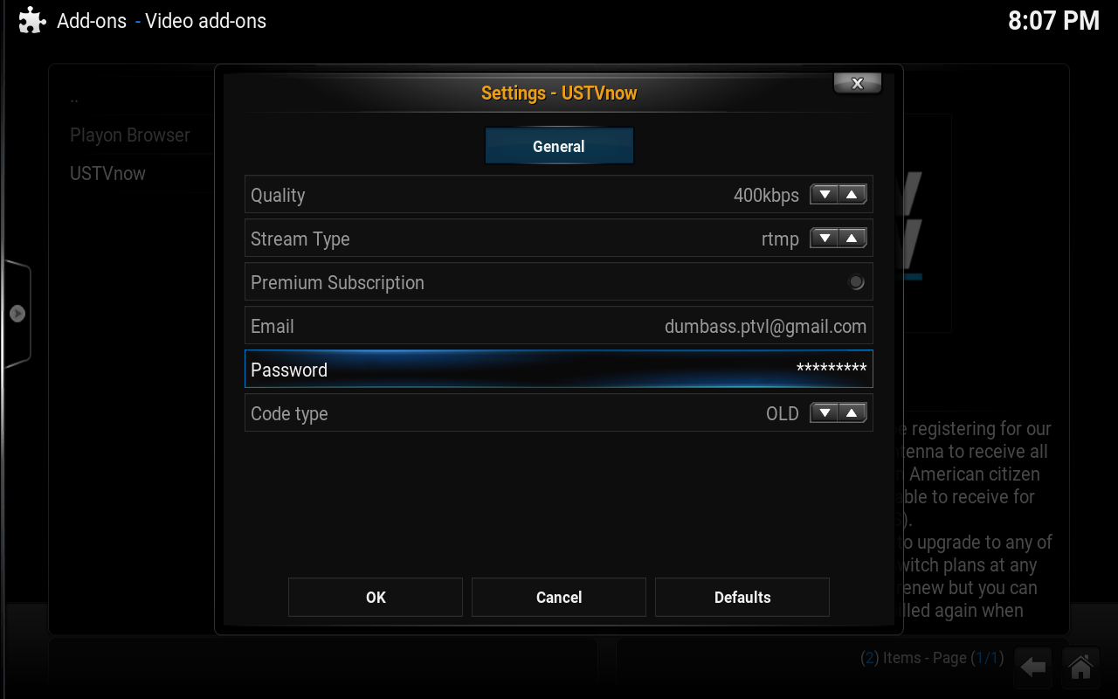
Now go ahead and fill everything out in the USTVNow video addon configuration so you can use it in PseudoTV Live! for your basic seven channel package. All your usual over the air channels will be represented here--so CBS, NBC, ABC, PBS, The CW and Fox. Oh and something called 'My Nine' which I don't think I've seen before I started using USTVNow.
Continued in the next post because there are too many images in this monkey-fighting post for this monday-to-friday part!

Find
Mr Dumbass
Junior Member
Posts: 20
Joined: Oct 2015
Reputation: 6
#4
2015-10-08, 05:28 (This post was last modified: 2015-10-08, 07:10 by Mr Dumbass.)
Continued from previous post....
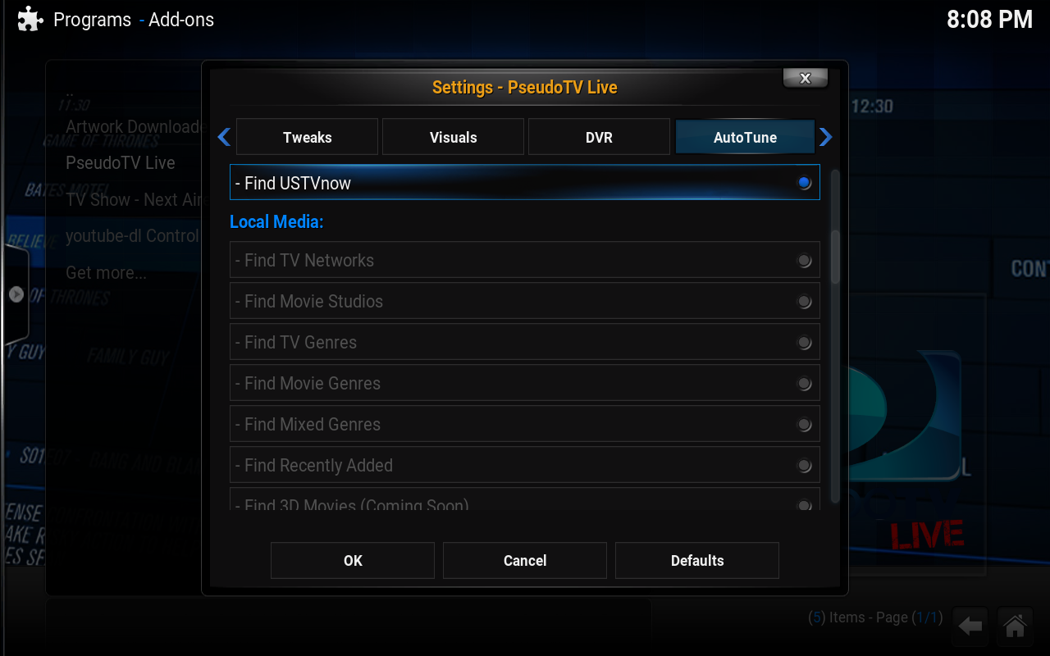
There! Now we can enable USTVNow in PTVL. That makes it all worth it, right? Right? Now we can watch our basic network channels.
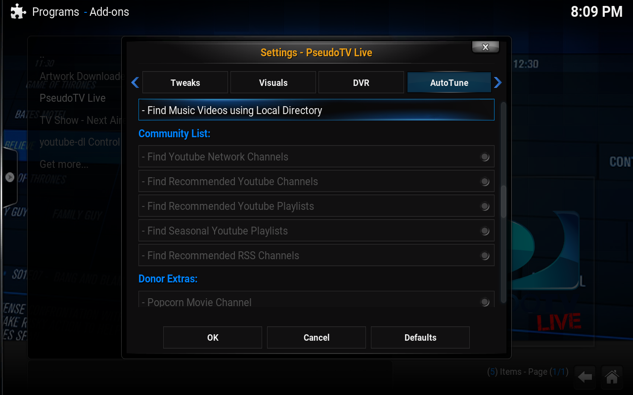
Huh? Why don't I have any of the youtube streams available? Why can't I enable any of the RSS feeds? Mommmmmmm!
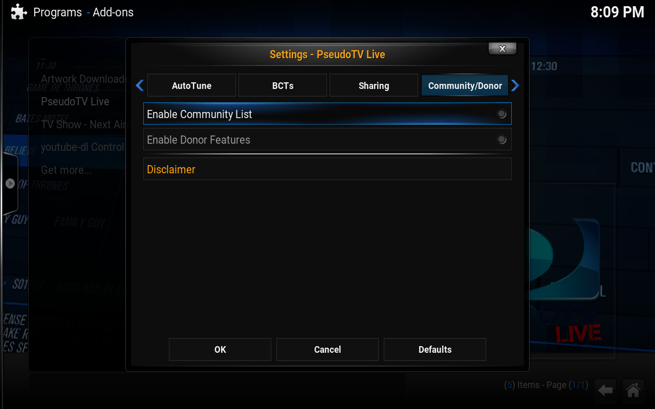
Oh. Someone forgot to enable the community List. What kind of dumbass would forget a thing like...oh. Well ex-squeeeeeze meeeeeee.
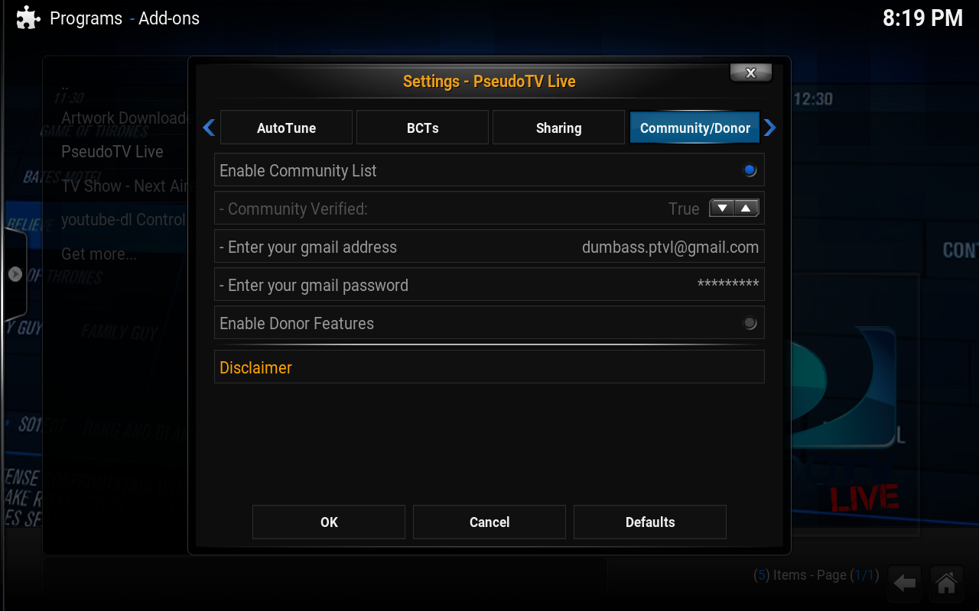
Remember how I told you to be ready to reuse that email address from the USTVNow site? This is why. You need to have an email address to be able to get the community lists enabled in the program. You don't need to be a donor, just have an email address. That may change down the road. Dunno. For now though an email address is enough, so go ahead and fill out the information requested. Once you do, bring the arrow to the bottom and hit OK, to save the email address in settings then exit Kodi and restart it and come back to the PTVL configuration page and the Autotune options.
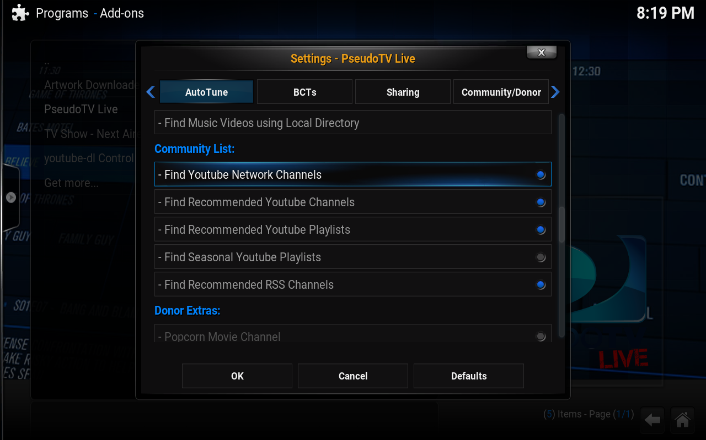
Now you should have the ability to add Youtube based channels to your PseudoTV Live! configuration, do so and hit OK again to save the settings and exit the configuration pages. Now start the PseudoTV Live! prgram again. Your channels will begin to build and you will have a bunch of free channels.
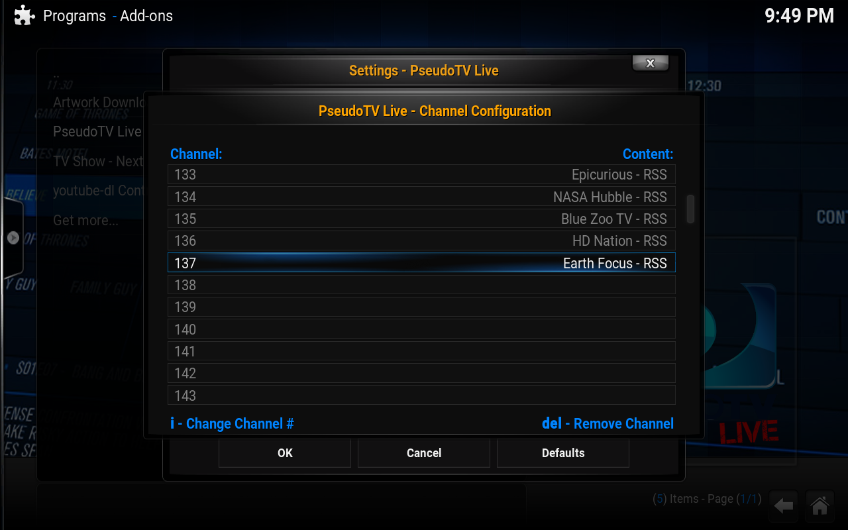
Just by doing this I was able to get 137 channels! Awesome! Your mileage may vary.
The biggest difference between a free user and a donor is that a free user does not get guide data or some of the exclusive channels and bumpers or other exclusive content Lunatixz is working on, so their EPG looks like this:
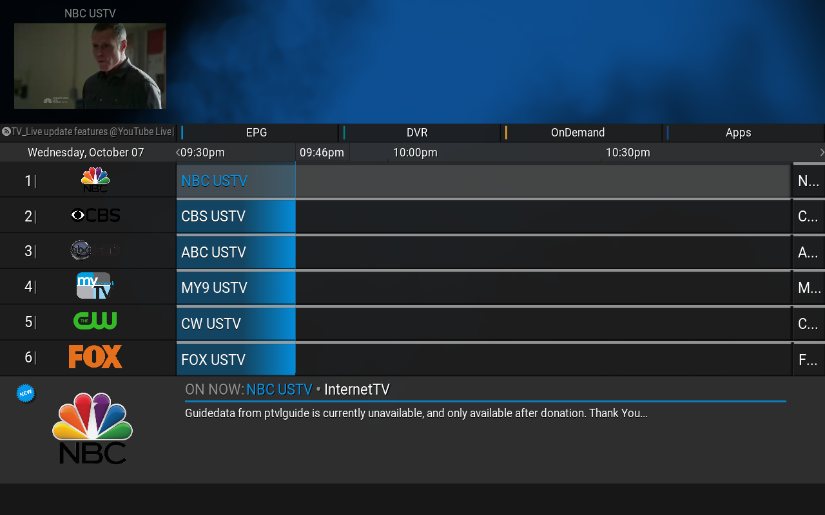
This is only for the USTVNow channels. The EPG is able to get the info just fine for free users using the YouTube and RSS feed channels. See:
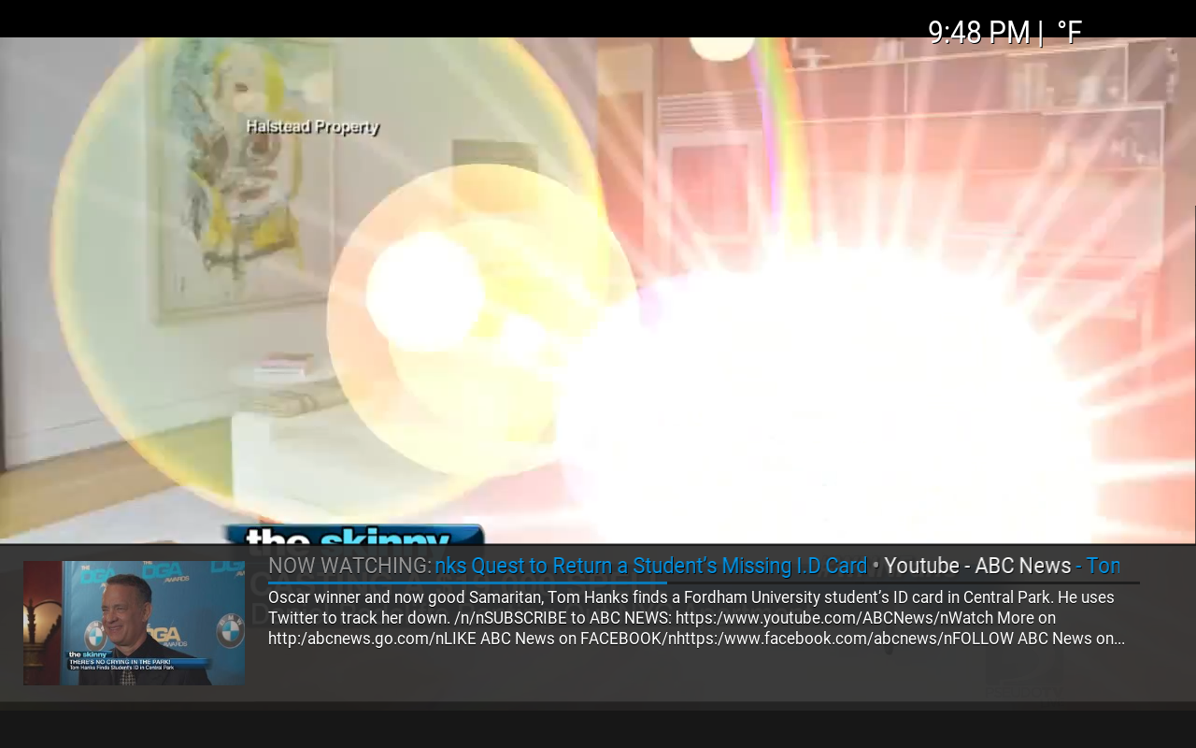
Personally I think it's worth donating to Lunatixz if for no other reason than to say thank you for working so hard to bring us this program and for extending the functionality as much as he has. As someone who remebers both PseudoTV and TV Time I appreciate the scope of what Lunatixz is doing here and continue to be impressed with his dedication to providing us with such a wonderful program that extends Kodi into something amazing.
Now if you've followed this guide you should have plenty of channels to play with! Have fun! Hopefully this has helped you to use PTVL if you were unable to before. If you get a Youtube configuration popup, just follow the directions or wait until part four gets posted.
Disclaimer: All errors were clearly intentional. Not responsible for unwanted pregnancies. Do not pour hydrochloric acid on your genitals. Avoid Dihydrogen Monoxide near computing devices. Badgers unneeded. Sailor Pluto sleeps naked, pictures available by request. Thread may contain images. Images do not contain nuts. Nuts taste good with beer. Mmmmm....beer.....

Find
Mr Dumbass
Junior Member
Posts: 20
Joined: Oct 2015
Reputation: 6
#5
2015-10-08, 06:02 (This post was last modified: 2015-10-09, 05:12 by Mr Dumbass.)
Trolldate: 1444356134
These are the voyages of the SS Socratic Method, in its continuing mission to guide newbs through the endless configurations of PseudoTV Live! making as many errors as possible....to explain as badly as needed to get the point across!
Configuration Options
General
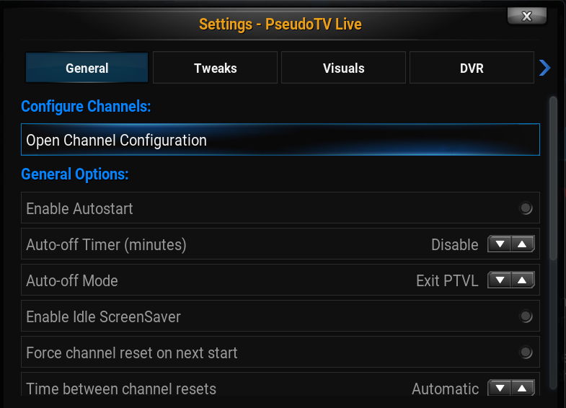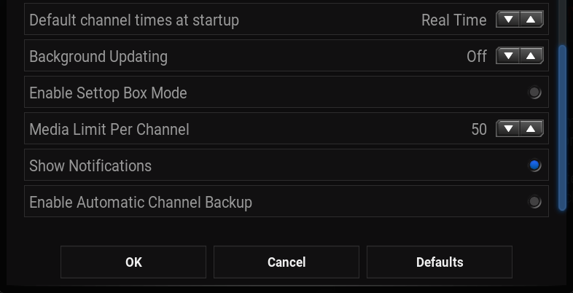
Opening the configuration options for PTVL should bring up a box like above. This is the General options section, which contains the following sections:
Configure Channels:
Open Channel Configuration
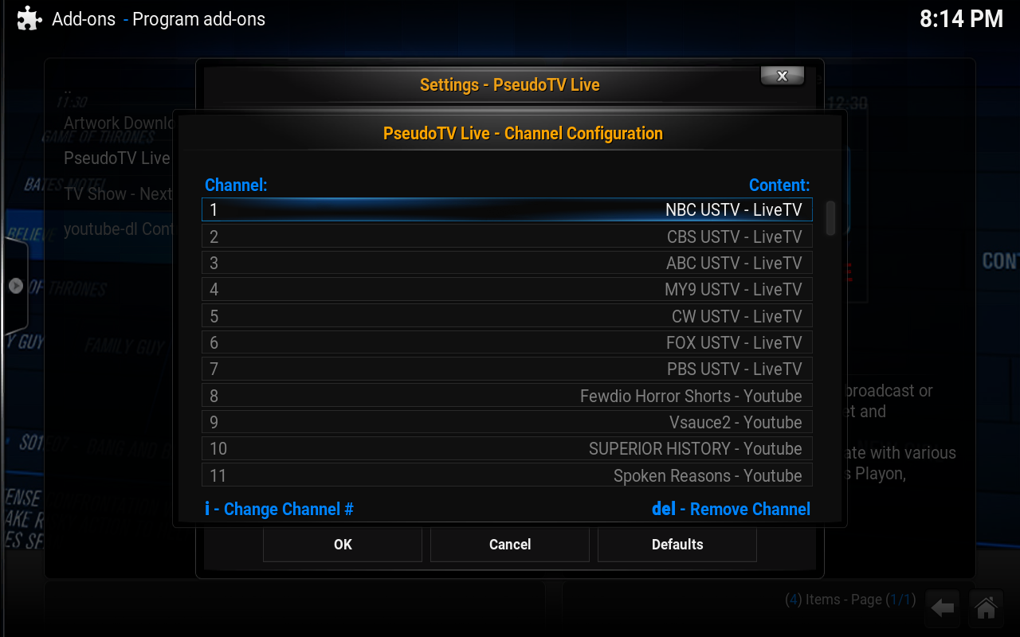
This is heap big magic and for right now outside of the scope of this guide because it's where much of the magic happens. This section is so powerful it needs an entire guide of its own, but you're going to have to find some other dumbass to write it. You can create your own channels here, name them as you like and fill them with all sorts of interesting rules to define what plays where when and how.
General Options:
Enable Autostart
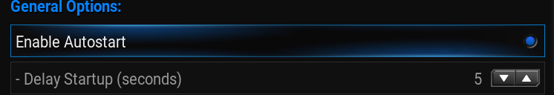
This option is somewhat self-explanatory. Some people prefer to live in PTVL at all times, this option set allows PTVL to start automatically once Kodi has been opened. The sub-option allows you to configure a delay, in case you discover that your preferred theme for Kodi takes a few minutes to completely initialize or your hardware needs more time to find and load the library completely. You can set the delay anywhere from 0 to 20 seconds.
Auto-off Timer (minutes)
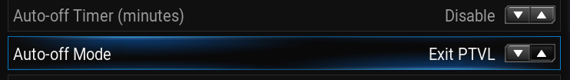
This option allows you to set a time limit on how long PTVL can run before turning itself off. You can set this anywhere from 30 to 240 (a total of four hours) after which time the program will exit itself and do whatever you have set in the next option.
Auto-off Mode
When you exit the PseudoTV Live program automatically you have several choices of options here:
- Exit PTVL
- CEC TVStandby
- EG Trigger
- Shutdown PC
- Sleep PC
- Quit Kodi
Whichever one of these options you choose here will be the action that PTVL executes once your Auto-off Timer limit has been reached.
Enable Idle ScreenSaver
Not sure why anyone would want to enable this or what it would do.
Force Channel reset on next start
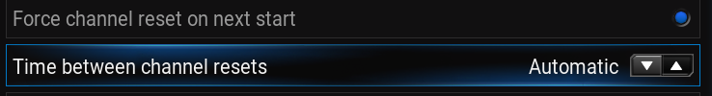
Like your settings but want to force an update of your channels? This will allow you to retain your autotune settings while causing all the feeds to be reloaded the next time you start PTVL. Particularly useful if you've updated the program recently.
Time between channel resets
You can configure these resets to happen automatically at intervals of:
- Automatic
- Daily
- Weekly
- Monthly
- Never
- Every Time
This can be useful if your live streams are no longer populating as they should be or if you find your EPG to be wildly out of sync with reality.
Default channel times at startup
Your choice of what channel begins playing first upon starting PTVL. You have a choice of the following:
- Real Time
- Random
- Resume
Real time makes the program try to stay ontop of its internal EPG scheduling, Random tosses on whatever channel and or show PTVL decides to throw at you and Resume assumes you would like to pick back up right where you left off the last time you opened PTVL.
Background Updating
By default this is enabled as 'ON'. Your other options are to optimize for minimal use or to disable it altogether. When enabled you can start watching channels immediately and the program will continue building your channels while you watch the currently playing stream but you will only have available the number of channels already built. If you turn this off you will have to wait for all channels to build before being allowed to start channel surfing but once the stream begins playing all possible channels will have been created and ready to go.
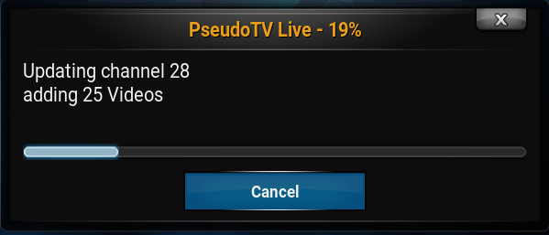
While it is some times good for troubleshooting purposes it can take a while for your channels to build if you disable background updating.
Enable Settop Box Mode
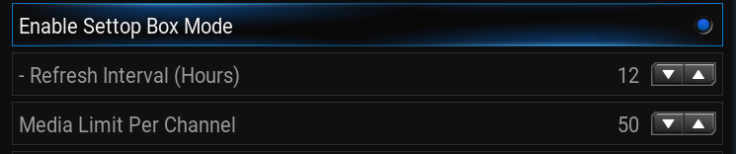
Nobody knows what this does.
Media Limit Per Channel
This configures how many shows you will allow in each channel. Bare in mind the higher this number goes the longer it may take for PseudoTV Live to build your channels. Lower end hardware should probably go with a lower number. Your options are:
- 25
- 50
- 100
- 250
- 500
- 1000
- 5000
- Unlimited

Show Notifications
This option allows you to see what is going on in the background while channels are being made. It will let you know what channel is being made at the moment, give you a heads up if the feed has been blocked in your region, etc.
Enable Automatic Channel Backup
Keeps a back up of your channels. What it does with those backups is unknown.

Find
Mr Dumbass
Junior Member
Posts: 20
Joined: Oct 2015
Reputation: 6
#6
2015-10-08, 07:11 (This post was last modified: 2015-10-18, 02:40 by Mr Dumbass.)
Configuration Options
Tweaks
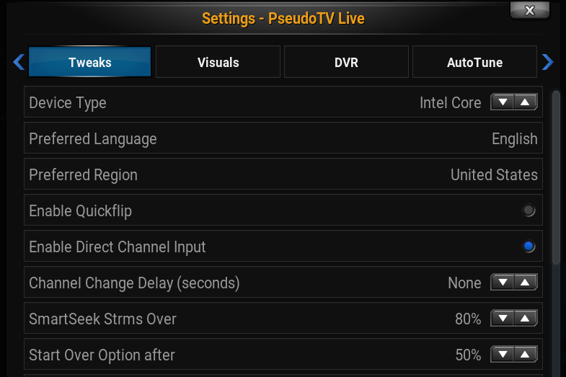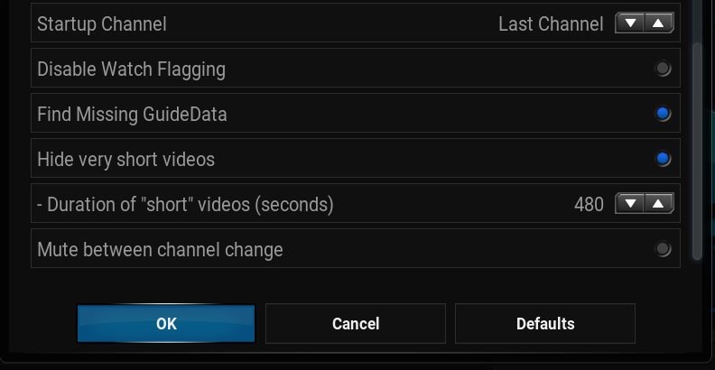
The first three options under tweaks are what I call the locale or regional settings. These are likely something that you've ignored the first time you looked at the program under the hood. This is a mistake! While the Language and Region are likely to be correctly set automatically, if you don't check your configuration you may be missing out on the performance available to you!
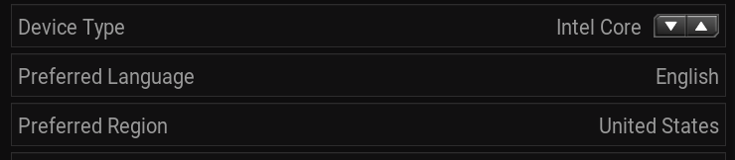
Device Type
This used to be called Operating System and contained a listing of the various devices that PTVL is known to work on. This has since been changed to a more consistent title of Device Type focusing on processor and hardware.
- Intel Core
- Intel Budget
- Raspberry Pi
- PowerPC
- iOS
- ATV
- Android
- AMD FX
- AMD Budget

(2015-10-18, 02:17)Lunatixz Wrote: Intel Core = core processor ie duo,quad and iseries
AMD FX = FX series only
Budget = Everything else... Same goes for AMD

Preferred Language
You can choose between fourteen different languages. I don't know if this is autodetected or if the program assumes English by default.
Preferred Region
The program allows for 252 different regions. Way more regions than I'm willing to list. Take my word for it there are a lot!
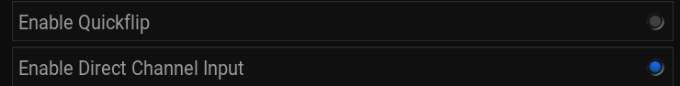

Enable Quickflip
Quickflip enabled bypasses (potentially) slower streams generated from plugin and internet streaming channels. If you have channels created by local content, this means you can flip through that quicker because PTVL will ignore the internet streams in favor of (possibly) faster local videos to allow a faster channel surfing experience because there will be less buffering required.
Enable Direct Channel Input
When this is enabled you no longer have to input your channel number + select; you can simply press your preferred channel number and be directed there.
Channel Change Delay (seconds)
How long to wait for the processes involved in shifting to the next channel. You will still have to wait for the channel to actually load so your mileage may vary. Object in rearview mirror may be closer than they appear. A légpárnás hajóm tele van angolnákkal
SmartSeek Strm Over
Sets the percentage of a show to be completed before PTVL will automatically start playing from the beginning. As Lunatixz has said, no point in waiting for it to only play for 10mins.
Start Over Option after
Sets the percentage of a show to have finished playing before you are offered an option to start from the beginning of the show.
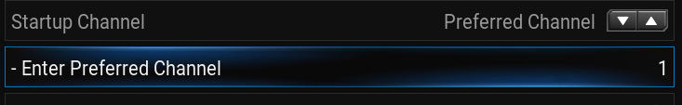

Startup Channel
Want to always start on the same channel you were watching when you exited? This lets you set that channel. Or you can set PTVL to always show the same channel on startup. If you choose the Preferred Channel option, a submenu appears allowing you to set the channel number of your preferred channel.
Disable Watch Flagging
Tells Kodi not to mark as watched anything played while in PTVL. A good idea when it works to make sure your played videos list doesn't get all out of order.
Find Missing GuideData
Finds and adds channel logos, fanart for shows playing and other nice touches. Turn this on but expect it to take a while to get everything the first few times you use the app.
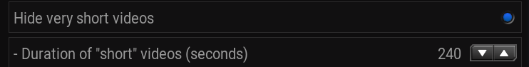
Hide very short videos
This allows you to hide all those bumpers or commercials and movie trailers from the EPG guide. Otherwise you'll see everything listed in the EPG in small slices.
- Duration of “short” videos (seconds)
Use this to set the duration of the short videos you wish to hide, as the title says this is in seconds, not minutes. This is counted from 15 seconds to 8 minutes total time.
Mute between channel change
Set whether or not you wish the audio to continue playing while shifting to the new channel.

Find
Mr Dumbass
Junior Member
Posts: 20
Joined: Oct 2015
Reputation: 6
#7
2015-10-21, 06:55 (This post was last modified: 2015-10-23, 04:51 by Mr Dumbass.)
Visuals
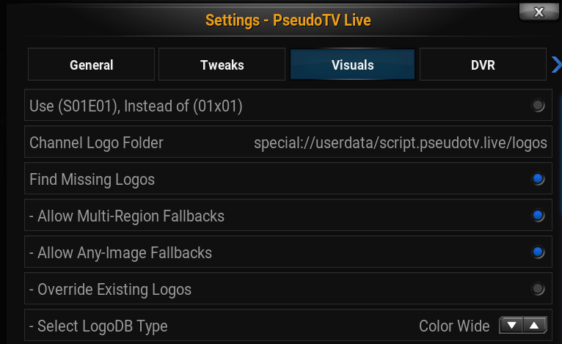
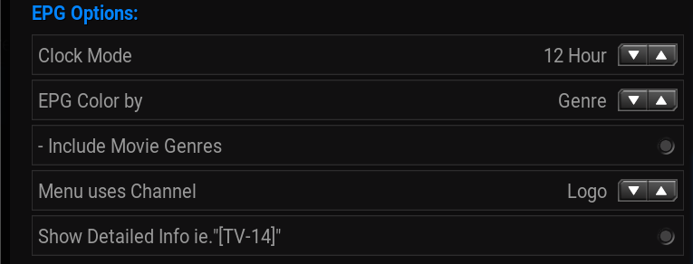
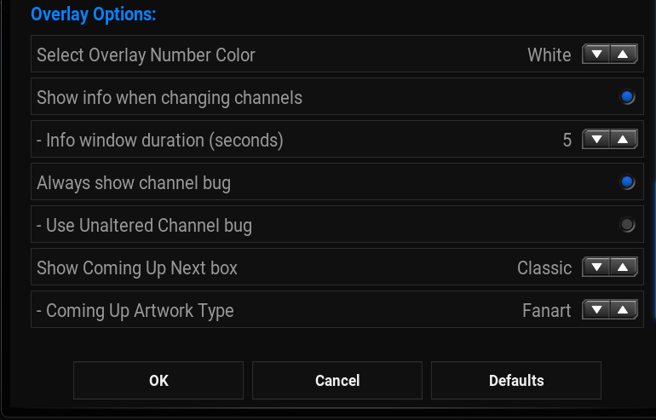
One of the better features of Kodi is that it allows you to customize your interface. So does PseudoTV Live! There are all sorts of ways to change and shape the visual options of the program, so strap in and pimp yo' PTVL!
Use (S01E01), Instead of (01x01)
This is entirely a user preference thing. Some people prefer the scene standard and want ye olde classic S01E01 markings and some of us have moved on from the dark ages when Abraham Lincoln fought Hitler during the Korean War and ...errr... changed to something else. That something else is 1x01, which gives the same information in a sleeker and more compact and manner. Which one do I personally prefer? Ehhh the first one! Couldn't you tell?
Logo Options:
Channel Logo Folder
By default this is already set to an internal location within the userdata folder, but you are free to set this wherever you'd like. The default path is:
special://userdata/script.pseudotv.live/logos

Find Missing Logos
This option enables the next four settings. If you cannot find some of the options listed after this one it is because you do not have Find Missing Logos enabled. They do not display otherwise.
Remember the Channel Logo Folder? PseudoTV Live! will search that directory for any matching logos to go along with your channels. If it cannot find any then having this enabled means that PTVL will download those logos to the directory and make use of it.
- Allow Multi-Region Fallbacks
If you live in Romania and have the Anime Plus channel--that channel has been renamed Animax. THe SyFy channel used to be known as the Sci-Fi channel. This setting makes PTVL a little smarter about what logos to use for your channels when it starts hunting for a logo.
- Allow Any-Image Fallbacks
No one knows what this does. Possibly related to user added images?
- Override Existing Logos
Maybe allows PTVL to download new logos over an older pre-existing one?
- Select LogoDB Type
Chooses what kind of logo images to use. You have a choice of the following four options:
- Color Wide
- White Square
- Color Square
- White Wide

EPG Options:
Clock Mode
What kind of time do you use? Do you prefer military time or divided into twelve hour segments for your clock? It's the difference between 11:15 pm and 23:15.
EPG Color by
This option allows you to change between the types of bars used to display the programming.
- Rating
- Chtype
- Genre

- Include Movie Genres
If you choose to use Genre for your EPG Color by, then this will be offered as an additional choice to color your movies according to what type of genre they are.
Menu uses Channel
Do you prefer text or do you prefer a logo?
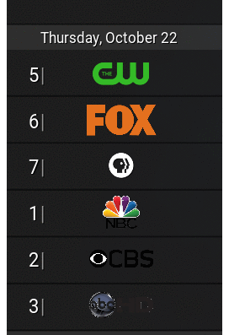

Show Detailed Info i.e.. “[TV-14]”
This is in part a user preference thing and in part a practical consideration. Not every show scrapes with a rating and there been issues, so I suppose it depends on how dedicated you are to keeping everything organized. Some of us aren't anal enough to go through hundreds of television shows and manually look them up and add ratings to them just so everything looks pretty in their system skin....
Overlay Options:
Select Overly Number Color
What color are the channels on your TV when you change stations? PTVL is intended to be a complete cablebox replacement, so to complete the illusion you want your channel colors to line up with the same display the TV uses, right?

- Holo
- White
- Light Gray
- Gray
- Green
- Cyan

Show info when changing channels


Donating is the difference between this and this.
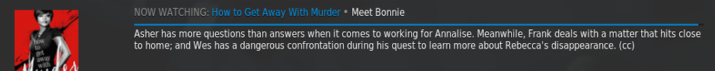
This is the info box that comes up and tells you the name of the show, the season and episode numbers, a short summary of what the episode is about which is hopefully spoiler free. If you are not a donor you will find this empty for USTVNow channels. If you like you can choose not to see the information box at all; of course this means you won't get it on channels with local content or youtube stations....
- Info window duration (seconds)
How long do you want to see the information above? You can choose between 3-25 seconds. By default it is set to display for 5 seconds.
Always show channel bug

The "channel bug" is that little icon of the channel or the network the show being displayed is from. Whether you want this is highly determined upon the source of your media. If the media does not have its own channel bug then it's a nice feature. If your media was recorded off a local network and already has its own channel bug built into the video then it can look a bit ridiculous...

Unfortunately at this time the option is all or nothing....

- Use Unaltered Channel bug
Not sure what this does exactly.
Show Coming Up Next Box
You have multiple options:
- Disabled
- Classic
- Popup
- Overlay
The default is Popup, which makes a small image display in the right corner of the next show's fanart. This can be further customized if the Classic option is chosen, allowing a submenu to appear.
- Coming Up Artwork Type
Here you can choose between five different artwork types, which is useful if you only have Posters or if you have many shows for which there are no Landscape artwork types available.
- Fanart
- Poster
- Clearart
- Logo
- Landscape

Find

Mr Dumbass
Junior Member
Posts: 20
Joined: Oct 2015
Reputation: 6
#8
2015-10-21, 06:56 (This post was last modified: 2015-10-26, 23:02 by Lunatixz.)
reserved
https://www.howtogeek.com/195099/how-to-recreate-the-channel-surfing-experience-on-xbmc/

How to Recreate the Channel Surfing Experience on XBMC

Jason Fitzpatrick
@jasonfitzpatric
Updated

Running a home media server is pretty awesome: beautiful cover art, playlists, and all your media right at your finger tips. One thing media centers fall short on, however, is recreating that feeling of aimlessly channel surfing just to scratch that TV watching itch. Read on as we show you how to recreate the channel surfing experience on XBMC with the use of a very clever add-on.

Why Do I Want To Do This?
More and more people are “cutting the cord” and breaking away from the traditional cable-centered TV watching experience. There’s a host of good reasons to do so: TV shows without commercials, media on demand the way you want it, and saving a chunk of change (the average cable bill in the US is $90). One thing that many people find missing from the post-cable experience, however, is the simplicity of turning on the television and just having something on.
Would it be nice if you could take your vast trove of media and some streaming sources and combine them into a pseudo-sort-of TV channel system where instead of poring over your media list and carefully picking something out you could just turn on your television and get the same what’s-on-now experience cable provides but, you know, without the cable bill and annoying commercials?
Thanks to the aptly named PseudoLive add-on for the popular XBMC media center platform you can. It’s an extraordinarily clever little plugin that we’re thoroughly impressed with. Let’s take a look at what you need and how to install it.

What Do I Need?
For this tutorial you’ll need the following items in order to follow along:
- An installation of XBMC 13.0 or higher.
- The PseudoTV Live add-on.
- Locally stored media (for local media channels)
- Internet access (for streaming media channels)
We’ve opted to use a branch of the original PseudoTV add-on, PseudoTV Live for two reasons. First, it supports the most recent release of XBMC. Second, it supports live streaming from sources like Hulu, YouTube, etc.

Installing PseudoTV Live
PseudoTV Live’s installation process is the same as any unofficial XBMC add-on. First, download the stable master release .ZIP file here. Once downloaded, fire up XBMC and navigate to System -> Settings -> Add-ons -> Install from zip file and browse to the location of the PseudoTV Live plugin .ZIP you just downloaded.

After a successful installation you’ll see a popup like the one above in the lower right hand corner indicating the add-on is installed and enabled. After that you can confirm the status of the add-on by navigating to System -> Settings -> Add-ons -> Enabled Add-ons -> Program Add-ons where you should see an entry for PseudoTV live. If you click on the entry you’ll see the add-on information panel for it.

In order for PsuedoTV Live to finish integrating with XBMC and appear in the primary menu, you’ll need to restart XBMC. After restart, navigate to Programs -> PseudoLive TV and run the application.

On first run, the add-on asks if you want to have it automatically generate channels for you. We recommend trying this feature out rather than jumping immediately into crafting your own channels from scratch. Click “Yes.”
PseudoTV Live will automatically load and tune into the first automatically generated channel (what this channel is and what content it provides is entirely dependent on the media you have linked to your XBMC installation). Here’s an example of what a channel looks like: number in the upper left corner, show summary on the lower portion of the screen.

Go ahead and use the up/down arrows on your keyboard or remote (or the PgUp/Dwn keys on your keyboard) to navigate to new channels. Want to check out the Electronic Program Guide (EPG)? Press the enter key while watching a video in PseudoLive TV and you’ll see a screen like the one below.

You’ll notice that PseudoLive TV has done it’s best to use your XBMC metadata to create a variety of channels including those named after actual networks such as TV Land, USA network, and TNT (these were created because we have DVR’ed shows from these networks on our media server) as well as general channels such as Action Movies and Animation Movies created based on the media tags from our library.

Creating Local Media Channels
Creating local media channels is a pretty straight forward affair. To create a new channel go into the settings menu for PseudoTV Live by navigating to Programs -> PseudoTV Live-> Add-on Settings.

Under the General tab, click on the “Open Channel Configuration” button.

Here you’ll find a list of all the current channels on your system. Find an empty spot to create a new channel and select the empty entry. You can set up a new channel to be a Directory, TV Show, Mixed Genre, Movie Genre, TV Genre, Movie Studio, TV Network, or a custom playlist.
Directory will simply play all the media from the selected directory, TV will create a channel dedicated to a single television show (such as an all South Park channel), Mixed Genre will create a channel focused on a single genre such as “Thriller” or “Sci-Fi” and will mix movies and television shows in that genre together (whereas Movie Genre and TV Genre will keep them separate), Movie Studio creates a channel that plays only movies from a certain studio (like Universal Pictures) and TV Network does the same with TV Networks (such as AE or Discovery). The final option, custom playlist, simply turns a playlist you’ve created on XBMC into a channel.

For the sake of demonstration, let’s create a 24/7 South Park channel. To do so, we select the channel type “TV Show,” select “South Park” and decide if we want the episodes to be showed sequentially. For some shows this is critical (as the show creates an extended story arc over time) but South Park has been on the air for over a decade and has had less than 10 multi-part episode arcs so we feel comfortable letting the show play on a more or less random schedule.
Let’s check out the new channel and see what it serves up.

All South Park, all the time. Using the simple channel creation system you can create channels for all manner of things.

Creating Streaming Media Channels
If you already had supported video add-ons installed, such as those for YouTube, Vimeo, Vevo, or Twitch.tv you’ll notice that not only are there channels based on your local media but on popular channels and playlists on the streaming media sites you have add-ons installed for. Notice in the screenshot below the two popular YouTube science channels: Bill Nye the Science Guy and Minute Earth are both pre-loaded.

What if you want to add in your own YouTube channels though? There’s two ways you can go about it, one semi-automatic way (that’s YouTube specific) and one manual way that can be adjusted to work for just about any streaming video source. The semi-automatic way involves logging into your YouTube account via the add-on and letting it turn your subscribed channels and playlists into channels for PseudoTV.
If you have a YouTube account (and you keep an active list of subscriptions) you can go to Programs -> PseudoTV Live-> Add-on Settings and then navigate to the “AutoTune” tab and scroll down to the “Plugins” menu. Here you’ll find settings for your video add-ons, including YouTube, and you can enter your YouTube username and password to import your subscribed channels and favorited videos. That’s easy enough, but things get a little trickier if you want to do more advanced importing.
For advanced importing you’ll need to manually edit one of PsuedoTV Live’s configuration files. Let’s look at how you add in a YouTube channel via manual configuration. First, you’ll need to locale the settings2.xml file. This file it located wherever your operating system stored the application data for XBMC. In the case of Windows, for example, it’s default location is \%AppData%\Roaming\XBMC\userdata\addon_data\script.pseudotv.live\settings2.xml.
Note: some PseudoTV Live users report that this file is not created until they turn on the “Channel Sharing” feature located in the add-on settings menu under Sharing -> Enabled Channel Surfing. Even if you’re using a single unit and don’t need the sharing function you may need to toggle it on to force the creation of the channel list.
Once you’ve located the settings2.xml you’ll need to open it up in a text editor to edit it. We strongly recommend using a text editor with proper code parsing and display. If you open it up in Notepad or another ultra-basic text editor the formatting is very messy and very difficult to deal with. If you open it up in a more advanced text editor like Notepad++, however, the code will be neatly formatted and easy to work with.
The help file for PseudoTV Live details how to add different channels from different sources, but we’re going to focus on adding a simple YouTube channel here. To add a YouTube channel you need to identify three things before we proceed. First, what number the channel will be, what the username of the YouTube channel you’re subscribing to is, how many back-videos you want the channel to access, and what you want PsuedoTV Live to display the channel description as.
In our case we want to add the popular Minecraft channel, TheDiamondMinecart to our PsuedoTV Live install. Here is the template you use to add a YouTube channel to the master channel list:
<setting id=”Channel_#_type” value=”10″ />
<setting id=”Channel_#_1″ value=”YouTube Username” />
<setting id=”Channel_#_2″ value=”1″ />
<setting id=”Channel_#_3″ value=”#ofbackvideos” />
<setting id=”Channel_#_4″ value=”0″ />
<setting id=”Channel_#_changed” value=”True” />
<setting id=”Channel_#_rulecount” value=”1″ />
<setting id=”Channel_#_rule_1_id” value=”1″ />
<setting id=”Channel_#_rule_1_opt_1″ value=”DescriptionName” />
You need to replace all of the bolded elements in the template above with data specific to the new channel. We’re going to replace the “Channel_#_” bit in each line with “Channel_43_”, then fill in “TheDiamondMinecart” for the YouTube username, the number of back videos as 50 (it can be any value but higher values require more processing power/time as the add-on has to parse out metadata for the backlog), and a channel description. The channel description is what will be displayed in the on-screen guide (so use something descriptive and around 14 characters in order to see the full name at once. Here’s what the edited code looks like.
<setting id=”Channel_43_type” value=”10″ />
<setting id=”Channel_43_1″ value=”TheDiamondMinecart” />
<setting id=”Channel_43_2″ value=”1″ />
<setting id=”Channel_43_3″ value=”50” />
<setting id=”Channel_43_4″ value=”0″ />
<setting id=”Channel_43_changed” value=”False” />
<setting id=”Channel_43_rulecount” value=”1″ />
<setting id=”Channel_43_rule_1_id” value=”1″ />
<setting id=”Channel_43_rule_1_opt_1″ value=”TheDiamondMinecart” />
Now, all you need to do is simply insert the edited block of text into your settings2.xml file. We’re inserting it at the very end (because we made a new channel at the end of the list) but if you’re replacing another channel insert it at the appropriate place in the list.

Note that the new channel is within the <setting></setting> tag. As long as you fill in all the values, you don’t select a channel number that conflicts with another channel, and you keep it inside the settings tag, everything should work just fine.
Let’s fire up PseudoTV Live and see how our new channel looks.

Fire it up, and you’ll see your favorite YouTube channel on your television set, configured like a TV channel.

By following along with the PseudoTV Live formatting guides you can add more channels, playlists, and video sources from a variety of supporting streaming sites.

Further Exploring PseudoTV Live
Now that you have the basics of setting up a local and streaming channel down, we’d encourage you to explore the wide range of settings available in the add-on configuration menu. While we’re not going to go through every possible configuration, we are going to highlight some configuration menu options you might want to take a peek at, grouped by the submenu they’re found it.

General
Here you can enable PseudoTV Live to automatically start, to play in real time (like actual TV) or to pause whenever you aren’t actively watching (useful for shows you’re following closely and would like to pause until you return). If you find that PseudoTV Live is lagging your system, you can also adjust the update frequency here to decrease the load on your system.

Tweaks
The tweaks section is primarily focused on adjusting how the channels act and appear. You can insert a fake channel delay (just like you experience when using a TV tuner), select what will play on startup (last channel or a prefered channel of your choice), and turn flagging on and off (if you’re using this setup as a kind of background noise instead of actively watching you may wish to turn off the “watched” flag so XBMC doesn’t think you’ve actually watched the content).
One of the most useful tweaks in this section is “Reserve Channels 501-999″ for Autotune” as it restricts the automatically created channels to that block.

Visuals
The toggle and adjustments in this submenu change the add-on’s skin, how the on-screen guide looks, and whether or not it will display logos for the different channels. You can also adjust the size and color of the on-screen channel number and various on-screen elements like the “Up Next” display box.

PVR
This section includes some highly experimental (or presently unavailable) options regarding integrating XBMC and PseudoTV Live with PVR software/hardware backends. Unless you’re willing to play beta tester for these features, we’d recommend skipping over this section entirely. If you want to play with it then be prepared to do some serious reading in the PseudoTV Live discussion threads.

AutoTune
We recommend playing around in this section early on as the AutoTune function recreates your channel list every time you use it. This is a very powerful submenu that automatically creates genre, network, and studio channels based on your input as well as channels based on popular YouTube channels and the like.

Community Network
Enables crowd-sourced channel content similar to the “channels” found on Pluto.tv. You can opt for a wide range of channel topics including TV, Movies, Episodes (dedicated to a single show), Sports, News, and Kids.

BCTs
Short for Bumpers, Commercials, and Trailers. Allows you to insert these content types into your PseudoTV experience. Bumpers are the television equivalent of splash screens like when the network’s logo spins up on the screen and then vanishes.
Commercials are, just like they sound, commercial content. You could, if you wanted, take a bunch of vintage 1960s commercials ripped off YouTube and insert them in your fake TV channels. You can also insert current TV ads using the iSpot.tv servers, as well as YouTube playlists. While most people use media servers specifically so they don’t have to see advertisements, we’ll admit there is a certain novelty in injecting advertisements for odd or dated thing. You could, if you desired, inject a giant playlist of funny foreign advertisements into your channels.
The trailers function allows you to inject movie trailers into your channels. You can specify where they come from (YouTube or local content), how often they play, and on what channels they play (e.g. only on movie channels or on all channels). Support for HD-Trailers.net is in the works.

Donor
This section contains features available only to those that support development of the add-on. If you donate your copy of PseudoTV Live will support access to Bring the Popcorn and Cinema Experience. Bring the Popcorn is a website devoted to scouring YouTube for full movies and then creating useful indexes of them. Cinema Experience adds in a channel that mimics the setup of movie theater movies: intros, outros, trailers, announcements, and other features found in a traditional movie theatre experience.

Whether you use AutoTune once to set it up or you pore over your channel choices, PseudoTV Live delivers what it promises: a simulated broadcast TV experience that injects a high level of novelty into the media center experience. It’s not for everyone, but if you’ve been longing for a way to enjoy the sort of impulsive “I wonder what’s on?” channel surfing that a cable box offers, this add-on certainly delivers.

Hi,
this addon is the All-In-One solution for the most important music video sources. You can create your own channels from various sources.
Supported sources:
- Local music videos (Directories / SmartPlaylists / XML Shareable Playlist Format)
- VEVO (Playlists / Artists / Charts)
- Spotify (Playlists / Artists / Albums)
- Deezer (Playlists / Charts / Radio / Artists / Albums)
- Muzu (User Playlists / Channel Playlists)
- Youtube Playlists
- Dailymotion Playlists
- iTunes Charts
- Reddit
Spotify playback is done via Youtube. This works really well, because of that I also wrote a small separate addon for Spotify playlists: SpotiTube.
Youtube search queries are cached for 24 hours.
You can create the channels with a text/xml editor of your choice. Configuration via XBMC is not possible - and not planned...
Simply create one .xml per channel in the channel directory (../XBMC/userdata/addon_data/plugin.video.my_music_tv/channels). The filename conforms the title in XBMC.
A simple example:
<channel>
<entry type="vevo:playlist" value="8b75ba3c-4322-4946-9288-949b6ac1bf5b" />
</channel>
There are also 3 optional attributes per channel: 'thumb', 'shuffled' and 'unwatched'.
Per default, all videos per channel are played in random order (shuffled="yes"). If you want the channel to be played in original order, you can force this via shuffled="no".
Also, all videos are played per default. It's possible to play only unwatched videos by using unwatched="yes". The watched state is saved separately for each channel.
2 attributes are required for each entry: 'type' and 'value'. The following 3 attributes are optional: 'title', 'limit' and 'cache'.
'title' is for your own organisation - you should use it. The maximum amount of videos per entry can be set via 'limit'. Useful for charts.
You can use 'cache' to force the caching duration in days. Default caching duration: see below
Example with all possible attributes:
<channel thumb="THUMB_URL" shuffled="no" unwatched="yes">
<entry title="VEVO: Top20 Today" type="vevo:charts" limit="20" cache="1" value="all:MostViewedToday" />
</channel>
A channel could contain as much sources as you want, but you should not use too much (1 entry = 1 request).
If a video occurs in multiple sources, it only gets added once: Priority: Directories->SmartPlaylists->xspf->VEVO->Muzu->Youtube->Dailymotion->Reddit->Spotify
Example for a channel with multiple sources:
<channel>
<entry title="VEVO: Staff Picks (German)" type="vevo:playlist" value="4d9ce4e3-3391-45cf-a472-b968ef6f4ba9" />
<entry title="VEVO: Top50 Alternative" type="vevo:charts" limit="50" value="alternative:MostViewedWeek" />
<entry title="VEVO: Top50 Indie" type="vevo:charts" limit="50" value="indie:MostViewedWeek" />
<entry title="VEVO: Top50 Rock" type="vevo:charts" limit="50" value="rock:MostViewedWeek" />
<entry title="Spotify: Top50" type="spotify:playlist" limit="50" value="spotify:4hOKQuZbraPDIfaGbM3lKI" />
<entry title="Spotify: New Music Friday Germany" type="spotify:playlist" value="spotify_germany:4HdOsN3i6umE8rN1y75NBi" />
<entry title="Spotify: Top30 Germany" type="spotify:playlist" limit="30" value="spotify:2vWo3FE3W86L3DHTGh2B2l" />
<entry title="Spotify: Viral30 Germany" type="spotify:playlist" limit="30" value="spotify_germany:0X1dFE1Bax2j1tbCRzI4Ol" />
<entry title="Spotify: Top20 Rock" type="spotify:playlist" limit="20" value="spotify:3qu74M0PqlkSV76f98aqTd" />
<entry title="Reddit: Top10/Week ListenToThis" type="reddit" limit="10" value="listentothis:top:week" />
</channel>
Information about the supported sources:
Local music videos:
- Directories
type: "folder"
value: "FULL_PATH" | Examples: "/folder", "c:\folder", "smb://HOST/SHARE"
(Local: All subfolder levels, Network: One subfolder level)
- SmartPlaylists
type: "xsp"
value: "FULL_PATH" | Example: "special://profile/playlists/video/SMARTPLAYLIST.xsp"
(The path must be provided in the "special://" format)
- XML Shareable Playlist Format
type: "xspf"
value: "FILENAME" | Example: "PLAYLIST.xspf"
(The playlist format is used for playlists created with the addon)
VEVO:
- Playlists
type: "vevo:playlist"
value: "PLAYLIST_ID"
You can find the ID in the url: http://www.vevo.com/watch/playlist/PLAYLIST_ID
Default caching duration: 7 days
- Artists
type: "vevo:artist"
value: "ARTIST_ID"
You can find the ID in the url: http://www.vevo.com/artist/ARTIST_ID
Default caching duration: 30 days
- Charts / Live-Concert-Charts
type: "vevo:charts" / "vevo:livecharts"
value: "GENRE_ID:ORDER_ID"
GENRE_IDs: 'all' + http://www.vevo.com/browse | http://api.vevo.com/mobile/v1/genre/list.json
ORDER_IDs: 'MostViewedToday' | 'MostViewedWeek' | 'MostViewedAllTime'
Default caching duration: 7 days
Spotify:
- Playlists
type: "spotify:playlist"
value: "USER_ID:PLAYLIST_ID"
You can find the ID in the url: https://play.spotify.com/user/USER_ID/playlist/PLAYLIST_ID
Default caching duration: 7 days
- Artists
type: "spotify:artist"
value: "ARTIST_ID"
You can find the ID in the url: https://play.spotify.com/artist/ARTIST_ID
(Only the Top10 tracks are added per artist)
Default caching duration: 30 days
- Albums
type: "spotify:album"
value: "ALBUM_ID"
You can find the ID in the url: https://play.spotify.com/album/ALBUM_ID
Default caching duration: 30 days
(Spotify Standalone-App: Right Click->Copy Spotify URI)
iTunes Charts:
type: "itunes"
value: "COUNTRY_ID:GENRE_ID"
All COUNTRY_IDs can be found here: https://rss.itunes.apple.com/
You can also test chart-lists there: Country->Media Type:Music!->Feed Type:Top Songs->Size:100->Genre
You can find the GENRE_ID in the url: https://itunes.apple.com/COUNTRY_ID/genre/music-GENRE_NAME/idGENRE_ID
A list of all genres: https://itunes.apple.com/us/genre/music/id34
Default caching duration: 7 days
Deezer:
- Playlists
type: "deezer:playlist"
value: "PLAYLIST_ID"
You can find the ID in the url: http://www.deezer.com/playlist/PLAYLIST_ID
Default caching duration: 7 days
- Charts
type: "deezer:charts"
value: "GENRE_ID"
You can find the ID in the url: http://www.deezer.com/tops/track/GENRE_NAME-GENRE_ID
(All Genres: '0' | http://api.deezer.com/editorial)
Default caching duration: 7 days
- Radio
type: "deezer:radio"
value: "RADIO_ID"
You can find the ID in the url: http://www.deezer.com/radio/genre/RADIO_ID
Default caching duration: 7 days
- Artists
type: "deezer:artist"
value: "ARTIST_ID"
You can find the ID in the url: http://www.deezer.com/artist/ARTIST_ID
(Es werden die Top100 Tracks des Artists hinzugefügt)
Default caching duration: 30 days
- Albums
type: "deezer:album"
value: "ALBUM_ID"
You can find the ID in the url: http://www.deezer.com/album/ALBUM_ID
Default caching duration: 30 days
Muzu:
- User Playlists
type: "muzu:user"
value: "USER_ID:PLAYLIST_ID"
You can find the ID in the share-url: http://www.muzu.tv/user/USER_ID/playlists/PLAYLIST_NAME/PLAYLIST_ID/
Default caching duration: 7 days
- Channel Playlists
type: "muzu:channel"
value: "CHANNEL_ID:PLAYLIST_ID"
You can find the ID in the url: http://www.muzu.tv/channel/CHANNEL_ID/playlists/PLAYLIST_NAME/PLAYLIST_ID/
Default caching duration: 7 days
Youtube Playlists:
type: "youtube"
value: "PLAYLIST_ID"
You can find the ID in the url: http://www.youtube.com/playlist?list=PLAYLIST_ID
Default caching duration: 7 days
Dailymotion Playlists:
type: "dailymotion"
value: "PLAYLIST_ID"
You can find the ID in the url: http://www.dailymotion.com/playlist/PLAYLIST_ID/
Default caching duration: 7 days
Reddit:
type: "reddit"
value: "REDDIT_ID:ORDER_ID:TIME_ID"
You can find the REDDIT_ID in the url: http://www.reddit.com/r/REDDIT_ID/
ORDER_IDs: 'hot', 'top', 'comments'
TIME_IDs: 'hour', 'day', 'week', 'month', 'year', 'all'
Default caching duration: 7 days
(A useful music reddit overview: http://www.tubalr.com/subreddits)
Per default, a notification appears 5 seconds after video playback has begun. Could be changed/deactivated via the addon settings.
It's also possible to add the currently playing video to playlists. These xspf playlists could then also be used as sources for channels.
You can map the following command to a key, use Commands, or do whatever you want with it:
RunPlugin(plugin://plugin.video.my_music_tv/?mode=addToPlaylist)
You can also add the currently playing video to a blacklist, so that it will never be played again:
RunPlugin(plugin://plugin.video.my_music_tv/?mode=addToBlacklist)
All this maybe sounds a bit complicated - but the configuration time is worth it
Of course, you can also post and share your channel configurations here.
All feedback is welcome...
Available via my Testing-Repo
Have fun
asde
My Add-ons

https://forum.kodi.tv/showthread.php?tid=200390

Working Skins Post #1 > 1982468 (post)
Titian
Metropolis New
Simply
Nix
Skye
----------------------------------------------------------------------------------------------------------------------------
Work In Progress Post #2 > 1982469 (post)
krave's unnamed first skin
----------------------------------------------------------------------------------------------------------------------------
How to Install Custom Skins
1) Get the skin files - In most cases it will be in zip format. For example Github links have a "Download Zip" on the side of the page.
2) Extract the files inside the zip file
3) Close Kodi/PTVL if it is open
4) Place the extracted files in the PTVL custom skin folder - The files that should be placed here should include several files and folders such as 720p and media. If those files are inside another folder ie a folder named after the skin, move them from that folder and put them in the skin folder itself.
5) Open Kodi
6) Go to PTVL settings > Visual
7) Set skin to custom and save
8) Start PTVL
9) Enjoy your new skin and give thanks/rep to the creator!
----------------------------------------------------------------------------------------------------------------------------
Where is PTVL's Custom Skin Folder? ****Changes Pending****
Linux >> ~/.kodi/addons/script.pseudotv.live/resources/skins/Custom
Windows >> C:\Users\USERNAME\AppData\Roaming\Kodi\addons\script.pseudotv.live\resources\skins\Custom
Mac OS X >> /Users/<your_user_name>/Library/Application Support/Kodi/addons/script.pseudotv.live/resources/skins/Custom
Openelec >> /storage/.kodi/addons/script.pseudotv.live/resources/skins/Custom
iOS >> /private/var/mobile/Library/Preferences/Kodi/addons/script.pseudotv.live/resources/skins/Custom
Android >> Android/data/org.xbmc.kodi/files/.kodi/addons/script.pseudotv.live/resources/skins/Custom
OR /sdcard/Android/data/org.xbmc.kodi/files/.kodi/addons/script.pseudotv.live/resources/skins/Custom
Note: In many cases these folders may be hidden by your OS. For example the entire ".kodi" folder is hidden in most Linux distros. In Openelec you have to manually go to the storage/ folder and type "/.kodi" to access the addons.
----------------------------------------------------------------------------------------------------------------------------
PTV skins that need to be updated for PTVL >> https://github.com/Lunatixz/PseudoTV_Skins

-------------------------------------------------------------------------------------------------------------
Working Skins Post #1 > 1982468 (post)
Titian
Metropolis New
Simply
Nix
Skye
----------------------------------------------------------------------------------------------------------------------------
Work In Progress Post #2 > 1982469 (post)
krave's unnamed first skin
----------------------------------------------------------------------------------------------------------------------------
How to Install Custom Skins
1) Get the skin files - In most cases it will be in zip format. For example Github links have a "Download Zip" on the side of the page.
2) Extract the files inside the zip file
3) Close Kodi/PTVL if it is open
4) Place the extracted files in the PTVL custom skin folder - The files that should be placed here should include several files and folders such as 720p and media. If those files are inside another folder ie a folder named after the skin, move them from that folder and put them in the skin folder itself.
5) Open Kodi
6) Go to PTVL settings > Visual
7) Set skin to custom and save
8) Start PTVL
9) Enjoy your new skin and give thanks/rep to the creator!
----------------------------------------------------------------------------------------------------------------------------
Where is PTVL's Custom Skin Folder? ****Changes Pending****
Linux >> ~/.kodi/addons/script.pseudotv.live/resources/skins/Custom
Windows >> C:\Users\USERNAME\AppData\Roaming\Kodi\addons\script.pseudotv.live\resources\skins\Custom
Mac OS X >> /Users/<your_user_name>/Library/Application Support/Kodi/addons/script.pseudotv.live/resources/skins/Custom
Openelec >> /storage/.kodi/addons/script.pseudotv.live/resources/skins/Custom
iOS >> /private/var/mobile/Library/Preferences/Kodi/addons/script.pseudotv.live/resources/skins/Custom
Android >> Android/data/org.xbmc.kodi/files/.kodi/addons/script.pseudotv.live/resources/skins/Custom
OR /sdcard/Android/data/org.xbmc.kodi/files/.kodi/addons/script.pseudotv.live/resources/skins/Custom
Note: In many cases these folders may be hidden by your OS. For example the entire ".kodi" folder is hidden in most Linux distros. In Openelec you have to manually go to the storage/ folder and type "/.kodi" to access the addons.
----------------------------------------------------------------------------------------------------------------------------
PTV skins that need to be updated for PTVL >> https://github.com/Lunatixz/PseudoTV_Skins
----------------------------------------------------------------------------------------------------------------------------

Find
Reply

azrael17
Fan
Posts: 335
Joined: Mar 2013
Reputation: 4
#2
2015-04-14, 14:25 (This post was last modified: 2015-04-16, 15:07 by azrael17.)
WORKING SKINS
Titian
(2015-03-11, 23:51)tromy Wrote: Custom skin "Titian" updated and fixed minor bugs
Anyone can found it on Github: https://github.com/tromyl/Skin_Titian
Screenshots:
Metropolis
(2015-04-16, 14:39)tromy Wrote: For anyone using the amazing skin "Metropolis",here is an update of the classic pseudo tv skin,including all the goodies of PLTV(video window,artwork,logos,sidebar..)
You can use it now as all custom skins.
Metropolis PLTV skin: https://github.com/tromyl/PLTV-Metropolis-skin
Simply
(2015-04-11, 19:56)tromy Wrote: Here is "Simply" skin.It's a light skin containing just the basics.I updated from an old custom pseudo tv skin made by @Barney stinsen.
You can find it among with my other custom skins: https://github.com/tromyl
OVERLAY

EPG
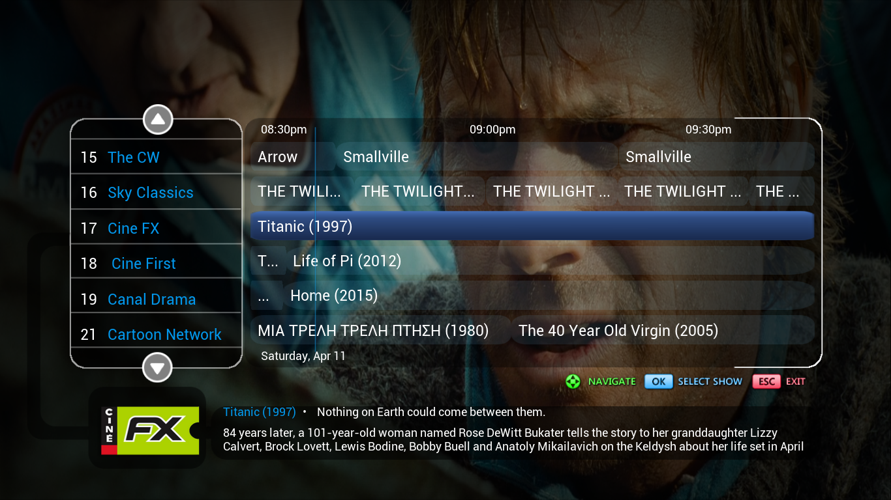
Nix
(2015-04-04, 12:44)tromy Wrote: Custom skin "Nix" updated.Fixed minor bugs and changed some artwork images.If anybody likes it can download from git:
https://github.com/tromyl/Nix-skin
Skye
(2015-03-12, 15:21)RayW1986 Wrote: Skin Release: Skye
Version: 1.0
Download: http://www.speedyshare.com/Vq32W/Skye.rar
Notes: This skin is based on the British satellite provider, Sky. This is a no-thrills skin, meant for those that don't care/need art work, logo's, etc.
Main Menu
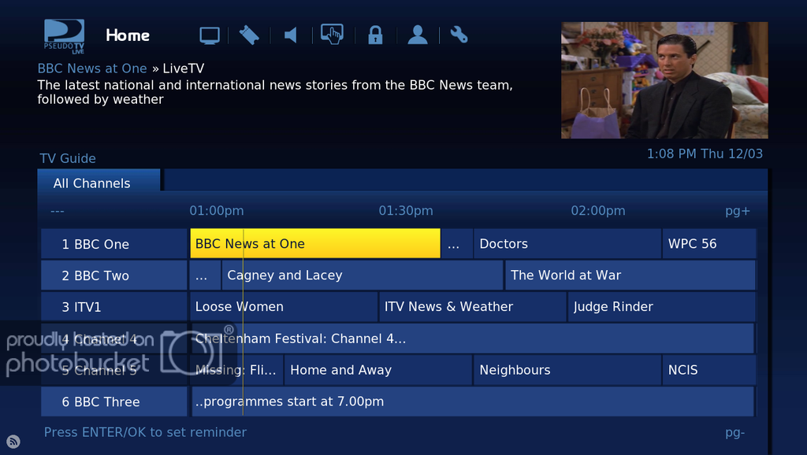
Info Overlay
Opinions, improvements, and criticism welcome, as always.... This is my first skin for PTVL, so I'm almost sure there will be issues or mistakes that I haven't noticed. Feel free to point them out to me so I can correct them.

Find
Reply
azrael17
Fan
Posts: 335
Joined: Mar 2013
Reputation: 4
#3
2015-04-14, 14:25 (This post was last modified: 2015-04-24, 19:22 by azrael17.)
Work in Progress
krave's first skin
(2015-04-13, 07:26)krave Wrote: Hey guys, this is my first skin for PseudoTV and XBMC, I'm a graphic designer so I'm trying to make it really clean and modern, I'm thinking I will go more with a material design (think Android phones & modern apps). Currently it is a work in progress but here it is so far.
Note: I've also used the theme suggestion in a few pages back for this idea, so hopefully it's something you all would enjoy.
My goals:
- Provide all PSD (Photoshop) source files for the background screens so others can edit the colors
- Create custom logos similar to the HBO one that match the EPG very well and provide PSD source files so you can make your own logos.
Also, this theme is being built using the BOX Kodi theme. I love the font on it and overall it's a very great skin that would go well with this.
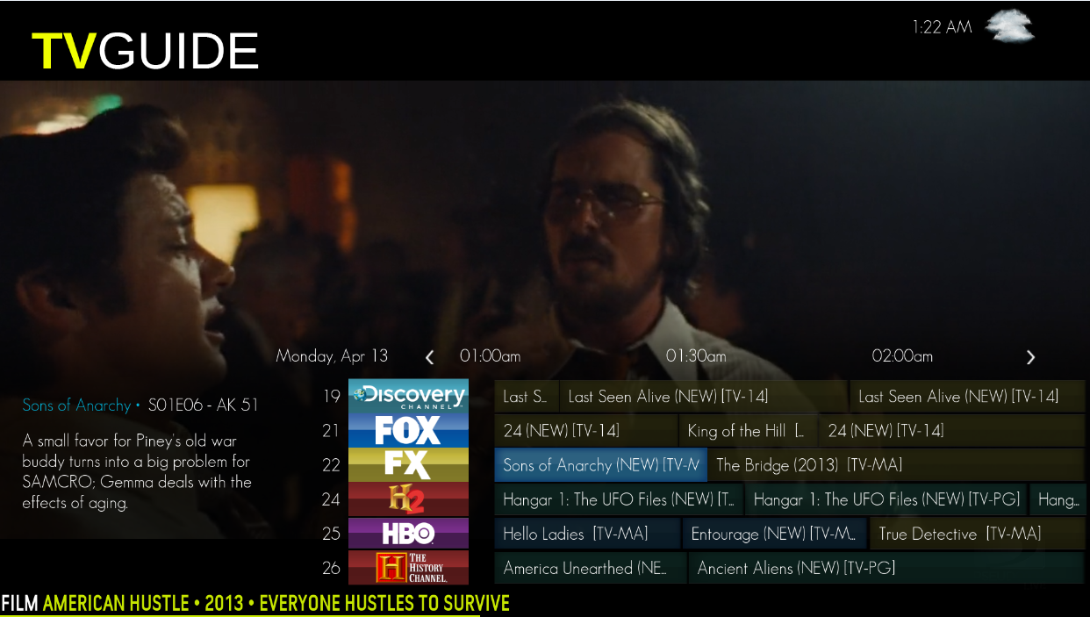
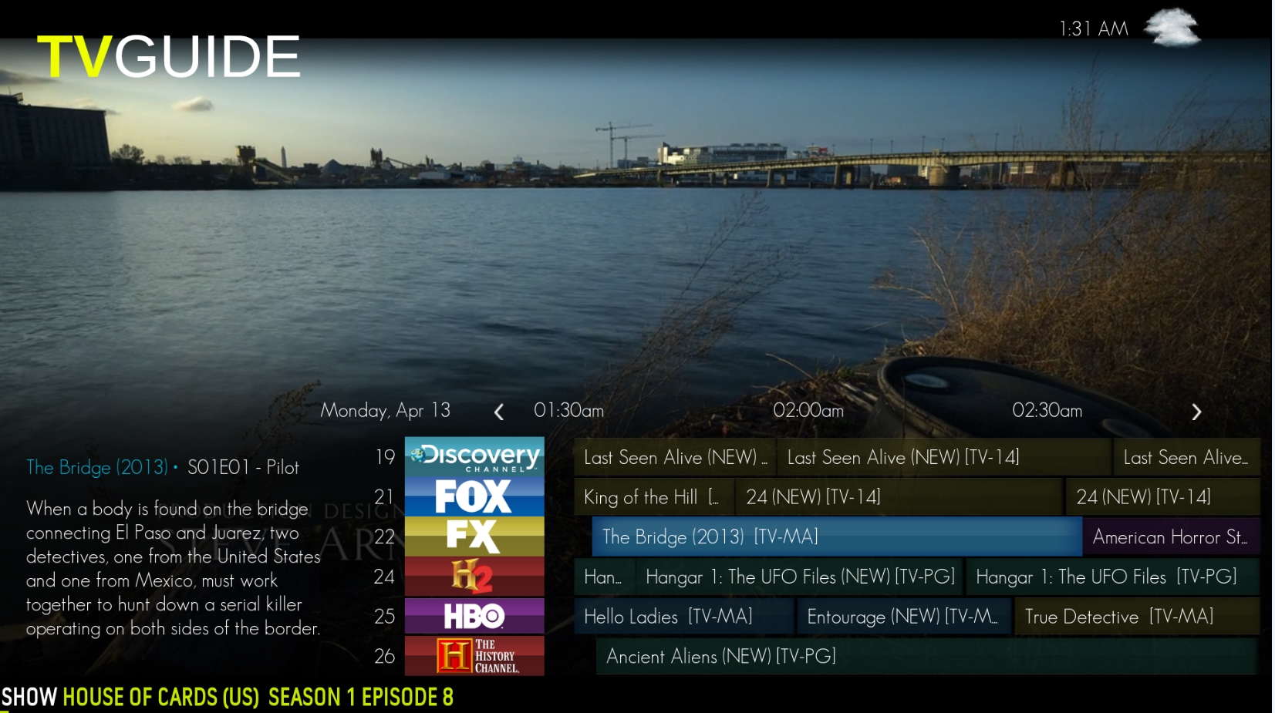
Actually I do have some questions on skinning...
1-Is there anyway to change the font sizes in a PseudoTV Skin or is this setting 100% overridden by the KODI Theme?
2-Is there anyway to position the Time Bar on the guide?
Thanks!
---------------------------------------------------------------------------------------------------------------------------------------------------
Present state of TV Guide screen:
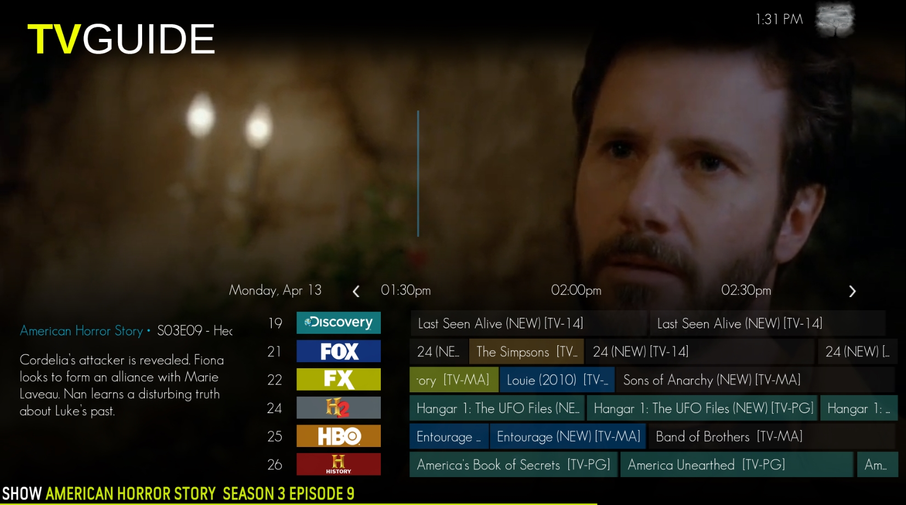
And the SHOWINFO screen still hasn't been modified at all, it uses the default PTVL layout so I'm going to really focus on that tonight:
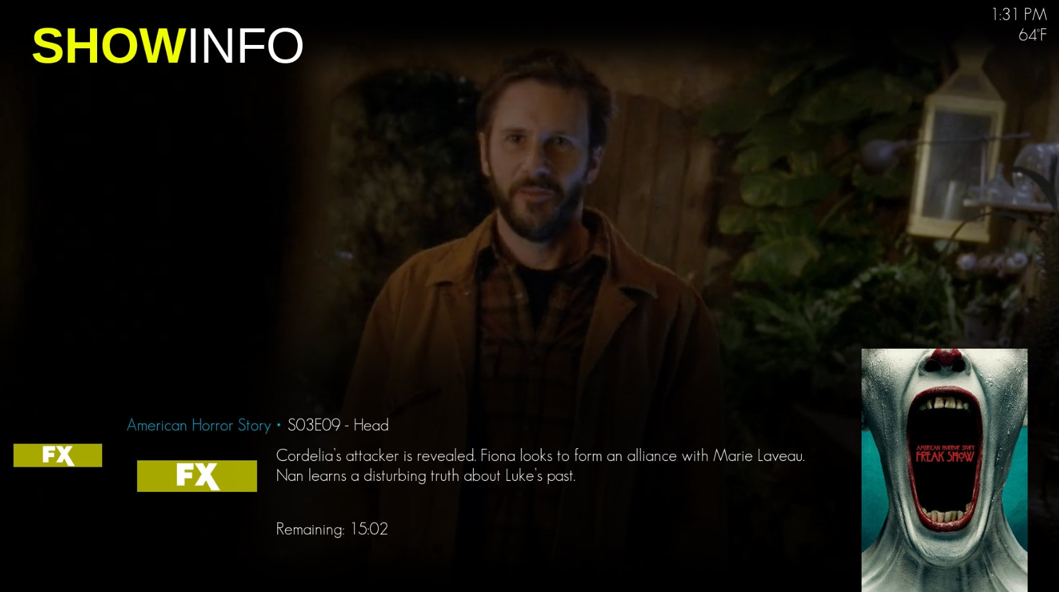
Here is my question to you all, do you like the Channel Icons / Listing Backgrounds from the original Pic I posted last night or the new ones in the above photo?
https://ftp.acc.umu.se/mirror/addons.superrepo.org/v7/addons/

http://mirrors.xbmc.org/addons/frodo/

