|  |  |  |  |  |  |
| --- | --- | --- | --- | --- | --- |
|  | | |  | Payroll Management System Project Proposal | |
| Under  Advanced Programming Language  [CSE-331]  Submitted to  Anwar Hussen Wadud  Lecturer Dept. of CSE BUBT |  |
| From Team of: Md. Khaled [38]  Md. Shezan Mahmud [41]  Md. Abdullah Al Noman [39]  Md.Ariful Islam Hridoy[28]  Intake: 30, Section: 01  Computer Science & Engineering(Eve)  Bangladesh University of Business and Technology | |
|  |  | |
|  |  | Rupnagar, Mirpur-2  Dhaka-1216 |
|  |  | |
|  |  | 01715451502 |
|  |  | |
|  |  | Imkhaled404@gmail.com |
|  |  | |
|  |  |  |



**Project Summary:**

Payroll Management System (PMS) is a system which is used to maintain records of all the users working in an organization, providing an easy GUI to the user. This System is per organization. At the front end of the system we have used NetBeans IDE in JAVA technology and WAMP server for maintaining databases. The project proceeds through a sequence of well designed JSP pages with validation to security, consistency, reliability, etc. Various users are provided which can perform various operations and tasks for which they have been authorized respectively. Basically there are 4 types of users: Employee, Accountant, HR Manager and Admin. Admin is fully authorized. While other users are authorized upto a certain level. Based on the user authorisation, users can perform various operations like Adding information of new Employee, Updating information, View list of employees, generate pay slip of particular employee, Generate report of the organization. This system is very user friendly and easily maintains all the information for all kind off users without any difficulties. The system also generates fault and error messages in case of invalid operation or the user enters invalid or wrong information for some particular cases. Various UML diagrams are prepared which may help a user to understand the flow of any module/task easily. It contains 6 various UML diagrams. Individual modules of the system are tested later and test cases are generated for that. Later all the modules are integrated and then whole system testing is performed to ensure that the system is error free and secured.

**Objective:**

The main objective of this project is to manage the details of the Employees, Payments and Salary. It also manages all the information about the Employee, Payroll and Salary slips. The project is totally built at the administration end of things. Only the administrator is granted access. The purpose of project is to build an application that reduces the manual work.

**Functionalities:**

-> Provides search facilities such as searching for employees

-> Tracks all salaries and employee payments

-> Stores all information about the employees to a secure SQL database

-> It generates reports of all employees, payments and salary slips

-> Manages all information of employees

-> Manages all information of employee salaries

**Software/Tools used:**

Front end: Java swings

Database: MySQL

Design tools: NetBeans IDE

**Diagram and Related Figures:**

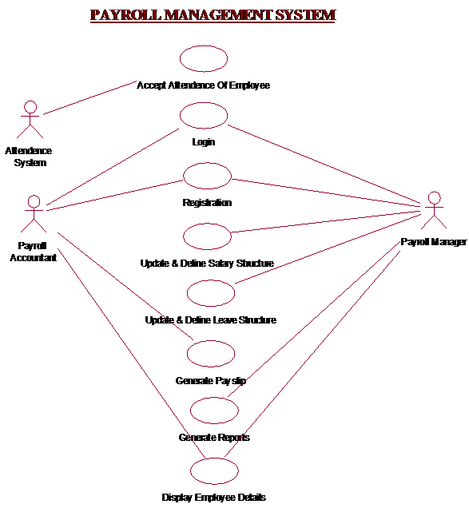

## **Plan**

**Software Description:**

|  |  |  |  |
| --- | --- | --- | --- |
| Sr no: | Process | Input | Output |
| 1 | Change Paygrade Details | Click on Edit Button of Paygrade | Updates DatabasePrompt message to user for completion |
| 2 | Change Leave Structure Details | Click on Edit Button of Leave Structure | Updates DatabasePrompt message to user for completion |
| 3 | Change Earnings Details | Click on Edit Button of Earnings | Updates DatabasePrompt message to user for completion |
| 4 | Change Deductions Details | Click on Edit Button of Deductions | Updates DatabasePrompt message to user for completion |
| 5 | Payslip Generation | Employee Id | Printed payslip |

**Test Team:**

Test team will have following members:

**Tester:**

Tester will perform the actual testing.

**Business Expert:**

Business Experts are those people who have knowledge about the business domain.

**Test-Team Manager**:

Test-Team Manager will be monitoring the whole testing process.

**User:**

User is the End user who will be actually dealing with the software.

## **Specifications & Evaluations:**

**Salary Structure Details:**

This will help the Organization to keep information of salary structures of each employees and will provide facilities to access it.

**Leave Structure Details:**

This will help the Organization to keep information of Leave structures of each employees and will provide facilities to access it…

**Report Generation**

This will generate various reports demanded by the organization to keep an eye on growth of their organization, working of staff etc.

**Structural Functions**:

**Give Specifications:**

User will have to register for that Application form will be provided.

After Registration, User will have Password..

**Employee Information**:

Depending upon the pay grade employee will be classified into either payroll employee or payroll manager. If user is a payroll manager of Organization then we will provide him facilities to Add, Edit as well as Delete payroll Details.

Payroll employee will be provided with search option to search particular employee for generation of his/her pays lip.

**Report Generation:**

User will be provided with list of Reports using which he can generate report by clicking on that options

User will be provided interface where he need to give dates of which report has to be generated.

According to the Report, user will need to give details on basis of that detail report will be generated.

**Functional Requirements**:

|  |  |  |
| --- | --- | --- |
| **Sl no** | **Functions** | **Tests** |
| 1 | Give Specification | Usability Correctness  Reliability  Security  Performance  Maintainability  Visibility |
| 2 | Report Generation | Security Reliability  Correctness  Understandability  Visibility |

**Methods & Constraints**:

**Methodology**:

We will be using White box testing for testing the project of payroll management.

**Evaluation**:

|  |  |  |  |
| --- | --- | --- | --- |
| **Sl no** | **Objective** | **Priorities** | **Completeness Criteria** |
| 1 | Adding Data | High | System should Add data into the database. It should also prompt acknowledgement to the user. |
| 2 | Updating data | High | System should update the old data with new updated data. System should check the authentication of user and then make changes to the database.  It should prompt message to the user about updating. |
| 3 | Deleting data | High | System should Remove the data demanded by the user from the database. It should check the authentication of the user before deleting the record.  It should also confirm that a message is prompted to user about deletion confirmation. |
| 4 | Searching data | High | System should retrieve data from database when search option has been clicked. If data is not found relevant to user demand, a message should be displayed to the user about data not present. |
| 5 | Report Generation | High | After selecting particular report, Data related to that report should be properly retrieved from the database in proper format. |

**Conclusion**

Payroll management system is designed to improve the accuracy, enhance safety and efficiency in the Employee Salary Management. It is a computer based system which helps the Offices to improve salary management.