ODT-CC
Olympic Digital Twin Command Center

Solution documentation: architecture, workflows and results
LA28 Games · LA Memorial Coliseum / Exposition Park venue zone
NVIDIA track · October 2026
Built with NVIDIA Omniverse Kit and OpenUSD, a self-hosted NVIDIA Nemotron NIM, and XGBoost trained on CUDA, on NVIDIA L40S GPUs.

Contents
1. Executive summary
2. The problem and our scenario
3. Solution overview
4. System architecture
5. Workflows
6. Data, sensing and forecasting
7. Optimizer and Nemotron agent
8. Incidents and detection
9. Planning mode and operations mode
10. The digital twin in Omniverse
11. The command dashboard
12. Results
13. Assumptions and data sources
14. Limitations and roadmap
15. Appendix: running the system and API

1. Executive summary
When a session ends at the LA Memorial Coliseum, 70,000 people leave at once. Most head for a single rail station, Expo Park/USC on the Metro E Line. Within about 18 minutes the walkway and the platform reach crush density, and by the time anyone radios it in, it is too late to act. Today, LA28, LA Metro, LADOT and police each see only part of the picture.
ODT-CC is a digital twin command center that gives everyone one shared live picture and turns it into decisions:
- It forecasts crowd danger 15 minutes ahead from sensor data (ticket scans, Bluetooth zone counts, gate counters, train departures).
- It tests 2,250 operator plans in about a second and keeps three safe options with different trade-offs, each scored 0–100.
- A self-hosted NVIDIA Nemotron model picks and explains the best option in plain language, under guardrails that stop it inventing numbers.
- A human always approves. The approved plan is applied from that minute to a live OpenUSD twin rendered in NVIDIA Omniverse, and every decision is logged.
- Incidents are not scripted: a world agent causes realistic surprises; reported ones trigger a re-plan, unreported ones are detected from sensor data.
- Planning mode lets planners test the event before it happens: crowd size, staggered exits, an overlapping event, the train timetable, road closures.
Table 1: Headline result
Outcome (normal egress) | Do nothing | With the approved plan
Dangerous zone-minutes (≥ 5 people/m²) | 99 | 0
Peak density | 6.44 people/m² | 0.98 people/m²
Warning before danger | – | 15 minutes
Stadium cleared by | minute 28 | minute 81 (the honest trade-off: people are held safely in the bowl)

2. The problem and our scenario

2.1 The venue zone
Our demo models the LA Memorial Coliseum and Exposition Park, an LA28 venue. The layout is schematic (positions and capacities are assumptions), but the chokepoint is real: the walkway to the Expo Park/USC station.
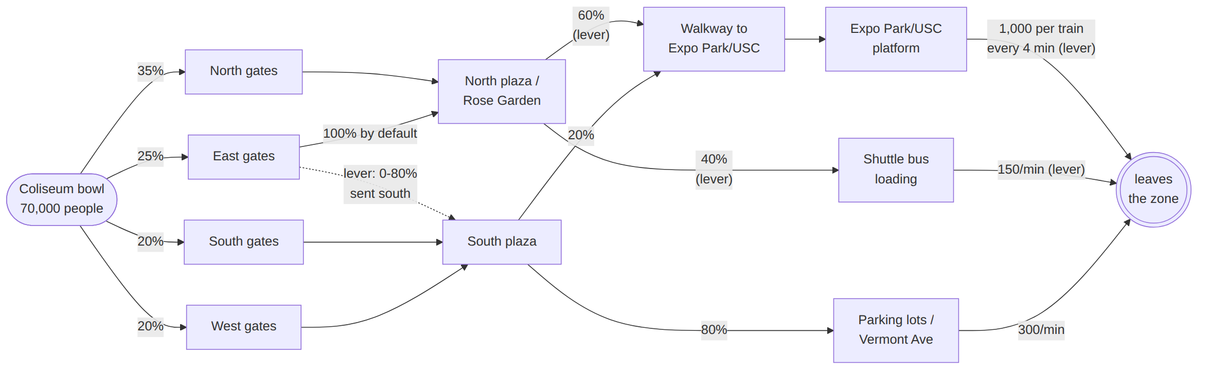
Figure 1: Venue network: the bowl, four gate groups, two plazas, the station walkway and platform, shuttle loading and parking. Dashed edge and "(lever)" labels are operator controls.
Table 2: Zones in the scenario
Zone | Role in the scenario | Capacity (assumed)
Coliseum bowl | 70,000 people leave at the final whistle | up to 2,500 people/min
North, east, south, west gates | 35% / 25% / 20% / 20% of the crowd | 650–750 people/min each
North plaza (Rose Garden) | Collects north and east exits; 60% go to the station walkway, 40% to shuttles | 1,500 people/min
South plaza | Collects south and west exits; mostly to parking | 1,400 people/min
Walkway to Expo Park/USC | The chokepoint | 600 people/min
Expo Park/USC platform | E Line trains | 1,000 people per train, every 4 min
Shuttle bus loading | Buses away from the venue | 150 people/min
Parking lots / Vermont Ave | Cars and walkers south | 300 people/min

Doing nothing, the walkway and platform exceed 5 people/m², the crush threshold, from minute 18, for 99 dangerous zone-minutes.

2.2 Synthetic data
All data is synthetic, shaped like the real feeds and clearly labelled as assumed.
Table 3: Synthetic data used
Data | How it is generated | Real equivalent
True crowd | Minute-by-minute flow simulator; full zones block the people behind them (back-pressure) | –
Ticket scans | People who entered, ±0.2% | LA28 ticketing
Bluetooth / Wi-Fi zone counts | ~30% of phones detected, ±8% noise, 2% missed minutes, outages | Venue sensors
Gate exit counters | People still in the bowl, ±1% | Turnstiles
Train departures | GTFS-realtime style feed | LA Metro
Incident reports | LA Metro alerts, LAFD dispatch, LA28 Transport, venue operations | Agency systems
Forecaster training data | 600 simulated events with random plans, incidents and sensor failures | Historical events

3. Solution overview

3.1 Five product modules
Table 4: Modules
Module | What it does in ODT-CC
1. Scenario planner | Planned-event inputs (tickets sold, staggered exit, nearby event, train timetable, road closures); score any plan SAFE / MARGINAL / UNSAFE; compare plans side by side; run the planned event live
2. Live operations view | Omniverse 3D twin; sensor strip; zone table; alerts; incident feed; role-based views per agency
3. Short-horizon forecasting | 15-minute forecast per zone from sensor estimates, with confidence; works with sensors offline
4. Incident response simulator | Incident builder; world agent with unscripted incidents; detection of unreported ones; re-plan on top of the plan in force
5. Recommendations with human approval | Three scored options, Nemotron briefing, agency-tagged actions, approve / keep / escalate, full audit trail

3.2 System overview
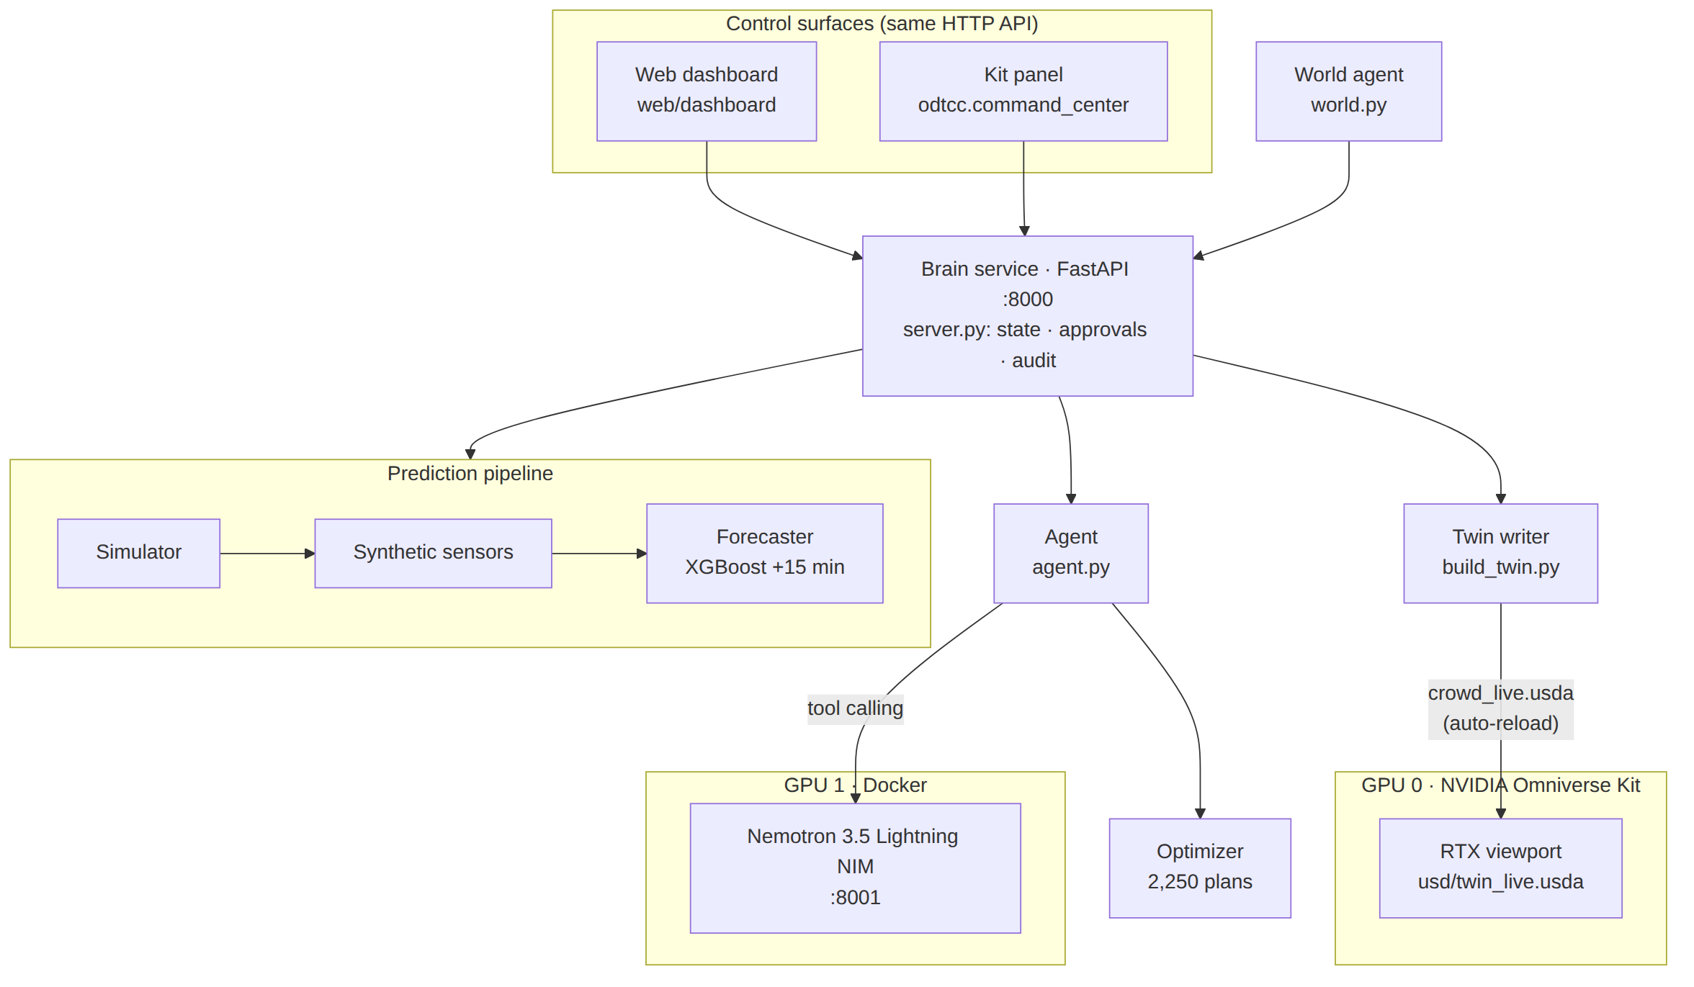
Figure 2: System overview: one brain service, two control surfaces (web dashboard and Kit panel), the Nemotron NIM on GPU 1 and the Omniverse twin on GPU 0.

3.3 NVIDIA stack
Table 5: NVIDIA technologies
Technology | Used for
NVIDIA Omniverse Kit 110 (RTX Real-Time 2.0) + custom omni.ui extension | 3D twin and the in-Kit command panel
OpenUSD | Layered twin: static venue layout plus a time-sampled crowd layer, rewritten live on every decision
NVIDIA Nemotron 3.5 Lightning 30B-A3B NIM (self-hosted, one L40S) | Tool-calling agent that picks and explains the plan
XGBoost on CUDA | Forecaster training (600 simulated events, ~33 s)
cuDF (cudf.pandas) | Optional GPU acceleration of the data scripts
2 × NVIDIA L40S (Launchpad) | GPU 0: Omniverse; GPU 1: Nemotron NIM

4. System architecture

4.1 Architecture layers
From raw data up to what the operator sees:
- Venue model: the Coliseum, gates, plazas, the station walkway, platform, shuttles and parking as a network of zones with capacities. Files: config/venue.json and config/scenarios.json.
- Simulation layer: produces the "true" crowd. File: odtcc/generate_data.py.
  - A minute-by-minute crowd-flow simulator that applies plans and incidents.
  - The world agent (odtcc/world.py) causes random, unscripted incidents.
- Sensor layer: turns the true crowd into what a command centre would actually see. File: odtcc/sensors.py.
  - Ticket scans, Bluetooth counts (about 30% of phones, with noise), gate counters and train departures.
- Prediction layer: works on sensor data, not the truth. File: odtcc/predictor.py.
  - The XGBoost forecaster, trained on CUDA, predicts density per zone 15 minutes ahead, with a confidence.
  - Detection of unreported incidents (sensors vs. what was expected) is done in the brain service, odtcc/server.py.
- Planning layer: files odtcc/optimizer.py and odtcc/scenarios.py.
  - Tests 2,250 lever combinations and keeps 3 safe options, each with a 0–100 score and an approval deadline.
- AI layer: file odtcc/agent.py.
  - Nemotron NIM (self-hosted on GPU 1) uses tools to read the facts, picks an option and explains it.
  - Guardrails stop it inventing numbers. If the model fails, a saved card or a template card is used instead.
- Brain service (API layer): the FastAPI server on port 8000 (odtcc/server.py) ties layers 2–6 together.
  - Endpoints include /state, /recommend, /approve, /simulate, /compare and /command.
  - Keeps the decision log in data/audit_log.jsonl.
- Digital twin layer (OpenUSD): file odtcc/build_twin.py.
  - A static venue layer plus a time-sampled crowd layer, which is rewritten every time a plan is approved.
- Visualization layer: Omniverse Kit (GPU 0) renders the twin with RTX.
  - Coloured pillars show density, a disc shows people still in the bowl, and the scene also shows trains and incident beacons.
- Control surfaces: these are the human decision layer.
  - The web dashboard (web/dashboard) and the Kit panel (kit/exts/odtcc.command_center) are thin clients of the same API.
  - The operator reviews the options and approves, keeps the current plan, or escalates.
In one line: Simulator → Sensors → Forecaster → Optimizer → Nemotron → Human approves → OpenUSD twin is updated → Omniverse shows it.

4.2 Runtime and deployment
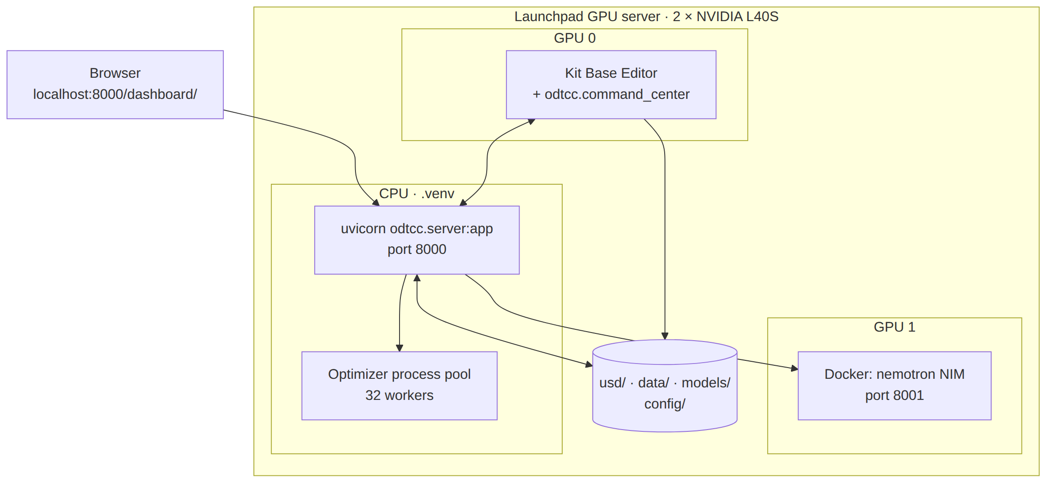
Figure 3: Runtime: Kit on GPU 0, the Nemotron NIM container on GPU 1, the FastAPI brain service on port 8000 with a 32-worker optimizer pool.
Table 6: Components
Component | Code | Technology
Venue model | config/venue.json | 11-node flow network
Crowd simulator | odtcc/generate_data.py, scenarios.py | Flow network with density cap, plan phases, incidents
Synthetic sensors | odtcc/sensors.py | Ticket scans, Bluetooth counts, gate counters, train feed
Forecaster | odtcc/predictor.py | XGBoost, 15-minute horizon
Optimizer | odtcc/optimizer.py | 2,250-plan sweep on 32 cores
Agent | odtcc/agent.py | Nemotron NIM, tool calling, guardrails
World agent | odtcc/world.py | Random incidents and follow-up reports
Brain service | odtcc/server.py | FastAPI, port 8000; serves the dashboard
Twin writer | odtcc/build_twin.py | OpenUSD layers
Kit panel | kit/exts/odtcc.command_center | omni.ui extension
Web dashboard | web/dashboard | Static HTML/JS/CSS

All computation runs in the Python brain service. The Kit panel and the web dashboard are thin clients of one HTTP API, so they always show the same state; the brain writes the live crowd layer of the OpenUSD twin and Kit renders it with RTX.

5. Workflows

5.1 The decision loop
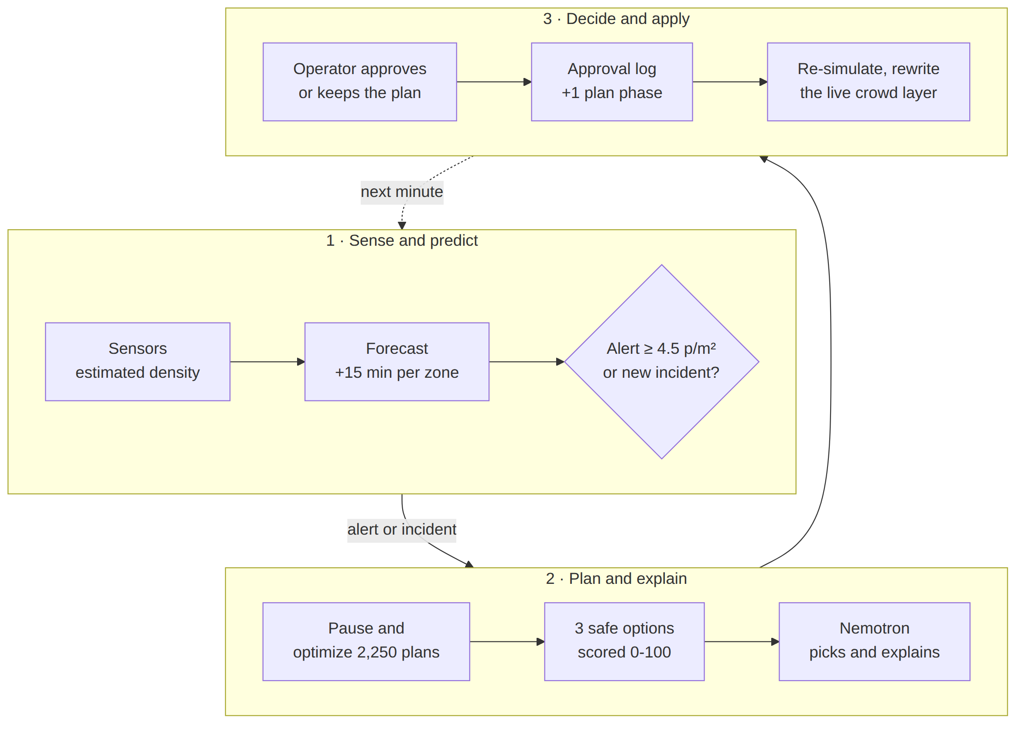
Figure 4: The decision loop, every simulated minute: sense and predict, plan and explain, decide and apply.

5.2 A live run with an unscripted incident
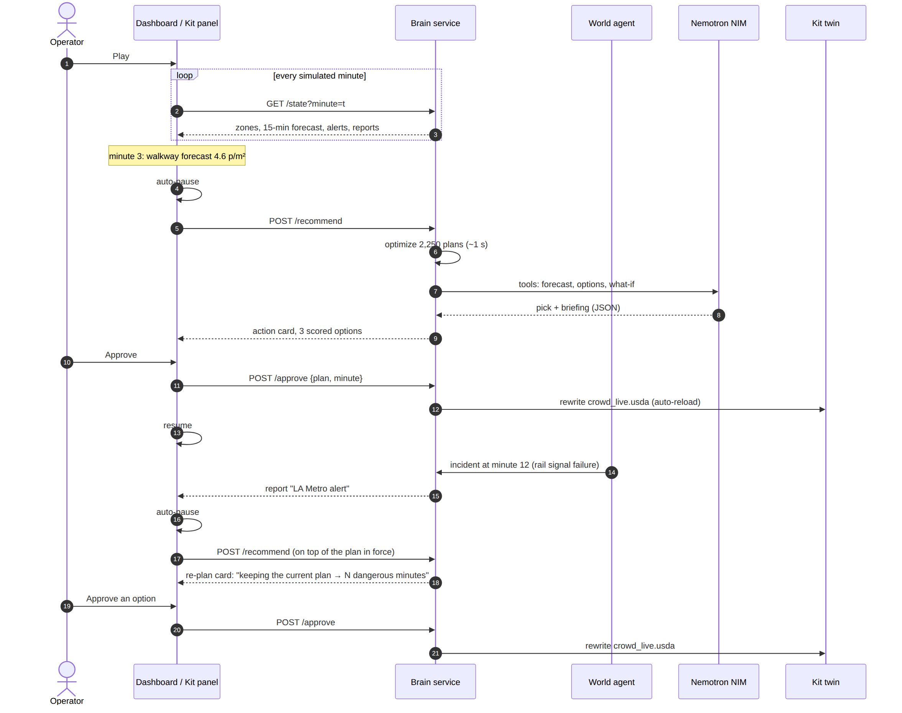
Figure 5: Sequence of a live run: alert at minute 3, Nemotron card, approval, then a world-agent incident and a re-plan on top of the plan in force.

5.3 What happens when the operator approves
- The plan is added to the run's approval log, in force from that minute; minutes before it are unchanged.
- The brain re-simulates the evening with the full log (re-simulating reproduces the past exactly; incidents only act from their start).
- It rewrites the twin's live crowd layer, usd/layers/crowd_live.usda.
- Omniverse Kit auto-reloads the layer; from that minute the pillars, colours, the "people still in the bowl" disc, train departures and incident beacons follow the approved plan.
- Playback resumes; the decision is written to the decision log, labelled as the AI's pick, another option, or the operator's own plan.

6. Data, sensing and forecasting

6.1 Truth, sensors and belief
A real command centre never sees the true crowd. ODT-CC keeps three views apart: the truth (drives the 3D twin and the sensors), the sensor estimates (drive the zone table and the forecaster) and the belief (reported incidents with their reported duration; drives the optimizer and the agent).
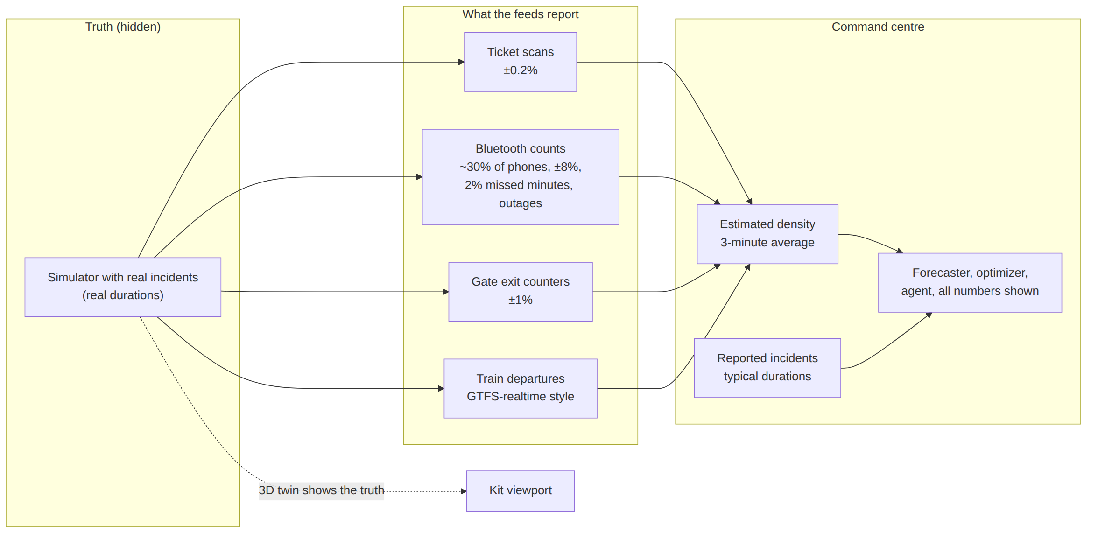
Figure 6: Truth, sensors and belief. The 3D twin shows the truth; every number the operator sees comes from sensors and reports.

6.2 Forecaster
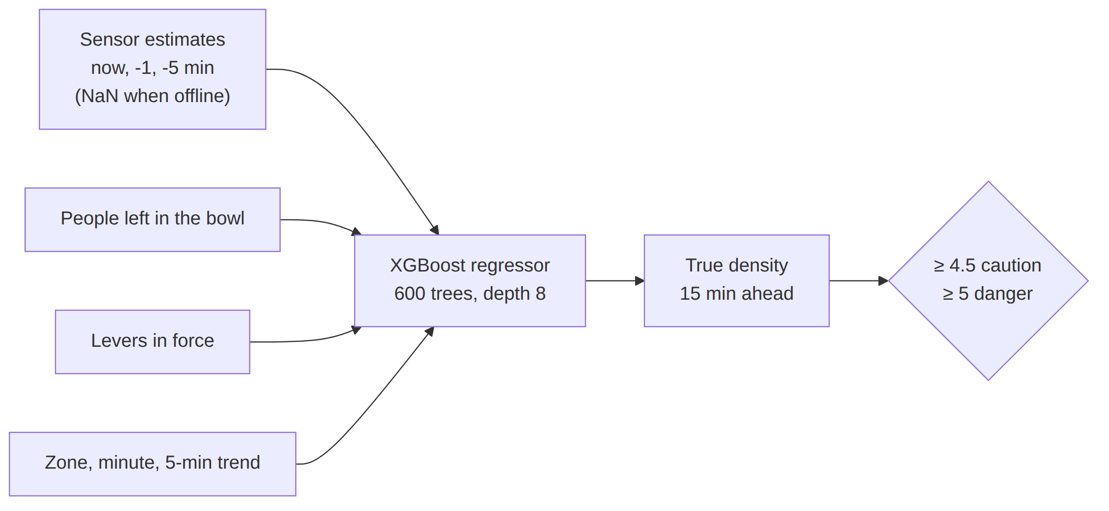
Figure 7: Forecaster: sensor estimates (with gaps when sensors are offline), people left in the bowl and the levers in force predict the true density 15 minutes ahead.
Table 7: Forecaster performance
Metric (held-out events) | Value
Dangers caught (recall) | 97%
Alerts that were real (precision) | 83%
Average error | 0.08 people/m² overall, 0.29 in busy zones
Warning before danger (walkway / platform / north gates) | 15 / 16 / 19 minutes
Walkway sensors dead | Still flagged from the surrounding zones, 12 minutes ahead

7. Optimizer and Nemotron agent

7.1 Optimizer and option scores
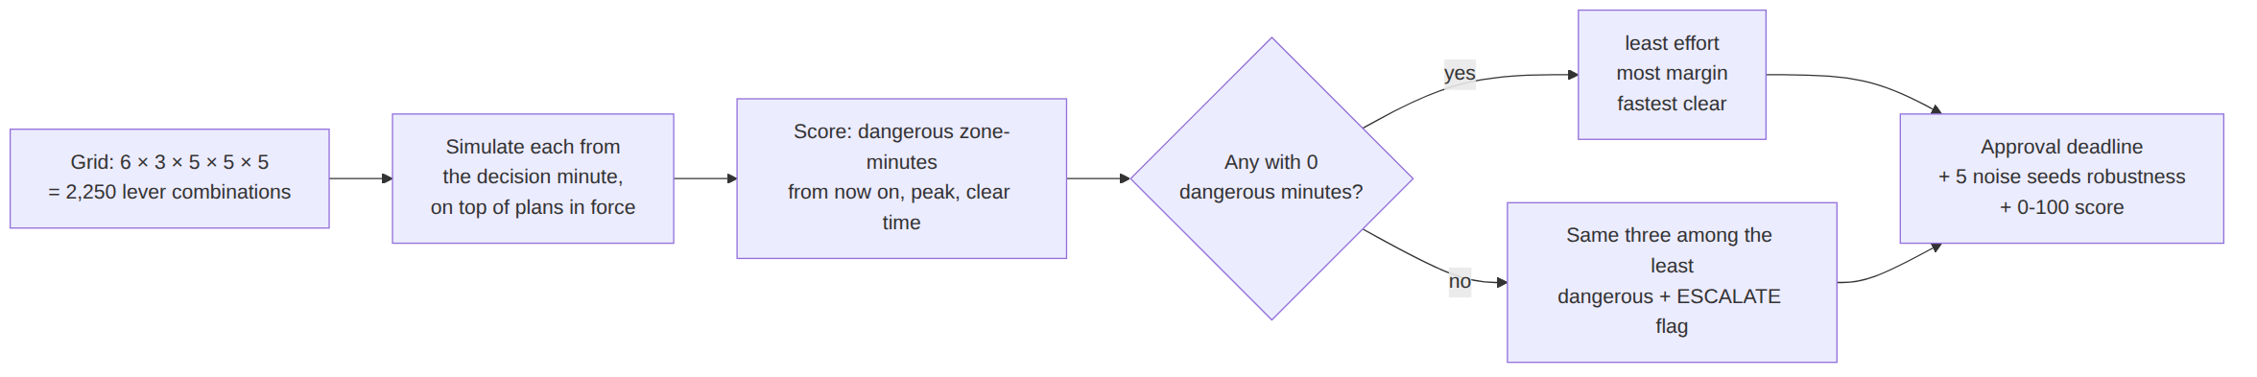
Figure 8: Optimizer: every lever combination is simulated from the decision minute on top of the plans in force; three safe options are kept, each with an approval deadline, a robustness check and a 0–100 score.
Table 8: Operator levers
Lever | Default | Range | Carried out by
Release from the bowl | 2,500/min | 800–2,500 | LA28 Venue Ops
Train every | 4 min | 2–4 min | LA Metro
Shuttle capacity | 150/min | 150–450 | LA28 Transport / LADOT
North plaza to shuttles | 40% | 40–80% | Venue stewards / LAPD
East gates to south | 0% | 0–80% | Venue stewards / LAPD

Option score (0–100), computed by code: safety 45 (headroom under the danger line; 0 if any dangerous minute), clear speed 20, ease 20 (1 − effort/5), time to act 15 (minutes left to approve).

7.2 Nemotron agent and guardrails
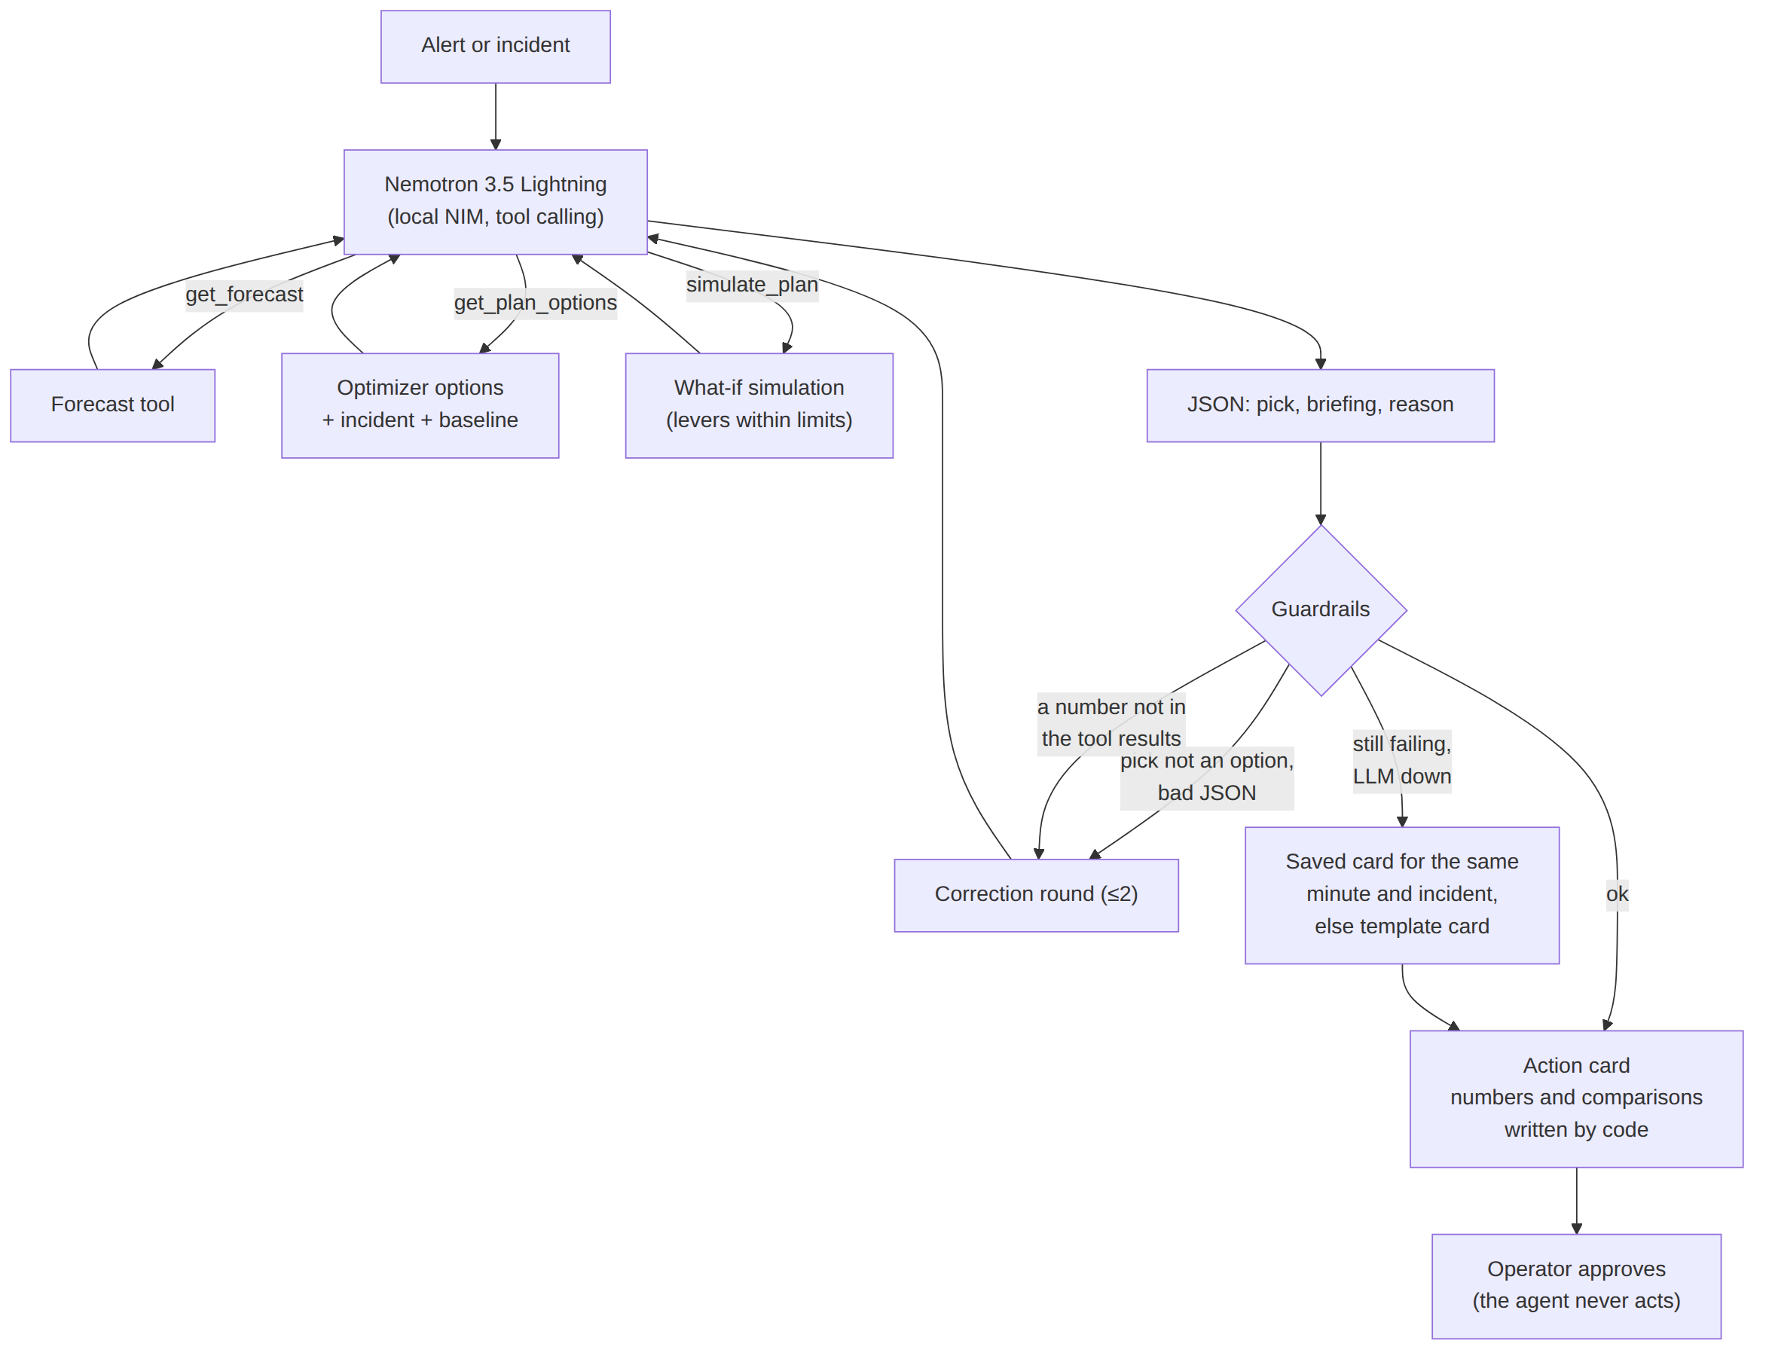
Figure 9: Agent: Nemotron gathers facts through three tools, returns a pick and a briefing, and must pass guardrails; otherwise a saved or template card is used. The agent never approves.
Division of labour: Nemotron chooses and explains; code writes every number, comparison and trade-off. Every number in the briefing must appear in the tool results; up to two correction rounds; the pick must be one of the optimizer's options. Acceptance run: 20 of 20 valid cards, median 2.0 s on one L40S.

8. Incidents and detection
A twin cannot predict that an incident starts; it detects it and simulates the consequences. In the live scenario a world agent causes realistic incidents at random (up to two, from minute 5): E Line signal failure, reduced train service, a medical emergency on the walkway, a crowd from a nearby event (BMO Stadium, Natural History Museum, California Science Center), shuttle breakdowns, sensor failures.
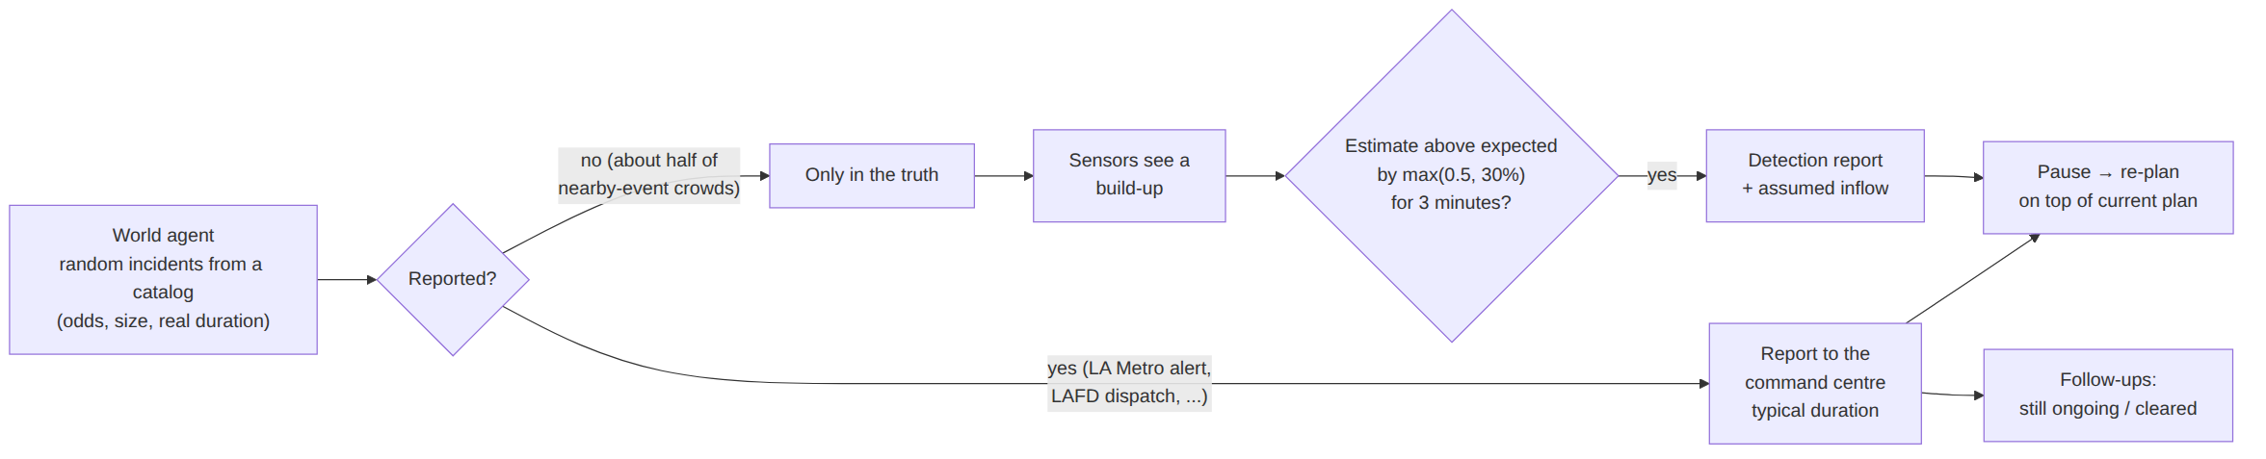
Figure 10: Incidents: reported ones reach the command centre as alerts with a typical duration and follow-ups; unreported ones are found by comparing sensor estimates with what the command centre expects.
- Reported: the report pauses the run and triggers a re-plan; follow-ups ("still not resolved", "cleared") update the command centre's picture.
- Unreported: a zone above expectation by max(0.5, 30%) for 3 minutes raises a detection. Tested: a 750 people/min surge was detected 4–6 minutes later, with no false detections across tested runs.
- Re-plans are computed on top of the plan in force and compared with "keeping the current plan"; the card can say No change needed or ESCALATE when no lever prevents the danger.

9. Planning mode and operations mode
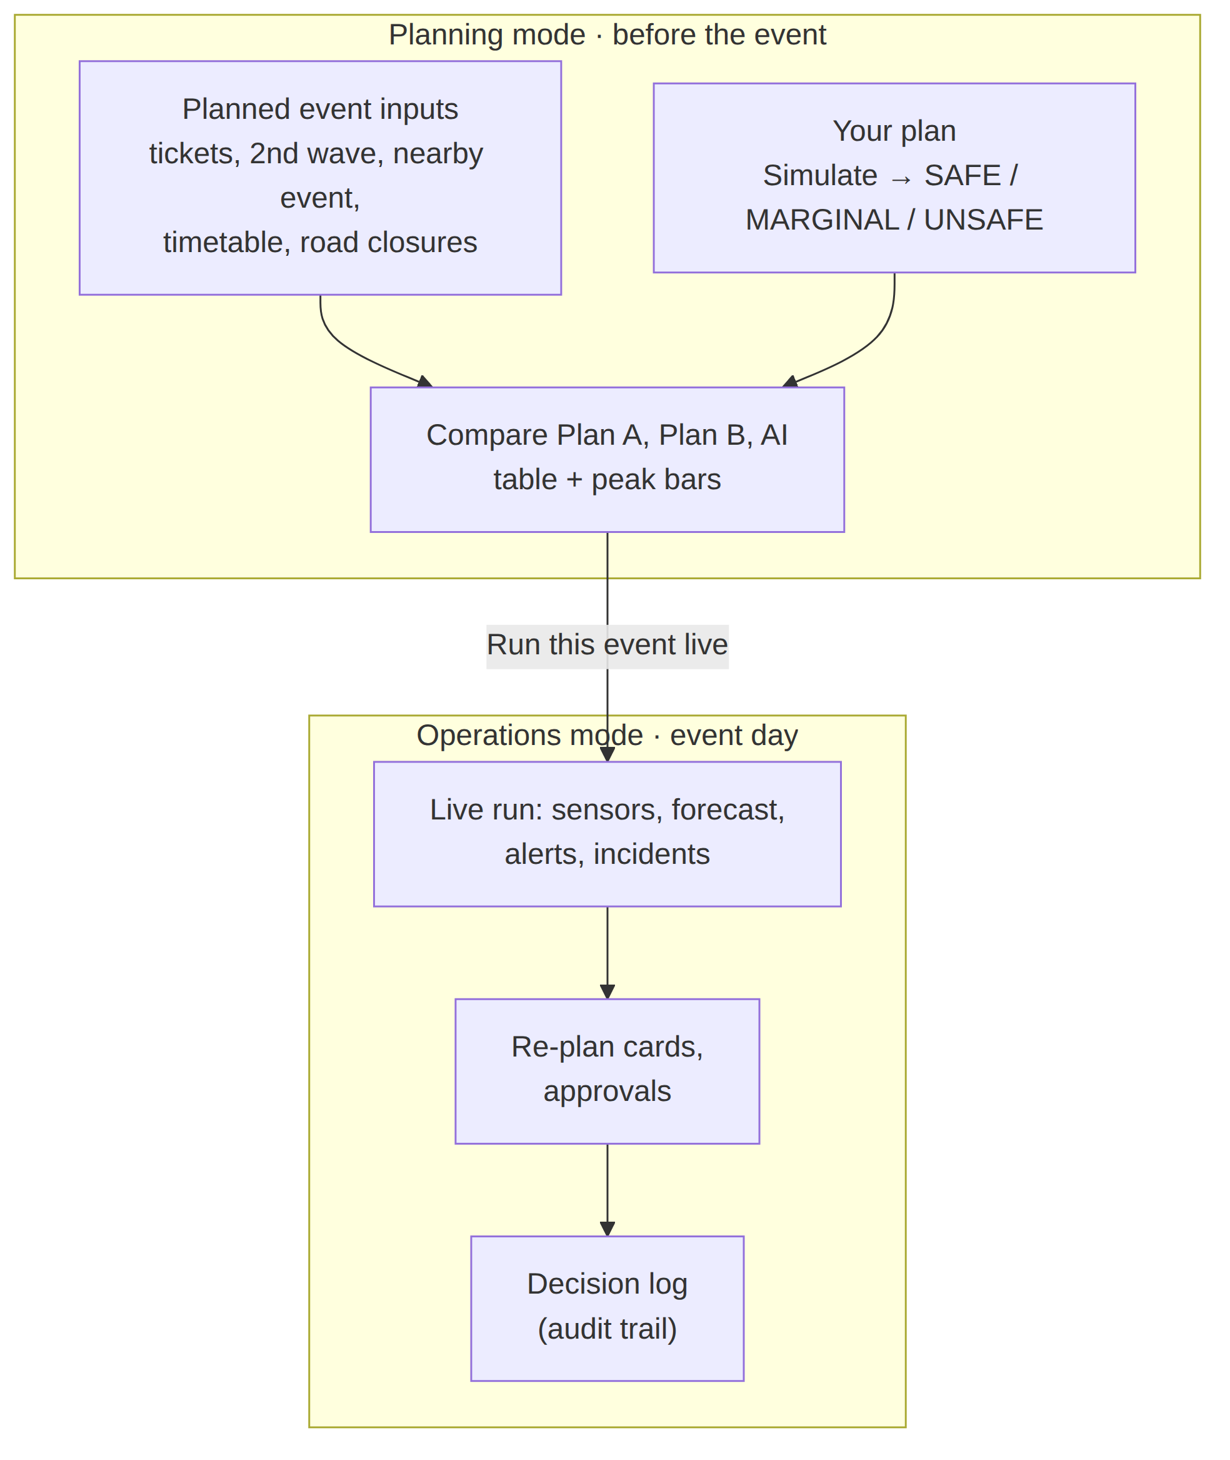
Figure 11: One platform, two modes. A planned event can be run live with one click.
Table 9: Planning inputs
Planning input | Meaning
Tickets sold | Crowd size, 40,000–80,000
Held for a 2nd wave, leaves after | Staggered session end: that share stays seated until the second wave
Nearby event crowd, lets out at | An overlapping session; its people head for the station walkway over 20 minutes
Timetable: train every, people per train | The planned Metro service (2–8 min; 600–1,200 people)
Road closures | Vermont Ave (parking exits at 40%); Exposition Blvd (shuttles at 50%)

10. The digital twin in Omniverse
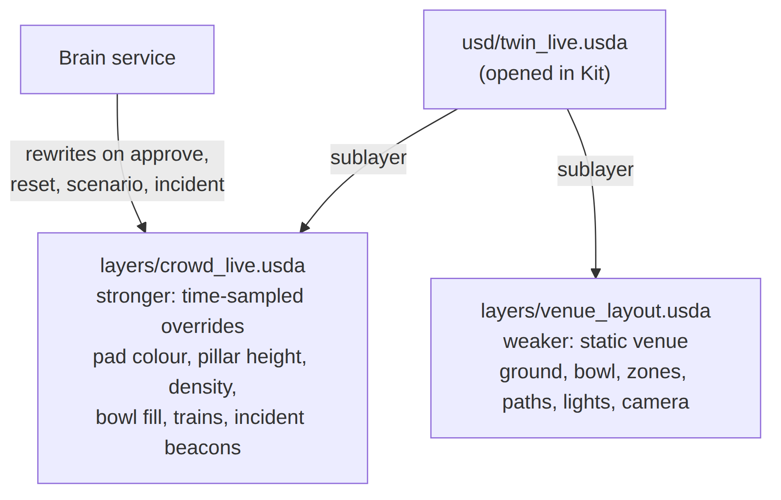
Figure 12: OpenUSD layering: the opened stage combines a static venue layer with a time-sampled crowd layer that the brain rewrites on every decision.
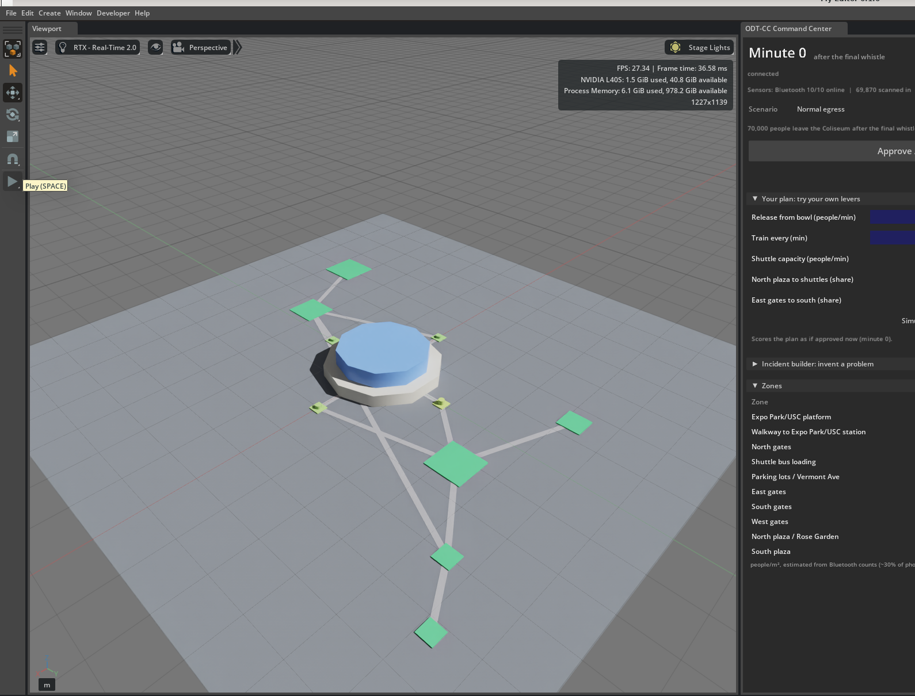
Figure 13: The twin in NVIDIA Omniverse Kit with the ODT-CC panel docked beside the RTX viewport.
Table 10: Visual encoding in the twin
Visual | Meaning
Pad and pillar colour | Density: green → yellow → orange → red (5+ people/m²)
Pillar height | 10 m per person/m²
Blue disc on the bowl | People still inside the stadium
Block at the platform | A train departing that minute
Pulsing sphere | Incident zone (red: capacity or crowd; amber: sensors)

11. The command dashboard
The web dashboard is served by the brain service at /dashboard/. When Kit is running it drives Kit's timeline (play, pause, reset, scenario, approve), so the dashboard and the 3D twin always show the same run; without Kit it runs its own clock.
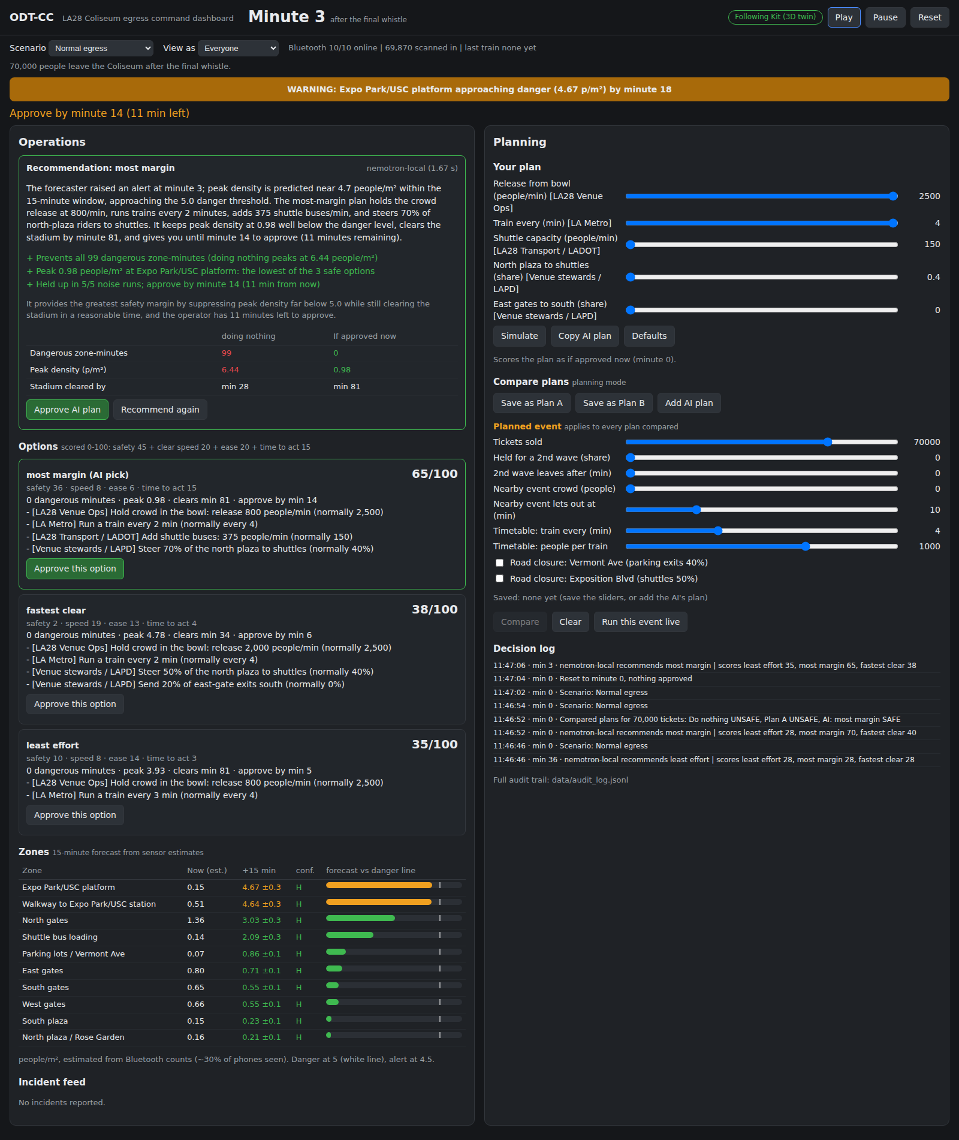
Figure 14: Dashboard at minute 3: walkway warning, the Nemotron recommendation with three scored options, the zone forecast with confidence (left); Your plan, planned-event inputs and the decision log (right).
Table 11: Dashboard features
Feature | What it does
Scenario dropdown | Normal egress; Live: random incidents; Expo Line delay; BMO Stadium event; Walkway sensor outage; Custom incident; Planned event
Operations panel | Recommendation card, three scored options with Approve buttons, Keep current plan, Recommend now, zone table with forecast and confidence, View as an agency
Recommend now | Runs the optimizer from the current minute on top of the plans in force, then Nemotron; also runs automatically on each new alert or incident
Incident feed | Reports with source and status (new, still ongoing, cleared), detections; Inject incident now (live), including unreported ones
Your plan | Five lever sliders; Simulate gives SAFE / MARGINAL / UNSAFE with the first zone and minute in danger; Approve my plan
Compare plans | Plan A, Plan B and the AI plan under the planned event: verdict, danger, worst bottleneck, clear time, trains/hour, buses, effort, deadline; peak bars; Run this event live
Decision log | Every scenario switch, incident, recommendation and approval; full trail in data/audit_log.jsonl

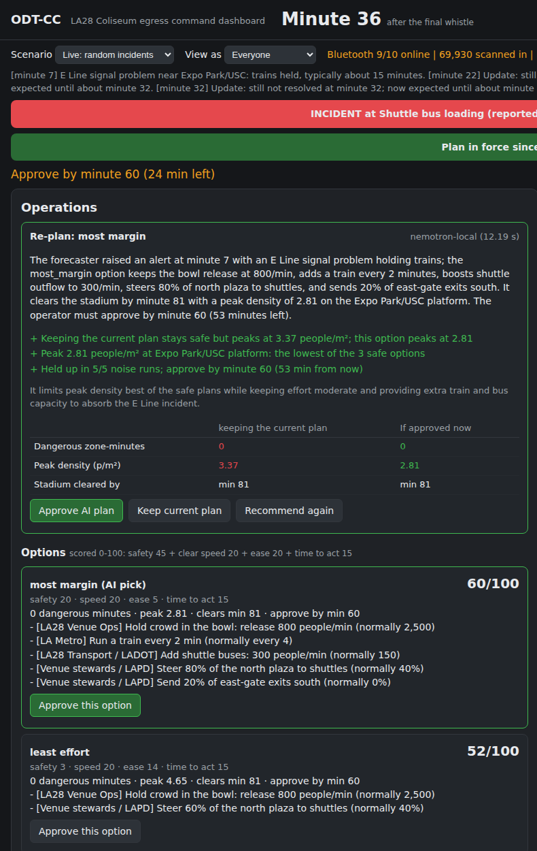
Figure 15: Re-plan after an E Line signal failure: compared with keeping the current plan, three scored options with agency-tagged actions.
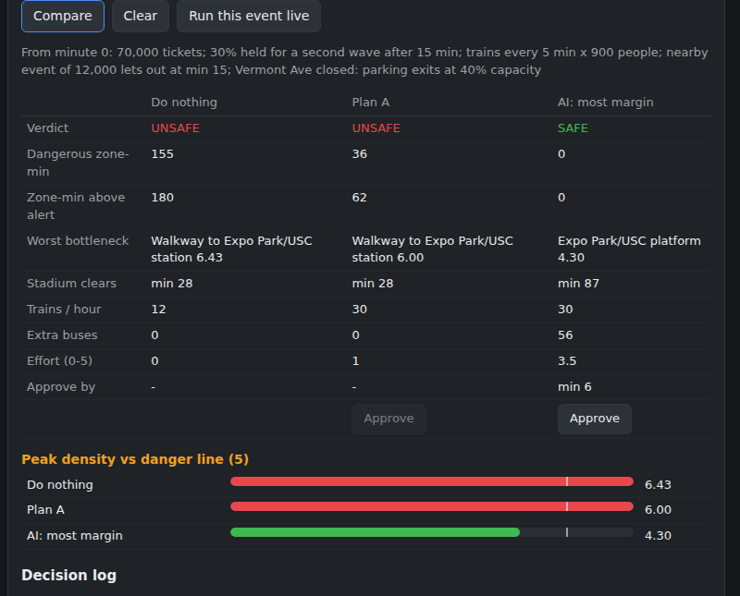
Figure 16: Planning mode: Do nothing and "double the trains" are UNSAFE under the planned event; the AI plan is SAFE.
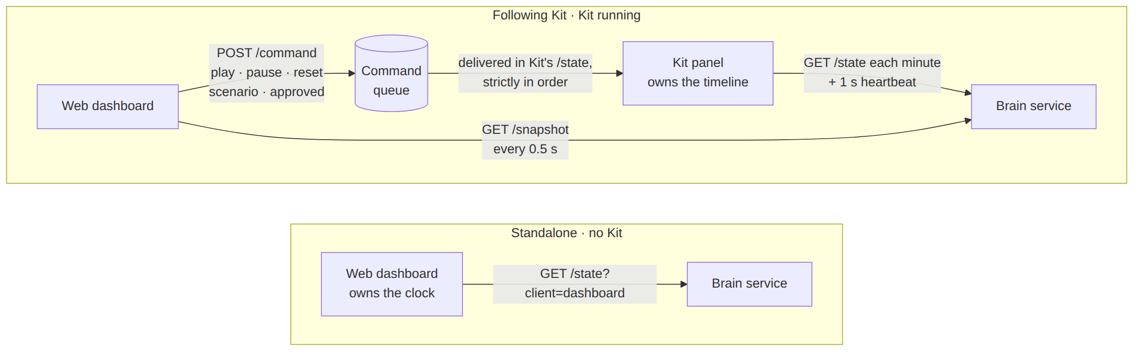
Figure 17: Control surfaces: following Kit through an ordered command queue, or standalone with the dashboard's own clock.

12. Results
Table 12: Scenario results
Scenario | Pause | Do nothing | Recommended plan | Approve by
Normal egress | min 3 | 99 dangerous zone-min | 0, peak 0.98 | min 14
Expo Line delay (no trains min 10–25) | min 2 | 129 | 0, peak 2.40 (shuttle-heavy) | min 6
BMO Stadium event | min 2 | 112 | 0, peak 1.82 | min 10
Walkway sensor outage | min 4 | 99 | 0, peak 1.09 | min 14

Table 13: Planning example: 70,000 tickets, 30% second wave after 15 min, 12,000-person nearby event at min 15, trains every 5 min × 900, Vermont Ave closed
Plan (planned event) | Verdict | Dangerous zone-min | Peak | Clears | Extra buses
Do nothing | UNSAFE | 155 | 6.43 | min 28 | 0
Plan A: double the trains | UNSAFE | 36 | 6.00 | min 28 | 0
AI plan (most margin) | SAFE | 0 | 4.30 | min 87 | 56

Table 14: Performance
Capability | Measured
Simulator | 120 minutes simulated in ~7 ms; past reproduced exactly when re-simulating
Optimizer | 2,250 plans in ~1.2 s; 1,028 safe at minute 3
Nemotron card | 1.5–4 s typical; 20/20 valid in the acceptance run
Forecaster | 97% recall, 83% precision, 15 minutes of warning
Detection of unreported incidents | 4–6 minutes; no false detections in tests
Dashboard end-to-end test | 11 checks in headless Chrome; standalone 11/11; driving Kit, latest runs 11/11

13. Assumptions and data sources
Table 15: Assumptions register
Input | Value used | Status | Production source (owner)
Crowd leaving | 70,000 at the whistle | Assumed | Ticket scan-ins (LA28)
Exit timing | All leave from minute 0 | Assumed | Gate counters, past events
Gate split | 35 / 25 / 20 / 20% | Assumed | Seat map to gates (LA28)
Capacities | Gates 650–750, walkway 600/min | Assumed | Venue layout, screening throughput
Mode split | 60% walkway, 40% shuttles | Assumed | Metro taps, LA28 plan
Trains | Every 4 min, 1,000 per train | Assumed | Metro GTFS, car capacity
Danger / alert lines | 5 / 4.5 people/m² | Fruin levels | Standard practice
Bluetooth sensors | 30% detected, ±8% | Assumed model | Calibrated on the day
Incident odds | World-agent catalog | Assumed | LAPD / LAFD incident logs

Most production data already exists with the organizing committee and the city: LA28 ticketing and venue operations, LA Metro GTFS-realtime (public) and tap data, LADOT ATSAC and Caltrans PeMS traffic data, aggregate camera counts through NVIDIA Metropolis, and LAPD / LAFD incident history. The twin mostly joins existing datasets.

14. Limitations and roadmap

14.1 Limitations
- Synthetic data and a schematic venue; capacities are assumptions; the forecaster is trained on the simulator.
- Exit timing is simplified; road traffic is not simulated (closures act through the capacity they remove).
- The optimizer's what-if runs start from the simulated state; production would start from the estimated state (data assimilation).
- Egress only; ingress (arrivals and security screening) is future work.

14.2 Target production architecture
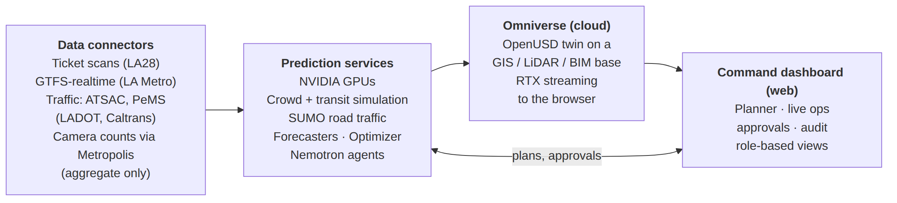
Figure 18: Target architecture: real data connectors, prediction services on NVIDIA GPUs, Omniverse in the cloud streamed to a web command dashboard.
Table 16: Roadmap
Item | Status
Web command dashboard on the same API | Built (this submission)
Omniverse streaming to the browser | Next: the streaming Kit apps are already built on the server
SUMO road traffic on an OpenStreetMap network | Next
Ingress: arrival curves, security screening, queues outside gates | Next
Real data connectors (ticketing, GTFS-realtime, traffic) | Production
Ops-as-a-Service for future host cities (Brisbane 2032) | Vision

15. Appendix: running the system and API

15.1 Start
scripts/demo_up.sh # NIM (GPU 1), brain :8000, Kit (GPU 0)
scripts/warm_caches.sh # saved cards for the fallback
open http://localhost:8000/dashboard/

15.2 Brain service API (port 8000)
Table 17: API summary
Endpoint | Purpose
GET /state?minute=t | Zones, 15-min forecast, confidence, alerts, sensors, incidents, reports, decisions
GET /snapshot | Everything the dashboard shows at the driving client's minute
POST /scenario | Switch scenario: preset, live (random incidents), custom, planned
POST /incident/inject | World agent strikes now (live); optionally unreported
POST /recommend | Optimizer + Nemotron action card
POST /simulate | Score an operator plan: SAFE / MARGINAL / UNSAFE
POST /compare | Compare plans under planning inputs
POST /approve | Apply a plan from a minute; rewrite the live crowd layer
POST /decision/keep | Log "kept the current plan"
POST /command | Drive Kit's timeline from the dashboard
GET /audit | Decision log
POST /reset | Back to minute 0

Full documentation in the repository: README.md, docs/ARCHITECTURE.md, docs/USER_GUIDE.md, docs/API.md, docs/DATA_AND_RESULTS.md, docs/DEMO_SCRIPT.md.

