Course-report Practical Bioinformatics for Biologists 2016
Iris Kromhout Van Der Meer (s2196425)

This report is meant to document personal experiences from the course, especially the problems you encountered and the solutions to those problems. The experiences I had before influenced my experiences during this course. Although I didn't have much experience with Python, I knew from the C++ course how for-loops and an if-statements work and how I can write a program. This made that I didn't really encounter problems from the moment I really started the course. Unfortunately, this start wasn't the first day..

First day, I was ready for the course: I installed Virtual Box and downloaded bio-linux the week before. However, when we started to set-up bio-linux on Virtual Box, it wasn't working for me. Below, I will describe the process I went through in order to solve my first problem, my rebellious computer:

First thing I tried was to download bio-linux again, but this didn't help anything. Other people using the same operating system (windows 8) had problems too. Their problems were solved by changing a (virtualization) setting in the BIOS. This was not working for me, thus I made the decision to update to windows 10. This took quite some time, but it seemed to pay off: bio-linux through the Virtual Box started working and I was happy.
However, after a few exercises, I found out that my computer kept crashing. The problem probably was windows. That is why I decided to dual-boot my computer. That way I would be able to choose between windows and linux when I boot the computer. I downloaded bio-linux on an USB stick. Then, I plugged it in and booted my laptop. After starting, I chose the option to install bio-linux. An installation screen opened and in the menu I chose the option to install linux alongside windows. The installation finished and everything seemed fine. However, when I started my laptop without the USB stick, it would boot directly into windows. That was not what I wanted. I tried over and over before I took the decision that would change my life forever.. I plugged the USB stick in and entered the installation screen once more. This time I chose for the option to remove windows and install bio-linux. The installation started and from that moment on, my computer hasn't crashed.

After this windows-experience and my transition to linux, I can recommend everybody that uses windows to create a dual-boot system with linux. If that, just like with my computer, doesn't work, I can recommend to seriously think about where the computer is being used for. So far, linux has provided me with all the programs I need for my study and entertainment.
From the moment I started using linux as operating system, it was possible to do exercises without computer problems.

However, in the week of my personal project, I encountered another problem: the data I wanted to use was stored in a Microsoft Access database. I read about databases for linux in the book and on internet and tried to set them up to work on my computer. I didn't manage to get it working and decided to take the easiest way. I created a datafile within Access on a windows computer, saved it and emailed it to myself, in order to open the textfile/worksheet on linux.
Below, I describe how I did this:

- I went to the site where you can access the RUG desktop (http://uwp.rug.nl/). As soon as you log in, you can click on desktop and a new tab will open that looks exactly like the desktop of the university computers (windows). There, I opened the access-file. It looks like this:
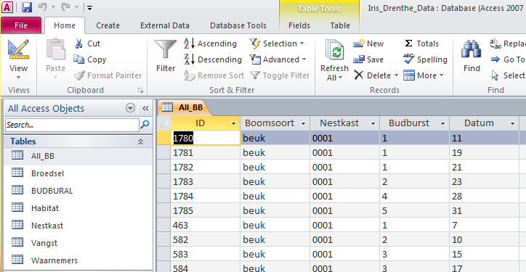
On the left are the tables that are in the database. If you double-click on one, it is shown on the right. Here: table All_BB is shown.

- Click on the Create tab in the toolbar, then on query design. This will pop-up:
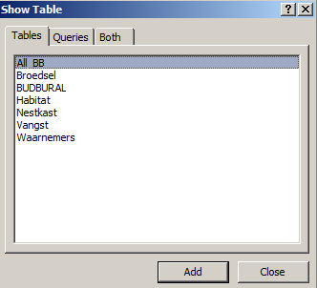

Here, you can select from which tables you want to extract data. Add them and close the Show Table screen.
Now, you will see this:
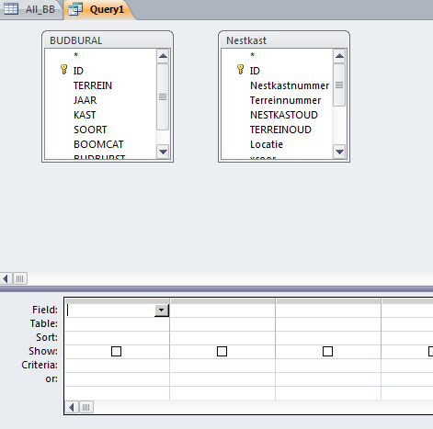

The two tables I selected are BUDBURAL and Nestkast. They each have their own little screen in which you can scroll through their variables (columns). Here, KAST (of BUDBURAL) and Nestkastnummer (of Nestkast) represent the same variable, namely the ID number of every nest box. To let the computer know what the connections between the two tables are, we have to literally connect the similar variables. You can do this by dragging the variable of the first table to the second. After that, it will look like this:
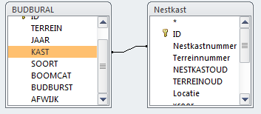
Here, only two variables are connected, but often there are more similarities between tables and more than two tables can be connected to each other. For example: for my project I used three tables with several variables that were equal.
Now that it is clear what variables the tables have in common, it is time to create our own table. In this example, I am interested in the the bud burst for each nest box in all years and since I want to make a map with the data points, the latitude and longitude are also of interest. Double-click the variables that you want to use, it will look like this:
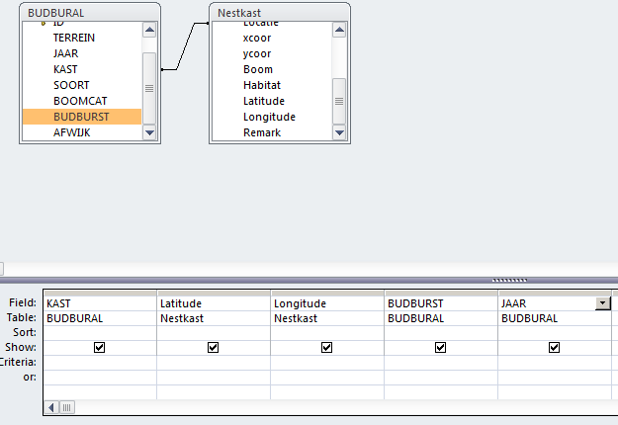
Note that it is only needed to use one of the two nest box ID variables (KAST). Since KAST is connected to Nestkastnummer, the data that belongs to a certain Nestkastnummer will now also belong to the corresponding KAST. Click on View (top left) to check if the table is how you want it to be. It looks like this:
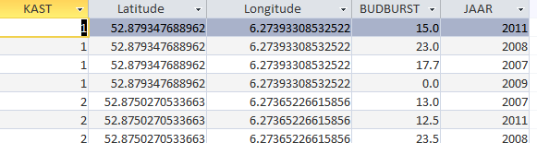
If you are happy, click on Run. Then, right-click on the Query1 tab, click on save and give your query a name (I named this query “myData”). It now appears in the Queries window, below the tables:
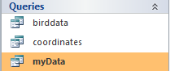

The final step in creating a data file that you can use in linux is exporting the query. To do so, right-click on the query, click export and choose in what format (For example excel worksheet or txt file).
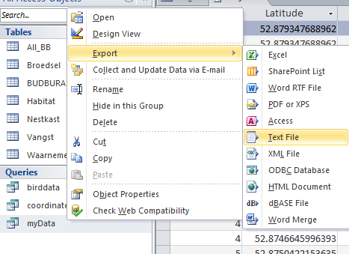

In this example I chose to export as a Text file. A window pops up. Choose where you want to save the file, click on next. Make sure you have Delimited selected, click next, choose delimiter (for example tab). Finish.

After this, the file is stored on the computer. Now, you can just email it to yourself or put it on Dropbox (or GitHub) and open it from your linux operated computer!

Some last words:
Two main problems arose during this course, but in the end I managed to deal with them. Maybe not the way I first planned, but sometimes that is not possible (bio-linux just wouldn't work together with windows) and sometimes it is just too time-consuming (figuring out how I can get a windows database file working on linux). Almost nothing is a problem, it just takes time to figure it out and when time is a restriction, it is sometimes needed to do something in a way that is less elegant, but which works for you.

