

Program Name: **BCS – IT**  
Course Code: **CSC 1510**  
Course Name: **Programming Fundamentals**  
Assignment: **Third(Short Semester)**  
Date of Submission: **10th May, 2020**

**Submitted By: Submitted To:**

Student Name: **Keshav Bhandari** Faculty Name: **Prakash Chandra**

IUKL ID: Department: BCS - IT

Semester: Second

Intake: September, 2019

1. **Answer the following:**
2. **Explain static variable:**

**Answer:**

A static variable is common to all the instances (or objects) of the class because it is a class level variable. In other words, you can say that only a single copy of static variable is created and shared among all the instances of the class. Memory allocation for such variables only happens once when the class is loaded in the memory.

**JAVA CODE:**

class Student {

    int id;

    String name;

    static String college_name = "Sunway International Business School";

    Student(int id, String name) {

        this.id = id;

        this.name = name;

    }

    void display() {

      System.out.println("******************Students Details******************");

        System.out.println("College Name: " + college_name);

        System.out.println("Student Name: " + this.name);

        System.out.println("Student Id Number: " + this.id);

    }

}

public class StaticVariable {

    public static void main(String[] args) {

        Student s1 = new Student(1001, "Keshav Bhandari");

        s1.display();

        System.out.println();

        Student s2 = new Student(1002, "Ram Bhandari");

        s2.display();

    }

}

**Output:**

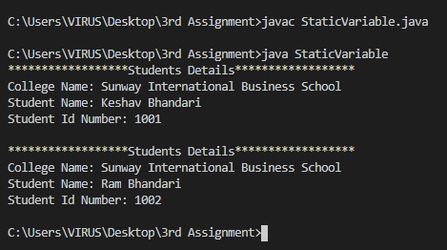

1. **Write a java program to count the number of objects created, using the concept of static variable.**

**Answer:**

**JAVA CODE:**

import java.util.Scanner;

class Object {

    String name;

    int age;

    static int numberOfObject = 0;

    Object(String name, int age) {

        this.name = name;

        this.age = age;

        numberOfObject++;

    }

    void display() {

        System.out.println("Name: " + this.name);

        System.out.println("Age: " + this.age);

        System.out.println("The total number of object created is: " + numberOfObject);

    }

}

public class CountObject {

    public static void main(String[] args) {

        Scanner sc = new Scanner(System.in);

        System.out.println("Enter details of s1 below: ");

        System.out.print("Name: ");

        String name = sc.next();

        System.out.print("Age: ");

        int age = sc.nextInt();

        Object s1 = new Object(name, age);

        System.out.println("===================================");

        s1.display();

        System.out.println();

        System.out.println("Enter details of s2 below: ");

        System.out.print("Name: ");

        name = sc.next();

        System.out.print("Age: ");

        age = sc.nextInt();

        Object s2 = new Object(name, age);

        s2.display();

        System.out.println("===================================");

        System.out.println();

        System.out.println("Total Objects Created is " + Object.numberOfObject);

        sc.close();

    }

}

**Output:**

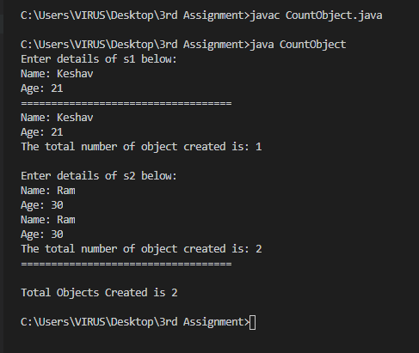

1. **You’ve been provided a .csv (comma separated values) file of student IDs and test scores. You are to write a class that reads a line from the .csv file, parse the input string into its constituent values, compute an average of the scores for each student, convert the average into a letter grade, and print the student ID, scores, average of the scores and the letter equivalent of the average for each student. Also, track min and max averages, and calculate the class average. After all student data has been processed, print a summary for the class. Your output should match the formatting in the example output below in *both the terminal* and an output file named *gradesout.txt*.**

GRADE is defined as follows:

[100-90]: A

[90-80]: B

[80-70]: C

[70-60]: D

[60-0]: F

**JAVA CODE:**

import java.io.File;

import java.io.FileWriter;

import java.text.DecimalFormat;

import java.util.Arrays;

import java.util.Scanner;

public class Question2 {

    public static String CheckGrade(double avg) {

        if (avg >= 90 && avg <= 100) {

            return "A";

        } else if (avg >= 80 && avg <= 90) {

            return "B";

        } else if (avg >= 70 && avg <= 80) {

            return "C";

        } else if (avg >= 60 && avg <= 70) {

            return "D";

        } else if (avg >= 0 && avg <= 60) {

            return "F";

        }

        else {

            return "Invalid Input"; // because if average is more than 100 it will also show grade F therefore

        }

    }

    // Method for getting the maximum value

    public static double getMax(double[] average) {

        double maxValue = average[0];

        for (int i = 1; i < average.length; i++) {

            if (average[i] > maxValue) {

                maxValue = average[i];

            }

        }

        return maxValue;

    }

    // Method for getting the minimum value

    public static double getMin(double[] average) {

        double minValue = average[0];

        for (int i = 1; i < average.length; i++) {

            if (average[i] < minValue) {

                minValue = average[i];

            }

        }

        return minValue;

    }

    public static void main(String[] args) {

        int sizeOfArray = 0;

        DecimalFormat twoDigits = new DecimalFormat(".00");

        try {

            Scanner sc1 = new Scanner(new File("scores10.csv"));

            while (sc1.hasNext()) {

                sc1.nextLine();

                sizeOfArray++;

            }

            // scores

            int id[] = new int[sizeOfArray];

            double average[] = new double[sizeOfArray];

            String grade[] = new String[sizeOfArray];

            String score[] = new String[sizeOfArray];

            Arrays.fill(score, "");

            double class_average = 0;

            Scanner sc2 = new Scanner(new File("scores10.csv"));

            for (int i = 0; i < sizeOfArray; i++) {

                String line = sc2.nextLine();

                String arr[] = line.split(",");

                id[i] = Integer.parseInt(arr[0]);

                for (int j = 1; j < arr.length; j++) {

                    String a = arr[j];

                    score[i] = score[i] + " " + a;

       average[i] = average[i] + Double.parseDouble(arr[j]) / (arr.length - 1);

                }

                double avg = average[i];

                grade[i] = CheckGrade(avg);

                class_average = (class_average + average[i]);

            }

            // output for terminal

            System.out.println("Student# \t\t Scores \t\t\t\t Avg \t\t Grade");

            System.out.println(

                    "---------------------------------------------------------------------------------------------");

            for (int i = 0; i < id.length; i++) {

                System.out.println(

                        id[i] + " \t\t " + score[i] + " \t\t " + twoDigits.format(average[i]) + " \t\t " + grade[i]);

            }

            // summmary

            // Calling getMax() method for getting max value

            double max = getMax(average);

            // Calling getMin() method for getting min value

            double min = getMin(average);

            // ======================================================

            System.out.println(

                    "----------------------------------------Summary Statistics-----------------------------------");

            System.out.println("Total Number of Students: " + sizeOfArray);

            System.out.println("Maximum Average: " + twoDigits.format(max) + "\t" + CheckGrade(max));

            System.out.println("Maximum Average: " + twoDigits.format(min) + "\t" + CheckGrade(min));

    System.out.println("Class Average: " + twoDigits.format((class_average / sizeOfArray)) + "\t"

                    + CheckGrade(class_average / sizeOfArray));

            // output for gradesout.txt

            FileWriter out = null;

            out = new FileWriter("gradesout.txt");

            out.write("Student# \t\t Scores \t\t\t\t\t\t\t Avg \t\t Grade\n");

            out.write(

                    "---------------------------------------------------------------------------------------------\n");

            for (int i = 0; i < id.length; i++) {  
out.write(id[i] + " \t\t " + score[i] + " \t\t " + twoDigits.format(average[i]) + " \t\t " + grade[i]

                        + "\n");

            }

            // summmary

            // Calling getMax() method for getting max value

            max = getMax(average);

            // Calling getMin() method for getting min value

            min = getMin(average);

            // ======================================================

            out.write(

                    "----------------------------------------Summary Statistics-----------------------------------\n");

out.write("Total Number of Students: " + sizeOfArray + "\n");  
out.write("Maximum Average: " + twoDigits.format(max) + "\t" + CheckGrade(max) + "\n");

out.write("Maximum Average: " + twoDigits.format(min) + "\t" + CheckGrade(min) + "\n");

 out.write("Class Average: " + twoDigits.format((class_average / sizeOfArray)) + "\t"

                    + CheckGrade(class_average / sizeOfArray) + "\n");

            out.close();

            sc2.close();

            sc1.close();

        } catch (

        Exception e) {

            System.out.println("An error occured.");

            e.printStackTrace();

        }

    }

}

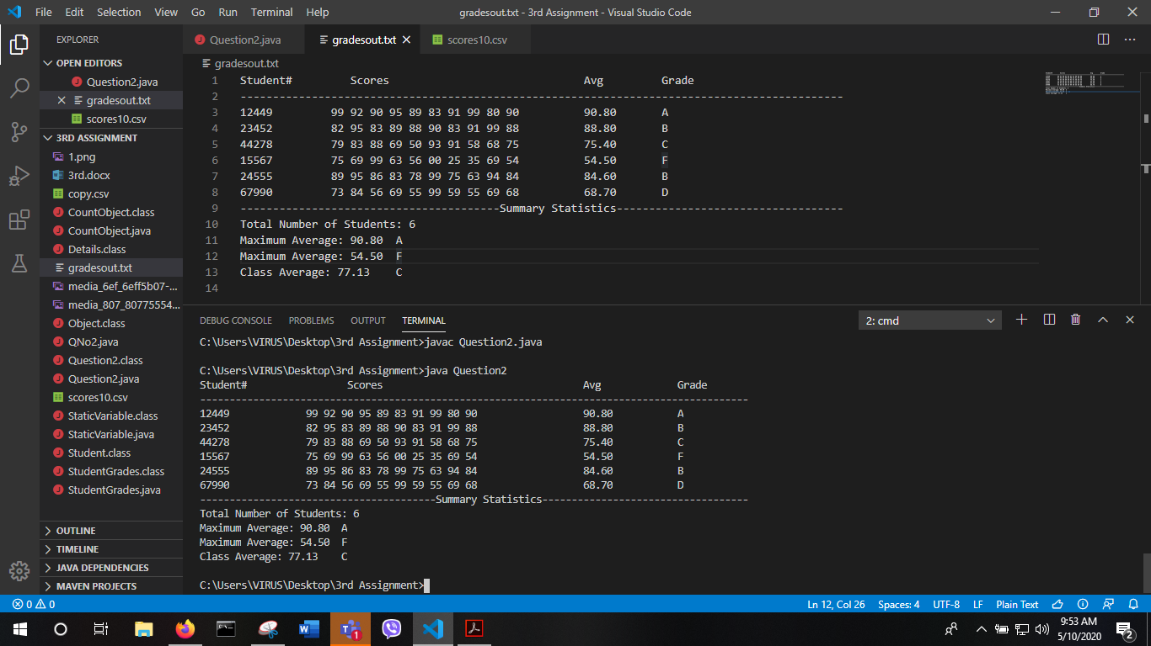**Output:**