Problem 1

import java.util.Arrays;  
  
public class problem1 {  
 static int[] twoSum(int []arr, int tar){  
 int i=0;  
 int j=arr.length-1;  
 while(i<j){  
 int sum=arr[i]+arr[j];  
 if(sum==tar){  
 return new int[]{i,j};  
 }  
 else if(sum>tar) j--;  
 else i++;  
 }  
 return new int[]{-1,-1};  
 }  
 public static void main(String[] args) {  
 int[] arr={-2,-1,-1,-1,-1,-1};  
 int tar=-3;  
 System.*out*.println(Arrays.*toString*(*twoSum*(arr,tar)));  
 }  
}

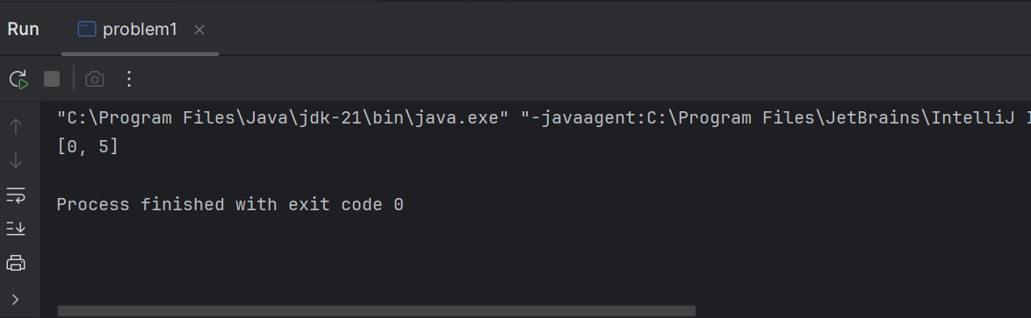

Problem 2

import java.util.\*;  
public class problem2 {  
 public static void main(String[] args) {  
 int[] arr={1,4,2,1,5};  
 int k=6;  
 int count=0;  
 int sum=0;  
 HashMap<Integer,Integer> map=new HashMap<>();  
 map.put(0,1);  
 for(int i=0;i<arr.length;i++){  
 sum+=arr[i];  
 if(map.containsKey(sum-k)){  
 count+=map.get(sum-k);  
 }  
 map.put(sum, map.getOrDefault(sum,0)+1);  
 }  
 System.*out*.println(count);  
 }  
}

Problem 3

import java.util.Arrays;  
  
public class problem3 {  
 static void reverse(int[] arr,int i,int j) {  
 while (i < j) {  
 int temp = arr[i];  
 arr[i] = arr[j];  
 arr[j] = temp;  
 i++;  
 j--;  
 }  
 }  
 static void swap(int[] arr,int i,int j){  
 int temp=arr[i];  
 arr[i]=arr[j];  
 arr[j]=temp;  
 }  
  
 static void nextPer(int[] arr){  
 int i=arr.length-1;  
 while(i>0&&arr[i-1]>=arr[i]){  
 i--;  
 }  
 if(i==0) {  
 *reverse*(arr, 0, arr.length - 1);  
 return ;  
 }  
 int j=arr.length-1;  
 while(j>=i&&arr[j]<=arr[i-1]){  
 j--;  
 }  
 *swap*(arr,i-1,j);  
 *reverse*(arr,i,arr.length-1);  
  
 }  
 public static void main(String[] args) {  
 int[] arr={6,5,7,8};  
 *nextPer*(arr);  
 System.*out*.println(Arrays.*toString*(arr));  
 }  
}

