FINAL ANALYTICAL REPORT / EXECUTIVE BRIEF

CREDIT CARD DELINQUENCY
EARLY WARNING
From repayment behavior to monitoring priorities | UCI credit card data, Taiwan, 2005.
Context: This report presents an independent historical portfolio case study for a hypothetical credit card issuer. The analysis informs a proposed management decision.

Decision to consider
Which customer segment deserves priority when monitoring capacity is limited, and what evidence is needed before payment support is expanded?
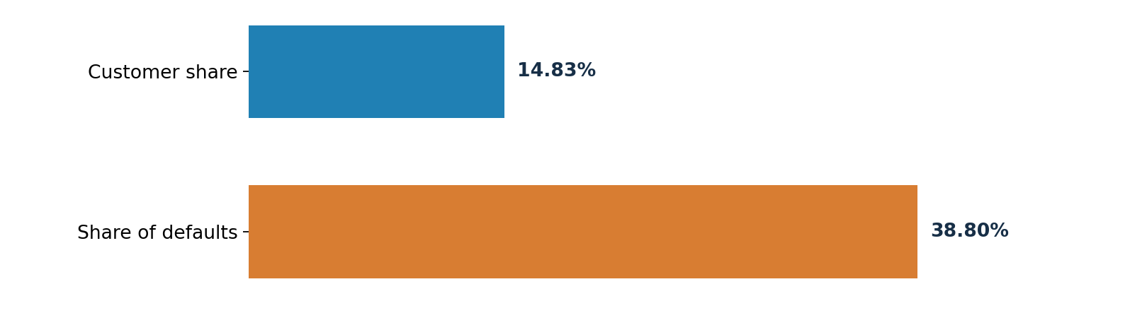
KEY FINDING | 14.83% of customers account for 38.80% of observed defaults
Customers in DELAY in September with at least two documented DELAY months from April through September form a segment of 4,449 people and 2,575 defaults. Its default rate is 57.88%, compared with 22.12% across the portfolio. The two DELAY months do not need to be consecutive.
Full portfolio | Priority review segment | Share of defaults
30,000 customers · 6,636 defaults | 4,449 customers · 2,575 defaults | 38.80% of all 6,636

Management recommendation
Prioritize an account eligibility and status review for customers in DELAY with at least two documented DELAY months. Then approve a controlled monitoring and payment support pilot with a comparison group and predefined evaluation measures.
KEY DECISION CONDITION
17,496 customers, or 58.32% of the portfolio, have UNKNOWN as their September status because source codes −2 and 0 lack sufficiently clear documentation for this analysis. Their definitions should be confirmed with the data owner before operational rules are introduced. These customers remain separate in the analysis.

01 Business problem, data and analytical trust

From a monitoring request to a decision question
Management question | Analytical approach
Where is observed default risk concentrated? | Default rate, default contribution and segment size
Which behavioral signals deserve attention? | Number of DELAY months and changes in status
Which groups should be reviewed first? | Latest status, repayment history and available capacity
When should an intervention be expanded? | A controlled pilot with cost and outcome evaluation

Data source and evaluation window
The UCI Default of Credit Card Clients dataset contains 30,000 customers and 25 original fields. Repayment behavior is observed from April through September 2005, with one next month default outcome per customer. The customer features view contains one row per customer, while the customer month view contains six monthly rows per customer.
Source field | Definition and analytical use
PAY_0, PAY_2 through PAY_6 | Status codes from September back to April. −1 means PAY_DULY; 1 to 9 means DELAY.
Codes −2 and 0 | Not sufficiently explained in the UCI documentation used here; classified as UNKNOWN.
BILL_AMT1 through 6; PAY_AMT1 through 6 | Statement balance and payment context. No inference of payment sufficiency.
DEFAULT_NEXT_MONTH | One outcome at the end of the observation window, not a label for each historical month.

Why validation matters to the default rate
When the 6,636 customers with observed defaults are expanded to six monthly rows each, they produce 39,816 rows carrying a default flag (6,636 × 6). Customer level metrics must therefore be calculated from the customer features view, rather than summing the flags in the monthly view.
Validation | Confirmed result | Risk addressed
Raw data versus customer features | 30,000 versus 30,000; 6,636 defaults in both | Missing or duplicated customers and outcomes
Customer month view | 180,000 rows; no duplicate customer and month pairs | Inflated observations and transition counts
Observation periods | Six months per customer | Incomplete behavioral histories
Unusual bill and payment values | 3,932 negative bills; 18,105 zero bills; 36,897 zero payments | Misleading financial interpretation

INTERPRETATION RULE | UNKNOWN ≠ PAY_DULY ≠ DELAY
In an operating environment, the data owner should confirm the source definitions. Keeping UNKNOWN separate allows analysis to continue without assigning unsupported meanings to these codes.

02 Behavioral evidence: from hypotheses to segments

Hypothesis A: Repeated DELAY is associated with higher default rates
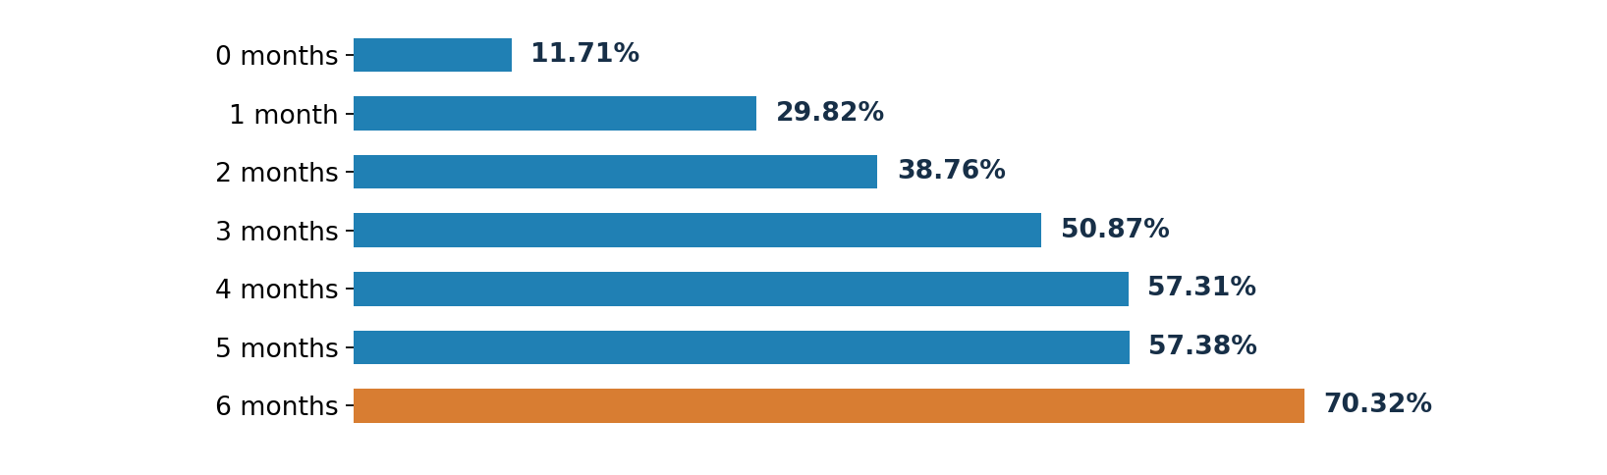
In the observed sample, customers with zero documented DELAY months have a default rate of 11.71% (19,931 customers), compared with 70.32% for those with six such months (1,341 customers). Zero documented DELAY months does not establish timely repayment in all six periods because UNKNOWN statuses are present.

Hypothesis B: Does history matter when the latest status is the same?
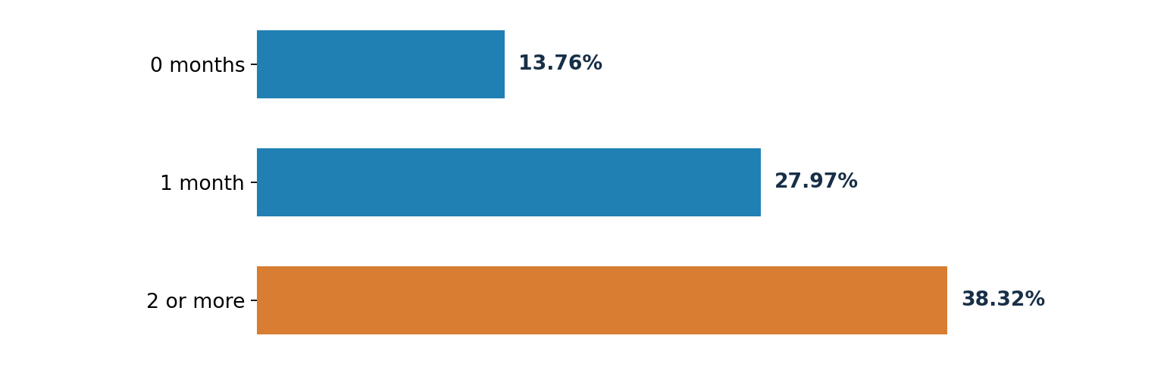
Among customers with PAY_DULY in September, default rates are 13.76%, 27.97% and 38.32% for histories of zero, one and at least two DELAY months, respectively. Looking only at the most recent month therefore misses important differences in earlier repayment behavior.

Monthly repayment status transitions
Monthly transitions from DELAY | Transitions | Share of transitions starting in DELAY
DELAY to DELAY | 13,878 | 76.22%
DELAY to PAY_DULY | 1,402 | 7.70%
DELAY to UNKNOWN | 2,928 | 16.08%

Transitions compare the project defined status groups, not raw delay severity. Each customer provides five adjacent-month transitions (150,000 instances in total); a DELAY to DELAY pair can still contain changes in raw codes.

03 Risk segments and the capacity tradeoff
Eight mutually exclusive segments combine September status with the number of documented DELAY months over the full six month observation window. They reconcile to 30,000 customers and 6,636 defaults. Each default contribution uses the full portfolio count of 6,636 as its denominator.
September status | DELAY months | Customers | Defaults | DR | Default share
DELAY | 2 or more | 4,449 | 2,575 | 57.88% | 38.80%
DELAY | 1 | 2,369 | 854 | 36.05% | 12.87%
PAY_DULY | 2 or more | 368 | 141 | 38.32% | 2.12%
PAY_DULY | 1 | 572 | 160 | 27.97% | 2.41%
PAY_DULY | 0 | 4,746 | 653 | 13.76% | 9.84%
UNKNOWN | 2 or more | 826 | 266 | 32.20% | 4.01%
UNKNOWN | 1 | 1,485 | 306 | 20.61% | 4.61%
UNKNOWN | 0 | 15,185 | 1,681 | 11.07% | 25.33%

Evidence supporting the priority choice
Coverage option | Customers | Customer share | Defaults | Share of observed defaults
Priority 1: DELAY with 2 or more | 4,449 | 14.83% | 2,575 | 38.80%
Priority 1 and 2 | 7,186 | 23.95% | 3,570 | 53.80%
Other customers | 22,814 | 76.05% | 3,066 | 46.20%

Priority 2 includes DELAY with one documented DELAY month and PAY_DULY with at least two. Together, Priority 1 and Priority 2 exceed the planning capacity of 5,000 proactive contacts. Their coverage figures describe default concentration in the historical sample, not validated predictive performance.
MANAGEMENT INTERPRETATION
Priority 1 stands out for default intensity (57.88%), volume (2,575 defaults) and a focused customer population (4,449 people). Yet UNKNOWN with zero documented DELAY months still accounts for 25.33% of observed defaults. Customers outside the priority segments therefore remain part of portfolio monitoring.

04 Financial context and recommended responses

What does financial context add?
Segment | Mean credit limit (TWD) | Mean September bill (TWD) | Mean September payment (TWD)
DELAY with 2 or more | 102,537 | 54,304 | 2,196
DELAY with 1 | 180,844 | 23,461 | 4,465
PAY_DULY with 0 | 215,628 | 11,061 | 8,172
PAY_DULY with 2 or more | 141,984 | 8,247 | 1,675

The DELAY segment with at least two documented DELAY months has a higher average September bill and a lower average September payment than the DELAY segment with one month. These are descriptive financial measures, not an estimate of a payment shortfall. In September, 2,598 customers have nonpositive bills, including 590 negative and 2,008 zero balances.

A two tier approach to monitoring and support
Tier | Customer group | Response to consider
Priority 1 | September DELAY with 2 or more documented DELAY months | Review account eligibility, contact permissions and appropriate support; design a pilot.
Priority 2 | DELAY with 1 month; PAY_DULY with 2 or more | Monitor recent changes and assess light touch support where suitable.
Data governance | Groups involving UNKNOWN | Clarify status codes with the data owner; retain separate classification until confirmed.

How should the 5,000 contact capacity be used?
The 5,000 proactive contacts represent a planning constraint. They do not imply outreach to all 4,449 Priority 1 customers. First establish account eligibility, contactability and an appropriate comparison group. Remaining capacity can support monitoring of other segments as pilot results become available.
APPROVAL REQUIRED
Approve clarification of UNKNOWN codes and an eligibility review for Priority 1. Authorize a pilot design with a comparison group, compliant outreach channels and predefined outcome measures. Broader rollout should follow the measured results.

05 Pilot evaluation, limitations and reproducibility

How will the pilot be evaluated?
Stage | Decision question | Evidence to collect
1. Eligibility | Who can be contacted appropriately? | Account condition, consent, reachability and fairness criteria
2. Treatment and control | Does the intervention outperform standard processes? | Assignment where appropriate, plus records of actual delivery
3. Outcomes | Does next month default improve? | Default outcomes by group, baseline and observation window
4. Safeguards | Do benefits justify costs and customer impact? | Costs, complaints, experience and well defined cure and roll measures
5. Decision gate | Expand, adjust or stop? | Reliable improvement, acceptable cost and no unacceptable impact

Limits relevant to the management decision
Default rates, default contributions and coverage figures describe associations within a historical sample. The project does not include out of sample validation, causal treatment estimates, intervention costs or verified credit losses. LIMIT_BAL and BILL_AMT are not observed exposure at default, so they are not used to estimate expected loss.

How the results can be checked
Analysis layer | Evidence and source
Raw data and quality | SQL analyses 01 to 03: 30,000 IDs, status distributions and financial checks
Analytical model | SQL 04: 30,000 customer feature rows, 180,000 customer month rows, outcome reconciliation
Behavior and segments | SQL 05 and 06: transitions and eight groups reconciling to 6,636 defaults
Financial context | SQL 07: segment means and 30,000 customer, 6,636 default validation
Dashboard | Power BI interactive analysis with KPI reconciliation to SQL before publication

Conclusion
Customers in DELAY in September with at least two documented DELAY months are the strongest initial monitoring review candidate in this analysis. They represent 14.83% of the portfolio, 38.80% of observed defaults and a 57.88% default rate. Management can now clarify status definitions, verify operational eligibility and evaluate a measured pilot before deciding whether to expand support.
Source: UCI Machine Learning Repository, Default of Credit Card Clients, https://archive.ics.uci.edu/dataset/350/default+of+credit+card+clients ; Yeh and Lien (2009). Results were reconciled against the project SQL analyses 01 through 07.

