**FITNESS CLUB**

End Term Report

***by***

**Lavish Gupta.**

**Ujwal Pandey.**

**Abhishek Dudi.**

Section: - K19TP

Roll Number: - 45,48,50



Department of Intelligent Systems

School of Computer Science Engineering

Lovely Professional University, Jalandhar

2019-20

**Student Declaration**

This is to declare that this report has been written by us. No part of the report is copied from other sources. All information included from other sources have been duly acknowledged. We aver that if any part of the report is found to be copied, I/we are shall take full responsibility for it.

Lavish Gupta, Ujwal Pandey, Abhishek Dudi

Roll Number: - 45,48,50

Place: - Lovely Professional University, Phagwara, Punjab

Date: - 7/4/2020

TABLE OF CONTENTS

TITLE PAGE NO.

1. **Introduction………………………………………………… 5**

**1.1** Background……………………………………………… 5

**1.2** Motivation………………………………………………. 5

**1.3** Outcomes………………………………………………… 6

**1.4** Concrete Goals…………………………………………… 6

**1.5** Objectives………………………………………………… 6

2.**Description…………………………………………………… 7**

**2.1** Header and Navigation Bar………………………………. 7

**2.2** Content…………………………………………………… 8

**2.3** Register window…………………………………………. 9

**2.4** Information Window…………………………………….. 11

**2.5** Latest news………………………………………………. 12

**2.6** Footer…………………………………………….. 13

3. **Frameworks and Technologies……………………………… 14**

**3.1** Technologies ….……….………………………………… 14

4. **Work Division…………………………………………………… 14**

5. **SWOT Analysis…………………………………………………. 15**

BONAFIDE CERTIFICATE

Certified that this project report “FITNESS CLUB” is the bonafide work of “Lavish Gupta, Ujwal Pandey, Abhishek Dudi” who carried out the project work under my supervision.

<<Signature of the Supervisor>>

<<Name of supervisor>>

<<Academic Designation>>

<<ID of Supervisor>>

<<Department of Supervisor>>

**Introduction**

* 1. **Background**

Fitness Club is a platform designed to help members meet their fitness goals. A platform where members can learn with fun. This website is designed to Increase your physical activity which helps to prevent cardiovascular disease and type 2 diabetes, among other common health hazards.The sole purpose to design this website is fitness. The website contains various topics and also contain panels where a visitor can share their views about the website and content. This website is designed with a simple Architecture and easy to understand content.

* 1. **Motivation**

The ideas and motivation regarding to theme is pure imagination and creativity of the designer and the attributes are motivated by various other fitness websites and color combination are well tested and applied on the website with the help of internet and various color websites which provides you suitable color combination for your designing work. The task given by the faculty is well handled and all the division and attributes are implemented.

* 1. **Outcomes**

During the designing and coding of the project there were many outcomes. We learned about the designing of layout of website. We also experienced some of the new techniques of designing and also learned the importance of the color combination in objects. We also learned to manage code in various steps, classes and objects. To increase the readability and understanding of the user. This project or platform is result of the education we gained from various areas and our faculty.

* 1. **Concrete Goals**

The goals are to establish understanding of website designing and coding with help of HTML, CSS, JavaScript etc.

To energize the reader with color combination and smoothness of the web page.

To show the various ideas implemented by the designer of the platform.

* 1. **Objectives**

The objectives are crystal clear and all point at the structure and architecture of the project and their various attributes and menus. The main objective is to clear any queries about the design of the learning by building one by hand with pure creativity.

We used inline CSS into header with various class which designs every single section of the website.

**Description**

**2.1** Header and Navigation Bar



We created a header with the grey color which shows true style and elegance and justifies the design like no other color. At top left corner we attached the logo of our Fitness Club which also designed by us with the help of online resources.

The logo contains a book with a ribbon in it inside a cross and in the logo, there is the title of the platform ‘Fitness Club’.

Beside the logo there is a navigation bar also which is at the bottom of the header containing section as Home, About, Training, Nutrition, Timetable, Gallery.

Each section has a dropdown menu of their own with content in it which turns into dark grey when we hover the cursor on them.

Every section and dropdown content has a demo link which onclick just change the URL but a suggestive link can be added inside the coding easily.

Upper image is the exact illustration of the points described in this section.

Navigation Bar also consist our Social websites (Facebook and Twitter).

Class for Dropdown Menu (dropdwn)

Class for Navigation (nav) with following specifications:

height: 60px;

background: #2c3e50;

box-shadow: 0 10px 15px rgba(0,0,0,.1);

font-family: sans-serif;

**2.2 Content**

First of all, we have added images, with a sliding feature, which contains 4 images and provides us the information about the features of the website.

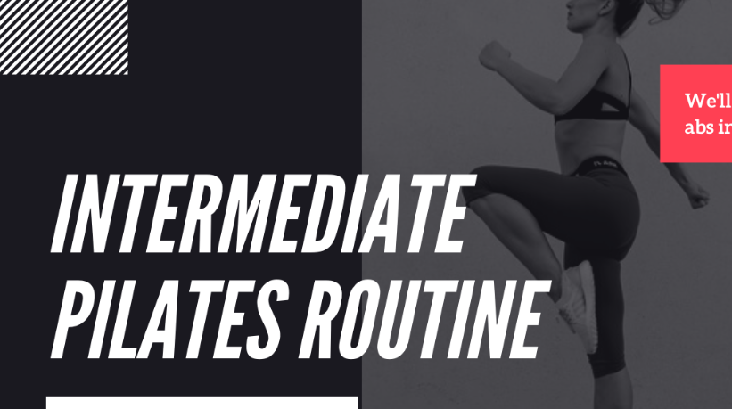

Class made for Sliding Images Division (Sliders) with following specs

display: block;

width: 55%;

background-color: #1f1f1f;

overflow: hidden;

position: absolute;

height: 55%;

margin-top: 220px;

margin-right: 200px;

margin-left: 30px;

**2.3 Register Window.**

At the side of Images, we have made a Register window where, New member can join and Old members can login.

Register window contains following information that is to be filled by user.

1)- First Name.

2)- Last Name.

3)- Email.

4)- Phone no.

5)- User Name

6)- Password.

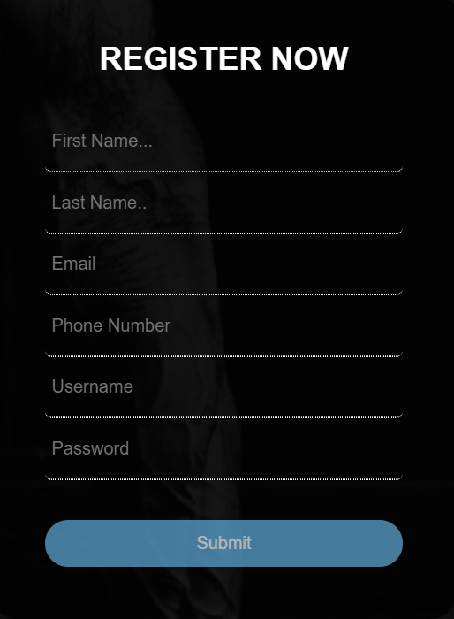

This Register window is made of a black background with opacity of 0.7 in which a “REGISTER NOW” is glowing with white colour and at last there is a submit button with blue colour.

Class made for Register Now Section(sign) with following specs:

max-width: 350px;

border-radius: 20px;

margin:auto;

background:rgba(0,0,0,0.8);

box-sizing:border-box;

padding: 40px;

color: #fff;

margin-top:100px;

margin-right: 80px;

**2.4Information Window**

Under the register window we added information table which briefly describe the price and program which are being followed under Fitness club.

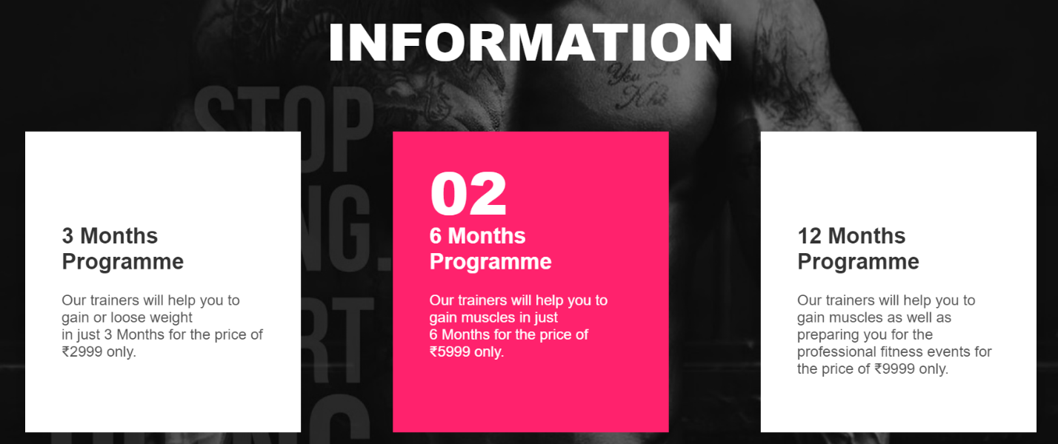

Under the register window we added information table which briefly describe the price and program which are being followed under Fitness club. The Information section consist of three white squares in which is a special type of button which flips 180 degree in x direction and changes color from white to Pink.

We made “container” and “box” classes for designing information division

Container:

width: 1100px;

display: flex;

justify-content: space-between;

flex-wrap: wrap;

Box:

position: relative;

width: 220px;

background: #fff;

padding: 100px 40px 60px;

box-shadow: 0 15px 45px rgba(0,0,0,.1);

**2.5 Latest News.**

We added a new division inside which we added a demo video which is regarding to the website content. Wehave arranged the size as follows.

Width="768".

Height="432".



**2.6 Footer**



At last we designed a footer having background sky blue inside the footer a we have provided our information to help members to contact us if they have any query or suggestion regarding the website.

Class Made for Footer Section (footer)

left: 0;

bottom: 0;

width: 100%;

background-color: #9EFFFF;

margin: 0;

padding: 0;

box-sizing: border-box;

color: black;

text-align: center;

**Frameworks and Technologies Used**

**3.1 Technologies and software**

It helps to determine tags and classes and also helps us to choose reasonable indent. It helps us to clean the code which helps us to understand the code better.

**Work Division**

All the designing and work is done by all three of us and all the working hours are used wisely for creativity, implementation, designing, color combinations etc.

1)- Lavish Gupta – After the completion of the making process of the website, I took the responsibility to make the final project report. Hence, I observed all the coding and final webpage look, and analysed the process of each part of the coding, and the output result of each part and collected all the screenshots and attached to the file accordingly.

2)- Ujwal Pandey –According to the allotment, He studied the topic and made the whole html coding to build the website perfectly. He gave a gorgeous look to our webpage structure by her coding skill.

3)- Abhishek Dudi-He took a keen look to the process of making the website and prepared a brief summary of the cooking website.

**SWOT Analysis**

Strengths

* **VERY FOCUSED ON FITNESS:** Fitness Club is largely focused on the fitness of the consumers; around 73% of the revenue comes from the gymnasiums
* **EXCELLENT SCHEMES IN BEST AFFORDABLE PRICES:** It has been found that majority of the customers look for suitable schemes and this is one of its major strength.
* **PRICING ACCORDING TO DEMOGRAPHY:** Prices of all the branches varies according to the locations. It is like a healthy contribution from our side.
* **CUSTOMER CARE SERVICES:**Customer care services of Fitness Club have been found excellent by all its users. 90% of the respondents are satisfied by its customer care services.

**WEAKNESS**

* **PRICE COMPETITION FROM POWERHOUSE AND TALWALKAR’S:** Addiction is facing tough competition from the service providers like POWERHOUSE and TALWALKARS as these two are offering services at a low rate.
* **UNTAPPED CENTRAL REGION OF DELHI**: Although Fitness Club have strong Presence throughout the Delhi but still, they are far away from the central part and generally this part is covered by Fitness First and THE GYM so indirectly Fitness Club is losing revenue from the central region.

**OPPORTUNITIES**

* **LATEST TECHNOLOGY:**The Fitness Club needs only to augment its equipment capacity and increase the number of base stations. The number of machineries it has covered already works to its advantage as putting more base stations for the full coverage. Besides such cost advantages, it has also other cost advantages for the latest machine technology. As a late entrant into the market, it has dual advantage of latest technology with modern features, unlike other private gym operators who started their service more than 4-5 years back.
* **HUGE MARKET:**The market for health industries is presently expanding at a phenomenal / whopping rate every year and there is still vast scope for Fitness Club to enter /expand in this market. Many customers are lookingtowardsFitness Club for providing the service to them. With its wide and extensive presence in all the areas, Fitness Club poised to gain a big market share in this segment when it expands its services.

THREATS

* **COMPETITION FROM OTHER UPCOMING HEALTH INDUSTRIES:**It is time for Powerhouse gym to improve/expand its services. Fierce and cut-throat competition is already in place with the markets ever abuzz with several reductions and announcement of attractive packages, trying to grab most of the ‘mind share’ of the ‘king’ - ‘the consumer’, whose benefits are increasing with passing of everyday. If Powerhouse is not innovative and agile, its service will be a flop. It needs to be proactive with attractive packaging, pricing and marketing policies lest its presence in the market be treated with disdain by the private companies.
* **HIGH CUSTOMER CHURN:**There is high customer churn i.e. they can come and go as they please resulting in bad debts.