Gains: k_1 , k_2, k_3 , k_4, k_5, k_6, k_7, k_8
External values (setpoints or measurements): v^*_{dc}, v_{dc}, i^*_q, v_{d,ff}, v_{q,ff}
States:
- \dot{v}_\alpha = k\omega_{0} (v-v_{\alpha}) - \omega_{0}v_{\beta}
- \dot{v}_\beta = \omega_{0}v_{\alpha}
- \dot{e}_2 = v_q
- \dot{\theta} = \omega_{0} + k_1\dot{e}_2 + k_2e_2
- \dot{i}_\alpha = k\omega_{0} (i-i_{\alpha}) - \omega_{0}i_{\beta}
- \dot{i}_\beta = \omega_{0}i_{\alpha}
- \dot{e}_3 = v^*_{dc} – v_{dc}
- \dot{e}_4 = i^*_d – i_d
- \dot{e}_5 = i^*_q – i_q
- \dot{i}_d = \frac{v_{conv,d} – v_d}{L} - \omega_{0}i_q
- \dot{i}_q = \frac{v_{conv,q} – v_q}{L} + \omega_{0}i_d
- \dot{v}_d = \frac{i_d – i_{g,d}}{C} - \omega_{0}v_q
- \dot{V}_q = \frac{i_q – i_{g,q}}{C} + \omega_{0}v_d
More equations:
- v_d = v_\alpha \sin(\theta) - v_\beta \cos(\theta)
- v_q = v_\alpha \cos(\theta) + v_\beta \sin(\theta)
- i_d = i_\alpha \sin(\theta) - i_\beta \cos(\theta)
- i_q = i_\alpha \cos(\theta) + i_\beta \sin(\theta)
- i^*_d = -k_3 \dot{e}_3 + k_4 e_3
- v^*_d = k_5 e_4 + k_6 \dot{e}_4 - \omega_{0} L i_q
- v^*_q = k_7 e_5 + k_8 \dot{e}_5 - \omega_{0} L i_d
- v’_d = v^*_d + v_{d,ff}
- v’_q = v^*_q + v_{q,ff}
- v^*_\alpha = v’_d \sin(\theta) + v’_q \cos(\theta)
- v^*_\beta = v’_d \cos(\theta) - v’_q \sin(\theta)
- m = \frac{v_conv*}{v_dc} ; m can only be from -1 to 1

Second iteration: dynamic model excluding DC link dynamics
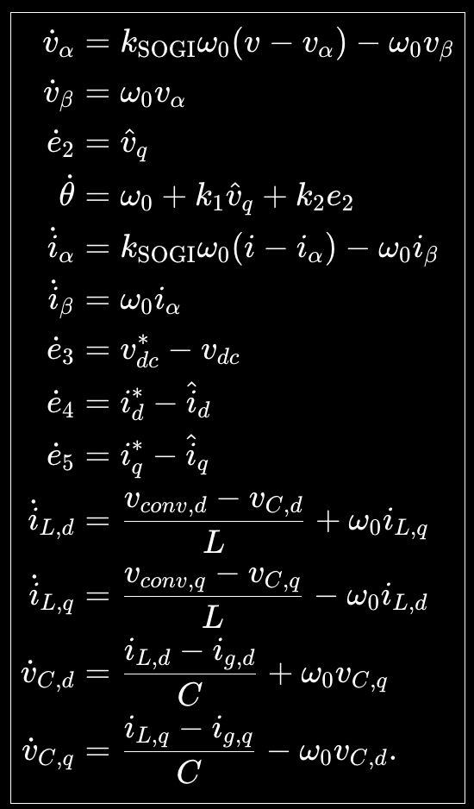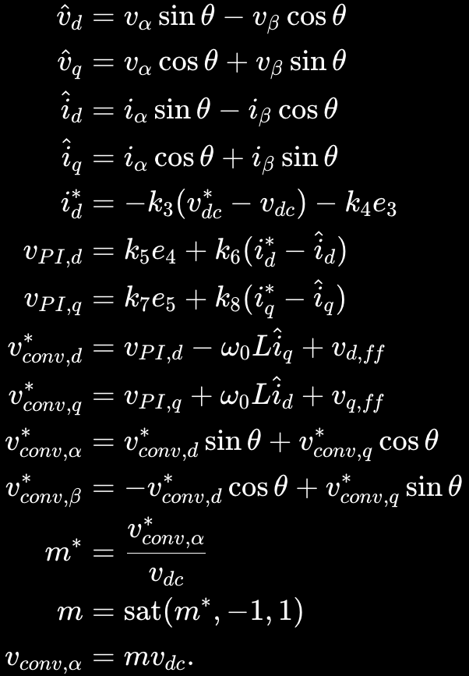

Third iteration: modeling DC link dynamics

