# CSWD Lab: HTML and CSS Revision Exercises

# Exercise 2

1. Open clients.html, examine the html, then add CSS rules to the to external file ***style.css*** to lay out the page like in the picture below.
2. Checklist of layout tasks that need to be completed:
   1. The client panels need to be lined up horizontally (you can use CSS property float for this).
   2. When the window width is changed, the number of client panels in a row should increase or decrease appropriately (to 4 when increased and to 2 when decreased).
   3. The client panels need to be sized with properties width and/or height.
   4. The image sizes need to be limited.
   5. Apply appropriate borders, padding, and margins to the client panels.
   6. Format text where needed.
   7. Make sure that the element with text “Please contact us…” is correctly positioned (you can use CSS property clear for this).

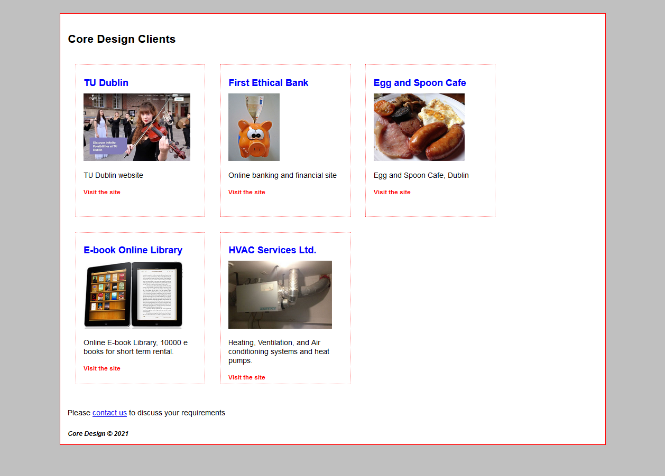

## Exercise 3

1. Modify index.html to include the CSS file provided in the folder **assets/css**.
2. Add rules to the CSS file in order to achieve the following (as shown in the picture).
   1. Size and position the element with id **container**.
   2. Format the navigation list. The **Home** link has the mouse over it (use selector a:hover to add a style for this).
   3. Format and position the title.
   4. Format, position and align content text.
3. Use inline CSS in the HTML file to position the breakfast image.

