# CSWD Lab1: HTML and CSS Revision Exercises

# Exercise 4

Create a small website with a simple homepage in HTML (create this from scratch). The homepage should include a table that lists the other three exercises from this lab and provides links to them. The table should include a row of header cells, a minimum of three columns (exercise name, exercise link, difficulty rating) and should include at least two colours, for example:

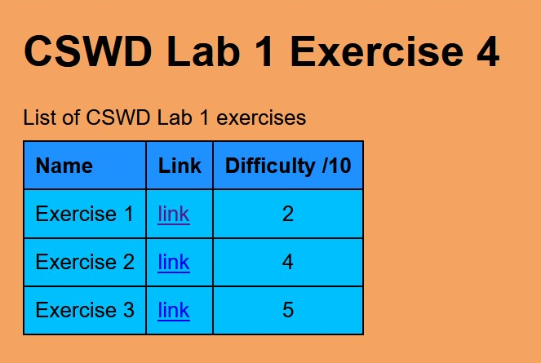

Your lab submission will consist of this mini-website (including the other exercises, completed). All the files of the mini-website should be in a directory called **Lab1_HTMLandCSS** and this should be directly inside your git repository working directory.