# Matlab实验报告

## 实验十

### 练习1.1

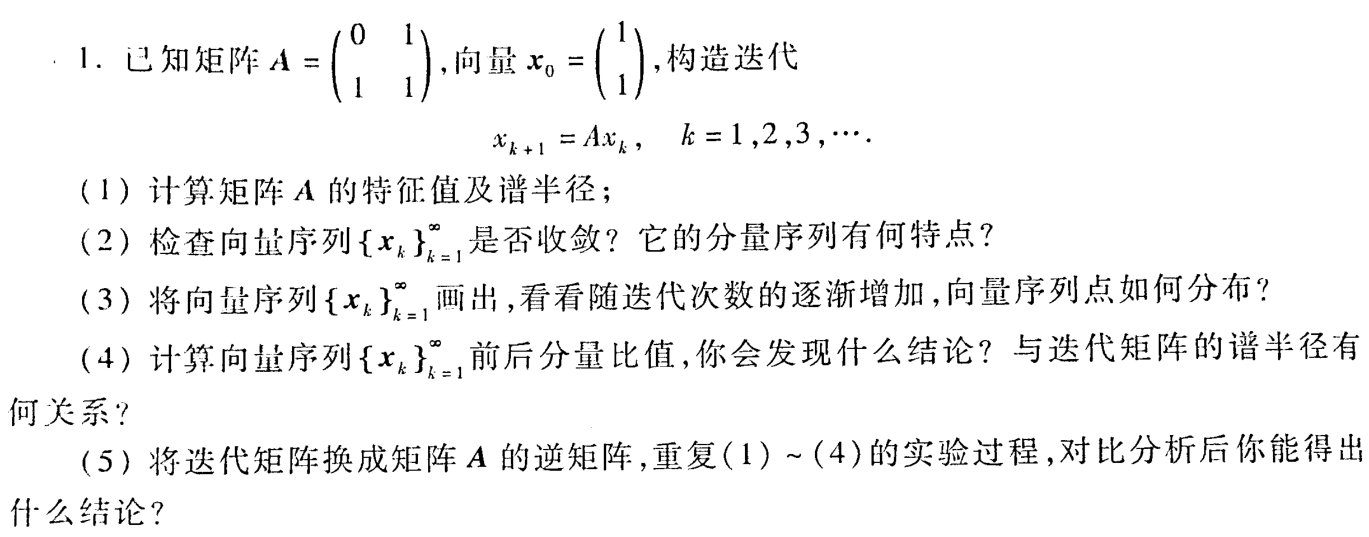

#### 程序

1. A = [0,1;1,1];  
   Adetezhengzhi = eig(A)  
   Adepubanjin = max(abs(eig(A)))  
     
   %结果  
   >> lx1_1_1  
     
    Adetezhengzhi =  
     
    -0.6180  
    1.6180  
     
    Adepubanjin =  
     
    1.6180
2. A = [0,1;1,1];  
   x = [1;1];  
   xl = [];  
   for k = 1:1:30  
    x = A * x;  
    xl = [xl,x];  
   end  
   xl;  
   plot(xl(1,:))  
   hold on  
   plot(xl(2,:))  
     
   %结果

* 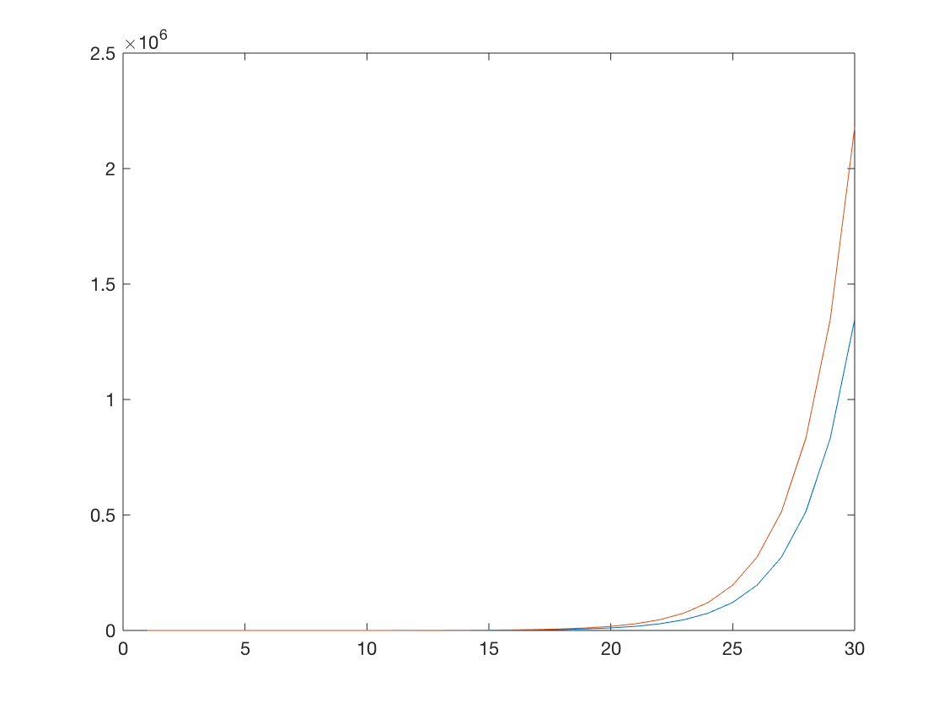

1. A = [0,1;1,1];  
   x = [1;1];  
   xl = [];  
   for k = 1:1:30  
    x = A * x;  
    xl = [xl,x];  
   end  
   subplot(2,2,1)  
   plot(xl(1,1:5),xl(2,1:5),xl(1,1:5),xl(2,1:5),'*')  
   subplot(2,2,2)  
   plot(xl(1,1:10),xl(2,1:10),xl(1,1:10),xl(2,1:10),'*')  
   subplot(2,2,3)  
   plot(xl(1,1:15),xl(2,1:15),xl(1,1:15),xl(2,1:15),'*')  
   subplot(2,2,4)  
   plot(xl(1,1:30),xl(2,1:30),xl(1,1:30),xl(2,1:30),'*')  
     
   %结果

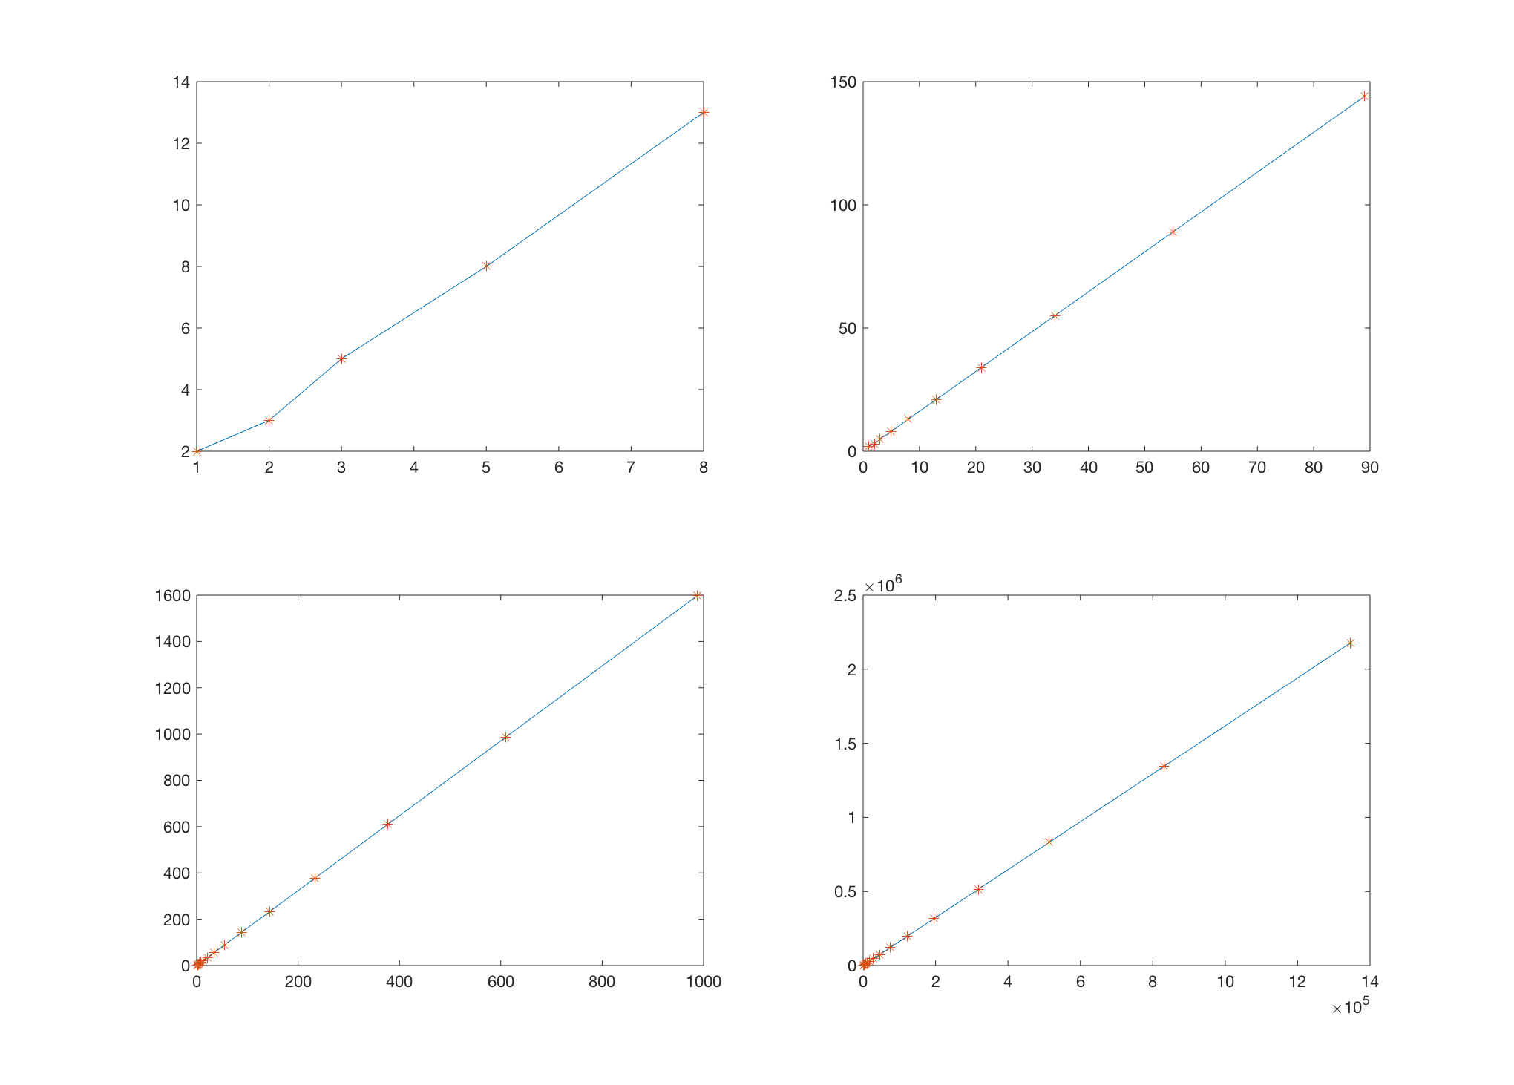

1. A = [0,1;1,1];  
   x = [1;1];  
   xl = [];  
   for k = 1:1:30  
    x = A * x;  
    if k>20  
    xl = [xl,x];  
    end  
   end  
   xl  
   xltedian=[];  
   for k = 1:1:10  
    xll = [xl(1,k)/xl(2,k);xl(2,k)/xl(1,k)];  
    xltedian=[xltedian,xll];  
   end  
   xltedian  
     
   %结果  
   >> lx1_1_4  
     
   xl =  
     
    列 1 至 6  
     
    17711 28657 46368 75025 121393 196418  
    28657 46368 75025 121393 196418 317811  
     
    列 7 至 10  
     
    317811 514229 832040 1346269  
    514229 832040 1346269 2178309  
     
     
   xltedian =  
     
    列 1 至 7  
     
    0.6180 0.6180 0.6180 0.6180 0.6180 0.6180 0.6180  
    1.6180 1.6180 1.6180 1.6180 1.6180 1.6180 1.6180  
     
    列 8 至 10  
     
    0.6180 0.6180 0.6180  
    1.6180 1.6180 1.6180
2. %1  
   a = [0,1;1,1];  
   A = inv(a)  
   Adetezhengzhi = eig(A)  
   Adepubanjin = max(abs(eig(A)))  
     
   %2  
   x = [1;1];  
   xl = [];  
   for k = 1:1:30  
    x = A * x;  
    xl = [xl,x];  
   end  
   xl;  
   plot(xl(1,:))  
   hold on  
   plot(xl(2,:))  
     
   %3  
   figure();  
   subplot(2,2,1)  
   plot(xl(1,1:5),xl(2,1:5),xl(1,1:5),xl(2,1:5),'*')  
   subplot(2,2,2)  
   plot(xl(1,1:10),xl(2,1:10),xl(1,1:10),xl(2,1:10),'*')  
   subplot(2,2,3)  
   plot(xl(1,1:15),xl(2,1:15),xl(1,1:15),xl(2,1:15),'*')  
   subplot(2,2,4)  
   plot(xl(1,1:30),xl(2,1:30),xl(1,1:30),xl(2,1:30),'*')  
     
   %4  
   xltedian=[];  
   for k = 10:1:20  
    xll = [xl(1,k)/xl(2,k);xl(2,k)/xl(1,k)];  
    xltedian=[xltedian,xll];  
   end  
   xltedian  
     
   %结果  
   >> lx1_1_5  
     
   A =  
     
    -1 1  
    1 0  
     
     
   Adetezhengzhi =  
     
    -1.6180  
    0.6180  
     
     
   Adepubanjin =  
     
    1.6180  
     
     
   xltedian =  
     
    列 1 至 7  
     
    -1.6190 -1.6176 -1.6182 -1.6180 -1.6181 -1.6180 -1.6180  
    -0.6176 -0.6182 -0.6180 -0.6181 -0.6180 -0.6180 -0.6180  
     
    列 8 至 11  
     
    -1.6180 -1.6180 -1.6180 -1.6180  
    -0.6180 -0.6180 -0.6180 -0.6180

* 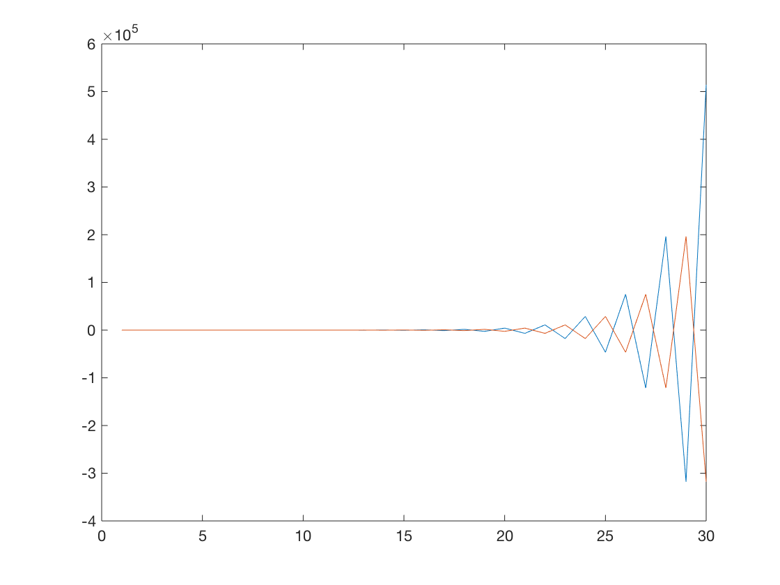
* 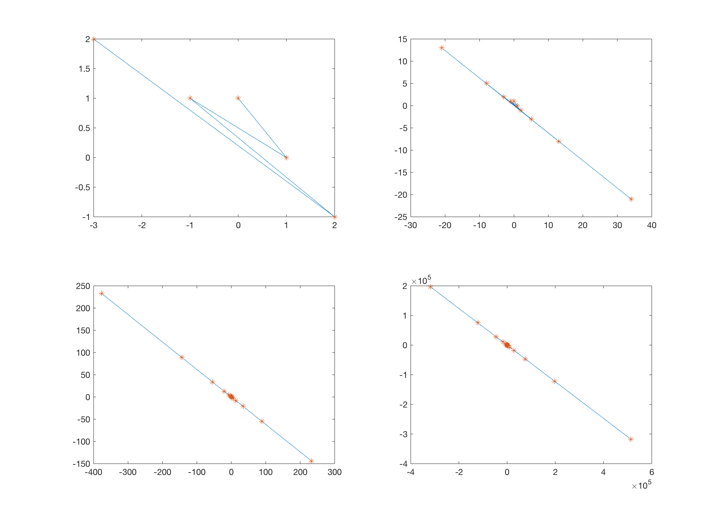

### 练习1.2

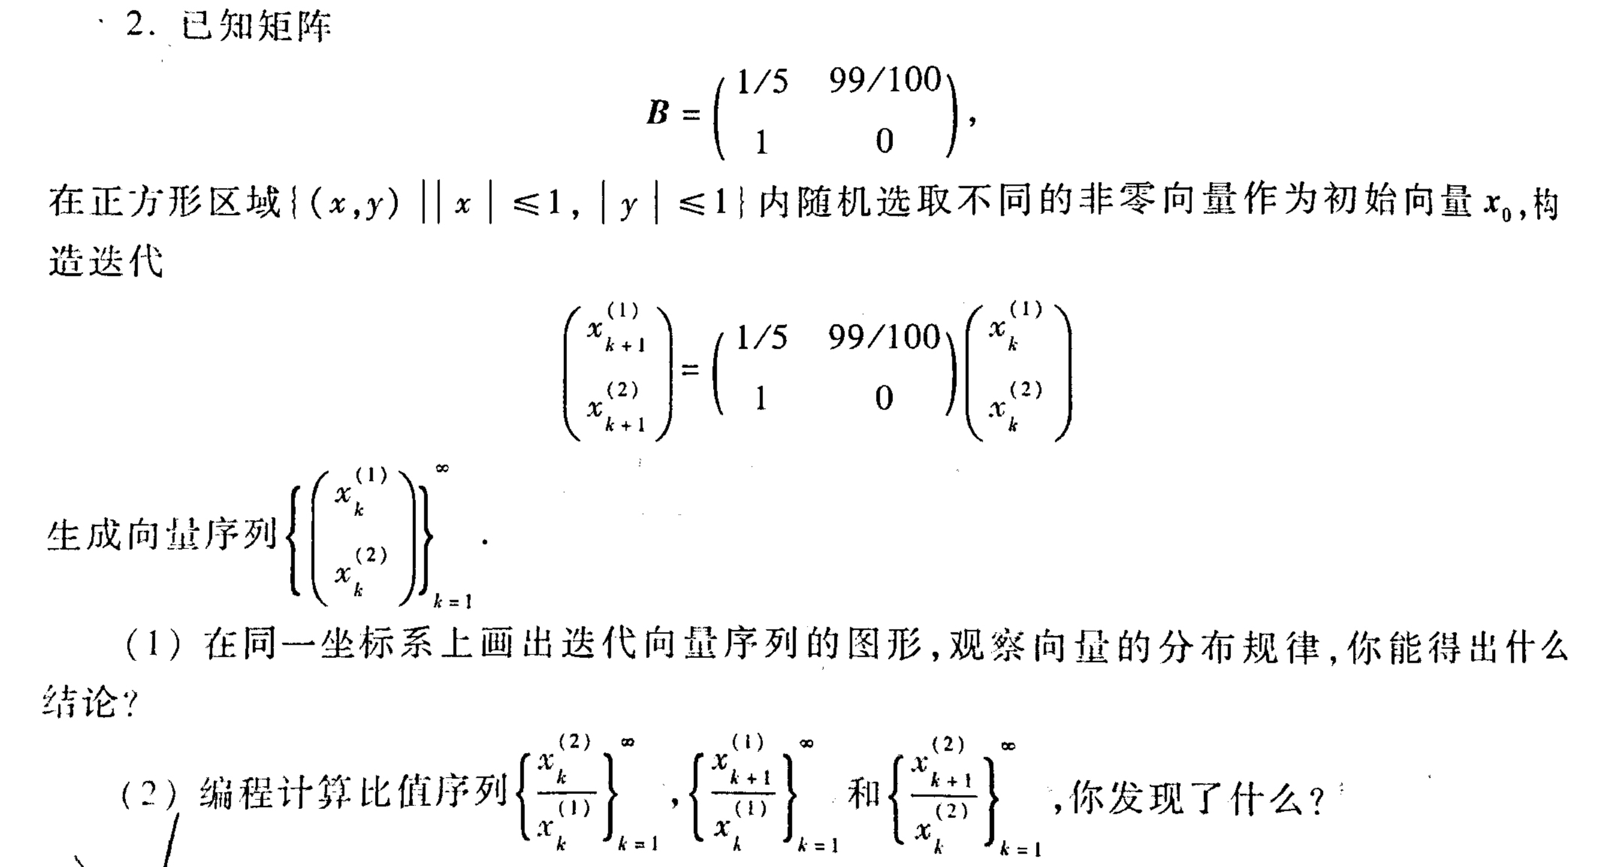

1. for i = 1:1:5  
    x = 2.*rand(2,1)-1;  
    B = [0.2,0.99;1,0];  
    xl = [];  
     
    for k = 1:1:40  
    x = B * x;  
    xl = [xl,x];  
    end  
    plot(xl(1,30:end),xl(2,30:end),xl(1,30:end),xl(2,30:end),'*')  
    hold on  
   end