

Nadyrkhan Shyntemir
CS-2310
Task 1

Task 2
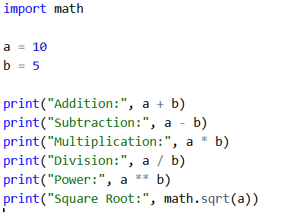
Basic mathematical operations such as addition, subtraction, multiplication, division, power, and square root were implemented using Python built-in operators and the math library. The results were printed in the console.
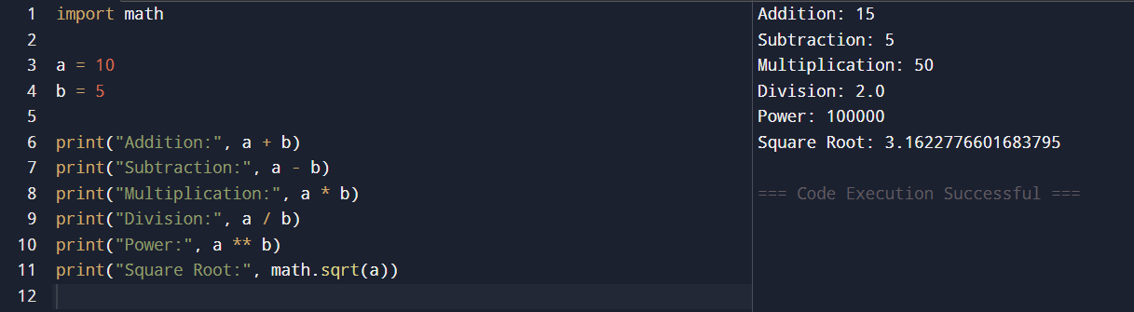

Task 3
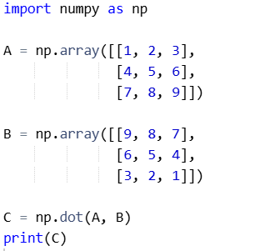
Two 3×3 matrices were created using the NumPy library. Matrix multiplication was performed using the dot function, and the resulting matrix was printed in the console.
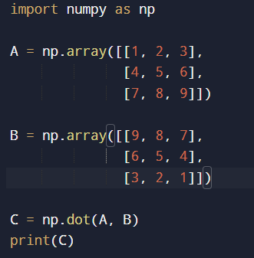
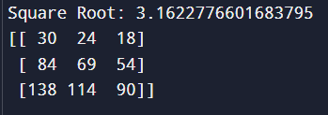
Task 4
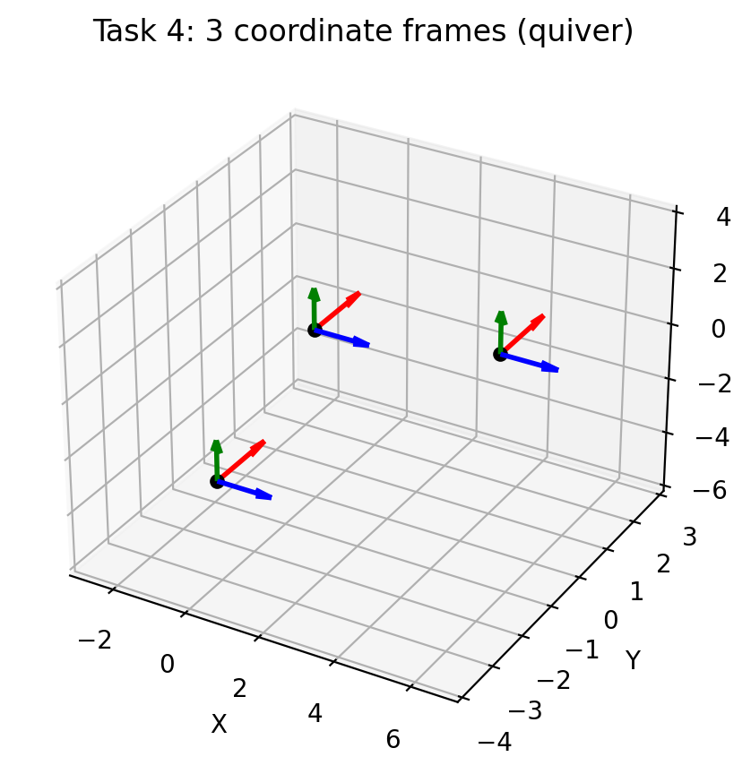
- Task 4 — 3D coordinate system with quiver (3 frames)
I used matplotlib with Axes3D to create a 3D plot and ax.quiver() to draw arrows that represent the axes of each coordinate frame.
For each frame, I drew 3 arrows starting from its origin point:

fig = plt.figure()
ax = fig.add_subplot(111, projection='3d')

- Blue arrow = X direction (1,0,0)
- Red arrow = Y direction (0,1,0)
- Green arrow = Z direction (0,0,1)
Frames were placed at the required coordinates:
- Frame 1 at (0, 0, 0)
- Frame 2 at (5, 0, 1)
- Frame 3 at (-1, -2, -4)

ax.quiver(x, y, z, 1, 0, 0, color='blue')
ax.quiver(x, y, z, 0, 1, 0, color='red')
ax.quiver(x, y, z, 0, 0, 1, color='green')

Task 5
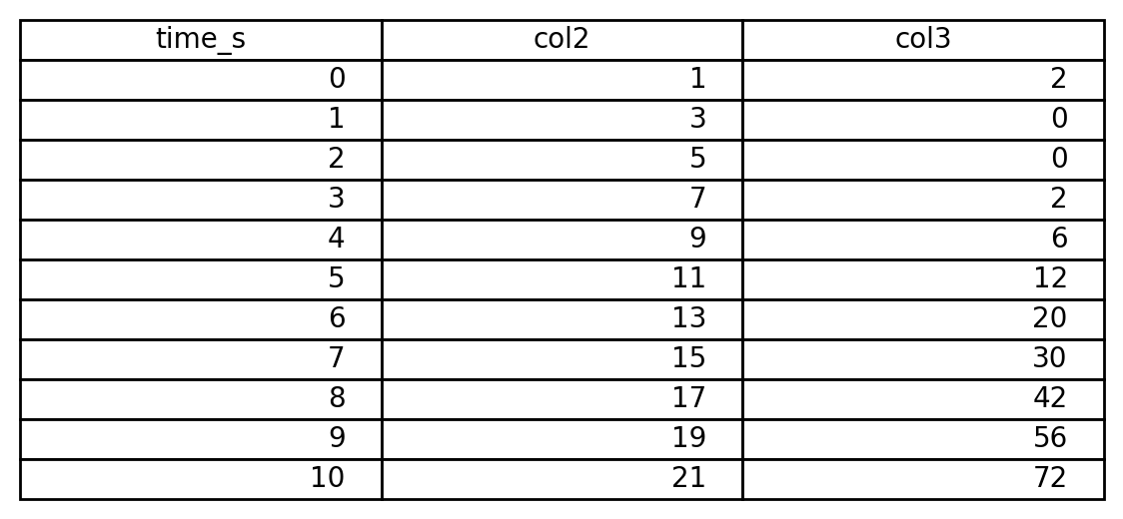
Task 5 — List (table) with 3 columns (time 0–10 sec, step 1)
I generated a time list from 0 to 10 using range(0, 11).
Then I created two more numeric columns (any values are allowed by the assignment).
Finally, I combined them into a “table-like” structure using zip(time, col2, col3) which produces rows like:
(time, value2, value3)
This matches the requirement: 3 columns, first column is time with 1-second interval.
Task 6
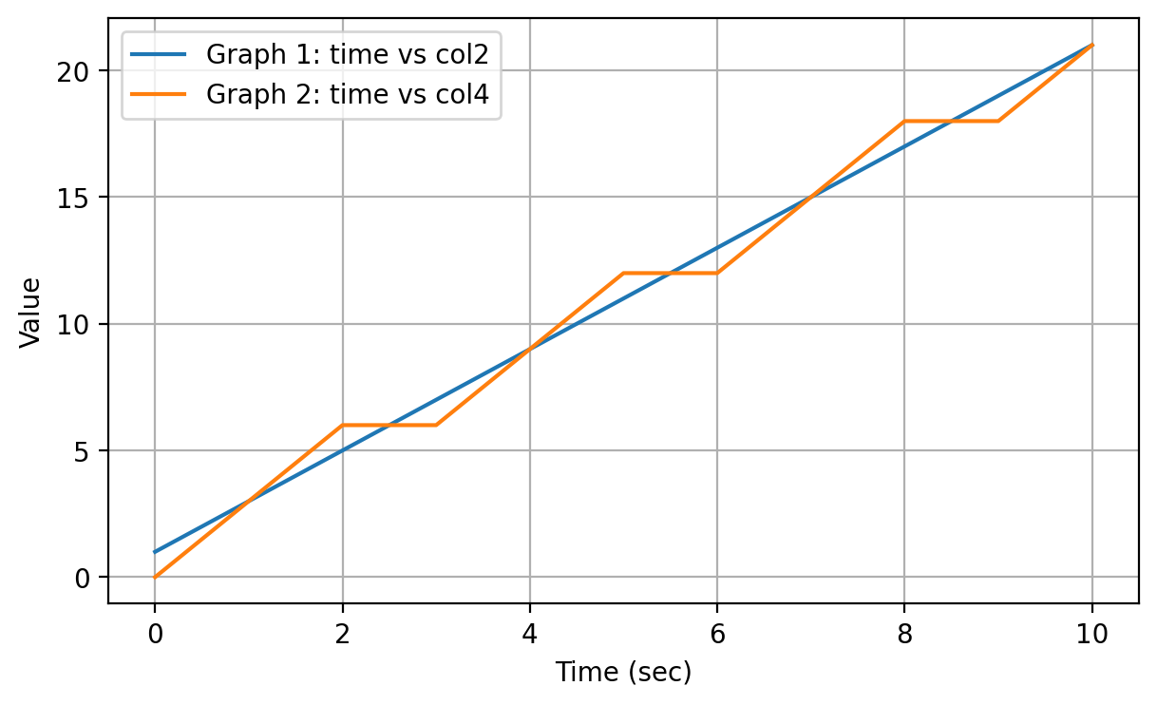
- Task 6 — Plot 2D graphs from the list (at least 2 graphs)
I used matplotlib.pyplot.plot() to plot graphs.
- X-axis: time (column 1)
- Y-axis: column 2 for the first graph
Then I added a second graph (another series) on the same plot to satisfy “at least 2 graphs.”
I added:
- axis labels (xlabel, ylabel)
- legend (legend())
- grid (grid(True))
This produces the required 2D visualization.

