ThesisTrack
Web-Based Thesis Management System
Process and Flow of the System, System Features and Flowcharts
Group name
Prepared by
Submitted to (Adviser)
School / Program
Date submitted
For checking by the thesis adviser.

Table of Contents
1. System Overview 3
2. System Users and Roles 3
3. System Features 3
3.1 Student 3
3.2 Adviser 4
3.3 Coordinator 4
3.4 AI Features (free) 5
3.5 Notifications 5
3.6 General System Features 5
4. Process and Flow of the System 6
5. Flowcharts 6
6. Status Rules 16
7. Security and Data Protection 16
8. Limitations and Future Work 17

1. System Overview
This document describes how ThesisTrack works, what it can do and how its main processes flow. It is submitted to the thesis adviser for checking.
ThesisTrack is a web-based system that manages the thesis process of a school from group formation up to the final defense. Students submit their thesis chapters online, advisers review them and leave feedback, and the thesis coordinator monitors every group, assigns advisers and schedules defenses. Free AI tools help students and advisers check similarity and grammar and answer questions.
The system is built with Node.js and the Express framework, EJS page templates and a MySQL database (run through XAMPP). It is used through a web browser on a computer or a phone, so users do not need to install anything.

Objectives
- Replace paper and email routing of thesis chapters with one online workflow.
- Let advisers review each chapter version and give written feedback in one place.
- Show everyone the real-time progress of each group and warn about delayed chapters.
- Help the coordinator assign advisers, schedule defenses and produce reports.
- Support students with free AI tools: a similarity check, grammar suggestions and a question-and-answer assistant.

2. System Users and Roles
User | Description | Signs in?
Student | Registers with a name, student ID number, email and a photo of the student ID. Forms or joins a thesis group, uploads chapters, requests consultations and uses the AI tools. | Yes
Adviser | Cannot register alone. The coordinator sends an invitation with a one-time 6-digit code. Reviews chapters of the groups assigned to them and uses the AI tools. | Yes
Coordinator | The administrator. Manages users, adviser invitations, panel members, groups, defense schedules, announcements and reports, and uses the AI tools. | Yes
Panel member | Record only. Added by the coordinator and attached to a group's defense, as recommended by the advisers. Has no account and no dashboard. | No

3. System Features

3.1 Student
- Registration with ID photo: name, unique student ID number, email, password and a photo of the student ID (taken with the device camera or chosen as a file).
- Thesis group: create a group with a name and thesis title, add members by email, and add more members later.
- Chapter submission: upload each of the five chapters as PDF, DOC or DOCX (up to 10 MB). Each upload is saved as a new version, so older versions are never overwritten.
- Feedback: read the adviser's comments, mark each one as resolved, or open it again.
- Progress tracking: the dashboard shows each chapter's status, deadline, version history and overall progress (for example, 3 of 5 chapters approved).
- Consultation requests: book a date, time slot and topic with the assigned adviser.
- Defense schedule: see the date, time and room set by the coordinator.
- AI check: run the plagiarism check and grammar suggestions on any uploaded version, and ask the chatbot questions (Section 3.4).
- Notifications and announcements: in-app alerts grouped by sender (Section 3.5).

3.2 Adviser
- Invitation-only registration: registers using the invited email and the 6-digit code sent by the coordinator.
- Accept or decline groups: the coordinator's assignment is only a request. The adviser accepts it, or declines it with a reason.
- Chapter review: download the latest version, then Approve, Return for revision or Reject. A comment is required unless the chapter is approved.
- Comments and deadlines: add comments at any time and set or change a chapter's deadline.
- Consultations: confirm or decline consultation requests from the groups.
- Group overview: a dashboard of assigned groups with pending reviews and progress.
- AI check and chatbot: run the similarity and grammar checks on a submitted version before or during review.

3.3 Coordinator
- Overview dashboard: number of groups and users, on-track, delayed and completed groups, groups without an adviser, and recent activity.
- User management: add users, activate or deactivate accounts, reset a user's password, and view each student's ID number and ID photo.
- Adviser invitations: send an invitation with a one-time code (valid for 60 minutes), send a new code, or cancel the invitation.
- Panel members: add, edit, deactivate or delete panel member records.
- Group management: request an adviser for a group, record at least two panel members, and set the defense date, time and room. The chapters table links to each group's latest file and its AI check.
- Announcements: post announcements that notify every active user.
- Reports and activity log: view the status of all groups and export them as a CSV file that opens in Excel; review and filter the log of important actions and download it as CSV.

3.4 AI Features (free)
The AI tools are available on every uploaded version through the "AI check" link, and the chatbot is available on every page. They use free services, so they cost the school nothing. Each person has an hourly allowance so the free daily limit is shared fairly.
Tool | What it does | How it works
Plagiarism (similarity) check | Shows the percentage of a chapter's wording that also appears in other groups' work, the closest files and the matching passages. Marked Low, Check or High. Students see "Another group"; advisers and the coordinator see the group names. | Runs on the system's own server with no AI service. Reads the text of PDF, DOCX and TXT files and compares runs of 6 words with the latest upload of every other group. It does not search the internet.
Grammar suggestions | Lists up to 15 grammar, spelling, punctuation and clarity fixes for one part of a chapter (about 1,200 words), each with the original text, a suggestion and the reason. | The chosen part is sent to a free AI service (Google Gemini free tier, or Ollama running on the school computer). Suggestions are advice only.
Chatbot | Answers questions about thesis writing, chapter requirements, defense preparation and how to use ThesisTrack. For students it also knows their group's chapter status and deadlines. | The "Ask AI" button opens a chat window. The last messages are sent with each question. It never writes the thesis for the student and cannot change any data.

3.5 Notifications
Notifications are shown on one page and grouped by who sent them, so messages are easy to read:
- From the adviser: chapter reviews, comments, new deadlines and consultation answers.
- From the coordinator: defense schedule, announcements, adviser requests and password resets.
- From students: new uploads, consultation requests and being added to a group.
- Reminders: chapters due within 3 days or overdue, sent automatically once an hour.
Each message is shown in its own box. Unread messages are highlighted, and a user can delete one message or clear all.

3.6 General System Features
- Role-based access: each role sees only its own pages and data.
- Five fixed thesis chapters: Introduction; Review of Related Literature; Methodology; Results and Discussion; Summary and Conclusion.
- Version history of every uploaded chapter.
- Automatic Delayed and Completed group status (see Section 6).
- Forgot-password link sent by email, and email delivery of adviser invitation codes (Gmail SMTP, or a log file when email is not configured).
- Phone-friendly layout: chapter and group tables become cards on small screens.
- Optional voice selection of the sign-in role, and light and dark display themes.
- Database backup script and a privacy notice page.

4. Process and Flow of the System
The system follows the stages below. Figure 1 shows the overall flow, and Figures 2 to 8 show the main processes in detail.
- Registration and sign in. A new student registers with a name, student ID number, email, password and ID photo. An adviser registers only with an invitation from the coordinator. The coordinator account is created by the system administrator. Every user then signs in by choosing a role and entering an email and password.
- Group formation. A student without a group creates one by entering a group name, a thesis title and the emails of the other members. The system saves the group and automatically creates the five chapters, each with a deadline.
- Adviser assignment. The coordinator picks an adviser on the group's page. This only sends a request. The adviser accepts it and becomes the adviser, or declines it with a reason, which is sent to the coordinator, who can then choose another adviser.
- Chapter submission. The student uploads a chapter file. The system saves it as a new version, sets the status to Pending review and notifies the adviser.
- Optional AI check. Before or after submitting, the student, adviser or coordinator can open "AI check" for any version to see how similar it is to other groups' work and to get grammar suggestions (Figure 6). Anyone can also ask the chatbot for help (Figure 7).
- Adviser review. The adviser reads the file and decides. Approved: the chapter is locked. For revision or Rejected: the adviser must leave a comment, and the student is notified.
- Revision cycle. The student reads the comment, marks it resolved, fixes the chapter and uploads a new version. The cycle repeats until the adviser approves the chapter. When all five chapters are approved, the group is Completed.
- Consultations. Once an adviser is assigned, the students can request a consultation by choosing a date, time slot and topic. The adviser confirms or declines, and the group is notified.
- Defense scheduling. The coordinator records at least two panel members and sets the defense date, time and room. The students are notified of the schedule.
- Notifications and reminders. At every step the system notifies the people concerned. Messages are grouped by sender (Figure 8), and deadline reminders are sent automatically.
- Monitoring and reports. The coordinator watches progress on the overview dashboard, posts announcements, reviews the activity log and exports reports.

5. Flowcharts
The flowcharts on the following pages use the standard symbols: oval for start or end, rectangle for a process, parallelogram for an input, and diamond for a decision. A dashed arrow means an optional step.
Figure | Title
Figure 1 | Overall system flow
Figure 2 | Chapter submission and review flow (updated with the optional AI check)
Figure 3 | Group, adviser and defense setup flow
Figure 4 | Adviser invitation and registration flow
Figure 5 | Consultation request flow
Figure 6 | AI check flow: plagiarism check and grammar suggestions (new)
Figure 7 | Chatbot flow (new)
Figure 8 | Notification flow (new)

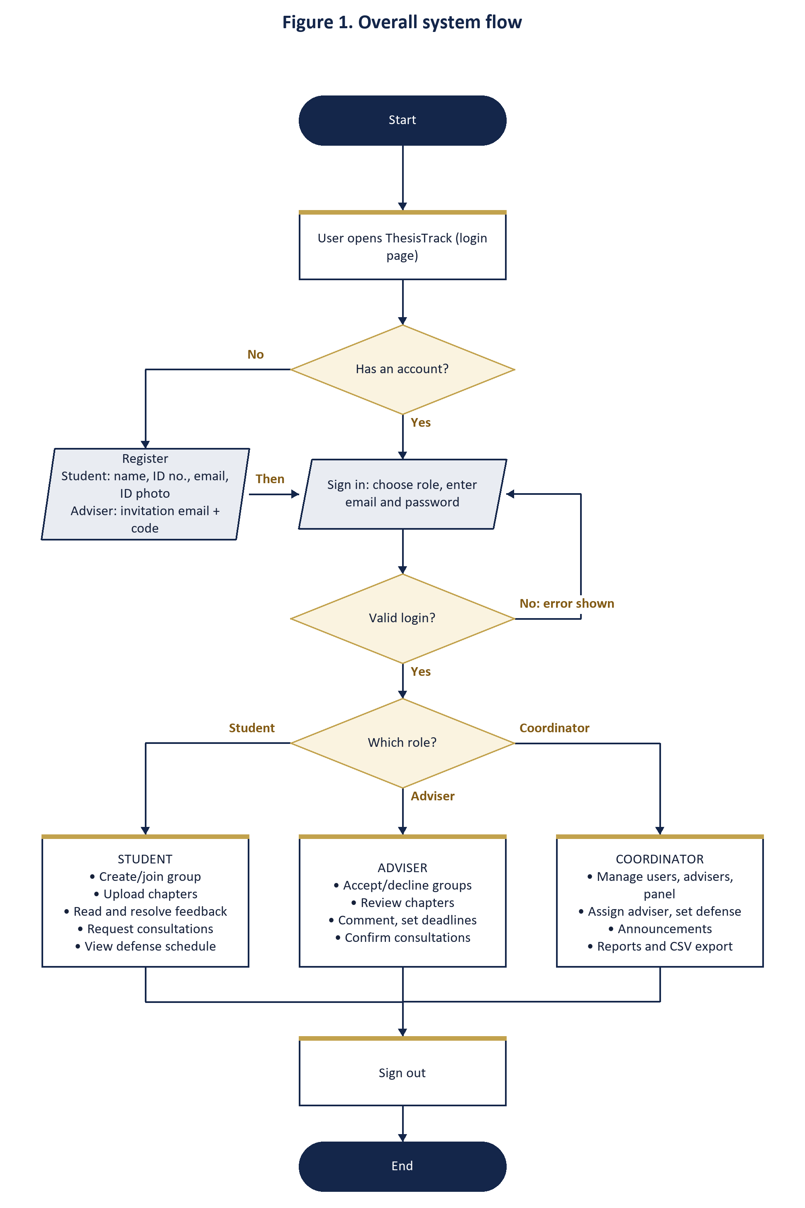

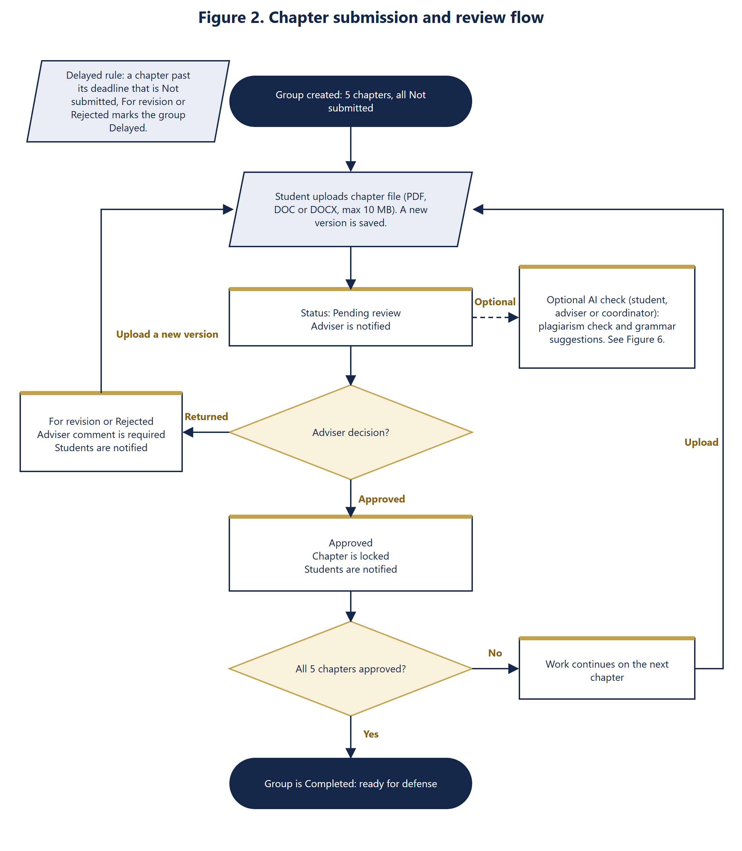

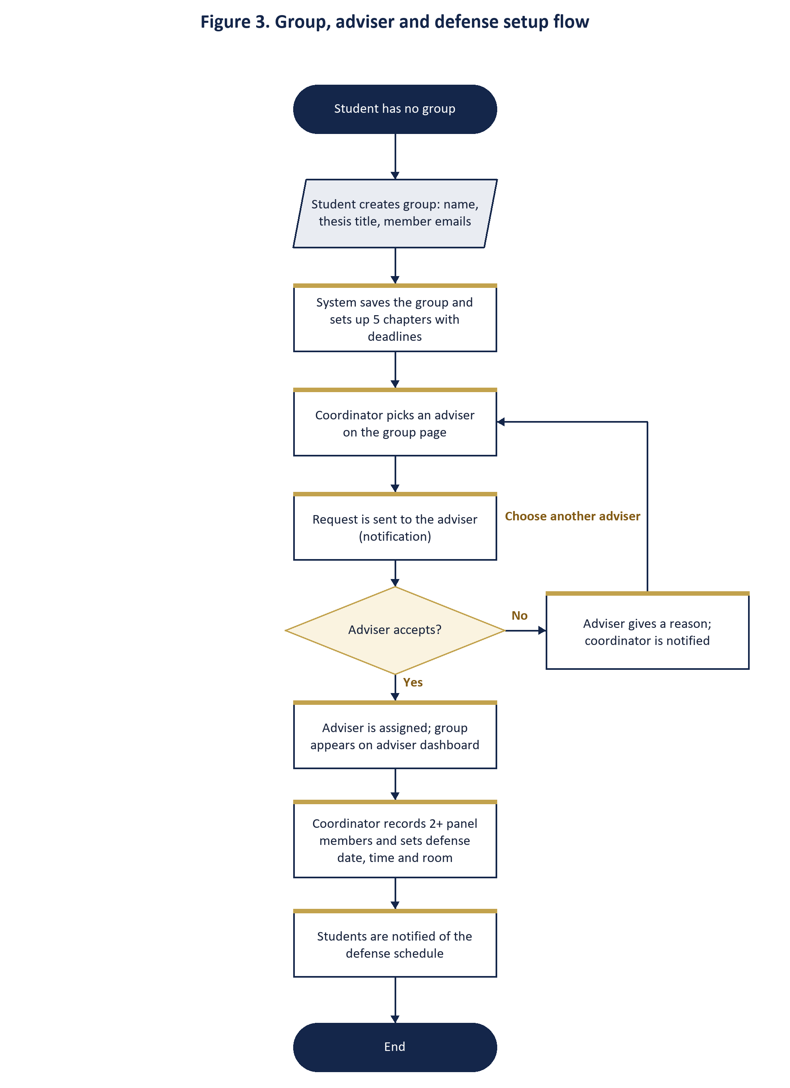

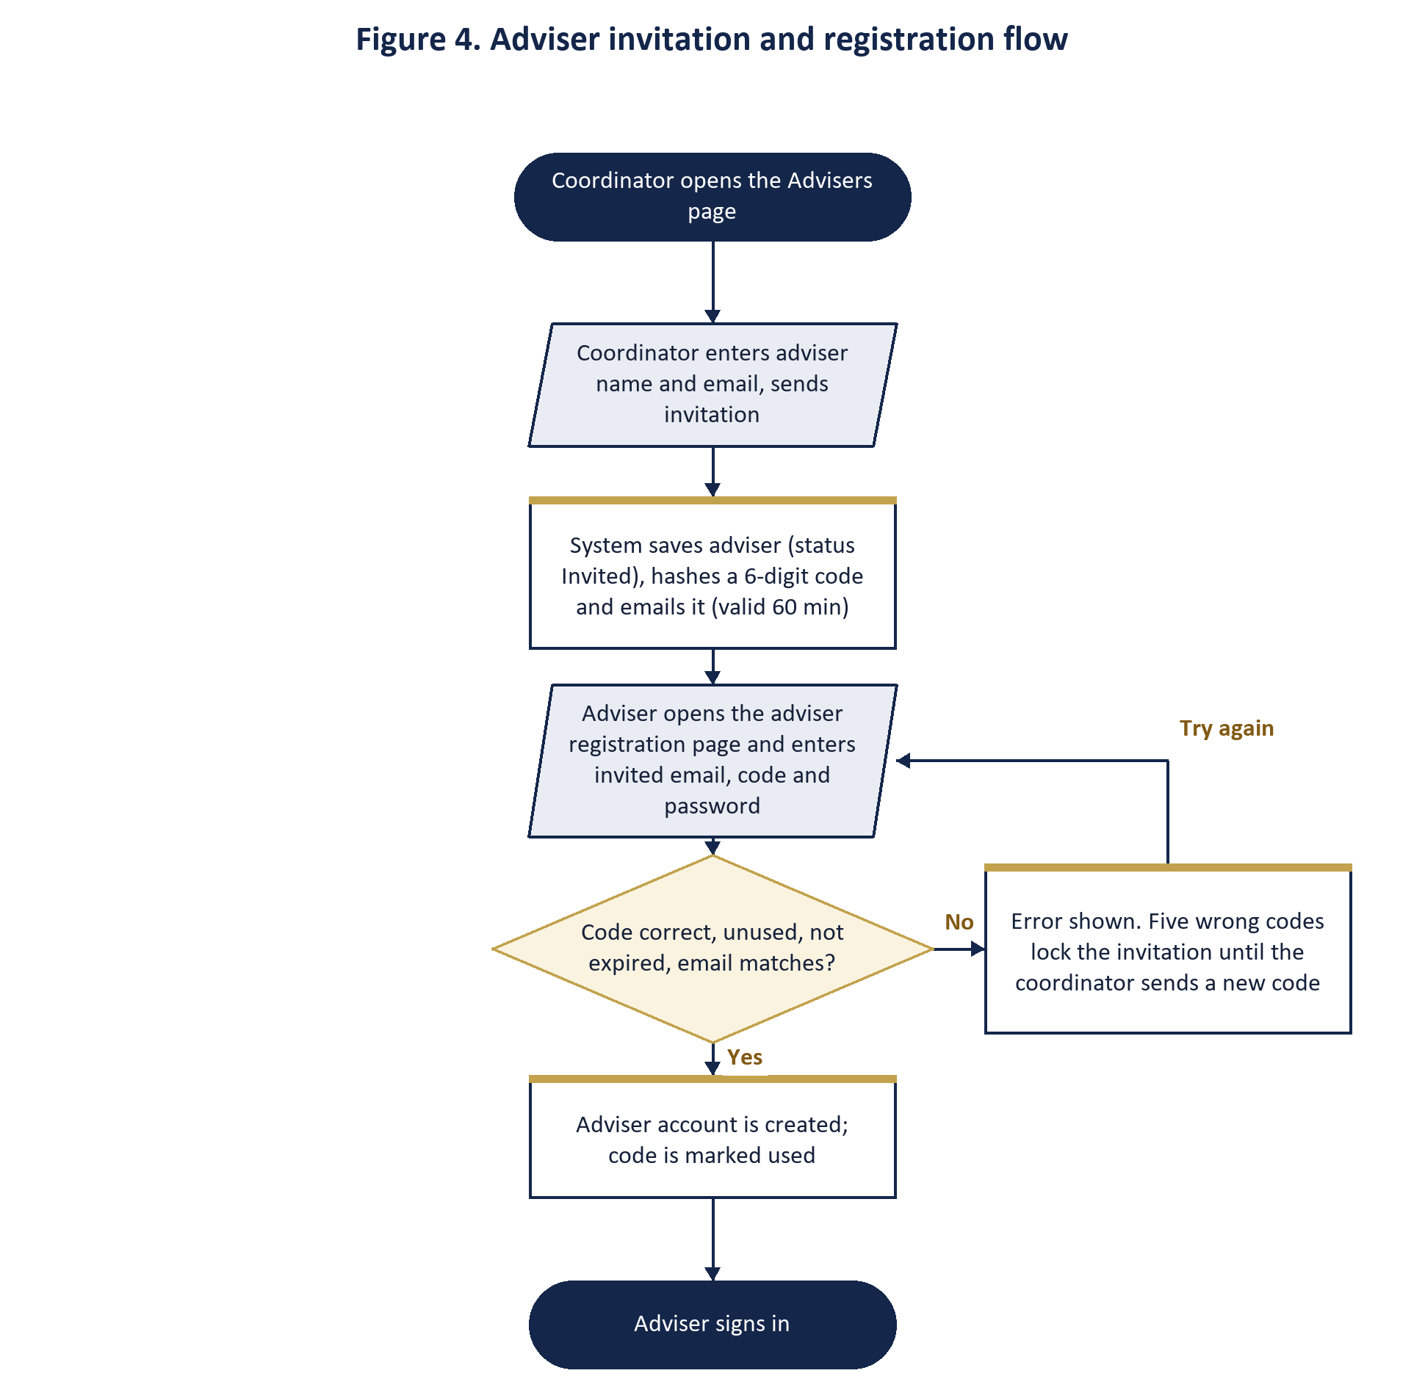

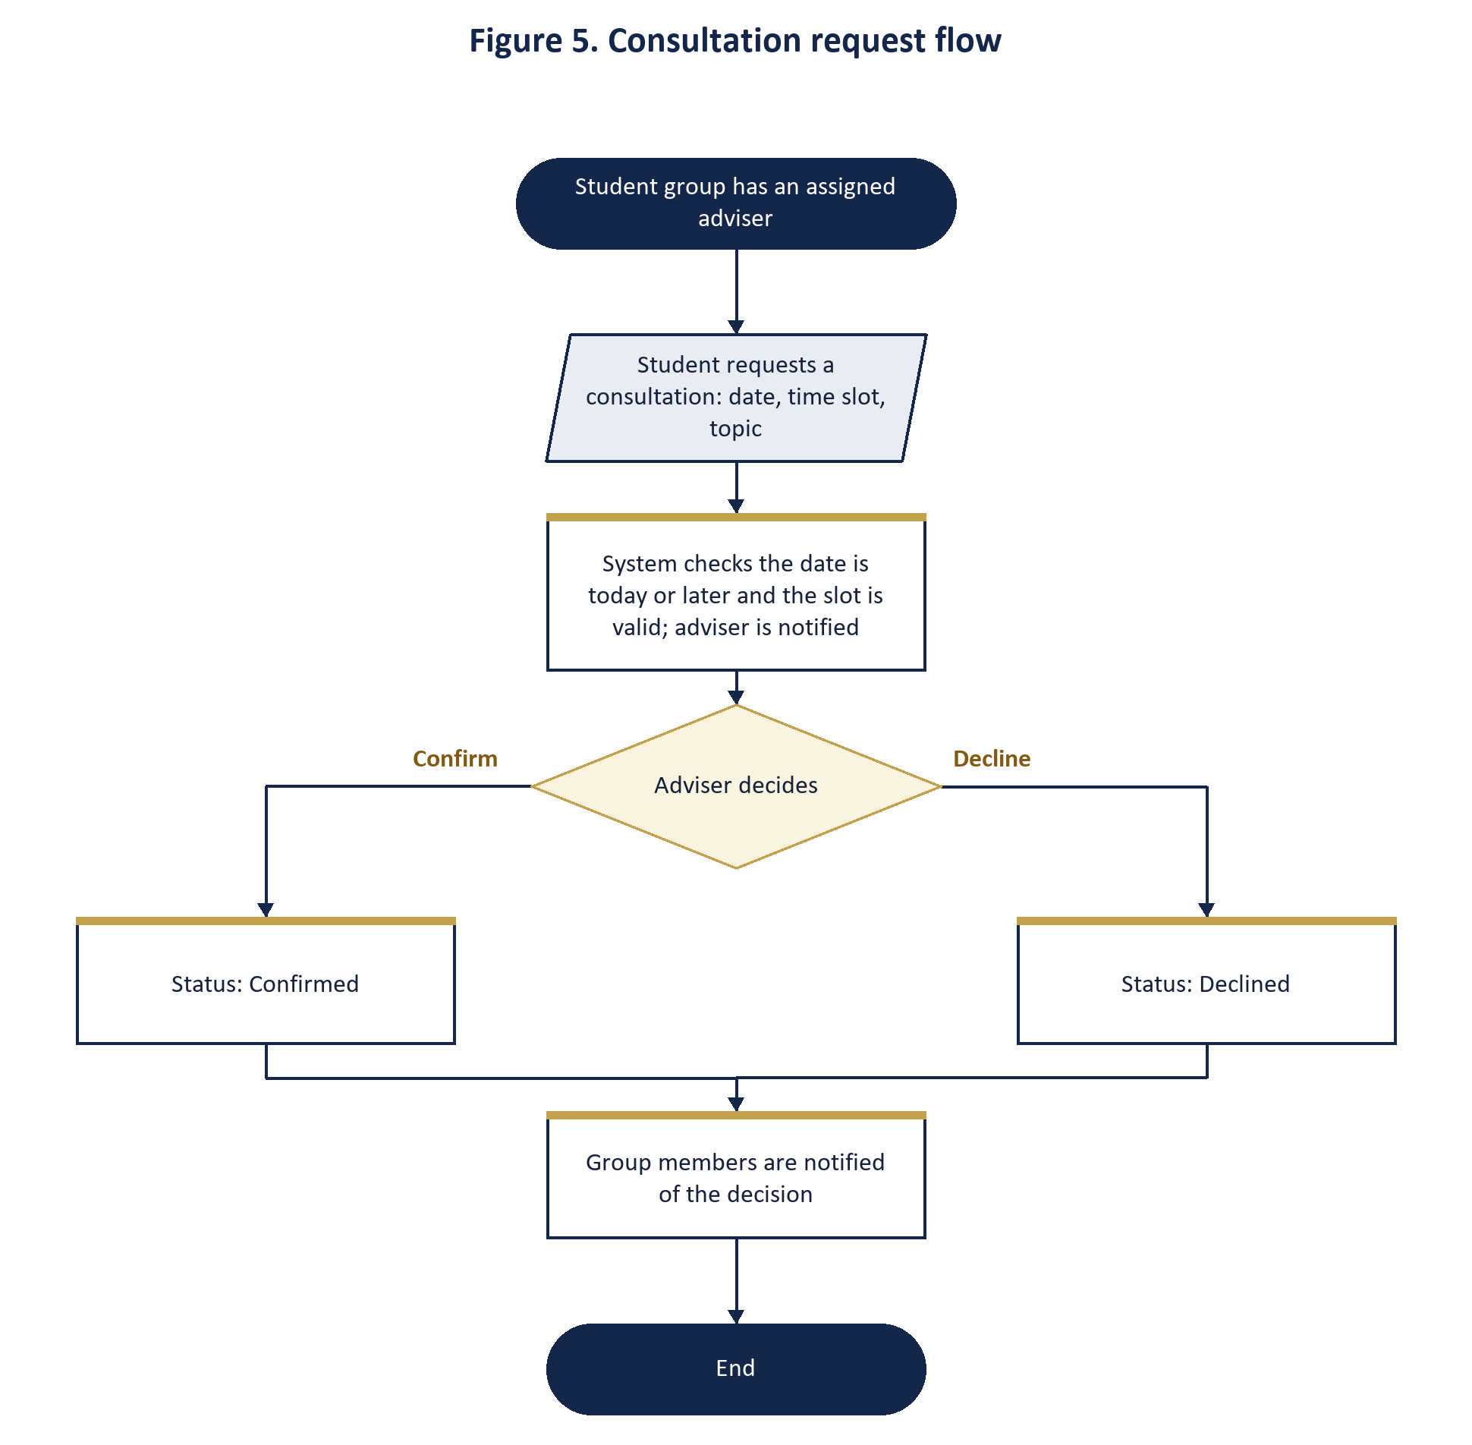

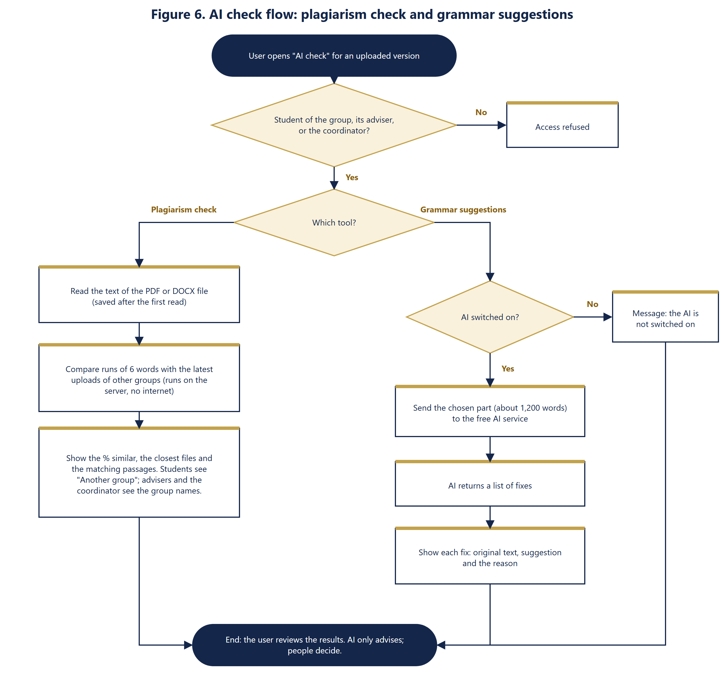

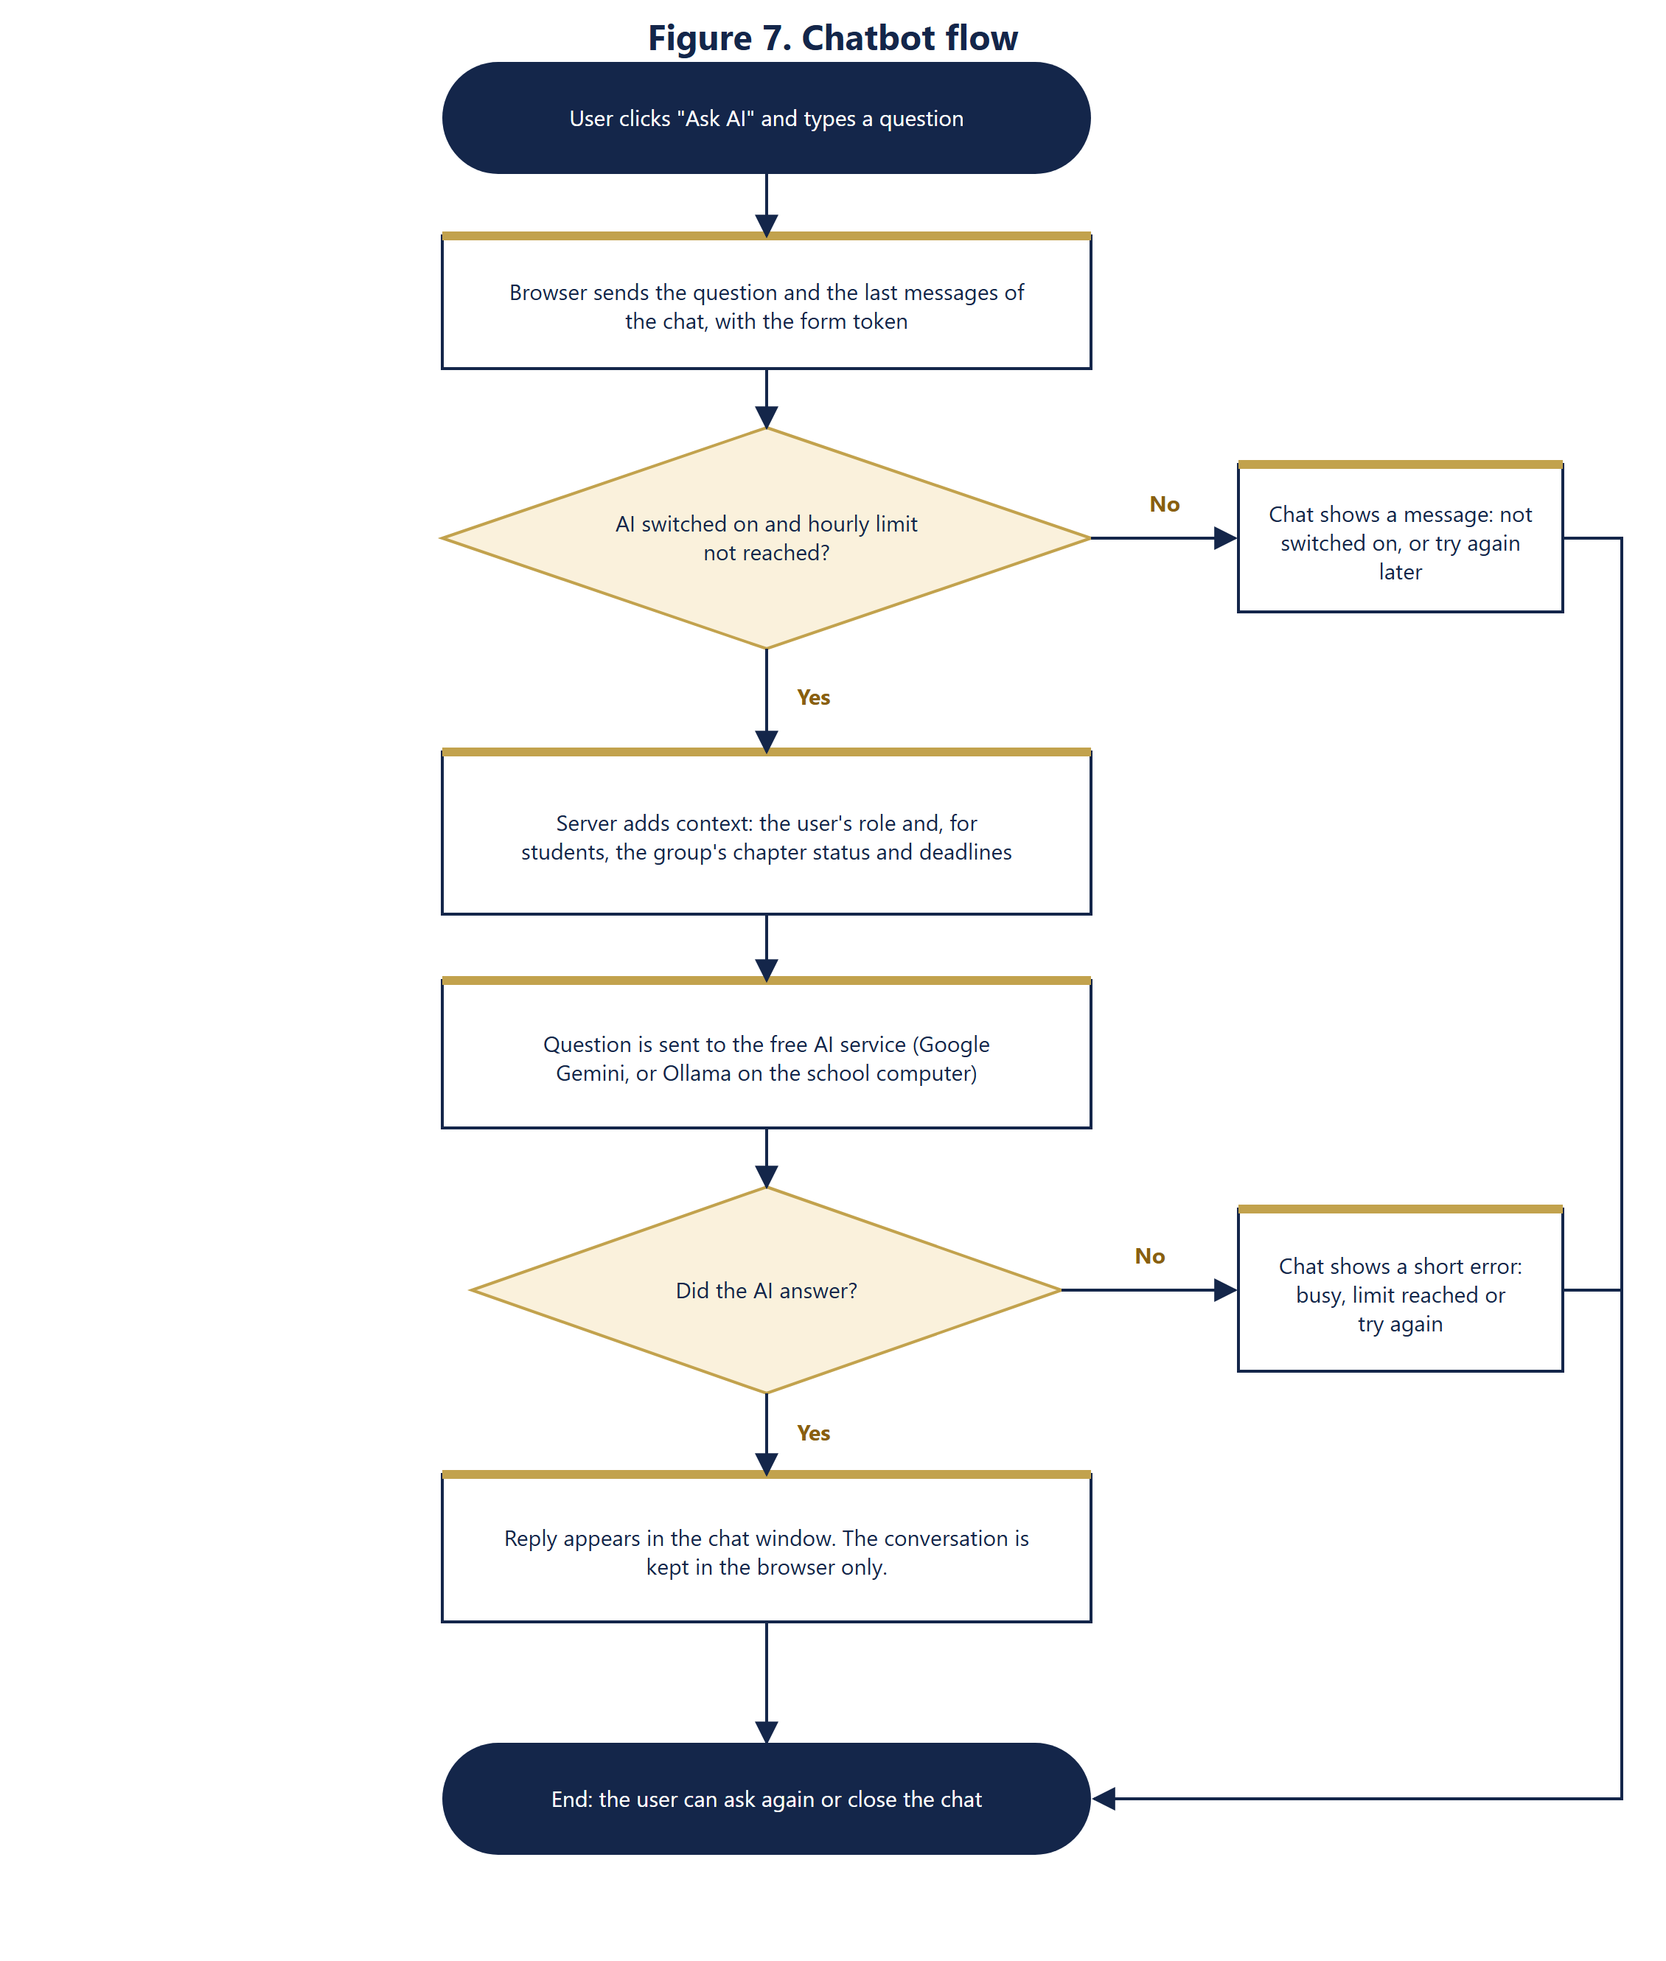

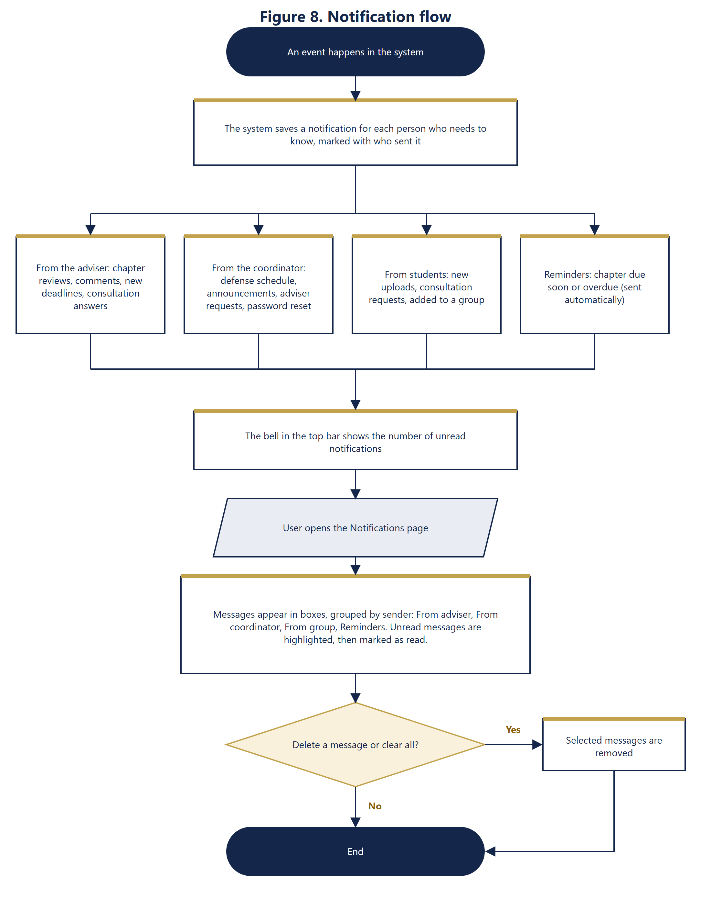

6. Status Rules

Chapter status
Status | Meaning
Not submitted | No file has been uploaded yet.
Pending review | The student uploaded a file and is waiting for the adviser.
For revision | The adviser returned the chapter with a comment. The student may upload a new version.
Rejected | The adviser rejected the chapter with a comment. The student may upload a new version.
Approved | The adviser approved the chapter. It is locked and cannot be changed.

Group status
Status | Rule
On track | No chapter is past its deadline while still Not submitted, For revision or Rejected.
Delayed | At least one chapter is past its deadline and is still Not submitted, For revision or Rejected.
Completed | All five chapters are Approved.

Similarity result (plagiarism check)
Result | Meaning
Low (under 10%) | Little of the chapter's wording appears in other groups' work.
Check (10% to 24%) | Some wording matches. A person should look at the matching passages.
High (25% or more) | A large part matches. The adviser should review the closest files and passages. The percentage is a guide only; common phrases can match by chance.

7. Security and Data Protection
- Passwords are stored as bcrypt hashes, with a minimum length of 8 characters. Adviser invitation codes are stored only as hashes and expire after 60 minutes; five wrong codes lock the invitation.
- Every form carries a CSRF token, and every database query uses bound parameters.
- Each page checks the user's role. Chapter files and AI checks can be opened only by the members and adviser of that group and by the coordinator.
- Uploads are limited to PDF, DOC and DOCX up to 10 MB, checked by their first bytes, and saved under random file names.
- Student ID photos are checked to be real images and are visible only to the coordinator and the student who owns the photo.
- Repeated failed sign-in attempts are blocked for 15 minutes, and password reset requests are limited.
- The similarity check runs on the system's own server, so chapter text is not sent anywhere. Grammar suggestions and the chatbot send the selected text or question to the AI service (Google Gemini free tier, or a model on the school computer if the coordinator sets that up). The privacy notice tells users this, and the AI key is kept in a private settings file that is not shared.
- The AI tools only suggest. People make every decision, such as approving a chapter.

8. Limitations and Future Work

Current limitations
- The similarity check compares only with other groups' uploads inside ThesisTrack. It does not search the internet or published papers, and it cannot read scanned PDFs or old .doc files.
- The free AI services have daily limits and can be busy at times. The system then shows a short message and the user tries again later.
- Free AI plans may keep what is sent to them, so private or sensitive text should not be checked with the grammar tool or the chatbot.
- Panel members are records only. Their scores and comments are not entered in the system.

Possible future work
- Defense result entry by the coordinator and a checklist to track the revisions required by the panel.
- A title proposal stage and an archive of completed theses, which would also make the similarity check stronger.
- Calendar export and conflict warnings when scheduling defenses.
- A usability evaluation with real students and advisers to measure the system's effectiveness.

