ThesisTrack
Web-Based Thesis Management System
Process and Flow of the System, System Features and Flowcharts

1. System Overview
ThesisTrack is a web-based system that manages the thesis process of a school from group formation up to the final defense. Students submit their thesis chapters online, advisers review them and leave feedback, and the thesis coordinator manages users, advisers, defense panels, schedules and reports. Every action is tracked, so students, advisers and the coordinator can always see the current status of each thesis group.
The system is built with Node.js and the Express framework, EJS page templates and a MySQL database (run through XAMPP). It is used through a web browser, so users do not need to install anything.

Objectives
- Replace paper and email routing of thesis chapters with one online workflow.
- Let advisers review each chapter version and give written feedback in one place.
- Show everyone the real-time progress of each group and warn about delayed chapters.
- Help the coordinator assign advisers, schedule defenses and produce reports.

2. System Users and Roles
User | Description | Signs in?
Student | Registers with a name, student ID number, email and a photo of the student ID. Forms or joins a thesis group, uploads chapters and requests consultations. | Yes
Adviser | Cannot register alone. The coordinator sends an invitation with a one-time 6-digit code. Reviews chapters of the groups assigned to them. | Yes
Coordinator | The administrator. Manages users, adviser invitations, panel members, groups, defense schedules, announcements and reports. | Yes
Panel member | Record only. Added by the coordinator and attached to a group's defense. Has no account and no dashboard. | No

3. System Features

3.1 Student
- Registration with ID photo: name, unique student ID number, email, password and a photo of the student ID (taken with the device camera or chosen as a file).
- Thesis group: create a group with a name and thesis title, add members by email, and add more members later.
- Chapter submission: upload each of the five chapters as PDF, DOC or DOCX (up to 10 MB). Each upload is saved as a new version, so older versions are never overwritten.
- Feedback: read the adviser's comments, mark each one as resolved, or open it again.
- Progress tracking: the dashboard shows each chapter's status, deadline, version history and overall progress (for example, 3 of 5 chapters approved).
- Consultation requests: book a date, time slot and topic with the assigned adviser.
- Defense schedule: see the date, time and room set by the coordinator.
- Notifications and announcements: in-app alerts for reviews, comments, deadlines, consultations and announcements.

3.2 Adviser
- Invitation-only registration: registers using the invited email and the 6-digit code sent by the coordinator.
- Accept or decline groups: the coordinator's assignment is only a request. The adviser accepts it, or declines it with a reason.
- Chapter review: download the latest version, then Approve, Return for revision or Reject. A comment is required unless the chapter is approved.
- Comments and deadlines: add comments at any time and set or change a chapter's deadline.
- Consultations: confirm or decline consultation requests from the groups.
- Group overview: a dashboard of assigned groups with pending reviews and progress.

3.3 Coordinator
- Overview dashboard: number of groups and users, on-track, delayed and completed groups, groups without an adviser, and recent activity.
- User management: add users, activate or deactivate accounts, and view each student's ID number and ID photo.
- Adviser invitations: send an invitation with a one-time code (valid for 60 minutes), send a new code, or cancel the invitation.
- Panel members: add, edit, deactivate or delete panel member records.
- Group management: request an adviser for a group, record at least two panel members, and set the defense date, time and room.
- Announcements: post announcements that notify every active user.
- Reports: view the status of all groups and export them as a CSV file that opens in Excel.

3.4 General System Features
- Role-based access: each role sees only its own pages and data.
- Five fixed thesis chapters: Introduction; Review of Related Literature; Methodology; Results and Discussion; Summary and Conclusion.
- Version history of every uploaded chapter.
- Automatic Delayed and Completed group status (see Section 6).
- In-app notifications and an activity log of important actions.
- Email delivery of adviser invitation codes (Gmail SMTP, or a log file when email is not configured).
- Light and dark display themes.

4. Process and Flow of the System
The system follows the stages below. Figure 1 shows the overall flow, and Figures 2 to 5 show the main processes in detail.
- Registration and sign in. A new student registers with a name, student ID number, email, password and ID photo. An adviser registers only with an invitation from the coordinator. The coordinator account is created by the system administrator. Every user signs in by choosing a role, then entering an email and password. Ten failed attempts from one address block further tries for 15 minutes.
- Group formation. A student without a group creates one by entering a group name, a thesis title and the emails of the other members. The system saves the group and automatically creates the five chapters, each with a deadline.
- Adviser assignment. The coordinator picks an adviser on the group's page. This only sends a request. The adviser accepts it and becomes the adviser, or declines it with a reason, which is sent to the coordinator, who can then choose another adviser.
- Chapter submission. The student uploads a chapter file. The system saves it as a new version, sets the status to Pending review and notifies the adviser.
- Adviser review. The adviser reads the file and decides. Approved: the chapter is locked. For revision or Rejected: the adviser must leave a comment, and the student is notified.
- Revision cycle. The student reads the comment, marks it resolved, fixes the chapter and uploads a new version. The cycle repeats until the adviser approves the chapter. When all five chapters are approved, the group is Completed.
- Consultations. Once an adviser is assigned, the students can request a consultation by choosing a date, time slot and topic. The adviser confirms or declines, and the group is notified.
- Defense scheduling. The coordinator records at least two panel members and sets the defense date, time and room. The students are notified of the schedule.
- Monitoring and reports. The coordinator watches progress on the overview dashboard, posts announcements and exports reports.

5. Flowcharts
The flowcharts on the following pages use the standard symbols: oval for start or end, rectangle for a process, parallelogram for an input, and diamond for a decision.
Figure | Title
Figure 1 | Overall system flow
Figure 2 | Chapter submission and review flow
Figure 3 | Group, adviser and defense setup flow
Figure 4 | Adviser invitation and registration flow
Figure 5 | Consultation request flow

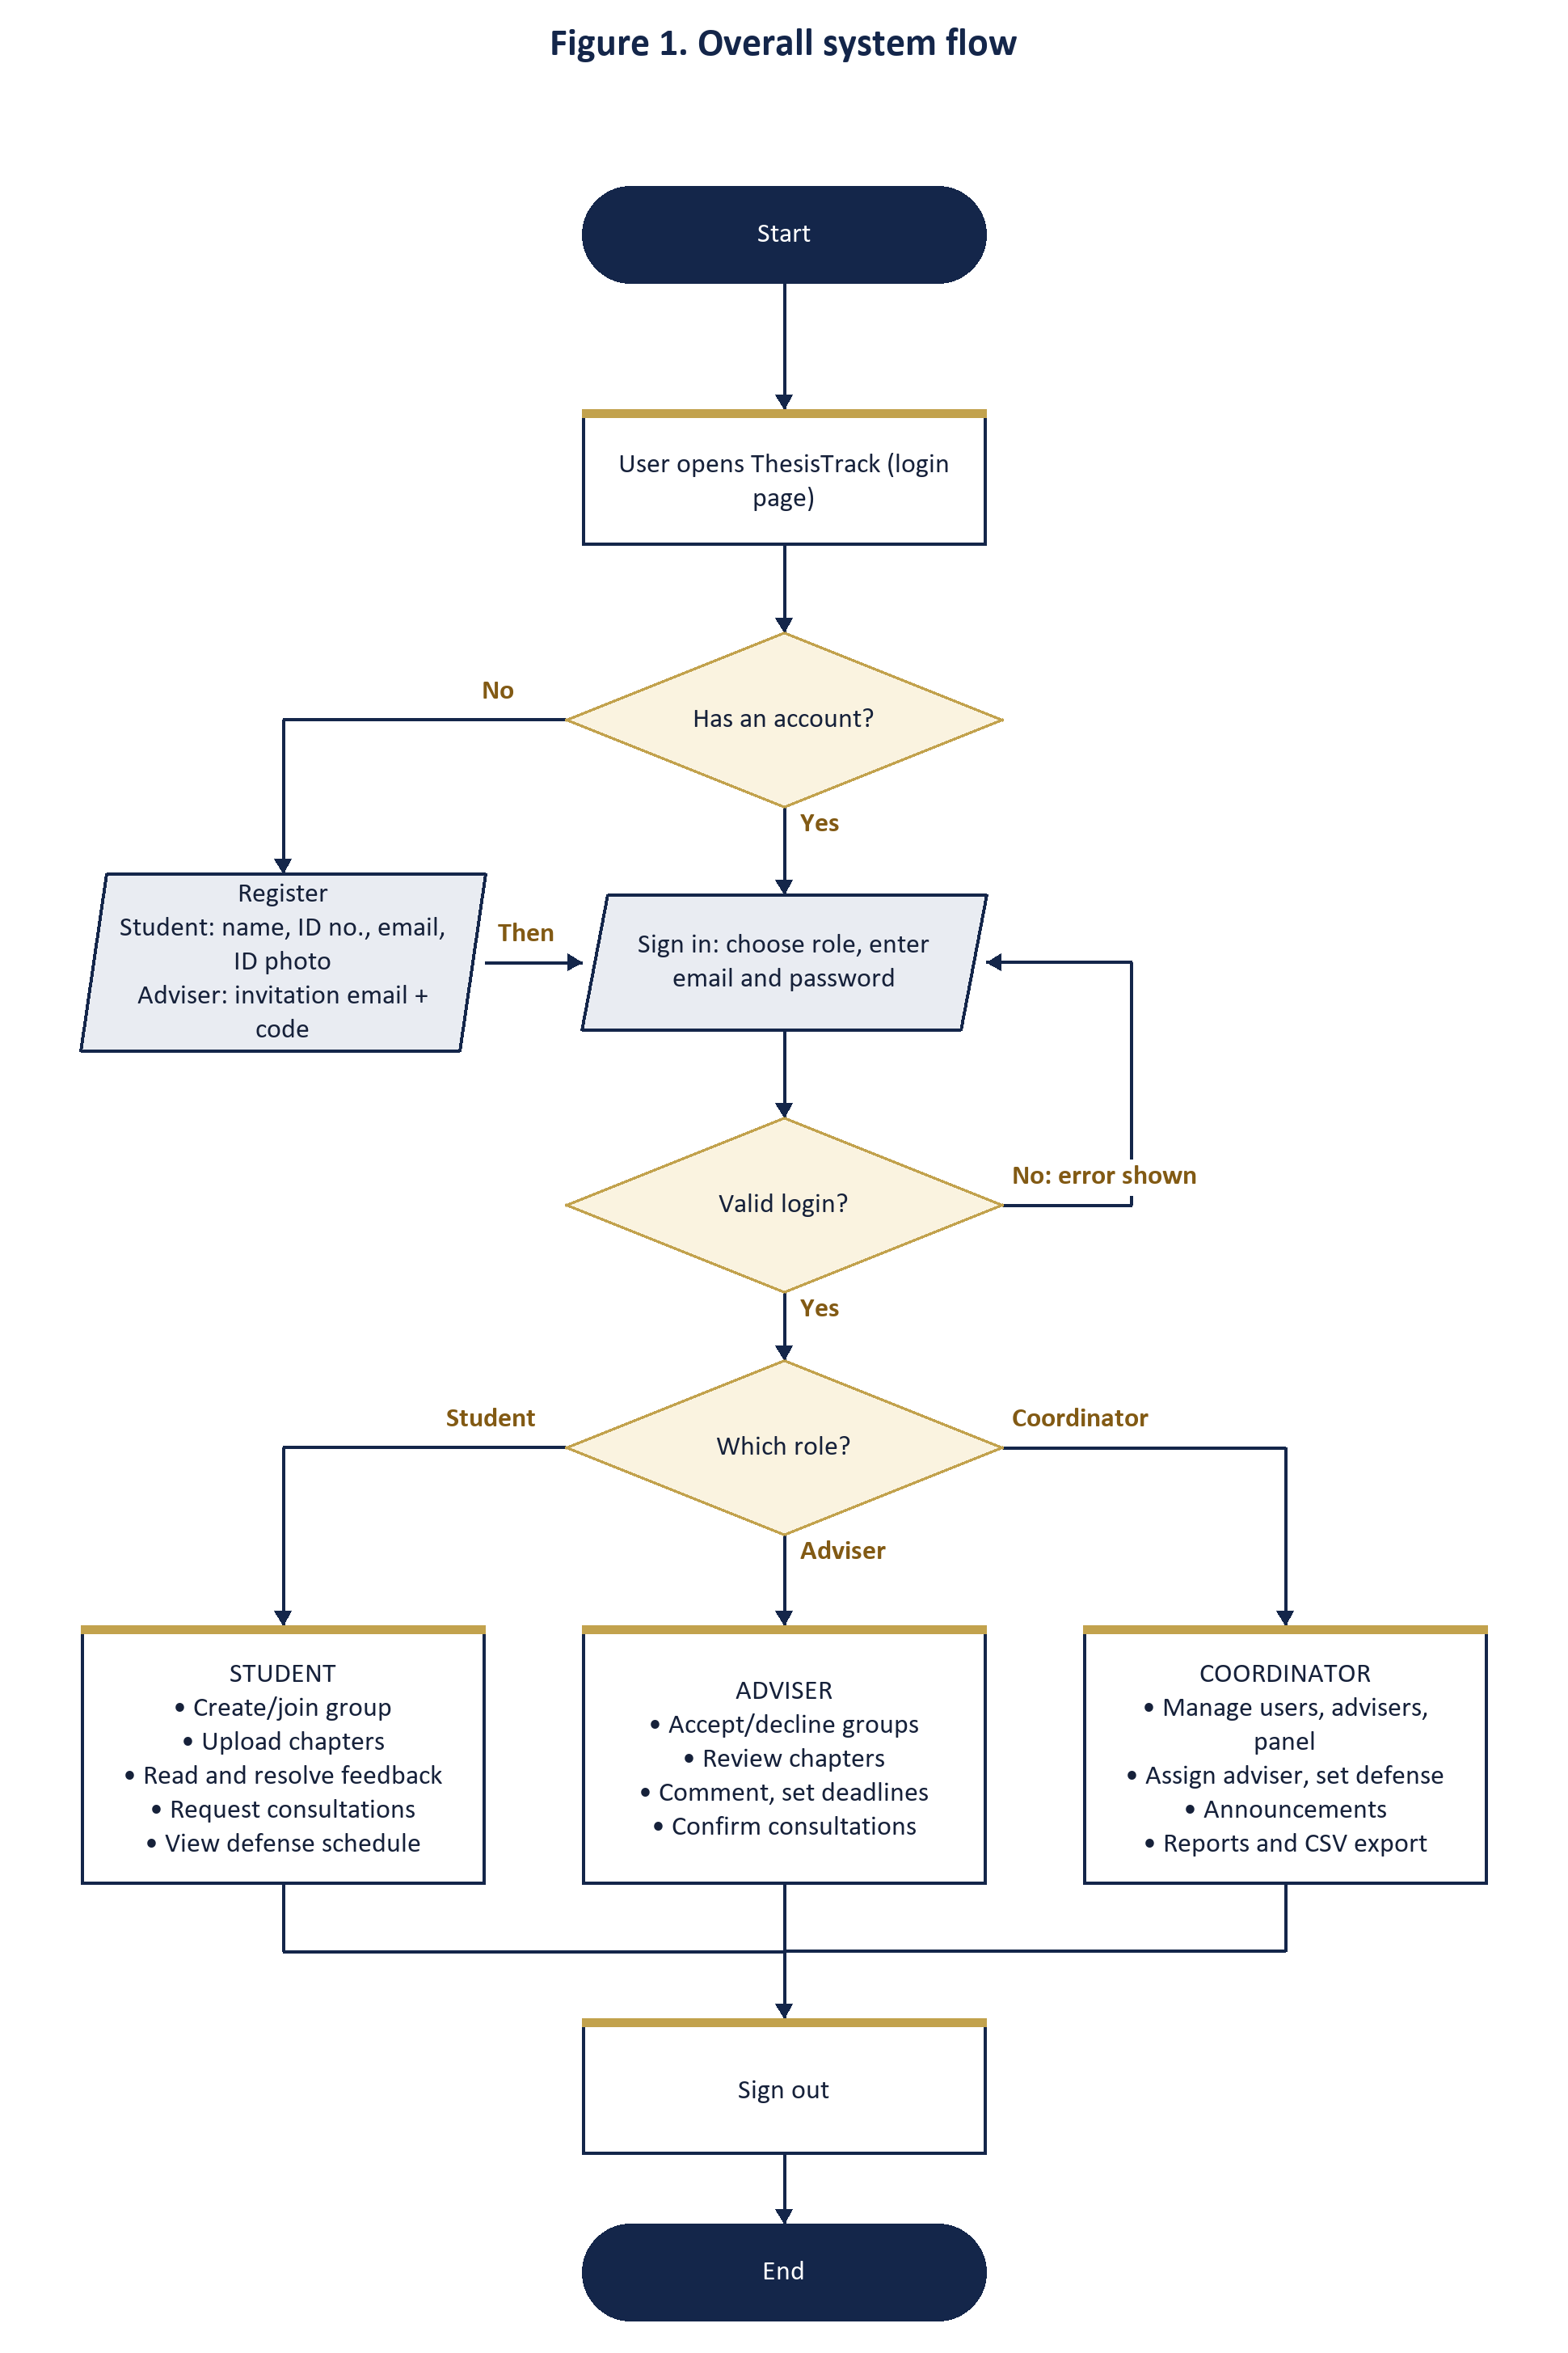
Figure 1. Overall system flow of ThesisTrack

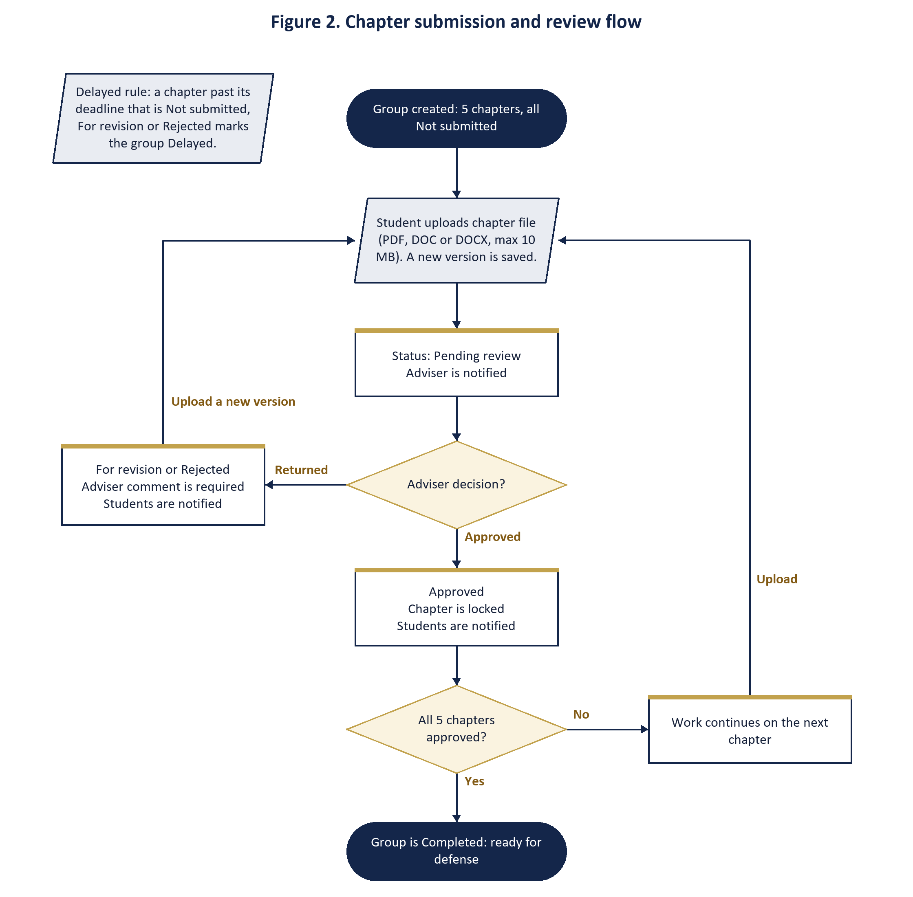
Figure 2. Chapter submission and review flow

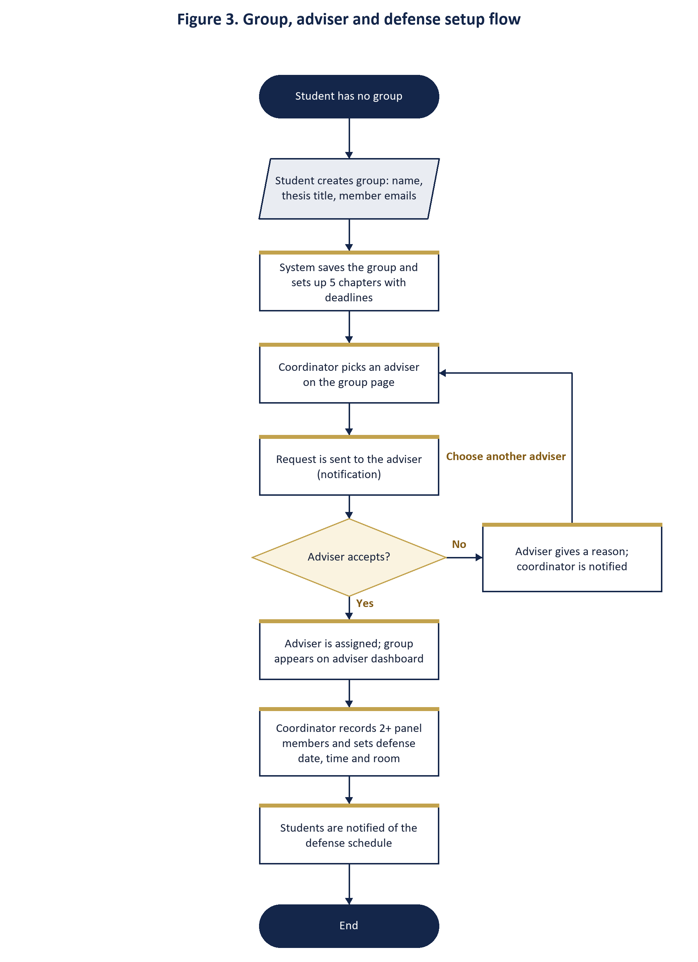
Figure 3. Group, adviser and defense setup flow

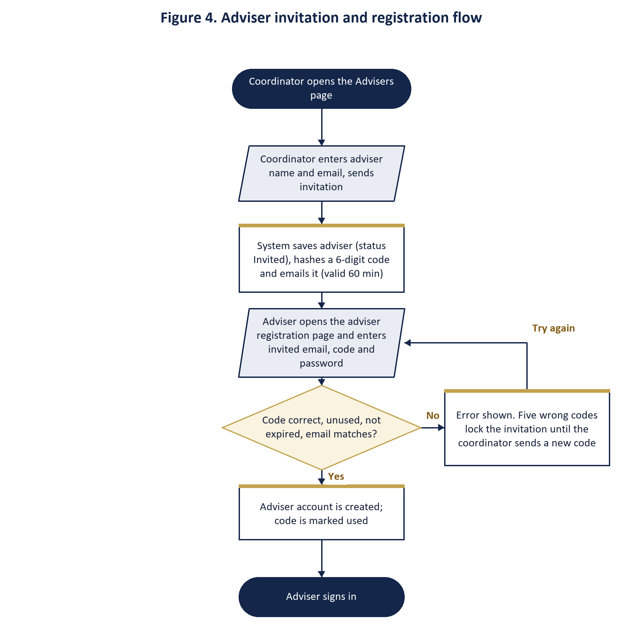
Figure 4. Adviser invitation and registration flow

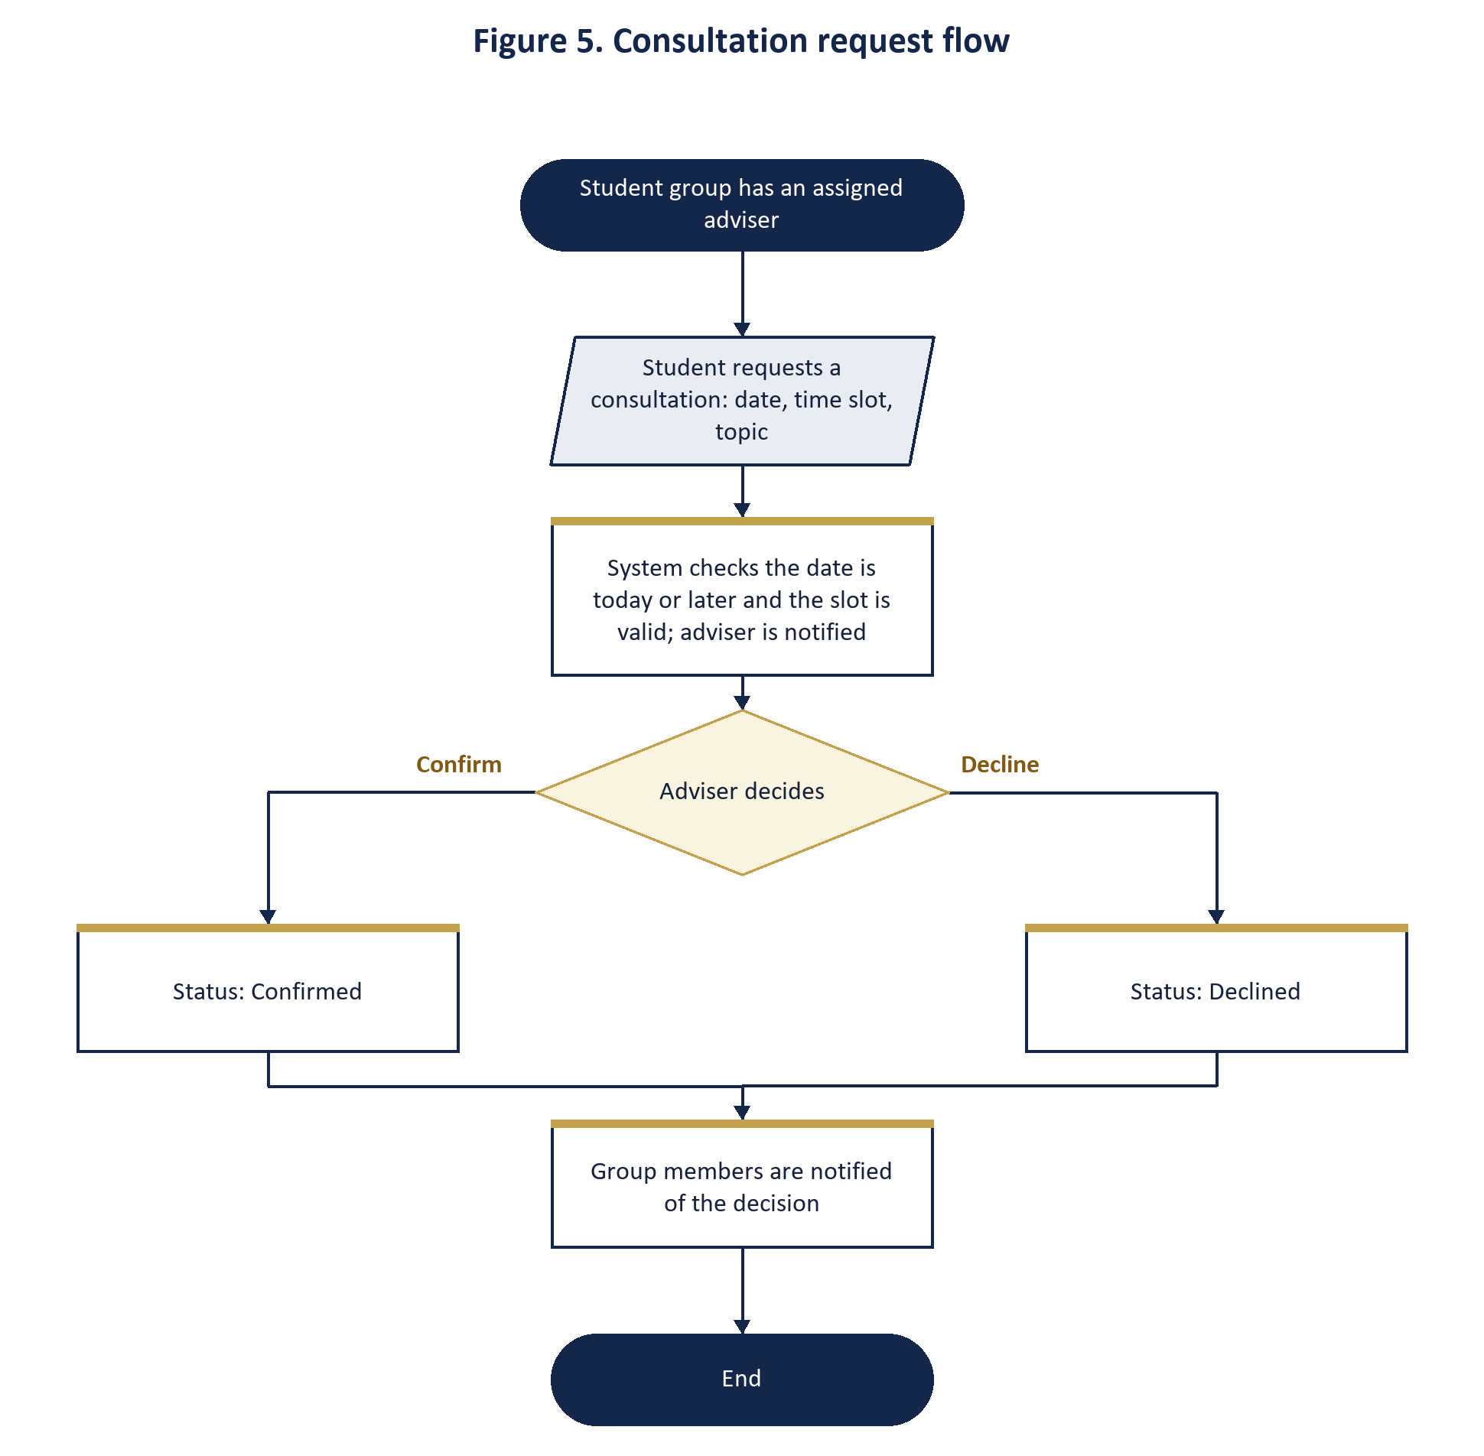
Figure 5. Consultation request flow

6. Status Rules

Chapter status
Status | Meaning
Not submitted | No file has been uploaded yet.
Pending review | The student uploaded a file and is waiting for the adviser.
For revision | The adviser returned the chapter with a comment. The student may upload a new version.
Rejected | The adviser rejected the chapter with a comment. The student may upload a new version.
Approved | The adviser approved the chapter. It is locked and cannot be changed.

Group status
Status | Rule
On track | No chapter is past its deadline while still Not submitted, For revision or Rejected.
Delayed | At least one chapter is past its deadline and is still Not submitted, For revision or Rejected.
Completed | All five chapters are Approved.

7. Security and Data Protection
- Passwords are stored as bcrypt hashes. Adviser invitation codes are stored only as hashes and expire after 60 minutes; five wrong codes lock the invitation.
- Every form carries a CSRF token, and every database query uses bound parameters.
- Each page checks the user's role. Chapter files can be downloaded only by the members and adviser of that group and by the coordinator.
- Uploads are limited to PDF, DOC and DOCX up to 10 MB and are saved under random file names.
- Student ID photos are checked to be real images and are visible only to the coordinator and the student who owns the photo.
- Repeated failed sign-in attempts are blocked for 15 minutes.

