- Solution Approach

The following section will describe the design steps for the solution of Sustainable Living.
The following java interface are introduced -

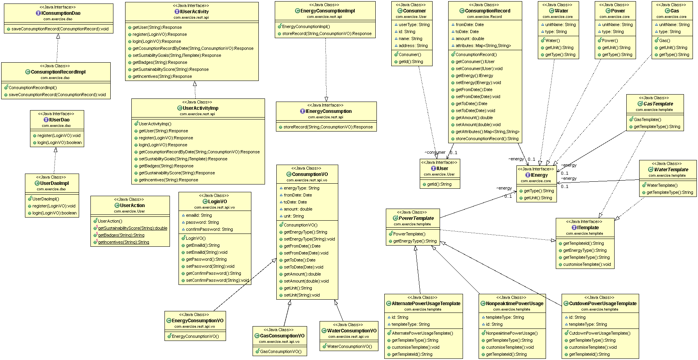

Class diagram of Sustainable Living solution

- Interface – The following interfaces are created -
  - Core Interfaces -
    - IEnergy – This is the base interface for energy. Different types energy can be created by this interface.
    - IUser – This is the base interface for users of the system. Various types of the user could be created from this interface
    - ITemplate – This is the base interface for goal template. Differenct types of energy saving template could be created by this interface.
  - Dao Interface -
    - IConsumptionDao – User consumption related database operation can be managed by this interface.
    - IUserDao – User specific database operation can be managed by IuserDao interfae.
  - Rest API Interface -
    - IUserActivity – This Rest API provides the facility of user activity with the system. All the user related opration can be done through this api.
    - IenergyConsumption – This interface exposes the Rest API for tracking the energy consumption. All the energy consumption related operations could be found in this api.
- Third party integration -
This solution approach provides an easy to go integration with third party system. Solution exposes the rest api according to funcationality, that will connect with the external system. The com.exercise.rest.api interface will expose the system api. System also may consume the external api as well.

- Data extensibility -
This soultion archtecture is interface driven. This design facilitates the data extensibilty at any point of time. The different modules are loosely couple and easy to incorporate new data point with out breaking the dependency among modules.
For an example, ConsumptionVO class holds the common consumption data for all energy types. The other energy specific consumptionVO (EnergyConsumptionVO, GasConsumptionVO, WaterConsumptionVO) holds the data for energy specific parameters.
At the same time, ConsumptionRecords class has attribute map to hold the other consumption parameters.

