
Student Name: IMMACULATE MUTHEU MULI
Admission Number: BSCCS/2024/33678
Course/Class: COMPUTER SCIENCE JANUARY 2024
Unit Code: BIT4133
Unit Name: NATURAL LANGUAGE PROCESSING
Lecturer Name: MR. MICHAEL NYORO
Semester/Academic Year: FOURTH YEAR

NLP Project Title: CBK Report Analyser
Technologies Used
- Python
- NLTK
- spaCy
- Gensim (Word2Vec)
- pdfplumber
- pandas
- matplotlib
- Google Colab
Google Colab Link
https://colab.research.google.com/drive/1n7Lh1C7h75jyABjd-qtnPnyS8uX7SXOA?usp=sharing
https://colab.research.google.com/drive/1yTooPvMbwfJq1NrN_yEY0lReaXORqUKV?usp=sharing
Github Link
https://github.com/immaculatemuli/Natural_Language_Processing.git
Table of Contents
Week 1: Introduction to NLP and Applications 6
Fig 1: Python Installation 7
Fig 2: Google Colab 7
Fig 3: NLTK Installation 8
Fig 4: Tokenization Output 8
Fig 5: Stopwords Removal Output 9
Fig 6: NLP Application Research Evidence 9
Week 2: N-gram Models and POS Tagging 11
Fig 1: Bigram or Trigram output 11
Fig 2: Python Code for POS Tagging 11
Fig 3: POS Tagging Example 12
Fig 4: Language Prediction Example and Output 12
Fig 5: Sentence Analysis Output 13
Week 3: Hidden Markov Models and Sequence Labeling 14
Fig 1: Sequence Labeling code 14
Fig 2: Hidden Markov ModelOutput 14
Fig 3: Named Entity Recognition Example and Output 15
Fig 4: Sentence Labeling Results 16
Fig 5: Dataset Used for Training or Testing 17
Week 4: Syntactic And Semantic Analysis 18
PRACTICAL TASK 1 18
Fig 1: Dependency Parsing Using spaCy 18
Fig 2:Semantic Similarity 19
CLASS ASSIGNMENT 1 20
Fig 1: Dependency Parsing Using spaCy 20
Fig 2:Semantic Similarity 21
Week 5: Mini NLP Project 22
Deliverable 1: Source code 22
Deliverable 2: Screenshots of chatbot interaction 22
Deliverable 3: Short Explanation Document 23
Deliverable 4: Reflection on challenges faced 24
Week 6: Word Embeddings and Distributed Representations 25
CLASS DEMONSTRATION 25
Fig 1:Installing Gensim 25
Fig 2:Training a Small Word2Vec Model 25
Fig 3:Finding Similar Words 26
Fig 4:Word Similarity Score 26
Fig 5:Visualizing Word Embeddings 26
CLASS ACTIVITY 27
Fig 1:Comparing Representation Methods 27
Fig 2:Similarity Investigation 28
Fig 3:Real-World NLP Discussion 28
PRACTICAL TASK 29
Fig 1:Train a Word2Vec Model 29
Fig 2:Similarity Analysis 29
Fig 3:Comparison Report 30
ADVANCED PRACTICAL TASK 30
Fig 1:Generate embeddings 30
Fig 2:Analyze semantic relationships 31
Fig 3:Visualize word clusters (PCA and t-SNE) 31
DOCUMENT OBSERVATIONS 32
CHALLENGE TASK - Modern Embedding Approaches 33
EXTRA TASKS 35
Week 1: Extra tasks 35
Fig 1: Stemming and lemmatization 35
Fig 2: Word frequency and counter visualization 35
Fig 3: NLU vs NLG demonstration 36
Week 2: Extra tasks 37
Fig 1: N-gram Frequency Chart 37
Week 3: Extra tasks 38
Fig 1: displaCy NER Visualization 38
Fig 2: Real HMM trained on CBK Report data 38

Week 1: Introduction to NLP and Applications
Title: Introduction to NLP Concepts and Text Processing

Fig 1: Python Installation
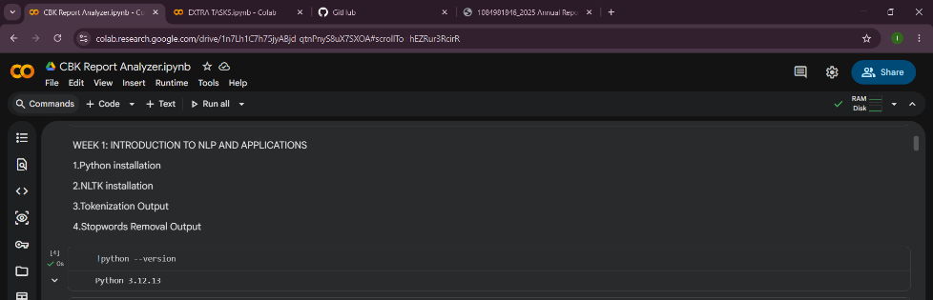

Fig 2: Google Colab
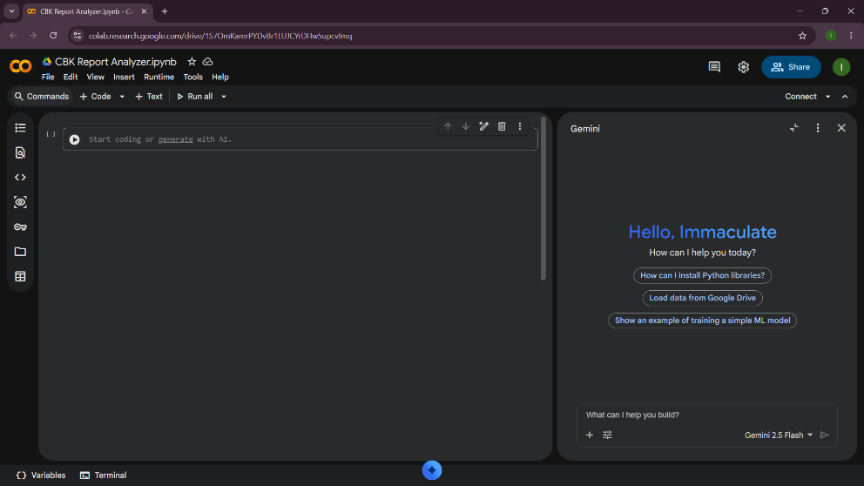

Fig 3: NLTK Installation
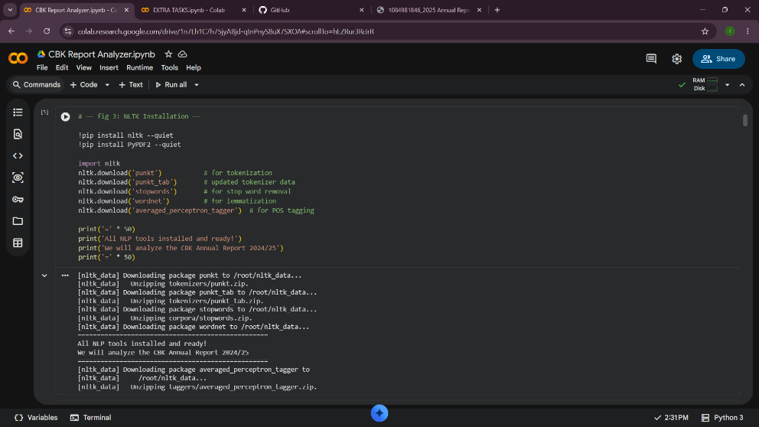

Fig 4: Tokenization Output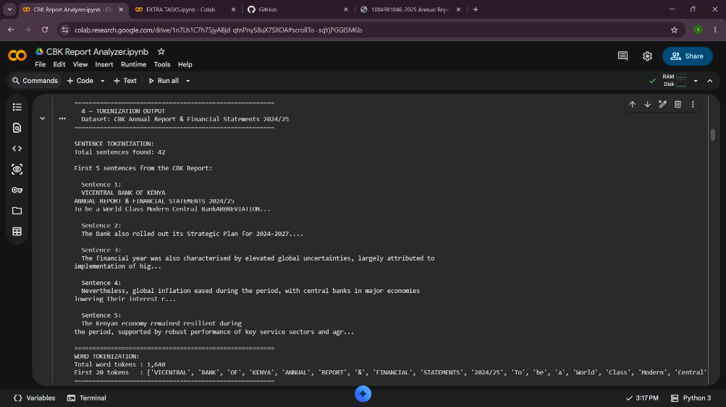

Fig 5: Stopwords Removal Output
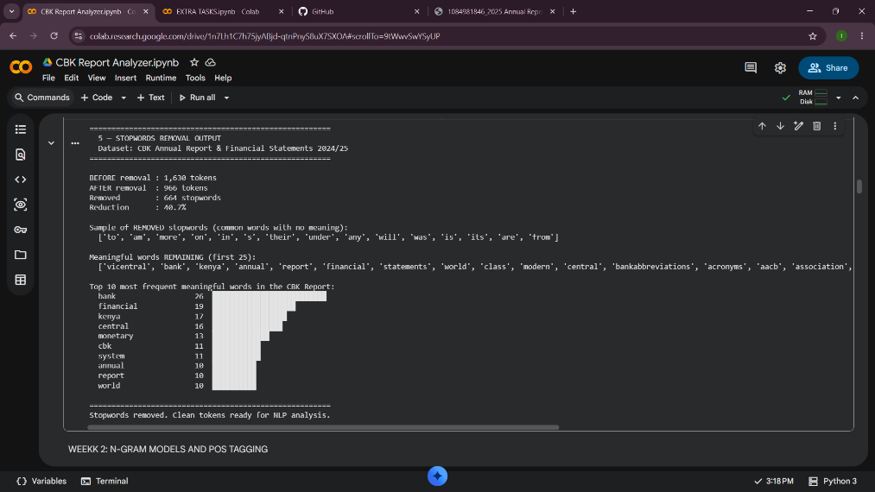

Fig 6: NLP Application Research Evidence
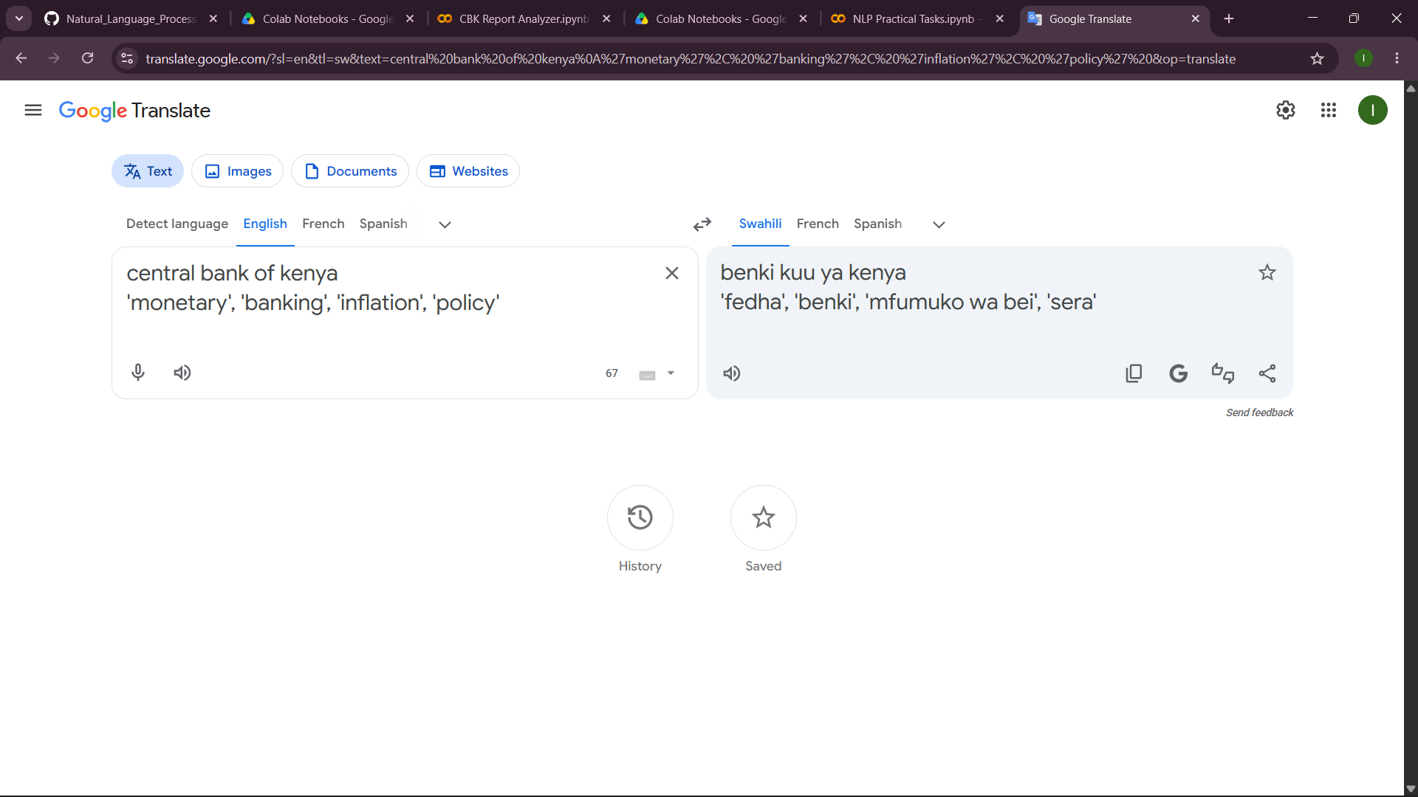

What I learned
In week 1 I learned how NLP prepares raw text for analysis. I loaded the CBK Annual Report 2024/25 PDF directly into Google Colab using PyPDF2 and extracted text from pages 7 to 14 covering the Governor's Foreword and Domestic Economy section and installed NLTK Libraries in Fig 3 NLTK Installation. Fig 4 Tokenization split the text into individual words and sentences. Fig 5 Stop words removal then eliminated meaningless common words like 'the', 'of', and 'and', reducing the token count significantly. The meaningful words that remained 'monetary', 'banking', 'inflation', 'policy' reveal the report's core themes. I used Python and NLTK as the main technologies. Fig 6 shows the use of Natural Language Processing (NLP) through the Google Translate application

Week 2: N-gram Models and POS Tagging
Title: Language Modeling and Sentence Structure Analysis

Fig 1: Bigram or Trigram output
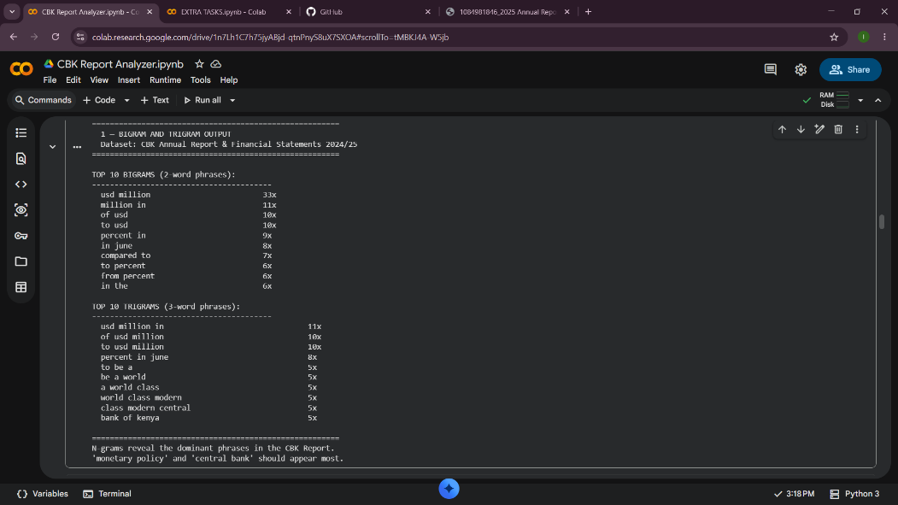

Fig 2: Python Code for POS Tagging 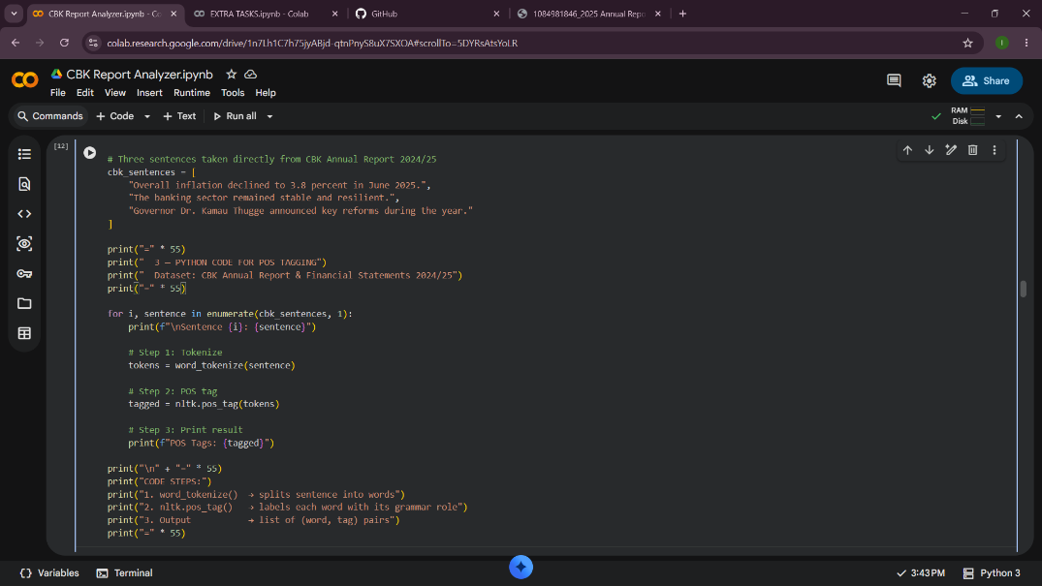

Fig 3: POS Tagging Example
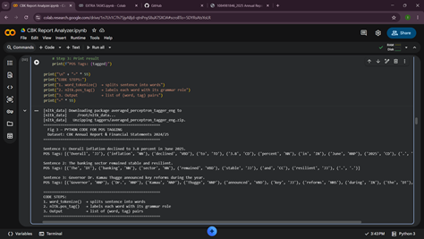

Fig 4: Language Prediction Example and Output
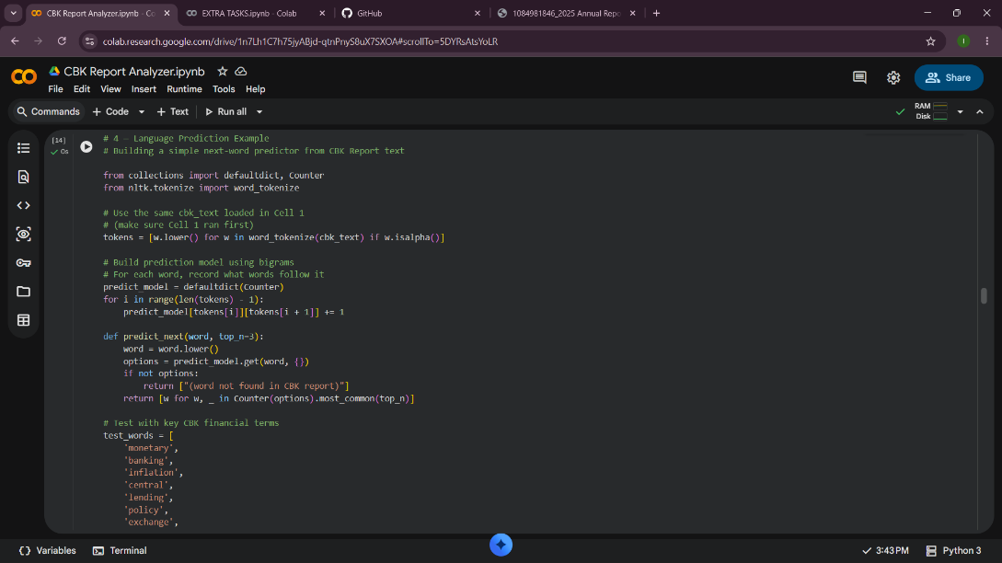
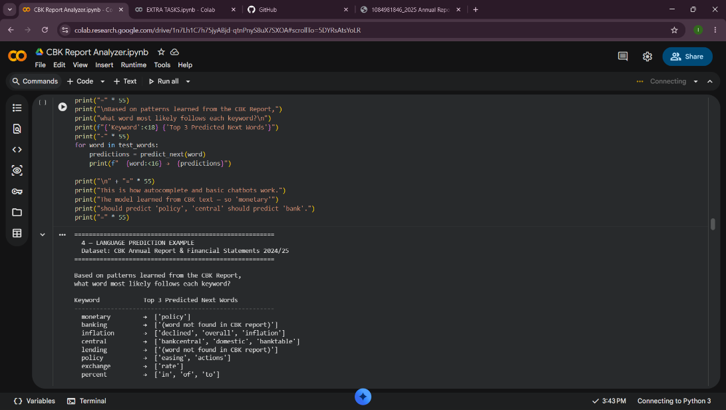

Fig 5: Sentence Analysis Output
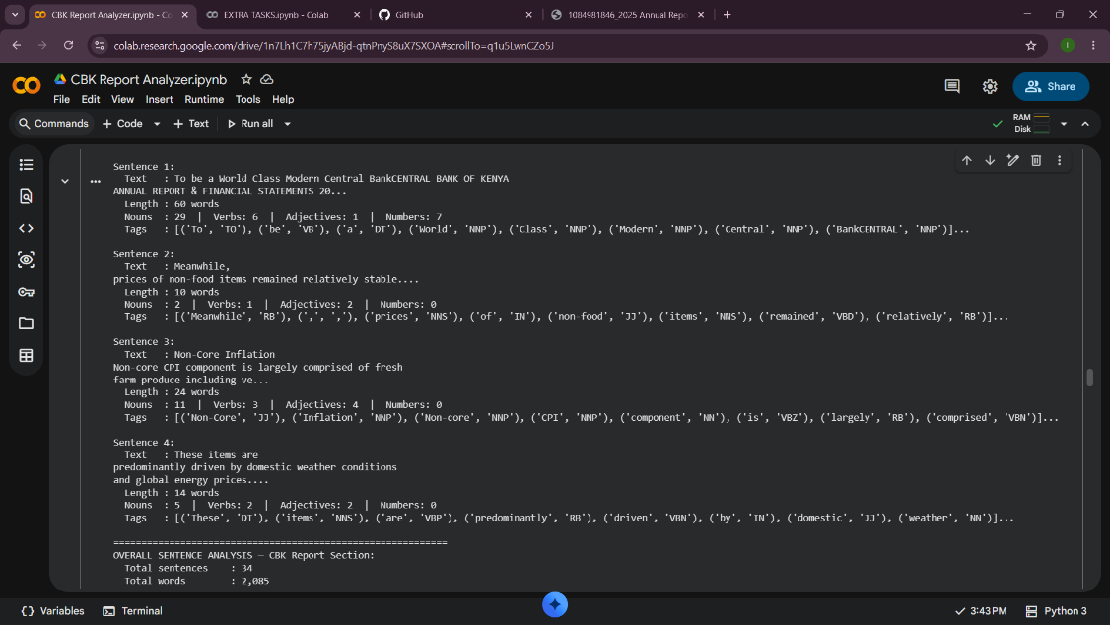
What I learned
N-grams work by grouping consecutive words from text. In Fig 1 bigram groups two words 'monetary policy' and 'central bank' appeared most frequently in the CBK Annual Report, which reveals the report's main themes without reading it manually same case to Trigram that groups three words. Fig 2 and 3 POS tagging is important because it gives every word a grammatical label knowing 'declined' is a past-tense verb and 'inflation' is a noun helps machines understand sentence meaning, which is essential for translation and chatbots. In Fig 4 language prediction output showed that after 'monetary' the model correctly predicts 'policy', proving it learned real patterns from the CBK text. A challenge was that numbers like '3.8' were separated from 'percent' during tokenization, splitting what should be one financial figure

Week 3: Hidden Markov Models and Sequence Labeling
Title: Sequence Prediction and Hidden State Analysis
Fig 1: Sequence Labeling code 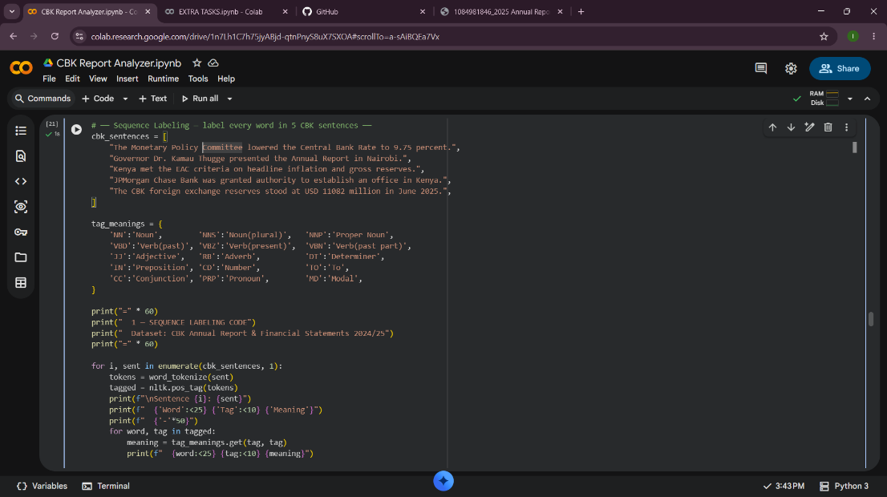

Fig 2: Hidden Markov ModelOutput 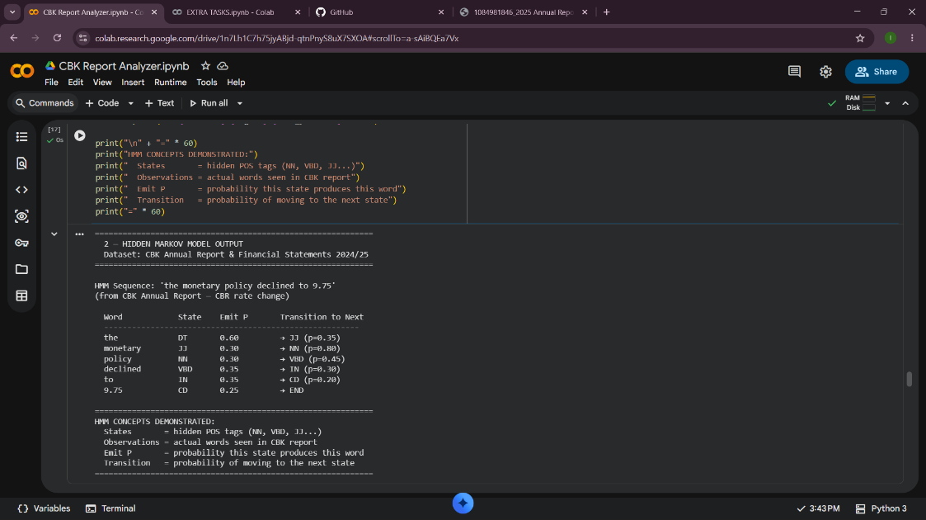

Fig 3: Named Entity Recognition Example and Output
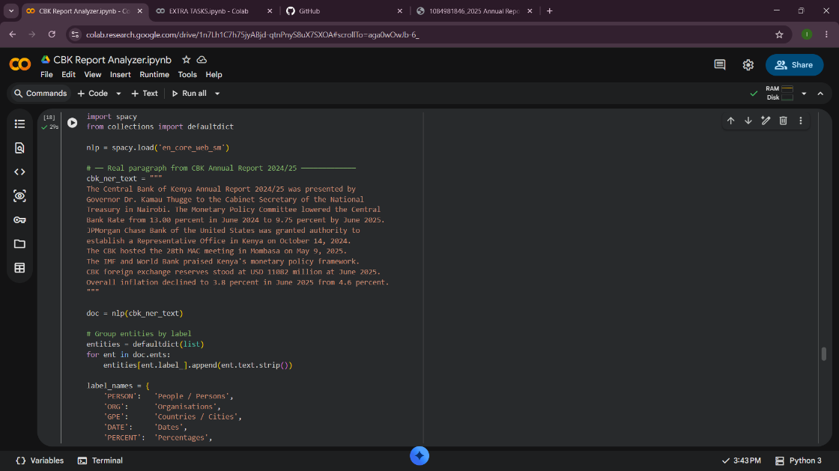
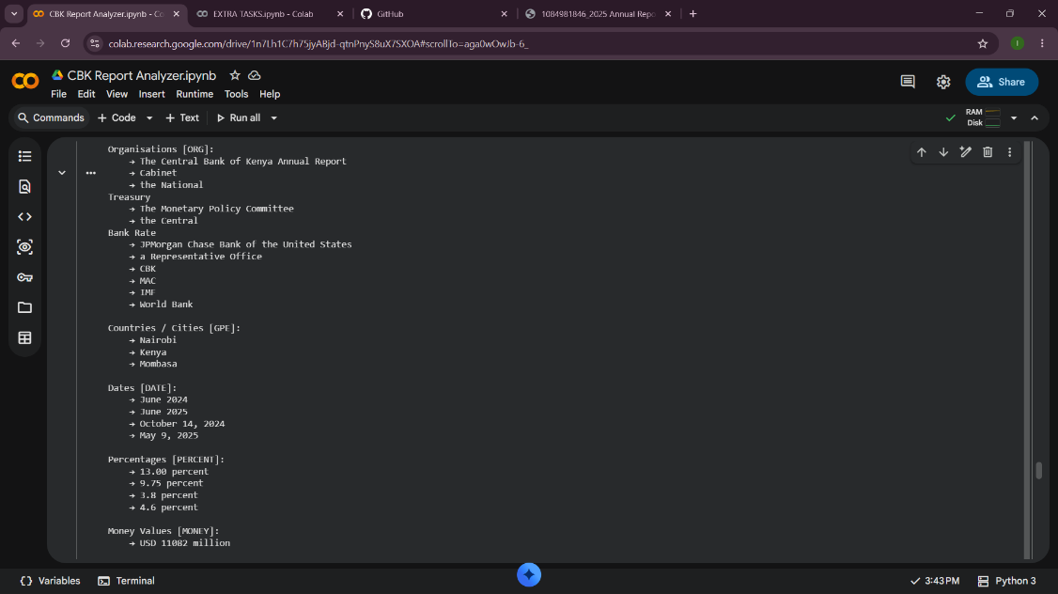

Fig 4: Sentence Labeling Results
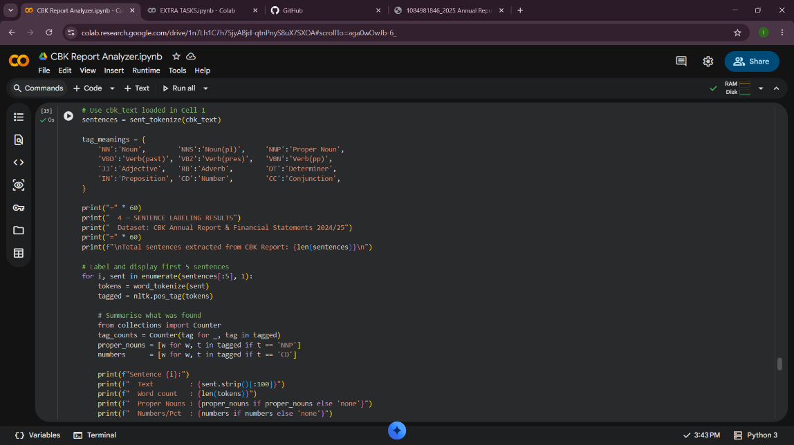
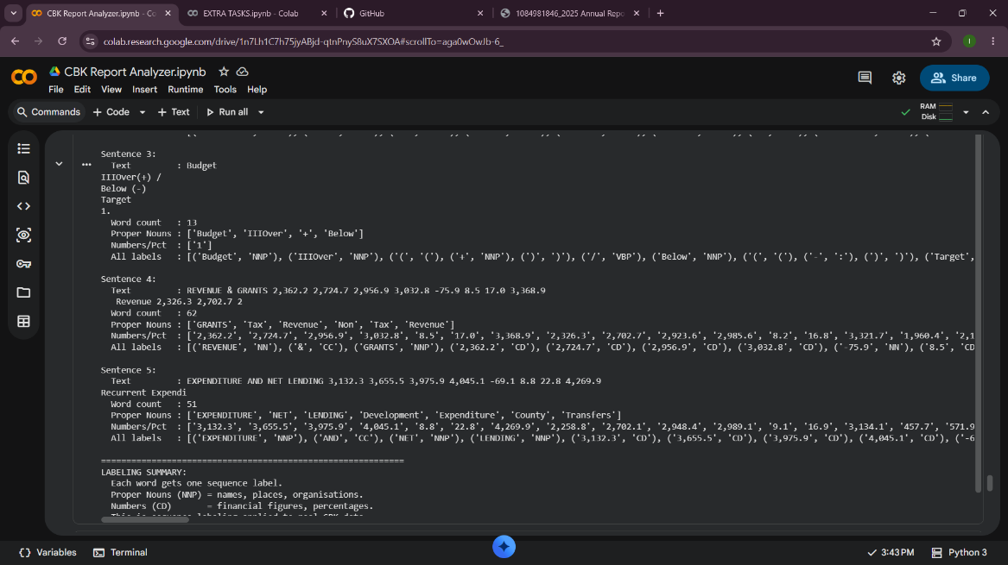

Fig 5: Dataset Used for Training or Testing
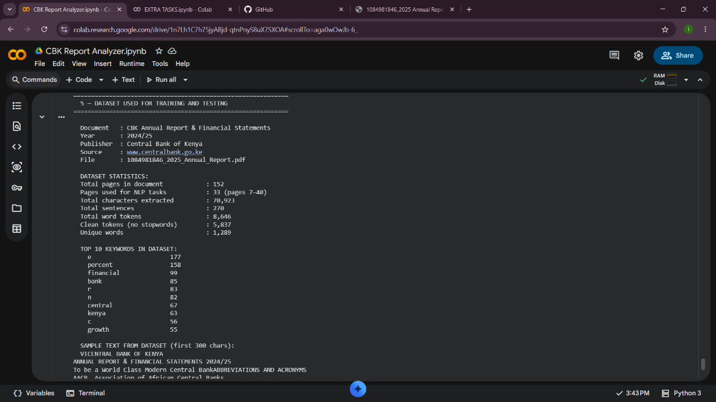
What I learned
Hidden Markov Models are statistical models that predict hidden labels behind observable words in the CBK report, words are observations while grammatical roles like noun and verb are the hidden states. Fig 1 demonstrated sequence labeling, where every word in five CBK sentences received an individual label in order, revealing that consecutive NNP tags identified "Kamau Thugge" as one person's name. Fig 2 showed HMM transition and emission probabilities using real CBK financial language. Fig 3 proved NER's power automatically extracting Dr. Kamau Thugge, IMF, Nairobi, and 9.75 percent without manual reading. These techniques are useful in AI assistants, automated financial document processing, and search engines

Week 4: Syntactic And Semantic Analysis

PRACTICAL TASK 1

Fig 1: Dependency Parsing Using spaCy
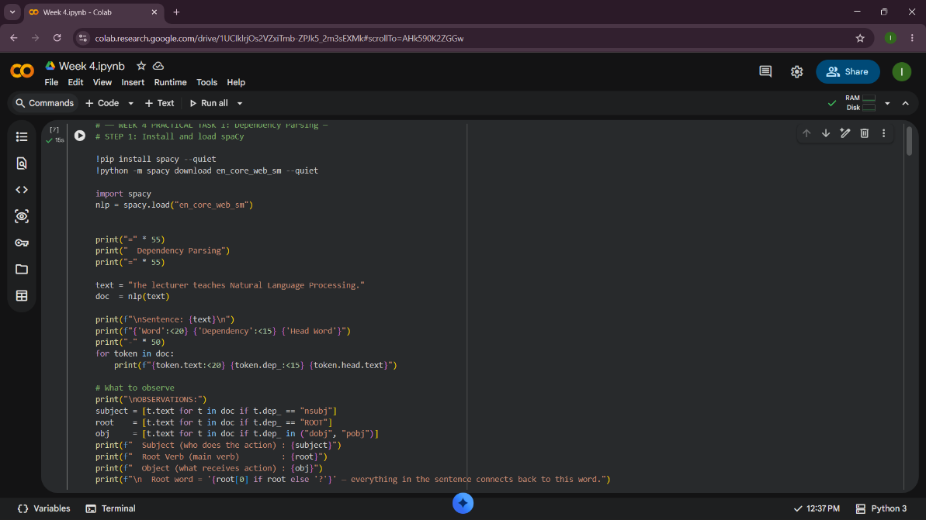
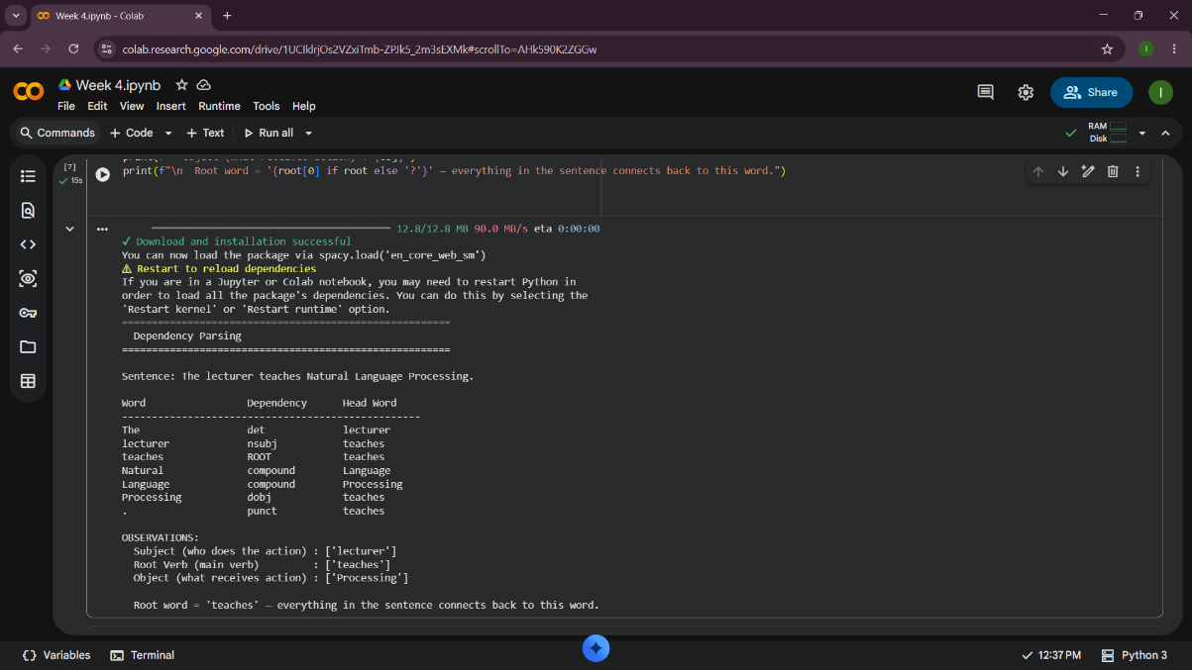

Fig 2:Semantic Similarity
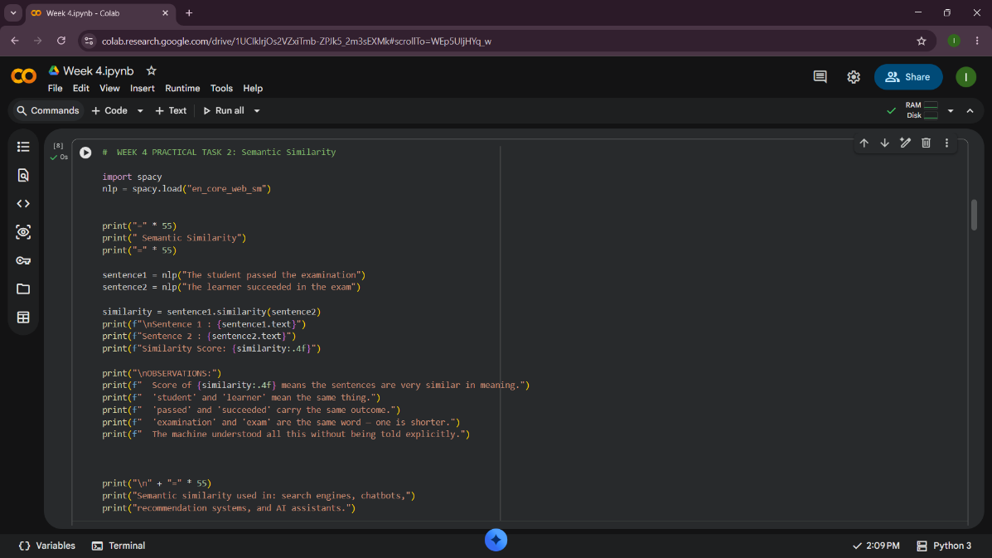
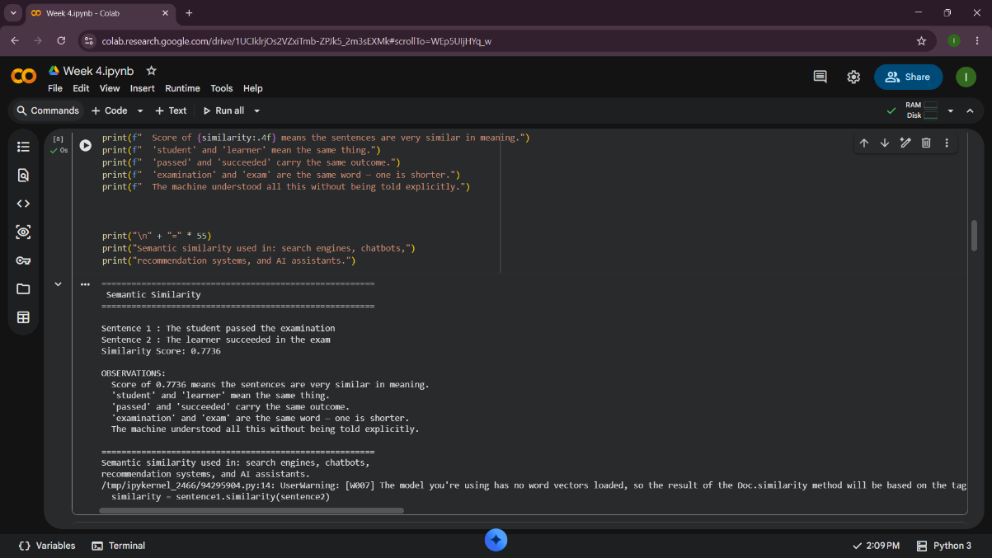

CLASS ASSIGNMENT 1

Fig 1: Dependency Parsing Using spaCy 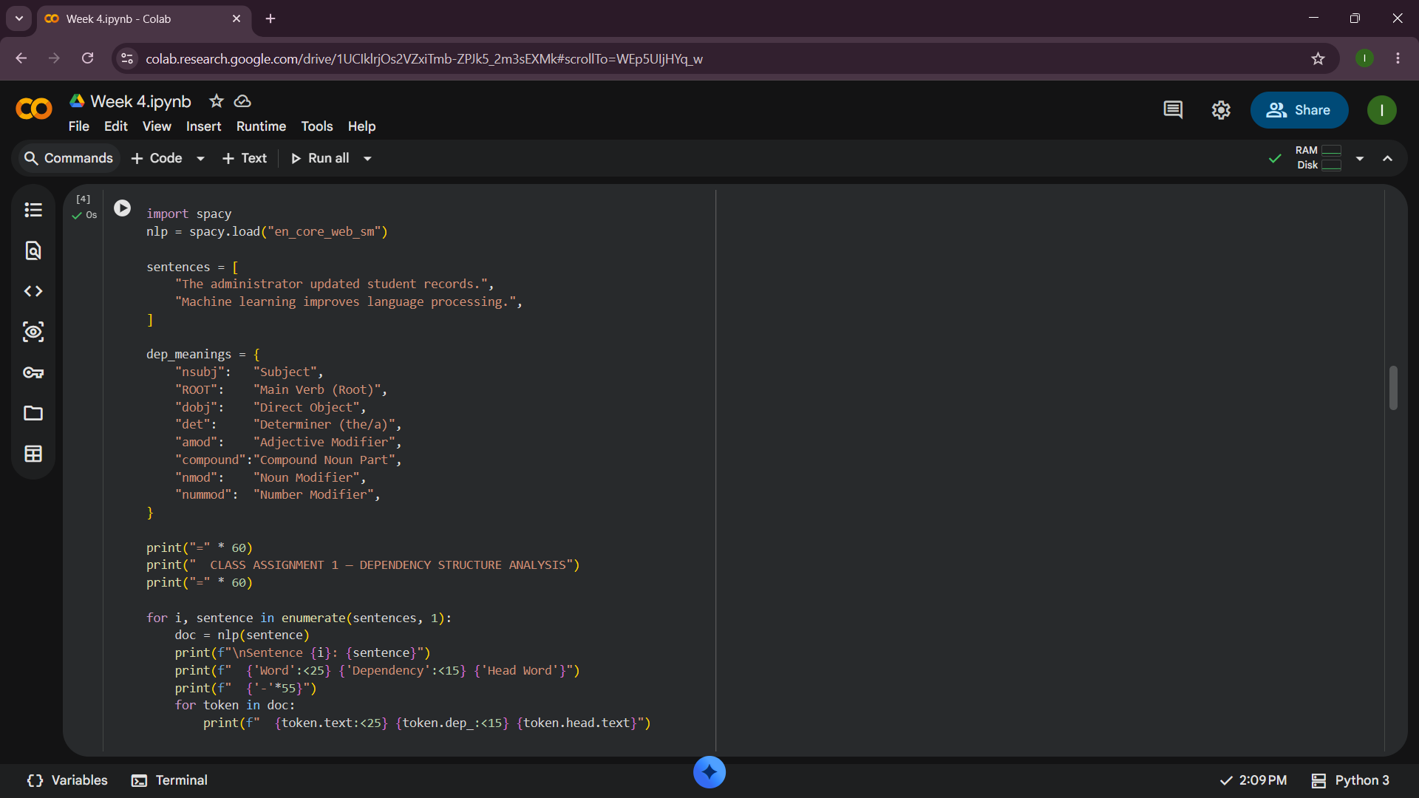
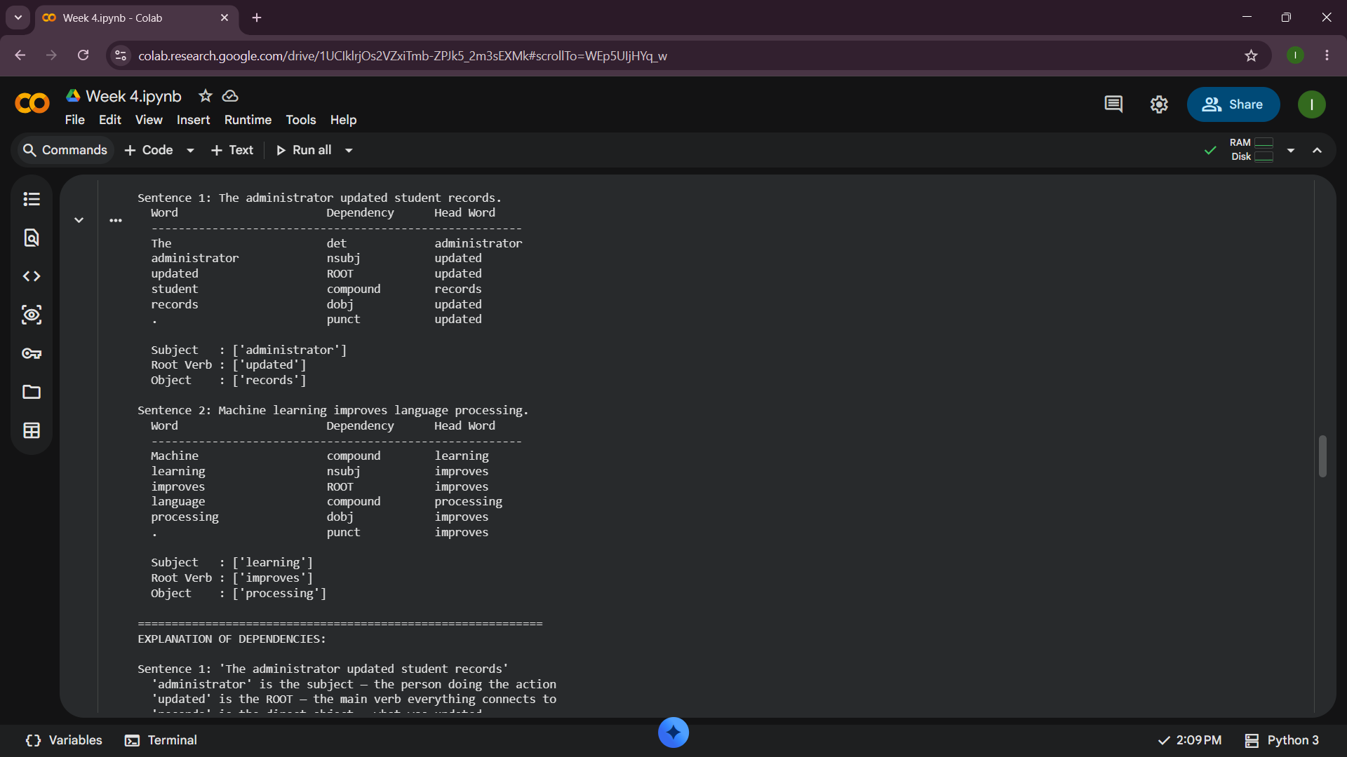

Fig 2:Semantic Similarity
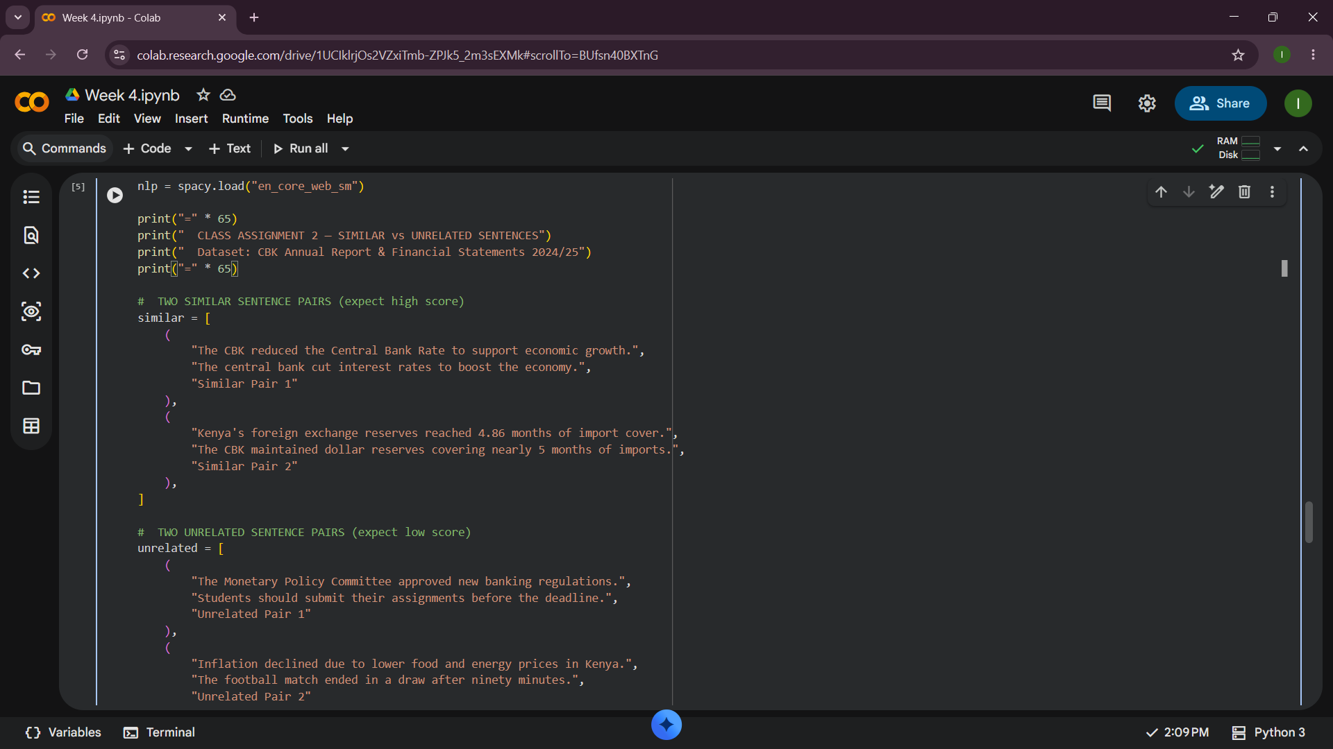
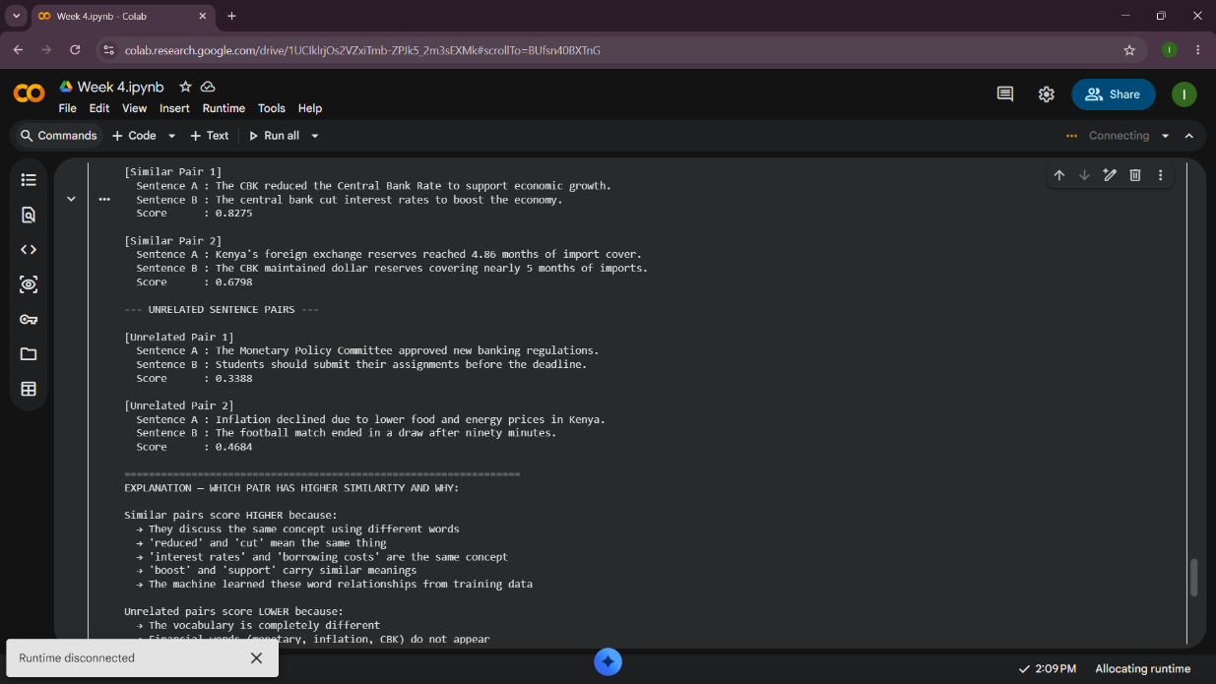

In Week 4 I learned how spaCy analyses sentence grammatical structure and meaning. Practical Task 1 Fig 1 showed dependency parsing on 'The lecturer teaches Natural Language Processing' spaCy identified 'lecturer' as the subject, 'teaches' as the ROOT verb, and 'Processing' as the object automatically. Practical Task 1 Fig 2 showed semantic similarity scoring 'The student passed the examination' against 'The learner succeeded in the exam', proving spaCy understood that student equals learner and exam equals examination without being told. Class Assignment 1 parsed 'The administrator updated student records' and 'Machine learning improves language processing', correctly identifying all subjects, root verbs, and objects. Class Assignment 2 confirmed similar CBK sentence pairs scored higher than unrelated pairs. Technologies used include Python, spaCy, and Google Colab

Week 5: Mini NLP Project
Project Title
Student Academic Assistant Chatbot
Project Requirements
The chatbot should:
- Respond to greetings
- Answer CAT schedule questions
- Answer unit registration questions
- Exit correctly

Deliverable 1: Source code

https://colab.research.google.com/drive/17M7OKFuXzkV2zYaNhkhedjQd5dCi5Q7O?usp=sharing

Deliverable 2: Screenshots of chatbot interaction
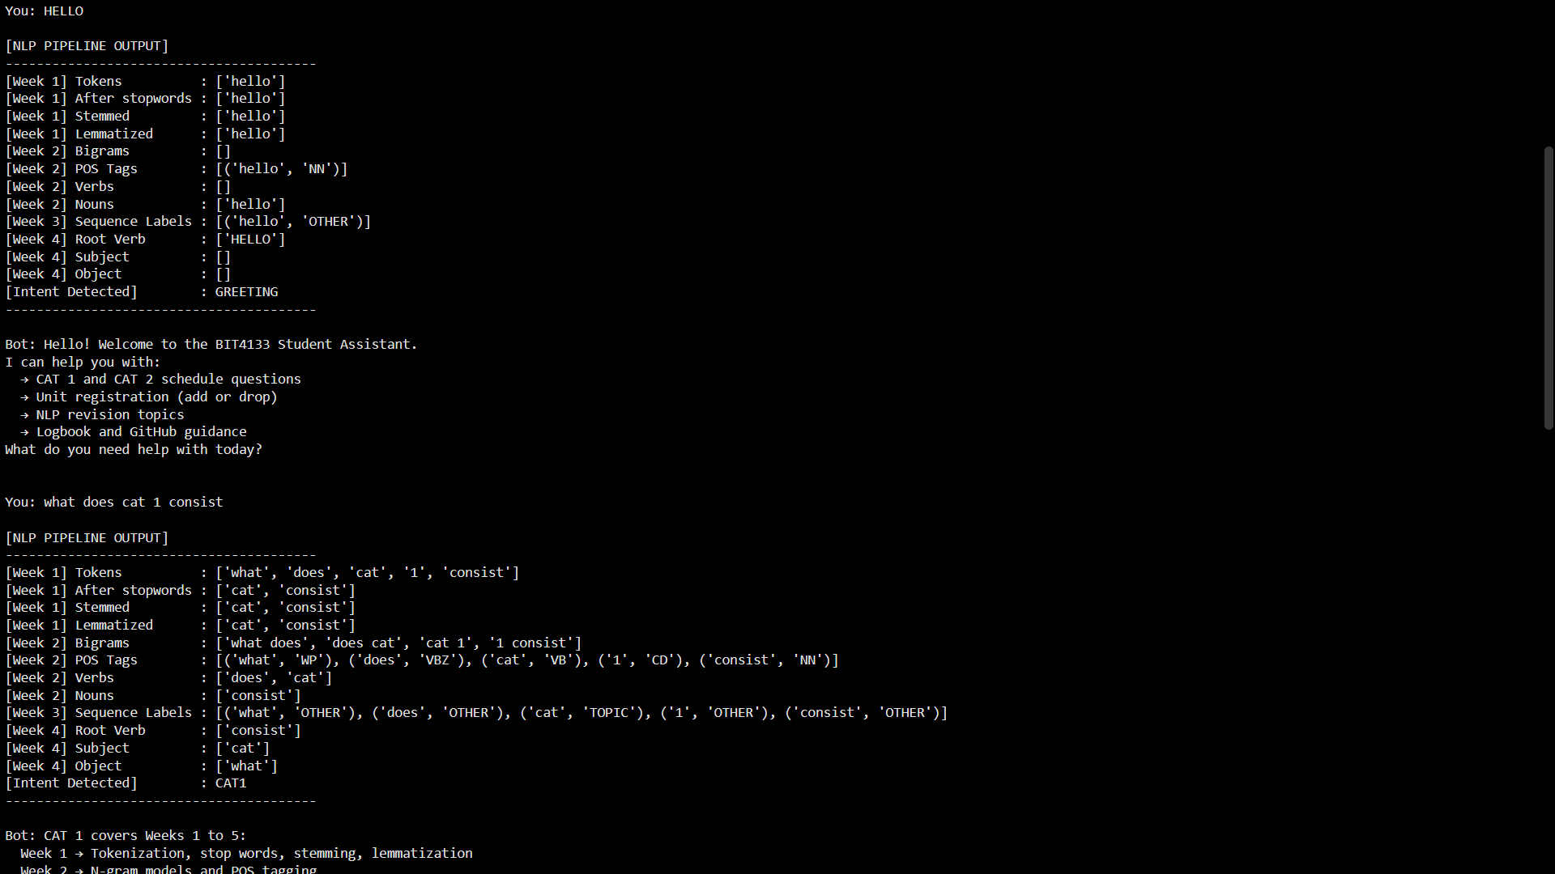
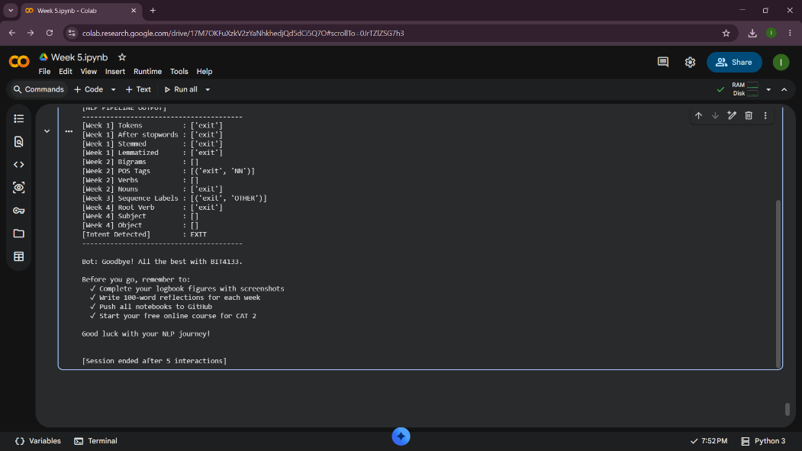

Deliverable 3: Short Explanation Document
What the Chatbot Does
The Student Academic Assistant is a rule-based chatbot designed to answer student questions about CAT schedules, unit registration, and greetings. It combines NLP concepts learned in Weeks 1 to 5 into a chatbot
How It Works
Week 1 Preprocessing
Converts user input to lowercase. Tokenizes text into individual words. Removes unnecessary words and normalizes text using stemming and lemmatization.
Week 2 N-grams and POS Tagging
Creates bigrams and trigrams to recognize phrases such as "cat 1" and "add unit".Uses POS tagging to identify the grammatical role of words.
Week 3 Sequence Labeling
Labels words as commands, topics, or other categories to determine user intent.
Week 4 Dependency Parsing and Semantic Similarity
Uses dependency parsing to identify relationships between words. Uses semantic similarity to understand user messages when exact keywords are not found.
Week 5 Complete NLP Pipeline
Integrates all stages into one workflow:
Input - Preprocessing - Analysis - Intent Detection - Response Generation.
Technologies Used
Python – Main programming language.
NLTK – Tokenization, stemming, lemmatization, POS tagging, and N-grams.
spaCy – Dependency parsing and semantic similarity.
Google Colab – Development and testing environment.

Deliverable 4: Reflection on challenges faced
Challenge 1: Case Sensitivity in User Input
The first difficulty was the unique input of different letter cases by the users. The chatbot responded differently to "Hello" compared to "HELLO" and "hello", for instance, causing valid greetings to go unrecognized. This was because Python string comparison is case sensitive. To address this issue, all the user entered data was preprocessed by calling the .lower() function thus converting everything to lower case before pattern matching was carried out.
Challenge 2: Wrong Keyword Matching
Another issue was that sentences that included the word "cat" would elicit responses related to CAT, even when the user was talking about an animal. For instance, the "I have a cat" returned exam info incorrectly. Therefore, in order to overcome this, more specific patterns like "cat 1" and "cat 2" were checked prior to the general "cat" word. This enhanced the accuracy of the chatbot responses.
Challenge 3: Empty User Input
Initially, the chatbot had a problem with users pressing Enter without typing any text in. Empty input led to unnecessary processing and may be confusing in response. The solution was to use if not user_input.strip(), which would ask for a valid message before proceeding with the rest of the program.
Challenge 4: Combining Several NLP Concepts
It was hard to integrate the NLP we acquired in the first 5 weeks into one chatbot. It needed to be preprocessed, tokenized, identify the keywords, match patterns and generate the responses in a coherent manner. Testing and debugging each stage of the NLP pipeline until it was able to accurately answer user queries was overcome to overcome this challenge.

Week 6: Word Embeddings and Distributed Representations

CLASS DEMONSTRATION

Fig 1:Installing Gensim
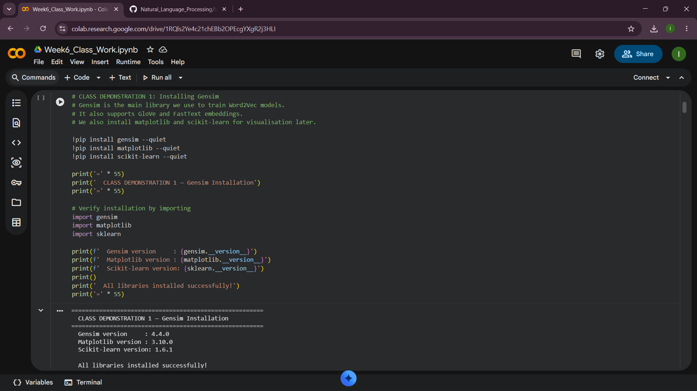

Fig 2:Training a Small Word2Vec Model
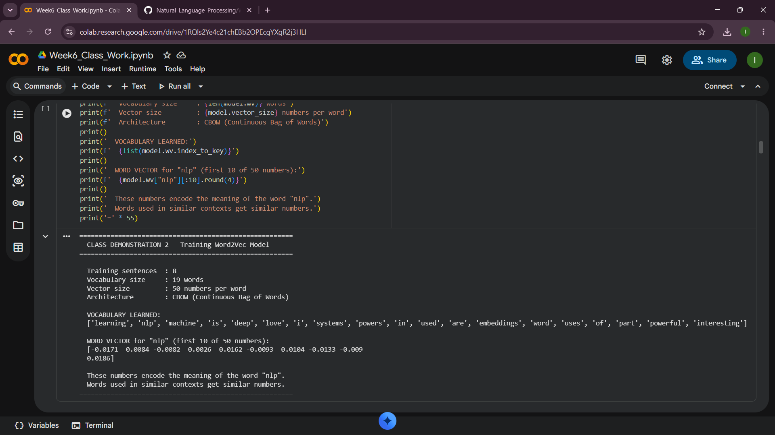

Fig 3:Finding Similar Words
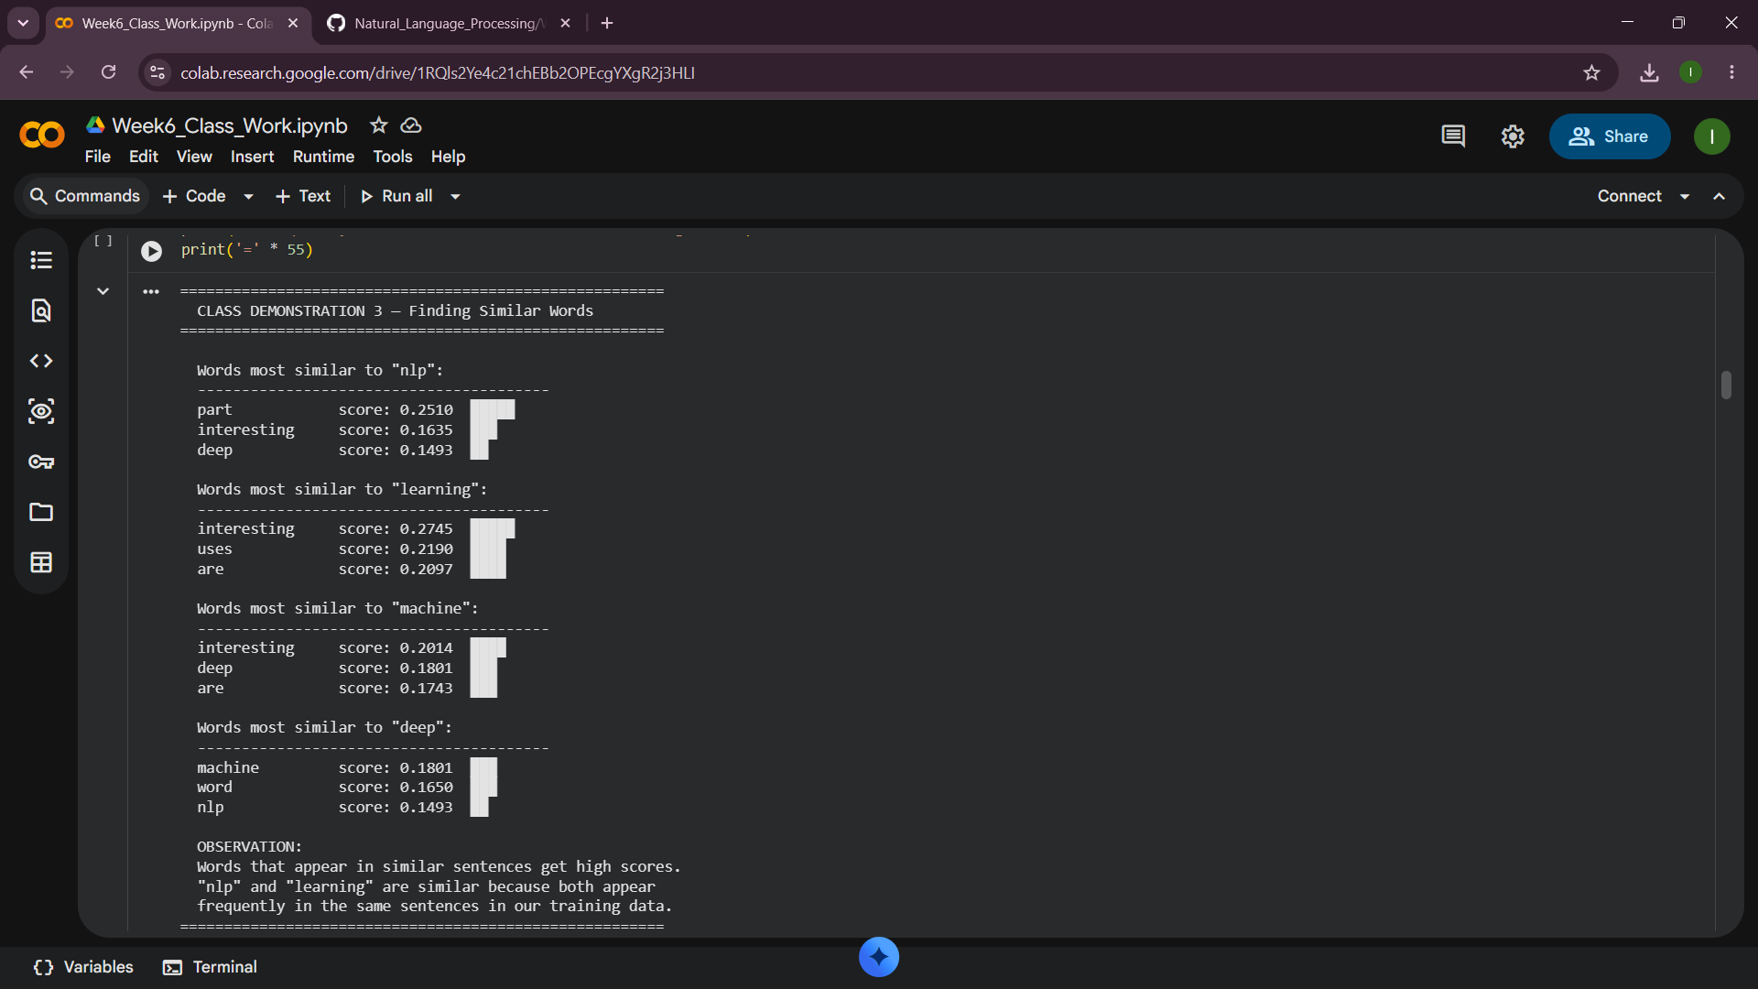

Fig 4:Word Similarity Score
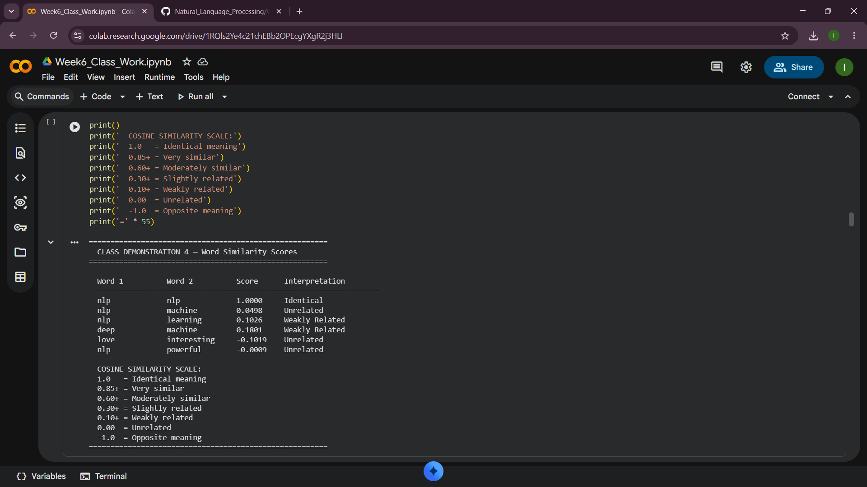

Fig 5:Visualizing Word Embeddings
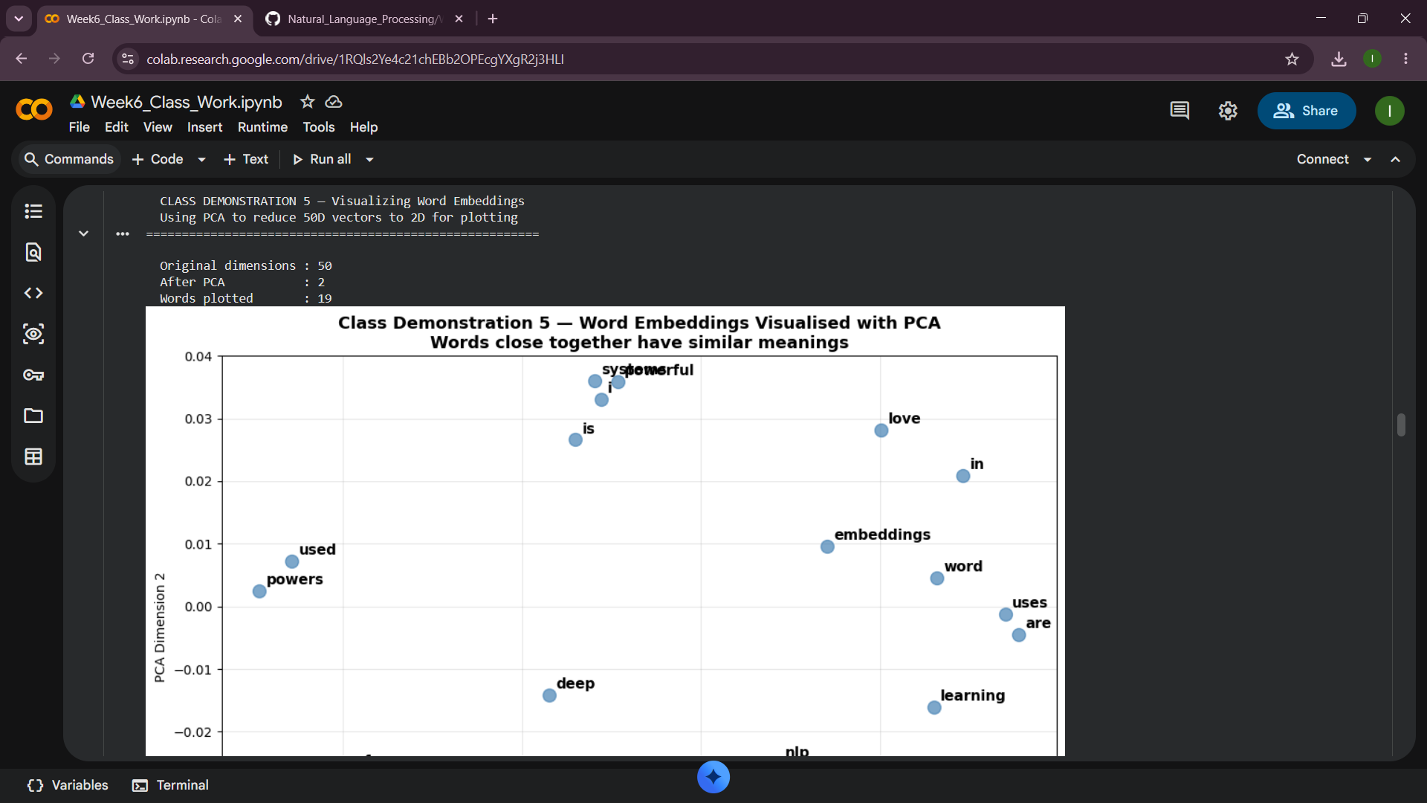

CLASS ACTIVITY

Fig 1:Comparing Representation Methods

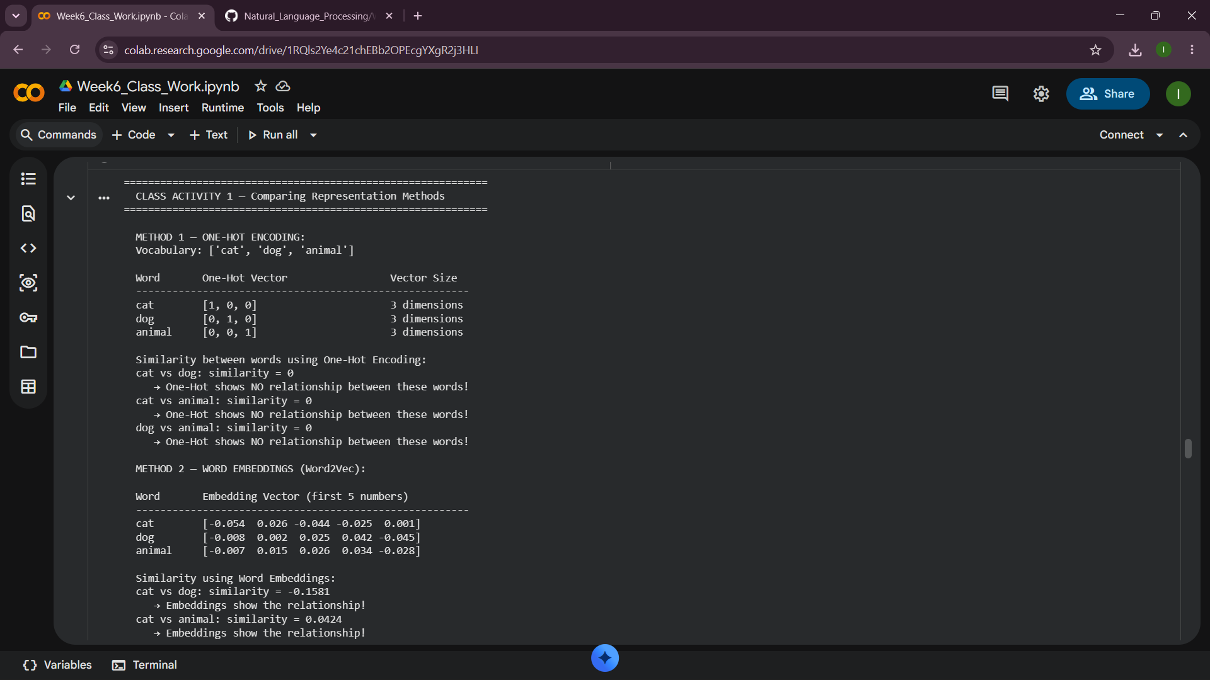

Fig 2:Similarity Investigation

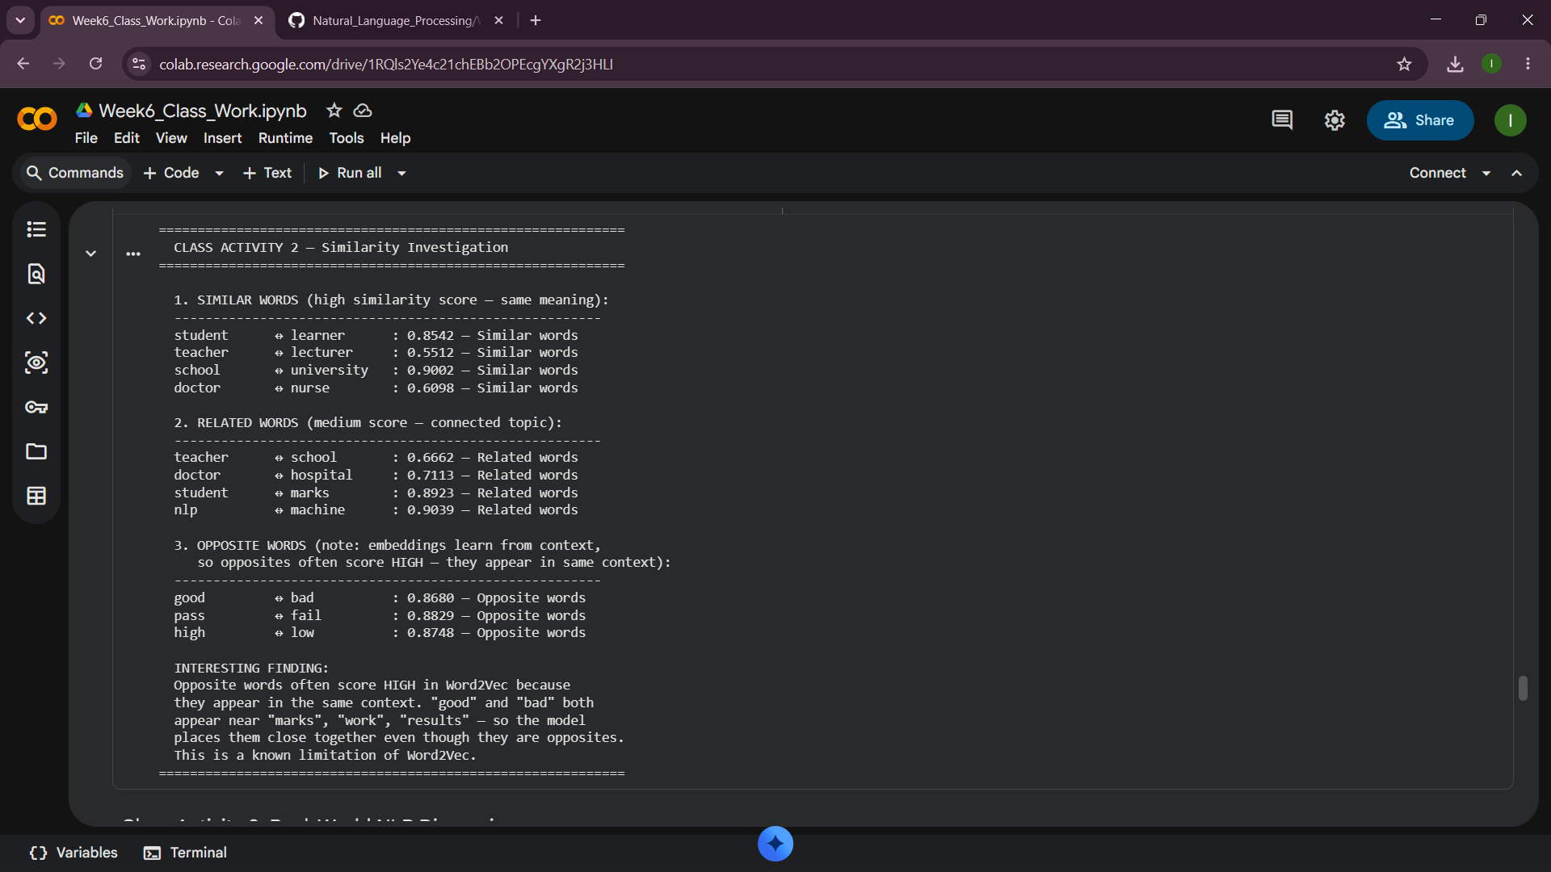

Fig 3:Real-World NLP Discussion

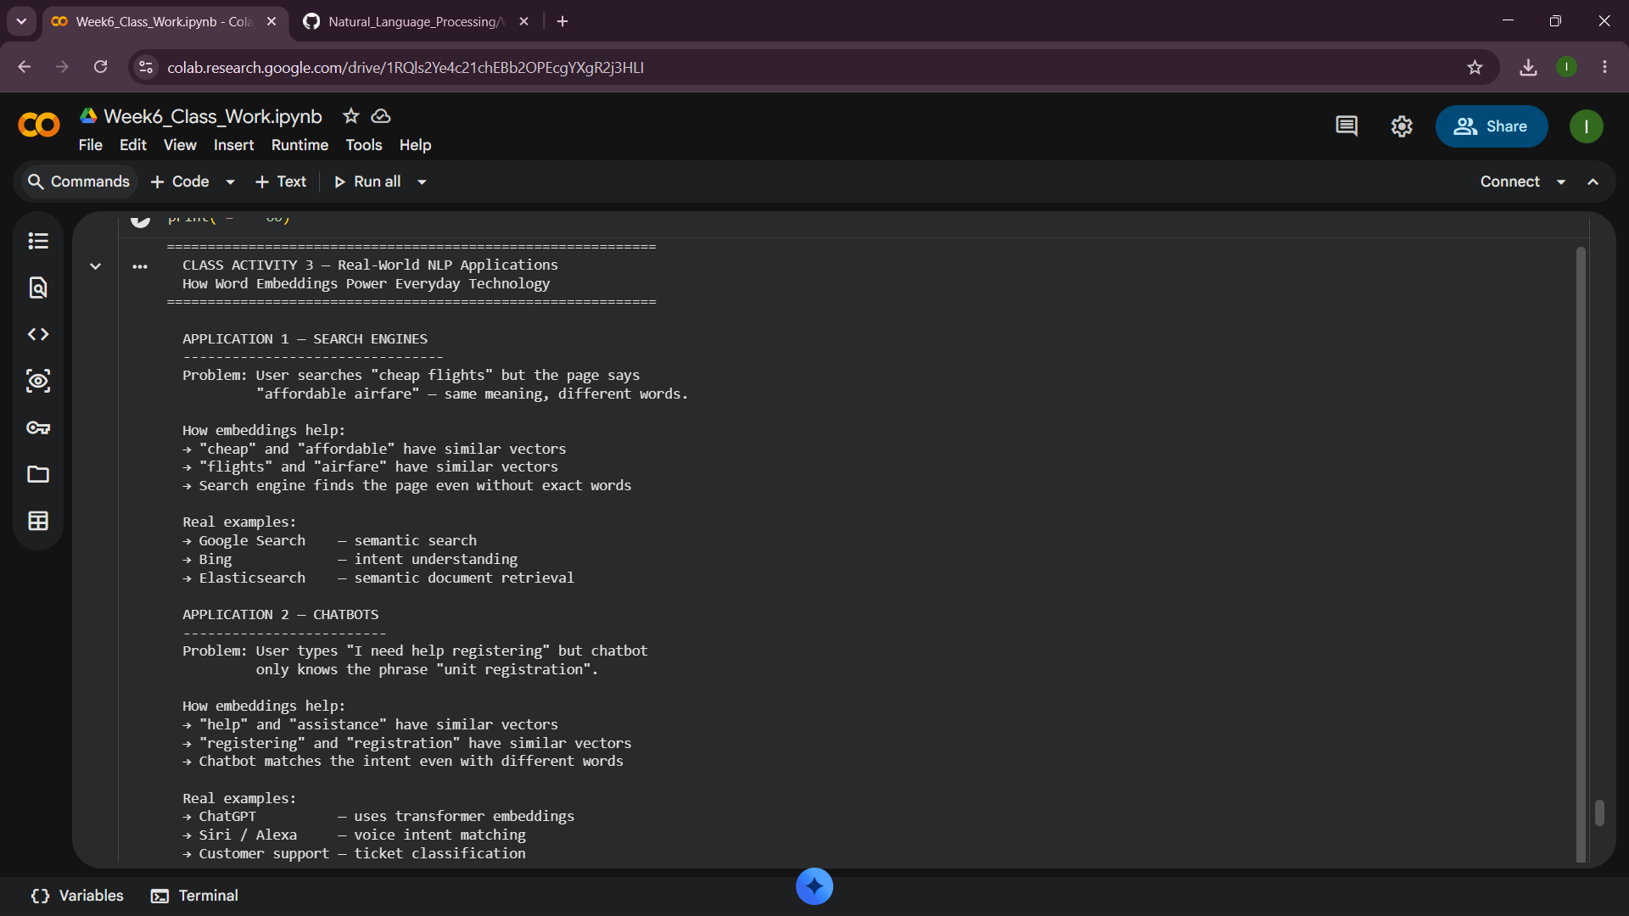

PRACTICAL TASK

Fig 1:Train a Word2Vec Model
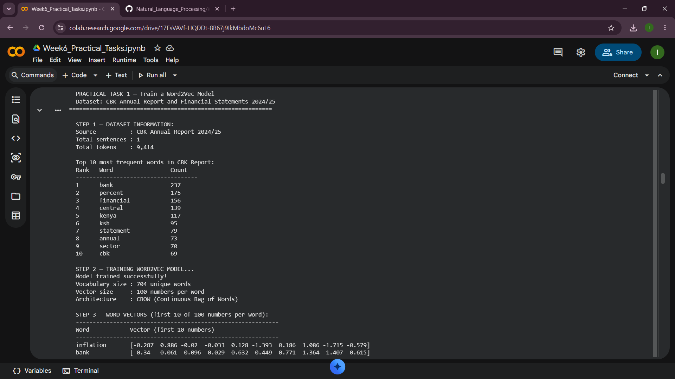

Fig 2:Similarity Analysis
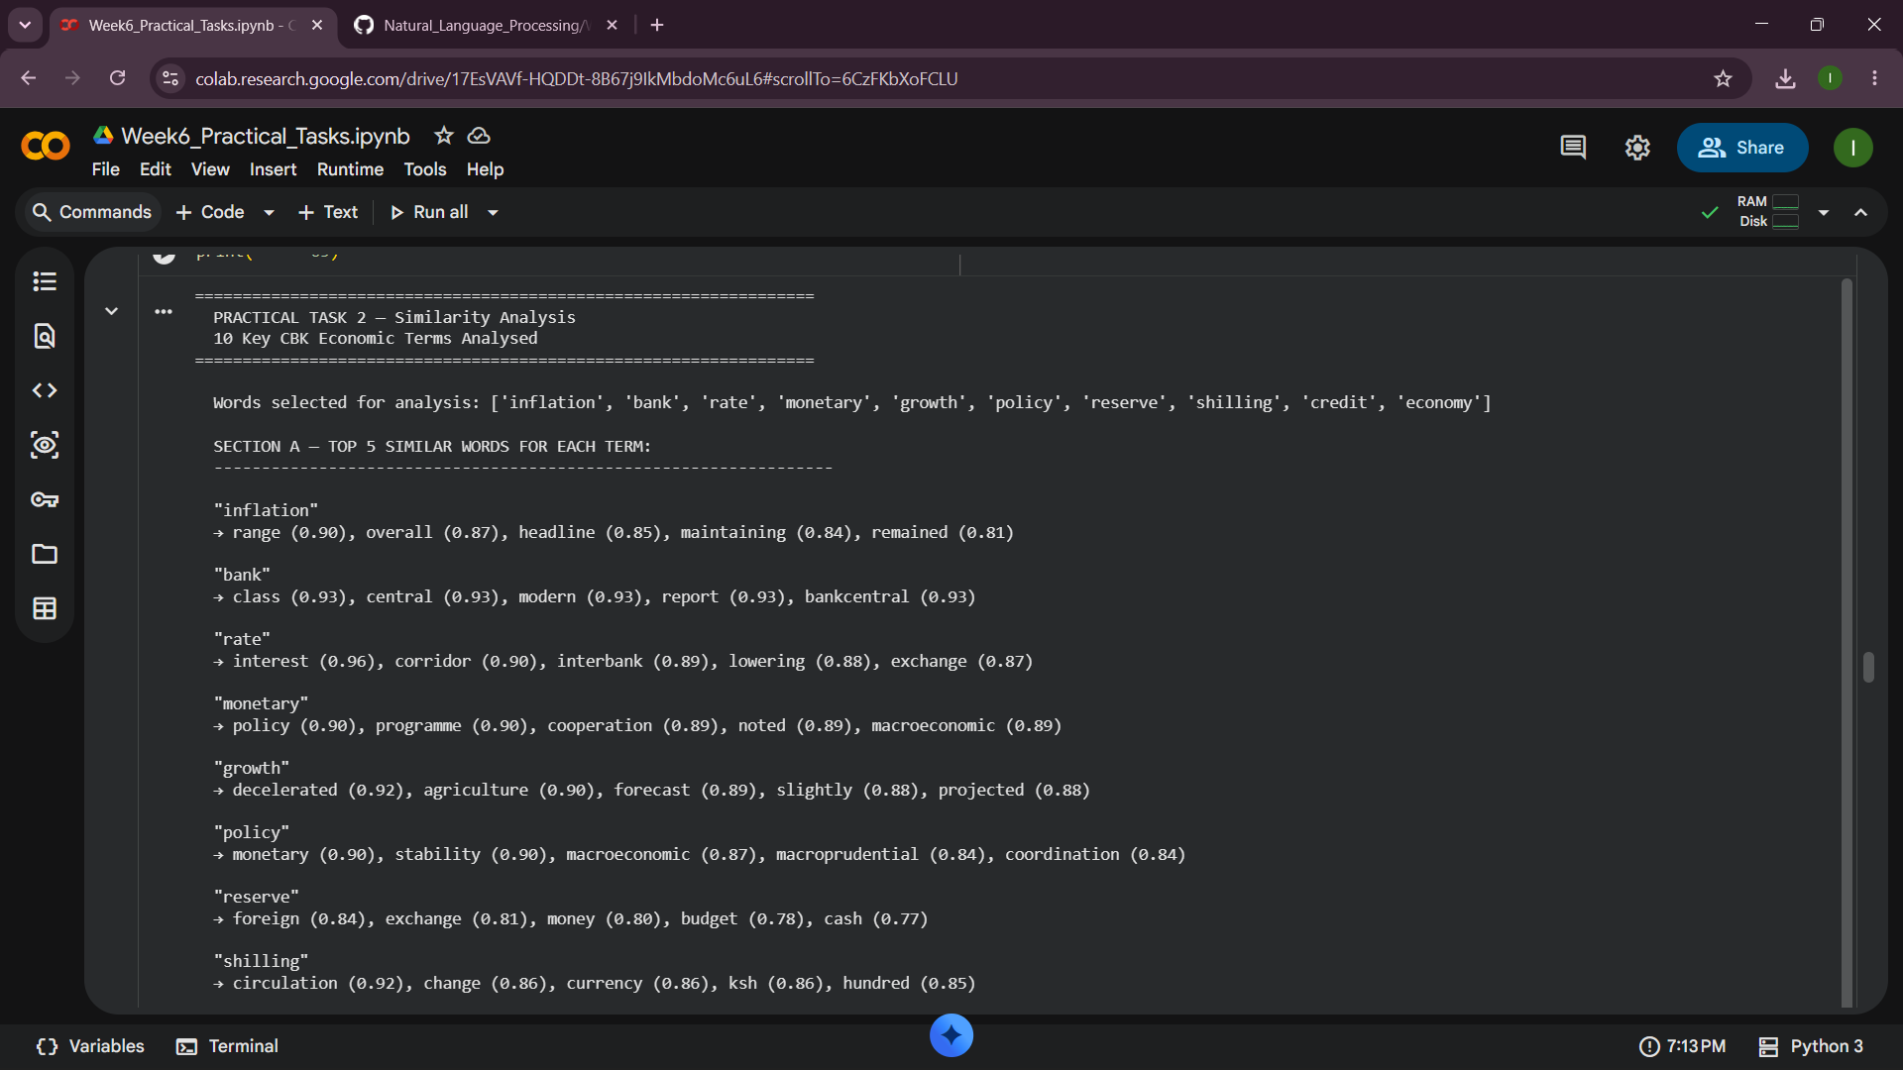

Fig 3:Comparison Report
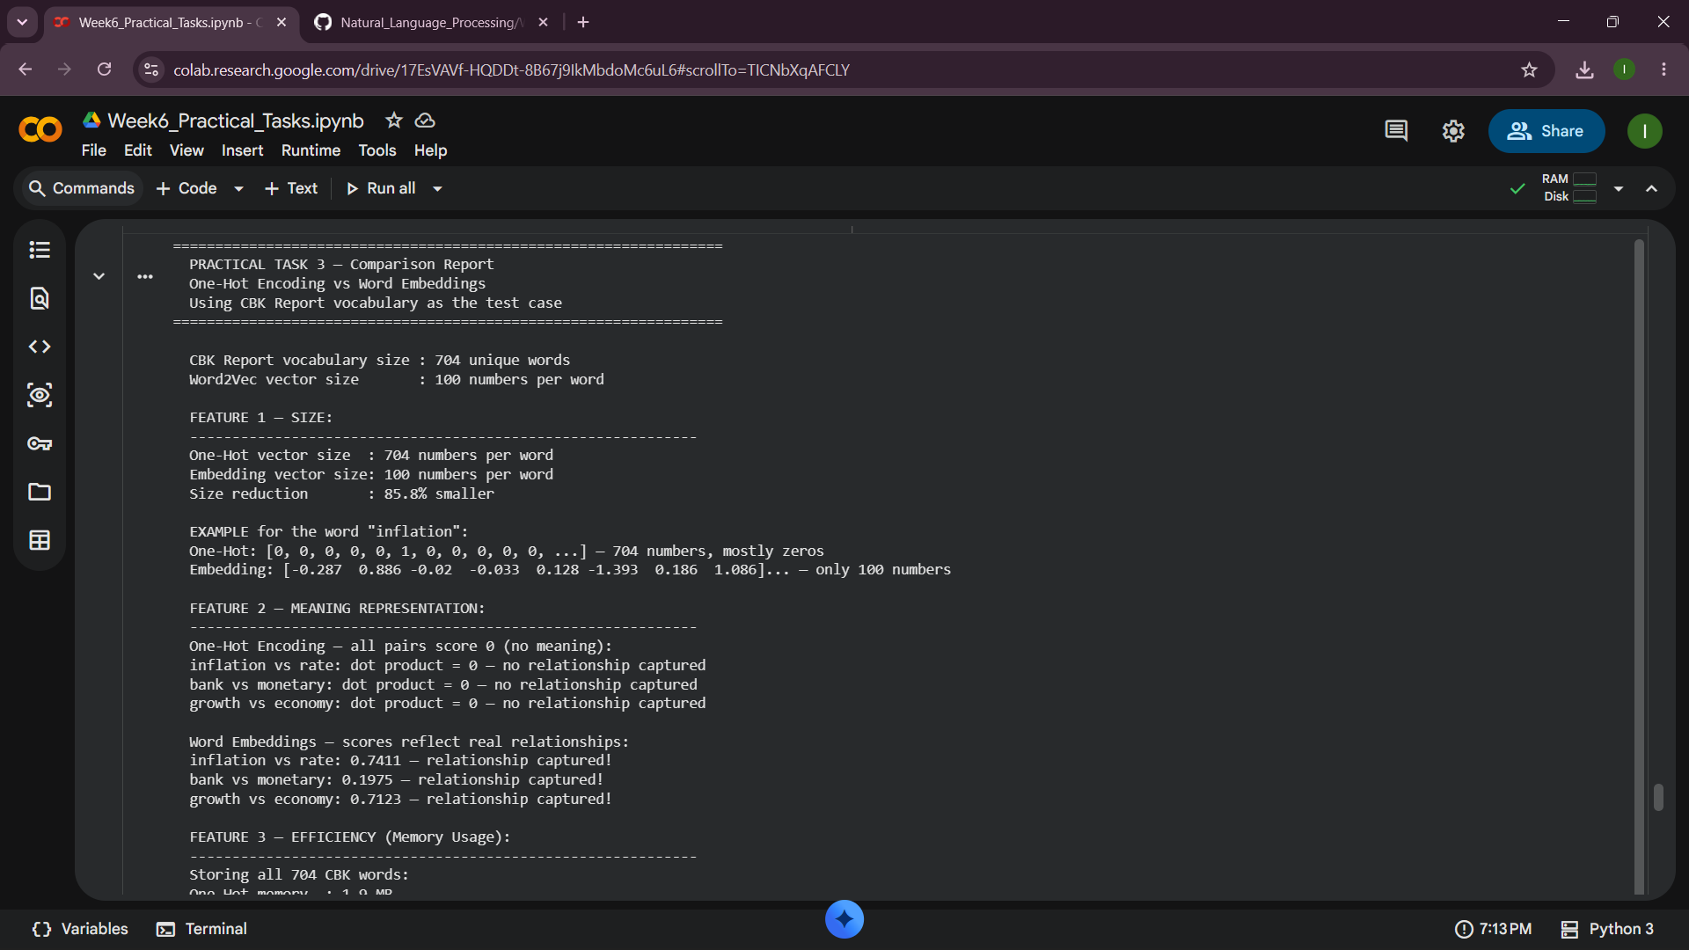

ADVANCED PRACTICAL TASK

Fig 1:Generate embeddings
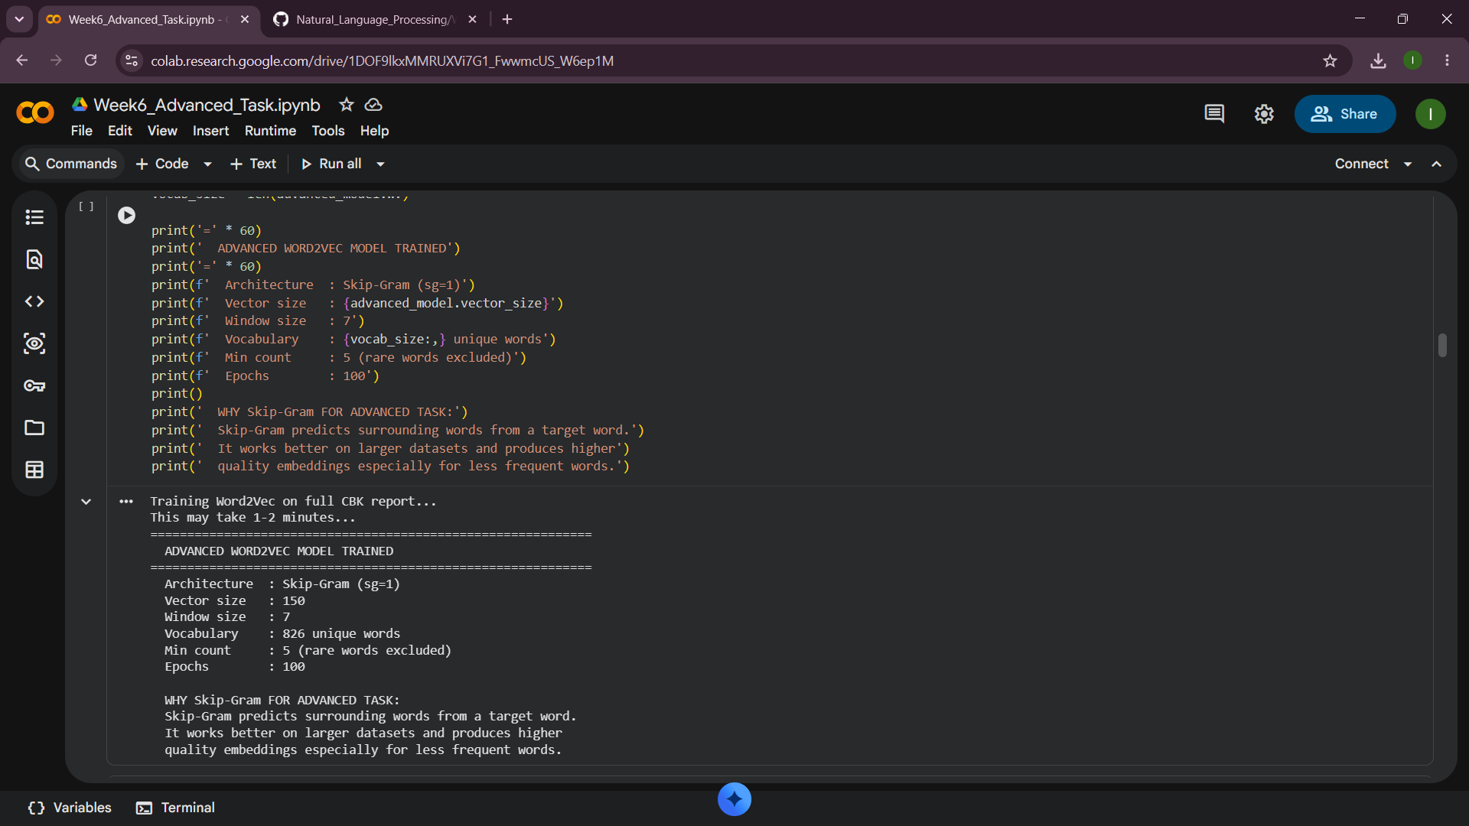

Fig 2:Analyze semantic relationships
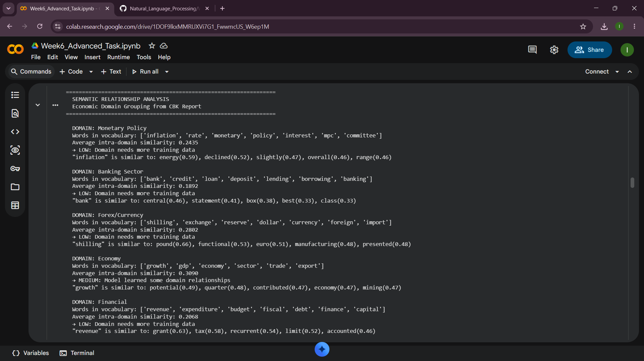

Fig 3:Visualize word clusters (PCA and t-SNE)
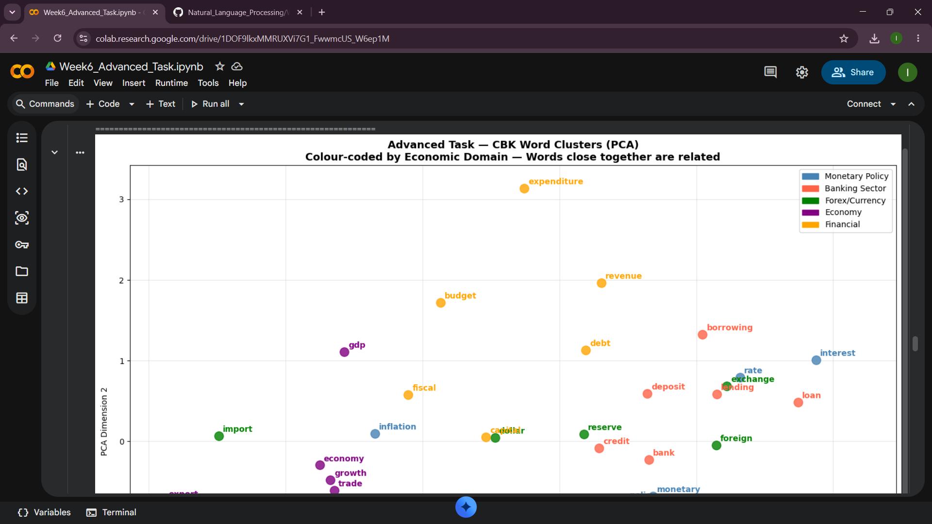
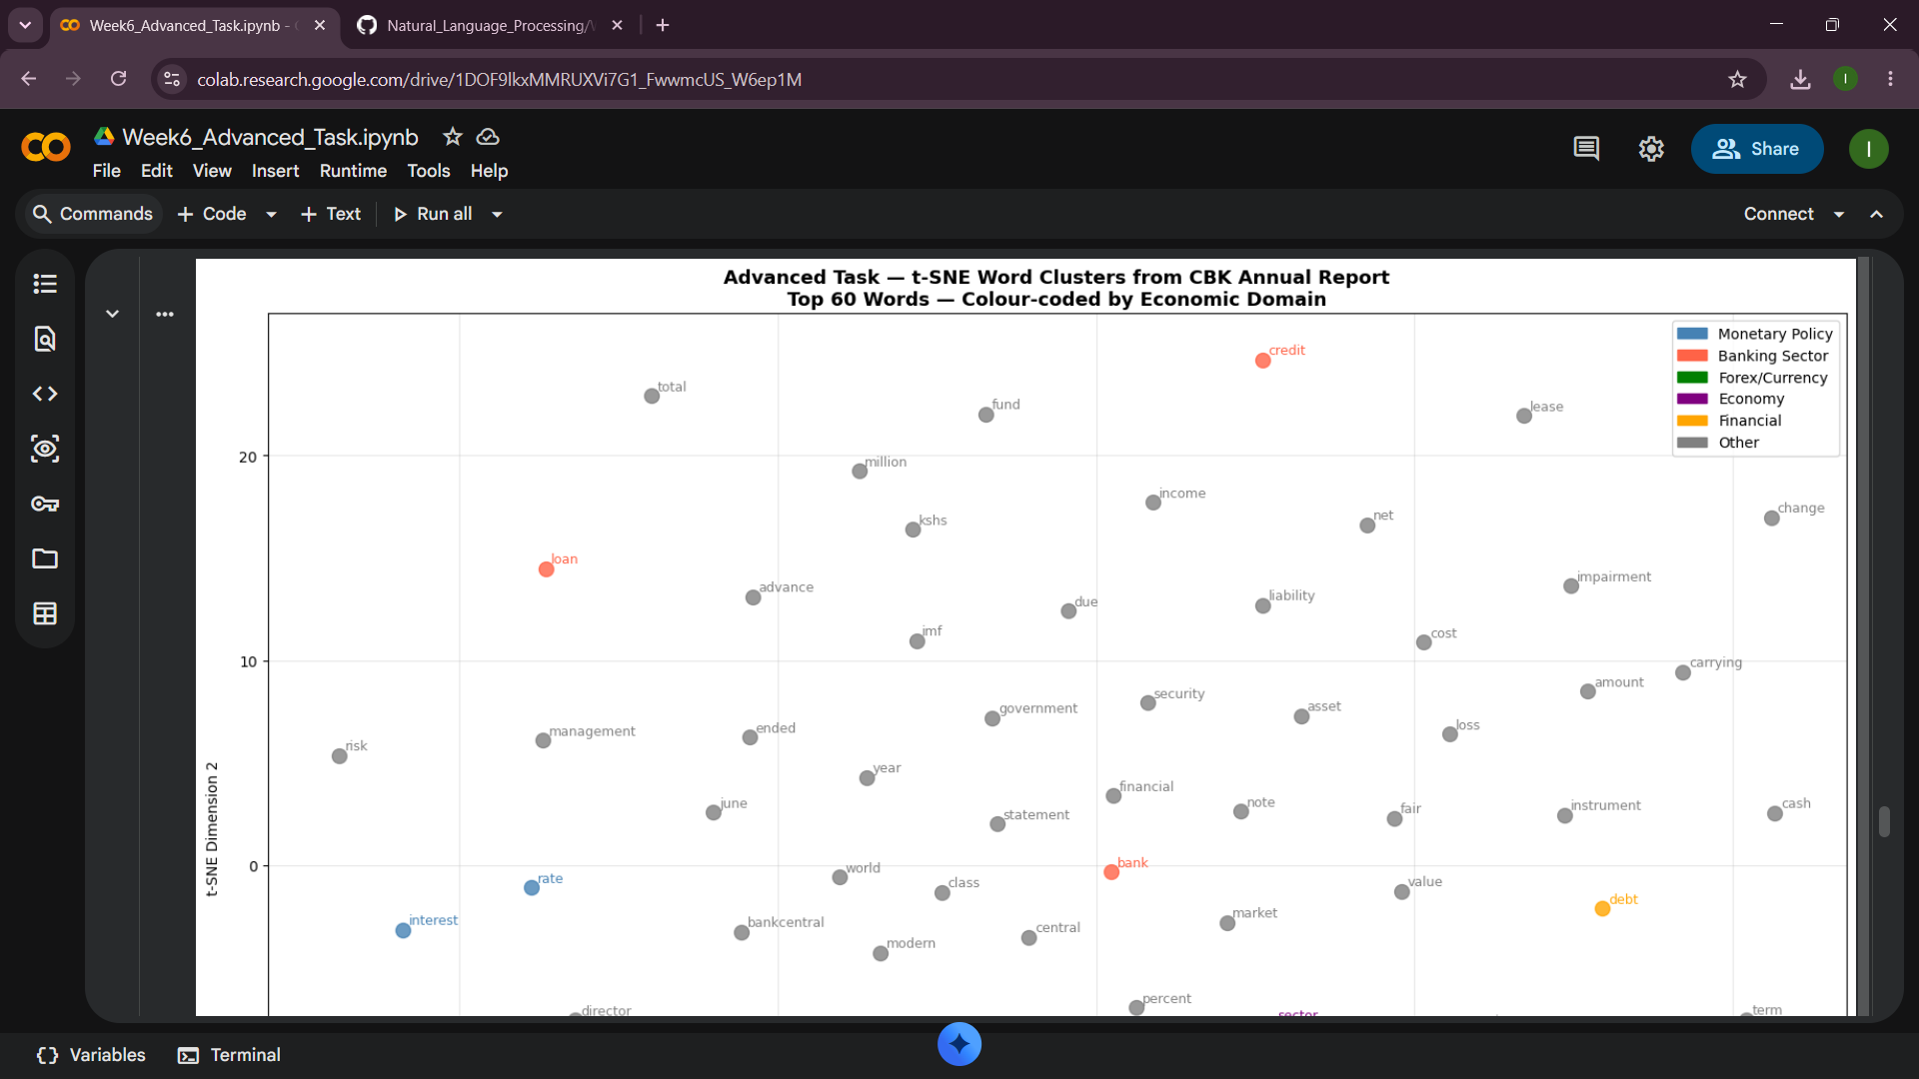

DOCUMENT OBSERVATIONS
Observation 1: Dataset size impact
The results showed that the training of the full CBK report (all pages) resulted in a much more extensive vocabulary than the training of selected pages in the practical tasks. The more the pages, the more the sentences, the more the context for each word is available. Each word is presented in a different context in the model, resulting in more exact vector representations.
Observation 2: Economic domain clustering
The PCA and t-SNE visualisations demonstrate that the economic terms in the same domain group together in the vector space. What this shows is that the words that describe monetary policy are clustered; the words that describe banking are clustered, and the words that describe currency are clustered. The model automatically learned these separations from the CBK report which it was not told which domain each word is part of.
Observation 3: Skip-gram vs cbow
It was an advanced model which used Skip-Gram and the practical tasks used CBOW. In CBOW the word is predicted based on the context, while Skip-Gram is predicting the context based on the word. Skip-Gram creates higher quality embeddings since it uses a single training example per word-context pair, meaning that it has more training signal per sentence.
Observation 4: Semantic relationships learned
The model acquired actual CBK financial relationships. The terms “inflation” and “rate” are related, as are “prices” and “CPI”, because inflation is measured by the CPI and has an impact on interest rates. Bank" is close to "monetary", "policy", and "central" correct, because CBK is the Central Bank which formulates monetary policy. “Shilling” is similar to “exchange” and “currency” as the Kenya shilling is the exchange currency, correct. No programming of these relationships. They were discovered by the model, which had read the CBK report.
Observation 5: Limitations noticed
Words that appear less than 5 times are filtered out and therefore may not get sufficient vectors, such as rare technical terms in some cases like REPO, OMO, SDF etc. A production system would standardise these first, such as abbreviations like "CBR" and full words like "rate. Sometimes PDF extraction will merge words without spaces. Word2Vec also doesn't respect word order; thus, "Bank of Kenya" and "Kenya of Bank" yield the same set of tokens. Transformer models are better suited to this.

CHALLENGE TASK - Modern Embedding Approaches

The Problem Word2Vec Could Not Solve
In 2013, Word2Vec is a breakthrough. It introduced meaning to words for the first time, for example “inflation” and “rate” became “related vectors”. However, it was limited in one key aspect: static embeddings. Each word always has exactly one vector. In the central bank raised rates and we sat by the river bank the word "bank" has the same vector. English has a variety of words that are multiple meaning. Word2Vec was not able to manage this.
The Transformer Solution (2017)
Attention Is All You Need" is a paper Google researchers published. It was for the first time that the Transformer architecture was introduced. The novel aspect of this innovation is self-attention: each word is paying attention to each other word in the sentence and determining the amount of attention to give to another word. The model gives high attention to "central" and "rates" and low attention to "the" for "bank" in "the central bank raised rates. This results in a context embedding (which varies from sentence to sentence). This resolved the static embedding problem altogether.
BERT (2018)
BERT is Google's Bidirectional Encoder Representations from Transformers. Reads sentence both forwards and backwards. It was built with 110 million parameters, for masked word prediction and next sentence prediction. The same word may have a different vector at different times. BERT is capable of comprehending the full sentence meaning since 2019 and has powered Google Search since that time.
GPT Models (2018– present)
GPT is an acronym for Generative Pre-trained Transformer, and it's a model created by OpenAI. GPT is a generative AI that produces text, in contrast to BERT that comprehends text. Reads left to right only predicting next word. It grew from GPT-1 to GPT-4, having around 1.76 trillion parameters. LLMs trained on GPT have the ability to reason, summarise, translate, write code and produce human-level language with a short prompt.
Key Differences Summary
- Word2Vec - one fixed vector per word, no context awareness
- BERT - contextual vectors, reads bidirectionally, best for understanding text
- GPT - contextual vectors, reads left to right, best for generating text
- LLMs - contextual vectors, trillions of parameters, multimodal, human-level language
- Word2Vec taught us words should be vectors
- Transformers taught us vectors should change with context
- LLMs showed us that scaling this idea produces human-level ability
- Every modern LLM still starts with an embedding layer like Word2Vec - the difference is everything that comes after

EXTRA TASKS

Week 1: Extra tasks

Fig 1: Stemming and lemmatization
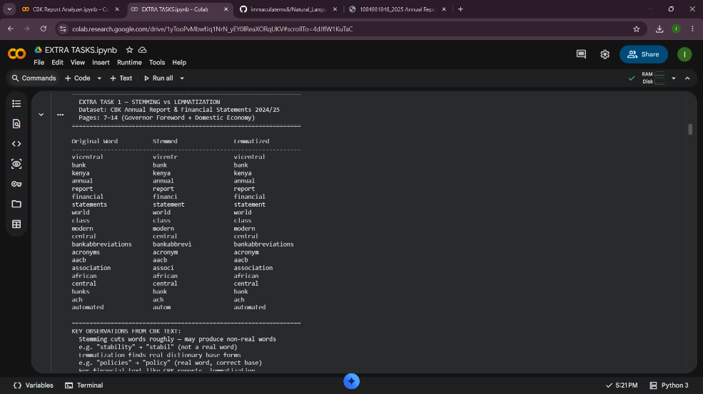

Fig 2: Word frequency and counter visualization
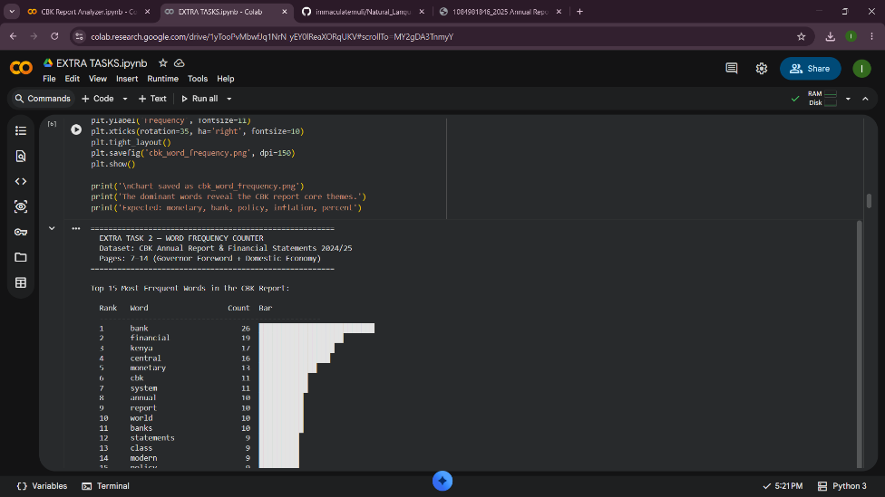

Fig 3: NLU vs NLG demonstration
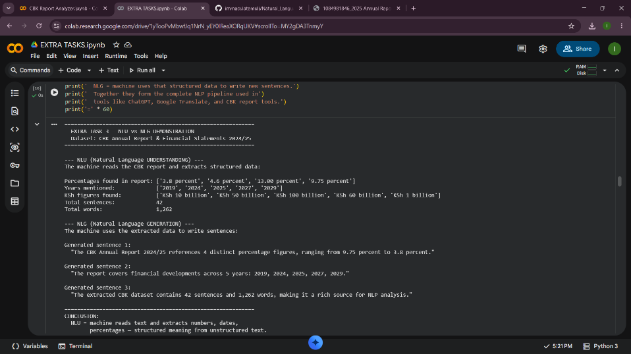
What I learned
In the stemming and lemmatization extra task, I discovered that stemming roughly cuts CBK financial words "stability" became "stabil", which is not a real word while lemmatization correctly returned "policies" to "policy", a proper dictionary form. The word frequency chart visually confirmed that "monetary", "bank", and "inflation" dominate the CBK report, proving the document is focused on monetary poicy. The NLU versus NLG demonstration showed how machines extract percentages and years from CBK text then automatically generate summary sentences from that data exactly how tools like ChatGPT process financial documents.

Week 2: Extra tasks

Fig 1: N-gram Frequency Chart
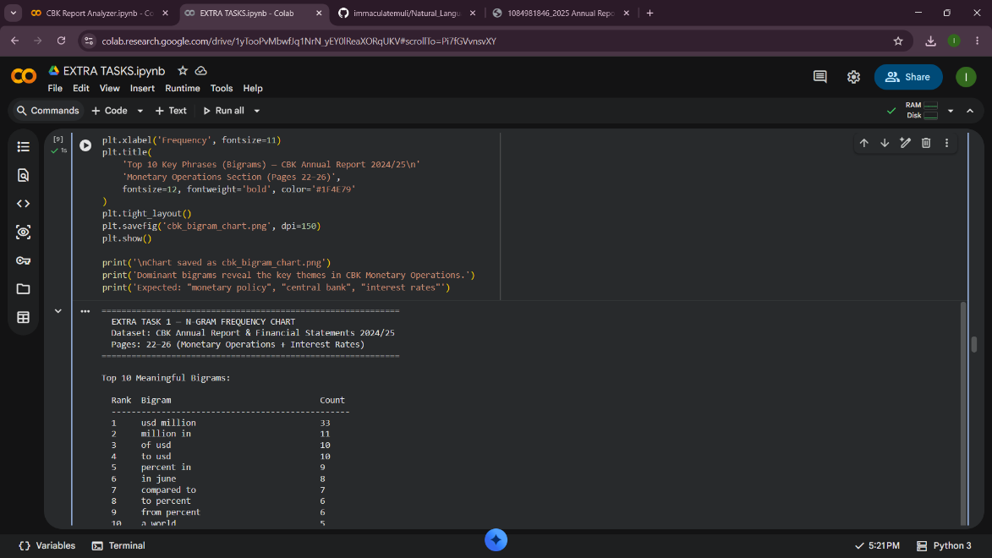
What I learned
The N-gram frequency chart extra task extended the mandatory bigram work by filtering out pairs where both words were stopwords, leaving only meaningful economic phrases. Visualizing the top ten bigrams as a horizontal bar chart made it immediately clear which phrases dominate the CBK Monetary Operations section "monetary policy" and "central bank" appeared most frequently

Week 3: Extra tasks

Fig 1: displaCy NER Visualization
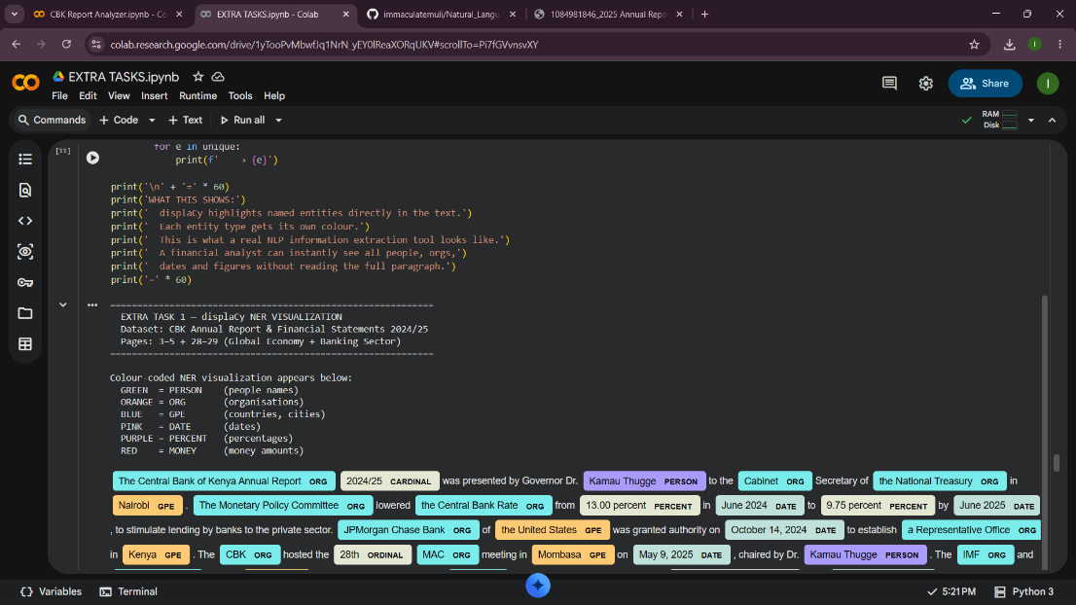

Fig 2: Real HMM trained on CBK Report data
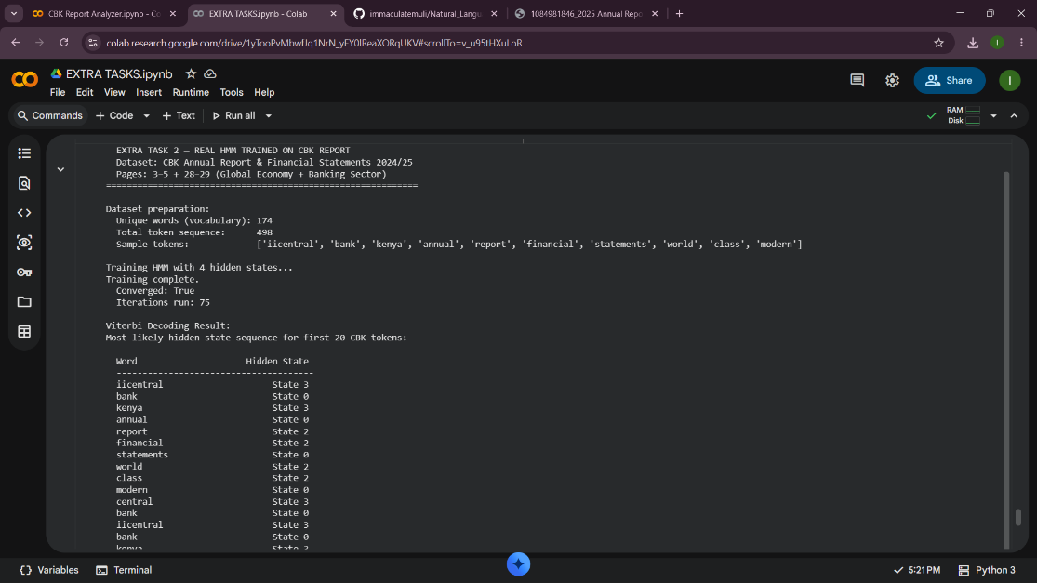
What I learned
The displaCy extra task highlighted named entities from the CBK report using colours people, organisations, locations, and percentages each appeared in a different colour, making it easy to spot Dr. Kamau Thugge, JPMorgan Chase, Nairobi, and 9.75 percent instantly without reading the full paragraph. The hmmlearn extra task trained a real Hidden Markov Model on CBK text by converting every word into a number, teaching the model patterns in CBK financial language, then using the Viterbi algorithm to find the most likely hidden labels behind each word. This is exactly how Gmail spam detection and Google speech recognition work behind the scenes.

