Scenario: ABC Logistics Warehouse
ABC Logistics wants to automate inventory tracking.
Currently, employees manually scan products entering and leaving the warehouse.
The company decides to install 100 Zebra fixed RFID readers (FXR90, FX9600, and other supported models) and integrate them with its Warehouse Management System (WMS).
Who will design, connect, develop, and maintain this solution?
That's where these four roles come in.

1. Solution Architect — Designs the entire system

Main responsibility: Decide how the entire RFID solution should work before implementation begins.
The Solution Architect looks at the business requirement and designs a system that connects 100 RFID readers to the warehouse application.
The Solution Architect asks questions such as:
- Should we use an on-premises server or AWS/Azure?
- Should all 100 readers connect to one MQTT broker?
- What happens if the MQTT broker fails?
- How will the system handle thousands of tag events?
- How do we secure communication between components?
- How can the system expand to 500 readers?
Example decision:
The architect proposes that all 100 readers publish events to an MQTT broker cluster, and a backend application processes the events and updates a central database.
The architect defines the system design but does not necessarily implement every component.
Documentation needed: System architecture, deployment modes, scalability, integration patterns, supported reader capabilities, and security considerations.

2. System Integrator — Connects the components
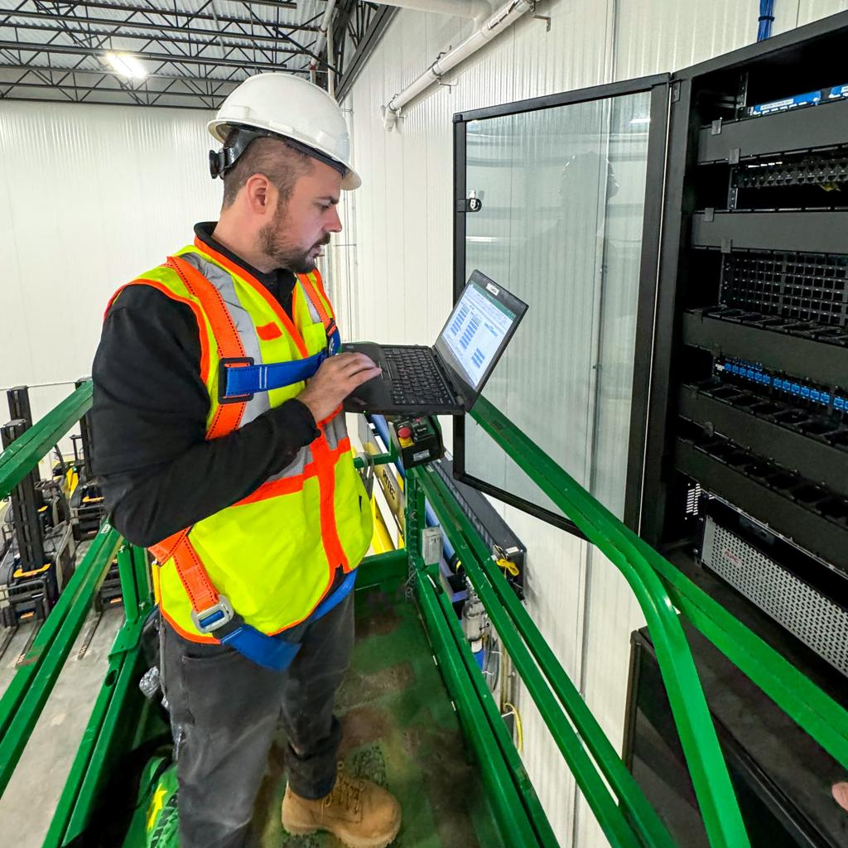
Main responsibility: Make different hardware and software systems communicate successfully.
The System Integrator takes the architect's design and connects the RFID readers to the MQTT broker and warehouse application.
Imagine Reader 1 is installed at the receiving dock.
The System Integrator:
- Connects the reader to the warehouse network.
- Configures the reader's IP address and connectivity.
- Opens the Zebra reader's web interface.
- Creates an MQTT endpoint.
- Configures the broker address, port, topics, and authentication.
- Maps the appropriate IoTC interfaces to the endpoint.
- Tests whether tag events reach the backend application.
For example:
Reader: FX9600
Reader IP: 192.168.1.10
MQTT Broker: 192.168.1.20
MQTT Port: 8883
Authentication: TLS certificates
These are illustrative configuration values.
Documentation needed: Network setup, endpoint configuration, MQTT topics, certificates, deployment procedures, and connectivity troubleshooting.

3. Application Developer — Builds the software

Main responsibility: Write the software that uses RFID data to solve the warehouse's business problems.
The Application Developer builds the backend application, data-processing logic, and potentially the dashboard used by warehouse employees.
For example, Reader 1 detects an RFID tag attached to a Dell laptop.
The application receives the event through MQTT.
The developer writes logic to:
- Extract the EPC from the tag event.
- Identify which reader detected the tag.
- Look up the EPC in the product database.
- Determine whether the product is entering or leaving, using business rules.
- Update the warehouse inventory records.
- Display the result on the dashboard.
The developer might also write code to start and stop inventory using REST APIs or supported MQTT commands.
For example, a simplified Python REST request:
import requestsresponse = requests.put( "https://READER_IP/cloud/start", json={}, timeout=10)
The exact payload and authentication must follow the reader's API specification.
Documentation needed: REST/MQTT APIs, request and response payloads, event schemas, sample code, integration tutorials, and error handling.

4. IT Administrator — Keeps everything running
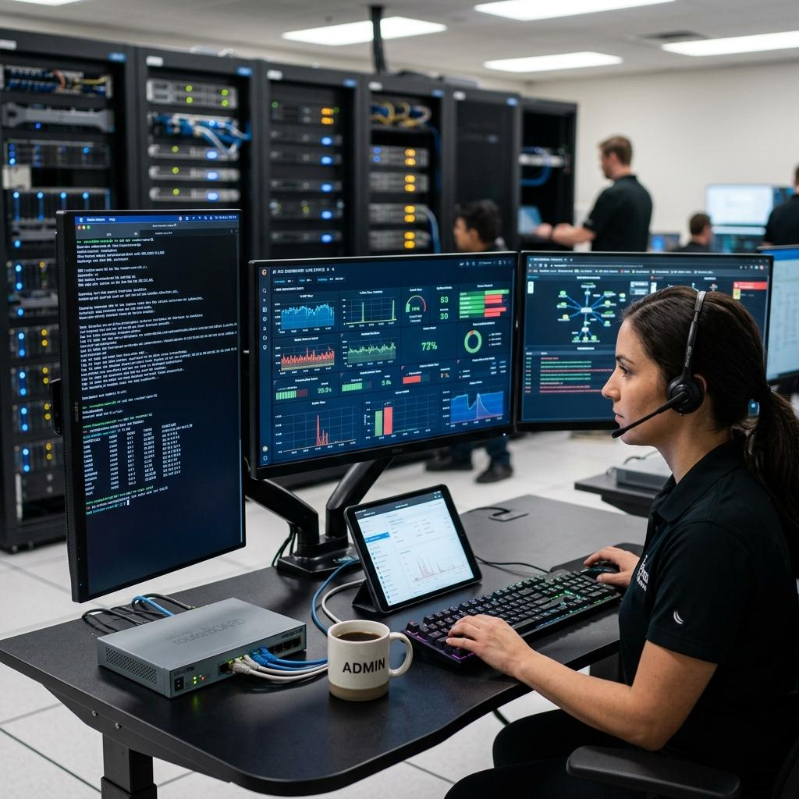
Main responsibility: Maintain the security, availability, and operational health of the deployed system.
After the solution is deployed, the IT Administrator ensures that the infrastructure continues functioning.
Imagine Reader 25 suddenly stops sending tag data.
The IT Administrator investigates:
- Is the reader connected to the network?
- Is the MQTT broker operational?
- Are the certificates still valid?
- Are heartbeat events arriving?
- Has the reader configuration changed?
- Is there a firewall or network issue?
The administrator may restart services, renew certificates, investigate network problems, or coordinate a reader firmware update.
Documentation needed: Monitoring, network configuration, security, firmware management, diagnostics, logs, and troubleshooting.

5. How all four roles work together
Solution Architect
Designs how the complete RFID system will work
System Integrator
Connects readers, networks, brokers, and systems
Application Developer
Builds application logic and user interfaces
IT Administrator
Secures, monitors, and maintains the deployed infrastructure
Illustrative responsibilities. In practice, these roles collaborate throughout the project, and responsibilities may overlap.

6. One problem, four different perspectives
Suppose Reader 10 stops sending RFID tag data.
Role | How they approach the problem
Solution Architect | Was the system designed to tolerate reader or broker failures?
System Integrator | Is Reader 10 correctly connected and configured?
Application Developer | Is the application subscribing to the correct topic and processing events correctly?
IT Administrator | Is the reader, network, or broker experiencing an operational problem?
This example shows why all four roles need different documentation, even though they are working on the same RFID system.

7. What this means for your Information Architecture
For your Zebra IoTC documentation project, you should not necessarily create four separate guides named after these roles.
Instead, organize documentation around the tasks they need to complete.
Documentation section | Primary audience
Architecture and Deployment Modes | Solution Architect
Getting Started and Endpoint Configuration | System Integrator
REST/MQTT API Reference | Application Developer
Integration Guides and Sample Applications | Application Developer, System Integrator
Multiple-Reader Deployment | Solution Architect, System Integrator
Security, Monitoring, and Troubleshooting | IT Administrator, System Integrator
The key difference to remember:
- Solution Architect: How should the entire system be designed?
- System Integrator: How do we connect everything together?
- Application Developer: How do we build software that uses the system?
- IT Administrator: How do we keep the system secure and working?
For your documentation planning, the most important distinction is between the System Integrator and Application Developer. One primarily establishes the integration between systems, while the other builds the software that uses that integration. In smaller projects, the same engineer may do both
Documentation needed: System architecture, deployment modes, scalability, integration patterns, supported reader capabilities, and security considerations.
how the document will look for this

