INITIAL REQUIREMENTS DOCUMENT
PROJECT NAME: |  |  | Type
REJECTIONS |  |  | New Feature
STAKEHOLDER |  | US UI/UX:
Dan Burns |  | Emme Ferguson
BA AUTHOR:
Rolando Arduo Jr.
PROJECT MANAGER:
Ma. Giselle Dionesio
DEVELOPMENT TEAM: (INCLUDING UI/UX)
SQA TEAM:
OTHER TEAMS:
PRIORITY: |  | BRAND:
High |  | All Brands

PROJECT INITIAL REQUIREMENTS FROM STAKEHOLDERS
Reworks

Goal
Create a visible, user-friendly system for identifying, editing, and resubmitting reworks.

Functionality Overview

- Visibility
- Items that need to be reworked are highlighted in Red, and status is “On Hold”
- Reworks appear clearly marked in red on:
  - Main Orders page
  - Order view
  - Item view
- Rework items should always stand out (badge + label).
- Within Customizer: Notes/Logs section has moved to the builder page tab area, with the section being renamed to “Issues/Logs”. Issues are where the reworks will be, and this section only appears if there is an issue that needs to be resolved with an item. Logs area is where resolved reworks will be. If there are multiple reworks users can look back on other reworks within that item.

- Rework Action
- Clicking the Fix Issue button (from Orders, Order view, Item view, or Email):
  - Opens the Customizer.
  - Shows rework notes, what needs to be changed.

- Editing Rules
- Rework unlocks the item for editing.
- Users may:
  - Fix the required issue(s)
  - Submit the revised item

- Handling Additional Changes
- Users receive a message advising NOT to change anything not included in the rework notes in a banner.
- If they DO make a change:
  - A text box appears for them to write why they changed it.
  - If the change was actually necessary, QC can accept it.
  - If it was just preference, QC can reject the additional change.

- Submitting Rework
- Required fields:
  - Confirmation that changes were made. Users cannot submit the rework until they have chosen one option. "Submit rework" modal is different depending on which option they chose.
  - Optional note field.
- Once submitted: Item returns to the workflow with updated date stamps.

Requirements
- Rework flag must be visible in all locations listed above.
- Customizer unlocks only during rework sessions.
- Clear error states if submission fails (confirmation that only outlined changes were made, or need for justification of extra changes).

Acceptance Criteria
- Reworks show in red.
- Rework button launches Customizer with notes.
- Users can only submit after making required fixes.
- Additional-change explanation required when applicable.
- Notes always send with submission.

QX7 CHECKLIST
SECTION | YES/NO | NOTES
OTHER QX7 PAGES
FE IMPLEMENTATION | YES
SYSTEM PERFORMANCE

CUSTOMIZER CHECKLIST
SECTION | YES/NO | NOTES
CUSTOMIZER LANDING PAGE
SPORT PICKER
PRODUCT PICKER
PRODUCT PICKER MODALS
PRODUCT PICKER (LOADING TIME)
BUILDER
SHOPPING CART
SHOPPING CART FLYOUT
ADMIN PAGES | YES
PDF | YES
PDF SERVICE
CHECKOUT PAGE
QSTRIKE SYSTEM
SYSTEM PERFORMANCE

PRODUCTS CHECKLIST
SECTION | YES/NO | NOTES
STOCKS
HYBRID
SUBLIMATED
TWILL
REVERSIBLE
BAGS

PROJECT REQUIREMENTS

BUSINESS REQUIREMENTS
NAME | DESCRIPTION
Overview
FUNCTIONAL REQUIREMENTS
NAME | DESCRIPTION
REWORK | 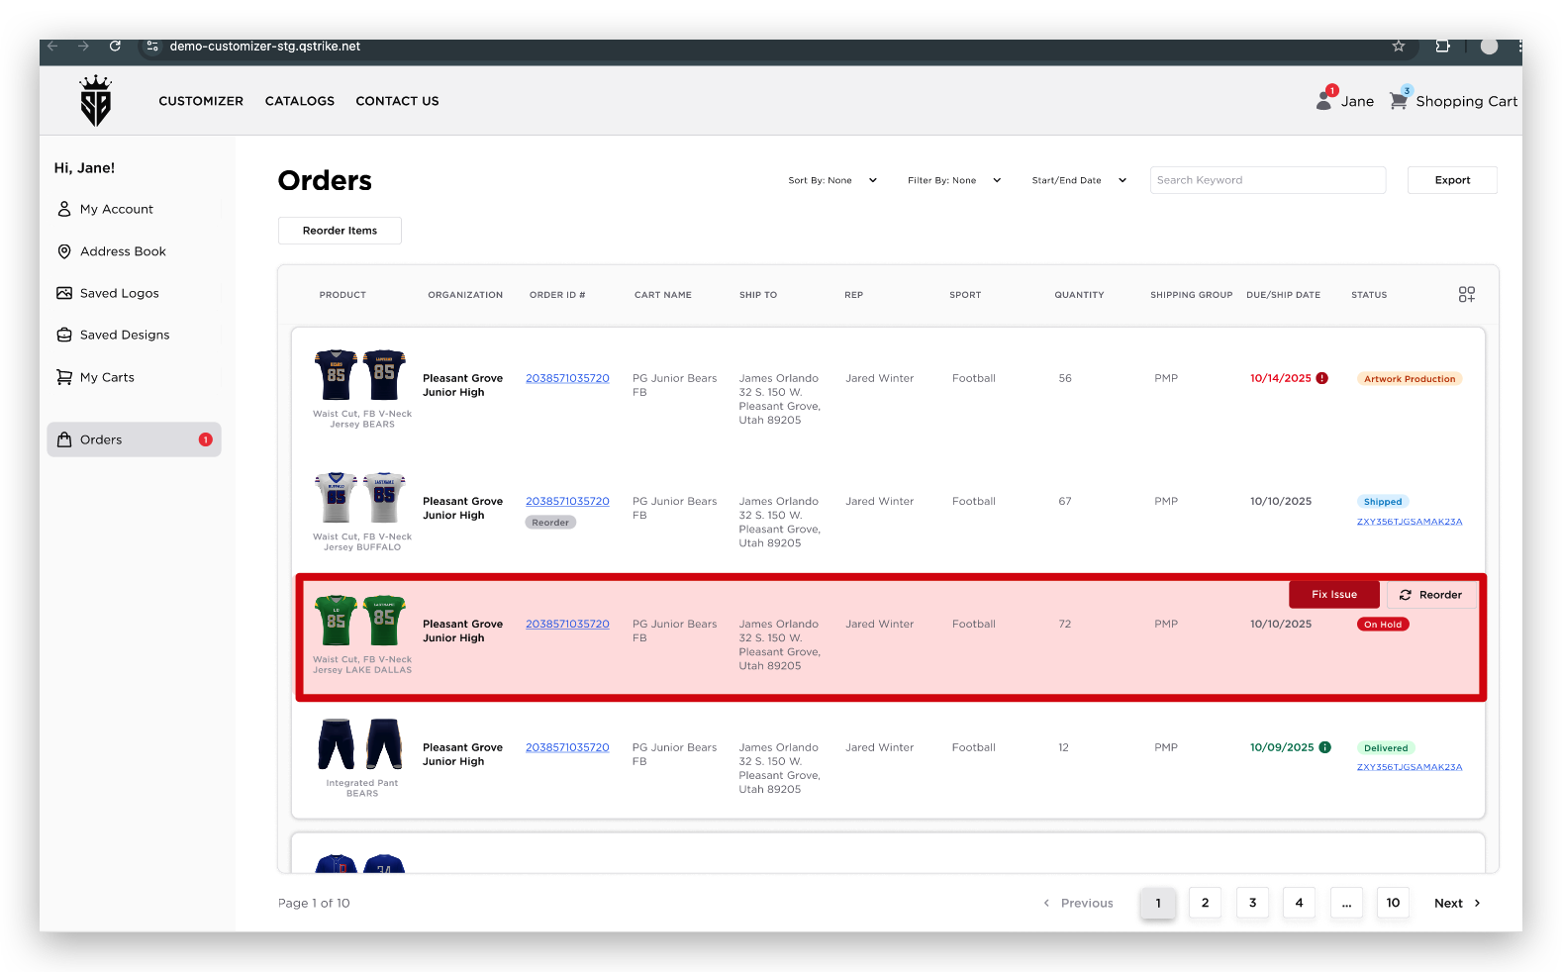  (For reference only) Artwork Production Site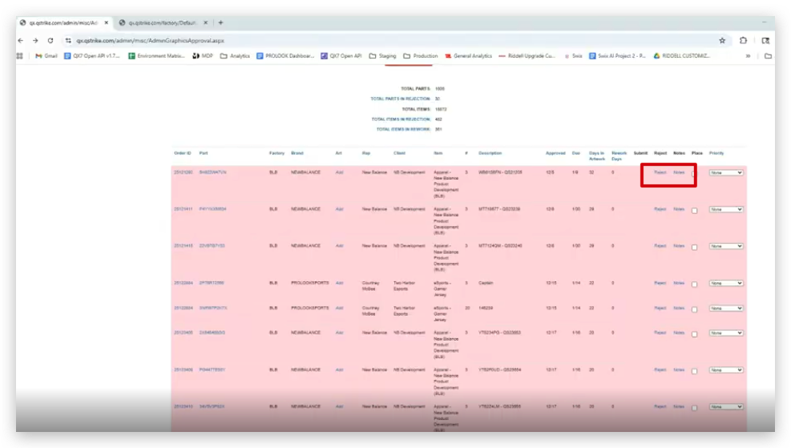  (For reference only) Factory Production Site  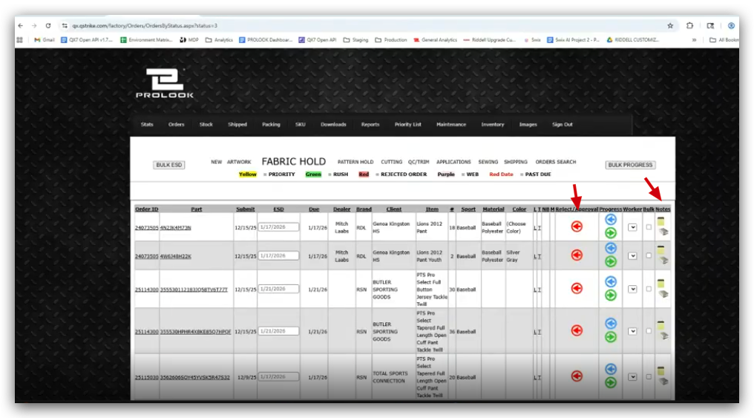  - Once the user rejects and provides notes in the item from the Artwork Production Site and the Factory Production Site, the following user notification and interface will be expected:  - The system should trigger an email alert upon rejection  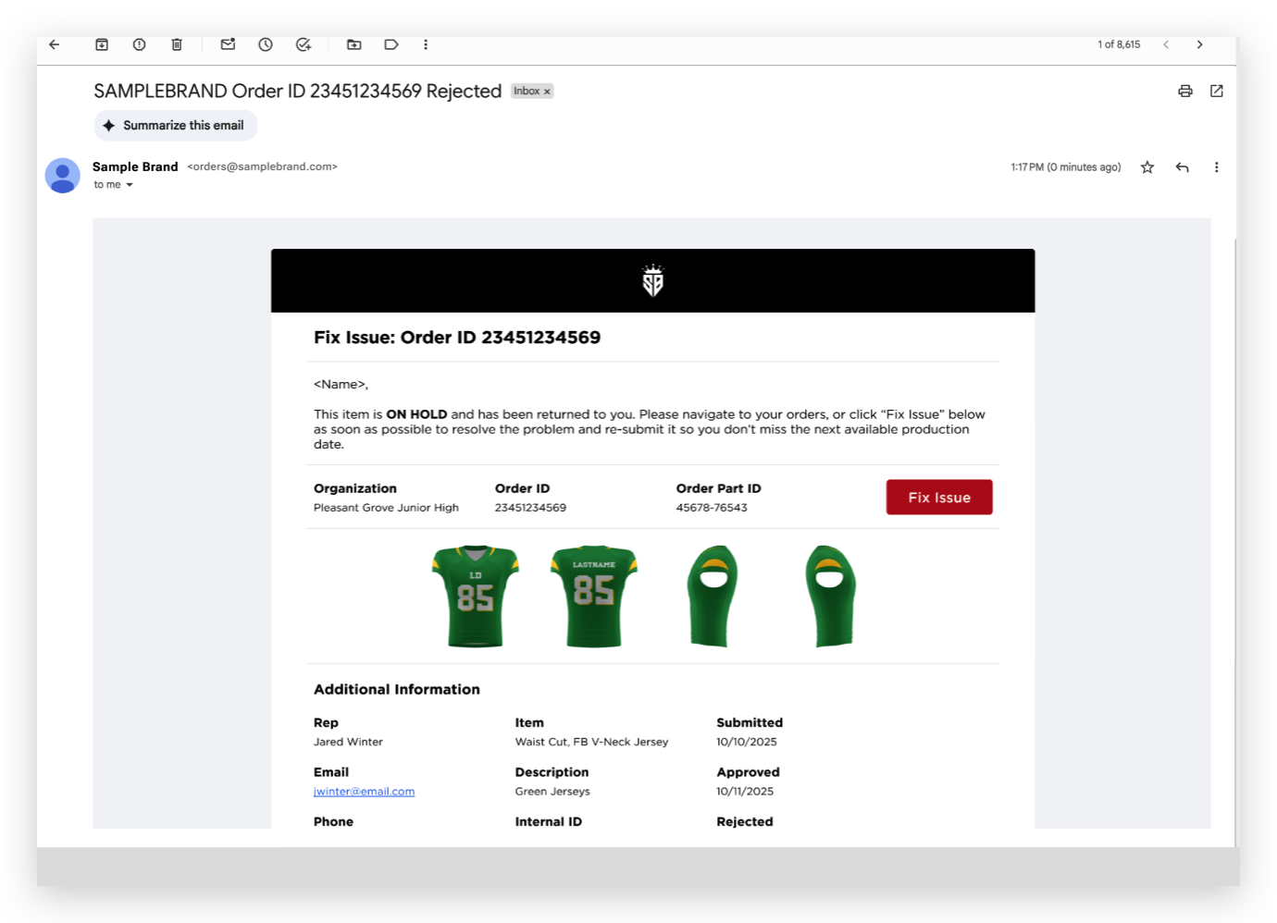  - The rejected order should remain in the 'orders' tab  - Rejected items should be highlighted, for example, with a "pink highlight" and have a badge "on hold".  - The front end needs an interface where users can "fix any issues" called out from the factory and add their own notes, typically within an "issues and logs" section/panel (see below process upon clicking the Fix Issue Button)  - Once the Fix Issue Button is clicked, the page will be redirected to the selected item in the builder  - A banner will show stating, “Please update only the items specified in the rework notes. Additional edits require an explanation and may be rejected if not properly justified.”  - In the Issues/Logs tab (a new tab will be added to the builder), the users can see the issues and logs subtabs. This new tab will only show if there’s a rework  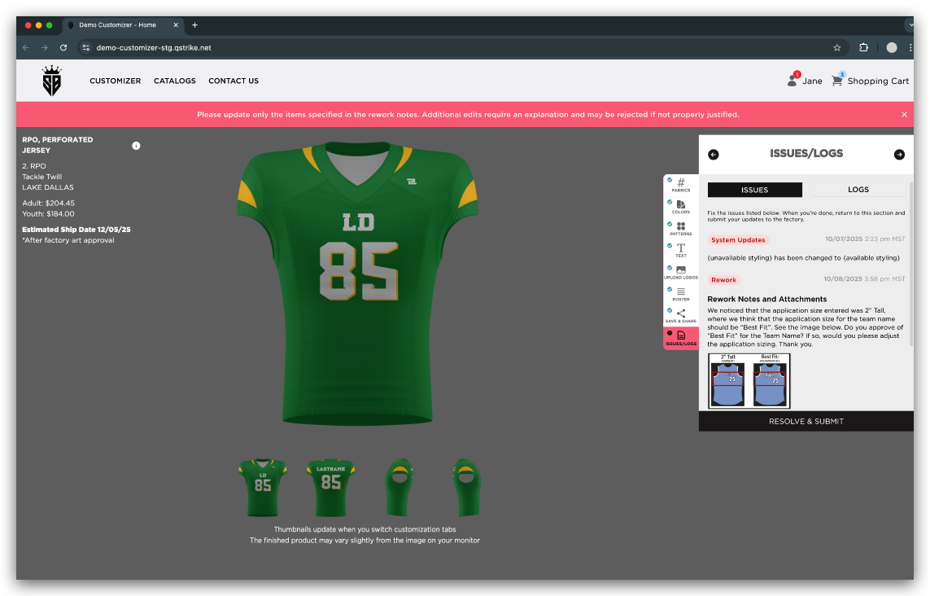  - ISSUES Sub Tab:  - Opening statement - “Fix the issue listed. When you are done, return to this section and submit your updates to the factory.”  - (1) System Updates and (2) Design Requests should be in the issues tab. Respective badges apply accordingly too  - (3) Rework Badge and time stamp (the time that it was loaded in the builder)  - They can view the image in the rework notes, but it can be seen within the drawer only  - Rework Notes and attachments:  - Added notes and attachments (Optional) - The user can add notes and attachments  - Confirmation Section: (Note: Rejection Response will include the changes made, whether any application changes, and or notes/attachments from the end-user)  - The First Radio button option is “I only made the changes listed in the rework notes.”  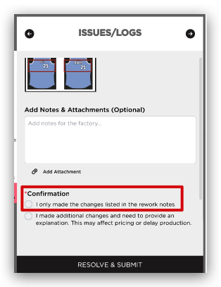  - The Second Radio button option is “I made additional changes and need to provide an explanation. This may affect pricing or delay production.” - An additional notes field will pop up once this option is clicked. The screenshot below is an example  - When a user clicks the button indicating they made additional changes and need to explain, the only purpose of that is to notify the artist that something is being changed. Displaying a real-time price change on the front end if a user makes additional changes is not required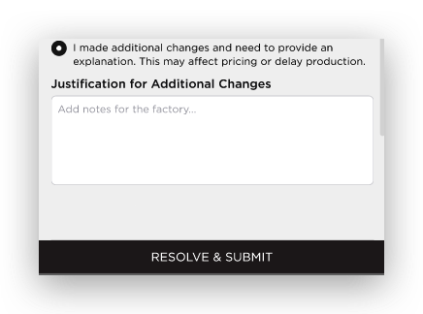  - The 'Resolve & Submit' button cannot proceed if the user does not provide any notes. The field will also be highlighted in red to emphasize the need to add notes. The user will be forced to add notes before clicking the 'Resolve & Submit' button  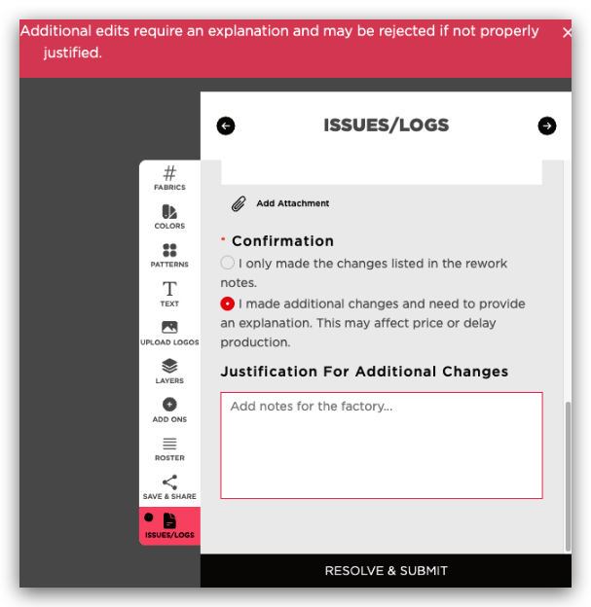  - If a rejection occurs on a reorder item, the customization panel tabs that were locked for the reorder should remain locked. The confirmation radio button ("I made additional changes") should be removed or taken away, as it would not apply. The resolution for the rejection on a reorder would be handled solely through the notes and attachments, and the resolve and submit button  - LOGS Sub Tab - Badge, Notes, dates are present for Rework, System Updates, and Design Requests are also present to this sub tab  - If there are multiple reworks in a single item, it will be listed here  - For System Updates and/or Design Request, follow the color of the badge in the mock-up  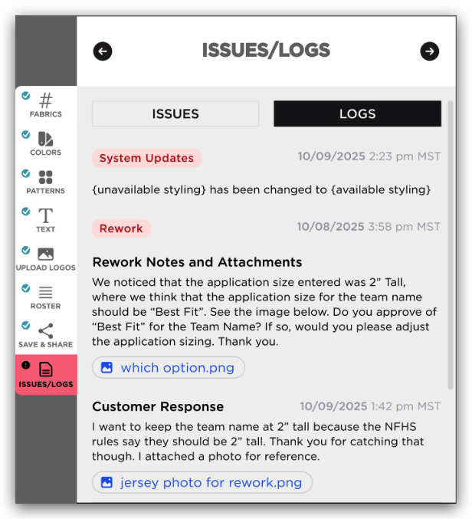  - In case there’s no rejection, the “Fix the issue listed. When you are done, return to this section and submit your updates to the factory.” will be removed. Below is a sample mock-up  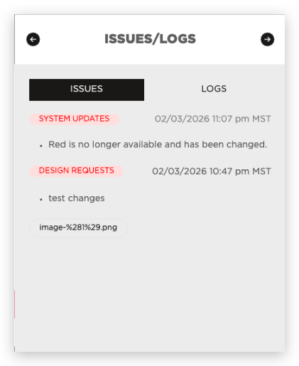  - RESOLVE & SUBMIT button - Once this is clicked, a pop-up modal will be displayed  - For the radio button option 1, the modal is stated below:  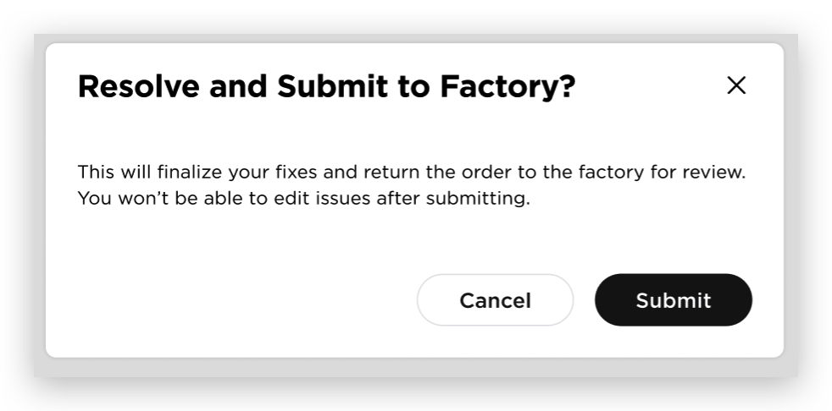  - For the radio button option 2, the modal is stated below (Note: the user should click the check box first before clicking submit. This is required)  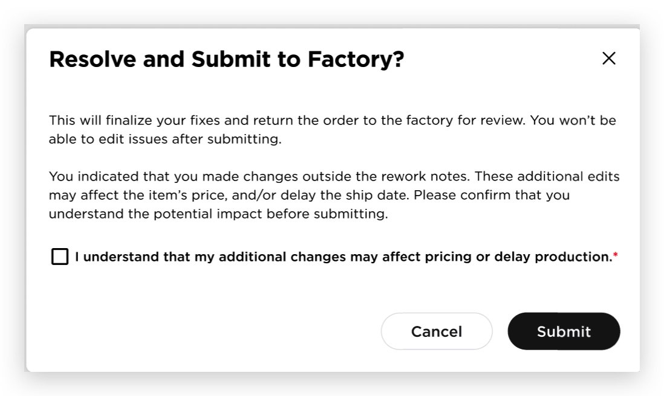  The options are Cancel and Submit. If the user clicks the cancel, it will close the modal. If the user submits, it will go back to the Order Tracking page with a Green Notification in the right corner. Additional note: (PDF Updates upon Change: If a user makes changes after an item is rejected and clicks the "submit" button, the PDF needs to be updated because they are changing what is being ordered. The updated item should reflect what was manufactured. The recommended solution is for the action on the front end when the "submit" button is clicked to save a new PDF with the updated selections. This new PDF would be sent as a new updated attachment tied to the same order ID to Josh (the factory side))  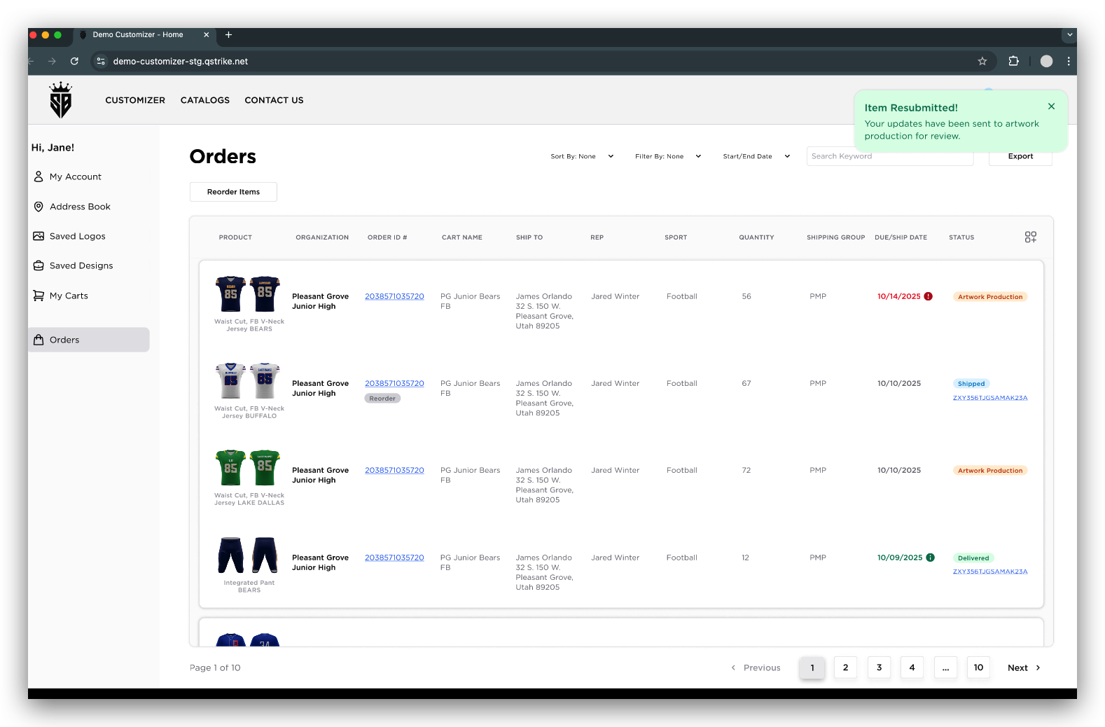  - The number showing in the ORDERS menu on the left side represents the number of reworks needed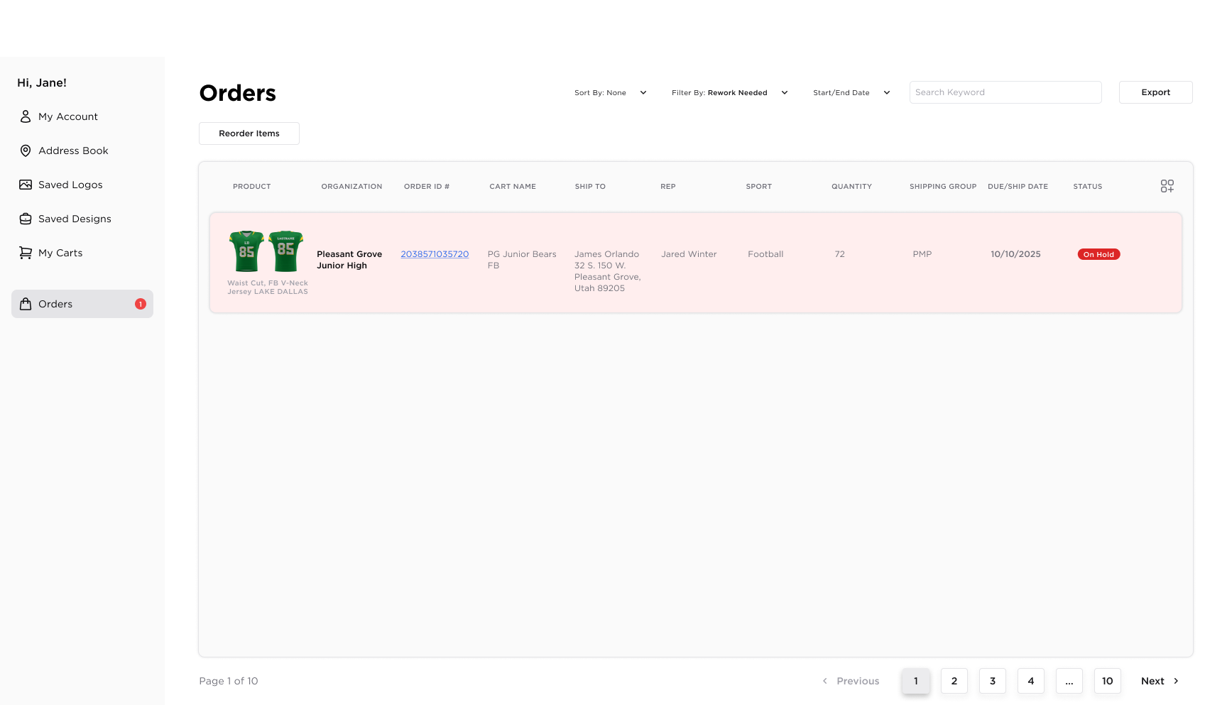  - ORDER DRAWER - FIX ISSUE and ITEM DRAWER - FIX ISSUE/ON HOLD  - The user can use the drawer to fix the issue. Same process above, after the Fix issue button is clicked through the drawers  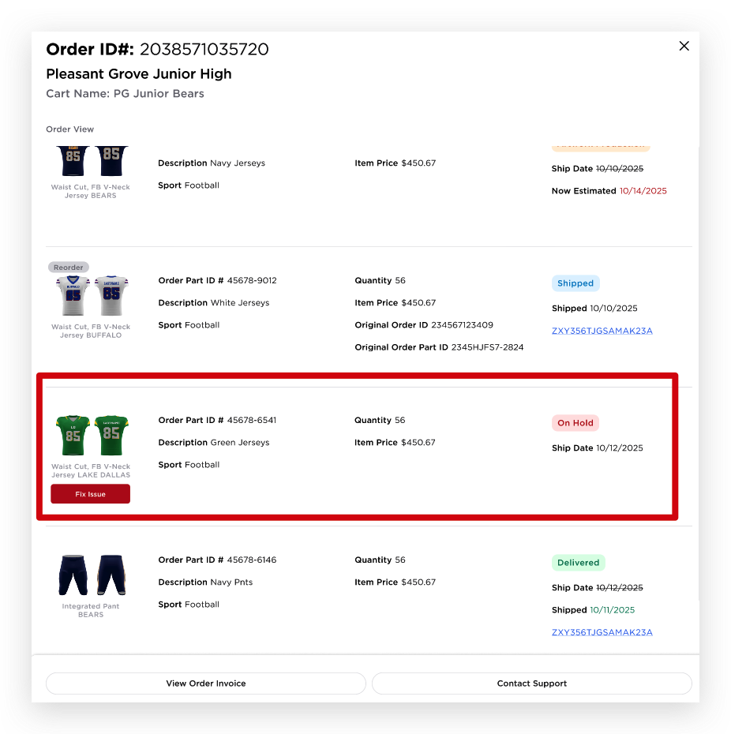  - The End-User should not see the fix issue button/badge. The expectation is that the sales rep will handle the fix issue and work with their customer if they have concerns/questions  - In the prevail brand, managing Rep should see the badge/fix issue button and highlight since they are allowed to act on behalf of the sales rep  Notes:
OUT OF SCOPE REQUIREMENTS
NAME | DESCRIPTION

REFERENCES
NAME | LOCATION
Final Design Figma Link | https://www.figma.com/design/ED5PAfAac5IPyMcy9uD3CU/Order-Tracking?node-id=2166-17306&t=FXI6xpVpWXFCVaIP-0
Monday ticket | https://prolook.monday.com/boards/4880298520/views/195635965/pulses/10638366158/posts/4702218950?reply=reply-4775952864
Hand-off Video
Technical Specs

