Experiment 6: Filtering and Inspecting DHCP Packets

Aim
To capture 100 packets from the LAN interface using Wireshark, apply a display filter to show only DHCP packets, and inspect the packet details.

Procedure
- Open Wireshark and select the Local Area Connection interface.
- Go to Capture → Options.
- Tick “Stop capture automatically after 100 packets”.
- Click Start to begin the capture.
- Type dhcp or dhcpv6 in the display filter bar and press Enter.
- Select a packet and expand the Frame, Ethernet II, Internet Protocol Version 6, User Datagram Protocol and DHCPv6 sections to inspect it.
- Save the captured packets using File → Save.

Display Filter Used
Filter | dhcp || dhcpv6
Protocols displayed | DHCP (IPv4) and DHCPv6 messages such as Discover, Offer and Solicit

Output
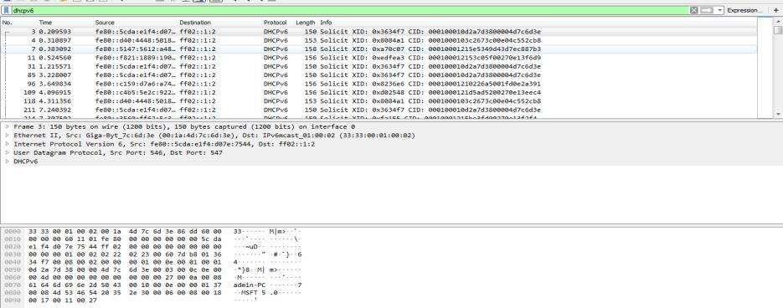
Figure 6.1: Wireshark output with the DHCPv6 display filter applied

Observation
- The captured packets are DHCPv6 Solicit messages sent from the client to the multicast address ff02::1:2.
- DHCPv6 runs over UDP, with source port 546 (client) and destination port 547 (server).
- The frame is carried in an Ethernet II frame with the multicast MAC address 33:33:00:01:00:02.
- Each Solicit message carries a transaction ID (XID) and a client identifier (CID).

Result
The DHCP packets were successfully filtered, captured and inspected using Wireshark.

