**AI-BASED DECISION SUPPORT SYSTEM FOR SMART AGRICULTURE**

**INTERDISCIPLINARY PROJECT**

Submitted in partial fulfillment of the requirements for the award of Bachelor of Engineering degree in Computer Science and Engineering

By

**IMMANUEL JEBARAJ**

**Reg. No–42110466**



**DEPARTMENT OF COMPUTER SCIENCE AND ENGINEERING**

# SCHOOL OF COMPUTING

SATHYABAMA

## INSTITUTE OF SCIENCE AND TECHNOLOGY

## (DEEMED TO BE UNIVERSITY)

**CATEGORY - 1 UNIVERSITY BY UGC**

**Accredited with Grade “A++” by NAAC | Approved by AICTE**

**JEPPIAAR NAGAR, RAJIV GANDHI SALAI, CHENNAI - 600119**

APRIL - 2025



**DEPARTMENT OF COMPUTER SCIENCE AND ENGINEERING**

**BONAFIDE CERTIFICATE**

This is to certify that this Professional Training-1 Report is the bonafide work of **IMMANUEL JEBARAJ (42110466)** who carried out the project entitled **“AI-BASED DECISION SUPPORT SYSTEM FOR SMART AGRICULTURE”** under my supervision from January 2025 to April 2025.

**Internal Guide**

**Dr. MURARI DEVAKANNAN KAMALESH, M.E., Ph.D.,**

**Head of the Department**

**Dr. L. LAKSHMANAN, M.E., Ph.D.,**

**Submitted for Viva voce Examination held on __________________**

**Internal Examiner External Examiner**

**DECLARATION**

I, **IMMANUEL JEBARAJ** (Reg. No- 42110466), hereby declare that the Professional Training-2 Report entitled “**LEAFSYNC:AI-BASED DECISION SUPPORT SYSTEM FOR SMART AGRICULTURE**” done by me under the guidance of **Dr. MURARI DEVAKANNAN KAMALESH, M.E., Ph.D**., is submitted in partial fulfillment of the requirements for the award of Bachelor of Engineering degree in Computer Science and Engineering.

**DATE:**

**PLACE: Chennai**

**SIGNATURE OF THE CANDIDATE**

**ACKNOWLEDGEMENT**

I am pleased to acknowledge my sincere thanks to **BOARD OF MANAGEMENT** of **Sathyabama Institute of Science and Technology** for their kind encouragement in doing this project and for completing it successfully. I am grateful to them.

I convey my thanks to **Dr. T. SASIKALA, M.E., Ph. D.,** Dean, School of Computing, and **Dr. L. LAKSHMANAN, M.E., Ph.D.,** Head of the Department of Computer Science and Engineering for providing me with necessary support and details at the right time during the progressive reviews.

I would like to express my sincere and deep sense of gratitude to my Project Guide **Dr. MURARI DEVAKANNAN KAMALESH, M.E., Ph.D.,** for her valuable guidance, suggestions, and constant encouragement paved the way for the successful completion of my project work.

I wish to express my thanks to all Teaching and Non-teaching staff members of the Department of Computer Science and Engineering who were helpful in many ways for the completion of the project

**ABSTRACT**

For generations, farmers have relied on traditional methods—often guided by instinct, experience, and uncertain weather—to nurture their crops. But in today’s world, where food demand is rising and climate conditions are unpredictable, these methods don’t always guarantee healthy yields. **LeafSync** was born from a simple yet powerful idea: to give farmers the tools they need to truly understand their soil and crops—not just guess, but know what their land needs.

**LeafSync** is an AI-powered decision support system that brings together real-time soil analysis, plant disease prediction, pest classification, and an intuitive chatbot that offers friendly, science-backed guidance. By combining technology with empathy, **LeafSync** provides a complete picture of soil health, helping farmers make informed choices that are tailored to their specific environment. Through interactive dashboards and location-based insights, the platform encourages a shift from traditional guesswork to modern, sustainable farming practices.

At its core, **LeafSync** is not just a system—it’s a partner in the field. It stands with farmers, helping them grow healthier crops, reduce waste, and secure better livelihoods, one decision at a time.

**TABLE OF CONTENTS**

|  |  |  |
| --- | --- | --- |
| **CHAPTER NO.** | **TITLE** | **PAGE NO.** |
|  | **ABSTRACT** | v |
|  | **TABLE OF CONTENTS** | vi |
|  | **LIST OF FIGURES** | vii |
| **1.** | **INTRODUCTION** | 1 |
|  | 1.1 OVERVIEW | 2 |
| **2.** | **LITERATURE SURVEY** | 3 |
|  | 2.1 CHALLENGES IN EXISTING SYSTEM | 5 |
| **3.** | **METHOD AND IMPLEMENTATION** | 6 |
|  | 3.1 REQUIREMENT ANALYSIS | 6 |
|  | 3.2 SYSTEM ARCHITECTURE | 9 |
|  | 3.3 IMPLEMENTATION | 13 |
| 4. | **RESULTS AND DISCUSSION** | 16 |
| 5. | **CONCLUSION** | 20 |
|  | **REFERENCES** | 21 |
|  | **APPENDIX** | 22 |
|  | A.SCREENSHOTS | 22 |
|  |  |  |

|  |  |  |
| --- | --- | --- |
|  | **LIST OF FIGURES** |  |
| **FIGURE NO.** | **FIGURE NAME** | **PAGE NO.** |
| 3.1 | FILE STRUCTURE | 11 |
| 3.2 | WORK FLOW | 13 |
| 4.1 | HOME SCREEN | 16 |
| 4.2 | SOIL METRICS SCREEN | 17 |
| 4.3 | LOGIN SCREEN | 18 |
| 4.4 | USER PROFILE SCREEN | 19 |

# CHAPTER 1

# INTRODUCTION

Agriculture is the backbone of many economies, especially in developing countries where farming is a primary livelihood. However, many farmers still rely on traditional methods that struggle to address challenges like climate change, soil degradation, and pest outbreaks. These methods often lack the precision needed to adapt to the changing agricultural landscape.

To meet these challenges, a more data-driven, sustainable approach is essential. Farmers need tools that provide accurate, real-time information about their soil and crops to make informed decisions. **LeafSync** was created to provide these tools, using technology to support farmers in improving productivity while maintaining environmental sustainability.

Farmers often face uncertainty due to a lack of scientific understanding of soil health and plant diseases, leading to inefficient practices and unpredictable yields. **LeafSync** addresses this by providing real-time soil analysis, AI-powered disease prediction, and tailored recommendations based on specific conditions.

Designed as both a web and mobile-based platform, **LeafSync** integrates a soil monitoring dashboard, AI models for plant health diagnostics, and an intuitive chatbot for farmer support. While the focus is on soil and crop health, the platform is designed to expand in the future to include weather forecasting, irrigation planning, and market analysis.

By combining AI with traditional farming knowledge, **LeafSync** empowers farmers with the data they need to make better decisions. It aims to boost yields, reduce waste, and support sustainable agricultural practices, ultimately benefiting the farming community and the world.

.

## 1.1 OVERVIEW

**LEAFSYNC** is a mobile-first platform designed to assist farmers in making data-driven decisions through real-time soil data and AI-powered diagnostics. By integrating advanced machine learning algorithms and a user-friendly interface, **LeafSync** empowers farmers with actionable insights to optimize crop health, soil management, and farm productivity. The system focuses on precision agriculture, helping farmers improve their yields while minimizing resource waste and promoting sustainable farming practices.

Key components of the system include:

* **User Interface (UI)**: **LeafSync** features a clean, intuitive interface that allows farmers to easily navigate through real-time soil health data, plant disease predictions, and personalized recommendations. The platform is designed for both web and mobile access, ensuring farmers can manage their crops from anywhere.
* **Real-Time Soil Health Monitoring**: **LeafSync** collects data on critical soil factors, such as moisture, temperature, and nutrient content, to give farmers a clear picture of their soil health. This real-time data enables farmers to make informed decisions about irrigation, fertilization, and other soil management practices.
* **AI-Powered Diagnostics**: The platform uses machine learning algorithms to predict plant diseases and identify pest infestations based on the data collected from the soil and crop images. This predictive capability helps farmers take early action to protect their crops and reduce the risk of crop damage, minimizing the need for chemical treatments.
* **Personalized Recommendations Engine**: **LeafSync** analyzes the data and provides personalized recommendations tailored to the specific conditions of the farmer's soil and crops. These recommendations cover aspects like optimal irrigation schedules, fertilizer use, pest control, and crop rotation, ensuring that resources are used efficiently and sustainably.
* **Mobile and Web Access**: The platform is designed for flexibility, allowing farmers to access their data and insights on both mobile devices and desktop platforms. This mobile-first approach ensures that farmers can stay connected to their farm’s data at all times, whether in the field or at home.

# CHAPTER 2

# LITERATURE SURVEY

The integration of artificial intelligence (AI) and machine learning (ML) in agriculture has shown great potential in optimizing farm management and enhancing productivity. This section reviews the relevant research and studies that have influenced the development of **LeafSync**, focusing on AI in precision agriculture, soil health monitoring, and pest prediction.

* **Precision Agriculture and Smart Farming**

Precision agriculture leverages technology to manage field variability and enhance farm productivity. **Zhao et al. (2019)** highlight the role of AI and sensor technologies in improving farm efficiency. These technologies monitor soil conditions and predict pest outbreaks, helping farmers make more informed decisions. **LeafSync** applies AI to analyze soil health, offering data-driven insights on moisture, temperature, and nutrient levels, which guide more precise farming practices.

* **Soil Health Monitoring Systems**

Soil health is a critical factor influencing crop yield. Research by **Bhatt et al. (2020)** emphasizes the importance of real-time monitoring of soil conditions, including moisture, pH, and nutrient levels, to ensure optimal crop growth. Systems that collect and analyze soil data can help farmers make better decisions regarding irrigation and fertilization. **LeafSync** follows a similar approach, providing real-time soil health analysis to help farmers optimize resource use and improve crop management.

* **AI-Based Plant Disease and Pest Prediction**

AI models for plant disease and pest prediction have become increasingly popular in recent years. **Khan et al. (2021)** reviewed various AI techniques, including deep learning and image processing, to detect diseases and pests in crops. These models can predict outbreaks and suggest preventative measures, reducing the reliance on harmful pesticides. **LeafSync** uses machine learning models to analyze soil data and crop images, offering predictions on plant health, pest outbreaks, and disease risks, thus enabling early interventions.

* **Personalized Recommendation Systems in Agriculture**

AI-driven recommendation systems have been successfully used to optimize agricultural practices, such as irrigation and fertilization. **Sahu et al. (2020)** developed a recommendation engine that suggests irrigation schedules based on soil moisture and weather data. **LeafSync** employs a similar recommendation engine, offering personalized advice on irrigation, fertilization, and pest management based on real-time soil and crop data, helping farmers make timely decisions.

* **Challenges in Adoption of AI in Agriculture**

Despite the potential benefits, the adoption of AI in agriculture faces several challenges. **Singh et al. (2021)** discusses barriers such as high costs, lack of technological infrastructure, and limited access to training in rural areas. **LeafSync** addresses these challenges by prioritizing user-friendliness and simplicity. The platform is designed to be easily accessible, with an intuitive interface that ensures farmers with minimal technical knowledge can use it effectively.

* **Future Directions in Agricultural AI**

The future of AI in agriculture is focused on further automation and integration with other technologies. **LeafSync** has the potential to incorporate additional features, such as weather forecasts, automated irrigation systems, and satellite imagery, to provide farmers with even more accurate recommendations. The research by **Patel et al. (2021)** suggests that combining AI with other technologies will enable more precise and sustainable farming practices, and **LeafSync** is positioned to evolve in this direction.

**2.1 CHALLENGES IN EXISTING SYSTEM**

Despite the availability of modern farming techniques, many farmers still depend on outdated and less reliable methods. This results in avoidable losses and inefficiencies that impact their productivity and income. **LeafSync** was built with the intent to overcome these long-standing issues. Below are some of the major challenges that exist in the current agricultural landscape:

* **Lack of Real-Time Soil Monitoring**

Farmers rarely have access to systems that provide instant insights into the condition of their soil. As a result, they often end up overwatering or under-fertilizing, which affects both the crop and the land in the long run. With changing weather patterns and unpredictable seasons, the need for on-the-spot data has never been more important.

* **Limited Access to Expert Knowledge**

Most small-scale farmers can't afford to consult agronomists or agricultural experts regularly. Even if they want help, expert services are either too far, too costly, or simply unavailable in their region. This often leaves them to rely on word of mouth or outdated advice passed through generations.

* **One-Size-Fits-All Recommendations**

Generic farming advice doesn’t account for local soil types, crop variety, or environmental factors. What works for one farm may not work for another even a few kilometers away. This leads to wasted resources and sometimes even damages crop due to improper use of chemicals or water.

* **Unstructured and Inaccessible Data**

Farming decisions are often made without any historical data or digital records. Most information is kept in notebooks or, worse, only remembered, which makes tracking progress or identifying patterns nearly impossible. When farmers do use digital tools, they’re often not designed to actually interpret the data meaningfully.

* **Dependency on Manual Observation**

Early signs of disease or pest problems are hard to detect with the naked eye. By the time a problem becomes visible, it's often too late to fix it without serious consequences. Many farmers end up spending more money on reactive treatments rather than preventative care.

* **Language and Usability Barriers**

Digital tools available today are often built with urban or tech-savvy users in mind. They use technical terms or complex dashboards that rural farmers find confusing or intimidating. The lack of local language support further limits adoption among the people who need these tools the most.

* **Delayed or Ineffective Decision Making**

Due to a lack of timely and personalized data, many farmers are forced to make critical decisions based on guesswork or outdated practices. This leads to increased costs, lower productivity, and higher environmental impact.

# CHAPTER 3

# METHOD AND IMPLEMENTATION

# 3.1 REQUIREMENT ANALYSIS

**3.1.1 SOFTWARE ANALYSIS**

**1. Frontend (Client Layer)**

* Technology Stack: React Native
* Objective: To offer farmers a mobile-first, intuitive interface that supports real-time interaction with soil analysis and crop health data.
* Key Features:
  + Soil analysis dashboard with visualized metrics
  + Integrated map with GPS location fetching
  + Voice-based chatbot for simplified interaction
  + Search functionality to fetch region-specific data
* State Management: Managed using React Context API and hooks for performance and modular code structure.
* API Communication: Handled using Axios for consistent interaction with the backend REST APIs.

**2. Backend (Application Logic Layer)**

* Technology Stack: Django with Django REST Framework (DRF)
* Objective: To manage business logic, user authentication, AI model inference, and API services for frontend communication.
* Core Modules:
  + Authentication: Implemented with SimpleJWT for secure, stateless user session management.
  + Soil Data API: Designed to handle soil metrics (pH, moisture, NPK, temperature) and pass them for further processing.
  + AI Integration: Integrated trained machine learning models (using PyTorch) for plant disease and pest classification.
  + Recommendation Engine: Generates personalized agricultural advice based on combined soil and AI model data.
  + Chatbot Response System: A lightweight NLP-based rule engine that processes user input and provides contextual responses.
* API Design: RESTful, with clear routing and modular viewsets for different system components.
* Security Considerations: Includes token authentication, input validation, and secure serializer handling.

**3. Database (Persistence Layer)**

* Database Used: PostgreSQL
* ORM: Django ORM facilitates interaction between application logic and relational database schema.
* Data Models:
  + User Profile: Stores farmer profiles and preferences.
  + Soil Metrics: Logs real-time environmental readings with timestamps.
  + Disease Reports: Records predictions along with image and crop metadata.
  + Recommendations: Maintains treatment suggestions for traceability and feedback loops.

**4. AI and ML Model Handling**

* Model Framework: PyTorch
* Export Method: Serialized using Torch Script or joblib for backend inference.
* Inference Flow:
  + Input (images/soil parameters) is preprocessed using NumPy and OpenCV.
  + Models are loaded into backend logic and predictions are made through API endpoints.
  + The output includes classification labels and confidence scores, returned to the frontend.
* Efficiency Considerations: Lightweight models chosen for faster inference on moderate hardware; batch processing support included.

**3.1.2 HARDWARE ANALYSIS**

**1. Development Hardware**

* Developer Machines:
  + Minimum Specs: Intel i5 Processor (8th Gen or higher), 8GB RAM, 256GB SSD
  + Preferred Specs: Intel i7 or AMD Ryzen 5, 16GB RAM, 512GB SSD, with a dedicated GPU for model training tasks
* Operating Systems Used:
  + Windows 11 and Ubuntu 22.04 LTS for backend development, model training, and API testing
* Mobile Devices for Testing:
  + Tested on iPhone 13 running iOS 18.
  + Ensured compatibility with Core Location Services for GPS-based soil data retrieval

**2. User-Side Hardware Compatibility**

**LeafSync** is built using React Native, enabling wide compatibility with low- to mid-range Android smartphones commonly used by farmers.

* Minimum Mobile Device Requirements:
  + Android OS 9.0 (Pie) or above
  + 2GB RAM and Quad-Core CPU
  + GPS module for location detection
  + Internet connectivity (2G/3G/4G recommended for responsive experience)

## 3.2 SYSTEM ARCHITECTURE

The architecture of **LeafSync** follows a layered, modular design that separates concerns across three primary layers: the Presentation Layer (Client Side), the Business Logic Layer (Application Server), and the Data Layer (Database). This structure ensures maintainability, scalability, and secure data flow between components. Communication across layers is achieved using RESTful APIs, enabling smooth interaction between the frontend and backend systems.

**3.2.1 PRESENTATION LAYER (Client Side)**

The Presentation Layer is responsible for the visual interface and interaction logic that users engage with. Built using **React Native**, this layer offers cross-platform support for Android and iOS devices.

* Provides a responsive and intuitive UI for farmers to input queries, view soil analysis results, and interact with AI-based recommendations.
* Features include: real-time location fetcher, soil status dashboard, interactive chatbot interface, and map integration.
* Uses HTTP requests to communicate with the backend for sending inputs and retrieving responses.
* Implements form validation and client-side error handling for smoother user experience.

**3.2.2 BUSINESS LOGIC LAYER (Application Server)**

The Business Logic Layer serves as the core engine of the application. Developed using **Django REST Framework**, it handles API endpoints, user authentication, data processing, and AI model integration.

* Authenticates users via **SimpleJWT**, ensuring secure access to personalized features and recommendations.
* Handles incoming requests (e.g., soil data input, disease query) and routes them to the appropriate logic modules.
* Integrates AI/ML models for disease classification and fertilizer/pesticide recommendation based on current soil parameters.
* Applies custom rules and condition checks before sending results to the client.

**3.2.3 DATA LAYER (Database)**

The Data Layer is implemented using **PostgreSQL**, which serves as the primary storage system for user credentials, soil records, analysis results, and recommendation logs.

* Maintains structured tables for authenticated users, historical analysis results, feedback logs, and location-tagged entries.
* Optimized with indexing and relational mapping for efficient query performance, especially during user interaction with historical insights.
* Works in sync with Django’s ORM to maintain data integrity and reduce the risk of injection or data leakage.
* Securely stores AI inference results for future comparisons and potential retraining datasets.
  + 1. **FILE STRUCTURE**

The LeafSync project is divided into two major components: the **frontend (React Native)** and the **backend (Django REST Framework)**. Each component is organized in a modular fashion for maintainability and ease of development.

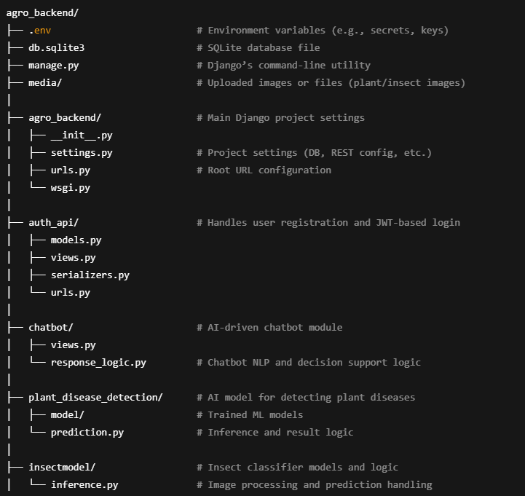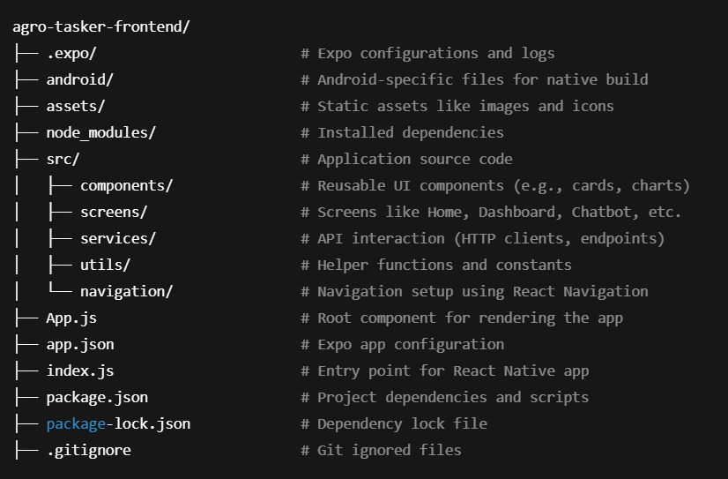

Fig 3.1 File Structure

**Figure 3.1** explains the file structure of the **LEAFSYNC:AI-BASED DECISION SUPPORT SYSTEM FOR SMART AGRICULTURE**, highlighting the clear separation between the frontend and backend components. The frontend, built using React Native (Expo), is well-structured with dedicated directories for screens, reusable components, navigation, and API service logic. This modular setup enhances maintainability and scalability for future features.

On the backend side, the Django REST Framework powers the business logic, including structured modules for user authentication, AI-based disease and insect classification, and chatbot interaction. The database used is SQLite for lightweight storage, and all media files (e.g., plant images) are managed through the media/ directory. This structured layout supports clean development workflows, encourages reusability, and simplifies debugging across the project lifecycle.

**3.2.5 WORKFLOW**

**Figure 3.2** illustrates the user workflow of the **LeafSync – Smart Agriculture Decision Support System**, beginning with secure user authentication through registration or login. Once authenticated, users land on the interactive home screen, where they can input or fetch their location, access real-time soil analysis, and view recommendations tailored to their region. Additional features include AI-based plant disease detection, insect identification, and access to a smart chatbot for personalized agricultural support.

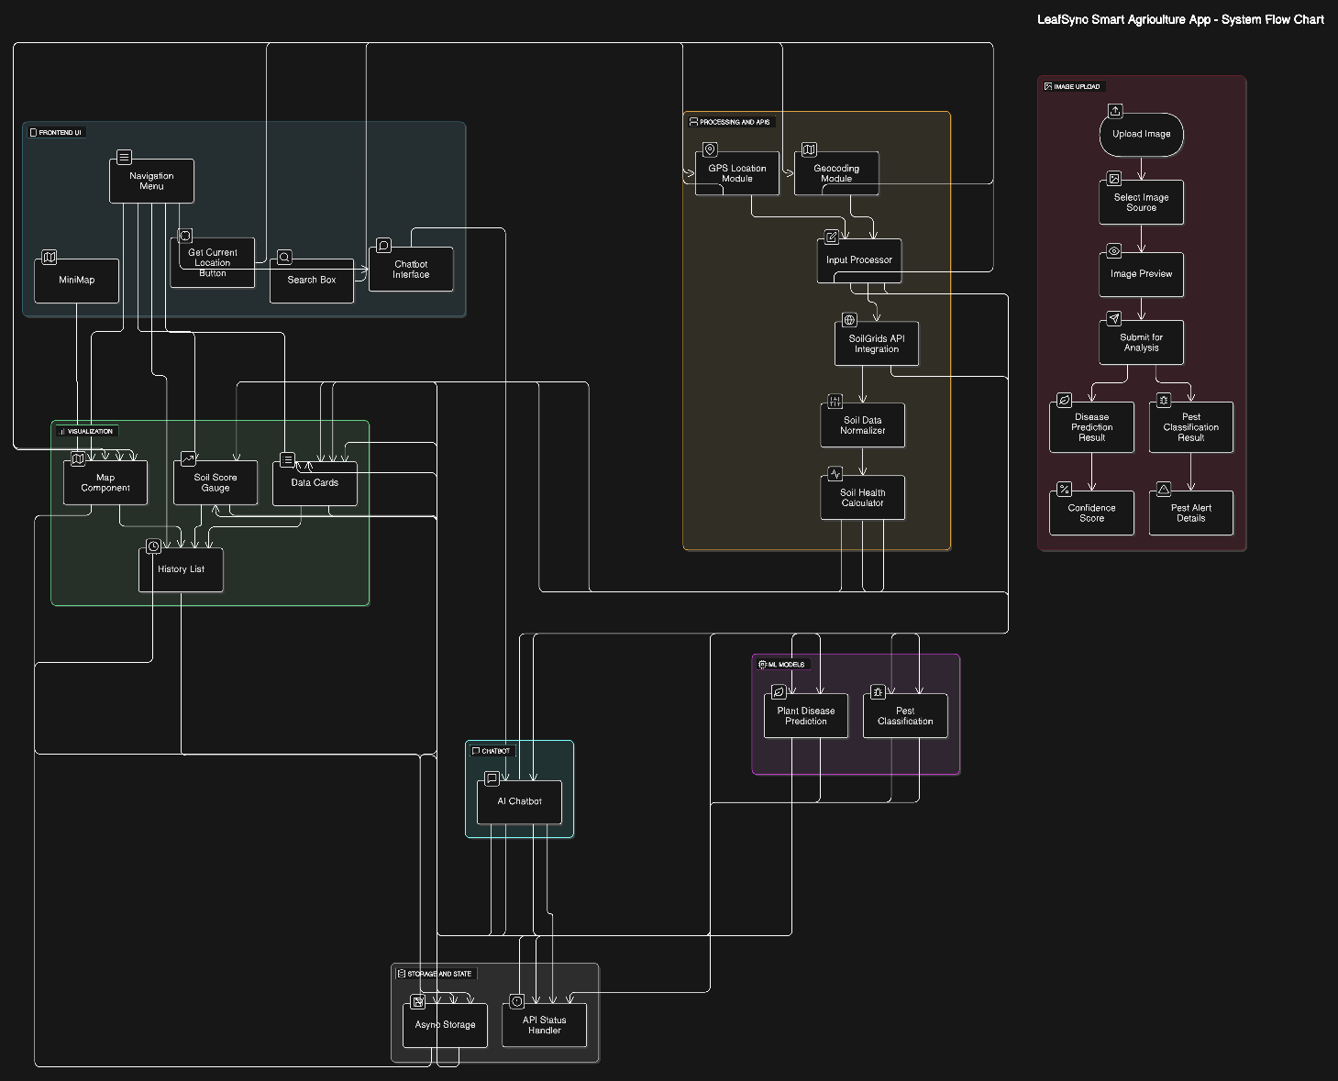

Fig 3.2 Work Flow

**3.3 IMPLEMENTATION**

The **LeafSync** application is currently developed as a functional prototype integrating AI-powered decision support for smart agriculture. It focuses on providing real-time soil analysis using sensor data such as NPK values, moisture, and temperature. the system emphasizes technical robustness, data accuracy, and ease of use for farmers and agronomists.

**3.3.1 SYSTEM DESIGN**

The system follows a modular and scalable architecture using the MVC (Model-View-Controller) pattern. The frontend, built with **React Native**, handles user interactions and visuals, while the **Django REST Framework** backend manages business logic and API services. Data flows through clearly defined layers, ensuring separation of concerns and maintainability. Each component interacts over secure HTTP connections, and APIs are structured using REST principles for flexibility.

**3.3.2 CORE FEATURES AND FUNCTIONALITIES**

* **User Authentication:** Secure login/registration using JWT with hashed passwords.
* **Soil Analysis Dashboard:** Displays soil data like NPK levels, moisture, and temperature based on location input or GPS.
* **AI Disease Detection:** Upload-based image recognition model that detects plant diseases and provides treatments.
* **Insect Classifier:** Identifies pests from images and gives suggested remedies.
* **Smart Recommendations:** Offers context-aware advice on fertilizers, pesticides, and treatment plans based on soil and disease analysis.
* **Location-Based Analysis:** Fetches user GPS data and integrates it into real-time map visualizations.
* **Chatbot Assistant:** Provides support, suggestions, and responses to farming-related queries.
* **Task Planner:** Enables users to schedule, track, and manage daily agricultural tasks. Tasks can be categorized, marked as completed, and updated with reminders, helping farmers stay organized and efficient.

**3.3.3 TOOLS & TECHNOLOGIES USED**

* **Frontend:** React Native, Expo, JavaScript
* **Backend:** Python, Django, Django REST Framework
* **Database:** SQLite (development)
* **APIs:** RESTful API architecture, Groq Api, OpenMapApi
* **AI Models:** TensorFlow models for disease and insect classification
* **Authentication:** SimpleJWT, Session Tokens
* **Map Integration:** React Native Maps, Location APIs
* **Testing Tools:** Postman (API), Android Emulator, Physical Devices

**3.3.4 SYSTEM TESTING**

System testing was performed in modules and as an integrated application. Testing involved:

* **Unit Testing:** Each module (e.g., login, soil data retrieval, classification) was tested individually.
* **Integration Testing:** Ensured seamless interaction between frontend, backend, and AI services.
* **Functional Testing:** Verified system outputs for valid user input, including image uploads and GPS fetching.
* **Device Testing:** The app was tested on physical Android and iOS devices with Android 9.0+ and iOS 13+ to ensure responsiveness and UI compatibility.

**3.3.5 DEPLOYMENT AND MAINTENANCE**

Although the application has not yet been deployed to a production environment, the current local setup supports full functionality and modular testing. The frontend (React Native) and backend (Django REST Framework) communicate seamlessly via RESTful APIs. Version control is managed using Git, and the project structure has been maintained for easy scalability and future CI/CD integration.

**Future Scope**

* **Deployment on Cloud Platforms**: Integration with cloud services like AWS or Azure for scalable backend hosting, real-time database access, and continuous deployment pipelines.
* **Offline Support**: Implementing offline-first capabilities to help users operate in low-connectivity rural areas.
* **Multilingual Support**: Adding language options to increase accessibility for non-English speaking users.
* **IoT Sensor Integration**: Future versions could include real-time data collection from soil sensors for precision agriculture.
* **Analytics Dashboard**: A detailed analytics section to provide farmers with insights on crop trends, usage history, and productivity reports.

**CHAPTER 4**

**RESULTS AND DISCUSSION**

**LeafSync: Smart Agriculture Decision Support System** addresses the critical need for intelligent, accessible solutions in modern farming. It empowers farmers with real-time soil analysis, crop disease detection, and actionable treatment recommendations, all within a mobile-friendly interface. By simplifying complex agricultural decisions through AI and machine learning, **LeafSync** enhances productivity and promotes sustainable practices. While offering significant advantages, the system also faces challenges such as data reliability, model accuracy, and user adoption in rural areas that require thoughtful handling.

**4.1 USER EXPERIENCE AND CONVENIENCE**

**LeafSync** provides a clean and intuitive user interface, enabling users to seamlessly access features such as soil analysis, crop disease detection, treatment recommendations, and task planning. The home screen is thoughtfully designed with straightforward navigation It minimizes complexity by presenting key functionalities in an organized manner. **Figure 4.1** illustrates the home screen layout

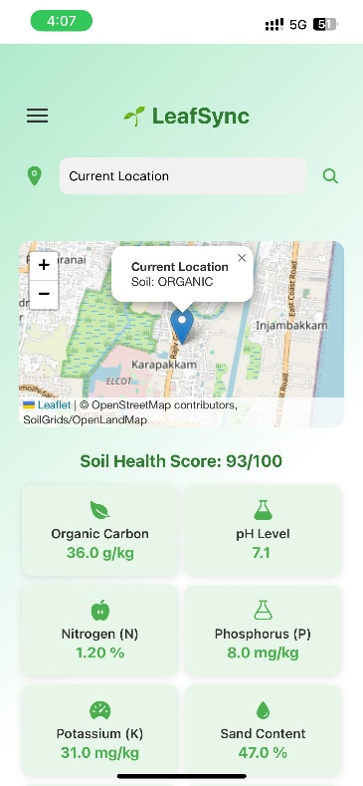 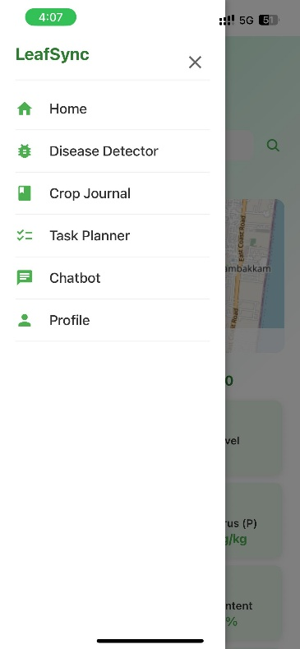

Fig 4.1: Home screen with options to search Location, request soil data, and navigate other tools.

**4.2 SCALABILITY AND FLEXIBILITY FOR HOSITALS**

**LeafSync** enables seamless handling of soil health and crop disease assessments through an interactive and accessible interface. Users can input or retrieve location-based data to analyze soil conditions, detect plant diseases, and receive intelligent treatment suggestions. The system is designed to scale with increased data inputs, ensuring responsiveness even during peak agricultural activity. **Figure 4.2** displays the Soil Analysis screen, where users initiate real-time diagnostics and track crop health insights.

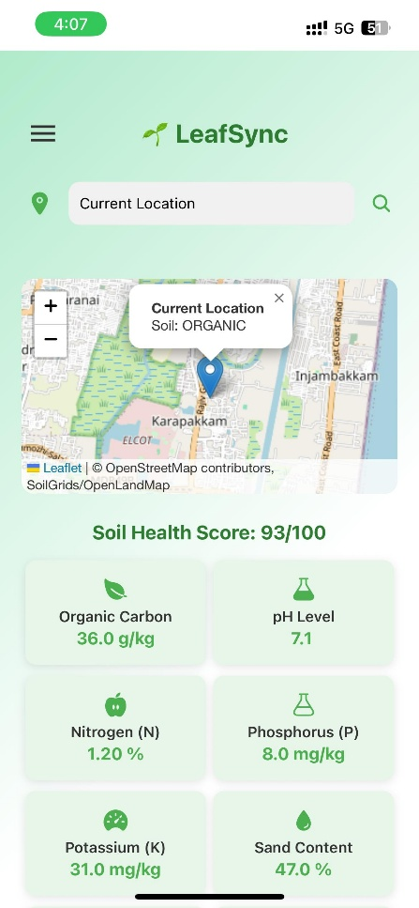 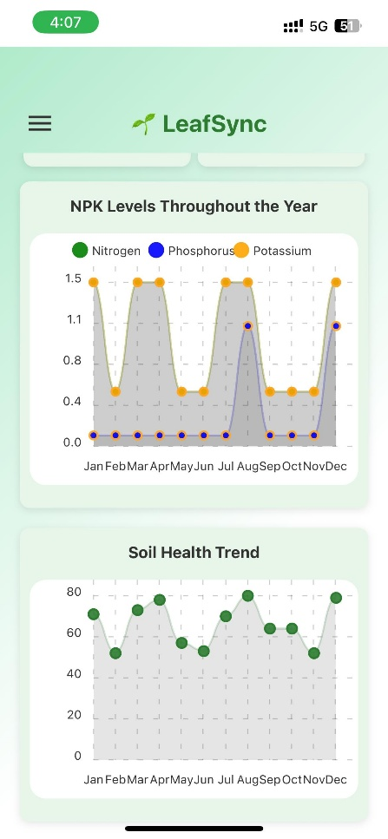

Figure 4.2: Request Soil Analysis where users can search and see their soil metrics and statistical charts.

**4.3 SECURITY CONSIDERATIONS**

**Security** is a critical concern in **LeafSync**, as it manages sensitive user data, including soil health, crop conditions, and treatment recommendations. The system ensures secure access through the use of JWT (JSON Web Tokens) for authentication, which provides stateless and secure user sessions. All user data, including soil and crop details, is encrypted to protect against unauthorized access. In addition, robust role-based access control (RBAC) mechanisms are implemented to ensure that only authorized users can access specific features and data. **Figure 4.3** shows the Login screen, which utilizes JWT for secure authentication and ensures that users' personal agricultural dataremains protected.

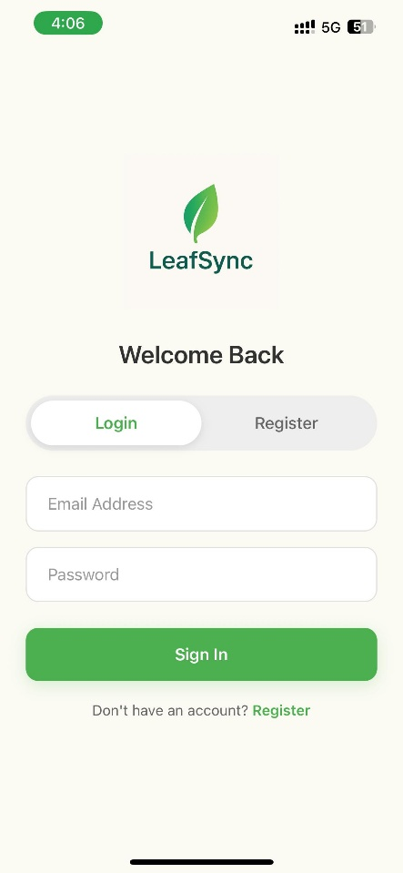

Fig 4.3: Login screen for secure user access to the system.

**4.4 OPERATIONAL EFFICIENCY AND COST REDUCTION**

**LeafSync** enhances operational efficiency by automating soil analysis, crop health monitoring, and treatment recommendations, significantly reducing the need for manual data collection and on-site inspections. Agricultural teams and users can access real-time data about soil conditions, crop health, and treatment histories instantly, enabling faster decision-making and timely interventions. Features like automated alerts, disease and pest detection, and crop treatment suggestions minimize the administrative workload, while also cutting down costs related to manual reporting, field visits, and communication. As a digital-first solution, **LeafSync** supports sustainable farming practices and allows agricultural organizations to scale with minimal infrastructure requirements.

**4.5 CHALLENGES IN ADOPTION AND USABILITY**

While **LeafSync** offers a comprehensive and user-friendly experience, challenges may arise for farmers and agricultural workers who are not accustomed to using digital platforms, especially in regions with limited internet access or digital literacy. First-time users may face difficulties in navigating the app or may be hesitant to input detailed soil or crop data. To address these challenges, the system design prioritizes simplicity, clarity, and mobile responsiveness, ensuring that users can easily access and understand the features with minimal effort. Future versions could enhance accessibility by offering tooltips, step-by-step guides, and multilingual support. **Fig 4.4** shows the user profile screen.

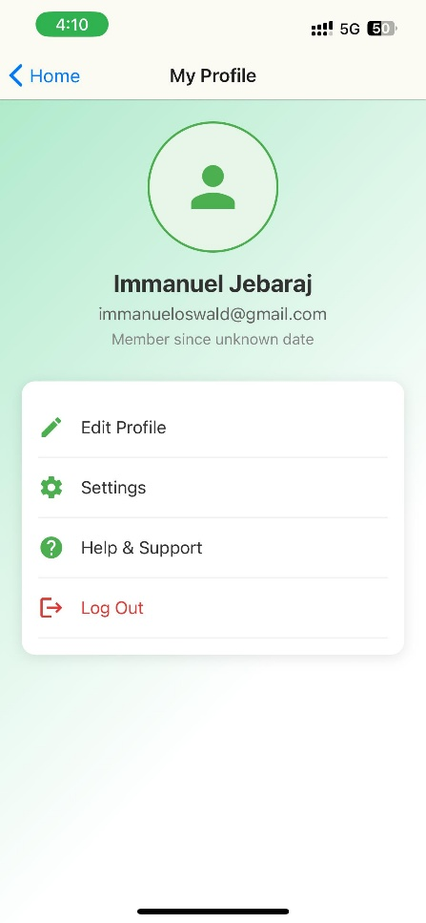

Fig 4.4: User profile screen showing logout options and personal details.

# CHAPTER 5

# CONCLUSION

In conclusion, **LeafSync** is more than just a tech solution—it’s a step forward in transforming agriculture into a smarter, more sustainable practice. By bringing AI-powered soil analysis to farmers' fingertips, the system enables them to make informed, real-time decisions that can directly impact their crops' health and productivity. Whether it’s recommending the right fertilizer or detecting early signs of plant diseases, **LeafSync** offers practical insights that can save both time and resources.

What makes **LeafSync** special is its simplicity and user-friendliness. We’ve focused on creating an experience that farmers—regardless of their tech-savviness—can easily adopt. From the intuitive mobile interface to personalized recommendations, the system is designed to help farmers make better decisions without feeling overwhelmed by complex data.

Though we’re proud of what we've accomplished so far, we know this is just the beginning. Moving forward, we’re committed to improving the AI models, incorporating local data, and expanding our features to support weather forecasting and pest control. Listening to our users’ feedback will remain a top priority as we continue to grow and adapt to the evolving needs of farmers.

At the heart of **LeafSync** is a vision to help farmers thrive by embracing technology that works for them. We believe that with the right tools and support, agriculture can be more efficient, sustainable, and rewarding for everyone involved.

# REFERENCES

1. **Hasan, M. S., Munna, M. H., Emon, Y. R., Rabbany, G., & Ahad, M. T.** (2023). A comprehensive review on plant leaf disease detection using deep learning. *arXiv*. Retrieved from <https://arxiv.org/abs/2308.14087>

*This paper provides a systematic review of deep learning models for diagnosing various plant leaf diseases, highlighting the advantages and limitations of models like CNN, ViT, and DDA.*

1. **Jha, S., Luhach, V., Gupta, G. S., & Singh, B.** (2023). Crop disease classification using support vector machines with Green Chromatic Coordinate and attention-based feature extraction for IoT-based smart agricultural applications. *arXiv*. Retrieved from <https://arxiv.org/abs/2311.00429>

*This study presents a novel classification method utilizing attention-based feature extraction and SVM for improved crop disease detection, suitable for integration with mobile and IoT devices.*

1. **Abade, A. S., Ferreira, P. A., & Vidal, F. B.** (2020). Plant diseases recognition on images using Convolutional Neural Networks: A systematic review. *arXiv*. Retrieved from <https://arxiv.org/abs/2009.04365>

*This systematic review delves into the application of CNNs in identifying and classifying plant diseases from images, providing insights into dataset characteristics and model performance.*

1. **Prevention of Soil Erosion, Prediction of Soil NPK and Moisture for Agricultural Applications.** (2021). *ScienceDirect.* Retrieved from<https://www.sciencedirect.com/science/article/pii/S1877050924009153/pdf?md5=42c7b1f3cadfd4a3a457297fe9f32903&pid=1-s2.0-S1877050924009153-main.pdf>

**APPENDIX**

**A. SCREENSHOTS**

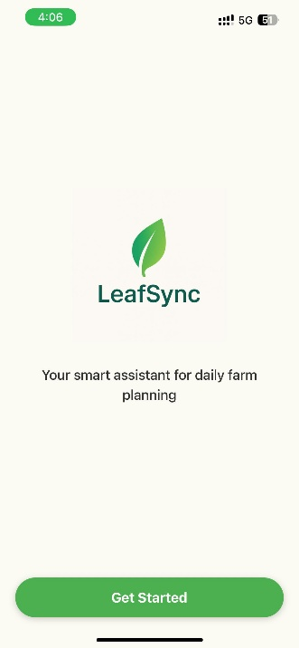 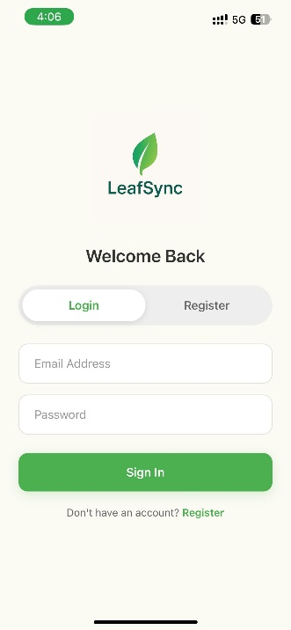 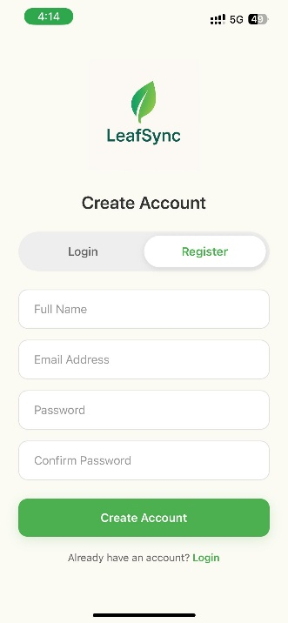

Fig a: Welcome Page, Login, Register Screens

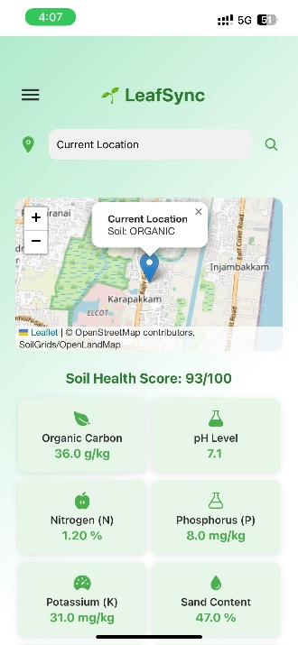 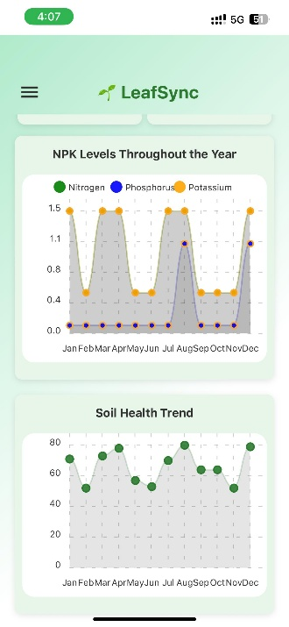 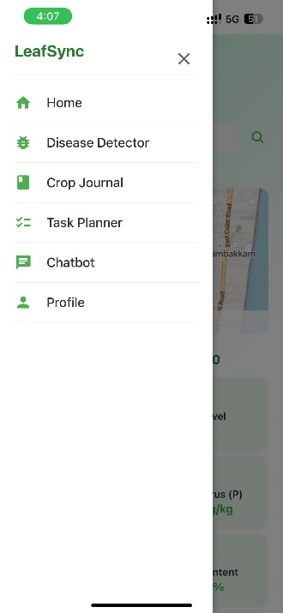

Fig b: Home screen, Soil Metrics, Navigation Menu screens

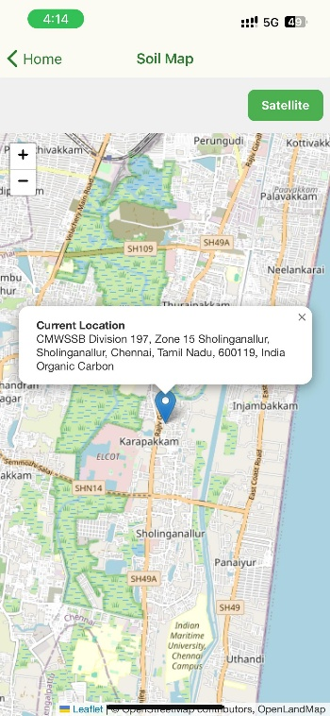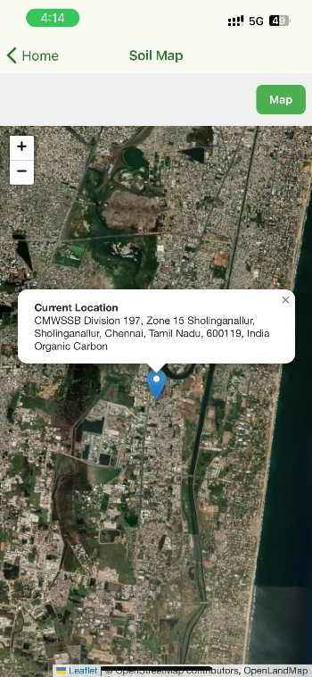

Fig c: topography map, satellite map, logout screen

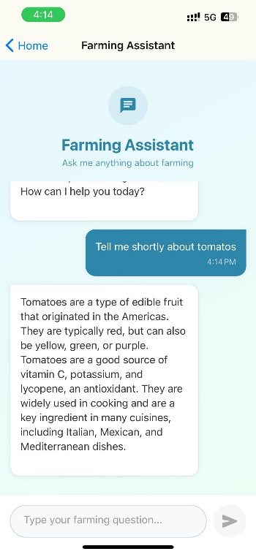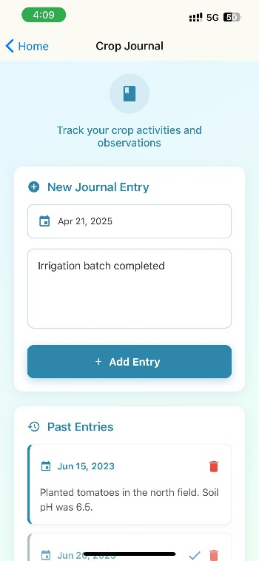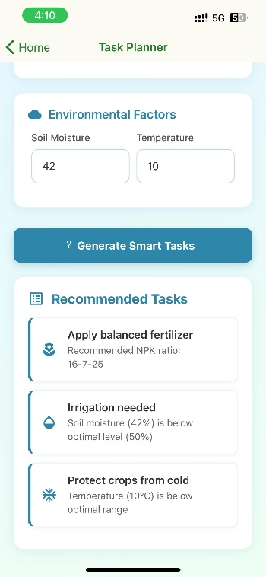

Fig d: Farming Assistant, Crop Journal, Task Planner

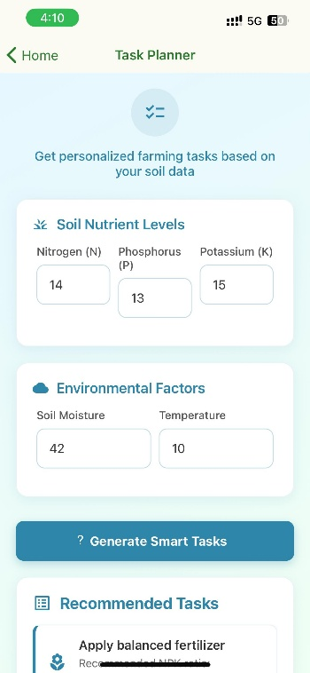 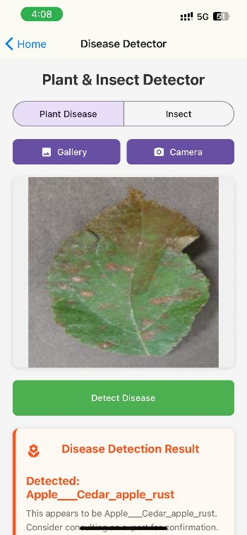 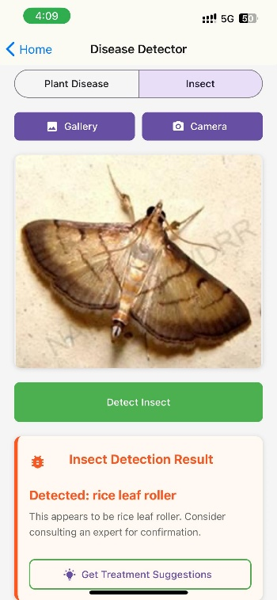

Fig e: Plant Disease Detector, Pest Detector