1. **Install Arduino IDE**
2. **Install ESP8266 Add-on in Arduino IDE**

To install the ESP8266 board in your Arduino IDE, follow these next instructions:

1. In your Arduino IDE, go to **File**> **Preferences**

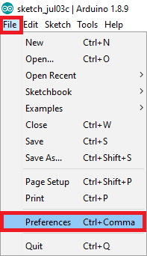

1. Enter **http://arduino.esp8266.com/stable/package_esp8266com_index.json** into the “Additional Boards Manager URLs” field as shown in the figure below. Then, click the “OK” button:

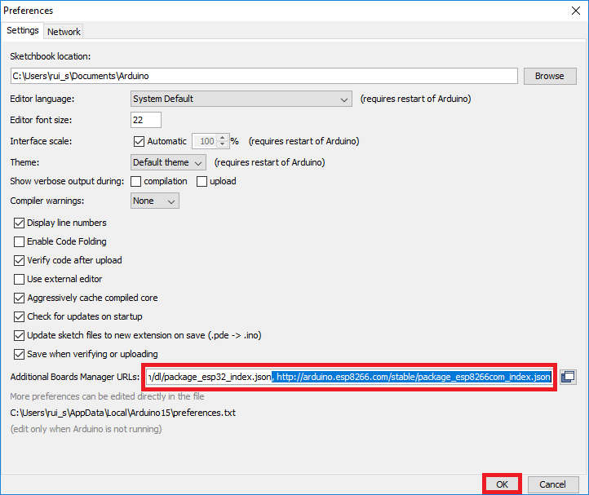

**Note:** if you already have the ESP32 boards URL, you can separate the URLs with a comma as follows:

https://dl.espressif.com/dl/package_esp32_index.json, http://arduino.esp8266.com/stable/package_esp8266com_index.json

1. Open the Boards Manager. Go to **Tools** > **Board** > **Boards Manager…**

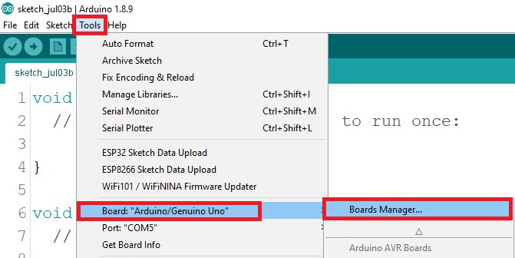

1. Search for **ESP8266** and press install button for the “**ESP8266 by ESP8266 Community**“:

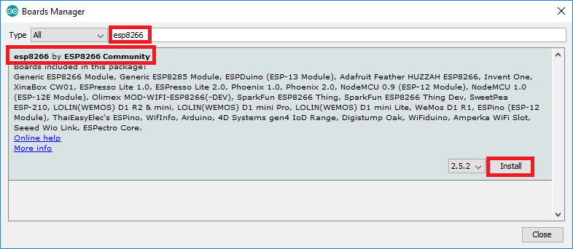

1. That’s it. It should be installed after a few seconds.

