KINGS ENGINEERING COLLEGE

**PROJECT TITLE**: NOISE POLLUTION MONTIOR (IOT_PHASE5)

**BATCH MEMBERS**: INDRIS.P, IMMANUEL JOSHUA.P, MOHAN BABU.R, PRASANNA KUMAR.S, GUNASEKAR.V

**DEPARTMENT:** B. TECH ARTIFICIAL INTELLIGENCE AND DATA SCIENCE

**MENTOR NAME:** MR. SUNDAR RAJ V

***Describe the project's objectives, IoT sensor deployment, platform and mobile app development, and code implementation:***

**Project Objectives:**

1. Monitor and assess noise pollution levels in urban areas to understand its impact on public health and well-being.
2. Identify sources of high noise pollution, including traffic, industrial activity, and construction. Promote public awareness about noise pollution and its effects on daily life.
3. Contribute to noise pollution mitigation through data-driven urban planning and noise regulation.

## IoT Sensor Deployment:

1. Sensor Selection: High-quality noise sensors with capabilities to measure sound levels in decibels (dB) are selected. These sensors are connected to a microcontroller, such as Raspberry Pi, Arduino, or specialized IoT boards.
2. Sensor Placement: Sensors are strategically placed at various locations, including residential areas, busy intersections, industrial zones, and near public spaces. This placement ensures comprehensive data collection across different noise sources.
3. Power Supply: Sensors are connected to a stable power supply source, whether through direct wiring, battery, or solar panels, to ensure continuous operation.
4. Data Collection: Sensors continuously monitor the ambient noise levels and send the data to a central platform at regular intervals (e.g., every minute).

## Platform Development:

1. Architecture: The platform is developed using a combination of technologies such as Python and Flask for the backend, HTML, CSS, and JavaScript for the frontend, and a relational database (e.g., PostgreSQL) for data storage.
2. Data Collection: An API endpoint is created to receive data from IoT sensors. The received data is parsed and stored in the database. Data is timestamped for analysis.
3. Data Analysis: Noise data is processed for real-time and historical analysis. Algorithms may be implemented to identify noise spikes, sources, and patterns.
4. User Interface: The platform offers a web-based user interface where users can access real-time and historical noise data. Users can filter data by location and time.

## Mobile App Development:

1. Cross-Platform Framework: A cross-platform mobile app framework like Flutter is used to build the app. This ensures compatibility with both Android and iOS devices.
2. Data Access: The app fetches data from the platform's API endpoints and displays it in a user-friendly manner. Users can view real-time noise levels, historical data, and noise source information.
3. Notifications: The app may include features to notify users of noise level spikes in their vicinity, promoting real-time awareness.

## Code Implementation:

1. Python scripts are used for IoT sensor data collection and transmission. The script captures noise data and sends it to the platform's API using HTTP requests. It can be executed on the IoT device.
2. The platform's backend is developed in Python using the Flask framework. It includes routes for receiving data from sensors, storing it in the database, and serving data to the mobile app.
3. The mobile app is developed in Flutter, using Dart for programming. It includes code for making HTTP requests to the platform's API, displaying data, and providing a user-friendly interface.

***Include diagrams, schematics, and screenshots of the loT sensors, noise pollution information platform, and mobile app interfaces:***

1. ***Mapping for noise pollution monitoring system***

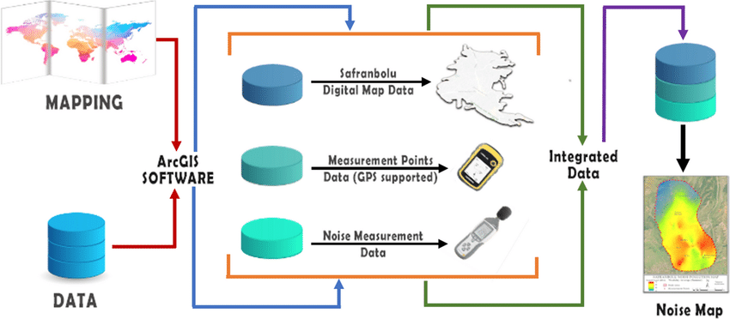

1. ***noise pollution control monitoring systems***

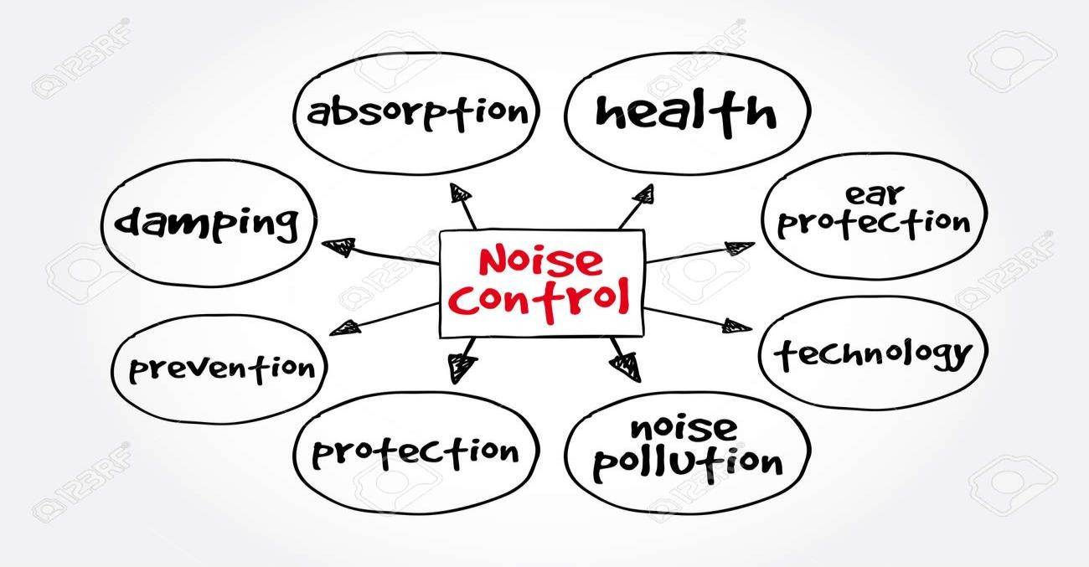

1. ***overcomes for noise pollution monitoring systems***

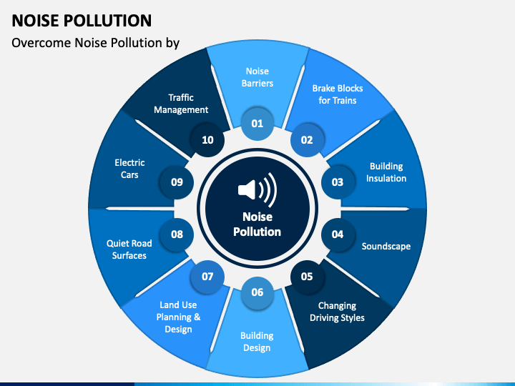

## IoT Sensors Deployment Schematic:

1. Create a schematic diagram showing the deployment of IoT noise sensors at various locations within the urban area.
2. Mark sensor placement points on a map, indicating residential areas, intersections, industrial zones, and public spaces.
3. Include arrows to represent data transmission from sensors to the central platform.

## Noise Pollution Information Platform Diagram:

1. Design an architectural diagram of the noise pollution information platform.
2. Include components like IoT sensors, API endpoints, data processing, storage, and user interface. 3.Use shapes and arrows to illustrate data flow and interactions between components.

## Mobile App User Interface Screenshots:

1.Capture screenshots of the mobile app's user interface to showcase its functionality and design. 2.Include screens displaying real-time noise data, historical data, location filtering, and notifications. 3.Highlight the app's user-friendly features and visual elements.

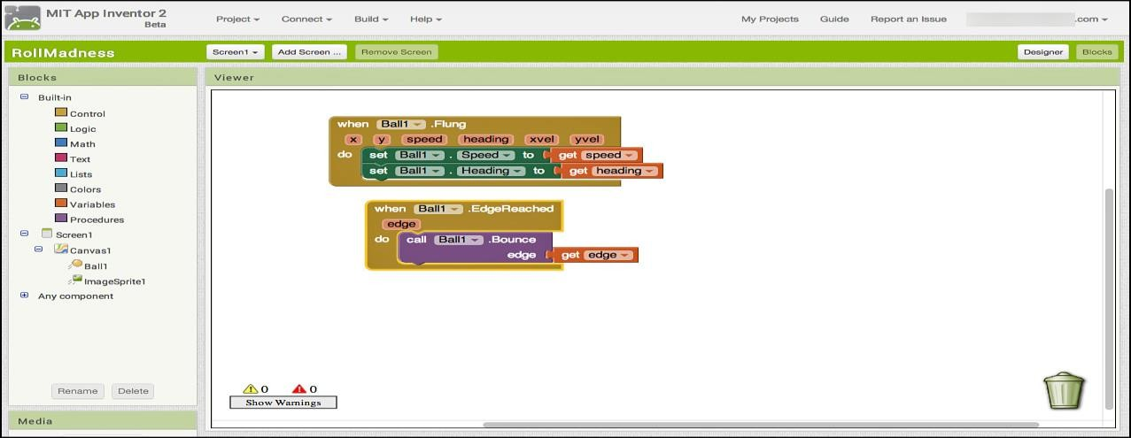

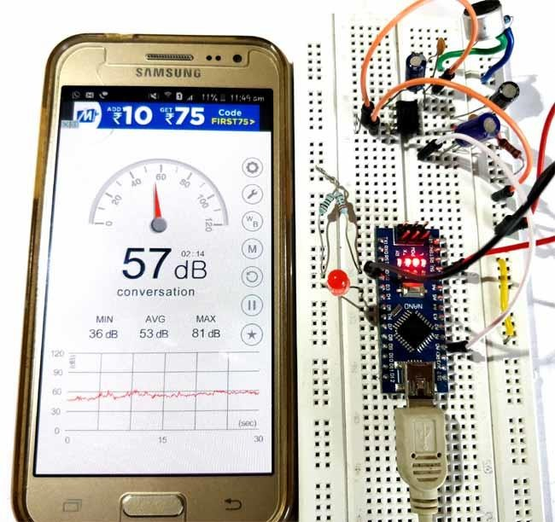

***Explain how the real-time noise level monitoring system promotes public awareness and contributes to noise pollution mitigation:***

## Real-Time Data Accessibility:

By providing real-time noise level data through a user-friendly mobile app or web interface, the public gains access to up-to-the-minute information about noise pollution in their area.

## Alerts and Notifications:

The system can send alerts and notifications to users when noise levels exceed certain thresholds. This immediate feedback helps individuals recognize and respond to high noise levels promptly.

## Education and Awareness:

The system can be accompanied by educational materials and tips on noise pollution and its effects on health and well-being. Users can learn about the sources of noise and how to reduce their exposure.

## Community Engagement:

Users can report noise disturbances they encounter, which fosters community engagement and encourages individuals to address noise issues collectively.

## Data-Driven Decision Making:

Local authorities and urban planners can use the collected data to make informed decisions regarding noise regulation and urban development. For instance, the data can identify areas with consistently high noise levels, leading to targeted mitigation efforts.

## Noise Source Identification:

Through advanced data analysis, the system can identify specific noise sources and their patterns. This information can be used to target specific sources of noise pollution and address them effectively.

## Policy and Regulation Advocacy:

The system provides valuable data for advocacy and policy changes. Citizens and organizations can use the data to lobby for stricter noise regulations or changes in urban planning.

## Noise Reduction Awareness Campaigns:

The platform can be used as a communication tool for noise reduction awareness campaigns, promoting behavior changes and responsible noise management.

## Public Health Benefits:

Public awareness and noise reduction efforts can lead to health benefits, as excessive noise has been linked to stress, sleep disturbances, and various health problems. Reduced noise levels can improve public health and well-being.

## Noise Mitigation Programs:

Local governments can initiate targeted noise mitigation programs, such as reducing traffic noise in residential areas or enforcing noise control at construction sites. These programs are guided by the data collected by the monitoring system.

## Positive Impact on Quality of Life:

Over time, a reduction in noise pollution contributes to an improved quality of life for residents, as they experience less disturbance and stress, better sleep, and an overall more pleasant living environment.

## Wowki stimilation:

<Wowki online stimulations for custom type noise sensor pollution monitoring systems>hase

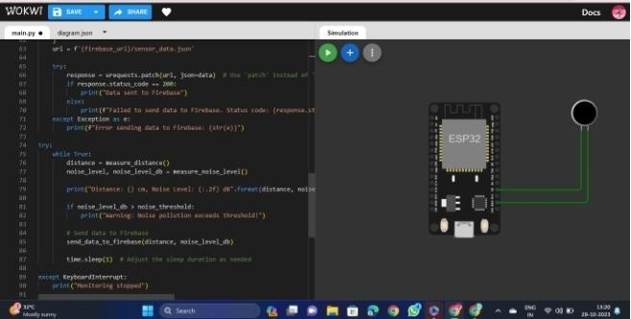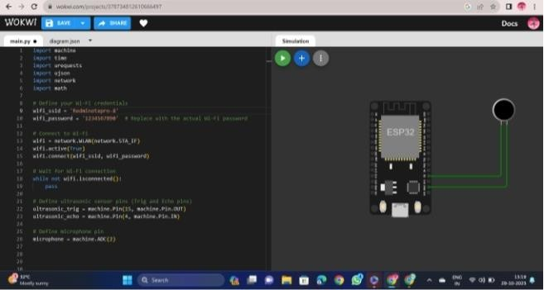

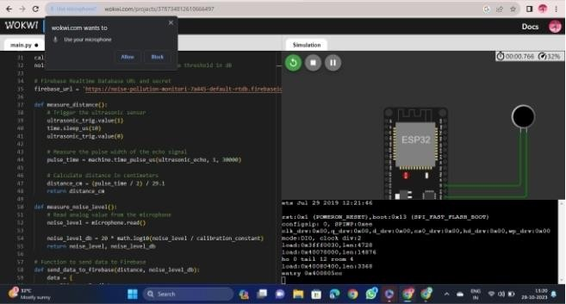

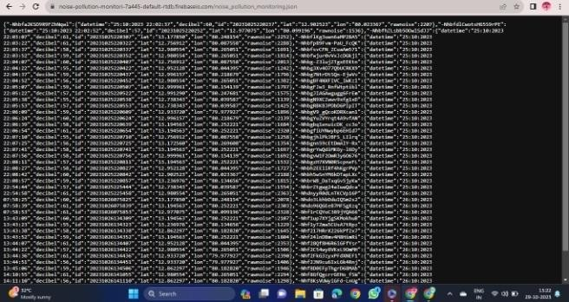

custom-type sensors play a vital role in addressing the unique challenges and requirements of specialized industries, enabling precise data collection and control, and ultimately contributing to the success of various projects and applications.