**Concept of a Self-Regulated Blockchain-Based Exchange Platform**

This paper provides a detailed concept of a self-regulated blockchain exchange platform for the *Valueline* network. The blockchain-based exchange platform will permit users (or holders) to exchange their resource tokens (*Valueline*) for redeemable store of value (SOV) tokens known as *Talent tokens*. Talent will have the potential to act as a secure mode of payment. For example, individuals will be able to pay their service providers with this redeemable token. The platform will use two forms of tokens in the exchange program, *Valueline* and *Talent. Valueline* tokens will have a fixed value while the value of *Talent* tokens will vary depending on their demand.

**The Exchange Process**

The blockchain exchange platform will largely act like any regulated foreign exchange platform. People will exchange different forms of assets on the exchange platform for tokens and they will be charged a commission by the platform. There are two ways through which individuals will acquire tokens: by purchasing directly from the exchange platform and by receiving tokens from existing users through a transfer of the right of ownership. In each case, all issued tokens will be transferred through the platform exchange.

Because all Valueline and Talent tokens are freely offered to users by the network, the network retains 33.333% of the Talent tokens. Accordingly, when a user votes with a freely received Valueline token, he accepts the condition that 33.333% of his vote was cast on behalf of the network. When the user is being paid for his vote, the network applies a 16.666% fee on the transaction. When the user is transferring his Talents from the holding account, the network applies another 16.666% fee on the transaction to complete the retention of the 33.333%. As a result, the exchange platform will earn a total commission of 33.333% for all issued and redeemed Talent tokens.

Noteworthy, *Valueline* tokens will not leave the exchange platform, only *Talent* tokens will be withdrawable. However, holders of *Valueline* tokens will have the right to exchange their tokens with *Talent* tokens at their existing market rates. This strategy will ensure there is a stable utility token to back contracts on the blockchain. Further, holders of any class of tokens (*Valueline* or *Talent*) will be able to transfer their tokens to a third party for free.

**Valuation of Tokens**

Two distinct models will be used to value the two categories of tokens, *Valueline* and *Talent,* which will be issued by the platform.

***Valueline***

The value of Valueline will be based on the average of the top three bitcoin-related cryptocurrencies and subsequently through the adherence to a 180° trajectory after the network obtains its 33.333% of the Talent tokens. Instead of price fluctuating depending on the demand of Valueline in the market, there will be a daily control of the price of Valueline by increasing or decreasing the supply of tokens (daily airdrop of Valueline tokens), platform fees, interest rates, and miners’ commissions. For stability of the exchange, the platform will float *Valueline* tokens daily less those that are already locked in the category of executed and unfulfilled contracts (See graphics below). This strategy will ensure that the price of *Valueline* is stable, which implies that it will follow the 180-degree projection. Since *Valueline* will have a stable price, all airdropped but unissued tokens will be under the category unmet demand (See graphics below).

The value of the unmet demand (c) will be equal to that of the class Held on the platform: Under contract (e). The increased demand for tokens required to make the platform stable will be under the class met demand provided that there is no increase or decrease of *Valueline’s* price (d). The issued token will be under the class Held in Reserve: Not under Contract (f). Past contracts of tokens that have been issued and used to make an exchange will be under the class Executed & Fulfilled Contracts (b). For example, purchased *Valueline* tokens that have been used to generate value via *Talent* tokens, like a user that purchased *Valueline and used the resources to sell a product or a service in exchange for Talent tokens.*Past contracts of tokens that have been issued and not used to make an exchange will be under the class Executed & Unfulfilled Contracts (a). For example, purchased *Valueline* tokens that have not yet been exchanged with *Talent* tokens. In future contracts, the funded contracts (h) are those that the exchange platform has allocated capital for purchase of tokens in future, while unfunded contracts are those that exchange platform has not yet allocated capital (g). 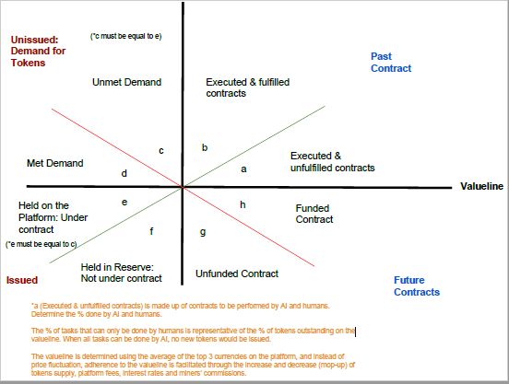

**Image 1: *Valueline* Token Management**

***Talent***

The value of *Talent* will adjust based on market demand. Therefore, the price of the token will increase or decrease depending on the number of active users willing to purchase this token at any given time. If the demand for the tokens increases relative to supply, the value of the issued *Talent* will increase. If the demand is low relative to the supply, the value of the issued *Talent* will decrease. The platform’s fees, interest rates, and miners’ commissions will also increase or decrease depending on tokens’ demand since these changes will also affect the usage of resources.

**More Active Applications**

A high demand for *Talent* tokens will imply that there are more active applications. The high number of applications will result in a scarcity of resources such as (RAM, Bandwidth, Storage, etc.). Therefore, miners and the exchange platform will earn a higher commission when there are more applications than when there are few active applications. Since the demand for tokens will be higher than the supply, which will result in a shortage of tokens, the token prices will increase to match the demand and supply forces. The platform will use its 33.333% asset (subject to the availability of complete insurance) to ensure that resources are distributed to meet growth needs.

**Less Active Applications**

A low demand for Talent tokens will imply that there are less active applications. The low applications will result in surplus resources (RAM, Bandwidth, Processors, etc.). As a result, miners and exchange platforms will earn a low commission due the low demand for their services and resources. Since the resources will exceed the demand, which will result in a surplus in token supply, the token prices will decrease to match the demand and supply forces.

**Image 2: Talent Demand and Supply**

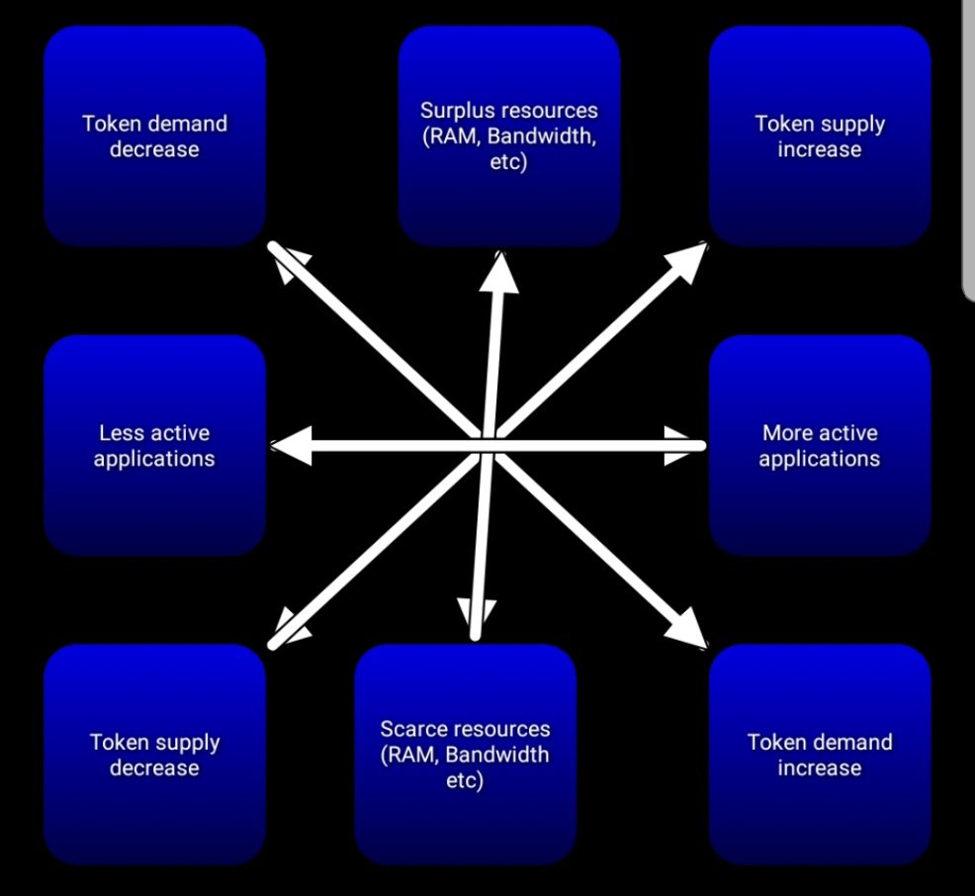**Graphical Illustration of *Talent* Pricing**

**Price**

Supply

P1 e1 



P0 e0 DD1



P2 e2 DD0

P min DD2



Q2 Q0 Q1 **Supply**

Where, P is price, DD is demand, Q is quantity

The equilibrium demand for Talent tokens results in price (P0) and quantity (Q0).

When there are more active applications, the demand for resources increases to DD1. At this level, the new equilibrium (e1) is attained by increasing the price to P1. At price P1, the exchange platform and miners will increase their resources to match the market’s demand.

When there are few active applications, the demand for resources decreases to DD2. The demand for *Talent* is Q2. At this demand level, a new equilibrium (e2) forms because miners and the exchange platform are willing to sell their services at a lower fee of P2.

Note: The price of *Talent* cannot fall past zero (P min) even with zero demand because it has a minimum exchange rate that is pegged at the equilibrium price of *Valueline.*

**Graphical Illustration of *Valueline* exchange with *Talent***

***Talent (T)*** 

Supply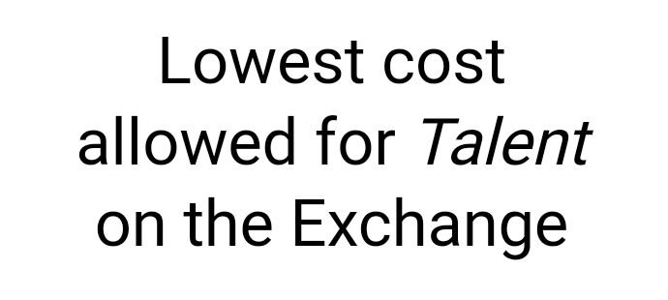

T1 e1 

Vs >Vd

T0 e0 DD1

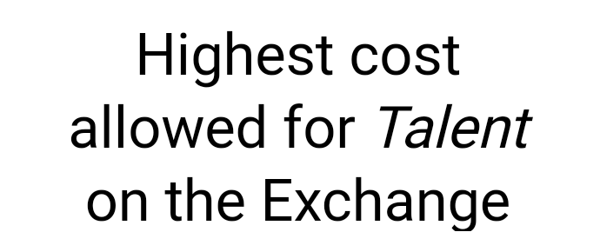

T2 e2 Vd > Vs DD0

DD2



Q2 Q0 Q1 *Valueline* **Supply**

The blockchain- exchange platform always aims at maintaining *Valueline* at the equilibrium levels e0. Since *Talent’s* value is based on *Valueline,* they have an inverse relationship. An increase in the supply of *Valueline* leads to fall in the exchange rate of *Talent* for *Valueline.* For example, an increase in the supply of Valueline from Q0 to Q1 results in a shift in exchange rate with *Talent* from T0 to T1.

A decrease in supply of *Valueline* results in an increase in the exchange rate of *Talent’s* for *Valueline.* For example, a decrease in the supply of Valueline from Q0 to Q2 results in a shift in exchange rate with *Talent* from T0 to T2.

The equilibrium exchange rate is T0 and the quantity of *Valueline* held on the market under contract (e) is Q0.