|  |
| --- |
|  |
| GME-NAC  (for IT-Team) |
| Standard |
|  |
|  |
| **2020-06-26** |

**문서 버전**

|  |  |  |  |  |  |
| --- | --- | --- | --- | --- | --- |
| 문서 버전 | 작성 일자 | 부서 | 직책 | 작성자 | 비고 |
| 1.0 | 2020.06.26 | IT | Manager | Max |  |
|  |  |  |  |  |  |
|  |  |  |  |  |  |
|  |  |  |  |  |  |
|  |  |  |  |  |  |

목차

1. 솔루션 업체 정보 4

2. 견적 정보 4

3. 접속 정보 4

3.1 접속 URL 4

3.2 Agent URL 5

3.3 Manual URL 5

3.4 IP 정보 5

# 솔루션 업체 정보



# 견적 정보

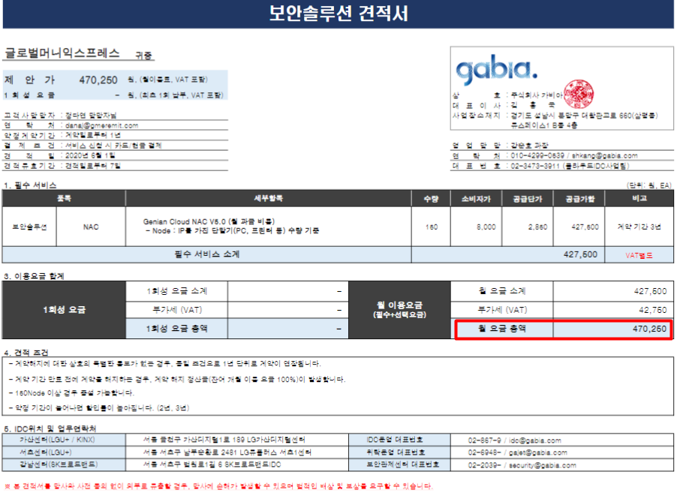

# 접속 정보



## 접속 URL

<https://gme.my.genians.co.kr>

|  |  |
| --- | --- |
| ID | PW |
| admin | GME#KOREA#321! |
| danaj | gmeremit.123 |
|  |  |

## Agent URL

<https://gme.my.genians.co.kr/agent>

<https://gme.my.genians.co.kr/cwp>

## Manual URL

<https://docs.genians.com/release/ko> (한글)

<https://docs.genians.com/release/en>

## IP 정보

|  |  |  |
| --- | --- | --- |
| Cloud Server Public IP |  | 52.78.69.213 |
| Sensor IP | Vlan10 | 192.168.10.196/24 |
|  | Vlan20 | 192.168.20.196/24 |
|  | Vlan30 | 192.168.30.196/24 |
|  | Vlan40 | 192.168.40.196/24 |
|  | Default Gateway | 192.168.10.1 |