2019.2.14

**Inbound Remittance Process**

**Objective**

1. Receiver Should Automatically receive Money in his bank account once the receiver KYC is completed and after CS team approves his ID
2. Receiver should be required to do KYC only first time
3. Receiver should have GME USer ID and password when he completes receivers’ KYC
4. If Receiver already has registered with GME as a sender then he shouldn’t have to do receivers KYC Again.
5. Receiver should be able to Send Money after he completes incomplete field while he sends the money.
6. There should be no duplicate customers ( Receiver and sender should not be duplicate)

**Basic Process**

Ria/Xpress Money System

GME Core System

If Receiver already not registered send SMS/Email to Receiver

Redirect user to our website using

Unique link

gmeremit.com/receiverkyc/Xbycgh20

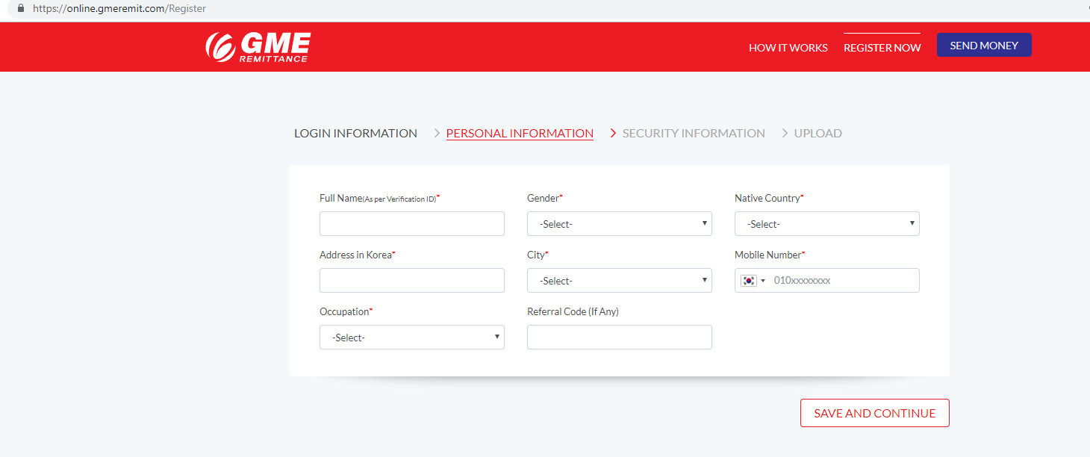

Receiver will key in his details* and upload photo of His ID

Penny Test and Real name verification from KJ Bank

Photo ID Verification by Nepal CS

After Successful verification , Money will be deposited

*Landing Page: Data Field for Receiver KYC

1. Full Name
2. Gender
3. Nationality
4. DOB
5. City
6. Mobile Number
7. Email Address
8. Bank Name
9. Bank Account No.
10. ID Type
11. ID No.

Page 2: Photo ID Required

1. Alien Card front and Back