Choose the Right Hardware

Proposal Template

# Scenario 1: Manufacturing

Client Requirements and Potential Hardware Solution

Look through the scenario and find any relevant client requirements. Then, suggest a potential hardware type and explain how this hardware would satisfy each of the requirements.

|  |
| --- |
| **Which hardware might be most appropriate for this scenario?**  **(CPU / IGPU / VPU / FPGA)** |
| *CPU+FPGA* |

|  |  |
| --- | --- |
| **Requirement Observed**  **(Include at least two.)** | **How does the chosen hardware meet this requirement?** |
| *Example requirement:*  *The client requires a tiny device to be connected to their CPU—and their budget is only about $100 for each device.* | *Example explanation:*  *VPU or NCS2 is only about 27.40 mm in size and would fit in the price range.* |
| To monitor people on each belt, at least 5time per sec. | CPU+FPGA is best fit for this because of monitoring no. of people in “multiple belts”. And FPGA has comparatively highest fps as per graph 3. |
| Fast inference time to detect flaws in chip packaging before shipment | As per graph 2 FPGA has the lowest possible inference time to resolve this issue. |
| Lifecycle requirement 5-10yers and easily reprogrammable. | FPGA is high performance device and it has guaranteed lifecycle of 5-10years, while CPU can also work longer if its TDP controlled as per data sheet. |

## Queue Monitoring Requirements

|  |  |
| --- | --- |
| **Maximum number of people in the queue** | 5 |
| **Model precision chosen (FP32, FP16, or Int8)** | For detection of people all three precision can be used, but in this case hardware is not restricted so that FP32 would be great choice. |

## Test Results

After you've tested your application on all four hardware types (CPU, IGPU, VPU, and FPGA), copy the matplotlib output showing the comparison into the spaces below. You should have three graphs (for model load time, inference time, and FPS).

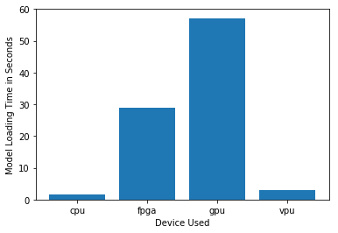

***Model Load Time***

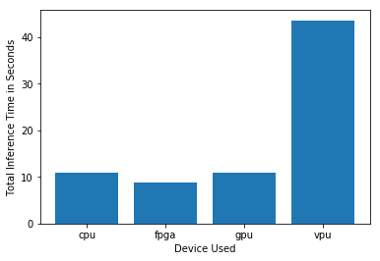

***Inference Time***

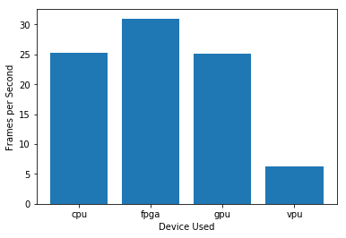

***FPS***

## Final Hardware Recommendation

Now synthesize your points from above and provide a brief write-up describing why the chosen hardware is the best choice for this scenario. Be sure to discuss the client's requirements, the test results, and how these relate to one another (e.g., perhaps one of the devices performed better than the rest, but does not meet one of the client's requirements).

|  |
| --- |
| **Write-up: Final Hardware Recommendation** |
| Mr. Biswas want to monitor people on each belt especially during shift change, and if we consider processing requirement of 5 times per sec. than both ncs2 and cpu would do the job, but for longer life spine and no restriction in budget CPU+FPGA would be great choice, because it can later reprogrammable for further requirements in future without upgrading the Hardwar because of guaranteed life span of 10years and performance of FPGA. |

# 

# Scenario 2: Retail

Client Requirements and Potential Hardware Solution

Look through the scenario and find any relevant client requirements. Then, suggest a potential hardware type and explain how this hardware would satisfy each of the requirements.

|  |
| --- |
| **Which hardware might be most appropriate for this scenario?**  **(CPU / IGPU / VPU / FPGA)** |
| *CPU* |

|  |  |
| --- | --- |
| **Requirement Observed**  **(Include at least two.)** | **How does the chosen hardware meet this requirement?** |
| *Example requirement:*  *The client requires a tiny device to be connected to their CPU—and their budget is only about $100 for each device.* | *Example explanation:*  *VPU or NCS2 is only about 27.40 mm in size and would fit in the price range.* |
| To monitor Max 5 people per que during rush hours | For this requirement Intel i7 CPU alone is capable to finish task, as per graph 3 Intel i5 performed >30 FPS by that reference we can assume i7 (Higher than i5) can defiantly fit the need. |
| Maintain electricity bill | Intel processors are very energy efficient and has dynamic clock which adjust according to workload, so it can save the overall electricity bill and only utilizes the power according to work load. |
| No budget to invest on hardware | As modern intel i7 more than enough to fulfill the requirements of Mr. lin. So no need to purchase any additional hardware. |

## Queue Monitoring Requirements

|  |  |
| --- | --- |
| **Maximum number of people in the queue** | 5 |
| **Model precision chosen (FP32, FP16, or Int8)** | FP16 (or INT8 if available for custom model) |

## Test Results

After you've tested your application on all four hardware types (CPU, IGPU, VPU, and FPGA), copy the matplotlib output showing the comparison into the spaces below. You should have three graphs (for model load time, inference time, and FPS).

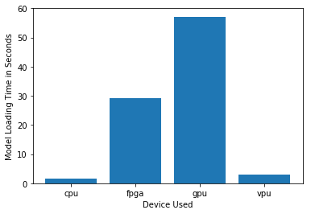

***Model Load Time***

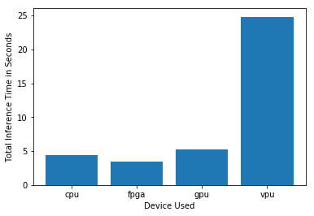

***Inference Time***

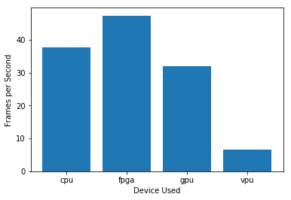

***FPS***

## Final Hardware Recommendation

Now synthesize your points from above and provide a brief write-up describing why the chosen hardware is the best choice for this scenario. Be sure to discuss the client's requirements, the test results, and how these relate to one another (e.g., perhaps one of the devices performed better than the rest, but does not meet one of the client's requirements).

|  |
| --- |
| **Write-up: Final Hardware Recommendation** |
| As per scenario, Mr.Lin already got the modern i7 computer on each checkout counter and **has very minimal computing tasks**, So it seems no additional hardware required to implement edge system. And as per graph stats for intel i5 CPU shows satisfactory performance for the requirement of tracking max 5 people per queue, From that we can be sure about modern i7 CPU can fulfill the requirements. In future iGPU of intel i7 can also reduce the work load of main CPU if any extension required. Integration of igpu can be easily done by update in program without change in hardware. |

# 

# Scenario 3: Transportation

Client Requirements and Potential Hardware Solution

Look through the scenario and find any relevant client requirements. Then, suggest a potential hardware type and explain how this hardware would satisfy each of the requirements.

|  |
| --- |
| **Which hardware might be most appropriate for this scenario?**  **(CPU / IGPU / VPU / FPGA)** |
| VPU or NCS2 |

|  |  |
| --- | --- |
| **Requirement Observed**  **(Include at least two.)** | **How does the chosen hardware meet this requirement?** |
| *Example requirement:*  The client requires a tiny device to be connected to their CPU—and their budget is only about $100 for each device. | *Example explanation:*  VPU or NCS2 is only about 27.40 mm in size and would fit in the price range. |
| Detection of people from 7 to max 15 | Considering the requirements of no of people in video can make difference in inference time, NCS2 can be sufficient for that in case of detection only. |
| Lower fixed budget of $300 | Considering $69/NCS2, customer can purchase max. 4 set of NCS2. |
| 7 camera feed from CCTV | One NCS2 stick can run 4 inference request, so 4 set of NCS2 can easily handle 7 request at same time. |

## Queue Monitoring Requirements

|  |  |
| --- | --- |
| **Maximum number of people in the queue** | *7* |
| **Model precision chosen (FP32, FP16, or Int8)** | FP16 |

## Test Results

After you've tested your application on all four hardware types (CPU, IGPU, VPU, and FPGA), copy the matplotlib output showing the comparison into the spaces below. You should have three graphs (for model load time, inference time, and FPS).

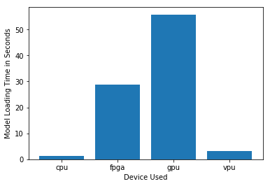

***Model Load Time***

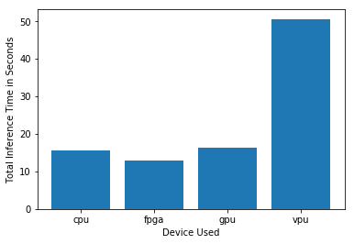

***Inference Time***

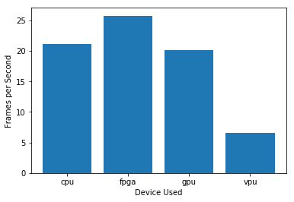

***FPS***

## Final Hardware Recommendation

Now synthesize your points from above and provide a brief write-up describing why the chosen hardware is the best choice for this scenario. Be sure to discuss the client's requirements, the test results, and how these relate to one another (e.g., perhaps one of the devices performed better than the rest, but does not meet one of the client's requirements).

|  |
| --- |
| **Write-up: Final Hardware Recommendation** |
| Customer used all in one pc and no computation available for inference. And by Considering the budget option limited to $300 there is no choice left other than NCS2. But 4 - NCS2 sticks are able to perform 16 inference request at same time, so that it will be enough to handle the given scenario by considering the lower FPS drawback as per graph 3. |

# 