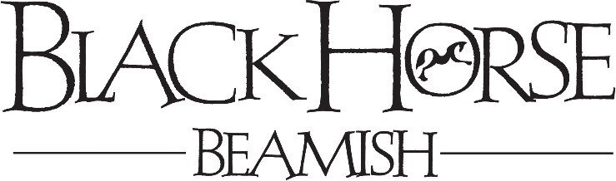

COACHING & ADVICE RECORD

Team Member Name :

Date :

What has been discussed?

Colleague response / explanation

Action Plan
Agree SMART actions and a suitable review date where appropriate.
Identify what implications there could be if the actions are not met.

Colleague Name: Manager Name:

Colleague Signature Manager Signature:

Date: Date:

