

**npm - node package manager**

**npm create vite@latest**

**Done. Now run:**

**cd vite-project**

**npm install**

**npm run dev**

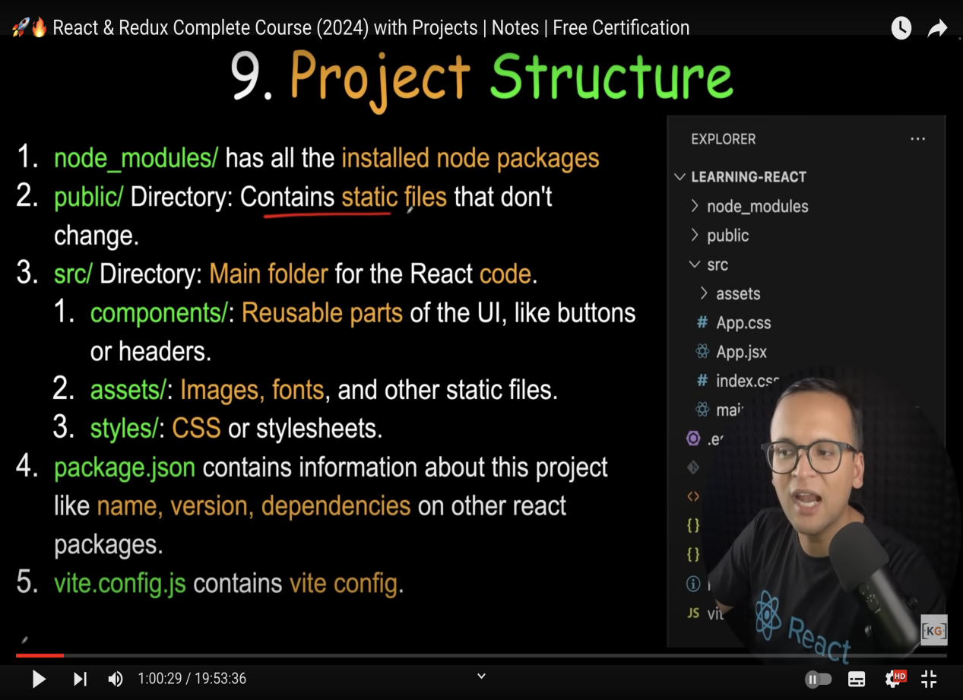

**App.jsx ->**

function App() {}

export default App;