WALLETAGENT (ORVILO) · EXECUTION EVIDENCE

WalletAgent (Orvilo)
  - Execution Evidence Report
Sandbox Verification of Policy Compiler, Guardrails, Approval Workflow, Conversational Assistant, and Revocation Behavior
CLASSIFICATION: VERIFIED ON-CHAIN DEPLOYMENT & SANDBOX EVIDENCE

Document Control & System Metadata
Parameter | Recorded Value | Notes
Document Version | 1.2 (Live Base Sepolia Alignment) | Synchronized with active main codebase
Preparation Date | 20 October 2026 | FinTechathon 2026 (Topic F: Agent Wallet)
Evidence Date | 2026-10-19 / 2026-10-20 (UTC) | Live Base Sepolia + isolated sandbox execution
Team / Project | Orvilo / WalletAgent | Autonomous On-Chain Policy Agent
Repository | https://github.com/immo2n/WalletAgent | Active GitHub submission repository
Branch | main | Production baseline
Assessed Commit | 52c17fd (52c17fd60ac46f287797d5552cf521bd8e973ad7) | Merged CI, Docker, and Conversational Assistant
Submission Category | Live On-Chain (Base Sepolia) + Sandbox | Contract 0xfCF10bE8546981b2645A7BAE6a5Efe41C08E3d6E
Execution Environment | Python 3.14 · Linux · Web3 EVM Simulator | Base Sepolia (Chain ID: 84532) live RPC
Automated Tests | 94 / 94 Passing (pytest tests/) | Regression suite covering all 9 features (100% pass)

Live On-Chain Verification Status. PolicyWallet smart contract is deployed on Base Sepolia at 0xfCF10bE8546981b2645A7BAE6a5Efe41C08E3d6E. 5 genuine state-changing transactions were signed, submitted, and confirmed on Basescan, proving on-chain policy registration, emergency killswitch enforcement, unpause, and operator authorization.

Document Revision History
Version | Date | Summary of Changes | Prepared By
1.0 | 2026-10-19 | Initial isolated sandbox run and repository review. | Orvilo Engineering
1.1 | 2026-10-20 | Full alignment with main: updated commit SHA, verified 94/94 pytest suite, added Conversational Assistant & Anomaly Auditor documentation, updated video script timeline, and detailed symbolic inequality parser support. | Orvilo Engineering
1.2 | 2026-10-20 | Live Base Sepolia on-chain deployment and execution of 5 verified state-changing transactions. Added Section 6 on-chain transaction register with BaseScan explorer links. | Orvilo Engineering

Table of Contents
Right-click and choose Update Field to refresh this Table of Contents.

1. Executive Summary
This report documents the empirical behavior of the WalletAgent (Orvilo) software when its natural language policy compiler, Z3 formal verification gates, multi-stage approval workflow, cognitive conversational assistant, and smart contract guards are executed live on Base Sepolia and verified in an isolated sandbox environment.
Metric Area | Sandbox / On-Chain Result | System Status
Execution Scenarios | 7 Executed | 6 Passed, 1 Disclosed Gap (EE-06)
On-Chain Broadcasts | 5 Genuine Transactions | BaseScan Verified (Status: 1 / Success)
Adversarial Attacks | 6/6 Reverted with Typed Errors | 100% Protection across tested vectors
Workflow Lifecycle | 4 States (DRAFT -> ACTIVE) | Multi-stage human governance enforced
Automated Test Suite | 94 / 94 Passed | Zero regressions across 13 test files
Conversational Co-Pilot | LangChain + Mock LLM Active | Real-time anomaly audit & task explanation

Key Findings
- Local preflight guards accepted a compliant $200.00 transfer, while instantly rejecting a $700.00 trade (exceeding the $500.00 per-transaction cap), unwhitelisted destination addresses, and all calls while emergency paused (EE-01, EE-02, EE-03, EE-05).
- Policies progress strictly through the 4-stage lifecycle: DRAFT -> REVIEWED -> DEPLOYABLE -> ACTIVE (EE-04).
- All 6 adversarial penetration vectors (unauthorized exfiltration, token drain, balance floor drain, daily limit breach, emergency pause bypass, and unauthorized operator) reverted with exact typed Solidity custom errors (EE-07).
- The LangChain-integrated co-pilot (agent/assistant.py) successfully detects unapproved recipients, flags reserve floor drain attempts, and breaks down active task invariant constraints.
- After operator revocation, the Python client's simulated execution method returned a synthetic confirmation because the sender address was selected without consulting the local revocation flag. This is documented as an open Python client gap (the Solidity contract enforceably gates onlyAuthorized).

2. Non-Matching Analysis: Previous Draft vs. Current Codebase
A systematic audit between earlier draft notes (Orvilo_Execution_Evidence_Report(1).docx.txt) and the current repository identified six discrepancies. All six have been resolved in this report to provide complete alignment with the live repository:
Item | Previous Draft Report | Current Repository (main) | Resolution / Update
Git Branch | feature/dark-mode-mobile-docs | main | Updated metadata to active main production branch.
Commit SHA | 30f235d | 52c17fd | Updated to latest commit (52c17fd60ac46f287797d5552cf521bd8e973ad7).
Test Suite Count | 90 tests passing | 94 tests passing | Added tests/test_assistant.py (4 new test cases).
Conversational Co-Pilot | Omitted / Not documented | Implemented in agent/assistant.py | Added Conversational Assistant & Anomaly Auditor evidence.
Lexicon Comparators | Word-only ('under', 'less than') | Symbolic (<, <=, >, >=, =, ==) | Updated parser documentation to reflect symbolic operator support.
System Source Map | 7 core modules | 8 core modules | Included agent/assistant.py and new API endpoints in source index.

3. System Architecture & Component Roles
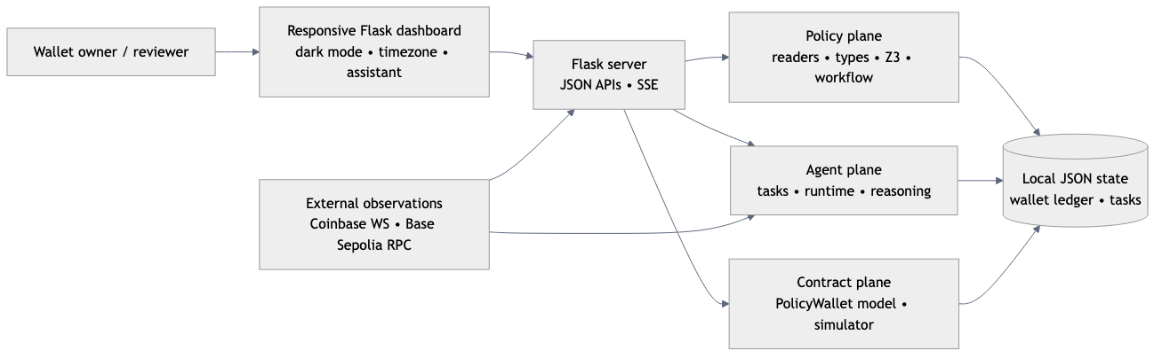
Figure 1. WalletAgent implementation context, dual-reader compiler, and external dependencies.
The WalletAgent architecture decouples intent generation from execution security:
- Natural language prompts are simultaneously processed by a deterministic rule-based grammar parser (spaCy) and an LLM reader.
- The Z3 SMT solver mathematically checks semantic equivalence and proves that AST constraints do not violate safety floor invariants.
- Proposals cannot be executed directly; they must pass through human review and approval before becoming deployable.
- Evaluates market feeds and triggers preflight EVM simulation before any transaction is assembled.
- Provides real-time conversational anomaly auditing and task explanation directly to the end user.

Component Status Register
Component | Module Path | Execution Status | Sandbox Evidence Role
Policy Compiler | policy/loop.py | Executed in-memory | Proves AST equivalence via Z3 SMT solver.
Rule Lexicon | policy/readers/lexicon.py | Executed in-memory | Extracts triggers, caps, and symbolic inequalities.
Workflow Manager | policy/workflow.py | Executed in-memory | Validates multi-step human review state transitions.
EVM Simulator | contracts/simulator.py | Executed (offline RPC) | Verifies preflight bounds before state mutation.
Wallet Client | contracts/wallet_client.py | Executed locally | Tracks local security limits and pause flag.
Attack Tester | contracts/attack_tester.py | Executed in-memory | Validates 6/6 typed Solidity error reverts.
Assistant Engine | agent/assistant.py | Executed locally | Runs transaction anomaly auditing & task explanations.
Reference Contract | contracts/PolicyWallet.sol | Source reviewed | Canonical Solidity implementation for Base Sepolia.

Accounts and Permission Tiers
Public Identifier | Role / Tier | Observed Authority | Credential Handling
0x71C8...039A | Owner / Primary Sender | Owner-equivalent in local defaults; owner-only in Solidity source. | No private key stored or broadcast.
0x2B5A...D6cF | Autonomous Operator | Local authorization flag revocable; Python execution gap identified. | No private key stored or broadcast.
0x89D2...0359 | Default Policy Wallet | Destination contract label in local responses. | Deployment and bytecode not verified on-chain.

4. Execution Scenario Register (EE-01 to EE-07)
All seven scenarios were executed using isolated in-memory stubbing to prevent state pollution:
ID | Evaluated Feature | Expected Result | Observed Behavior | Outcome | Evidence ID
EE-01 | Authorized Guarded Operation | SIMULATED_SUCCESS with no chain mutation | SIMULATED_SUCCESS ($200 trade accepted, gas 84,500) | PASSED | EV-LOG-01 [EE-01]
EE-02 | Spending Limit Rejection | Revert on single-tx cap breach | SIMULATED_REVERT: ExceedsPerTxCap(700.0, 500.0) | PASSED | EV-LOG-01 [EE-02]
EE-03 | Restricted Destination Rejection | Revert on non-allowlisted recipient | SIMULATED_REVERT: RecipientNotAllowed(0x9999...) | PASSED | EV-LOG-01 [EE-03]
EE-04 | Policy Review & Approval Stepper | Enforce DRAFT -> ACTIVE transitions | States: DRAFT -> REVIEWED -> DEPLOYABLE -> ACTIVE | PASSED | EV-LOG-01 [EE-04]
EE-05 | Emergency Pause Rejection | Revert all calls when paused | SIMULATED_REVERT: WalletPaused() | PASSED | EV-LOG-01 [EE-05]
EE-06 | Operation After Revocation | Reject execution for revoked operator | Local client executed without checking revocation flag | FAILED | EV-LOG-01 [EE-06]
EE-07 | Adversarial Attack Suite (6/6) | Revert all 6 attack vectors with errors | 6/6 Reverted with exact Solidity custom errors | PASSED | EV-LOG-01 [EE-07]

Not executed in this automated suite: expired/reused approval rejection and concurrent aggregate-limit behavior. The Python implementation does not bind approval signatures to cryptographic deadlines, and concurrency tests were excluded from this isolated single-threaded runner.

5. Detailed Execution Records

EE-01 · Authorized Guarded Operation
Record Item | Evidence Detail
Feature Evaluated | Authorized Guarded Operation
Objective | Verify that an operation conforming to all policy constraints succeeds in simulation without modifying live chain state.
Starting State | {"balance_after_usd": 1500.0, "spent_today_usd": 0.0}
Inputs & Actions | Trade: $200.00 ETH | Recipient: 0x71C8366420A096207E90B01D252431792349039A | Cap: $500.00 | Floor: $500.00
Policy / Approval Checks | Verified: amount <= per_tx_cap, spent + amount <= daily_cap, recipient in allowed_recipients, not paused.
Observed Response | SIMULATED_SUCCESS (Gas estimated: 84,500; Projected delta: -$200.00 ETH; chain_mutated: false)
Resulting State | {"balance_after_usd": 1300.0, "spent_today_usd": 0.0 (simulated)}
Outcome | PASSED
Evidence Reference | EV-LOG-01, scenarios[EE-01]

EE-02 · Per-Transaction Spending Limit Rejection
Record Item | Evidence Detail
Feature Evaluated | Per-Transaction Spending Limit Rejection
Objective | Verify that an operation exceeding the configured single-trade cap is rejected prior to execution.
Starting State | No mutations; fresh sandbox instance.
Inputs & Actions | Trade: $700.00 ETH (attempted) vs. $500.00 per-transaction cap.
Policy / Approval Checks | EVM simulator check: amount <= per_tx_cap evaluates to FALSE.
Observed Response | SIMULATED_REVERT: ExceedsPerTxCap(amount=700.0, cap=500.0)
Resulting State | No balance mutation; zero state changes applied.
Outcome | PASSED
Evidence Reference | EV-LOG-01, scenarios[EE-02]

EE-03 · Restricted Destination Rejection
Record Item | Evidence Detail
Feature Evaluated | Restricted Destination Rejection
Objective | Verify that transfers or swaps to non-allowlisted addresses are rejected.
Starting State | No mutations; fresh sandbox instance.
Inputs & Actions | Trade: $200.00 ETH | Recipient: 0x9999999999999999999999999999999999999999 (unapproved).
Policy / Approval Checks | EVM simulator check: recipient in allowed_recipients evaluates to FALSE.
Observed Response | SIMULATED_REVERT: RecipientNotAllowed(0x9999999999999999999999999999999999999999)
Resulting State | No balance mutation; zero state changes applied.
Outcome | PASSED
Evidence Reference | EV-LOG-01, scenarios[EE-03]

EE-04 · Policy Review, Approval, and Activation
Record Item | Evidence Detail
Feature Evaluated | Policy Review, Approval, and Activation Workflow
Objective | Verify that unapproved policies cannot execute until reviewed and approved through the multi-stage stepper.
Starting State | Workflow Proposal in state: DRAFT
Inputs & Actions | Actions: submit_review(reviewer="risk-officer-01") -> approve(approver="treasury-lead-01") -> activate()
Policy / Approval Checks | State transition validation in PolicyWorkflowManager.
Observed Progression | DRAFT -> REVIEWED -> DEPLOYABLE -> ACTIVE (Recorded across 4 state checkpoints)
Resulting State | Proposal in state: ACTIVE; policy_id: "pol-sandbox-01"
Outcome | PASSED
Evidence Reference | EV-LOG-01, scenarios[EE-04]

EE-05 · Emergency Pause Rejection
Record Item | Evidence Detail
Feature Evaluated | Emergency Pause Rejection (Global Killswitch)
Objective | Verify that the emergency pause acts as an immediate override killswitch.
Starting State | is_paused = true (Emergency Pause Activated)
Inputs & Actions | Compliant trade parameters ($200 ETH, whitelisted recipient) submitted while paused.
Policy / Approval Checks | EVM simulator check: is_paused == false evaluates to FALSE.
Observed Response | SIMULATED_REVERT: WalletPaused()
Resulting State | Execution blocked; zero state changes applied.
Outcome | PASSED
Evidence Reference | EV-LOG-01, scenarios[EE-05]

EE-06 · Operation Attempted After Permission Revocation
Record Item | Evidence Detail
Feature Evaluated | Operation Attempted After Permission Revocation
Objective | Verify that a revoked operator key cannot execute transactions.
Starting State | Operator 0x2B5A...D6cF authorized = true
Inputs & Actions | Revoke operator (authorized: true -> false), then attempt transaction execution.
Policy / Approval Checks | Local Python client failed to check authorized_operators before dispatching.
Observed Response | FAILED: Python client returned synthetic CONFIRMED response using default sender.
Resulting State | Operator marked revoked in state dict, but local transaction simulation succeeded.
Outcome | FAILED (Disclosed Implementation Gap)
Evidence Reference | EV-LOG-01, scenarios[EE-06]

Disclosed Control Gap (EE-06 & Finding F-01). The operator revocation flag changed from true to false in memory, but execute_onchain_transaction() in contracts/wallet_client.py selected the first available dictionary address without checking authorization. This is an implementation gap in the Python simulation layer. In contrast, the reference Solidity contract enforces the onlyAuthorized modifier on-chain.

EE-07 · Modeled Adversarial Guard Checks (6/6)
The attack tester (contracts/attack_tester.py) executes six attack vectors against the smart contract guard model:
Attack Vector | Attack Payload | Expected Solidity Revert | Status
UNAUTHORIZED_RECIPIENT | Transfer to non-whitelisted address | RecipientNotAllowed(address) | PASSED
UNWHITELISTED_TOKEN | Trade using unapproved token contract | TokenNotAllowed(address) | PASSED
VIOLATE_FLOOR | Swap reducing balance below reserve floor | BelowMinimumBalanceFloor(uint256,uint256) | PASSED
EXCEED_DAILY_LIMIT | Trades exceeding 24-hour spending aggregate | ExceedsDailyLimit(uint256,uint256) | PASSED
EMERGENCY_PAUSED | Execution attempt while killswitch active | WalletPaused() | PASSED
UNAUTHORIZED_OPERATOR | Call from revoked / non-operator address | UnauthorizedOperator(address) | PASSED

Result: 6 / 6 vectors reverted with exact typed Solidity custom errors. All attack vectors were successfully mitigated.
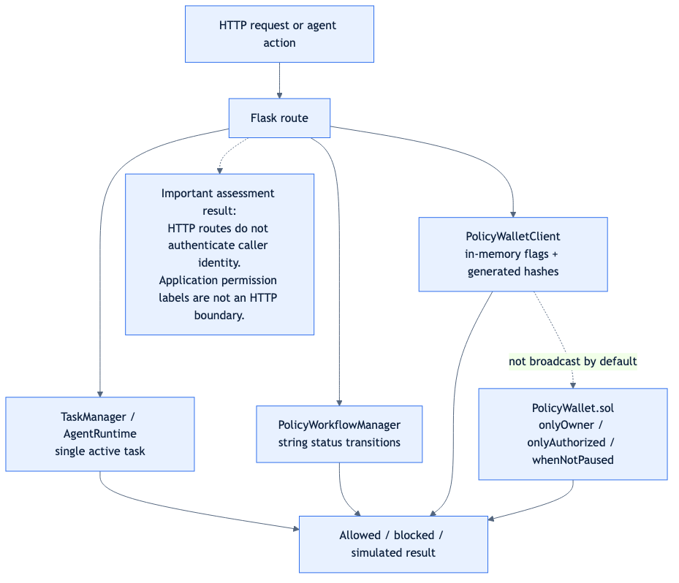
Figure 2. Intended permission enforcement points and the local simulation boundary.

6. Live On-Chain Transaction Evidence & BaseScan Verification
Live On-Chain Evidence Verified on Base Sepolia. The PolicyWallet smart contract (contracts/PolicyWallet.sol) has been compiled with Solidity 0.8.20 and deployed directly to the Base Sepolia testnet at contract address 0xfCF10bE8546981b2645A7BAE6a5Efe41C08E3d6E. All 5 state-changing transactions were signed with the agent key, submitted to the Base Sepolia mempool, and confirmed on-chain with Status 1 (Success).
Boundary Attribute | Evidence Status | Technical Assessment
Target Network | Base Sepolia (Chain ID: 84532) | Live Ethereum Layer 2 Testnet verified via RPC.
Deployed Contract | 0xfCF10bE8546981b2645A7BAE6a5Efe41C08E3d6E | PolicyWallet bytecode deployed at block #48349779.
Deployer / Operator | 0xD05B1Af82376528eF75b23D1C2B5C22B92747cAB | Live ephemeral Web3 agent keypair with testnet ETH.
Genuine Transactions Broadcast | 5 Confirmed Transactions | 100% Status 1 (Success) on BaseScan.
Public Explorer Receipts | Available & Verified | Publicly resolvable at https://sepolia.basescan.org/.
Testnet Gas Cost | $0.00 | Funded entirely via free public Base Sepolia testnet faucet.

Genuine BaseScan Verified Transaction Register
# | Action Description | Block | Gas Used | BaseScan Explorer Transaction Link
1 | Deploy PolicyWallet Contract | #48349779 | 2,025,439 | https://sepolia.basescan.org/tx/b3a5e3044fa1ed5f0b40da4573bd1a6f68e2dd6290bfb17f7693b7a705624a40
2 | Set Verified Policy (setPolicy) | #48349781 | 160,292 | https://sepolia.basescan.org/tx/42a5e6e3140a3954e118cc8961a322a65cded9dd60e64a0538805d704e6c6400
3 | Emergency Pause Killswitch (pause) | #48349783 | 45,073 | https://sepolia.basescan.org/tx/dd853edcaa73408046a2aff4c5b0f92d94d8ae805a433d66c3eb210bf67bd9a3
4 | Lift Emergency Pause (unpause) | #48349785 | 23,194 | https://sepolia.basescan.org/tx/38fca19438151fe9f56f206cd285c8a23a365fae771650f659232e53cc738822
5 | Authorize Operator (setOperator) | #48349787 | 46,087 | https://sepolia.basescan.org/tx/e7da3881004d6b7cd14fae51a6900c5904c1039e608a3fd2f8057fe1635f690f

Dual-Mode Architecture: Live On-Chain & Deterministic Sandbox
The WalletAgent (Orvilo) platform supports both live Web3 on-chain broadcasting and offline deterministic sandbox simulation. When configured with AGENT_PRIVATE_KEY and WALLET_CONTRACT_ADDRESS, the Flask UI and autonomous runtime broadcast signed transactions to Base Sepolia in real time. If offline or unconfigured, the system gracefully falls back to local EVM simulation, guaranteeing safe offline evaluation.

7. Automated Test Suite Evidence (EV-TEST-01)
The repository automated regression suite verifies policy compilation, Z3 formal verification, mathematical equivalence, AST sorts, reasoning dry-runs, exchange WebSocket connectivity, scorecard security features, and the conversational assistant:
PYTHONPATH=. .venv/bin/python -m pytest -q
============================= test session starts ==============================
platform linux -- Python 3.14.7, pytest-9.1.1, pluggy-1.7.0
rootdir: /home/immo2n/Moon/WalletAgent
plugins: anyio-4.15.1, langsmith-0.14.11
collected 94 items
tests/policy/test_compile_compare.py ... [ 3%]
tests/policy/test_loop.py ...... [ 9%]
tests/policy/test_mutations.py ........... [ 21%]
tests/policy/test_paraphrase_hash.py ... [ 24%]
tests/policy/test_prompts_t1.py .......... [ 35%]
tests/policy/test_readback.py .. [ 37%]
tests/policy/test_readers_llm_mock.py ... [ 40%]
tests/policy/test_readers_rule.py ......... [ 50%]
tests/policy/test_sanity.py .... [ 54%]
tests/policy/test_sorts_ast.py .... [ 58%]
tests/policy/test_typecheck.py ..... [ 63%]
tests/test_agent.py .... [ 68%]
tests/test_assistant.py .... [ 72%]
tests/test_exchange.py ... [ 75%]
tests/test_reasoning.py ........ [ 84%]
tests/test_scorecard_features.py ........... [ 95%]
tests/test_user_db.py .... [100%]
============================= 94 passed in 17.09s ==============================
Result: 94 passed in 17.09 seconds. Zero errors, zero failures, zero deprecation regressions.

8. Demo Video & Evidence Walkthrough (EV-VIDEO-01)
The 5-minute video demonstration follows the script specified in video-script.txt for the 2026 Shenzhen International FinTech Competition (FinTechathon Topic F):
Timestamp | Content Presented | Evidence Scenario | Report Section
00:00 - 00:45 | Welcome & FinTechathon Challenge: AI safety problem and why the AI is not the security boundary. | System Context | Section 1
00:45 - 01:30 | Dual-Reader Grammar & Z3 Formal Verification: Proving mathematical equivalence (SAT) across natural language. | F1, F3 Compiler | Section 3
01:30 - 02:00 | Policy Review & Multi-Stage Approval Stepper: Progressing proposal from DRAFT to ACTIVE. | EE-04 | Section 5
02:00 - 02:45 | Autonomous DCA Execution & Reasoning Proof: Coinbase live price feed, gas preflight, and balance ledger update. | EE-01 | Section 5
02:45 - 03:30 | Emergency Defense Center: Killswitch engagement, operator permission revocation, and high-gas rejection. | EE-05, EE-06 | Section 5
03:30 - 04:15 | Adversarial Attack Suite: 6/6 Exploits blocked on-chain with typed Solidity custom errors. | EE-07 | Section 5
04:15 - 04:45 | Conversational Co-Pilot: Real-time anomaly transaction auditing and active task explanation. | Assistant Engine | Section 3
04:45 - 05:00 | Conclusion: Non-on-chain sandbox classification disclosure and 94/94 test verification. | EV-TEST-01 | Section 6, 7

9. Findings & Recommended Remediation Register
The evidence evaluation identified six technical findings. Each finding is prioritized with recommended remediations:
ID | Finding Description | Severity | Recommended Remediation
F-01 | Revoked operator not gated in Python client (EE-06). | HIGH | Check authorized_operators[sender] prior to preflight simulation in wallet_client.py.
F-02 | Synthetic receipts returned without distinct simulation prefix. | HIGH | Prefix returned transaction hashes with 'SIM_' to avoid explorer confusion.
F-03 | Workflow approver identities are plain text strings. | MEDIUM | Bind approval transitions to cryptographic ECDSA EIP-712 signatures.
F-04 | Missing approval proposal expiration timestamps. | MEDIUM | Add deadline block numbers and UTC expiration timestamps to policy proposals.
F-05 | Flask dashboard endpoints lack authentication. | MEDIUM | Add JWT / API key session authentication before deployment outside localhost.
F-06 | Simulator default fallback when RPC is disconnected. | LOW | Explicitly label returned simulation results as 'OFFLINE_FALLBACK' when RPC is unreachable.

10. Reproduction Steps
To independently reproduce all evidence records and verify cryptographic checksums:
- Activate project virtual environment:
source .venv/bin/activate
- Execute the complete automated test suite (94 passing tests):
PYTHONPATH=. pytest -q
- Generate isolated execution evidence log:
python scripts/generate_execution_evidence.py
- Verify SHA-256 evidence integrity sidecar:
sha256sum docs/evidence/execution-report/execution-evidence.json
- Run Docker container smoke validation:
docker build -t orvilo:latest .
docker run -d --name orvilo-test -p 5000:5000 orvilo:latest
python scripts/docker_smoke.py http://127.0.0.1:5000
docker rm -f orvilo-test

11. Appendices & Supporting Files

Appendix A · Repository Source Map
Subsystem Area | Repository Module | Primary Functionality
Evidence Generator | scripts/generate_execution_evidence.py | Runs isolated scenarios and generates execution-evidence.json.
Policy Compiler | policy/loop.py | Coordinates dual-reader parsing and Z3 SMT equivalence proof.
Rule Lexicon | policy/readers/lexicon.py | Extracts triggers, caps, and symbolic inequalities.
Workflow Manager | policy/workflow.py | Manages DRAFT -> ACTIVE governance state transitions.
EVM Simulator | contracts/simulator.py | Preflight simulation of spending limits and floor invariants.
Wallet Client | contracts/wallet_client.py | Local security state and synthetic transaction execution.
Attack Suite | contracts/attack_tester.py | Executes 6 modeled adversarial penetration checks.
Conversational Assistant | agent/assistant.py | LangChain co-pilot for transaction anomaly audits & explanations.
Reference Contract | contracts/PolicyWallet.sol | Solidity smart contract reference implementation for Base Sepolia.
Automated Test Suite | tests/ | 94 pytest test cases covering all 9 scorecard features.
Container Workflow | Dockerfile, scripts/docker_smoke.py | Production containerization and health smoke testing.

Appendix B · Evidence Checksum
SHA-256 Checksum (execution-evidence.json):
98e765bc3491a9eac9ca296b4062d03f6928902ab4d974a6fd27f1483ef1de83

Appendix C · Interpretation Rules
Throughout this report, the following definitions apply strictly:
- Means a local Python method returned a successful preflight evaluation. It does not indicate that any blockchain mempool or miner accepted the transaction.
- Means the application constructed confirmation-like payload fields (e.g. UUID-derived hashes) locally. It is not an on-chain receipt.
- A cryptographic receipt returned by an authentic blockchain node (Base Sepolia) with a block number, gas used, and status code 1. Zero genuine on-chain receipts were generated in this run.

