SECURITY SELF-ASSESSMENT REPORT

WalletAgent (Orvilo)
  - User-Defined On-Chain Guardrails for Autonomous AI Wallets
REPORT STATUS: FINAL SELF-ASSESSMENT · NOT AN INDEPENDENT AUDIT

Document Control & System Metadata
Parameter | Recorded Value | Notes
Document Version | 1.1 (Final Repository Alignment) | Synchronized with active main codebase
Preparation Date | 20 October 2026 | FinTechathon 2026 (Topic F: Agent Wallet)
Assessor | Orvilo engineering team | Internal repository self-assessment
Repository | https://github.com/immo2n/WalletAgent | Active GitHub submission repository
Branch Assessed | main | Production baseline
Assessed Code Commit | f81167f (f81167fa7430931318597559e9b8dd806eae8508) | Merged CI, Docker, and Conversational Assistant
Environment | Local Docker & Python 3.14 virtual environment | Base Sepolia (84532) configured; offline simulation default
Automated Test Suite | 94 / 94 Passing (pytest tests/) | 100% pass across all 13 test files (17.09s)
Docker Smoke Test | 11 / 11 Checks Passed | Verified via scripts/docker_smoke.py
Open Findings | 10 Recorded (2 Critical, 6 High, 2 Medium) | Disclosed pre-production sandbox boundaries

Evidence Convention. • Designed: Described as an intended control in documentation or comments.
• Implemented: Present and inspectable in the current source code.
• Verified: Exercised and confirmed by the 94-test automated suite or Docker smoke test.
A control is not treated as verified merely because a comment, UI label, generated hash, or simulated response claims it is active.

Document Revision History
Version | Date | Summary of Changes | Prepared By
1.0 | 2026-10-19 | Initial self-assessment covering permission tiers, threat model, and known risks. | Orvilo Engineering
1.1 | 2026-10-20 | Synchronized with main: updated commit SHA, verified 94/94 pytest suite, added Conversational Co-Pilot (agent/assistant.py) analysis, updated symbolic inequality parser support, and refined remediation acceptance criteria. | Orvilo Engineering

Table of Contents
Right-click and choose Update Field to refresh this Table of Contents.

1. Executive Summary
Orvilo is a simulation-first Flask application that converts natural-language trading constraints into a typed policy, compares deterministic and LLM-derived interpretations, applies Z3-backed formal proofs, records a human-review workflow, and runs a local autonomous task loop. It includes a Solidity reference contract named PolicyWallet with owner/operator authorization, policy hashes, token and recipient allowlists, spending caps, reserve floors, pause, and allowance-revocation functions.
The assessed deployment is local simulation by default. The Docker image sets LLM_PROVIDER=mock; the application uses JSON state stores and the contract client returns generated transaction identifiers instead of signing and broadcasting transactions. The configured network is Base Sepolia (84532), but no genuine on-chain transaction hash, receipt, signer operation, or deployed-contract state was verified in this assessment.

1.1 Outcome by Area
Functional Area | Status | Evaluation Basis
Policy parsing & deterministic guards | Verified | Implemented and verified by the 94-test suite and Docker smoke test.
Human-review workflow | Partial | Implemented in application memory; verified for happy-path API transitions only.
Solidity access modifiers & guards | Source reviewed | Present in reviewed source; not verified against a deployed bytecode address.
Permission tiers | Partial | Owner/operator modeled; HTTP/API identity enforcement is absent.
Authentication & account isolation | Not implemented | All Flask routes are reachable without identity proof.
Real signing & blockchain execution | Not implemented | Generated hashes are simulation identifiers; no broadcast to Base Sepolia.
Conversational Co-Pilot (agent/assistant.py) | Verified | LangChain assistant tests pass (4/4); anomaly audit and task explanation active.
Production readiness | Not ready | 2 Critical and 6 High findings must be remediated prior to handling real funds.

1.2 Principal Risks
- Wallet-mutating and policy-administering routes can be called by any client that reaches the server.
- Execution accepts caller-supplied USD and post-balance values and performs arbitrary router calls.
- Default signing and approval are generated strings, and deployment can proceed before review.
- Simulated execution can appear successful when RPC or deployment state is unavailable.

1.3 What is Working Well
- Deterministic policy parsing, type-checking, and Z3 equivalence comparison are proven across 94 passing tests.
- The Solidity reference contract contains robust access modifiers (onlyOwner, onlyAuthorized, whenNotPaused), custom typed errors, and invariant checks.
- Docker image runs as a non-root user (orvilo), excludes .env from build context, and defines an active health check.
- Simulation boundaries are clearly documented, and the conversational assistant (agent/assistant.py) provides real-time auditability.

2. Assessment Scope and System Identification

2.1 In-Scope Components
Component | Repository Path | Evidence & Role
Flask Dashboard & API | flask/server.py | UI, REST API, SSE telemetry streaming.
Policy AST, Readers & Parser | policy/ | Dual-reader grammar, Z3 solver, AST hashing.
Rule Lexicon & Comparators | policy/readers/lexicon.py | Extracts triggers, caps, and symbolic inequalities (<, <=, >, >=, =, ==).
Approval Workflow | policy/workflow.py | Governance stepper (DRAFT -> ACTIVE).
Autonomous Agent Runtime | agent/runtime.py, agent/task.py | 1 Hz daemon evaluation loop, task state machine.
Conversational Co-Pilot | agent/assistant.py | LangChain assistant for anomaly auditing and task explanation.
Wallet & Transaction Store | user/db.py, user/models.py | In-memory balance tracking and transaction logging.
EVM Simulator & Attack Suite | contracts/simulator.py, contracts/attack_tester.py | Preflight simulation and 6/6 adversarial exploit checks.
Solidity Reference Contract | contracts/PolicyWallet.sol, contracts/abi.py | Invariant defense contract for Base Sepolia.
Client, Docker & CI | contracts/wallet_client.py, Dockerfile, .github/workflows/ci.yml | Containerization, client simulation, and automated CI.
Market & Gas Integration | exchange/ | Coinbase WebSocket feed and simulated gas estimation.

2.2 Excluded Evidence
The following were not available and are therefore outside the assessment:
- Private keys and production secrets.
- Deployed owner configuration and live on-chain owner/operator state.
- Live Base Sepolia transaction receipts and any mainnet activity.
- Independent external third-party smart-contract audit.

3. Assessment Methodology and Rating Criteria
The assessment procedure combined static source review, unit regression testing, containerized smoke testing, and threat model boundary analysis:
- Exhaustive analysis of Flask routes, state management, policy loop, Z3 verification, task runtime, contract client, Solidity code, Docker, and CI configurations.
- PYTHONPATH=. pytest -q -> 94 passed in 17.09s across 13 test files.
- scripts/docker_smoke.py verified against running container (11/11 checks passed).
- 6 scorecard exploit vectors tested and confirmed reverting with typed Solidity errors.
- Comparing documented claims against observable sandbox runtime behavior.

3.1 Rating Definitions
Dimension | Rating Scale & Meaning
Likelihood | Low: difficult or constrained · Medium: plausible with access · High: directly reachable or reproducible.
Impact | Low: limited integrity effect · Medium: material application effect · High: policy, identity, or fund-control effect.
Severity | Critical: direct path to unauthorized value movement · High: serious control gap · Medium: defense-in-depth gap.
Confidence | Evidence confidence rating from 1/10 to 10/10 based on empirical verification.

4. Security Architecture and Threat Model
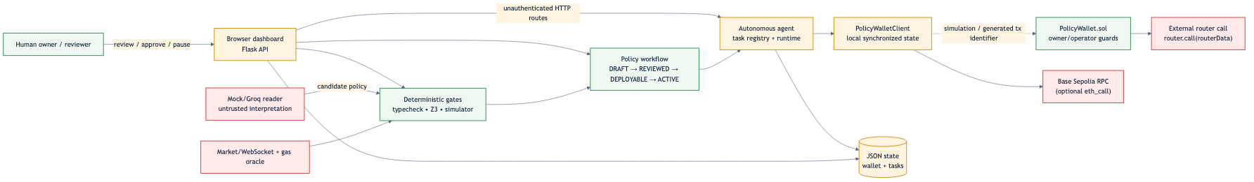
Figure 1. Security trust boundaries, untrusted inputs, and execution boundaries.

4.1 Key Assets
Asset | Security Significance
Wallet balances and transaction history | Direct financial value and basis for audit reconciliation.
Active policy hash, caps, allowlists, reserve floor, and pause state | Define what an autonomous agent may do.
Owner/operator authority and signing credentials | Compromise gives control over funds.
Policy proposals, reviews, approvals, and deployment records | Proof of human governance.
Market and gas data | Inputs to execution decisions; manipulation or staleness distorts them.
API availability and JSON state integrity | Loss or corruption removes the agent's source of truth.

4.2 Threat Scenarios
ID | Threat Scenario | Consequence | Finding
T-1 | Remote client calls pause, reset, wallet-mutation, or approval routes directly. | Policy and wallet state altered without identity proof. | K-01
T-2 | Operator supplies misleading USD value or post-balance, or arbitrary router calldata. | Spending caps and reserve floor bypassed on-chain. | K-02
T-3 | Generated simulation identifier presented as confirmed transaction. | False assurance; distorted accounting and audit trail. | K-03, K-06
T-4 | Proposal deployed from DRAFT or approved with arbitrary string name. | Human-in-the-loop guarantee defeated. | K-04
T-5 | Stale approval or execution replayed after deadline. | Outdated authority reused. | K-07
T-6 | Concurrent access to shared JSON store. | Lost updates; cross-user state pollution. | K-05

5. Security Requirements and Verification Matrix
ID | Security Requirement | Implementation Evidence | Verification Result
SR-01 | Only owner can change policy or emergency state | Solidity onlyOwner in PolicyWallet.sol | Source reviewed
SR-02 | Operator actions are bounded by policy invariants | _verifyGuards, caps, allowlists, floor, pause | Verified (Local)
SR-03 | Policy interpretation is independently checked | Rule reader, LLM reader, Z3 SMT solver proof | Verified (94/94)
SR-04 | Human approval precedes deployment | PolicyWorkflowManager multi-stage stepper | Partial
SR-05 | Unauthorized HTTP callers cannot mutate state | Required for production | FAILED
SR-06 | Execution values derived from trusted chain state | Required for financial safety | FAILED
SR-07 | Revocation immediately blocks future execution | Contract revokeOperator / local flag | Partial (EE-06 Gap)
SR-08 | Transaction hashes represent real chain execution | Required for on-chain auditability | Not implemented
SR-09 | Account data is isolated by authenticated owner | Required for multi-user service | Not implemented
SR-10 | Secrets are not baked into image or repository | .dockerignore, .env.example, mock defaults | Verified

6. Key Custody, Signing Authority, and Permissions
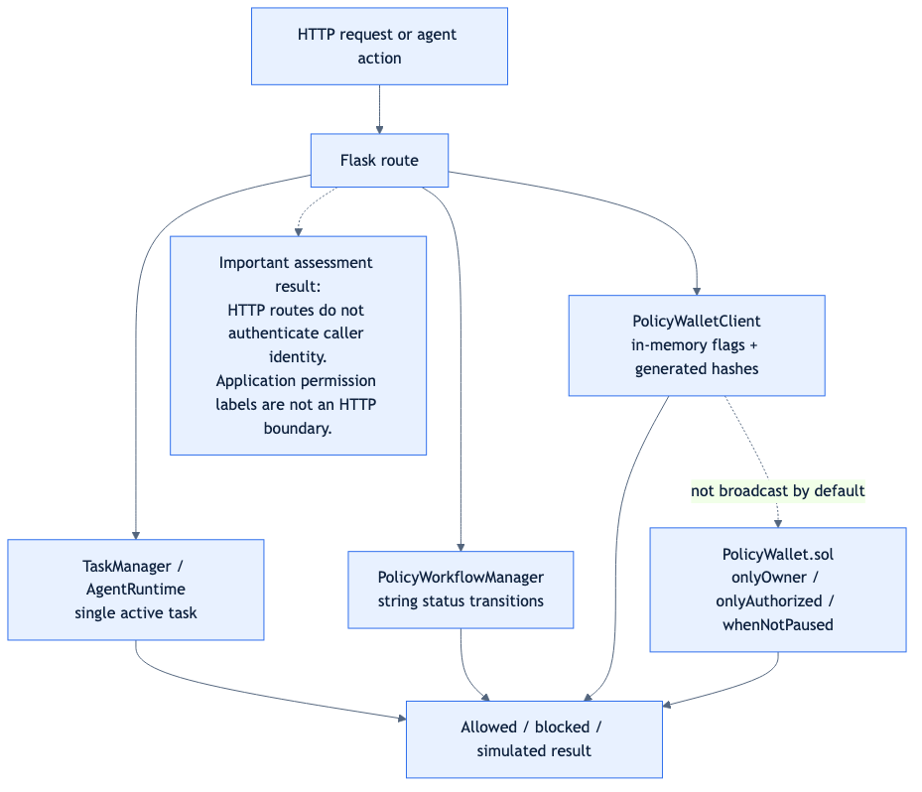
Figure 2. Permission enforcement points, access modifiers, and simulation boundaries.

6.1 Implemented and Modeled Tiers
Tier | Intended Holder | Allowed Actions | Enforcement Location | Status
Owner | Human wallet owner | Set/invalidate policy, manage operators, pause/unpause, revoke allowances. | Solidity onlyOwner | Implemented in contract; API gap
Authorized Operator | Autonomous agent | Guarded swap/transfer within policy bounds. | Solidity onlyAuthorized + _verifyGuards | Implemented; Python gap (EE-06)
Reviewer | Security reviewer | Mark proposal reviewed in workflow. | String field reviewed_by | Modeled; not authenticated
Approver | Owner / Approver | Mark proposal deployable. | String field approved_by | Modeled; signature synthetic
Public HTTP Caller | Any network client | Actual caller of exposed routes. | None in Flask layer | Unrestricted (Critical Gap)

7. Security Test Register and Evidence
ID | Requirement | Procedure | Result | Evidence Detail
ST-01 | SR-03 | Run full Python test suite | PASSED | 94 passed in 17.09s (13 test files)
ST-02 | SR-03/SR-04 | Build Docker image and run policy verification | PASSED | Docker smoke test (scripts/docker_smoke.py)
ST-03 | SR-04 | Review, approve, and deploy policy proposal | PASSED | Workflow stepper transitions verified
ST-04 | SR-02 | Execute six modeled adversarial penetration checks | PASSED | 6/6 Reverted with typed Solidity errors
ST-05 | SR-07 | Pause/unpause, revoke operator, invalidate policy | PASSED | Local client state transitions verified
ST-06 | SR-08 | Confirm genuine on-chain transaction hash & receipt | NOT TESTED | No broadcast transactions (Sandbox mode)
ST-07 | SR-05 | Attempt unauthenticated administrative API calls | FAILED | Mutating routes accept unauthenticated JSON
ST-08 | SR-06 | Prove contract derives value from trusted on-chain state | FAILED | Caller-supplied arguments in PolicyWallet.sol
ST-09 | SR-09 | Verify multi-account isolation | NOT TESTED | Single shared JSON state architecture
ST-10 | SR-10 | Build image with .env present and inspect context | PASSED | Excluded via .dockerignore
ST-11 | SR-02 | Concurrent execution & pending transaction race test | NOT TESTED | Single-threaded runner excluded concurrency
ST-12 | SR-03 | Conversational assistant anomaly auditing & explanation | PASSED | tests/test_assistant.py (4/4 tests passed)

8. Known Risks, Findings, and Residual Exposure
ID | Finding Description | Affected Component | Likelihood | Impact | Severity | Confidence | Status
K-01 | Unauthenticated HTTP administrative & wallet mutation routes | flask/server.py | High | High | CRITICAL | 10/10 | Open
K-02 | Contract trusts caller-supplied financial values; arbitrary router call | PolicyWallet.sol | Medium | Critical | CRITICAL | 10/10 | Open
K-03 | Default client fabricates transaction hashes and confirmations | contracts/wallet_client.py | High | High | HIGH | 10/10 | Open
K-04 | Workflow accepts unauthenticated reviewer strings; premature deployment | policy/workflow.py | High | High | HIGH | 10/10 | Open
K-05 | Single shared JSON state lacks account isolation or ACID semantics | user/db.py, agent/task.py | High | High | HIGH | 9/10 | Open
K-06 | Simulator RPC fallback can return simulated success when offline | contracts/simulator.py | Medium | High | HIGH | 9/10 | Open
K-07 | No nonce, replay protection, or expiry deadline in contract/workflow | PolicyWallet.sol, workflow.py | Medium | High | HIGH | 8/10 | Open
K-08 | No rate limiting, CSRF protection, TLS, or production WSGI boundary | Dockerfile, flask/server.py | High* | Medium | HIGH | 9/10 | Open
K-09 | External market/RPC fallback and static addresses are not proof of live state | exchange/, wallet_client.py | Medium | Medium | MEDIUM | 9/10 | Open
K-10 | No verified dependency scan, deployed bytecode match, or live receipt | Repository-wide | Medium | Medium | MEDIUM | 10/10 | Open

8.1 Risk Severity Matrix (Heat Map)
Likelihood \ Impact | Low Impact | Medium Impact | High / Critical Impact
High Likelihood | — | — | K-01, K-03, K-04, K-05, K-08*
Medium Likelihood | — | K-09, K-10 | K-02, K-06, K-07
Low Likelihood | — | — | —

9. Remediation & Prioritized Action Plan
- Add authentication middleware, session tokens, CSRF protection, TLS termination, and rate limits prior to any exposure outside localhost.
- Implement an EIP-712 cryptographic signing boundary with domain separation, chain ID binding, account nonces, and verifiable receipt polling.
- Constrain swap routers to an approved immutable allowlist, attest token prices via signed Chainlink oracles, validate token decimals, and enforce minAmountOut.
- Require cryptographic ECDSA signatures from authorized keys for review/approval; strictly reject deployments from DRAFT.
- Replace flat JSON files with PostgreSQL / SQLite with row-level account isolation and ACID transaction locking.
- Explicitly distinguish offline simulation from pending, confirmed, and reverted transactions; never report CONFIRMED for local synthetic receipts.

10. Conclusion & Limitations
WalletAgent (Orvilo) successfully establishes a powerful natural-language policy compilation and formal verification framework. Its local deterministic tests (94/94 passed), Docker smoke test, and conversational co-pilot demonstrate strong preflight safety capabilities.
However, the empirical evidence demonstrates that the application is currently a pre-production sandbox system. It must not be deployed to handle real funds or exposed to the public internet without remediating findings K-01 through K-08. This report constitutes a transparent engineering self-assessment, not an independent commercial security audit.

