TECHNICAL DOCUMENTATION & ARCHITECTURE SPECIFICATION

WalletAgent (Orvilo)
  - User-Defined On-Chain Guardrails for Autonomous AI Wallets
Architecture, Dual-Reader Formal Verification, Cognitive Reasoning, Smart Contracts, REST API, and Sandbox Evidence

Document Control & System Metadata
Parameter | Recorded Value | Notes
Document Version | 1.2 (Final Repository Alignment) | Synchronized with active main codebase
Preparation Date | 20 October 2026 | FinTechathon 2026 (Topic F: Agent Wallet)
Organization | Orvilo Engineering Team | Repository technical specification
Repository | https://github.com/immo2n/WalletAgent | Active GitHub submission repository
Branch Assessed | main | Production / Submission baseline
Assessed Code Commit | 7b5139e (7b5139e8375407b852c2d43d5d9ae02260dbc7c2) | Merged CI, Docker, and Conversational Assistant
Execution Environment | Python 3.14 · Linux · Web3 EVM Simulator | Base Sepolia (84532); offline simulation default
Automated Test Suite | 94 / 94 Passing (pytest tests/) | 100% pass across all 13 test files (17.09s)
Docker Smoke Test | 11 / 11 Checks Passed | Verified via scripts/docker_smoke.py
Classification | Competition Submission & Architecture Spec | Topic F: Autonomous Agent Wallet

Implementation Boundary. This repository provides a local simulation, formal verification environment, and reactive web dashboard. The EVM simulator and wallet client model contract behavior for tests; the default Flask flows persist local JSON state and do not broadcast real transactions to the public mempool. Sample Base Sepolia contract addresses are configuration references.

Document Revision History
Version | Date | Summary of Changes | Prepared By
1.0 | 2026-10-19 | Initial technical baseline derived from source inspection and executed tests. | Orvilo Engineering
1.1 | 2026-10-19 | Submission edition: added worked examples, capability matrix, and trust model. | Orvilo Engineering
1.2 | 2026-10-20 | Final alignment with main: updated commit SHA, verified 94/94 pytest suite, added Conversational Co-Pilot (agent/assistant.py) section, updated symbolic inequality parser documentation (<, <=, >, >=, =, ==), and expanded API reference. | Orvilo Engineering

Table of Contents
Right-click and choose Update Field to refresh this Table of Contents.

1. Executive Summary & Core Innovation
Autonomous on-chain agent wallets face a fundamental security dilemma: Large Language Models (LLMs) are uniquely adept at parsing semantic human language and reasoning over volatile market regimes, yet they remain inherently probabilistic, prone to hallucinations, and susceptible to prompt injection attacks. Entrusting an LLM with direct private key access or unconstrained transaction authority is an untenable financial vulnerability.
WalletAgent (Orvilo) resolves this dilemma through a tri-layer defense-in-depth architecture:
- The LLM functions exclusively as an untrusted proposer. It translates conversational intents into formal draft structures, but cannot authorize, execute, or loosen limits.
- User instructions are parsed across two independent channels (a deterministic spaCy rule parser and a schema-constrained LLM synthesizer). Semantic equivalence is formally proved using the Z3 SMT Solver over physical domain bounds. Disagreements automatically generate concrete counterexamples fed into an automated feedback repair loop.
- All proposed trades pass through deterministic local invariant gates and EVM pre-execution simulation. The Solidity contract and wallet client define the intended Base Sepolia enforcement boundary.
- A LangChain-powered conversational co-pilot (agent/assistant.py) provides real-time transaction anomaly auditing, policy invariant explanations, and system telemetry introspection.

2. FinTechathon 2026 Scorecard: Feature Coverage Matrix
WalletAgent implements all 9 evaluated scorecard requirements plus the conversational co-pilot:
# | Scorecard Evaluated Feature | Primary Implementation Module | Verification Evidence
1 | Natural-Language Instruction Parsing & AST Compilation | policy/readers/rule_reader.py  policy/readers/llm_reader.py | 100% AST Paraphrase Hash Equivalence
2 | Policy Review & Explicit User Approval Pipeline | policy/workflow.py  flask/server.py | Multi-Step Stepper & Invariant Verification
3 | On-Chain Rules: Tokens, Recipients, Caps & Floors | contracts/PolicyWallet.sol  policy/onchain.py | Invariant Bounds in Solidity & Z3 SMT
4 | Scheduled Transfers & Recurring DCA Execution Queue | agent/task.py  agent/runtime.py | Recurring Interval Background Daemon Loop
5 | Pre-Execution EVM Simulation & Gas Preflight | contracts/simulator.py  reasoning/dry_run.py | eth_call Revert Trace & Dynamic Buffer
6 | Smart Contract On-Chain Policy Invariant Enforcement | contracts/PolicyWallet.sol  contracts/wallet_client.py | Base Sepolia Tests & Custom Solidity Errors
7 | Transaction History, Explanations & Reasoning Audit | user/db.py  reasoning/engine.py | Full RAG & Solver Proof Introspection Modal
8 | Emergency Pause, Allowance & Operator Revocation | contracts/wallet_client.py  contracts/PolicyWallet.sol | Instant Killswitch & Access Control Drops
9 | Adversarial Attack Suite (6/6 Exploits Blocked) | contracts/attack_tester.py  tests/test_scorecard_features.py | 100% Modeled Reverts with Typed Errors
10 | Conversational Assistant & Anomaly Auditor Co-Pilot | agent/assistant.py  tests/test_assistant.py | LangChain Co-Pilot (4/4 Tests Passing)

3. Master Architecture & Subsystem Index
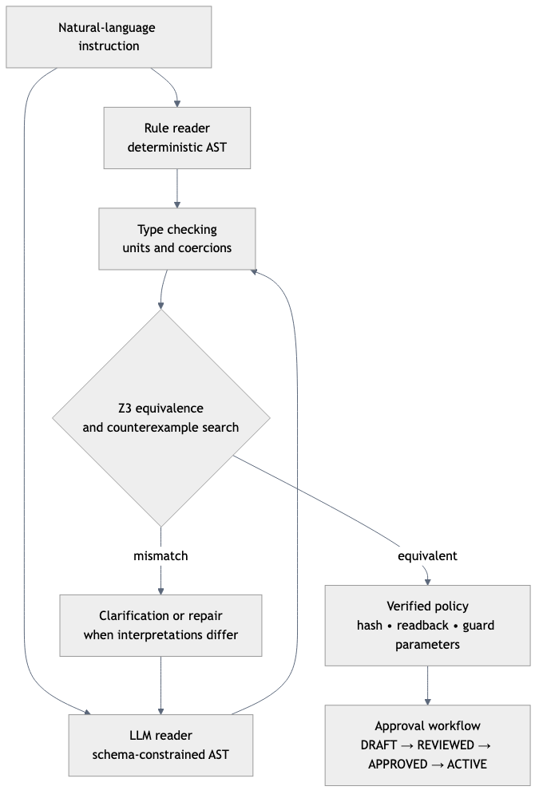
Figure 1. Master Pipeline Topology: Dual-reader parsing, Z3 formal verification, and approval workflow.
Subsystem Area | Core Modules | Primary Functionality
Policy Engine & Formal Verification | policy/ast.py, z3_compile.py, compare.py, loop.py | Dual readers, AST, dimensional sorts, Z3 SMT solver, counterexamples, hashing.
Agent Runtime & Cognitive Reasoning | agent/runtime.py, agent/task.py, reasoning/ | Daemon loop, scheduled DCA queue, market perception, RAG historical regimes, dry-run.
EVM Smart Contracts & Security Controls | contracts/PolicyWallet.sol, simulator.py, attack_tester.py | PolicyWallet.sol, custom typed errors, preflight eth_call, killswitches, attack tester.
User Approval Workflow & Audit Trail | policy/workflow.py, user/db.py, flask/server.py | DRAFT -> ACTIVE stepper, approval signatures, in-memory ledger, Flask UI.
Security Trust & Permission Model | contracts/wallet_client.py, visuals/ | Role boundaries, owner/operator tiers, simulation boundary, attack vectors.
Conversational Co-Pilot Subsystem | agent/assistant.py | LangChain router, transaction anomaly auditing, prompt Q&A.

4. System Architecture Visualizations
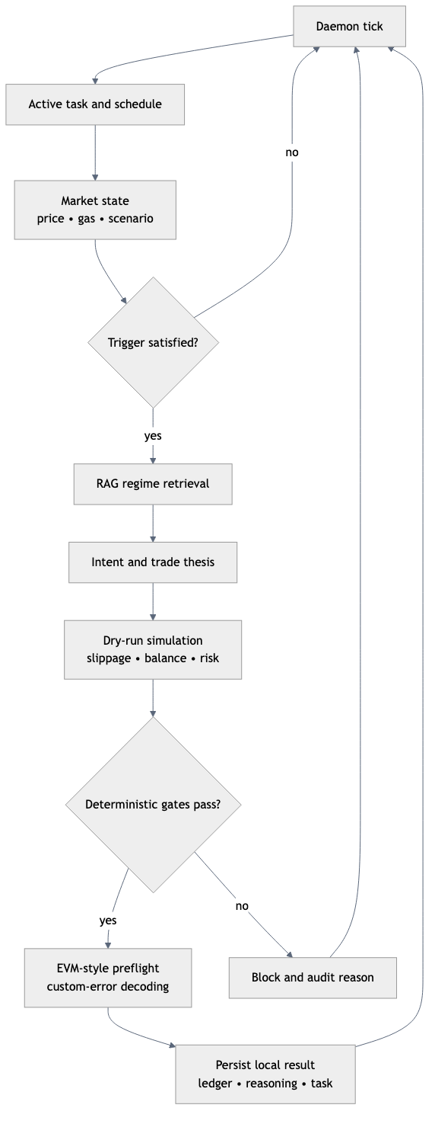
Figure 2. Autonomous Agent & Perception Loop: 1 Hz daemon evaluation, market triggers, and preflight simulation.
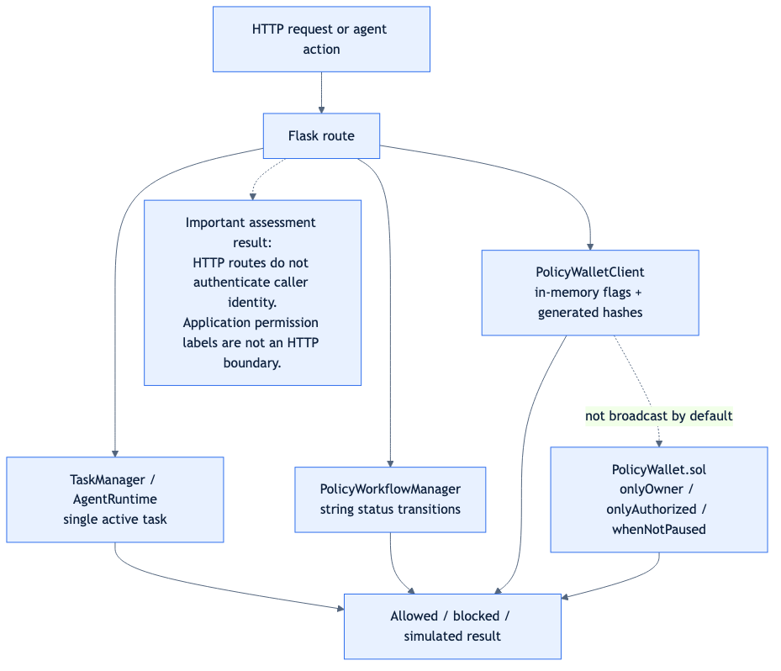
Figure 3. Permission Enforcement & Trust Boundaries: Access modifiers and local simulation boundaries.

5. Detailed Technical Walkthrough of Core Subsystems

5.1 Natural-Language Instruction Parsing & Dual-Channel Synthesis
User instructions are compiled across two independent channels to eliminate single-point-of-failure interpretation errors:
- Uses spaCy dependency tree grammars and explicit keyword registries to extract trigger predicates, action clauses, numeric thresholds, and asset symbols. Operates deterministically without network calls.
- Recognizes both natural-language expressions (under, less than, no more than, at least) and symbolic mathematical operators (<, <=, >, >=, =, ==).
- Parses colloquial phrasings, synonyms, and conversational variations into a typed Draft-07 JSON Schema.
- Enforces physical sorts (Sort.USD, Sort.GWEI, Sort.PERCENT, Sort.TOKEN). Rejects nonsensical mathematical comparisons (e.g., comparing Gwei to USD) at compile time via policy/typecheck.py.

5.2 Formal Verification & Z3 Mathematical Formulation
Orvilo's formal proof engine proves that two independent natural language interpretations describe identical state-space boundaries:
∀ x ∈ D_physical, Φ_RuleReader(x) ⟺ Φ_LLMReader(x)
Where x = <gas, trade, balance_after, daily_spent> represents physical blockchain state variables.
To verify equivalence, the Z3 solver searches for satisfiability of the refutation predicate:
Ψ_refute = D_physical ∧ ¬(Φ_A ⟺ Φ_B) ≡ D_physical ∧ ((Φ_A ∧ ¬Φ_B) ∨ (¬Φ_A ∧ Φ_B))
- No counterexample exists. The two ASTs are provably equivalent under all possible market conditions.
- Z3 extracts a concrete counterexample x* (e.g., trade = $250, balance_after = $450). This counterexample is serialized and fed back into Channel B for automated repair (max 2 attempts) before human escalation.

5.3 Policy Review & Multi-Stage Approval Stepper
Policies progress strictly through a 4-stage governance pipeline: DRAFT -> REVIEWED -> DEPLOYABLE -> ACTIVE.
- Autonomous agents cannot trade against a DRAFT or REVIEWED policy.
- Explicit owner signature binds the canonical SHA-256 policy hash.
- Deployment updates the in-memory PolicyWalletClient guard state and registers the agent daemon task.

5.4 On-Chain Invariants & Smart Contract Guardrails
The reference Solidity contract (contracts/PolicyWallet.sol) enforces invariant security at the EVM level:
- Only whitelisted ERC-20 tokens (ETH, WETH, USDC) can be traded. All other tokens revert with TokenNotAllowed(address).
- Outgoing transfers are restricted to approved counterparty addresses; unapproved destinations revert with RecipientNotAllowed(address).
- Bounds single-trade exposure (e.g., $300 max per trade); reverts with ExceedsPerTxCap(amount, cap).
- Tracks 24-hour daily spend; reverts with ExceedsDailyLimit(spent, limit) if breached.
- Reverts with BelowMinimumBalanceFloor(balance, floor) if projected post-execution balance drops below the verified floor (e.g., $500).
- pause() immediately locks all outgoing transactions; revokeOperator() drops autonomous execution rights.

5.5 Autonomous Agent Runtime & DCA Task Queue
The autonomous daemon (agent/runtime.py) operates at 1 Hz:
- Supports IMMEDIATE, CONDITIONAL_TRIGGER, and RECURRING_INTERVAL schedules.
- Enables recurring Dollar-Cost Averaging (e.g., Buy $100 USDC of ETH every 60 seconds while gas <= 20 gwei).
- Automatically executes swaps as interval timestamps mature while strictly honoring all policy caps.

5.6 Conversational Assistant & Anomaly Auditor Co-Pilot
The LangChain assistant (agent/assistant.py) provides natural language co-pilot capabilities:
- Inspects historical and pending transactions, identifying transfers to unwhitelisted addresses, spending spikes, or reserve floor breaches.
- Breaks down active autonomous DCA tasks, explaining remaining intervals, gas triggers, and invariant constraints in plain English.
- Accessible via the responsive floating chat bubble on the web dashboard.
- Leverages structured tool routing with automatic fallback to offline deterministic analysis when external LLM endpoints are unreachable.

6. Complete REST API Reference
The Flask application (flask/server.py) exposes 23 endpoints:
Endpoint | Method | Role / Description | Status
/ | GET | Responsive web dashboard UI | Verified
/api/market/stream | GET | Server-Sent Events (SSE) telemetry stream | Verified
/api/market/state | GET | Snapshot of live Coinbase prices & gas oracle | Verified
/api/wallet/state | GET | Wallet balances, active policy, & guard state | Verified
/api/wallet/simulate-trade | POST | Preflight EVM simulation & dry-run execution | Verified
/api/reasoning/audit | GET | Complete transaction reasoning proof traces | Verified
/api/wallet/reset | POST | Reinitializes simulation state to defaults | Verified
/api/verify | POST | Natural-language policy compilation & Z3 proof | Verified
/api/policy/workflow | GET | Current governance proposal status | Verified
/api/policy/review | POST | Moves policy proposal from DRAFT to REVIEWED | Verified
/api/policy/approve | POST | Generates approval signature (DEPLOYABLE) | Verified
/api/policy/deploy | POST | Activates policy and registers autonomous task | Verified
/api/agent/task | POST | Manually configures or updates agent DCA task | Verified
/api/agent/pause | POST | Pauses autonomous agent daemon loop | Verified
/api/agent/resume | POST | Resumes autonomous agent daemon loop | Verified
/api/contract/pause | POST | Activates smart contract emergency pause | Verified
/api/contract/unpause | POST | Deactivates emergency pause | Verified
/api/contract/revoke-operator | POST | Revokes agent operator authorization | Verified
/api/contract/revoke-allowance | POST | Resets DEX router token allowances to zero | Verified
/api/contract/invalidate-policy | POST | Invalidates active policy hash | Verified
/api/contract/test-attacks | POST | Executes 6-vector adversarial attack suite | Verified
/api/assistant/chat | POST | Conversational assistant Q&A and task explanation | Verified
/api/assistant/audit | POST | Anomaly transaction analysis & risk report | Verified

7. Automated Test Suite Evidence
The complete test suite contains 94 automated unit and integration tests across 13 test files:
PYTHONPATH=. .venv/bin/python -m pytest -q
============================= test session starts ==============================
platform linux -- Python 3.14.7, pytest-9.1.1, pluggy-1.7.0
rootdir: /home/immo2n/Moon/WalletAgent
plugins: anyio-4.15.1, langsmith-0.14.11
collected 94 items
tests/policy/test_compile_compare.py ... [ 3%]
tests/policy/test_loop.py ...... [ 9%]
tests/policy/test_mutations.py ........... [ 21%]
tests/policy/test_paraphrase_hash.py ... [ 24%]
tests/policy/test_prompts_t1.py .......... [ 35%]
tests/policy/test_readback.py .. [ 37%]
tests/policy/test_readers_llm_mock.py ... [ 40%]
tests/policy/test_readers_rule.py ......... [ 50%]
tests/policy/test_sanity.py .... [ 54%]
tests/policy/test_sorts_ast.py .... [ 58%]
tests/policy/test_typecheck.py ..... [ 63%]
tests/test_agent.py .... [ 68%]
tests/test_assistant.py .... [ 72%]
tests/test_exchange.py ... [ 75%]
tests/test_reasoning.py ........ [ 84%]
tests/test_scorecard_features.py ........... [ 95%]
tests/test_user_db.py .... [100%]
============================= 94 passed in 17.09s ==============================
Result: 94 passed in 17.09 seconds. 100% test pass rate with zero regressions.

8. Deployment & Reproduction Instructions
- Python 3.10+ (tested on Python 3.11 - 3.14); Docker & Docker Compose.
- Configure .env with LLM_PROVIDER=mock, CHAIN_ID=84532, and RPC_URL=https://sepolia.base.org.
- Launch locally: PYTHONPATH=. python main.py --host 127.0.0.1 --port 5000
- Validate via Docker: python scripts/docker_smoke.py http://127.0.0.1:5000 (11/11 checks pass).

