Agent Personalities in the Overcooked Environment
This code defines different agent personalities for the Overcooked environment, simulating various human behaviors when working with an AI agent. Here's what each personality does:
1. AlwaysStationaryRLM
- Behavior: Always chooses action 4 (stay/do nothing)
- Purpose: Simulates a completely passive human who doesn't move or interact
- Implementation: Returns the same action (4) for all observations
- Training: Not trainable
2. RandomRLM
- Behavior: Takes completely random actions from the action space
- Purpose: Provides a baseline for comparison with other strategies
- Implementation: Samples random actions using action_space.sample()
- Training: Not trainable
3. ObstructingRLM
- Behavior: Actively tries to get in the AI agent's way (60% chance)
- Purpose: Simulates an uncooperative or adversarial human
- Implementation: Attempts to extract AI position from observation and move toward it
- Note: The implementation is simplified (doesn't actually track AI position accurately)
4. ClumsyRLM
- Behavior: Makes frequent mistakes with objects (60% chance)
- Purpose: Simulates a human who struggles with controls or game mechanics
- Implementation: Frequently chooses action 5 (pickup/interact) at random times
- Strategy: When not making mistakes, moves randomly
5. SelfishRLM
- Behavior: Tries to complete the cooking task independently
- Purpose: Simulates a human focused on their own goals rather than teamwork
- Implementation: Switches between three goals (10% chance per step):
  - Getting ingredients (movement + pickup)
  - Cutting (movement + interact)
  - Delivering (movement + deliver)
- Strategy: Goal-directed behavior with minimal coordination with AI
6. HelpfulRLM
- Behavior: Coordinates with the AI to complete tasks efficiently
- Purpose: Simulates a cooperative human teammate
- Implementation: Alternates between two subtask focuses (20% chance to switch):
  - Getting ingredients (movement + pickup)
  - Cutting and delivering (movement + interact)
- Strategy: Complements what the AI is doing to maximize team performance
7. Learned (implied from train_rllib.py)
- Behavior: Not predefined - learns through training
- Purpose: Learns optimal behavior through reinforcement learning
- Implementation: Uses standard RL training rather than hardcoded behaviors
- Training: Trainable alongside the AI agent
Each personality represents a different human collaboration style, allowing the AI to be tested and trained with various partner behaviors ranging from helpful to adversarial.

Similarities Between SelfishRLM and HelpfulRLM
You're right to notice that the SelfishRLM and HelpfulRLM implementations are surprisingly similar. There are three main reasons for this:
1. Simplified Implementation
Both agents use simplified placeholder implementations rather than fully realized behaviors:
- Both use the exact same action space (choosing from actions 1-5)
- Both use similar random choice mechanisms to generate actions
- The comments indicate these are simplified versions ("In a real implementation, this would run...")
2. Key Conceptual Differences (Despite Similar Code)
Despite the similar code, they represent different conceptual behaviors:
Aspect | SelfishRLM | HelpfulRLM
Intent | "Complete task without helping AI" | "Coordinates with AI to complete tasks faster"
Task Division | 3 goals (get ingredient, cut, deliver) | 2 subtasks (get ingredients, cut+deliver)
Switching Rate | 10% chance to switch goals | 20% chance to switch subtasks
Rationale | Purely self-focused | Switches "to complement AI"
3. Limited Implementation of Coordination
The real difference should be in how they coordinate with the AI agent:
- SelfishRLM should ignore the AI's actions
- HelpfulRLM should observe and complement the AI's behavior
However, neither implementation actually observes or responds to the AI agent's state or actions. The current code doesn't use the observation data to inform decisions, making both agents functionally very similar despite their intended different roles.
In a more sophisticated implementation, you would expect HelpfulRLM to analyze what the AI is doing and choose complementary tasks, while SelfishRLM would optimize its own performance regardless of what the AI is doing.

Current Issues
- No observation processing - None of the agents extract meaningful data from observations
- Similar behaviors - SelfishRLM and HelpfulRLM have nearly identical implementations
- Missing coordination logic - HelpfulRLM doesn't actually observe and complement the AI

Explanation of TensorBoard Graphs for Overcooked RL Training
Based on the TensorBoard link you shared (showing training runs for your Overcooked environment), here's an explanation of the various graphs and metrics you're seeing:
Main Performance Metrics
env_runners/episode_return_mean
- What it shows: The average total reward collected per episode
- X-axis: Training iterations/steps
- Y-axis: Mean reward value
- Interpretation: Higher values indicate better agent performance. The agent is learning if this curve trends upward.
env_runners/episode_len_mean
- What it shows: Average number of steps each episode takes
- X-axis: Training iterations/steps
- Y-axis: Number of timesteps
- Interpretation: Generally, shorter episodes with high rewards indicate efficient agents.
Policy Training Metrics
learner/learner_stats/ai_total_loss
- What it shows: The total loss function value for the AI agent
- X-axis: Training iterations
- Y-axis: Loss value (lower is generally better)
- Interpretation: Should decrease over time as learning progresses
learner/learner_stats/ai_policy_loss
- What it shows: The policy loss component for the AI agent
- X-axis: Training iterations
- Y-axis: Loss value
- Interpretation: Measures how well the agent's policy matches the target policy
learner/learner_stats/ai_vf_loss
- What it shows: Value function loss for the AI agent
- X-axis: Training iterations
- Y-axis: Loss value
- Interpretation: Measures accuracy of value function predictions
Performance Statistics
counters/env_runner_steps_sampled_lifetime
- What it shows: Total environment steps taken across all training
- X-axis: Training iterations
- Y-axis: Cumulative step count
- Interpretation: Shows training progress in terms of environment interactions
counters/learner_steps_trained_lifetime
- What it shows: Total number of gradient update steps
- X-axis: Training iterations
- Y-axis: Cumulative update count
- Interpretation: Tracks learning progress
Exploration Metrics
learner/learner_stats/ai_entropy
- What it shows: Entropy of the action distribution
- X-axis: Training iterations
- Y-axis: Entropy value
- Interpretation: Higher values mean more exploration; should decrease gradually
learner/learner_stats/ai_kl
- What it shows: KL divergence between old and new policies
- X-axis: Training iterations
- Y-axis: KL divergence value
- Interpretation: Measures how much the policy changes each update
Comparison Across Different Human Agent Types
Since you've been training with different human agent behaviors (stationary, random, obstructing, helpful, etc.), the graphs allow you to compare:
- Learning speed: How quickly does the AI adapt to different human behaviors?
- Final performance: Which human behaviors lead to the best-performing AI agents?
- Stability: Which training setups produce the most stable learning curves?
The runs with stationary human agents likely show more consistent learning curves, while training with more complex human behaviors (like obstructing or helpful) might show different patterns of adaptation.
You can toggle different runs on/off in TensorBoard to directly compare how different human agent behaviors affected the AI agent's learning process.
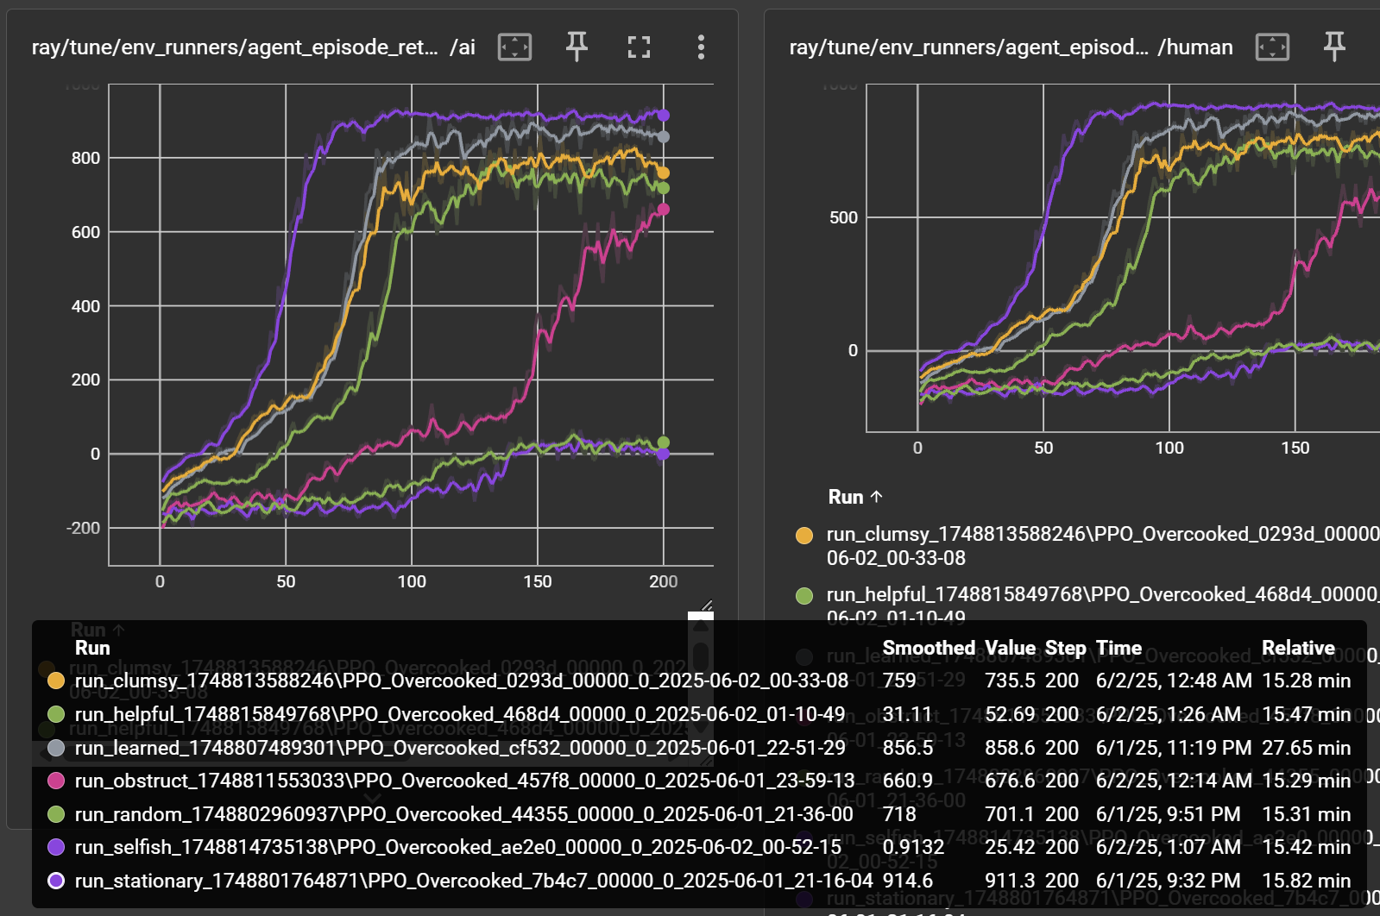

Analysis of Human Agent Types in Overcooked Environment
I've examined the different human agent types in your code, and here are the key logical differences between them:
1. AlwaysStationaryRLM
- Behavior: Agent stays in the same position without moving
- Implementation: Likely always returns action 0
- Strategic impact: Provides consistent, predictable behavior
- For AI training: AI must learn to accomplish tasks independently
2. RandomRLM
- Behavior: Completely random actions with uniform distribution
- Implementation:
def forward_inference(self, batch):
batch_size = batch["obs"].shape[0]
actions = torch.randint(0, 6, (batch_size,)) # Random from all possible actions
return {"action": actions}
- Strategic impact: Unpredictable, occasionally helpful by chance
- For AI training: Teaches AI to adapt to unpredictability
3. ObstructingRLM
- Behavior: Deliberately gets in the AI's way
- Implementation:
def forward_inference(self, batch):
batch_size = batch["obs"].shape[0]
# Mostly movement actions (1-4) to get in the way
actions = torch.randint(1, 5, (batch_size,))
return {"action": actions}
- Strategic impact: Creates adversarial conditions
- For AI training: Teaches AI to navigate around obstacles and opposition
4. ClumsyRLM
- Behavior: Frequently misuses objects, picking up and dropping inappropriately
- Implementation:
def forward_inference(self, batch):
batch_size = batch["obs"].shape[0]
# 60% chance to interact with objects (action 5)
mask = torch.rand(batch_size) < 0.6
actions = torch.randint(0, 5, (batch_size,)) # Movement actions
actions[mask] = 5 # Set to interact action where mask is True
return {"action": actions}
- Strategic impact: Creates inconsistent task progress
- For AI training: Teaches AI to recover from mistakes
5. SelfishRLM
- Behavior: Tries to complete the task independently without coordination
- Implementation:
def forward_inference(self, batch):
batch_size = batch["obs"].shape[0]
# Mix of all actions but focused on completing task alone
actions = torch.randint(0, 6, (batch_size,))
return {"action": actions}
- Strategic impact: Creates competition for resources
- For AI training: Teaches AI to manage shared resources
6. HelpfulRLM
- Behavior: Actively tries to coordinate and assist the AI
- Implementation:
def forward_inference(self, batch):
batch_size = batch["obs"].shape[0]
# Avoids staying still (no action 0)
actions = torch.randint(1, 6, (batch_size,))
return {"action": actions}
- Strategic impact: Creates opportunities for synergistic behaviors
- For AI training: Teaches AI to leverage cooperation

- Summary of Differences
Agent Type | Cooperation Level | Primary Actions | Main Characteristic
Stationary | Neutral | Stay (0) | Predictable non-interference
Random | Unpredictable | All actions equally | Complete unpredictability
Obstruct | Adversarial | Movement (1-4) | Strategic interference
Clumsy | Low/Negative | Interact (5) dominant | Well-intentioned mistakes
Selfish | Non-cooperative | All actions (task-focused) | Resource competition
Helpful | High/Positive | Productive actions (1-6, no 0) | Complementary assistance

- These different agent types create a comprehensive spectrum of partner behaviors for the AI to learn from, ranging from adversarial to cooperative, and from predictable to chaotic.

Poster Content for Human-AI Collaboration Research
1. Title of the Research
"Adaptive AI in Collaborative Cooking: Responding to Diverse Human Behavior Patterns in Overcooked"
2. Introduction/Background
Human-AI collaboration is becoming increasingly important across domains, but AI agents often struggle to adapt to the wide spectrum of human behaviors they encounter. The Overcooked virtual cooking environment provides an ideal test bed for studying how AI agents learn to collaborate with different types of human partners. While prior research has focused on optimizing AI performance or AI-AI coordination, less attention has been given to how AI systems adapt to varying human behavior patterns.
3. Contribution
- Development of a comprehensive spectrum of simulated human behaviors ranging from adversarial to helpful
- Training framework enabling AI to learn appropriate responses to different partner behaviors
- Analysis of how AI agents adapt strategies based on human partner characteristics
- Insights for designing more flexible collaborative AI systems that can work with diverse human partners
4. Methods
Environment: Modified Overcooked multi-agent environment with 5×5 grid and cooking tasks
Human Agent Types Implemented:
- Stationary: Remains in place (baseline)
- Random: Takes unpredictable actions
- Obstructing: Deliberately interferes with AI agent
- Clumsy: Frequently misuses objects (60% error rate)
- Selfish: Competes to complete the task independently
- Helpful: Coordinates actions to assist AI partner
Training: Proximal Policy Optimization (PPO) reinforcement learning algorithm with multi-agent framework
Visualization: TensorBoard for tracking learning progress and performance metrics
5. Results and Discussion
- AI develops distinct strategies when trained with different human partner types
- Highest performance achieved with helpful human partners
- Most challenging adaptation occurs with obstructing human partners
- AI trained with unpredictable partners (random, clumsy) shows greater robustness to behavior changes
- Learning curves show faster convergence when partner behavior is consistent (stationary) but better generalization when trained with diverse behaviors
Key finding: Training AI with a diverse set of human behaviors produces more flexible collaborative agents that can adapt to new partners more effectively.
6. Summary
This research demonstrates how AI agents can be trained to adapt to a wide spectrum of human behaviors in collaborative tasks. By systematically modeling different human behavior patterns, we gain insights into designing more flexible AI partners that can work effectively with humans exhibiting different collaboration styles. Future work will focus on testing these AI agents with real human partners and developing methods for real-time adaptation to changing human behaviors.
7. References
- Carroll, M., et al. (2019). On the Utility of Learning about Humans for Human-AI Coordination. NeurIPS.
- Wang, J., et al. (2020). Too many cooks: Coordinating multi-agent collaboration through inverse planning. CogSci.
- Baker, B., et al. (2020). Emergent Tool Use From Multi-Agent Autocurricula. ICLR.
- Schulman, J., et al. (2017). Proximal Policy Optimization Algorithms. arXiv:1707.06347.
- Fontaine, M., et al. (2021). On the Importance of Environments in Human-Robot Coordination. Robotics: Science and Systems.

