CS1002 W03-Piratical 170025298 Tutor:Alice Toniolo Date: Sep 29th

Overview:
To calculate the total cost of a party and try to make the program easy to be debugged.
Design:
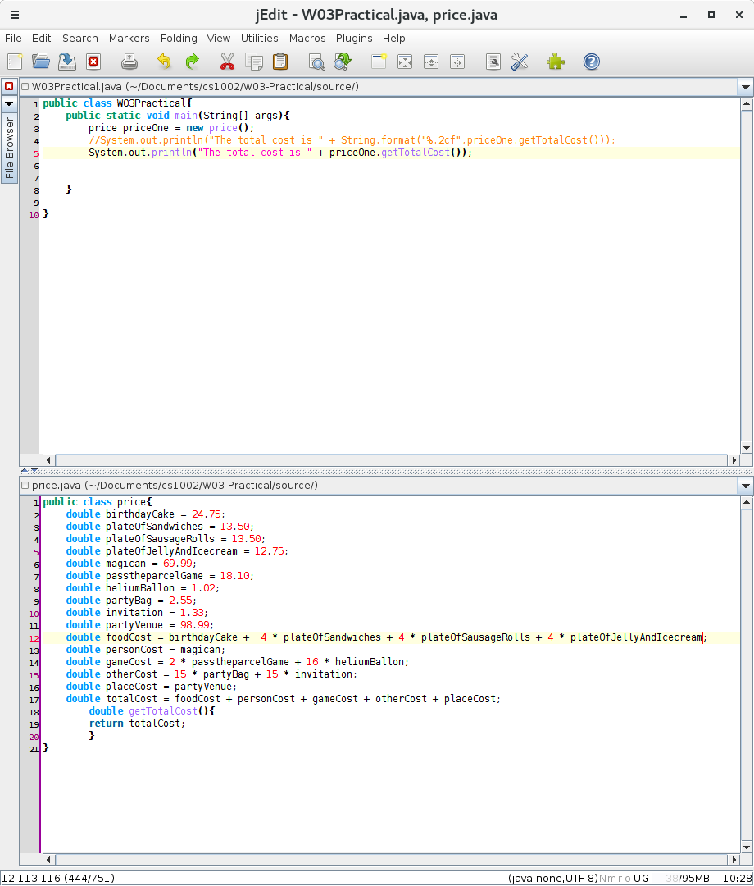
ssss With listening to the lectures of the lecturer this week, I want to make the program better to debug and be brief. I choose to divided the programmes in two java class in order to make the program be more organized and easy to debugged( but mostly for my curiosity). It’s quite hard to do so for me because this is the first time I did so. I found my fault that I spelled the wrong vocabulary.
Testing:
To reach to the better UI, I added “The total cost is”, But the result is all fine.
Examples :
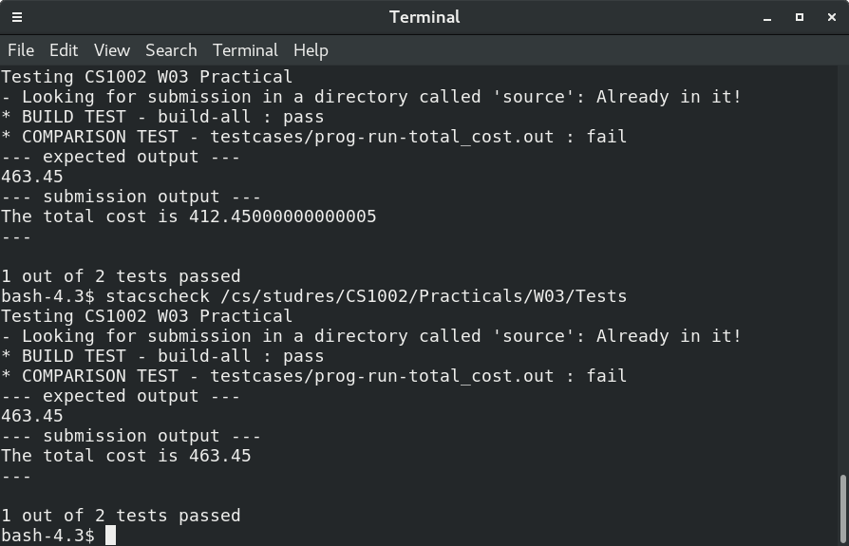
Succeed!
Evaluation:
I think it’s better than what I am required.
Conclusion:
I find that I studied the use of use more classes and use method to return values back to main Java program via new command. If I have more time I will try to make users choose wheather they want to see more messages about price use “if” command.
Extension1:
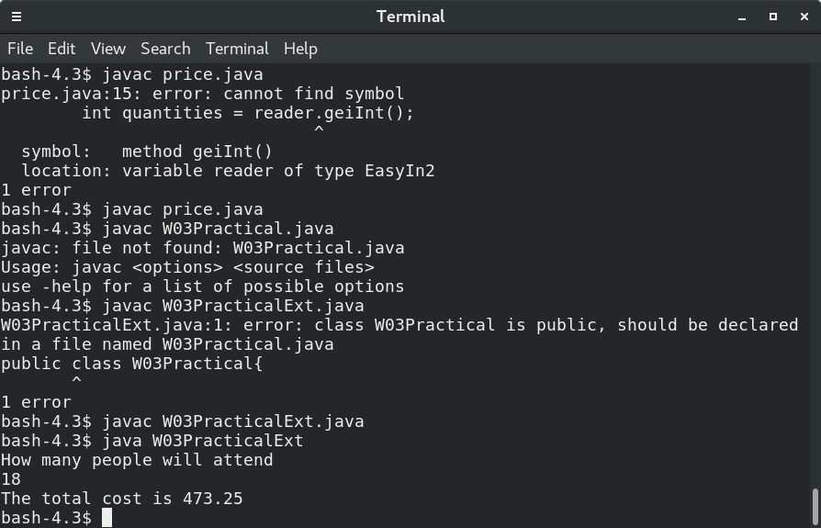
I added the quantities of participater and the photo is like this:

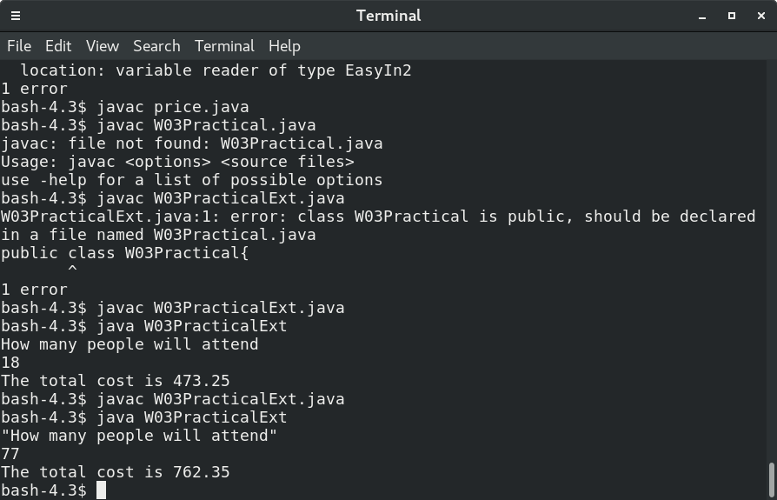
Extension2:with “\””being used and its just like this

