CS1002 W05-Practical 170025298 Tutor:Alice Toniolo Date: Oct 13th
Overview:
W05 Practical is for use the conditionals to make UI more friendly and interactively.
The program is using IF command to make sure that the programmes could convert a number to different numbers.
Design:
Math.round is used to properly calculate the programme from long to int.
Math.floor is to get the under round of the number
I use both and to try myself to finish the programmes and to make sure that the programmes to be more execute and be easy to calculate.
In conditional I tried to use if command and I have caused different fault:
/*if(meter == 1){
System.out.println(meter + " metre in yards, feet and inches is:");
System.out.println(yard + " yards, " + foot + " feet and " + inch + " inches");
}
else{
if(foot == 1){
System.out.println(meter + " metres in yards, feet and inches is:");
System.out.println(yard + " yards, " + foot + " foot and " + inch + " inches");
}
else{
if(yard == 1){
System.out.println(meter + " metres in yards, feet and inches is:");
System.out.println(yard + " yard, " + foot + " feet and " + inch + " inches");
}
else{
if(inch == 1){
System.out.println(meter + " metres in yards, feet and inches is:");
System.out.println(yard + " yards, " + foot + " feet and " + inch + " inch");
}
else{
System.out.println(meter + " metres in yards, feet and inches is:");
System.out.println(yard + " yards, " + foot + " feet and " + inch + " inches");

}
}
}
}

}*/

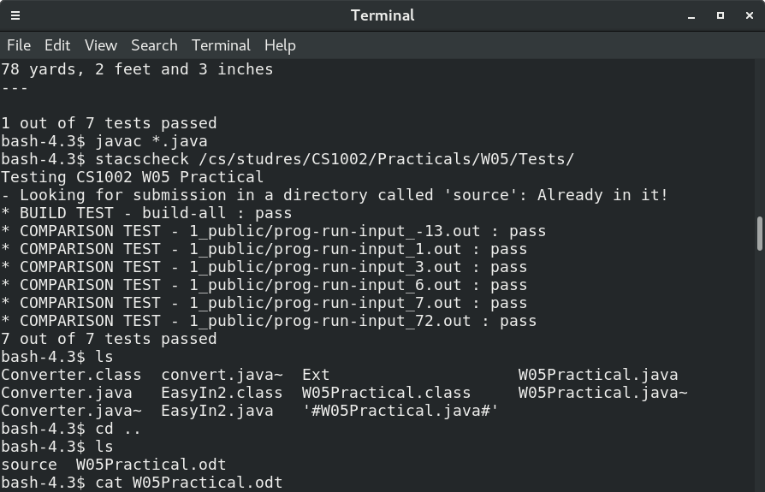
and however this usually showed more than two answers and this is incorrect. Finally I found what I should do and finished step by step.
At the beginning of the program, Initially I want to use a private method called:
private String name()
How ever I can’t return String with
return String;
So I changed it to main class without method.
In W05-Practical, This was used to call everything and is the key programme which is brief but important. This cannot be changed or the programmes will unable to run. I put EasyIn in this programme and called converter to calculate.
Test:Before using stacscheck I tried 1, 0, -1, 0.5, 99999999999999999999999999999999999999999999 and it gives out correct words back.
I still disagree with during input number is 7 and the result should be 2 feet that it’s not a good idea and 11 inches and 1 foot might be better.
Stacscheck is correct as following:
and I think I should limit the number users input that the number shouldn’t be too big.

Questions:
1.In this practical you had to write conditional statements
—
explain why you chose
to use the particular conditional statements that you did.

Well. If command is used to decide where to use one command and where to use another command. With if command I can decide which unit I use(eg. Foot/Feet) and what output should I use.

2.Explain why you think that the number of tests you submitted as output is
enough to indicate
that your program satisfies the specification.

Double is big enough and it conclude different kinds of number such as 0.1, 0 and so on. I only need to calculate its max number and special number.
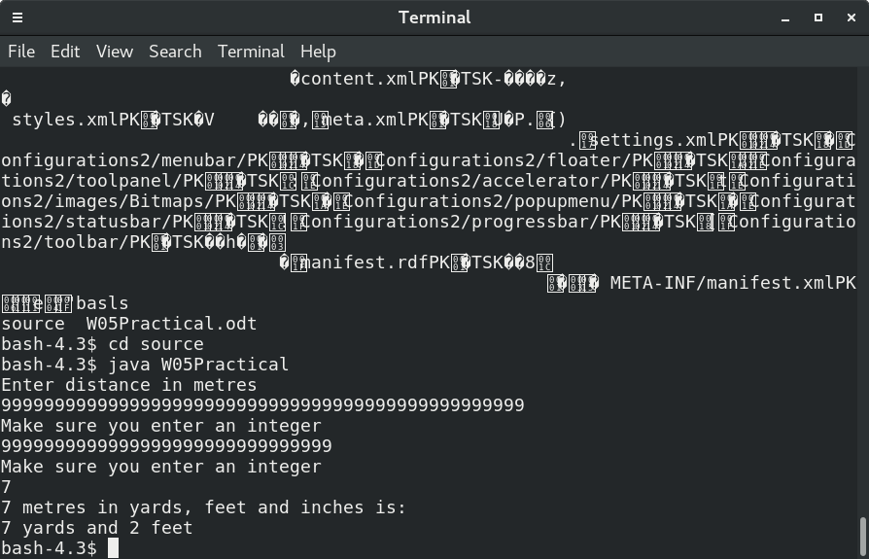
If these are correct and the program is totally correct.

Evaluation:
Confident and surely success.
I have added comments and make everything clear. I think with the extension I can reach at least 19.0;
BTW: I don’t think my last programme is only worth 16.5 score.

Conclusion:
If command is one of the most important command during programming. With the use of if command I can decide which unit and what output should shows to users.
I have faced with a lot of difficulties and finally everything has to be alright. Actually I found that if can solve loads of questions we are facing and with the help of google, I finished this programme which is too hard but is one of the stage I have reached to.
I will try for and while loop after this report and I think extension can be also satisfied.

Extension:
Finished choice part
Finished metre → others
Finished yard → metres
Unfinished Foot → metres
Unfinished Inch → metres

