CS1002 W03-Piratical 170025298 Tutor:Alice Toniolo Date: Nov 3rd
Overview:
Welcome to my online banking.
Well, this is the program that similar to online banking and I have tried my best to make UI as beautiful as possible. If The grade is less than 19.5 and I will even cry QAQ
So let’s start with the design:
Design:
This program contains 4 classes:
-EasyIn2
-Customers
-System Date
-Main class.
Customer contains setter and getter, is used to set the information of customer.
System date is to show the system date for sure
EasyIn2 for input
and Main class contains UI and switch case.
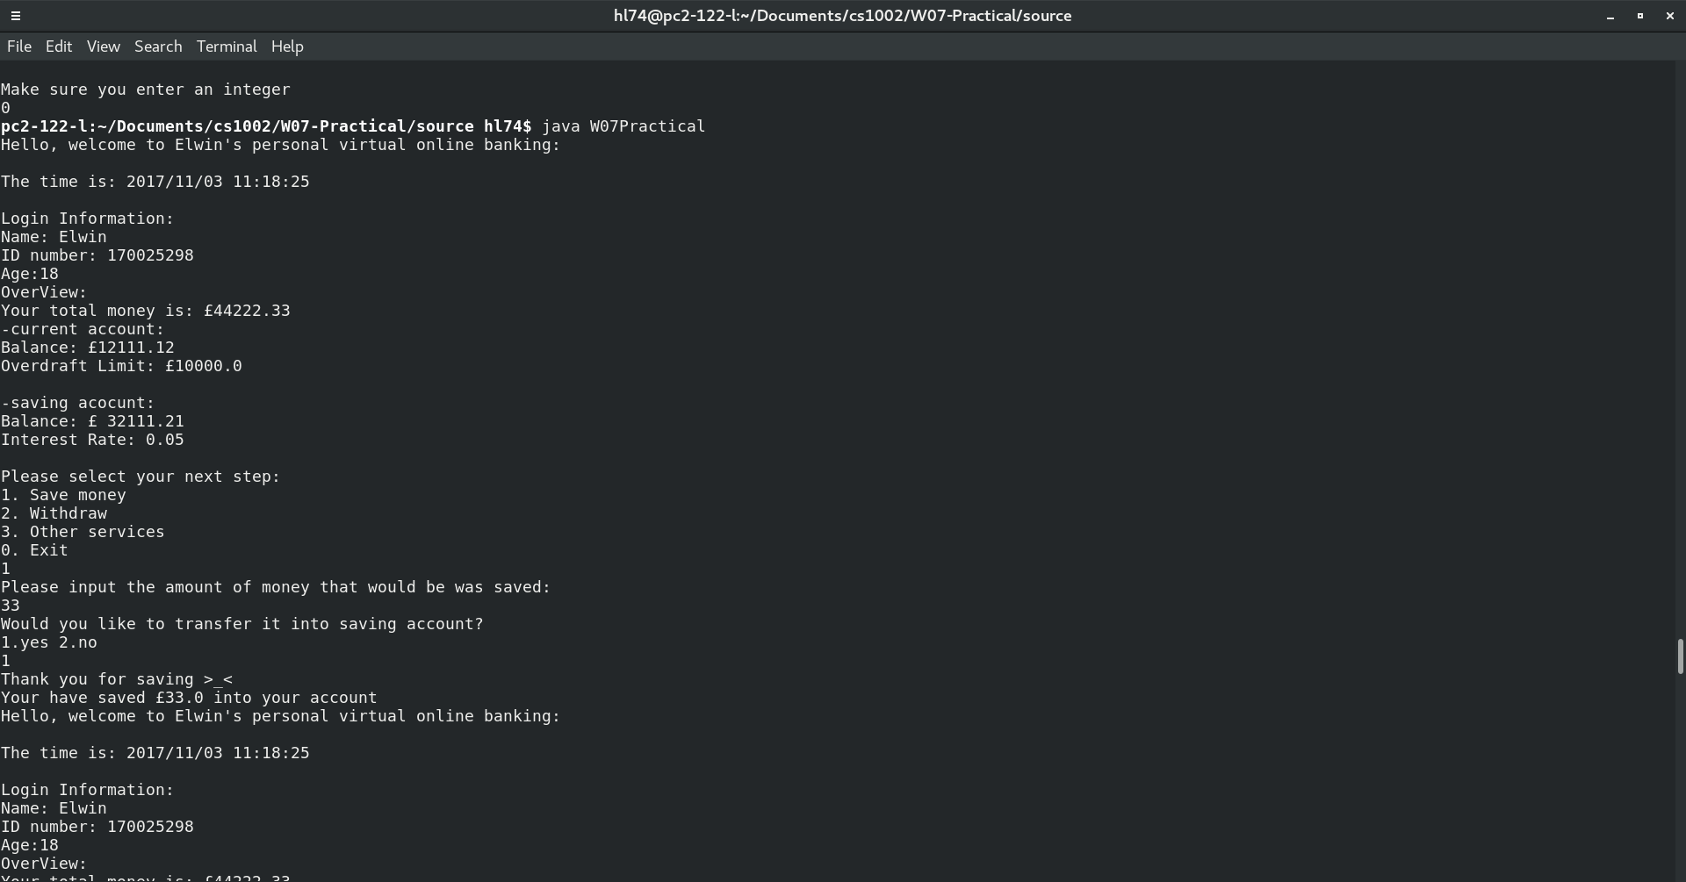
This is the UI of my program and it contains 3 features:
Save , withdraw and other services. In the save case you have to input the amount you want to save
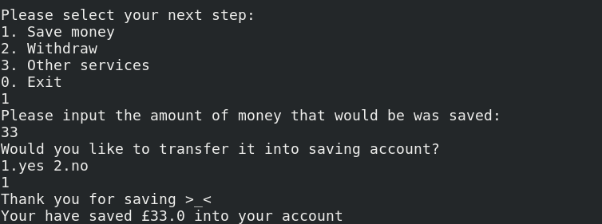
After you save money and you will be asked whether you are going to save money into saving account.>_<is a face that is cute!

Withdraw contains if command for judge whether your money is enough. If it is enough you will get “succeed”
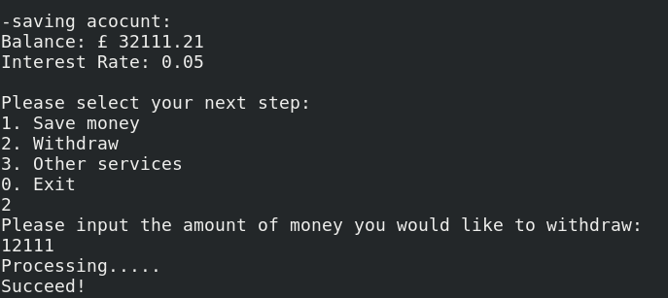
There is an over draft limit to the account and it can also be used

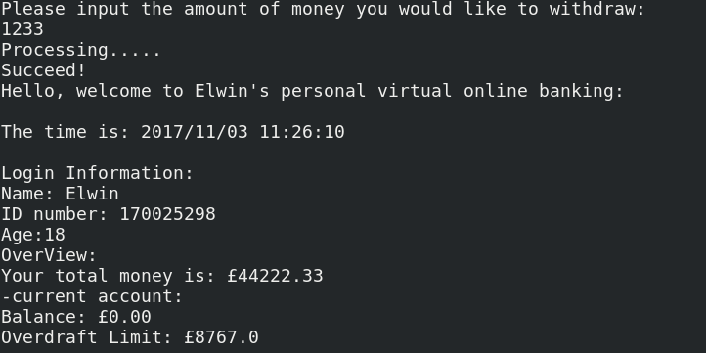

3. Saving- balance transfer:

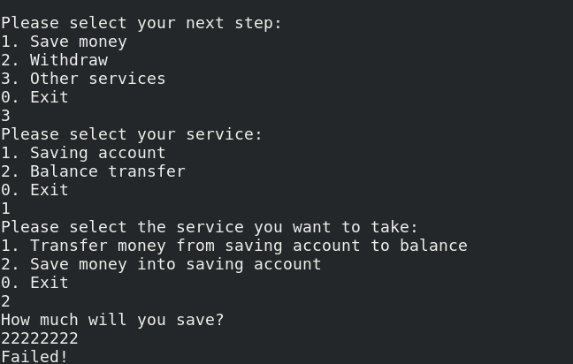

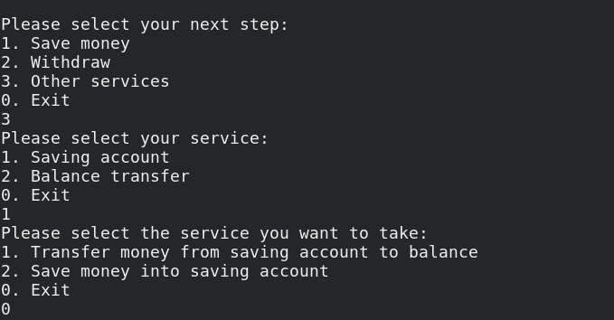

This is used to transfer money between saving account and current account. However, you can’t use overdraft to save.

-Test:
The following is the test result:

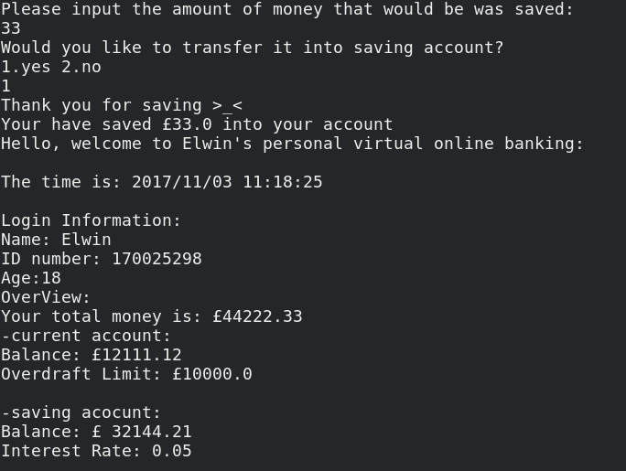

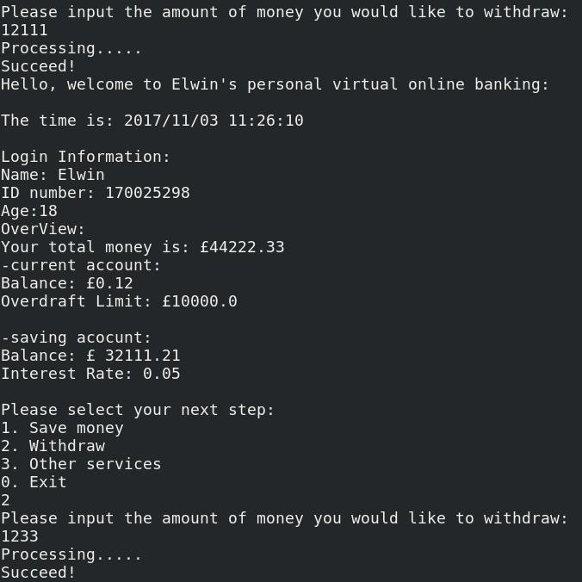

These are the result of each actions and you can see that from the change of saving account and current account.

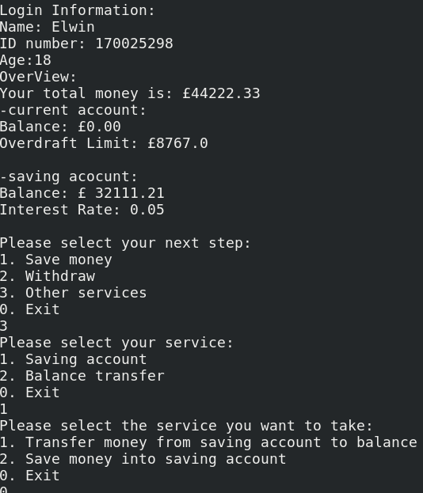

And 0 can exit the program.
Question:
We need only to set two account for saving and balance and that would be ok.
As for customers, We can set some method and save their informations in it so that all their informations can be set. If I have a data base and I am able to transfer money to database for each customers However I don’t know how to do so.
Evaluation:
I think as for UI and functions, this program should gain at least more than 19.5.
If anyone’s program is better than me and please tell me. I will try to make my program better.
I want grades OTZ
Conclusion:
I am quite curiosity about how to save data in database or XML.
Well, I used double to make sure that customers could save money big enough. However, obviously, we can’t make the number too big OR it will print like 1E+12 and so on.

