CS1003 W03 Practical 170025298 13 Feb 2018
Overview:
This practical mainly aims at testing and exercise read and write from .csv file and learn to use BufferedReader and PrintWriter method, which can also be concluded as try to read and write from files. This report figure out the process of programming W03- Practical and the the design of this program. Testing and example of the program runs will also be contained. At the end of the report the evaluation will be conclude and evalued.
Note have been made properly in the program.

Design:
This program contained 3 classes. They are:
Main class
Read and write class(RW in program)
protector(For security)
In the main class, only the direction to rw class is contained. RW class contains 6 methods, which are:
Access – void:
This method is the most important part of the program, which is used to access to the csv file and re-write the data into .txt file. Try and catch are used in this program to throw FileNotFoundExcption, IOexception and ArrayIndexOutOfBoundException. In try and catch command, these has been wrote the replaced message :
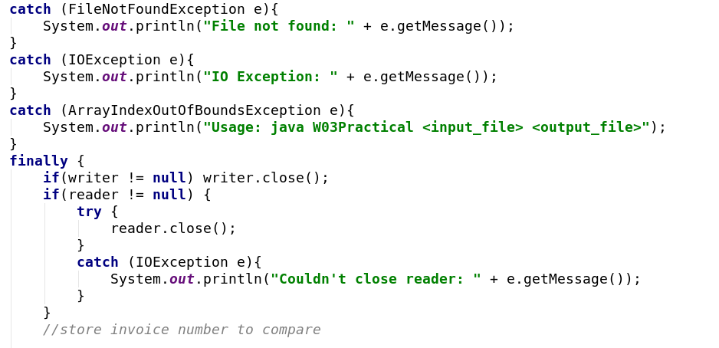
Decimal format package have been imported before class and this class is used to control the decimal number into two. Args[] has been write to the parameter of this method to fit to the main class.
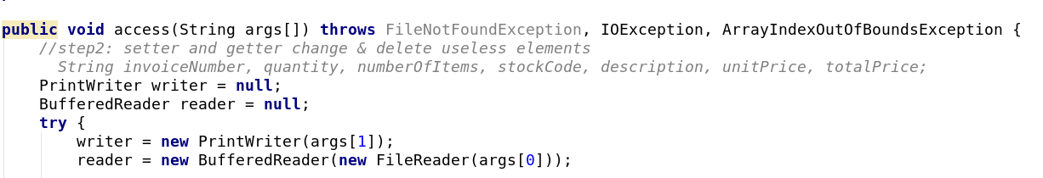

Two argument is organised in this way.

The title of .csv file is only be read but not wrote to the document by readline() the title. Data is split by line.split(“,”) and the detail is at the follow:
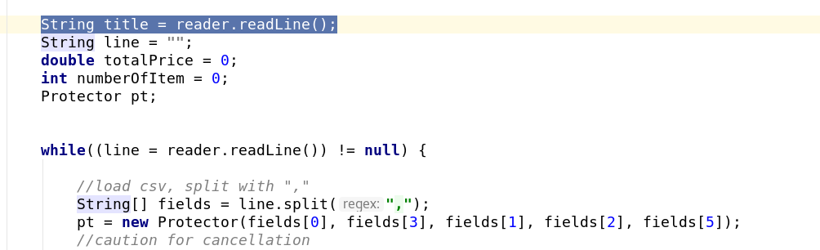
compare-boolean
Compare method is for compare whether two methods are the same.
pre_InvoiceNumber
This method is to store the previous invoice number
totalUnitPrice-double
This method is to calculate the total unit price
getMax/getMin-void
This method is use to get the main data from the csv via compare
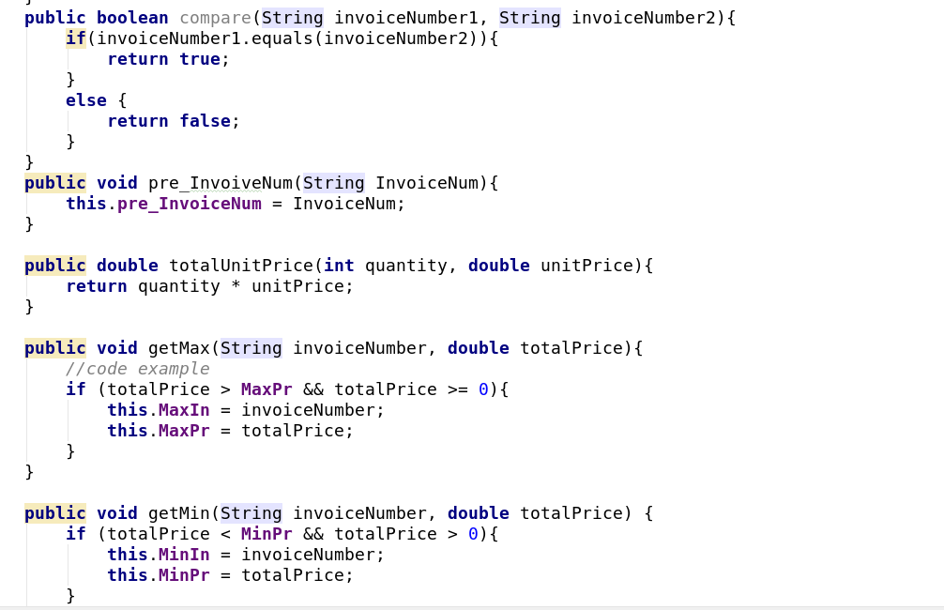

Testing:
Stacscheck:
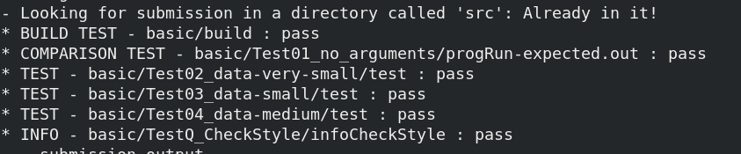

while file not found:
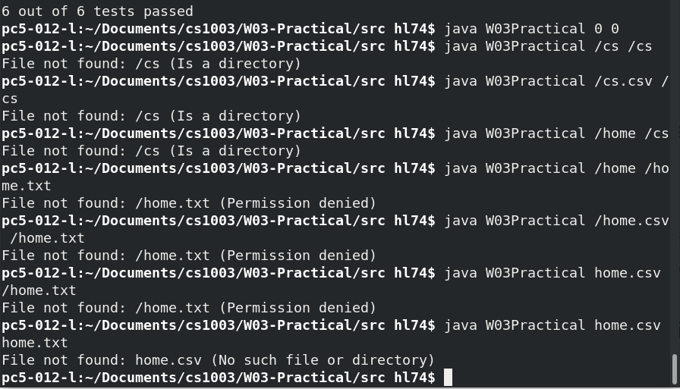

While using wrong format file:
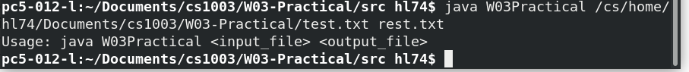

while using wrong fomat data:

Test end.

Examples:
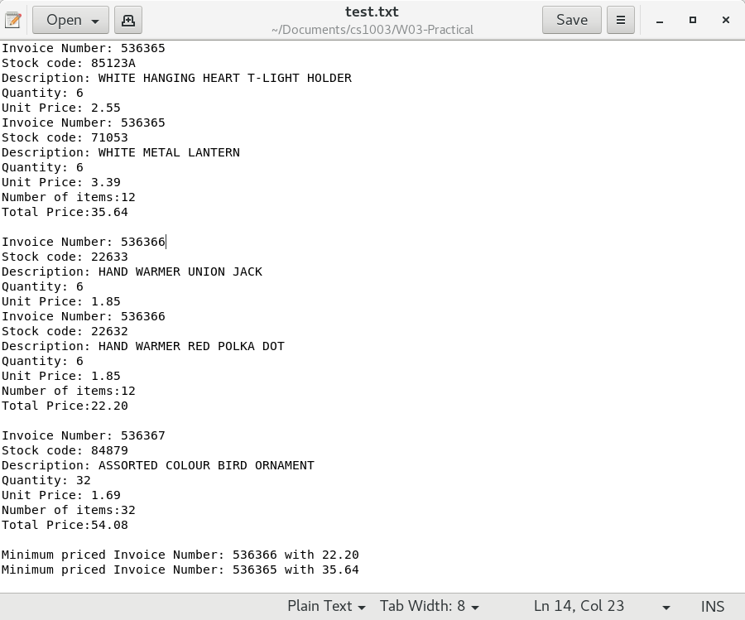

This is the screen shot from data_very_small.csv the program runs well and good to use.

Evaluation:
To make the program be more secured, the data of the total number and total price should might be saved in protector to keep the data safe.
List command might be used to make the data be read and save and change and finally write.
From stacscheck, @ should be use to make the java comment and I will repair the formative issue as much as possible before hand in.

Conclusion:
The program is well organized and works well. Structures of the code is also good organised.
New knowledges have been used properly and knowledge from last semester has also been reviewed. Comments has been used well in program and method has been used properly. As for this result, it is detailed and every steps has been finished, there might be some grammar mistake but after all, My report should be good enough. Extension will be wrote in report soon.

Tips: Invoice Number of 536463 and 536400 have same total price from stacscheck in data-small.csv
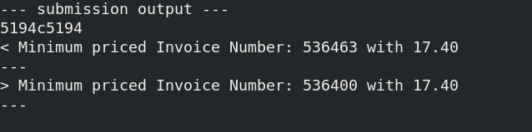

Extension:
1. cancellation: All of the invoice number started with C, C have been deleted and this will not be concluded in both number of invoices(Extension 2) and the number and total price will be 0 in this trade.
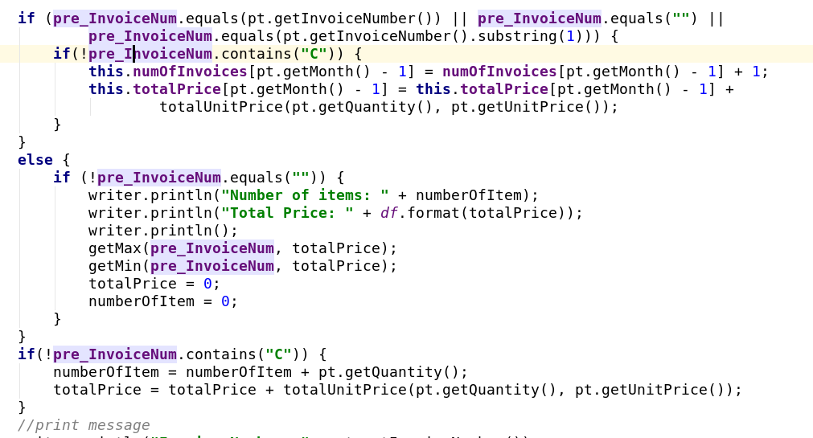
2. I screen shotted the picture from webpage and the data is from data-medium2.csv. The program is available to divide data by month which is achieved by array:
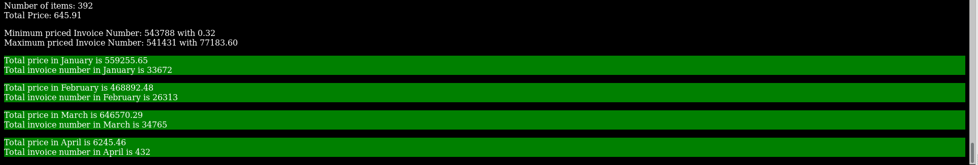
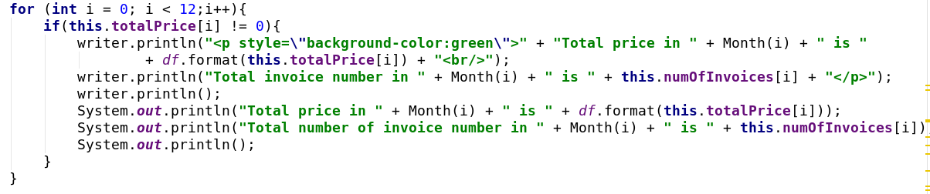
3. I use writer to write the html and I can't really tell how do I do this, but the detailed program is like followed:
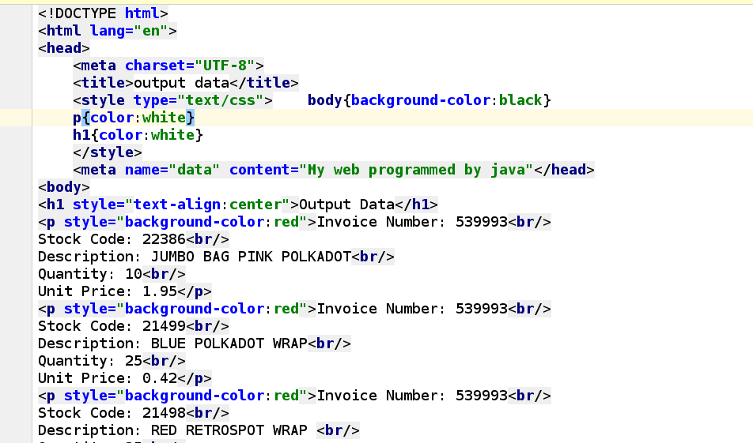
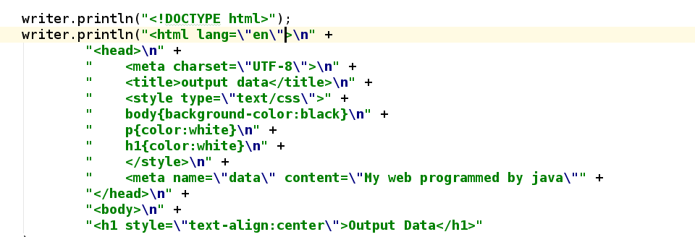
I use print writer to write the code into html file and create a new html code and the appearance is like follows:
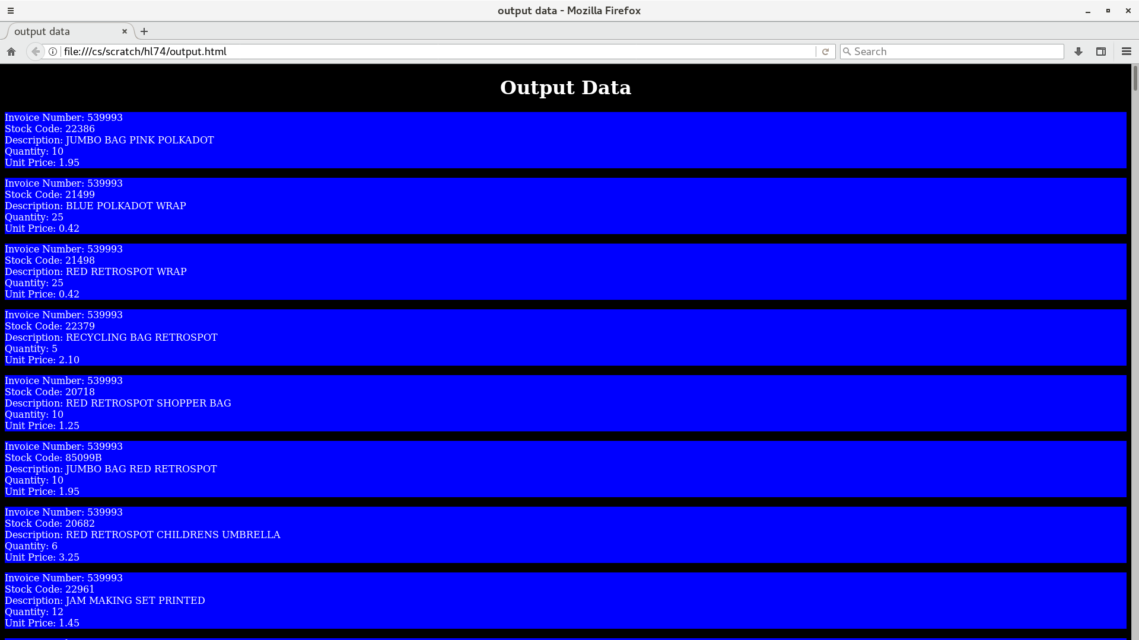

These are all extensions I write and Thank you for looking at my report.

