CS1003 W05 Practical 170025298 22 Feb 2018
Abstract:
This report about week 5 practical that aiming at show the similarity of input arguments. The similarity with be shown as jaccard index and will shows as format:
“jaccard index” + “Result”

There are 2 classes that provided in practicals, I added W05-Practical and changes mainly available at ScoredResult.

Design:
W05Practical class is the main method, this method throws IO Exception and its sub-Exception File not found exception. I used if command to make sure that there are 2 arguments available. If not, the program will return Usage.
Try and catch is used to prevent error that might happens when there is no such file or java issue. The error will be shown to tell users where was wrong.
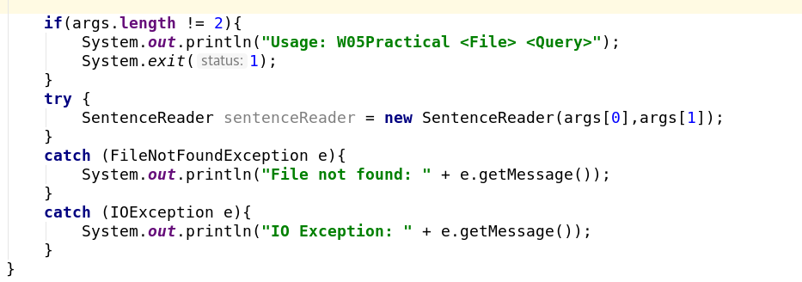
Scored result class haven’t changed.

Main changed happened in Sentence reader class: One constructor has been add and 4 methods have been added. Parameter provided by practical has deleted in readAllSentence method and all methods have been set to private.

-list: readAllSentence():
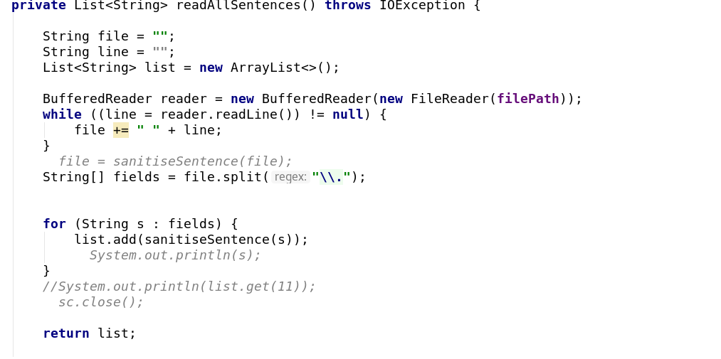
This method uses buffered reader to read all sentence from file. I was eager to use scanner but I found that it’s a little bit hard for me. The similar condition happens to me while using buffered reader method: to split “.”, I am required to use “\\.”, this gave me a lot troubles but have been dealt by teachers’ help.
The design of this method is to put all the text in a String and split it as arrays. All elements in the array will be added into the list and will be called by scoreCalculate method.

-List: Biagram():
This method uses substring to divide the word by using for loop.
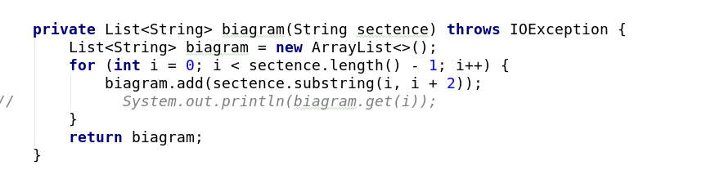
The biagram will be returned as lists.

-List: Score Calculate:
This method aims at calculate the score by using biagram method. I putted the design in java doc as following
There are orders in list but there is no order in set.
* While comparing the biagram, I put all the sentence in the list but put the biagram into sets
* Then I compare words between two sets
* The result is like the following
* One thing puzzeled me a lot is sanitise and I have been stuck in it for a long time
* I ignored to sanitise the input word and caused a lot of mistakes
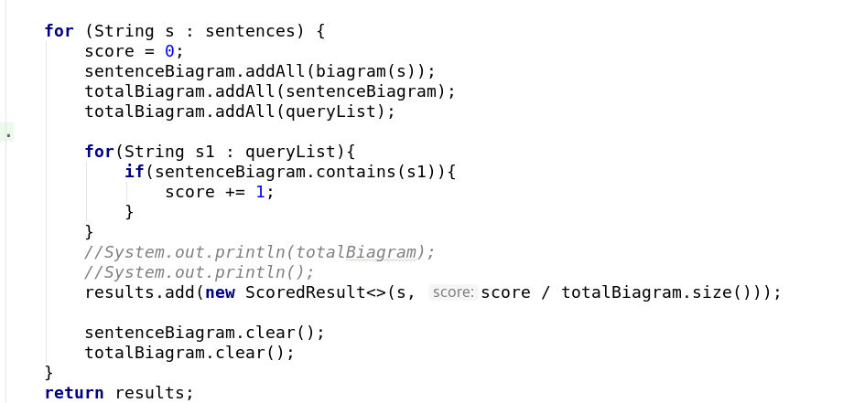
For loop is used to calculate the jaccard index.
-void:showResult():
Because of the decimal is required in 4 decimal number, I use Decimal Format to do so. To prevent there might be text have less than 50 “.”, result().size and if is used to prevent it
To make the accuracy, I set the rounding mode as halp up to make the decimal upper 5 will be up to 10
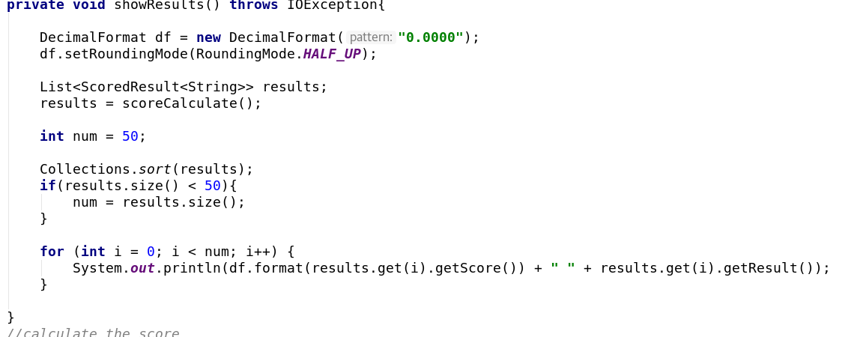
At the end of the method, System.out.println() is used to print the message.

Testing:
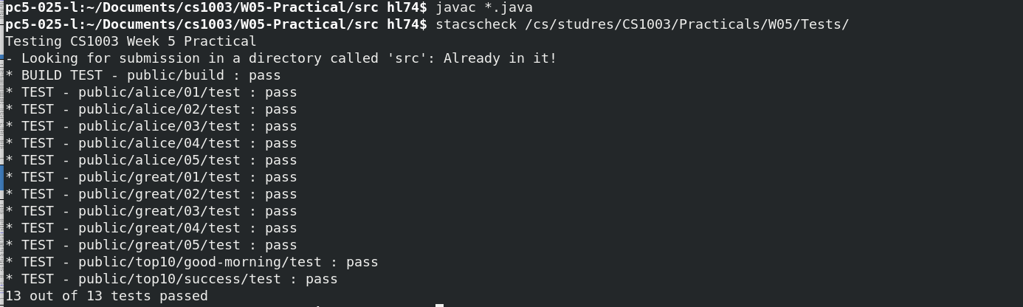
Stacscheck have passed and I have also used argument as alice to test “alice.txt”

Evaluation:
I think I have programmed a neat and tidy code. Methods are used closely and codes is much lower than I imagined. However, scanner might be a better way to scan the “.” in text and buffered reader might increased the working hardness and made the time of reading file longer.
Some new classes might be added to lower the method in only one class.
I am unable to understand the compareTo method in scored result method.

Conclusion:
During the process of programming the program, many difficulties have been met such as the lower-case and upper-case of query and I should be more familiar to programming. However, but check the program once and once again and compare it with expect output in practical in studres, All drawbacks have been solved and I have finally done well.
If I could gain more time, I will try to add some functions such as scan the file automatically or make the result outputted into file.
In conclusion, I think this is a success program.

Extensions will be made and will be reported at the following page:

Extension 1: n_gram choice:
This is the first extension that make people can choose the number of n in n-gram.
Input stream reader is used to achieve the goal:
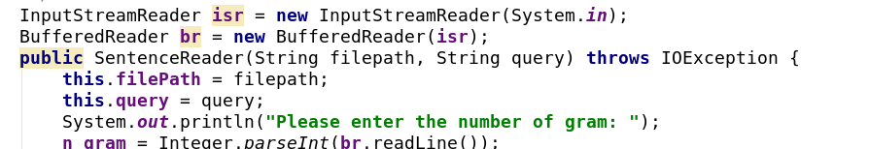
The value of n is given in constructor and is called in biagram:
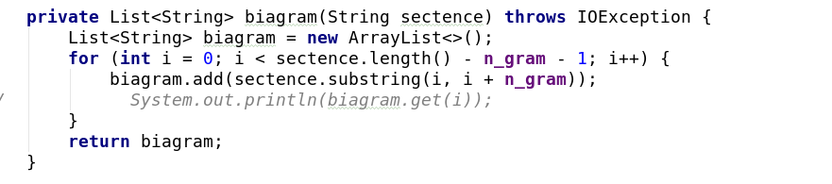
Extension 2: word based choice:
This Extension uses scanner to achieve the goal.
Because the word is divided by space, I use scanner to divide all the word with space.
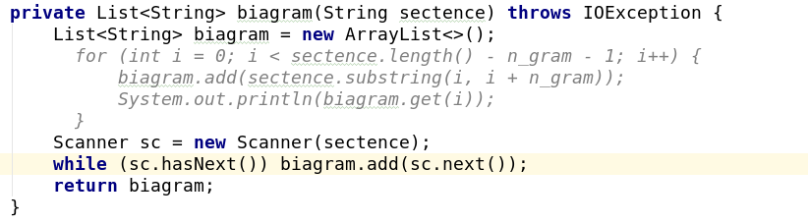
The result is as follow:
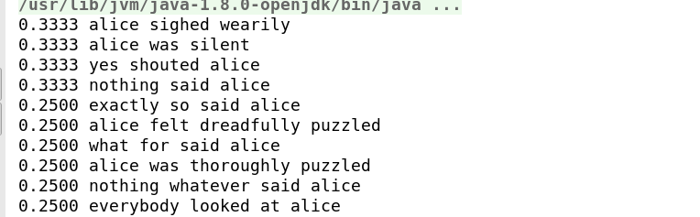
which uses alice.txt in practical and the second argument for “alice”

Extension 3: search multiple file with one one query
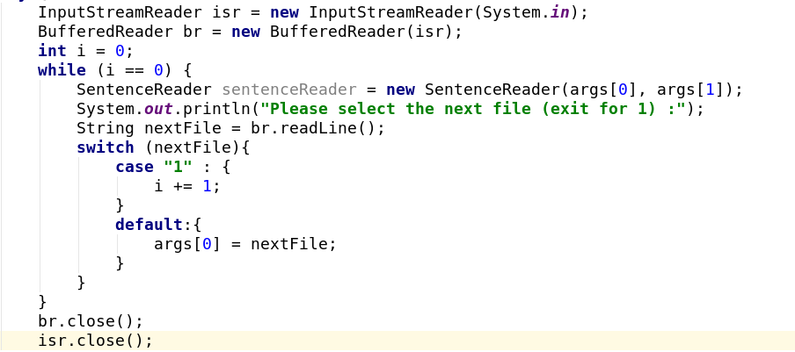
As you can see from the picture above, there is a switch that was created and to replace the argument.
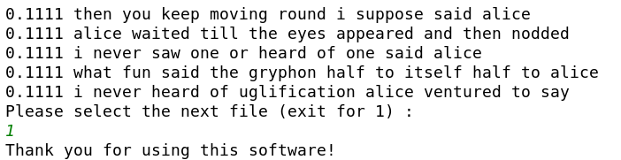
While input 1 , the program will exit with polite System.out.println();

Thanks for looking at my extensions!

