Report for W11-Practical
CS1003 W09 Practical 170025298 25th ,April 2018

Overview:
This practical uses Hadloop to map all the data and reduce it to count how many times the urls apperaed. In my practical I added one JsonRead class and changes some in main class and mapper class. The changes will be shown in design part.
This practical have several extension in extension folder and the basic program is W11Practical.

Design:
ScanWordsMapper- map – void:
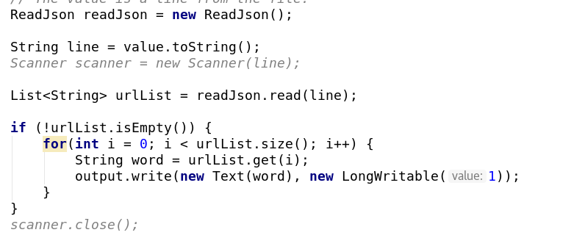
I found that the previous code does not fit to my expectation so I change the code as above:
Because the list return may empty, so I putted output only available when the url list does exist.
This method uses list the provided by ReadJson class which is a list that contains the elements that needed. For loop is used for get all the elements in this list.

ReadJson – read(String input) – List<String>

This class read Json file that provided by mapper and it uses JsonReader API to read the Json line. Because of the nullable url and expanded_url, So I uses judgement to judge if it is null to prevent null pointer exception:
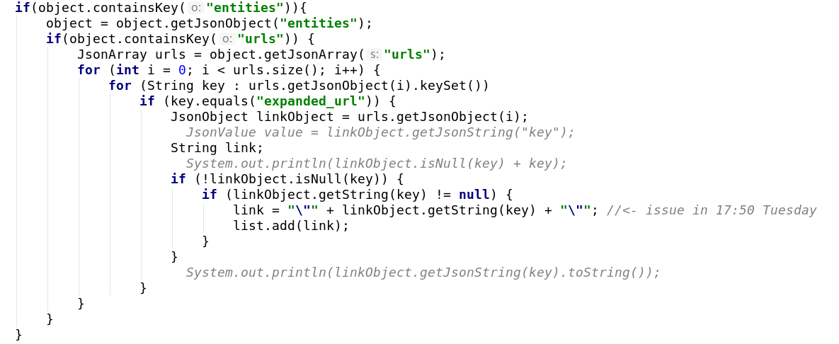

Main:
Map reduce area is not changed but I found that the hadloop may return file exist when files are available. So I add file.delete to prevent it:
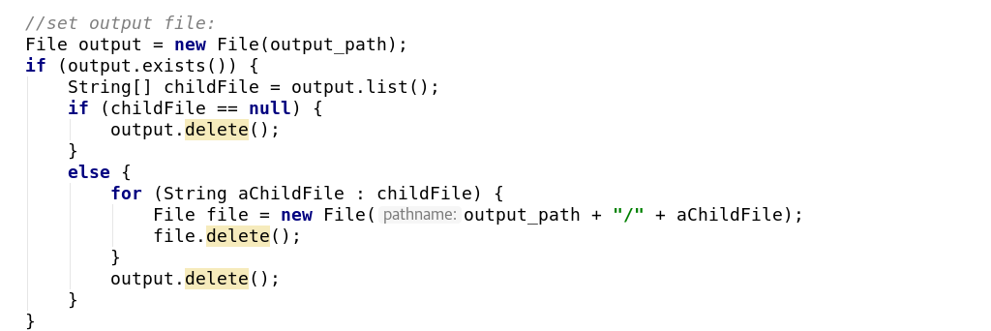

Testing:
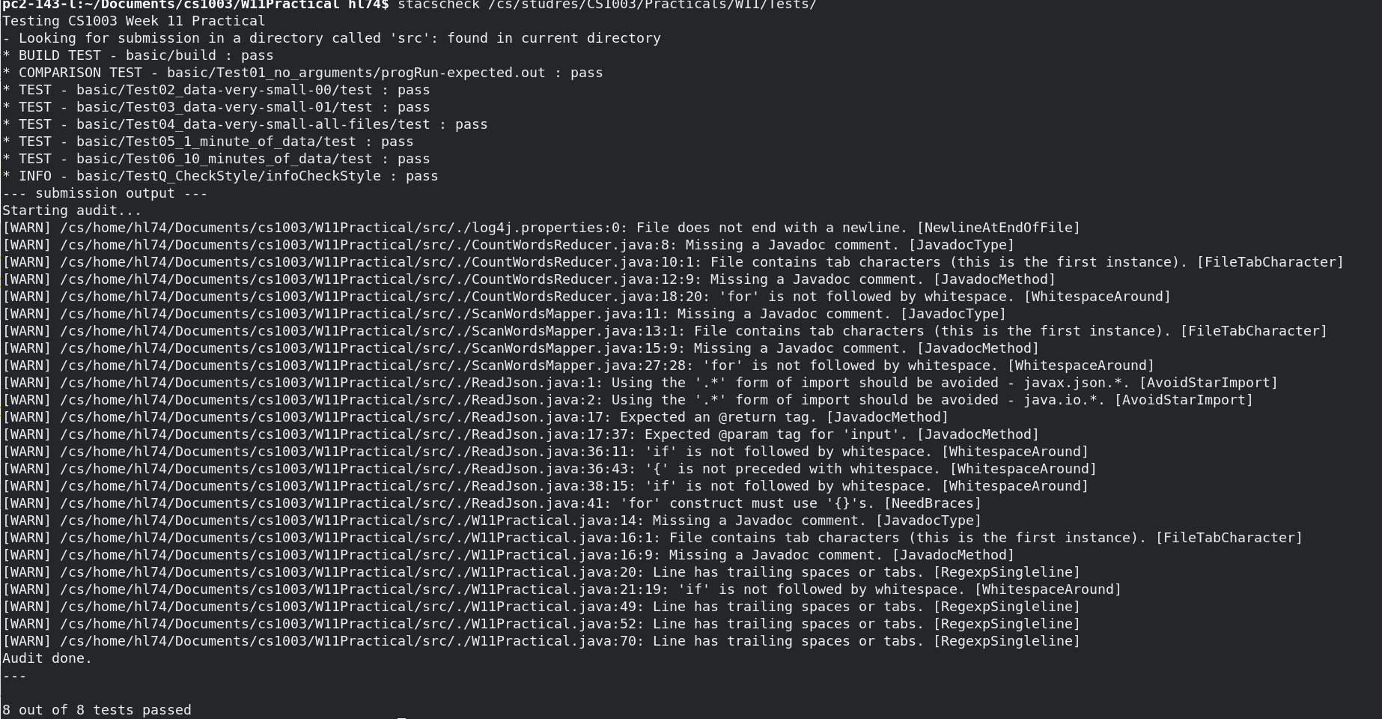
8/8 tests passed.

The hardness happened when I read Json which returns null pointer exception, My classmates asks me to use try and catch to prevent Null in ReadJson, but I found that the exception happens as a result of null in url arrays
I have done several in-program tests such as I test whether the object is null in ReadJson class, which alert me to add if(object.isnull) to prevent the object is null condition.

Examples:
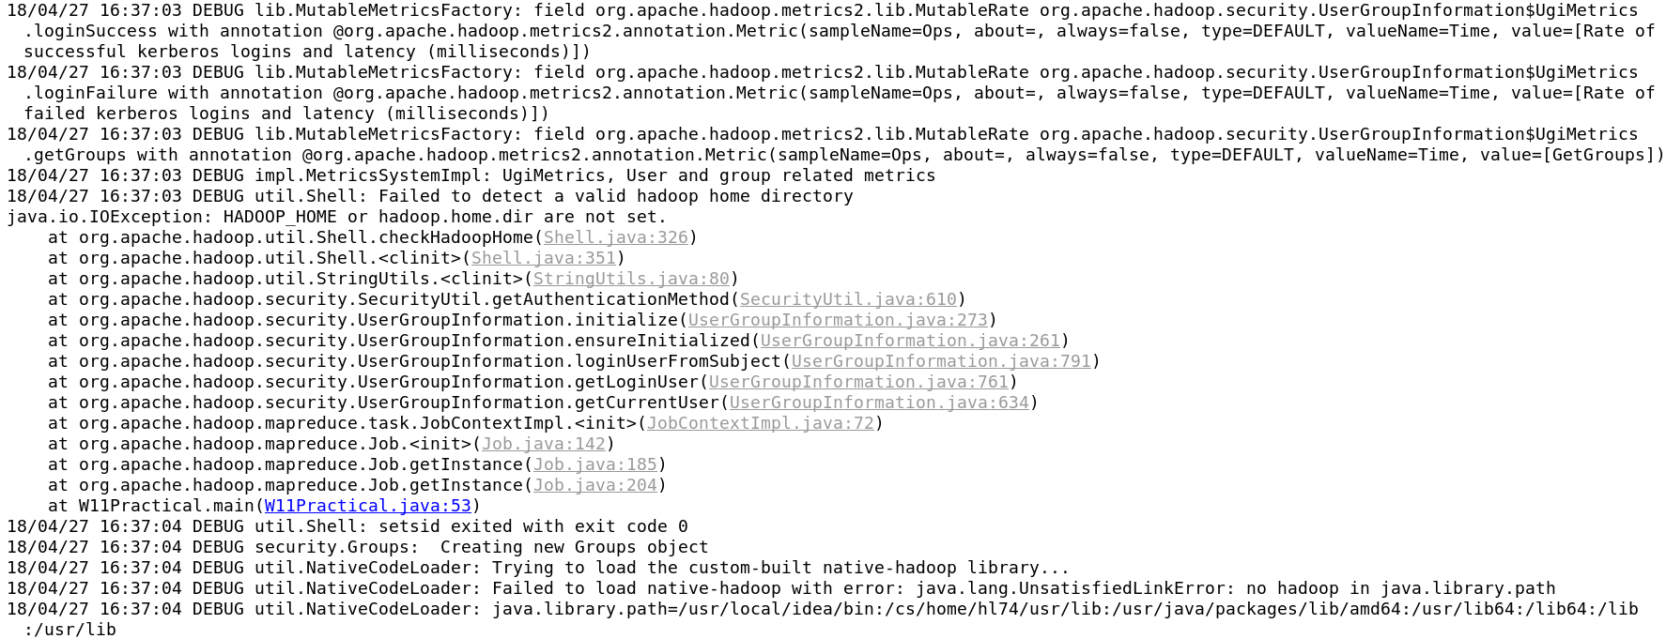
I don’t know to to show the example of this because all of these are hadloop running process. But as you can see, there is an exception occurred that I don’t know where it comes from.
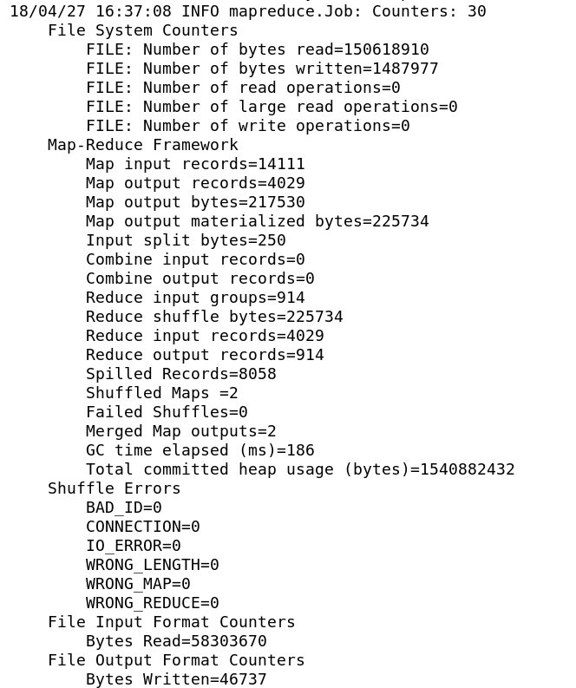
This might be an running example with the argument:
/cs/studres/CS1003/Practicals/W11/data/1_minute/00.json output00
and it returns the result like above.

Evaluation:
Here is one exception occurs in my program but doesn’t affect running:
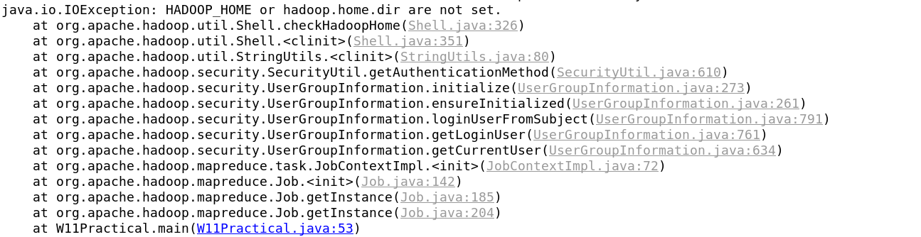
I haven’t get rid of it and have no idea to solve it. This is the only thing that I failed and others I did should be all fine.

Conclusion:
This program teaches me about how to use hadloop to map the data and reduce them. In this program, I studied about how to map the data and reduce it, I have also reviewed about how to read Json file. I have also learned from readJson file that in order to red the file, Read from top to bottom is neccessary or it may return exception that get in the way of running program.

Extension 1: Most popular tweet:
Design: Initially I want to use another map reduce to do it, however after I read the file I found a good way to do it which is like the following:

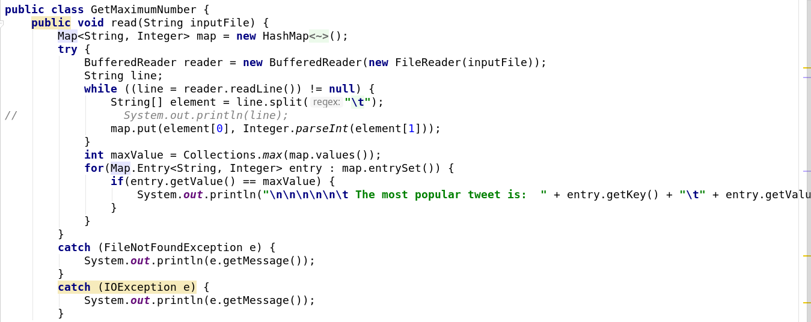

Because that there are only two elements available in the output file, I can use line.split to split the data and then use map to get the maximum data of it.
The drawback of this method is that I can’t get the associated users to this tweet.
The result of this shows as follows:

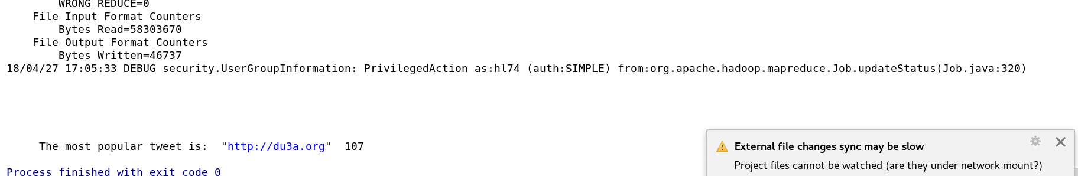

Extension 2 : reorder

This extension uses similar method as the method before. The extension uses buffered reader to read from output file and export it by using print writer and output as the txt file which shows like this:

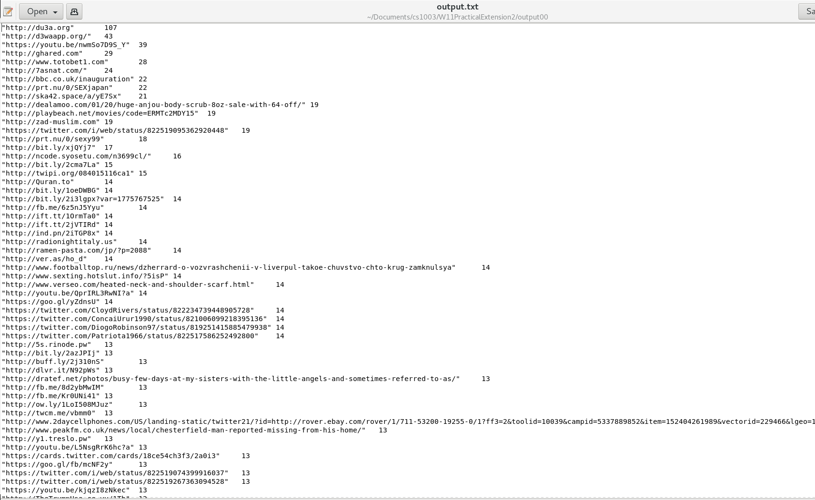
The program uses ArrayList and uses collections.sort, which compare is overrided in Tweets class implement compareable package. I got this idea from previous practical and uses it this time.

These are all extensions.

