Week 3: JUnit and Test Driven Development
170025298， Michael Weir， 30/09/2018

Section 1: Overall description
This project is used to create a map of loyalty card which contains functions of register and unregister users, process money using or without using points, get total amount of users and get total amount of points, and it can get the most used user. With TDD and all functions above will be tested to make sure that the program is able to deal with all of operation. As there are three possible exceptions: point is not enough, user is unregistered and user is already registered, these three exceptions will also be test.

Section 2: Design
#2.1 Functions

2.1.1 Register owner & Unregister owner: these two methods are used to register or unregister the loyalty card owner to the map which has the key “E-mail”. Because of owner might already be registered or when unregistering, owner may not registered, the method will throw the Owner Already/Not registered Exception so that error message will be printed.

2.1.2 Process Money(Points) purchase: These two methods are used to process purchases using money or points. As all values are stored in map using emails as their keys, these two methods will use keys to get the loyalty card information and get related information. If process money using cash, points will be added that 100 pence worth 1 point. If process money using points, the operator will check if these money are less than points that in this account, and then if not the method will throw Insufficient Points Exception than print the message. If points are enough, account will finish this purchase and points will be used. Both process will add one use to the account.

2.1.3 get number of customers & get number of points: These two methods will return the total number of customers and total number of points. In order to get total number of customers, map.size can be a good way to solve the problem. Map.size will return the size of map and return the value. In order to get total number of points, I use for loop to get points information in each accounts and return the sun of all accounts.

2.1.4 get number of points & get number of used: These two method uses the method in loyalty card:
2.1.4.1 In loyalty card class, number of points and number of uses will initially set 0, in 2.1.2, when the card uses money or points purchase, uses will always add one. Numbers and points will be returned and will be able to get.
2.1.4.2 In loyalty card owner class, get email and get name will return owners’ name so that e-mail can be the key of the map to search the accurate data.

#2.2 Tests
2.2.1 loyaltyCardCreationNonNull() & loyaltyCardOwnerCreationNonNull() will create the test to test loyalty card owner and such loyalty card can be successfully created with the result not null.

2.2.2 loyaltyCardOwnerInformationNonNull() & loyaltyCardInformationNonNull() will create the test to test information inside of the map can be successfully retrieved.

2.2.3 loyaltyCardInformationRetrival() will test information such as owners’ e-mail and name can be successfully retrieved and loyalty card factory can successfully create the loyalty card with correct information such that e-mail can be made as the key of map to store data.

2.2.4 mapDoesExistTest() will test the map is successfully created and informations will be stored in map. However in formal situation information can be stored in database and map can be replaced.

2.2.5 loyaltyCardInformationStoredInMap() & loyaltyCardInformationInMapRetrival() will test information stored in map can be successfully retrieved and number of customer will comes to 1. Hence then specific information can be retrieved such as number of users and number of uses and number of points that fits expect.

2.2.6 functions test: loyaltyCardOperatorTest() and loyaltyCardOperatorPointsTest() will test all functions in loyalty card operator such as use and get points and unregister owner

2.2.7 Exception test: this will test the junit test will print exactly error message when exceptions happens such as insufficient points exception happens, true exception message will print on the screen.

2.2.8 points purchase test: This will test number of uses will be added when points purchase are being processed

2.2.9 money purchase test: This will test points are not able to add to a null map so that exceptions will be thrown

2.2.10 no user to get most used test: this will test no most used users will be found when there is no users in system

#2.3 Edge test
2.3.1 Loyalty Card test: These tests will test all functions can be normally used and initial values are 0 as java doc described.

2.3.2 Loyalty card owner test: These tests will test name and e-mail will be successfully retrieved from functions.

#2.4 Extension
2.3.1.1 monetary: addCertainPoints() allows operator add certain points.
2.3.1.2 monetary test will test certain points will be added to exact account.

2.3.2.1 points transaction: allows user to make points transaction between accounts and when points are not enough, error message will be printed that shows no enough points available and shows current points.
2.3.2.2 points transaction test will test points in two accounts are successfully transacted and when there is no enough points, error will be printed that shows current points error message.

Section 3: Stacscheck result
Notice: Loyalty Card Owner Test and Loyalty Card Test are not contained in stacscheck with unknown reason.
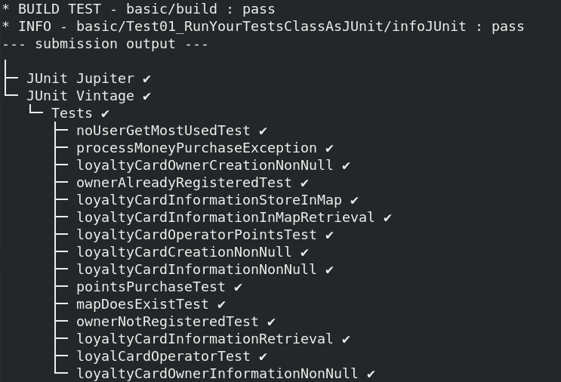
All checks passed with stacscheck and error messages are successfully printed
Section 4 : improvement & Conclusion
This practical is the overall well finished practical but I think some code can be improved:
For the operator class, information of loyalty card can be stored in comparable Collection so that further programming will be more likely to be finished.
Some code style in stacscheck style check should be improved.
Next step I will try to program GUI as extension 3, as this might not be easy for me and I will try to do it.

