|  |  |
| --- | --- |
| **Experiment Number** | WEEK2 LAB - 2,3 |
| **Date of Experiment** | 17/12/2024 - 18/12/2024 |
| **Date of Submission** | 21/12/2024 |
| **Name of student** | DIVYANSHU KUMAR |
| **Roll Number** | 2230441 |
| **Section** | ECSc-2 |

# Title of the Experiment:

Operators in Java

# Aim of the Experiment:

1. To learn writing, executing and debugging programs related to basic I/O functions.
2. To learn writing, executing and debugging programs related to arithmetic operators.

# Programming Language used: “JAVA”

* Problem Statement & Solution:

1. Shows the console input-output of the program.In this program, all the assignment operator statements.

SOL:-

public class java6 {

    public static void main(String args[]) {

        int a = 50, b = 60, x = 30, y = 30;

        boolean L, G, LE, GE, E, NE;

        System.out.println("a =" +a);

        System.out.println("b =" +b);

        System.out.println("x ="+x);

        System.out.println("y =" +y);

        System.out.println();

        L = a < b;

        G = a > b;

        LE = a <= b;

        GE = x >= y;

        E = x ==y;

        NE = a != b ;

        System.out.println("a < b is " + L);

        System.out.println("a > b is " + G);

        System.out.println("a <= b is " + LE);

        System.out.println( "x>= y is" +GE);

        System.out.println( "x== y is" +E);

        System.out.println("a != b is " + NE);

}

}

1. Shows the console input-output of the program Logical operators are used to construct compound conditional expressions.

SOL:

public class java7 {

    public static void main(String args[]) {

    int a = 50, b = 60, c = 70;

boolean x, y, z;

System.out.println("Name:Divyanshu Kumar");

System.out.println("Roll No:2330441");

System.out.println();

System.out.println("a = " + a + " b = " + b + " c = " + c);

System.out.println();

System.out.println("Working of relational operators...");

System.out.println();

x = (a<b) || (a > c);

System.out.println("(a<b) || (a > c) is " + x);

y = (a<b) && (a > c);

System.out.println("(a<b) && (a > c) is " + y);

z = !(b> c);

System.out.println("!(b> c) is " + z);

}

}

1. Shows the console input-output of the program Conditional operator helps in decision-making. The general syntax of a conditional operator is :

(condition) ? statement1 : statement2

SOL:

iimport java.util.Scanner;

class java9 {

    public static void main(String args[]) {

        Scanner sc = new Scanner(System.in);

        System.out.println("Name:Divyanshu Kumar");

        System.out.println("Roll No:2330441");

        int a, b;

        String largest;

        System.out.println("Enter the first number (a): ");

        a = sc.nextInt();

        System.out.println("Enter the second number (b): ");

        b = sc.nextInt();

        System.out.println("\nYou entered:");

        System.out.println("a = " + a + " b = " + b);

        largest = (a > b) ? "a is largest" : "b is largest";

        System.out.println("\nLargest number using conditional operator...");

        System.out.println(largest);

}

1. WAP in java to bitwise OR operators allow us to perform operations on data at bit-level.

SOL:

import java.util.Scanner;

class java10 {

    public static void main(String[] args) {

        Scanner sc = new Scanner(System.in);

        System.out.println("Name:Divyanshu Kumar");

        System.out.println("Roll No:2330441");

        System.out.println("Enter the first number (a): ");

        int a = sc.nextInt();

        System.out.println("Enter the second number (b): ");

        int b = sc.nextInt();

        int ORresult = a | b;

        System.out.println("\nBitwise OR operation:");

        System.out.println("a = " + a + " (Binary: " + Integer.toBinaryString(a) + ")");

        System.out.println("b = " + b + " (Binary: " + Integer.toBinaryString(b) + ")");

        System.out.println("Result (a | b) = " + ORresult);

        System.out.println("Binary: " + Integer.toBinaryString(ORresult));

    }

}

1. WAP in java to show that a number is -ve or +ve using if else.

SOL:

import java.util.Scanner;

class java11 {

    public static void main(String[] args) {

        Scanner sc = new Scanner(System.in);

        System.out.println("Name:Divyanshu Kumar");

        System.out.println("Roll No:2330441");

        System.out.println("Enter a number: ");

        int number = sc.nextInt();

        if (number > 0) {

            System.out.println("The given number " + number + " is Positive.");

        } else if (number < 0) {

            System.out.println("The given number " + number + " is Negative.");

        } else {

            System.out.println("The given number is Zero.");

        }

    }

}

1. WAP to make a day selection using Switch case.

SOL:

import java.util.Scanner;

class java12 {

    public static void main(String[] args) {

        Scanner sc = new Scanner(System.in);

        System.out.println("Name:Divyanshu Kumar");

        System.out.println("Roll No:2330441");

        System.out.println("Enter a day: ");

        int day = sc.nextInt();

        switch(day) {

            case 1:

            System.out.println("Monday");

            break;

            case 2:

            System.out.println("Tuesday");

            break;

            case 3:

            System.out.println("Wednesday");

            break;

            case 4:

            System.out.println("Thursday");

            break;

            case 5:

            System.out.println("Friday");

            break;

            case 6:

            System.out.println("Saturday");

            break;

            case 7:

            System.out.println("Sunday");

            break;

            default:

            System.out.println("Invalid day");

            break;

            }

        }

}

1. WAP to make a very basic calculator.

SOL:

import java.util.Scanner;

public class java13 {

    public static void main(String[] args) {

        Scanner sc = new Scanner(System.in);

        System.out.println("Name:Divyanshu Kumar");

        System.out.println("Roll No:2330441");

        System.out.println("Enter the first number");

        int num1 = sc.nextInt();

        System.out.println("Enter the second number");

        int num2 = sc.nextInt();

        System.out.println("Enter the operator :- +,-,*,/");

        String op = sc.next();

        switch (op) {

            case "+":

            System.out.println("Addition of two number is " + (num1 + num2));

            break;

            case "-":

            System.out.println("Subtraction of two number is " + (num1 - num2));

            break;

            case "*":

            System.out.println("Multiplication of two number is " + (num1 * num2));

            break;

            case "/":

            if (num2 != 0) {

                System.out.println("Division of two number is " + (num1 / num2));

                }

            else {

                System.out.println("Error! Division by zero is not allowed.");

                }

            break;

            default:

                System.out.println("Invalid operator");

        }

}

}

1. **Write a Java program to print a table of values of the function y = e−x**

**for x varying from 0 to 1 in steps of 0.1. The table appears as follows.**

**X 0 0.1 0.2 0.3 0.4 0.5 0.6 0.7 0.8 0.9 1.0**

**Y**

**SOL:**

public class java17 {

    public static void main(String[] args) {

        System.out.println("Name:Divyanshu Kumar");

        System.out.println("Roll No:2330441");

        double x = 0.0;

        double y = 0.0;

        for (int i = 0; i <= 10; i++) {

            x = i * 0.1;

            y = Math.exp(-x);

            System.out.println("x = " + x + " y = " + y);

            }

            }

}

1. **Write a Java program to find the largest of three numbers using a conditional operator.**

**SOL:**

public class java18 {

    public static void main(String[] args) {

        java.util.Scanner sc = new java.util.Scanner(System.in);

        System.out.println("Name:Divyanshu Kumar");

        System.out.println("Roll No:2330441");

        System.out.println("Enter first number");

        int a = sc.nextInt();

        System.out.println("Enter second number");

        int b = sc.nextInt();

        System.out.println("Enter third number");

        int c = sc.nextInt();

        int max = (a > b) ? ((a > c) ? a : c)

        : ((b > c) ? b : c);

        System.out.println("Largest number is " + max);

        }

        }

1. **Write a Java program to accept a point (x, y) and find whether it lies on the circle or inside the circle or outside the circle. The center of the circle is (0, 0) and the radius of the circle is 5. Equation of a circle with (0, 0) as the center and r as the radius is given by x2 + y2 = r2.**

**1. If x2 + y2 < r2, then the point (x, y) lies within the circle.**

**2. If x2 + y2 > r2, then the point (x, y) lies outside the circle.**

**3. If x2 + y2 = r2, then the point (x, y) lies on the circle.**

**SOL:**

import java.util.Scanner;

public class java19 {

    public static void main(String[] args) {

        Scanner sc = new Scanner(System.in);

        System.out.println("Name:Divyanshu Kumar");

        System.out.println("Roll No:2330441");

        System.out.println("Enter the value of x");

        int x = sc.nextInt();

        System.out.println("Enter the value of y");

        int y = sc.nextInt();

        System.out.println("Enter the radius of the circle");

        int r = sc.nextInt();

        //check whether the point lies on the circle or inside the circle or outside the circle

        if (x * x + y * y < r * r) {

            System.out.println("The point (" + x + "," + y + ") lies within the circle");

            } else if (x * x + y * y > r * r) {

                System.out.println("The point (" + x + "," + y + ") lies outside the circle");

                } else {

                    System.out.println("The point (" + x + "," + y + ") lies on the circle");

                    }

}

}

1. **Write a Java program to find whether a number is an Armstrong number or not.**

**SOL:**

import java.util.Scanner;

public class java20 {

    public static void main(String[] args) {

        System.out.println("Name:Divyanshu Kumar");

        System.out.println("Roll No:2330441");

        //declare variable

        int num, sum = 0, temp, digit;

        Scanner sc = new Scanner(System.in);

        //input number

        System.out.println("Enter a number: ");

        num = sc.nextInt();

        //find the sum of the cubes of the digits of the number

        temp = num;

        while (temp != 0) {

            digit = temp % 10;

            sum = sum + (int) Math.pow(digit, 3);

            temp = temp / 10;

            }

            //check whether the number is an Armstrong number or not

            if (num == sum) {

                System.out.println(num + " is an Armstrong number");

                } else {

                    System.out.println(num + " is not an Armstrong number");

            }

        }

}

1. **Write a Java program to generate a Fibonacci series.**

**SOL:**

public class java21 {

    public static void main(String[] args) {

        int n = 10; // number of terms in the series

        int t1 = 0; // first term

        int t2 = 1; // second term

        System.out.println("Fibonacci Series:"); // print the series title

        System.out.print(t1 + " " + t2 + " "); // print the first two

        // terms

        for (int i = 3; i <= n; i++) {

            int nextTerm = t1 + t2; // calculate the next term

            System.out.print(nextTerm + " ");

            t1 = t2; // update the first term

            t2 = nextTerm; // update the second term

            }

            }

}

# Output:

OUTPUT 1:- OUTPUT 2:-

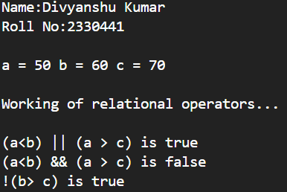

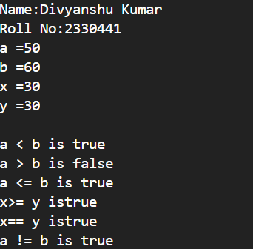

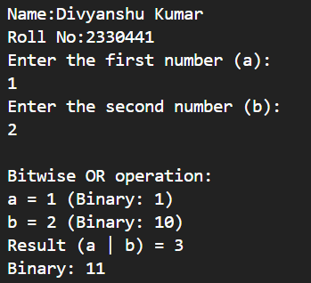OUTPUT 3:- OUTPUT 4:-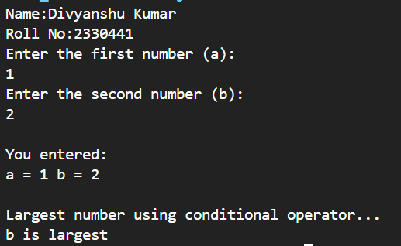

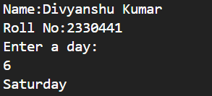OUTPUT 5:- OUTPUT 6:- 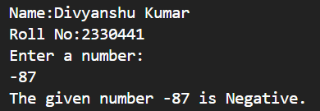

OUTPUT 7:- OUTPUT 8:-

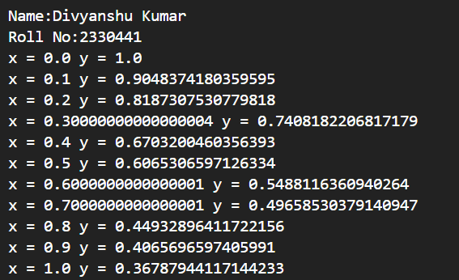

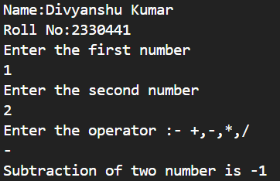

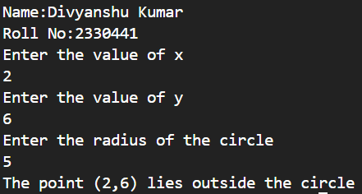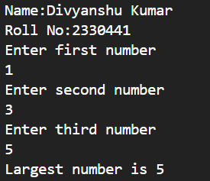OUTPUT 9:- OUTPUT 10:-

OUTPUT 11:- OUTPUT 12:-

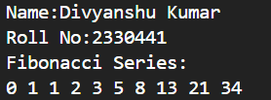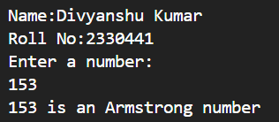

# Conclusion:

Learned to develop and execute basic Java programs .

**Faculty Signature**