Collateral Appraisal System API — RabbitMQ User Setup via the Management UI

RabbitMQ User Setup via the Management UI
GUI equivalent of the offline guide's step A5·5 — RabbitMQ user hardening for the security team
Companion to: offline-installation-configuration-guide.html (section A5, step 5) · Placeholders <RABBITMQ_USER> / <RABBITMQ_PASSWORD> match that document.
Contents
- Before you start (prerequisites)
- Steps (Management UI)
- S1 · Open the Management UI
- S2 · Log in as guest
- S3 · Add the application user
- S4 · Grant permissions
- S5 · Re-login as an administrator
- S6 · Delete the guest user
- Repeat on every app node
- Placeholder glossary

Before you start (prerequisites — read first)
This procedure is entirely UI-driven, but it depends on three conditions being true first. The first is inherently a command-line step and is not something the UI can replace.
Three conditions must hold before the first screen will work.
- The management plugin is already enabled. The Management UI only exists after the Windows administrator has run rabbitmq-plugins.bat enable rabbitmq_management (offline guide A5, step 4). There is no UI way to enable it — the UI is what that step turns on. If http://localhost:15672 does not answer, this step has not been done yet; stop and ask the Windows administrator.
- You are at the server console (or its RDP session), not a remote machine. The built-in guest account — the only account that exists at this point — is restricted by RabbitMQ to localhost. You must open the browser on the RabbitMQ server itself and use http://localhost:15672. It will not accept guest from another host.
- The credentials are agreed. The values for <RABBITMQ_USER> and <RABBITMQ_PASSWORD> have been decided and will be recorded on the deployment sign-off sheet for the application-deploy step.

Steps (all performed in the Management UI)

S1Open the Management UI
On the RabbitMQ server, open a browser and go to the management address http://localhost:15672. The RabbitMQ login page appears:

S1 — the Management UI login page at http://localhost:15672.
Verify: the login page loads. If the browser cannot connect, the management plugin is not enabled yet — see the prerequisites above.

S2Log in as guest
Sign in with the built-in bootstrap account. This is the only account that exists so far, and it works only from the server console (localhost).
Field | Value
Username | guest
Password | guest
Verify: the Overview dashboard appears with a top menu bar (Overview · Connections · Channels · Exchanges · Queues and Streams · Admin).

S3Add the application user
Click the Admin tab (top-right). It opens on Users — at this point only guest exists. Below the user list is an “Add a user” section:
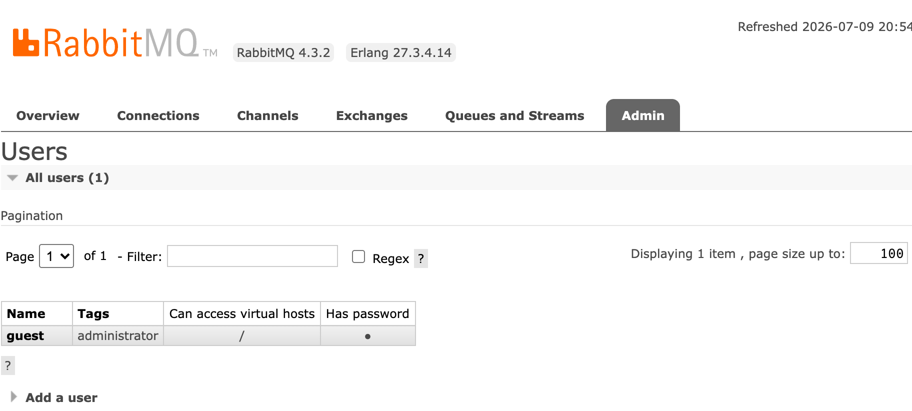
S3 — Admin › Users: only guest exists; the collapsible “Add a user” section is at the bottom.
Expand “Add a user” and fill it in, then click Add user:
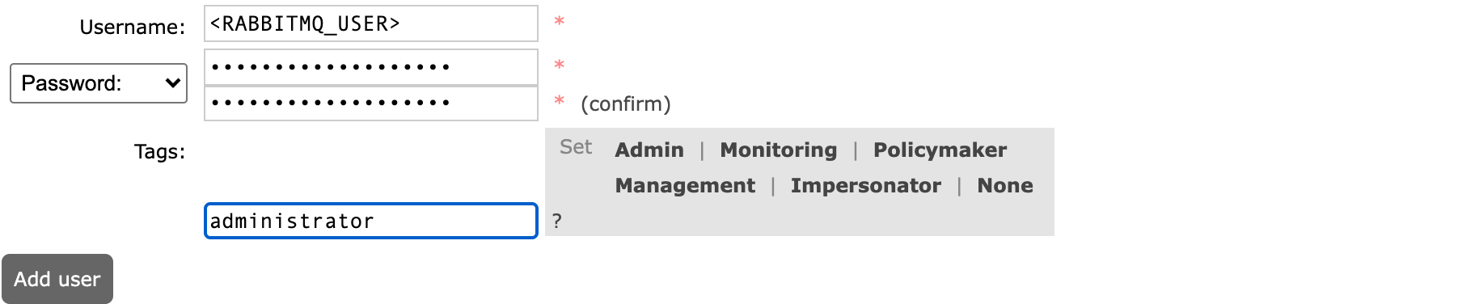
S3 — the Add a user form, showing where <RABBITMQ_USER> / <RABBITMQ_PASSWORD> go. Set the Tags field with the quick buttons under “Set” (or by typing) — see the note below on which tag to use — then Add user.
Field | Value | Notes
Username | <RABBITMQ_USER> | The agreed application account name.
Password | <RABBITMQ_PASSWORD> | The agreed password.
(confirm) | <RABBITMQ_PASSWORD> | Must match Password.
Tags | see note below | Leave empty (click None) for a least-privilege application account, or administrator to match the offline guide. Either way the application needs the permissions granted in S4.
Application account vs administrator — which tag to use. The administrator tag grants full RabbitMQ Management UI rights (managing users, virtual hosts, policies). The application itself does not need that — it only publishes and consumes messages, which is governed entirely by the virtual-host permissions granted in S4, not by the tag.
- Least-privilege application account (recommended for the app): leave Tags empty (or click None) when adding the user. It cannot administer the broker or sign in to the Management console, but it publishes and consumes normally once S4 grants it .* / .* / .* on /.
- Administrator account (matches offline guide A5): set Tags to administrator (the Admin quick button). Use this if the same account is also meant for operators to log in to the Management console, or simply to stay identical to the offline guide.
Follow the bank's standard. A common split is: one least-privilege account for the application and a separate administrator account for the operators who need the console. The screenshots in this guide show the administrator tag (A5 baseline); every other step is identical for either choice.
Verify: <RABBITMQ_USER> is now listed under Admin › Users (with the tag you chose). Its “Can access virtual hosts” column is still empty — that is set in the next step.

S4Grant permissions
In the Users list, click <RABBITMQ_USER> to open its detail page. Under “Set permission”, grant full access on the default virtual host, then click Set permission. This is what the application actually needs to publish and consume — it applies whether or not the account carries the administrator tag:
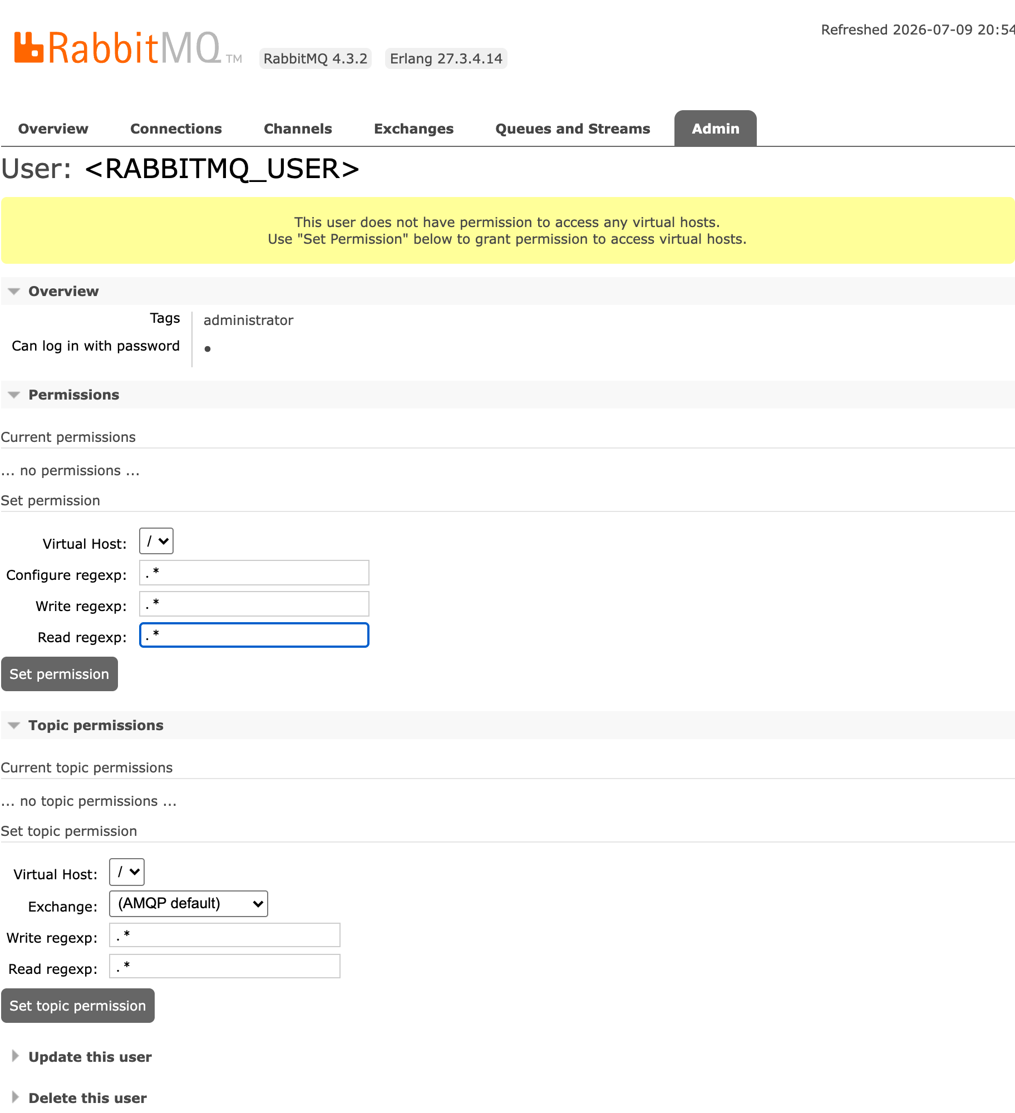
S4 — User: <RABBITMQ_USER>. Set permission on virtual host / with Configure / Write / Read all .*.
Field | Value | Notes
Virtual Host | / | The default vhost. Select it from the dropdown.
Configure regexp | .* | Full configure rights (declare/delete resources).
Write regexp | .* | Full write rights (publish, bind).
Read regexp | .* | Full read rights (consume, get).
Verify: the user's Current permissions table now shows one row — virtual host / with .* / .* / .*.

S5Re-login as an administrator
Log out of guest using the link in the top-right corner, then log back in as an administrator account — either the account you just created (if you tagged it administrator) or a separate administrator account. This is required for two reasons: RabbitMQ will not let you delete the account you are currently logged in as, and only an administrator-tagged account can log in to the Management console to perform the deletion.
If the application account is least-privilege (no tag), do not log in as it here. A tag-less application account cannot sign in to the Management UI, so use an administrator account for S5–S6. The application account itself is verified separately by the app connection — it does not need console access.
Verify: you are signed in as an administrator (shown in the top-right of the header) and the Admin tab is available.

S6Delete the guest user
Go to Admin › Users and click guest to open its detail page. Expand “Delete this user” at the bottom, click Delete, and confirm:
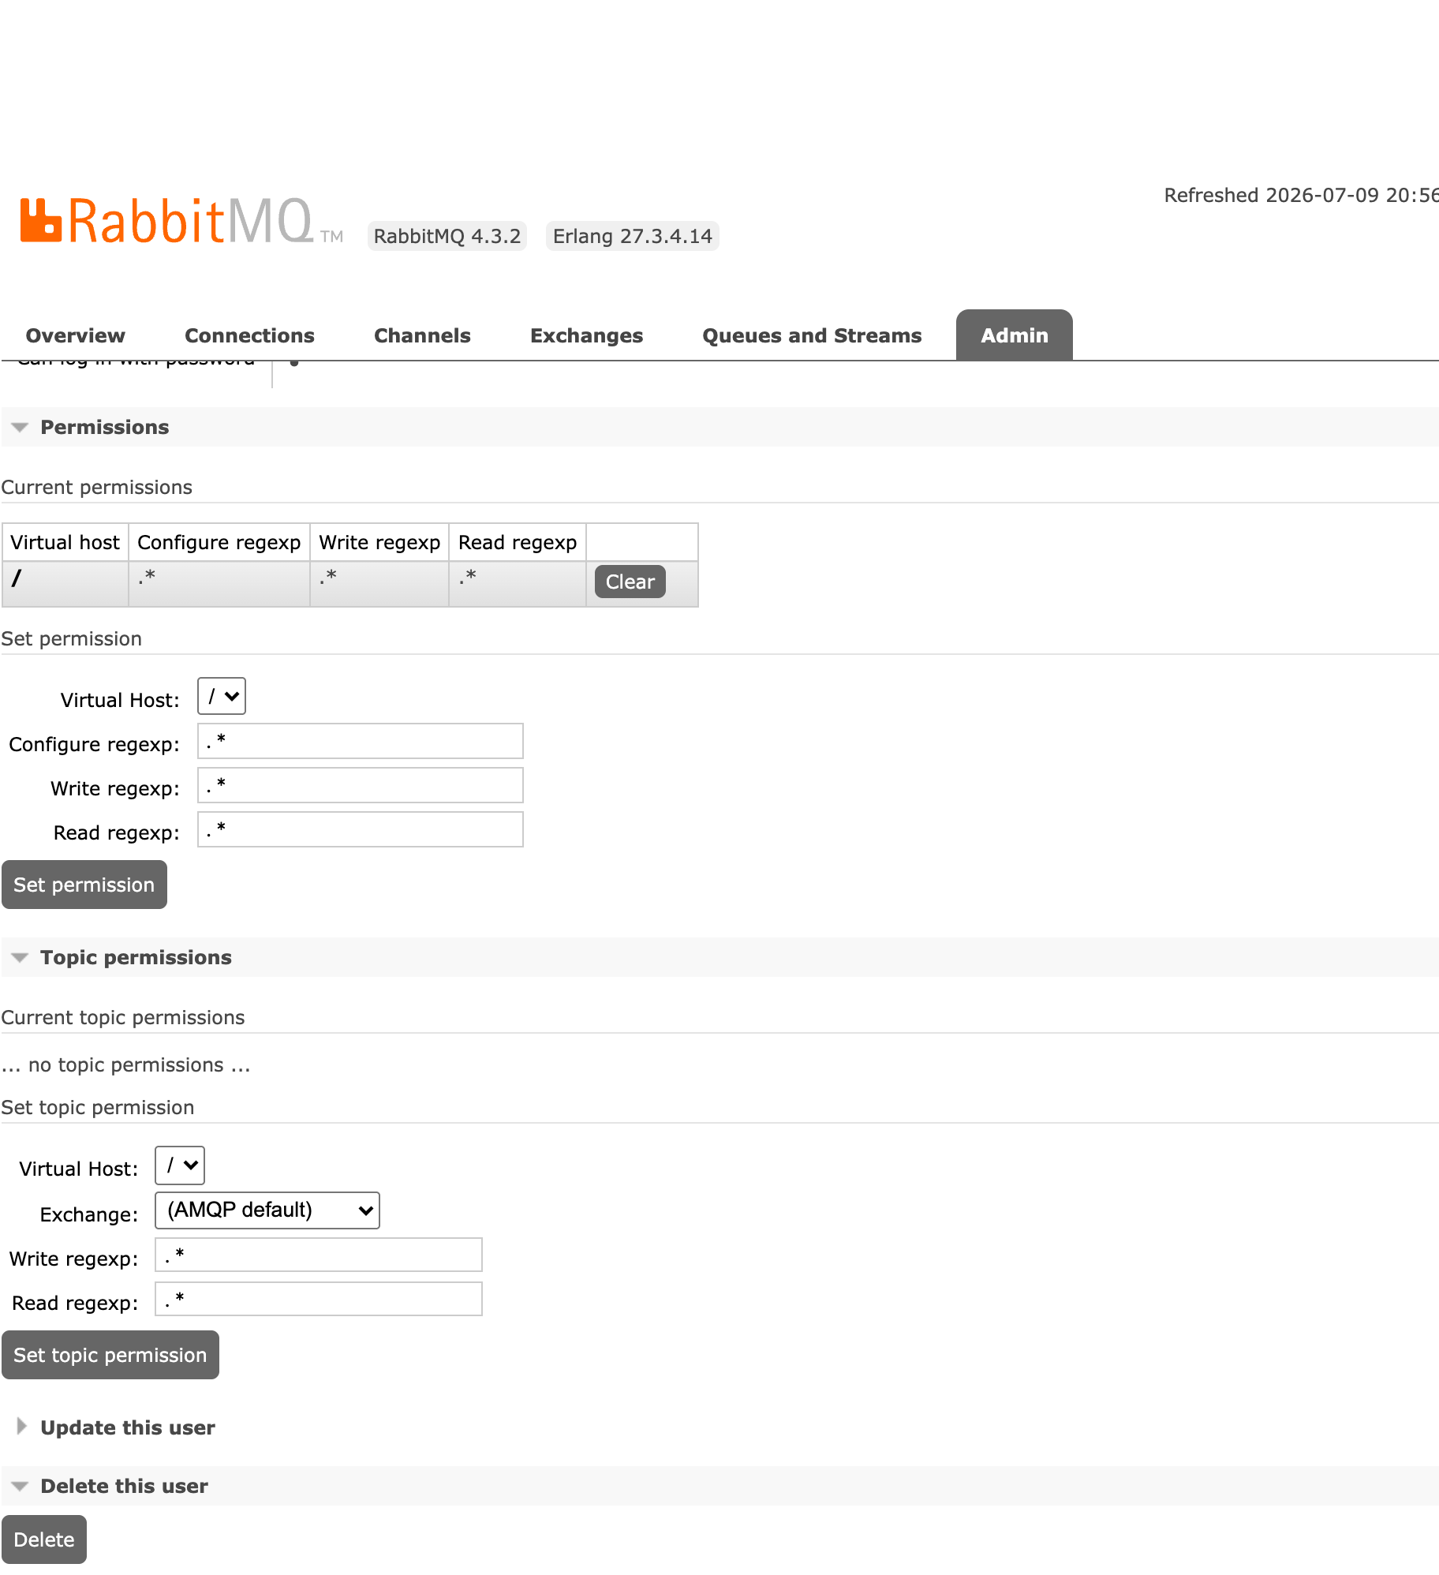
S6 — User: guest, “Delete this user” expanded. Click Delete to remove the default account.
Verify: after deletion the Users list no longer contains guest — only the accounts you created remain. The default credential no longer exists on this node.
Done — final state on this node.
- Admin › Users lists your <RABBITMQ_USER> application account (and any separate administrator account you created); guest is gone.
- The application account has permissions .* / .* / .* on virtual host /.
- guest has been deleted.
- The UI still answers at http://localhost:15672.
The application connects to its own broker at amqp://localhost:5672/ (default virtual host /) using the <RABBITMQ_USER> credentials.

Repeat on every app node
Each application server runs its own local RabbitMQ broker — there is no clustering. Production runs two IIS app nodes, and this user hardening is per node. Perform S1–S6 on App Server 1, then repeat identically on App Server 2 (each at its own server console, http://localhost:15672). The same <RABBITMQ_USER> / <RABBITMQ_PASSWORD> values are used on both, and guest must be deleted on both.
- App Server 1 — application user created, permissions .* / .* / .* on /, guest deleted.
- App Server 2 — application user created, permissions .* / .* / .* on /, guest deleted.
- Credentials recorded on the deployment sign-off sheet for the application-deploy step.

Placeholder glossary
Replace every <PLACEHOLDER> in the screens above with the bank's real value. These are the same placeholders used in the offline guide's A5 section.
Placeholder | Meaning
<RABBITMQ_USER> | Application's RabbitMQ account name, created per node
<RABBITMQ_PASSWORD> | Password for that account, created per node
Collateral Appraisal System API — RabbitMQ User Setup via the Management UI. Companion to docs/deployment/offline-installation-configuration-guide.html (section A5, step 5). Covers UI-based user hardening only; installation of Erlang/RabbitMQ and enabling the management plugin are in that guide. Print to PDF via Chrome/Edge for distribution.

