# Title: System update is not working properly

# Description:

When I am trying to run automated shell script to update the system, it gives me an error and won’t let me pull the updated code from repository. The repository, I am using to pull the code from is as follows:

<https://github.com/spiffrgr/MagicMirror2.git>

This is the same repo, I used for my initial clone and install.

# Hardware Used:

I am using Raspberry Pi 3 model B with the following specs:

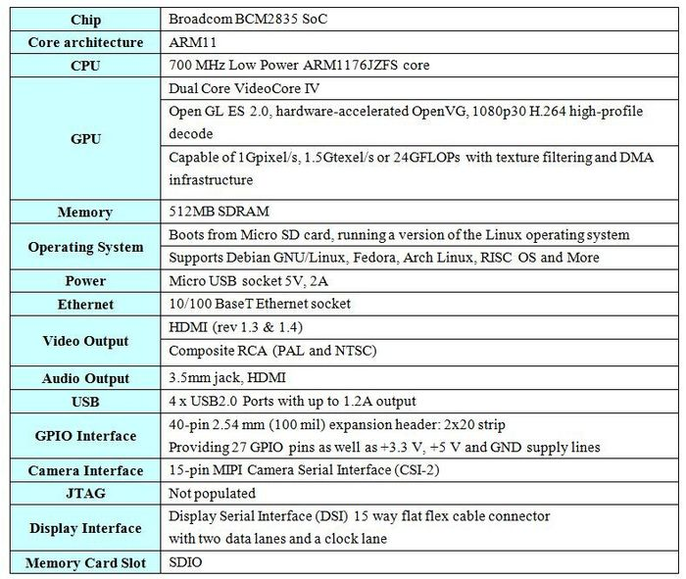

# Operating System:

* Linux Raspbian Buster Release 2019/09/26
* Download Link: <https://www.raspberrypi.org/downloads/raspbian/>
* MagicMirror2: <https://github.com/spiffrgr/MagicMirror2>
* Auto Install Command used:

curl -sL https://raw.githubusercontent.com/MichMich/MagicMirror/master/installers/raspberry.sh | bash

# 3rd Party Modules Used:

Following modules are installed and with the configuration changes and are running fine.

Config.js file in the folder /MagicMirror/config/ is altered as per module specifications.

* <https://github.com/eouia/MMM-AVStock.git>
* <https://github.com/paviro/MMM-PIR-Sensor.git>
* <https://github.com/nigel-daniels/MMM-3Day-Forecast.git>

# Configuration Changes Done by me:

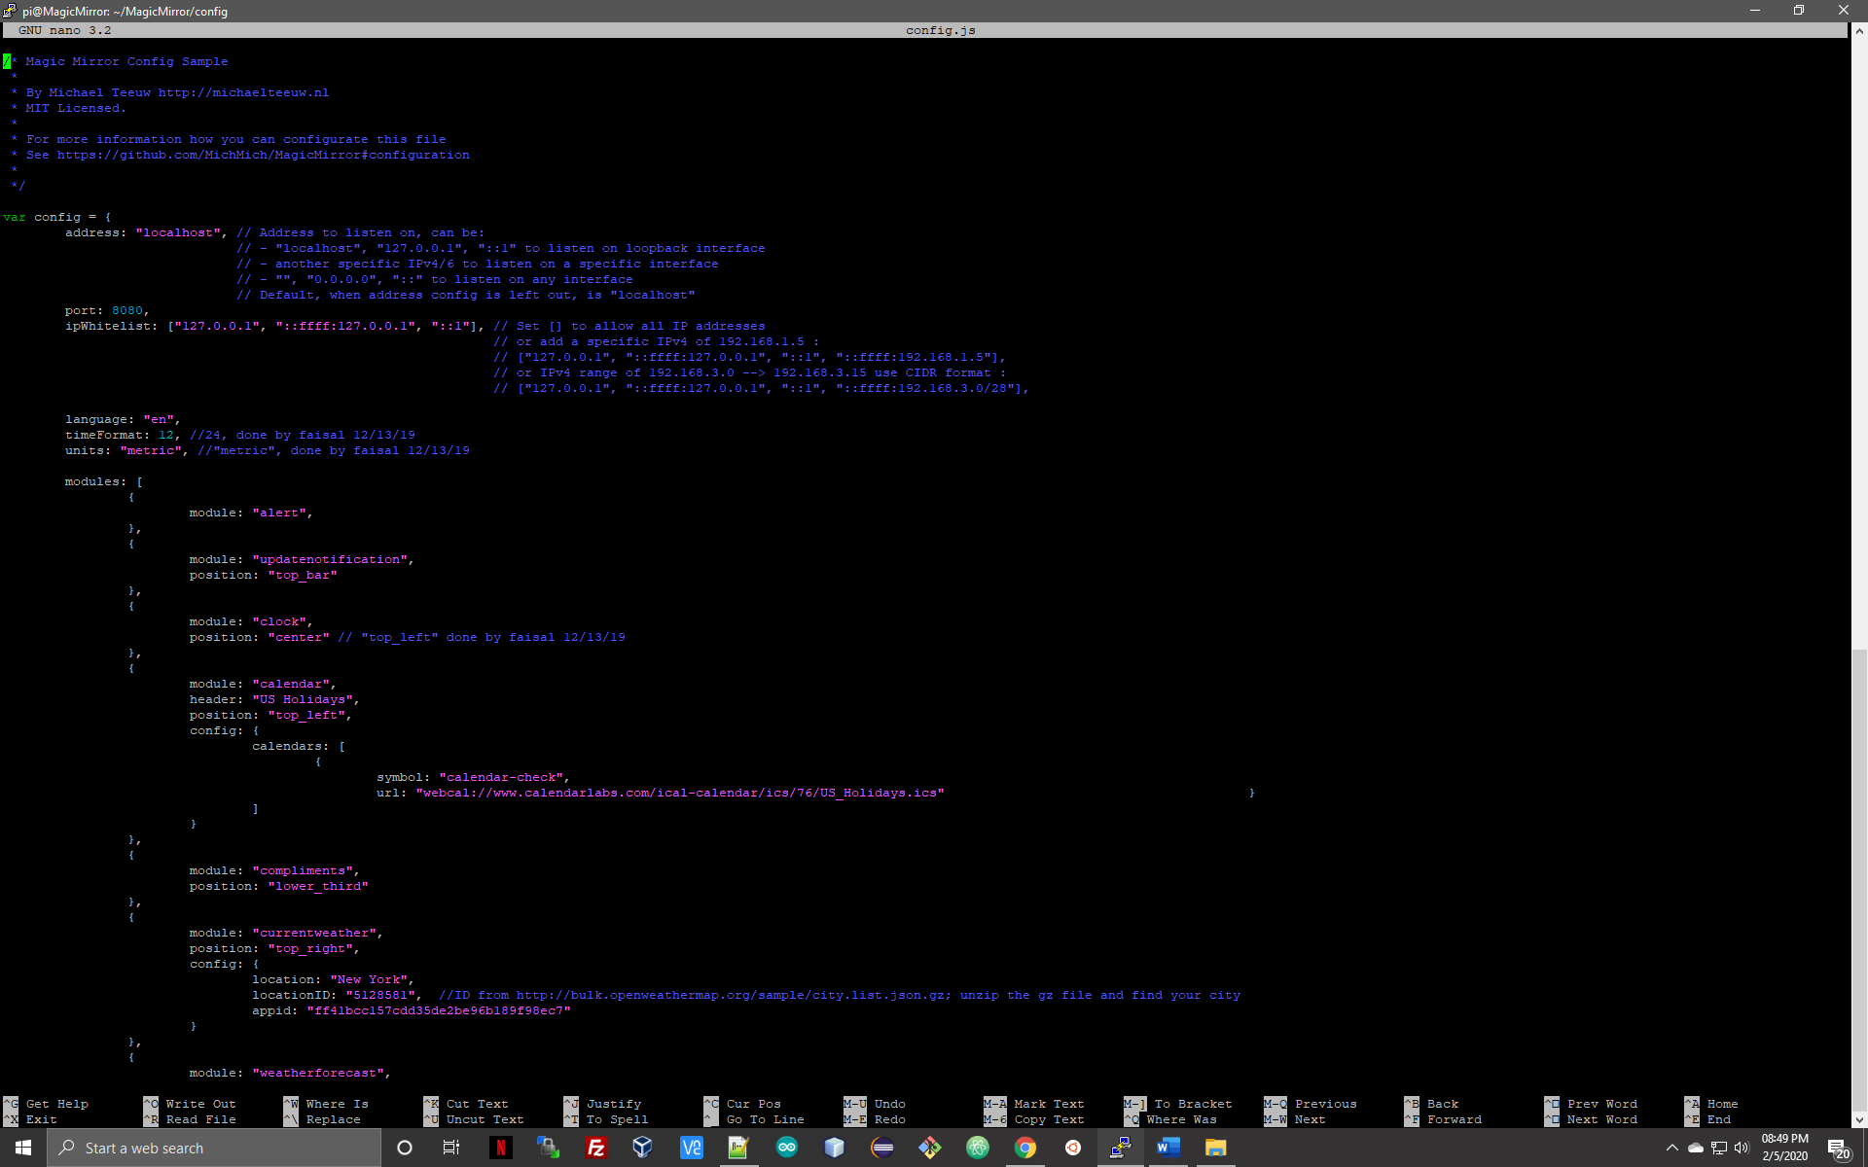

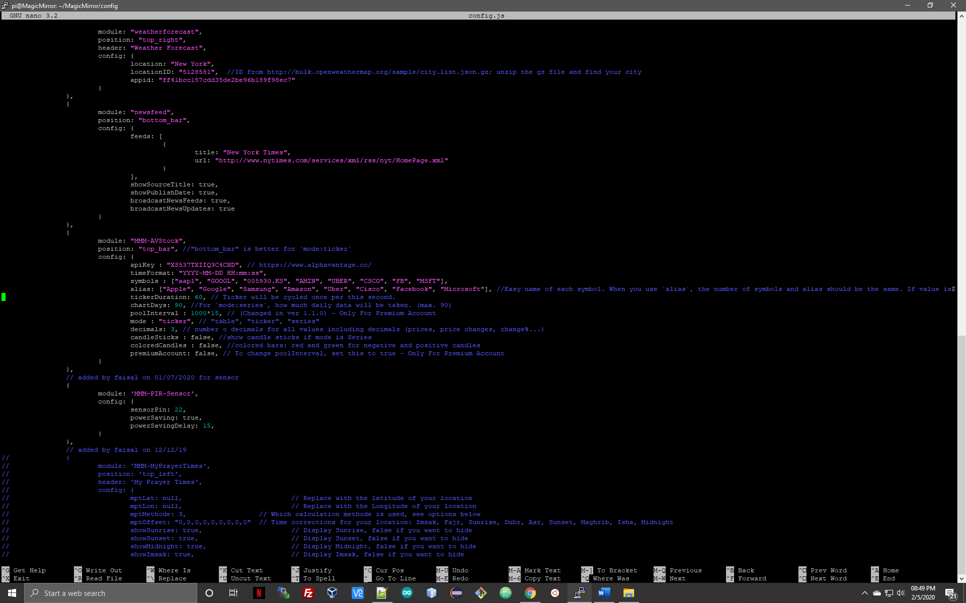

# Steps to Reproduce:

* ssh into the terminal (I am using rsa key for password less ssh)
* As described in the ripo documentation run “git pull”
* My git remote is set to the official MagicMirror2 ripo.

origin https://github.com/MichMich/MagicMirror.git (fetch)

origin https://github.com/MichMich/MagicMirror.git (push)

* In the 1st place, it won’t let you pull as I have untracked, and uncommitted changes made to my code in the form of config.js and other 3rd party installs.
* My modules folder is highly cluttered with the changes I have made to make the mirror as per my likings.

# Screenshot of git-pull & git status:

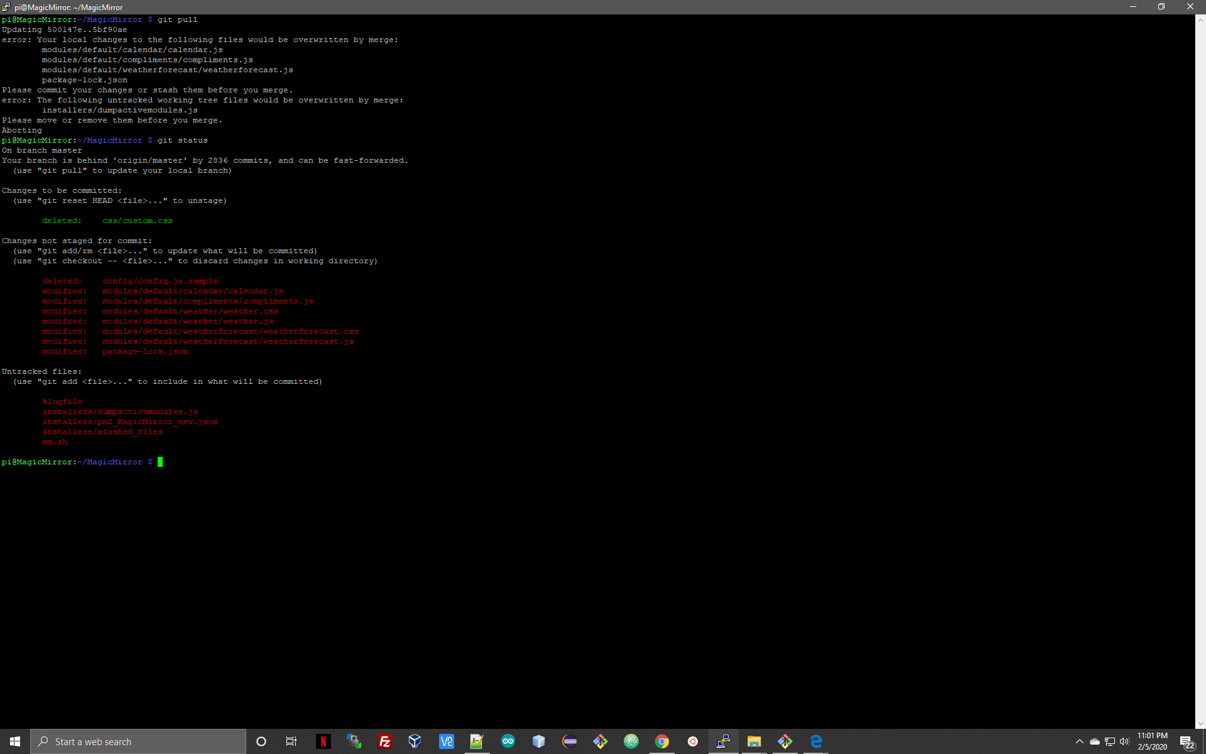

As you can see all the module changes are not accepted and configuration changes also would be affected in case I do git reset –hard.

# How it is meant to work:

* git pull should bring the new updated version in.
* npm install && npm start, should run the install on updated version.
* It shouldn’t mess with the configuration changes or give an option to back them up before writing them over with the default ones.
* App should be able to check for previous installs.

# What really happens:

* git pull doesn’t work, and user is not able to pull the latest version.
* There is always a message on the screen stating that user is certain commits behind and need to update the system.
* Prescribed solution to use “git reset –hard” let the user pull updated version but it comes with its own problems:

1. Configuration files is replaced
2. Modules are over-written.
3. It’s like user must start over again

# Suggestions:

* App itself should be capable of checking the previous installation and avoid copy over the default config file.
* User should be informed in the documentation that this could happen and should make a backup of the cofig file and modules folder.
* I think as this issue comes up over the user screen and may affect user experience with the app, you might give it a high priority to resolve – or – in the meantime you are working on it, you might put a way around it as I suggested to ask users to make a backup of the affected folders.

# Severity:

I would say medium, as it doesn’t stop the working of the mirror but affects user experience negatively.